THE IMPACT OF CORPORATE SOCIAL RESPONSIBILITY ON THE BRAND IMAGE OF THE AUTOMOBILE SECTOR IN THE UK
STUDENT NAME :PAYYAUVLA SAIKISHAN
STUDENT ID NO:2126308
PROGRAMME OF STUDY:MBA MARKETING MANAGEMENT
PROGRAMME MODULE :LCMB7020
SUBMISSION DATE :13/02/2024

ACKNOWLEDGEMENT
I am going to convey thanks to my friends and my teachers for completing the research project. I also show my heartfelt gratitude to my teacher for finding the relaxing journals and scholarly articles. I am going to convey the help that I have from my departmental head. In addition, my research partners have helped me to gain ideas to accomplish the research work efficiently.

ABSTRACT
CSR responsibilities become highly crucial for businesses to enhance their brand image. The research also focuses on the influence of corporate social responsibility on companies belonging to the automobile sector, especially in the United Kingdom. Despite the significant steps taken to improve CSR strategies, it is identified that high rates of competition affect the brand image improvement initiatives of automotive companies to improve their business performance. Through the help of implementing Triple Bottom Line theory, the study is continued with the analysis of previous literature based on various aspects of the topic. The identification of literature gaps is followed by selection of secondary data collection methods to analyse subjective data to address the research objectives. Total 20 journals are selected based on some inclusion and exclusion criteria to obtain results through the help of thematic data analysis. The result of the data analysis shows different kinds of CSR activities are related with the improvement of corporate brand image and challenges like pandemic related impacts are affecting the initiatives of automobile companies to improve their performance. However, the study does not focus much on the impact of philanthropic activities to improve brand image.
Keywords: UK automobile sector, Philanthropic contribution, brand image, employee perception, CSR strategies, customer loyalty

TABLE OF CONTENTS

ACKNOWLEDGEMENT ii

ABSTRACT iii

TABLE OF CONTENTS iv

LIST OF FIGURES viii

CHAPTER 1: INTRODUCTION 1

1.1 Introduction 1

1.2 Background of Study 1

1.3 Problem Statement 2

1.4 Objective of Study 2

1.5 Research Question 3

1.6 Significance of the study 3

1.7 Scope of the study 4

1.8 Operational definition 4

1.9 Organisational Structure 5

1.10 Summary 5

CHAPTER 2: LITERATURE REVIEW 6

2.1 Concept of CSR and Brand Image 6

2.2 Relationship between CSR and Brand Image 8

2.3 Impact of CSR on the Brand Image of the Automobile Sector 10

2.4 Strategies to Improve CSR to reflect the brand image of the Automobile Sector 12

2.5 Theoretical Framework 14

2.6 Conceptual framework 16

2.7 Literature Gap 17

2.8 Summary 17

CHAPTER 3: RESEARCH METHODOLOGY 18

3.1 Introduction 18

3.2 Methodological Framework 18

3.2.1 Research Philosophy 18

3.2.2 Research Approach 18

3.3 Research Design 19

3.4 Review Scope 19

3.5 Data Collection 20

3.6 Data Analysis 21

3.7 Inclusion and Exclusion 21

3.8 Prisma 22

3.9 Review Limitations 23

3.10 Ethical Consideration 23

3.11 Time Horizon 23

3.12 Summary 24

CHAPTER 4: RESULTS 25

4.1 Introduction 25

4.2 Thematic analysis 25

4.2.1 Corporate Social responsibility Strategies are crucial for brand awareness enhancement 25

4.2.2 CSR strategies influence positive customer loyalty through the enhancement of brand image 27

4.2.3 Employee’s perception, participation and organisation marketing approaches towards brand’s corporate social responsibility helps to enhance the corporate reputation 29

4.2.4 Green Corporate image creation is possible with commitment towards proper environment CSR outlook 31

4.3 Discussion 33

4.4 Summary 35

CHAPTER 5: CONCLUSION AND RECOMMENDATION 37

5.1 Conclusion 37

5.2 Linking with Objectives 37

5.3 Recommendation 38

5.4 Implication 40

5.5 Limitation 40

5.6 Future Scope 40

REFERENCES 41

APPENDICES 48

Appendix 1: Literature Review Matrix 48

LIST OF FIGURES

Figure 1.2: Motor industry's contribution to the UK economy from 2009 to 2021 7

Figure 1.8: Structure of Dissertation 11

Figure 2.1.1: Average Investment Level in the Automobile Industry 13

Figure 2.3.1: Automotive Industry Trend 17

Figure 2.4.1: Factors affecting the brand image of the automobile industry 20

Figure 2.5: The Triple Bottom Line Theory 22

Figure 2.3: Conceptual Framework 23

Figure 3.8: PRISMA Flowchart 28

Figure 3.11: Time Horizon (Gantt Chart) 30

CHAPTER 1: INTRODUCTION

1.1 Introduction
Corporate Social Responsibility of an organisation and their brand image have a positive correlation; therefore, CSR of a company in a specific sector can really affect the brand image. There are various studies, which have shown and explored that the CSR and the brand image are strongly correlated as the effective CSR practices can enhance the brand image and the reputation. This study has put its emphasis on the way corporate social responsibility affects the brand image of a company in the automobile industry in the market of the United Kingdom. The purpose of this chapter is to develop the research objectives, questions, and background information of the stud. Additionally, the problem selected for the study and its significance in providing better scope for future development in the automobile industry in the market of the United Kingdom are also illustrated here.

1.2 Background of Study
Corporate Social Responsibility is the integral part of the automobile industry of the UK and has its four main agenda to provide a positive impact upon the society, which include shaping the future of sustainable mobility, being a committed and responsible employer, incorporating a responsible business culture and practices for the reduction of internal environmental footprint. Carroll (2021) stated that Corporate Social Responsibility and its different functions have been evaluated and can be tracked to the early 20th century, when the business has started to engage itself into philanthropic work. A study conducted by Debenedetti et al. (2021) has been observed in the UK on the sustainability initiatives mandated and deployed in their respective automotive markets.
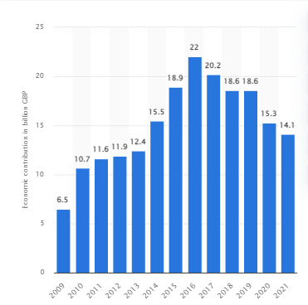

Figure 1.2: Motor industry's contribution to the UK economy from 2009 to 2021
(Source: statista.com, 2024)
It has been noted that the UK government has been granted GBP 91.7 million funding for the green auto technology projects and as per the current report the automobile industry has contributed £14.1 billion into the whole UK economy. According to SMMT (2022) UK automotive related manufacturing mainly contributed £67 billion turnover to the UK economy and invested approximately £3 billion each year in R&D. It has been observed that the top most companies in the automobile industry of the UK are contributing towards environmental sustainability, for example, Toyota has developed a community fund, which has designed small grants for helping the local charities, schools, and projects (toyota.co.uk, 2024).

1.3 Problem Statement
The automobile industry has been contributing a good amount of revenue into the whole UK GDP and economy but there are huge major issues which have been impacting the automobile industry of the UK. It has been observed that there is a huge competitive rate into the automobile industry, for that reason the car companies have been using various strategies and approaches to make them unique and to maintain a good brand reputation. For instance, it has noted that Volkswagen, being a largest importer of vehicles, has been facing issues regarding using fraudulent software to pass the Emission Tests for diesel cars, which has negatively affected its brand image (Kakade and Haber, 2020). Similarly, BMW, Toyota, Audit and Mitsubishi recalled their vehicle because of defective inflator, which can cause an expansion (cnet.com, 2020). All these activities have created serious issues to enhance their brand image. For this scenario, the effective CSR practices can really become helpful strategies to apply and which allows the companies of the automobile industry of UK to take the other beneficial advantages to enhance brand image and reputation.

1.4 Objective of Study
The main aim of this study is to find out how corporate social responsibility affects the brand image of companies associated with the automobile industry in the market of the United Kingdom. The research objectives have been described based on the main research aim; the research objectives are the following:
RO1: To evaluate the idea related to the concept of corporate social responsibility in automobile sector in the UK
RO2: To analyse the relationship between different CSR activities and improvement of brand
image in the automobile industry in the UK.
RO3: To identify how brand image of an automobile company can be impacted both positively
and negatively by the adoption of CSR strategies in the UK.
RO4: To assess different challenges automobile companies, face to implement effective CSR
strategies and how the challenges can be mitigated in the UK.

1.5 Research Question
The research question has been stated based on the research objectives to find out the exact answers for those questions. The data collection procedure is also crucial for stating these research questions. The three most important research questions have been stated below:
RQ1: What is the relationship between CSR and Brand Image in the UK?
RQ2: What is the significant positive impact of CSR on the Brand Image of the Automobile
Sector in the UK?
RQ3: What are the challenges Automobile companies face on the brand image due to poor CSR?
RQ4: What are the strategies to improve CSR to reflect the brand image of the automobile sector in the UK?

1.6 Significance of the study
The importance of this research study is highly justified because this research study has adequate and significant contributions in the field of the automobile industry of the UK. The findings of this research study can help the automobile industry to realize how the CSR activities and the brand image have been correlated. The effective CSR activities can resolve the unethical issue of the automobile industry which ultimately helps to enhance the brand image (White, 2022). From this research study the automobile industry players can allocate their resources for the CSR practices to align them according to their company value which has positively impacted their brand image.
The study has involved vast concept of the brand image which also include the customer perception and the results of the study can help to understand the positive impact of the CSR and how the practice of CSR. It can help to develop a positive perception the customer to have a greater inclination of making purchases from the business they trust to be socially conscious. The findings of the study can also explore the challenges, which have been recently faced by the automobile industry, and some suggestive approaches to mitigate those issues effectively which help to improve the brand image. However, the overall findings of study can significantly contribute to the UK automobile sector for deeply understanding both the positive and negative effects. Not only that, the results of the study can also provide a critical discussion on the role of CSR to improve brand image and so provide valuable insights for the future researchers and scholars.

1.7 Scope of the study
The scope of this study is to use the effective activities of CSR that have been beneficial to reduce the negative impact of the business such as for the automobile industry. The CSR can be implemented for reducing the environmental pollution and raw material consumption through environmental compensation. These activities can improve the brand images of the companies under automobile industry (Wang eta l., 2021). It has been observed that the automobile industry has faced some serious issues since the past few years such as the COVID-19 pandemic, which has developed semiconductor shortage, and the trilemma of ongoing supply pressure and financial impact has negatively affected the industry (ey.com, 2023). That is why the choice of the UK country is also appropriate and most suitable for the research topic. However, the scope of the study has also involved the term CSR and collecting more information which can elaborately discuss all the aspects such as environmental initiatives, community engagement and ethical activities and the vast concept of brand image. This also includes customer perception, trustworthiness and brand reputation, which can be measured effectively in this research study.

1.8 Operational definition
This section has described the definition and explains briefly the two concepts which include CSR and Brand Image.
Corporate social responsibility (CSR): The term corporate social responsibility mainly refers to a self-regulating business model which can help the company to become socially accountable and responsible to reduce the negative impact of the economy, society, and environment (Duy, 2023). The company has emerged to CSR activities to operate its business by enhancing society and the environment instead of contributing negatively.
Brand Image: The consumer’s perception and perception about some specific company and its products or service generally described as the brand image (Bernarto et al., 2020). A strong brand image can develop brand recognition and motivates the formation of a loyal customer base, which can provide profits to the business for a longer period. The brand image of a business has evolved over the time and did not necessarily involved customer making purchase of the products or services

1.9 Organisational Structure
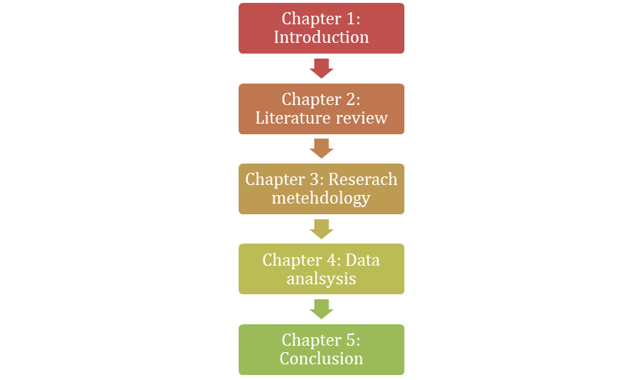

Figure 1.8: Structure of Dissertation

1.10 Summary
This introduction chapter has briefly described the background of the study and the main goal of the conduction of this research study. This section has explored that the study has its significance to investigate how CSR can become helpful approaches to the automobile industry for enhancing the brand image.

CHAPTER 2: LITERATURE REVIEW

2.1 Concept of CSR and Brand Image
According to Krishna (2021), all brands within the automobile sector are included in the phrase “automotive brand.” The phrase “automotive brand” refers to the individual producer brand rather than the corporate brand while an automobile business has many brands. The way a customer perceives the company is determined by their experiences with it. It can change throughout time and fails to be dependent on a client buying from the company or utilising the services. Riasanow et al., (2020) stated that a profitable car brand conveys its distinctive personality from its interior to the exterior by building on its basic principles throughout many years of development. Robust (automobile) companies are distinguished by outstanding speed combined with strength, apart from exceptional capabilities. Successful car brands continue to face a lot of obstacles to overcome. The automotive sector is evolving into a mobility services supplier, with electric and hybrid cars looking to replace traditional gasoline-powered automobiles.
Islam and Husung (2023) stated in a study that companies handle their ethical obligations in a variety of methods. Many companies incorporate their CSR initiatives into their larger business plans since they could be useful in communicating their beneficial social effect with its corporate image. CSR activities have gained significant attention in the highly saturated marketplace due to their strategic importance in corporate industries. Another study by Özcan and Elçi (2020) evaluated that tThe reality that businesses are spending a significant amount of their funds on CSR initiatives serves to emphasise this. However, customers care about corporate social responsibility (CSR) and demand that companies keep their cultural and moral responsibilities. Corporate social responsibility, or CSR, has grown in significance in both academia and industry.
A study investigated by Avotra et al. (2021) asserted that assessments on the effectiveness and advantages of CSR solutions and strategies typically concentrate on topics like financial results, staff productivity, and firm operational efficiency. Additionally, CSR gives businesses additional external reputation, social standing, and corporate attractiveness. It has been proposed that CSR has a favourable impact on worker productivity and interactions at work (Ahmad et al., 2022). Participating in corporate social responsibility (CSR) initiatives can enhance a business's overall reputation, which may therefore positively affect the brand reputation of the business.
An organisation's dedication to socially responsible practices yields beneficial results where CSR initiatives impart a profound impact on brand performance and awareness. In addition to this, businesses are often empowered with the privilege to improve their reputation and corporate image through adherence to CSR (Alam and Islam, 2021). According to Lu et al. (2020), establishing a company's image and fostering brand loyalty are difficult tasks, thus businesses should engage in CSR and other meaningful initiatives to increase satisfaction with customers, foster trust, and ultimately increase brand loyalty. Consistent innovation initiatives, robust branding, global value chain efficiency, and skilled and motivated workforce are the key components of long-term success in the automotive sector (Mahmood and Bashir, 2020).
Customers' views and interpretations of a company's identity, messaging, and values are known as its brand image. Numerous elements, such as societal impact, narrative technique, and artistic execution affect this perspective. The way that a brand is seen is greatly influenced by its appearance. Customers' perceptions of a good or commodity are shaped by their beliefs, not by the claims made by the corporation that owns the brand. Consumer usage, knowledge, operation, public image, and personal recommendations impact the perception of an organisation (Štreimikienė and Ahmed, 2021). As companies all around the world keep coming to realise how important it is to have powerful brands, the advertising sector is growing. Alongside the growth of social networks and the web, there has been a specific increase in digital marketing.
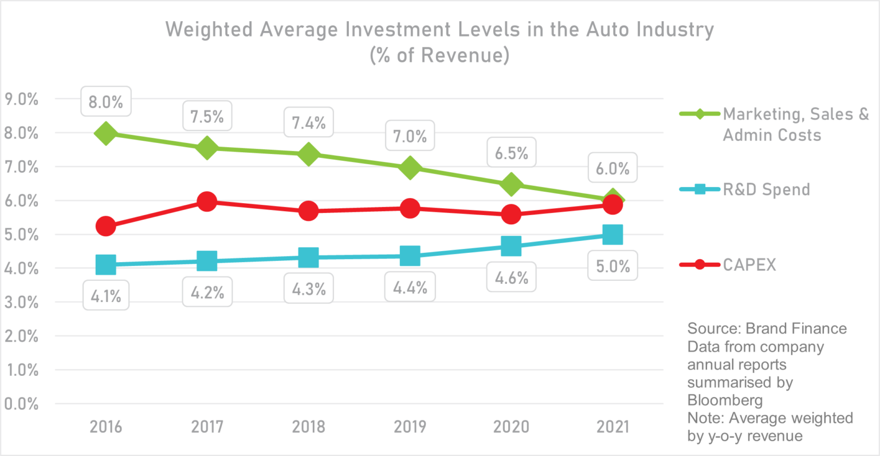

Figure 2.1.1: Average Investment Level in the Automobile Industry
(Source: brandfinance.com, 2023)
The following market partners are affected by several noteworthy changes in the automobile industry. Total revenue from marketing and associated office expenses continue to decline, falling from 8.0% in 2016 to 6.0% in 2021 (brandfinance.com, 2023). The decline might be attributed to higher requirements on capital expenditures and research & development (R&D). For example, Tesla was lucky to have a highly creative and relevant product line-up, significant “word of mouth” support from influential people, and the infinite PR utility of a charming and often contentious CEO who enjoys being the centre of public attention brandfinance.com, 2023). According to Vázquez-Martínez et al. (2021), it is important to note that external variables that impact consumer perception include recalls, poor media attention, and worldwide difficulties. The resale market still has chances to service a deteriorating generation of vehicles with more maintenance requirements, despite the obstacles that lay ahead (Phillips et al., 2020). Fostering a pleasant customer experience by providing exceptional service, being attentive, and being transparent may help create a positive impression in the eyes of the public.
Therefore, it has been comprehended that, all the automotive companies of the UK, generally build their specific and distinct brand image within the industry, which can make them unique from their rivals. The factors, which can provide a long-term profit to the brand, also have been identified such as effective supply chain, innovations and more. It has been also observed that adherence to the CSR initiatives and activities really become helpful to improve the brand image of the companies and not only that the realisation of the brand image among the brand and companies has also helped the advertising industry to grow.

2.2 Relationship between CSR and Brand Image
Consumer perception refers to the thoughts, emotions, and attitudes that consumers have towards the brand. It is crucial for increasing brand recognition and awareness and for consumer attraction and retention. These types of encounters with the company have an impact on how consumers perceive business. Consumer impression is influenced by several variables such as celebrities, price, quality, social networking sites, online critiques, and CX (zendesk.com, 2023). According to Zhao et al. (2021) culture of consumption research, 71% of customers prefer to purchase products from companies that share their beliefs. Building trust can be enhanced by a favourable consumer perception. Before making a purchase, 93% of consumers examine internet reviews (Chen et al., 2021). This implies that how potential buyers see the company might be greatly influenced by their online evaluations. Feedback from customers impacts the company by influencing how people see the brand.
According to the Aflac survey 2019, as much as 77% of the consumers prefer an organisation and are more likely to make purchases from them when the firms are committed to social and environmental causes (Edwards and Porter, 2023). Incorporating CSR components in the marketing strategies help a brand in establishing its ethical, philanthropic, social, and environmental attributes which in turn contributes to the brand image. In the opinions of He and Harris (2020) customers and the public will value a company significantly more when it engages in genuine and authentic CSR because they have high expectations from well-known brands, especially their favourable brands. In this respect it can be stated that highlighting the CSR initiatives taken by the automotive sector in the United Kingdom or globally can contribute significantly to the further development and proliferation of the industry (Lu et al., 2020). It can be witnessed in the case of the Ford Motor Company, which has increased its investment in electrification from $11 Billion to $22 billion with the aim to achieve carbon neutrality by 2050 and has been highlighting these initiatives to retain an astute brand reputation in the UK (Caldeira, 2024).
According to Wentze et al. (2022), despite being widely accepted social phenomena that has been documented in commercial literary works, CSR has recently started to get attention from researchers worldwide in the field of building. CSR is the process by which organisations, perceived by the general population as socially conscious enterprises, make temporary obligations to a variety of stakeholders. Companies, including SMEs, who adopt social responsibility (CSR) approaches, are more probable to demonstrate sustainable economic success, according to research showing a favourable correlation between the incorporation of CSR with corporate financial performance (CFP). However, Kim and Oh (2020) stated that corporate executives are under intense pressure to maximise return on investment, which may push them to take a monopolistic strategy to making money. For instance, the Swedish global fashion brand H&M declared that, by 2030, 100% of the resources utilised in their goods will be sustainable or regenerative due to their ethical assortment.
Consideration of CSR perspective is very important for enhancing the brand reputation as well as corporate image of an organisation. According to (Özcan and Elçi 2020), consideration of expectations of employees is important to setting required strategies that are important to improve the image of a business. Additionally, studies help in identifying that fort on implementing CSR is highly important for the enhancement of CSR practices and strategies in an organisation that can be developed through effective programs. Satisfaction of internal and external stakeholder is equally important to enhance the sustainable image of a corporate organisation. Therefore, it has been observed that the consumer perception has a huge impact upon the brand image and most of the customers prefer to shop from that company who shares their beliefs. The companies can build their good brand image and reputation through their CSR initiative and sharing those to their target audience. It can include ethical, social, and philanthropic activities, which can contribute positively towards the enhancement of brand image. However, the CSR activities within the UK automobile sector not only improve the brand image but also help the industry for future other development.

2.3 Impact of CSR on the Brand Image of the Automobile Sector
According to Chen (2023), the approach of the Triple Bottom Line (TBL) Theory, brand participation is crucial in governing how Corporate Social Responsibility (CSR) impacts the UK automotive industry's brand image. TBL emphasises how social, environmental, and economic facets of a company are interdependent, which is compatible with the growing importance of CSR in brand development. Through active involvement with societal and environmental barriers, brands can elaborate their purposefulness to cause positive profit uninterrupted brand participation (Aslaksen et al., 2021). TBL stimulates businesses in the automotive organisation to take part in environmental barriers, social concerns, and sustainability functions (Phan Tan, 2023). Active collaboration upgrades company reputation because consumers are becoming more admiring of companies that make profitable social offerings. The UK car industry may construct a peculiar and positive brand image, in line with TBL principles and valuing the changing command of socially conscious consumers, by collaborating CSR into brand implication creativity (Liu et al., 2021). The UK car industry may build a unique and positive brand image, in line with TBL essence and acceptable the changing demands of socially considered consumers, by collaborating CSR into brand involvement vitality.
Zhao et al. (2021) examined in their study that corporate social responsibility, or CSR, is garnering an abundance of attention and curiosity in the fierce global marketplace. The realisation that businesses are investing millions in CSR could be used as evidence of the significance of CSR. Still, CSR actively plays a role in establishing an excellent image and shareholder value. Additionally, it has been also observed that they pay little attention to improving the communities upon which they function while making a difference to society. According to Balmer et al. (2020), businesses invest millions in disseminating information about their goods, and this investment could either make or undermine their success. Strong automotive brands are more important than ever before. The growing number of entrepreneurs in the industry not only causes disturbance but also fosters competition. One of the primary items on the promotional checklist is still brand image. Consequently, it is essential to examine more closely the distinctive steps that certain companies take. For example, BMW with Mini, have undertaken to stand out to customers and, hopefully, boost both recognition and revenues (autovista24.autovistagroup.com, 2021).
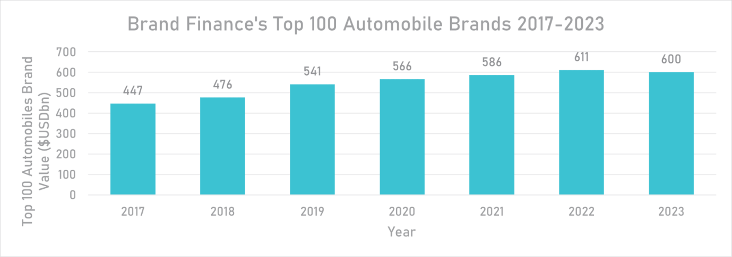

Figure 2.3.1: Automotive Industry Trend
(Source: brandfinance.com, 2023)
The year 2022 was not easy for the car business. During the year 2017, Brand Finance launched the first-ever Automobile company worth assessment. Since then, the total brand assets have decreased from “$611 billion USD” to “$600 billion USD”. This decline in value draws attention to a pattern for automobile companies that should alarm those who manage brands in the sector. This is the car brands' diminishing significance inside the international brand ecology (brandfinance.com, 2023). A study by Mao et al. (2020) asserted that a buyer's opinion of a brand is determined by the connections to it that are imprinted in their memory. This is known as brand image. It sets a business apart from rivals and can help the customer realise the demands and desires surrounding the company's reputation.
As a result, a brand's image evolves with time. According to Bashir et al. (2020), it is a significant indicator of how customers will feel about the brand and behave, especially when they assess an item or offering before making a purchase. Demand is being pushed by growing worries about global warming and the associated backing of alternate forms of transportation (brandfinance.com, 2023). However, expenses for customers remain substantial and uncertain due to factors including price hikes, rising auto loan interest rates, fluctuating gasoline prices, and costly electric vehicles. Businesses may leverage their unique brand images to create positive thoughts about their brand, and they can employ corporate social responsibility to enhance their image. Consumers are more inclined to trust in the craftsmanship of the products they buy when a company has a high reputation.
Therefore, the CSR activities can really influence brand image though the concept of brand image development takes a long time. The TBL theory is also closely aligned and supports that the brand image and the CSR are closely connected. The companies have been invested so much into their promotion of their products and services because the customers purchase products, which have attracted them rather than the rival companies. Additionally, it has been also observed that, there are various factors, which have its influence over the customer perception such as price range, interest rate and more.

2.4 Strategies to Improve CSR to reflect the brand image of the Automobile Sector
According to Head et al. (2023), the incorporation of global standards and guidelines with the Triple Bottom Line (TBL) Theory has a significant effect on the Corporate Social Responsibility (CSR) on the automotive organisation's brand identity in the United Kingdom. TBL cohere to international calibre for moral business effectiveness by arranging an intensity on all these features. The automotive industries in the UK are undertaking to notice the social and environmental effectiveness in addition to economic consideration by admirers of the worldwide CSR guidelines. Therefore, von Ingersleben‐Seip (2023), also stated that exhibiting a striving for sustainability, moral behaviour, and circle well-being, this alignment upgrades brand perception. In the highly competitive automotive market, the UK car organisation may advance its CSR motivation and form a strong brand image that intrigues customers who value uprightness and socially conscious decisions by following international norms and mandates that are based on TBL essence.
According to Wuisan and Handra (2023), marketing strategies have significant influence on the CSR capabilities of a company. It is understandable that the main purpose of selecting a marketing strategy is to communicate the functions and characteristics of the company to the stakeholders. Additionally, facilitation of stakeholders in the business operation can be easier for the companies so that strong trust and relationships can be developed. Principles of CSR can be incorporated in marketing strategies and it can help to differentiate the products and services in an uncharted market (García-Ortega et al., 2019). However, Saura et al. (2023) stated that social, environmental, and economic dimensions of the business operation could not be neglected during the development of an effective marketing strategy. This indicates that triple bottom line theory is a suitable choice for the marketers and policy makers to optimise the efficiency of their marketing operation. Alignment of the products with these functions can improve the brand reputation of a company (Özcan and Elçi, 2020). Therefore, thorough research on the influence of marketing strategies on brand reputation is essential.
Multinational corporations are expected to abide by several rules, regulations and restrictions that are generally implemented to safeguard the environment, the employees, and the communities they serve (Alakkas et al., 2022). Corporate Social Responsibility (CSR) is a critical component in a company's success, particularly for those operating in a worldwide economy such as the automobile industry. Customers' perceptions regarding a business primarily impact their purchasing decisions, hence a company's success or failure may be determined by the brand image. According to Wellbrock et al. (2020), significant challenges in the automobile sector include the increasing prevalence of electric motors and related optimization areas, lightweight construction, and reducing CO2 emissions, which are crucial determinants of brand image in the automobile industry.
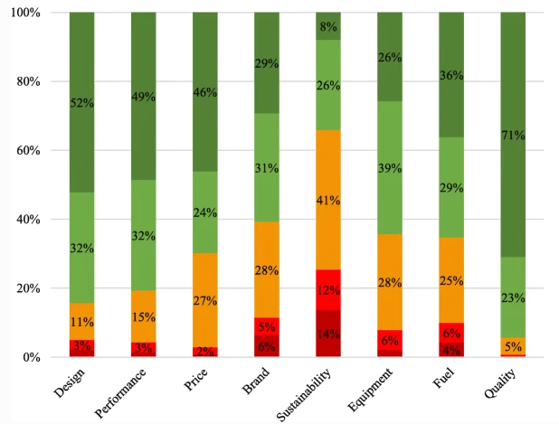

Figure 2.4.1: Factors affecting the brand image of the automobile industry
(Source: Wellbrock et al., 2020)
Automobile manufacturers are subjected to increasing pressure related to adherence to corporate and governmental directives as well as to the ever-evolving preferences of individual customers (Lukin et al., 2022). It can be observed from the graph provided above that the brand image of the automobile industry is significantly influenced by the design aspect, performance, price as well as CSR paradigms such as quality, sustainability and others which has been established by studies conducted by Heilbronn University of Applied Sciences and the University of Stuttgart (Wellbrock et al., 2020). According to Araújo et al. (2023), CSR imposes a direct impact on the corporate results and levies influence on several aspects including consumer loyalty, brand reputation, consumer trust and repurchase intention; and the perception of corporate performance. Hence, it can be identified that CSR is highly efficient in terms of generating positive results to maintain business level or standards in the corporate world. Additionally, assessment of “real” effects of CSR is highly crucial in terms of measuring the extent of the performance that is to be accomplished under an organisation (Fiechter et al., 2022). In addition, it is important to maintain consistency as much as possible in such cases.
It has been noted that the brands and the companies within the automobile industry really need to improve their CSR activities to enhance their brand images. The more CSR will be aligned with the sustainability and moral behaviour the brand perception of the company is also enhanced. The company can really align and set out their products with their CSR activities so that the customer perception also improves. Not only that, the companies main the car brand need to reduce their CO₂ emission due to their car which is also involved under the CSR activities.
CSR initiatives are highly crucial in terms of enhancing the brand identity for a company irrespective of its sector (Lu et al., 2020). Additionally, the growth of online purchase is an significant opportunity for the business companies in terms of enhancing their brand image to enhance their image in their business market. In this communication can play an recognisable role to promote the CSR activities that are taken by business organisations to convince customers as well as other business shareholders. Alakkas et al. (2022), has identified that considering factors like marketing communications is considered highly efficient in terms of improvement of brand equity. Therefore, it results in a positive brand recognition for a company that is important to maintain their reputation on a long-term basis.

2.5 Theoretical Framework
The Triple Bottom Line Theory
John Elkington developed the Triple Bottom Line (TBL) Theory, which assesses a company's overall presentation in addition to financial initiative. It comprises three dimensions: economic, social, and environmental. The TBL framework governs enterprise towards sustainable and attentive business enactment, and it is well oriented with global standard and guidelines, marketing strategy, brand participation, consumer perception. CSR, or corporate social responsibility, is a main principle of the TBL Theory. TBL focuses on how organisations need to think about their effect on society in addition to gaining profit (Bonfanti et al., 2023). Since CSR places a strong stress on moral efforts, community incorporation, and employee well-being, it is compatible with the TBL's social measurement.
Businesses who incorporate CSR into their functioning make a positive social impact and reinforce the TBL's operation to develop a value that advances beyond financial metrics. In the framework of the TBL Theory, a brand's active involvement with social and environmental barriers is raised as brand engagement that helps to proficient marketing strategies. Businesses that are successful in applying the triple bottom line principle also try to give more to the society. They know that offering back involves more than just financial contributions. It also involves giving of a person's time and assets. Giving back to society at large has several advantages for the company in addition to helping those or organisations whose circumstances are transformed (ezop.com, 2020). Businesses that accompany TBL utility understand that clients are becoming more captivated in brands that have higher efficacy than just making money (Henry et al., 2023). Therefore, incorporation in ecological and social assessments as a brand creates customer sureness and a company's name. This orientates TBL's mainly aims at social value design and effective brand image. The TBL Theory revitalises companies to embrace resilience into their marketing schemes, which is how it interchange with marketing strategy. Businesses that accompany TBL requirements frequently highlight in their advertising capability their commitment to environmental and social influence. This scheme is harmonious with the TBL's unbiased aim of reconstructing customer behaviour and encouraging sustainable procurement actions through well-informed choice of options provoked by a brand's dedication to more immeasurable societal and environmental objectives.
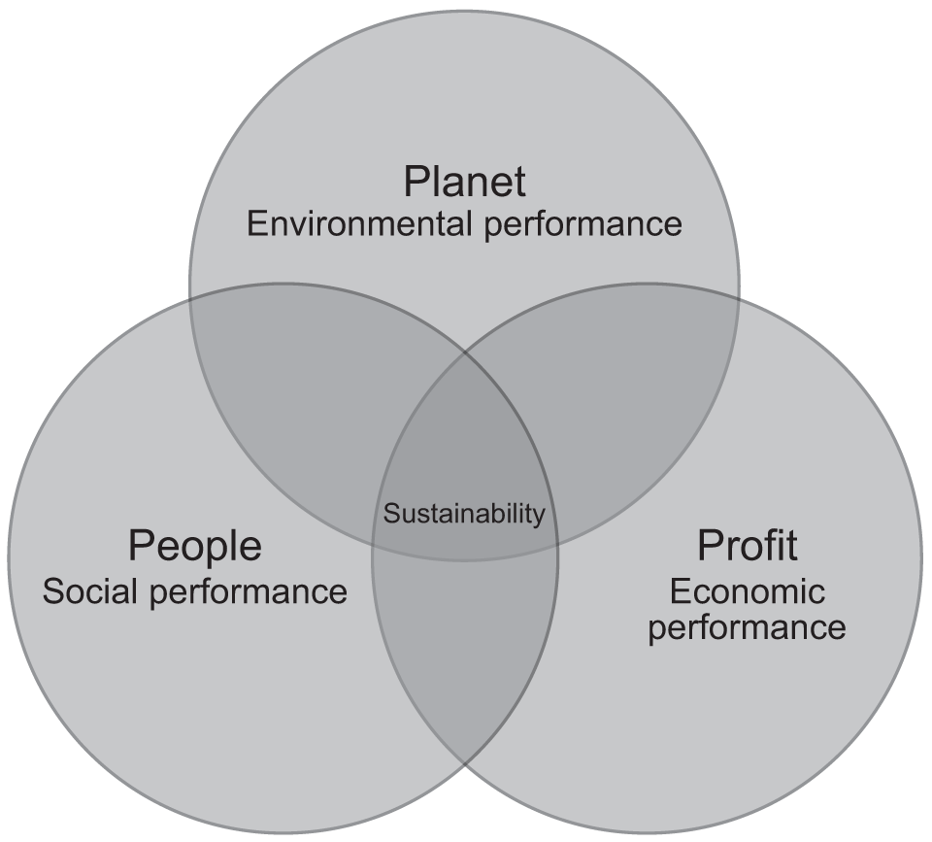

Figure 2.5: The Triple Bottom Line Theory
(Source: Elshaer, 2023)
A crucial factor of the TBL Theory's compliance with the corporate system is consumer perception. According to TBL, customers are becoming more responsive and troubled about the way they obtain and impact society and the environment. Customer loyalty and inclination may be regulated by a favourable notion of a brand's commitment to the triple bottom line economic, social, and environmental issues (Elshaer et al., 2023). Therefore, it has been observed that adhering to the TBL concept aims to advance their reputation among socially and environmentally minded consumers, which is compatible with the theory's focus on comprehensive value creation.
In addition to encouraging sustainable development and social corporate citizenship, this design puts companies in a competitive supremacy as customers place a growing urgency on ethical and ecologically responsive company practices. Therefore, a strong structure between the Triple Bottom Line Theory and global standard and guidelines, marketing strategy, brand participation, consumer perception (Hermawan et al., 2023). It vitalises an immense proposition to value production by urging action to consider the effects on the economy, society, and territory. Adopting TBL principles can improvise brand reputation; nourish that make the bond stronger between businesses and their stakeholders, and assist a more ethical and sustainable organisation ecosystem.

2.6 Conceptual framework
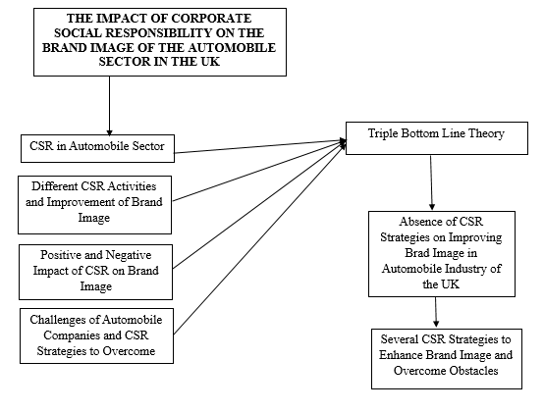

Figure 2.6: Conceptual Framework

2.7 Literature Gap
A significant dearth of emphasis on the complex connection between the several CSR initiatives taken by the automobile brands and its implication on the mitigation of the concerns those are prevalent in the industry. Some of these potential issues consist of fraudulent practices, vehicle recalls and so on. Furthermore, the importance of marketing strategy in forging a unique brand identity has been exorbitantly discussed through previous literature. However, the precise aspects of marketing that have the most impact on brand image especially in the automobile sector in the UK has not been explored in a precise manner which serves as the base for this study.

2.8 Summary
This chapter held a comprehensive analysis of the previous research materials that are specifically focussed on the impact of CSR on brand image. Therefore, an exhaustive analysis has been carried out which highlighted global standard and guidelines, marketing strategy, brand participation, consumer perception to be key aspects that has been utilised in this research to derive a better perspective of the topic being explored. Similarly, the inclusion of the triple bottom theory to CSR and its role in sustainable management has been explored in a profound manner. Subsequently, this detailed analysis led to the identification of the literature gap, which has been included in this chapter.

CHAPTER 3: RESEARCH METHODOLOGY

3.1 Introduction
Research methodology is a set of techniques and procedures that are implemented by the researcher to answer the research questions. Along with this, it is also a detailed procedure to achieve research objectives as well as design the proposed study. Moreover, research methodology refers to the practical decisions that help to select relevant research strategies. Similarly, in this study different kinds of research methodology are selected such as research philosophy, approach, design, data collection and analysis. Some criteria are also pointed out that help the researcher to select suitable articles to deliver authentic and meaningful findings.

3.2 Methodological Framework

3.2.1 Research Philosophy
Research philosophy indicates a set of beliefs that help the researcher in research execution and design. It is one of the crucial research methods that help to solve research problems. There are different kinds of research philosophy such as positivism, interpretivism, realism, and pragmatism research philosophy (Alharahsheh and Pius, 2020). Among all of these, interpretivism research philosophy is selected for this study. It is one kind of sociological method that analyses the data based on a culture or society. Similarly, in this study it is appropriate to understand the corporate social responsibility of the automobile sector. Help of interpretivism research philosophy also identifies its roles and responsibilities toward society’s people.
The researcher socially constructs all the collected data related to the impact of CSR on brand image. The nature of brand managers regarding CSR in their automobile sector is also analysed by this selected research philosophy (Scauso, 2020). The implementation of interpretivism research philosophy ensures that reality (impact of CSR on brand image) is constructed through the experience of the brand managers. All the CSR related actions or events incorporated by the automobile sector are also analysed that have significant impact on brand image. Due to all these reasons, interpretivism research philosophy is applied in this study.

3.2.2 Research Approach
Research approach is a detailed procedure to gather, interpret and analyse data based on proposed empirical study. Apart from that, a research approach is also a set of general strategies and techniques that help to conduct a study. Two kinds of research approaches are deductive and inductive research approaches (Sibeoni et al., 2020). An inductive research approach has been selected for this research work. The main idea of an inductive research approach is to collect and interpret data to develop a hypothesis or theory. Following the bottom-up method in the inductive research approach, the researcher developed the Triple Bottom Line theory. Based on this, a general concept of CSR and its relation with brand image has also been highlighted.
During the same period, the inductive research approach also helped to make a link between the underpinned theory and its related components (Kyngäs, 2020). The researcher can derive some effective factors from the underpinned theory like relationship between CSR and brand image, how to mitigate CSR related challenges through the components of this theory and many more. Based on this discussion, it can be said that an inductive research approach helps to maintain flexibility of study along with closely linking the theory with context.

3.3 Research Design
A research design is an entire strategy that is used by the researcher to answer research questions. In order to analyse the collected data more critically, the method of research design is also very helpful. There are different kinds of research design- descriptive, exploratory, explanatory, experimental, and quasi-experimental research design (Bentouhami et al., 2021). The explanatory research design has been selected for this empirical study. In order to explain different CSR aspects related to this study, explanatory research design selected by the researcher. Moreover, to establish the future scope of this study like utilisation of CSR activities for organisational growth is analysed by explanatory research design.
Following explanatory research design helped to develop research questions like relationship between CSR and brand image, significant impact of CSR on brand image, challenges of CSR and strategies to improve CSR activities in automobile sector. Along with the development of research questions, explanatory research design also assists to formulate a framework that represents the relationship between research objectives and topic (Toyon, 2021). Apart from that, after the critical analysis regarding research objectives, the researcher provides suggestions for further research. In order to conduct the study in a systematic way, explanatory research design is selected.

3.4 Review Scope
The use of above-mentioned techniques and approaches enable the researcher to develop further scope of the future research and reviewing for this research. It can also be stated that the utilisation of the effective methods and techniques corresponding to the topic of the research has presented some specific viewpoints over the research topic (Rezigalla, 2020). Therefore, utilisation of this research philosophy, research approach and design can help the researcher to present this study based on a variety of perspectives along with enabling them to highlight its important findings and contribution to the automotive industry of the UK along with society.

3.5 Data Collection
The Data Collection Method is one of the crucial stages of the research methodology that is used to collect data from the data sources. Concerning this research, the secondary data collection method is selected. The secondary data collection is the process of collecting information from the secondary data sources that has previously been gathered by other scholars for a different area of research (Lê and Schmid, 2022). In addition, secondary data sources are easily available which also beneficial to reduce the expanse of the research. Therefore, the researcher has studied the works of other scholars who have published on this same topic and has gained useful information from their research studies to conduct this new research.
3.5.1 Search sentence
The researcher identified key terms like “corporate social responsibility”, “brand image” and “automobile sector” and searched databases to find research papers about the topic. In addition, some specific quotations were also used to identify appropriate articles and collected effective information from a variety of search engines. Some words were left out to avoid repetition (Zaman et al., 2022). This developed authentic research skills by giving close attention to articles that addressed relevant methods for conducting the study. In addition, some specific terms are also avoided to avoid reading meaningless material.
3.5.2 Database and other sources
Various databases, including Google Scholar, ProQuest, MDPI (Multidisciplinary Publishing Institute), and ScienceDirect, are used to collect authentic secondary data and information from various research articles (Wang and Alavi, 2020). Google Scholar has been particularly helpful in identifying scholarly articles on the impact of Corporate Social responsibilities on brand image development. The database provides authentic authors, citations, and publications, making it a reliable source for secondary data collection. MDPI (Multidisciplinary Publishing Institute) has also been effective in gathering accurate data related to corporate social responsibility and its impact on brand image development in the automobile sector (Bauer and Kirchner, 2020). In addition, various websites and Google Scholar also used to collect and extract data, while prioritising data quality. Official publications were only followed for data collection from Google Scholar, some government websites also used.

3.6 Data Analysis
Data analysis is another important stage of the research methodology. Since, this research employed a secondary data collection method, a thematic analysis is applied in this research, in this regard, a thematic analysis involves seven steps: data familiarisation, first code generation, theme search, theme examination, theme definition and identifying report authoring, and reference (Lester et al., 2020). The method is applied to the analysis of CSR strategy in the automobile sector in the UK. In this regard, all the information that is gathered by the researcher is carefully reviewed before developing preliminary codes to classify it.
In this study, themes were selected from collected data and secondary sources After gathering the data, the six steps of Braun and Clarke's schema were used to extract code and construct themes (Feng and Behar-Horenstein, 2019). Prior to establishing inclusion and exclusion criteria, a PRISMA framework was utilised to filter and screen the selected papers. Additional advantages of this system included maintaining a proper meta-analysis of the study and presenting it in a "recognized standard for reporting evidence". Additionally, the PRISMA framework has allowed us to present the research in compliance with acknowledged norms for reporting evidence and upholding adequate meta-analysis.

3.7 Inclusion and Exclusion
Inclusion criteria refers to a set of terms and conditions that are applied by the researcher at the time of data collection (Newman and Gough, 2020). On the other hand, exclusion criteria help to eliminate duplicate, vague, and non-relevant data from the proposed study. Some inclusion and exclusion criteria that are followed throughout this research work are discussed in below-
Inclusion Criteria:
All the articles should be published after 2019 and written in English.
All the journals should include relevant resources and abstract of the study.
Data in articles and journals should be selected according to proposed topic and related with developed research objectives.
Exclusion Criteria:
Many articles are eliminated due to being published before 2019 like 2015, 2017 and many more.
Some journals are excluded because these are written in Chinese, German, and Arabic.
Some of the selected articles are eliminated because these are not clearly answered by their developed research objectives.

3.8 Prisma
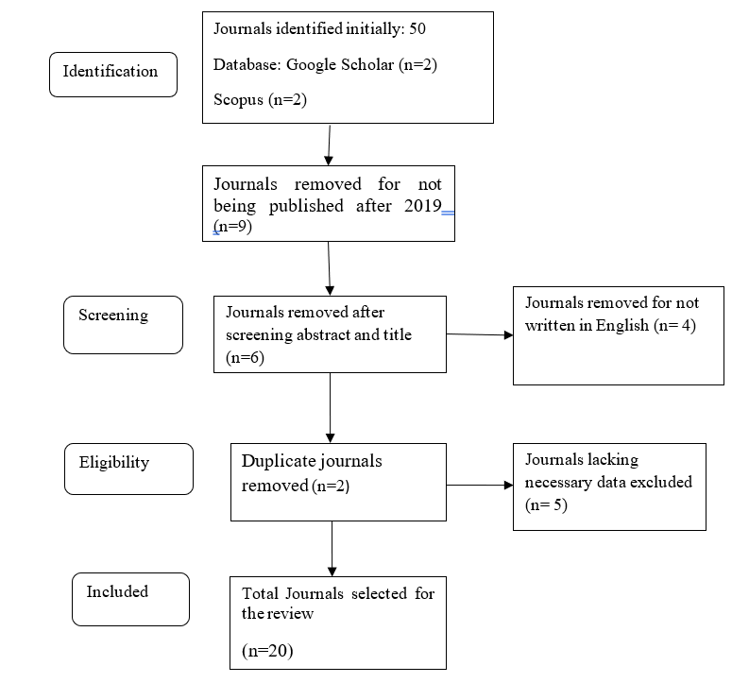

Figure 3.8: PRISMA Flowchart
Based on the above flowchart it can be identified that a total of 50 articles have been identified in this research. However, by employing the inclusion and exclusion criteria some of the articles have been removed to find appropriate articles related to this research. Hence, 20 articles are finalised in this research for data analysis process.

3.9 Review Limitations
Based on the information and understanding of this research, various research limitations have been identified. One of the limitations of this research is that statistical data cannot be supplied since it depends on secondary data and information. Moreover, the challenges of developing corporate social responsibility in the automobile sector are not sufficiently covered by this study. The potential benefits of corporate social responsibility for improving the car industry's brand image have not received much consideration in this study. Lack of funds and time compelled the researcher to conduct the investigation under these limitations.

3.10 Ethical Consideration
The concept of ethical considerations in research methodology is a set of different principles that assist in research designs and practices. All these principles include confidentiality, informed consent, transparency, individual consent and many more (Broesch et al., 2020). The researcher selected “Data Protection Act, 2018” as an ethical act for this empirical study. Following this act, the researcher ensures that all the data are collected from authentic and legal sources. Apart from that, this ethical act also ensures that the collected data are not shared to anyone that can ensure the chance of data duplicity or bias.

3.11 Time Horizon
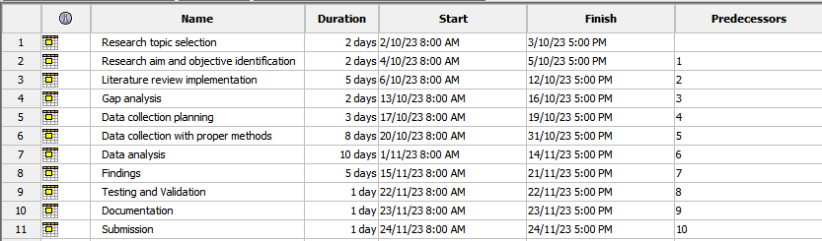


Figure 3.11: Time Horizon (Gantt Chart)

3.12 Summary
A review of the chapter reveals that the researcher to create relevant research questions has identified the themes and objectives of the study. Additionally, the use of a secondary data collection approach has allowed them to present the theme analysis in an interesting way. In order to conduct this study, the researcher used a descriptive research design, logical technique, and positivist philosophy to establish his own understanding and perspective of the selected topic. In addition, the investigator has utilised a time schedule to provide a methodical methodology for the study by breaking down different tasks based on assigned deadlines.

CHAPTER 4: RESULTS

4.1 Introduction
This chapter mainly involves the data analysis process and the whole procedure through which the result has been evolved and conclusions can be drawn from the findings. This secondary research study has executed thematic data analysis for the research topic the impact of corporate social responsibility on the brand image of the automobile sector in the UK. This research study has executed the thematic analysis based on the qualitative data gathered from the 20 chosen relevant articles. The themes of this data analysis have been developed by using these articles. This chapter is going to develop four themes based on the articles by using the software. The chapter concludes with a discussion section which is used to summarise the below findings. The main aim of this chapter is going to be the analysis of these themes and understanding if there is a link between CSR initiatives and the brand image.

4.2 Thematic analysis

4.2.1 Corporate Social responsibility Strategies are crucial for brand awareness enhancement
Modern business has experienced a heightened regard for corporate social responsibility to enable a sustainable business. Arauja et al. (2023), who also added that corporate social responsibility has gained key importance in enhancing brand image and awareness, have supported this. The corporate social responsibilities of a company show its efforts to address the social, environmental, and ethical issues of the community. However, for assessing the value of CSR for brand awareness enhancement, it is important to consider its effect on brand image, customer loyalty and long-term sustainability of the company. Özcan and Elçi (2020) asserted that CSR is used as a tool by organisations to achieve their goals. The study further added that organisations always ensure to align four aspects for achieving the full potential of CSR in their business. These four aspects are “economic, legal, ethical, and volunteering” (Özcan and Elçi, 2020). The study also reported to have observed an increasing rate of research supporting the impact of CSR on employee psychology. In other words, CSR initiatives of a company have the potential to influence employee attitudes towards their job role and the company.
The brand awareness can be perceived from the attitude of customers and employees. According to Özcan and Elçi (2020), brand attractiveness to job seekers depends on their CSR initiatives. However, the employee perception of righteous and relevant CSR initiatives for a company has been categorised into “social and non-social stakeholders”, “employees”, “consumers”, and “the government”. Corporate social responsibilities can provide organisations with the opportunity to make a mark in the competition with innovations that meet the demand for sustainable businesses by focusing on CSR-centric research and development. As a result, having a sustainable goal for R&D improves the commercial, social, and ethical areas of responsibility by developing high-quality products and services for the customers.
According to Arauja et al. (2023), customer demand for sustainable products has changed the business philosophy of big companies. These organisations have shifted their focus from being profit-centric to sustainable. Therefore, aligning sustainable objectives in product R&D would help the company produce sustainable products, enhancing the brand image. A positive brand image suggests brand awareness, especially when the brand is willing to meet the imminent consumer need in the market. As per Özcan and Elçi (2020), this consumer needs are for “more sustainable products with lower carbon impact”. However, the study also states that CSR effects on brand awareness also involve other business criteria, such as employee loyalty, job satisfaction, turnover intention, and corporate image.
The CSR initiatives of a brand show its commitment to the environment as well as society. Therefore, a strong CSR policy can improve the perceived trustworthiness of the brand for customers. However, ignoring social issues to ensure profit could have a significantly negative impact on the company's image. This too would gain brand awareness but for all the wrong reasons (Balmer et al., 2020). Failing to meet the standard expectations of corporate social responsibility could earn severe backlash for the company, affecting corporate image, and sales and losing customer trust. Similarly, engaging in unethical practices for profit could also have a long-term impact on brand awareness and profitability, or even result in civil lawsuits. Araujo et al. (2023) have suggested that corporate social responsibilities foster customer loyalty and increase buying consideration from the brand that shows more actionable sustainable-initiatives in their business and product making. The core of this relationship is linked to people’s positive feelings for doing good deeds, caused by the release of dopamine.
The globalisation of industries has opened new competitions across the globe, where companies must make a distinctive image for themselves while competing with local and international brands. As the study findings of Araujo et al. (2023) indicated, upholding an actionable corporate social responsibility, and devising strategies to achieve them might reflect the company’s commitment and morality, which holds higher significance for convincing new potential customers. According to the research findings discussed by Bashir et al. (2020), working towards social and environmental issues benefits the people who are a part of the community, thereby enhancing brand awareness among customers who prefer sustainability and goodwill in society. These aspects of the CSR implementation create an emotional relationship between the brand and the consumer, enhancing brand awareness through organic marketing. However, it is important to ensure that the CSR strategies companies adopt and announce aligns with their organisational values and brand vision to ensure authenticity in their goodwill gesture and charities. Instances of greenwashing and superficial CSR initiatives can could stakeholder to lose their trust and have an adverse impact on brand. According to Bashir et al. (2020), correct CSR initiative implementation could gain massive positive attention, enhancing brand awareness. Therefore, conducting research on the ongoing issues related to the brand and its operating industry might be beneficial adopt more relevant CSR strategies, both for the company and the social issue.

4.2.2 CSR strategies influence positive customer loyalty through the enhancement of brand image
Corporate social responsibility or CSR activities have become a very core part of any business in the global perspectives. It has been helping the companies around the world to foster customer loyalty through being committed towards different social responsibilities (Balmer et al., 2020). This not just been a reason for staying morally correct, however, it also helps to enhance the customer base. It is done through displaying the different social responsibilities implemented by each of the companies. Customer loyalty is subjected to the brand image created by the different companies among their customer base in different competitive markets (Lu et al., 2020). It is evident that the brand image for a company is impacted by how the company can stay committed to fulfil different social and environmental responsibilities in the region where it operates.
In recent years, consumer demands are hugely being impacted by the company's commitment to being socially and environmentally responsible (He and Harris, 2020). This means that the companies are generally able to attract more customers to avail their brand when they can deliver to the different corporate social responsibilities that these companies have been claiming since the operations began. In this aspect, the most crucial thing to keep an enhanced brand image is to communicate the different business processes attached with the different corporate social responsibilities (CSR) with utmost honesty and transparency to not just the customers but all the other stakeholders as well.
Customers in today's modern business environment are more aware of the details regarding the business processes. This means that the businesses that can communicate openly about the authority of the different CSR initiatives that were undertaken by the company are better able to maintain the customer loyalty for a prolonged period (Mao et al., 2020). This not only helps to build a better customer base but also helps to improve the brand image, which can further enhance customer loyalty as well. Corporate social responsibility initiatives in the recent business years have also become one of the most crucial starters for the companies to gain a competitive advantage among the other key players in the respective market (Štreimikienė and Ahmed, 2021). It has been found in the different market conditions that the brands that are able to stay committed towards different corporate social responsibilities are able to achieve a higher competitive edge in the markets.
It has also become very common that the consumers stick to a particular brand if the latter is able to stay committed towards the different claimed Corporate Social Responsibilities (CSR). This means that companies that are more involved in different CSR projects such as community development initiatives or environmental conservation projects can attract more consumers into their consumer base and maintain the loyalty of the existing customers better as well (Balmer et al., 2020). This further means that the consumers draw specific perceptions of the social responsibilities undertaken by the different businesses. This perception being a positive one can led to the enhancement of the brand image of the company.

The companies that is unable to deliver this form of perception for the customers can face deterioration in the brand image (Özcan and Elçi, 2020). For instance, the brand Body shop has become extensively committed towards maintaining sustainability in the different business processes. This includes activities such as the use of cruelty free ingredients for the production purpose and more. This has helped the brand to gain a higher number of customer base in the last few years in and around the world (Mao et al., 2020). These brands around the world must also seek to keep gathering insights into the different customer demands and the changes in the same, which can further help the brands to tailor their CSR activities and enhance the brand image even furthermore.

4.2.3 Employee’s perception, participation and organisation marketing approaches towards brand’s corporate social responsibility helps to enhance the corporate reputation
Employee’s perception towards brand’s CSR helps organisations to effectively execute their CSR objectives and achieve sustainable development to maintain a positive corporate reputation over the industry and market. At the time, organisations engaged in pro-social activities were required to select their employees or staff's feelings involving their sense of wellbeing and identification (Alam and Islam, 2021). Organisation CSR initiatives help employees to get involved in community development, environmental conservation, and ethical business practices (Alakkas et al., 2022). Different researches present that employees' perception have a significant connection or positive relation towards the organisations or brands execution of CSR and their innovative behaviour.
Employees or organisation staff present an important role while implementing and over the success of company corporate social responsibility initiatives. Employees' active participation is very important for the company to implement different workplace responsibilities over the organisation (Zhao et al., 2021). Similarly, every company requires their employees' commitment against their CSR approaches or policies to present successfully a corporate reputation (Lu et al., 2020). Organisations believe that all their employees are required to get involved over the company's corporate social responsibility activities or practices (Chen et al., 2021). It directs the sense of purpose and ownership among all their employees (Štreimikienė and Ahmed, 2021). Over company, corporate social responsibility activities the employees represent themselves as the brand ambassadors to help the company effectively present their social responsibility efforts and execute success.
Most of the automobile organisations in the UK influence their employees to be involved in organisation CSR volunteer programs. Additionally, companies also involve their employees in different social works to support environmental clean-ups or local community (Lukin et al., 2022). Organisations believe that this type of CSR initiatives help their employees to upgrade their morale and teamwork skills within the organisation (Liu and Jung, 2021). Additionally, UK automobile organisations prefer the corporate social responsibility trends to create a positive work environment for their organisation employees (Phillips et al., 2020). Most of the employees appreciate the positive working environment provided by the company, which cares about the employees environmental and social issues (Araújo et al., 2023). This type of CSR initiative used by the companies to affect directly the organisation employees will be by influencing the sense of fulfilment and purpose.
UK automobile organisations use different types of employee volunteer programs to encourage the employee’s participation over the company CSR initiatives. This type of volunteer program involves volunteer opportunities for the organisation employees to engage effectively towards the environmental projects and community service (Özcan and Elçi, 2020). These volunteer programs involve food drives, tree planting, mentoring programs, and beach clean-ups, which allow the organisation to significantly contribute towards the social causes and effectively improve their corporate reputation (Aslaksen et al., 2021). Organisation CSR initiative involves skill-based volunteering which influences the employees to use their professional skills to contribute towards the social good (Riasanow et al., 2021). Different UK automobile organisations host events where they are skilled employees offer training sessions, workshops, and consulting services towards the local communities without any financial profit.
Organisations involve employees to take part over their CSR initiatives where they have partners with different educational institutions or schools against skill development workshops, scholarship programs or career guidance. Over this type of CSR programs, the organisation employees get involved as guest speakers or mentors to support the academics (Vázquez-Martínez et al., 2021). Organisation employees also participate in different environment friendly initiatives over their workplace to develop the company's sustainability performance or corporate reputation over the industry and market (Krishna, 2021). UK automobile companies host different types of charitable donations where all their employees contribute against the social causes they care about (Mao et al., 2020). CSR initiatives also help the organisation employees to promote inclusion diversity and equity over their workplace and personal life.
Organisations host employee discussions, awareness campaigns and workshops to educate the employees about the role of diversity and inclusion over the workplace. Additionally, Employee driven corporate social responsibility projects empower the employees to present an approach and lead CSR initiative over their organisation (Bashir et al., 2020). This type of employee involvement or perception significantly fosters the sense of enthusiasm and ownership, which help the organisation to maintain effectively their reputation among the customers and other business companies.
Organisation corporate-responsibility initiatives help them to nurture their goodwill, trust, assets and present a positive reputation. Present commitment towards corporate social responsibility to influence the market customers to see them as responsible towards corporate and social challenges and situations (Balmer et al., 2020). Most of the UK automobile organisations connect their branding and CSR (He and Harris, 2020). It healthy company to develop their public image and brand value. The companies link their CSR initiative with their branding or marketing approaches to build trust with their employee’s, stakeholder’s, investors, and customers.

4.2.4 Green Corporate image creation is possible with commitment towards proper environment CSR outlook
The creation of a green corporate image in a competitive market requires a genuine and deep commitment from the company to ensure that environmental sustainability initiatives can be associated with the company’s core values. Aslaksen et al. (2021) emphasise that companies need a deeper assessment of the ongoing issues in the industry for a more focused and thought-out plan for environmental stewardship. Discussion of the collected data by Balmer et al. (2020) suggested that the brand must show and practice genuine consideration to implement green practices into the business process. This can be achieved by implementing eco-friendly policies in product development and manufacturing, and sustainable supply chain, raw material, and organisational management. Sustainability can also be implemented by implementing energy-efficient innovations for production, and power sources and reducing waste generation (Alam and Islam, 2021). These strategies are much more effective than implementing CSR policies in the organisation since they are more tangible (Phillips et al., 2020). Mao et al. (2020) stated that making noticeable changes to accommodate CRS strategies of the company to minimise carbon footprint shows its dedication level to the stakeholders.
Research conducted by Liu and Jung (2021) revealed that CSR activities held a key position when analysing its negative perceptions for commercial gains. However, the study also noted that organisations could not bring authenticity with underlying intentions or social obligations. For CSR strategies to be highly effective, they must be authentic, which can only be introduced with genuine care for social issues. The perception of a brand’s CSR initiatives can be either positive or negative, based on their motivation and sincerity (Liu and Jung, 2021). This reason organisations hire professionals would do thorough assessment of the company values to choose the right CSR goals.
In the current business environment, the environmental impact of the different business processes is also a crucial point of concern for the brands to be able to have a positive brand image among the consumers around the world (Bashir et al., 2020). This has led to the growth of the green corporate image creation for the different brands with specific commitment towards reducing the negative environmental impacts of different parts of the business processes. The companies have started initiating different environments Corporate Social Responsibility initiatives for remaining committed towards reducing the carbon footprints of different business activities by the brand (Zhao et al., 2021). This has led the business to understand the different alternative business process choices that can be made by the management of the companies to reduce the negative effect of the business on the environment where the business operates.
It is important to note that any environmental corporate responsibility or CSR initiative is based on specific regulatory guidelines that are issued by authorities of the region where the business operates (Mao et al., 2020). This makes it important for the businesses to understand and adhere to these guidelines. The companies must voluntarily be involved in different initiatives such as using eco-friendly business practices, seeking to reduce the overall carbon footprint of each of the business processes. The environmental corporate social responsibilities also often involve the different brands to invest more on the use of different renewable energies into the different business processes (Aslaksen et al., 2021). These initiatives not only help the company to be able to stay committed to reduce the environmental impact of the business processes but also help the company to have a proper Green corporate Image (Alam and Islam, 2021). This can further help the brand to display the commitment towards the environment where the business operates and attract more customers who seek brand products, which are produced through the highest sustainable methods.
UK automobile brands were increasingly identifying the significance of green brand image and sustainability. According to the 2023 automotive sustainability report, the UK automotive industry presented a great effort towards sustainability. Most of the UK automobile brands were presented with the challenges like pandemic related disruptions and global parts shortages. In 2022, there was 16.6% of battery electric vehicles registration surpassing the diesel cars (García-Ortega et al., 2019). Additionally, plug in vehicles reached towards a new record height of 22.9% of new registrations. Similarly, there were hybrid electric vehicles that contributed towards 6.9% of the reduction over average CO2 tailpipe emissions (Alam and Islam, 2021). Most of the automotive brands presented that their brand reputation depended on lifestyle and imagery. Most of the consumers perceive value depending on the organisation's commitment towards sustainability (Aslaksen et al., 2021). The luxury automobile brands over the United Kingdom focused on the standard luxury vehicles and Ultra luxury vehicles considering design quality and environmental consciousness. Additionally, in the UK the ethical spending has doubled from the last decade.

4.3 Discussion
The thematic analysis of this secondary research study has explained in detail about the Corporate Social Responsibility and the brand image enhancement. The CSR has its huge impact upon the brand images of the companies under the automobile sector. Although it has been, also proceed that the COVID-19 has also influences the CSR activities of the companies and which ultimately has impacted the market philosophy. This pandemic has also allowed the companies to grow more opportunities for the CSR activities and the situation has shifted the companies to developed more authentic and genuine CSR activities to perform for the mitigation of the environmental challenges. The company and brand who has their responsibilities towards the mitigation of the environmental issue has a positive brand reputation, which also improves their profit. The first theme has been discussed in what way the CSR has become very crucial for brand awareness enhancement. The companies need to be aware of their audience and target customers regarding their brand so that the audience can identify their brand from the rivals with the same industry and the CSR can really become one of the most effective strategies to enhance the brand awareness among the audience. It has been observed that, the companies need to realise the effects of the CSR on the brand image, customer loyalty and long-term sustainability of the company.
The companies have involved themselves into the CSR initiatives, which aim to solve and reduce any ethical and environmental issues. Customer perspectives have been considered as a valuable factor for the brand image enhancement so the company's initiatives of legal, ethical, economical, or environmental CSR initiatives can positively influence the customer perception and their initiatives for innovation and research can also help them to enhance their brand awareness and affect their employee’s psychology. The second theme has discussed the development of positive customer loyalty through brand image enhancement by CSR strategies. It has been explored that the CSR activities of the companies are helpful to enhance the brand image on an international level for the business operation, which ultimately maximises the loyalty of the customer. The companies have their loyal customer base and it has encouraged the company to be involved into different social responsibility activities within the competitive and dynamic market. It has been explained that the customer's demand and their loyalty has been influenced by the company's commitment towards the society and environment. The companies can focus into their CSR activities of the social and environmental issues, which has been considered as the proof to their target audience, and in result, the company has been able to achieve a loyal and strong customer base, which also enhance their brand image, and reputation as well as the company can get more profit through this. It has been also explored that effective communication is really needed because every CSR has its distinct business process so to maintain the honesty and the authenticity the communication is necessary. The companies, which have not provided a better brand reputation or image between the customer and audience, might face various difficulties, and deteriorate the brand image. The third theme has discussed the perception of the employees towards the CSR as a major contributing factor to enhance corporate reputation. The company has executed their CSR activities through an effective employee perception towards the brand as it has developed a positive and good corporate reputation. It has been revealed that the companies not only need to execute social and environmental CSR activities but also need to initiate various CSR activities involving community development and ethical business practices which can really develop growth and opportunity for the employees. The employee perception and their thought about the company has its direct and positive connection with the organisation's CSR activities execution and innovation. It has been stated that employees are the major stakeholders of the organisation so they have their huge role in sharing the success of the CSR activities of the firm, and their participation really becomes beneficial for the implementation of workplace responsibilities. The employees also have their distinct perception regarding their company as they have been working within different departments. Although it has been revealed that the companies whenever the company has been provided or performing CSR activities based on the employee’s good development, mainly the employee-oriented CSR activities then it has first direct positive effects on employee’s perception.
The fourth but the last theme has discussed the commitment towards proper environment CSR outlook has really become possible through Green Corporate image development. The concern about the environment has really become the most important factor for the companies, as the customers also prefer those companies, which have their commitment towards the positive contribution towards the environment. It has been also observed that green brand preferences and corporate images has its huge influence over the proper environment CSR outlook. The green brand image has been really developed through the companies’ initiatives towards the reduction of carbon emission and utilisation of renewable energy resources. These types of activities have really become beneficial under the CSR initiatives of the brand to reduce negative impact of the business on the environment and which ultimately develop a green corporate image. The managers of the companies are the most accountable people who can devise green branding strategies for their companies and display the green campaigns, which have an agenda to highlight the ecological concerns with green customers. Therefore, it has been comprehended from the above discussion of the four themes, the corporate social responsibilities have really influenced both the positive and negative upon the brand awareness or image, but the pandemic situation has opened various opportunities to the companies for performing several CSR activities which can really enhance the brand image. Not only, the employee's perception and the customer loyalty also influenced by the CSR activity, which has been considered as the major aspects and components for the enhancement of the brands.

4.4 Summary
Based on this research chapter, 20-research articles were used to create four themes to critically analyse the research topic and different authors' perception. All the themes were critically analysed through the thematic analysis process. The first research theme presented that Corporate Social responsibility Strategies are crucial for brand awareness enhancement. The second theme of the research presented that CSR strategies influence positive customer loyalty through the enhancement of brand image. The third theme identifies Employee’s perception, participation and organisation-marketing approaches towards brand’s corporate social responsibility were the main contributors to enhancing the corporate reputation. Additionally, the fourth theme suggested that Green Corporate image creation is possible with commitment towards proper environment CSR outlook. All the critical findings against the themes were effectively discussed using a proper discussion process.

CHAPTER 5: CONCLUSION AND RECOMMENDATION

5.1 Conclusion
The results that are obtained after the secondary data analysis helps in identifying that implementation of corporate social responsibility and improving the corporation responsibilities strategies are input important for automotive companies to the level of brand awareness. The result of data analysis shows that corporate social responsibility is one of the important contributors for enhancing the corporate reputation as well as green corporate image creation can be fasted through it. Previous studies identify that appropriate cola collaboration between people, planet and profit is significantly crucial for enhancing the sustainable image. Supported by the result of the data analysis four aspects like economic aspect, legal aspect, ethical aspect, and volunteering aspect should be maintained to improve the CSR efficiency in an organisation. The outcome is to be assessed in respect to all the identified.

5.2 Linking with Objectives
RO1: To evaluate the idea related to the concept of corporate social responsibility in the automobile sector in the UK
The first objective that was made to analyse the corporate social responsibility concept in the context of the automobile sector is full field through the obtained research outcome. From analysing secondary data closely associated with the improvement of the automobile sector. The increase in the production of electric and hybrid cars are considered environment friendly because the demand for such products is also increased among the customers belonging to highly developed nations like the United Kingdom. Additionally, CSR approaches are important to reduce the pressure of competition hence it is getting massive participate positive attention from the stakeholders
RO2: To analyse the relationship between different CSR activities and improvement of brand image in the automobile industry in the UK
The outcome of secondary data analysis and review of the previous literature shows that CSR is highly crucial for automobile companies for enhancement of their brand image, thus significantly contributing to improving the green corporate image. Additionally, it is observed that the needs of implementing effective and eco-friendly policies are important to make product manufacturing more efficient. Therefore, the second objective is also addressed.
RO3: To identify how the brand image of an automobile company can be impacted both positively and negatively by the adoption of CSR strategies in the UK
Brand image is a crucial factor for development of business efficiency as well as efficiency improvements for the adoption of strategic approaches. However, studies also find out that the perception about the CSR initiatives that are taken by a company can be both positive and negative by nature. Additionally, the research work also shows that professionals should do an effective assessment about the company values for the formation of accurate CSR goals. Therefore, the third objective is also met through the research outcome
RO4: To assess different challenges automobile companies, face to implement effective CSR strategies and how the challenges can be mitigated in the UK
The study focuses on the analysis of the efficiency of CSR implementation and challenges that take place for CSR implementation is also assessed in the research. Studies show that challenges can emerge in this case can be numerous by nature and it is associated with recent pandemic related impact on the financial ability of the organisation. Issues like those that shortage in supply is observed in this case along with some business field related issues like those that rapid change in the demand of customers is also noticed. Some mitigation ways are also analysed through the outcome of the research. Therefore, the last objective is also addressed through the data analysis results.

5.3 Recommendation
It has been observed that the automobile industry of the UK has been facing serious issues regarding the implementation of the CSR activities to align it with the ethics for enhancing their brand image. Here are some recommendations, which might help the UK automobile companies to mitigate the issue effectively.
Investment on research and development- It can be advised that the companies need to invest more into research and development so that they can make adequate philanthropic contributions towards the automobile sector. For instance, the company in the automobile sector in the UK can provide funds to incorporate research activities for the development of alternative fuel options which ultimately can reduce the carbon emissions. They also can invest in new innovative technological solutions for electric vehicles and hydrogen fuel cells. These types of research and development initiatives can help the companies to utilise new renewable energy resources and which also promotes the recycling of the materials for reducing the negative environmental impact. As within the automobile industry the research and development has become the crucial element in driving the innovation and development in the industry for this technological and digital era.
Development of community engagement-The automobile sector at first needs to address the local issues and for this reason the sector can develop and initiate partnership or collaboration with the local communities. Through this type of activities, the companies within the automobile sector can support the education, healthcare, and infrastructure development of the specific region and not only that this type of activities can also help the companies to build its brand reputation and enhance its brand image so that the customers can purchase products from them which ultimately increase their revenue. It has been also advised that this type of community engagement activities also encourage employees to volunteer and participate within these community service projects to foster the sense of responsibility and concern about the society and environment which effectively enhance the brand image of the company.
Promotion of safety initiatives- The CSR activities of the automobile sector not only serve for the betterment of the environment but also need to ensure the safety of their customer and the society. The automobile sector needs to prioritise first the safety of the customers within their vehicle design for avoiding any casualties on the road and reducing the accident. The companies need to arrange various educational and awareness campaigns to inform their customers regarding the new technological usage within the vehicles. The case of BMW, Toyota, Audit and Mitsubishi can be taken as their defective inflators can cause serious issues that is why the companies need to put emphasis on the safety of the public. The company can arrange campaigns or programs to make the audience understand about the importance of the usage of safety measures while driving such as seat belts.
Make CSR activities transparent- It has been observed that the customer prefers those companies, which have highlighted or shared their activities near their customers. That is why it can be advised that, the companies within the automobile sector need to make their CSR activities transparent and inform their customers about this to their customers so that they can realise the company is really taking initiatives to positively contribute to the societal good. It can be suggested that the companies of the automobile sector need to publish their annual corporate social responsibility report in detail to highlight the company’s initiative and activities regarding the progress of the environment and society which not only impact the customer but also effectively influences the stakeholders. These transparent and accountable CSR activities can engage all the stakeholders including investors, customers, and employees to ensure the alignment of the CSR activities with proper ethics and morale which ultimately enhance the brand image of the company.
Focus on employee wellbeing- It has been observed that the employees have their effective role to the improvement of the corporate social responsibility of the company. That is why the company can prioritise the health, safety, and wellbeing of their employees through some effective initiatives and campaigning such as wellness programs, mental health support campaigns and some initiatives for helping the employees to balance their professional and personal life. This it can be also advised that the companies also developed some training and skill enhancement campaigns to improve the skills of the employees, which maximise the productivity of the company and positively influence the employee perception, which ultimately enhance the company's brand image.

5.4 Implication
The study outcome has both theoretical and practical implications that are mainly associated with the generation of ideas that takes place within the research outcome. It can be considered by the business professional belonging to the automobile sector that can guide their strategy formation. In addition, the outcome is effective to add significant value to the existing previous research that has the potency to mitigate the gap to some extent in the previous research works.

5.5 Limitation
The limitation of the study is observed because it is not able to explore much the role of philanthropic activities that can be done by the automobile companies to improve their CSR image. High involvement in philanthropic activities improves the reputation of a brand to their customers that is less explored in the study.

5.6 Future Scope
The willing future researchers can research on the less explored aspect of the research topic such as identifying the role of philanthropic activities on the development of CSR activities that can positively impact the brand image. The philanthropic activities of the automobile sector in nations like the UK can be analysed in this case.

REFERENCES
Ahmad, A.M.K., Shattal, M.H.A., Rawashdeh, L.A., Ghasawneh, J. and Nusairat, N., 2022. Corporate social responsibility and brand equity of operating telecoms: brand reputation as a mediating effect. International Journal of Sustainable Economy, 14(1), pp.78-97. https://www.inderscienceonline.com/doi/pdf/10.1504/IJSE.2022.119722
Alakkas, A.A., Vivek, Paul, M., Nabi, M.K. and Khan, M.A., 2022. Corporate social responsibility and firm-based brand equity: the moderating effect of marketing communication and brand identity. Sustainability, 14(10), p.6033. https://www.mdpi.com/2071-1050/14/10/6033
Alakkas, A.A., Vivek, Paul, M., Nabi, M.K. and Khan, M.A., 2022. Corporate social responsibility and firm-based brand equity: the moderating effect of marketing communication and brand identity. Sustainability, 14(10), p.6033.https://www.mdpi.com/2071-1050/14/10/6033
Alam, S.S. and Islam, K.Z., 2021. Examining the role of environmental corporate social responsibility in building green corporate image and green competitive advantage. International Journal of Corporate Social Responsibility, 6(1), p.8.https://link.springer.com/article/10.1186/s40991-021-00062-w
Alharahsheh, H.H. and Pius, A., 2020. A review of key paradigms: Positivism VS interpretivism. Global Academic Journal of Humanities and Social Sciences, 2(3), pp.39-43. https://gajrc.com/media/articles/GAJHSS_23_39-43_VMGJbOK.pdf
Araújo, J., Pereira, I.V. and Santos, J.D., 2023. The Effect of Corporate Social Responsibility on Brand Image and Brand Equity and Its Impact on Consumer Satisfaction. Administrative Sciences, 13(5), p.118. https://www.mdpi.com/2076-3387/13/5/118
Aslaksen, H.M., Hildebrandt, C. and Johnsen, H.C.G., 2021. The long-term transformation of the concept of CSR: Towards a more comprehensive emphasis on sustainability. International Journal of Corporate Social Responsibility, 6(1), p.11. https://scholar.google.com/scholar?output=instlink&q=info:-I_0LjWgd8EJ:scholar.google.com/&hl=en&as_sdt=0,5&as_ylo=2020&scillfp=18014056806967827453&oi=lle
Avotra, A.A.R.N., Chengang, Y., Wei, X., Ming, J. and Marcelline, T.R.S., 2021. Struggling with business corporate cynical impression? Powerful methods of CSR to enhance corporate image and consumer purchase intention. Frontiers in Public Health, 9, p.726727. https://www.frontiersin.org/articles/10.3389/fpubh.2021.726727/full
Balmer, J.M., Lin, Z., Chen, W. and He, X., 2020. The role of corporate brand image for B2B relationships of logistics service providers in China. Journal of Business Research, 117, pp.850-861. https://www.sciencedirect.com/science/article/pii/S0148296320302022
Bashir, S., Khwaja, M.G., Rashid, Y., Turi, J.A. and Waheed, T., 2020. Green brand benefits and brand outcomes: The mediating role of green brand image. Sage Open, 10(3), p.2158244020953156. https://scholar.google.com/scholar?output=instlink&q=info:MXX_5v50LDgJ:scholar.google.com/&hl=en&as_sdt=0,5&as_ylo=2020&scillfp=9585848896867931315&oi=lle
Bauer, M.S. and Kirchner, J., 2020. Implementation science: What is it and why should I care?. Psychiatry research, 283, p.112376. https://www.sciencedirect.com/science/article/pii/S016517811930602X
Bentouhami, H., Casas, L. and Weyler, J., 2021. Reporting of “Theoretical Design” in explanatory research: a critical appraisal of research on early life exposure to antibiotics and the occurrence of asthma. Clinical Epidemiology, pp.755-767. https://www.tandfonline.com/doi/pdf/10.2147/CLEP.S318287
Bonfanti, A., Mion, G., Brunetti, F. and Vargas‐Sánchez, A., 2023. The contribution of manufacturing companies to the achievement of sustainable development goals: An empirical analysis of the operationalization of sustainable business models. Business Strategy and the Environment, 32(4), pp.2490-2508. https://onlinelibrary.wiley.com/doi/abs/10.1002/bse.3260
Broesch, T., Crittenden, A.N., Beheim, B.A., Blackwell, A.D., Bunce, J.A., Colleran, H., Hagel, K., Kline, M., McElreath, R., Nelson, R.G. and Pisor, A.C., 2020. Navigating cross-cultural research: methodological and ethical considerations. Proceedings of the Royal Society B, 287(1935), p.20201245. https://royalsocietypublishing.org/doi/full/10.1098/rspb.2020.1245
Carroll, A.B., 2021. Corporate social responsibility: Perspectives on the CSR construct’s development and future. Business & Society, 60(6), pp.1258-1278. https://www.researchgate.net/profile/Archie-Carroll/publication/352029873_Corporate_Social_Responsibility_Perspectives_on_the_CSR_Construct%27s_Development_and_Future/links/632f533686b22d3db4dbe95b/Corporate-Social-Responsibility-Perspectives-on-the-CSR-Constructs-Development-and-Future.pdf
Chen, C.C., Khan, A., Hongsuchon, T., Ruangkanjanases, A., Chen, Y.T., Sivarak, O. and Chen, S.C., 2021. The role of corporate social responsibility and corporate image in times of crisis: The mediating role of customer trust. International journal of environmental research and public health, 18(16), p.8275. https://www.mdpi.com/1660-4601/18/16/8275/pdf
consultancy.in (2019). Evolving automotive consumer preferences in India and the world. [online] Available at: https://www.consultancy.in/news/2384/evolving-automotive-consumer-preferences-in-india-and-the-world [Accessed 1 Feb. 2024].
Debenedetti, A., Philippe, D., Chaney, D. and Humphreys, A., 2021. Maintaining legitimacy in contested mature markets through discursive strategies: the case of corporate environmentalism in the French automotive industry. Industrial Marketing Management, 92, pp.332-343. https://hal.science/hal-02493108/file/IMM2020%20Debenedetti%20Philippe%20Chaney%20Humphreys.pdf
Edwards, S. and Porter, D. (2023) The role of Corporate Social Responsibility in marketing, Galactic Fed. Available at: https://www.galacticfed.com/blog/the-role-of-corporate-social-responsibility-in-marketing (Accessed: 01 February 2024).
Elshaer, I.A., Azazz, A.M. and Fayyad, S., 2023. Green Management and Sustainable Performance of Small-and Medium-Sized Hospitality Businesses: Moderating the Role of an Employee’s Pro-Environmental Behaviour. International Journal of Environmental Research and Public Health, 20(3), p.2244. https://www.mdpi.com/1660-4601/20/3/2244
ezop.com (2020). Benefits of the Triple Bottom Line for Local Businesses. [online] EZ Office Products. Available at: https://ezop.com/blog/water-cooler-talk/benefits-of-triple-bottom-line-madison-wisconsin/.
Feng, X. and Behar-Horenstein, L., 2019. Maximizing NVivo utilities to analyze open-ended responses. The Qualitative Report, 24(3), pp.563-571. https://pdfs.semanticscholar.org/6f80/ee0002d49a941bc8c36741785e8a85229de9.pdf
Fiechter, P., Hitz, J.M. and Lehmann, N., 2022. Real effects of a widespread CSR reporting mandate: Evidence from the European Union's CSR Directive. Journal of Accounting Research, 60(4), pp.1499-1549.https://onlinelibrary.wiley.com/doi/abs/10.1111/1475-679X.12424
García-Ortega, B., de-Miguel-Molina, B. and Galán-Cubillo, J., 2019. Examining CEOs’ moral reasoning in the automotive industry. Sustainability, 11(21), p.5972. https://www.mdpi.com/2071-1050/11/21/5972/pdf
He, H. and Harris, L., 2020. The impact of Covid-19 pandemic on corporate social responsibility and marketing philosophy. Journal of business research, 116, pp.176-182. https://www.ncbi.nlm.nih.gov/pmc/articles/PMC7241379/
Henry, M., Hoogenstrijd, T. and Kirchherr, J., 2023. Motivations and identities of “grassroots” circular entrepreneurs: An initial exploration. Business Strategy and the Environment, 32(3), pp.1122-1141. https://onlinelibrary.wiley.com/doi/abs/10.1002/bse.3097
Hermawan, S., Sari, Y.A., Biduri, S., Rahayu, D. and Rahayu, R.A., 2023. Corporate social responsibility, firm value, and profitability: Evidence from pharmaceutical companies in Indonesia and Malaysia. International Journal of Professional Business Review: Int. J. Prof. Bus. Rev., 8(2), p.1. https://dialnet.unirioja.es/servlet/articulo?codigo=8955845
Krishna, G., 2021. Understanding and identifying barriers to electric vehicle adoption through thematic analysis. Transportation Research Interdisciplinary Perspectives, 10, p.100364. https://www.sciencedirect.com/science/article/pii/S2590198221000713
Kyngäs, H., 2020. Inductive content analysis. The application of content analysis in nursing science research, pp.13-21. https://link.springer.com/chapter/10.1007/978-3-030-30199-6_2
Lê, J.K. and Schmid, T., 2022. The practice of innovating research methods. Organizational Research Methods, 25(2), pp.308-336. https://journals.sagepub.com/doi/pdf/10.1177/1094428120935498
Lester, J.N., Cho, Y. and Lochmiller, C.R., 2020. Learning to do qualitative data analysis: A starting point. Human resource development review, 19(1), pp.94-106. https://journals.sagepub.com/doi/full/10.1177/1534484320903890
Liu, H. and Jung, J.S., 2021. The effect of CSR attributes on CSR authenticity: focusing on mediating effects of digital transformation. Sustainability, 13(13), p.7206. https://www.mdpi.com/2071-1050/13/13/7206/pdf
Lu, J., Ren, L., Zhang, C., Wang, C., Shahid, Z. and Streimikis, J., 2020. THE INFLUENCE OF A FIRM'S CSR INITIATIVES ON BRAND LOYALTY AND BRAND IMAGE. Journal of Competitiveness, (2).https://www.cjournal.cz/files/368.pdf
Lu, J., Ren, L., Zhang, C., Wang, C., Shahid, Z. and Streimikis, J., 2020. THE INFLUENCE OF A FIRM'S CSR INITIATIVES ON BRAND LOYALTY AND BRAND IMAGE. Journal of Competitiveness, (2).https://www.cjournal.cz/files/368.pdf
Lukin, E., Krajnović, A. and Bosna, J., 2022. Sustainability strategies and achieving SDGs: A comparative analysis of leading companies in the automotive industry. Sustainability, 14(7), p.4000. https://www.mdpi.com/2071-1050/14/7/4000
Mahmood, A. and Bashir, J., 2020. How does corporate social responsibility transform brand reputation into brand equity? Economic and noneconomic perspectives of CSR. International Journal of Engineering Business Management, 12, p.1847979020927547. https://journals.sagepub.com/doi/pdf/10.1177/1847979020927547
mansirana.com (2022). The Objectives of Digital Marketing in the Automotive Industry. [online] Mansi Rana. Available at: https://mansirana.com/the-objectives-of-digital-marketing-in-the-automotive-industry/ [Accessed 1 Feb. 2024].
Mao, Y., Lai, Y., Luo, Y., Liu, S., Du, Y., Zhou, J., Ma, J., Bonaiuto, F. and Bonaiuto, M., 2020. Apple or Huawei: Understanding flow, brand image, brand identity, brand personality and purchase intention of smartphone. Sustainability, 12(8), p.3391. https://www.mdpi.com/2071-1050/12/8/3391/pdf
Newman, M. and Gough, D., 2020. Systematic reviews in educational research: Methodology, perspectives and application. Systematic reviews in educational research: Methodology, perspectives and application, pp.3-22. https://library.oapen.org/bitstream/handle/20.500.12657/23142/1007012.pdf?sequenc#page=22
Özcan, F. and Elçi, M. (2020). Employees’ Perception of CSR Affecting Employer Brand, Brand Image, and Corporate Reputation. SAGE Open, 10(4), p.215824402097237. doi:https://doi.org/10.1177/2158244020972372.
Özcan, F. and Elçi, M. (2020). Employees’ Perception of CSR Affecting Employer Brand, Brand Image, and Corporate Reputation. SAGE Open, 10(4), p.215824402097237. doi:https://doi.org/10.1177/2158244020972372.
Özcan, F. and Elçi, M., 2020. Employees’ perception of CSR affecting employer brand, brand image, and corporate reputation. Sage Open, 10(4), p.2158244020972372.https://journals.sagepub.com/doi/abs/10.1177/2158244020972372
Phillips, R., Schrempf-Stirling, J. and Stutz, C., 2020. The past, history, and corporate social responsibility. Journal of Business Ethics, 166(2), pp.203-213. https://link.springer.com/article/10.1007/s10551-019-04319-0
Rezigalla, A.A. (2020). Observational study designs: Synopsis for selecting an appropriate study design. Cureus, [online] 12(1). doi:https://doi.org/10.7759/cureus.6692.
Riasanow, T., Jäntgen, L., Hermes, S., Böhm, M. and Krcmar, H., 2021. Core, intertwined, and ecosystem-specific clusters in platform ecosystems: analyzing similarities in the digital transformation of the automotive, blockchain, financial, insurance and IIoT industry. Electronic Markets, 31, pp.89-104. https://link.springer.com/article/10.1007/s12525-020-00407-6
Scauso, M.S., 2020. Interpretivism: Definitions, trends, and emerging paths. In Oxford Research Encyclopedia of International Studies. https://oxfordre.com/internationalstudies/display/10.1093/acrefore/9780190846626.001.0001/acrefore-9780190846626-e-522
Sibeoni, J., Verneuil, L., Manolios, E. and Révah-Levy, A., 2020. A specific method for qualitative medical research: the IPSE (Inductive Process to analyze the Structure of lived Experience) approach. BMC Medical Research Methodology, 20(1), pp.1-21. https://bmcmedresmethodol.biomedcentral.com/articles/10.1186/s12874-020-01099-4
SMMT (2022). UK Automotive Industry - SMMT. [online] SMMT. Available at: https://www.smmt.co.uk/industry-topics/uk-automotive/.
statista.com (2024). Motor industry contribution to UK economy 2021. [online] Statista. Available at: https://www.statista.com/statistics/299342/motor-industry-contribution-to-the-economy-of-the-united-kingdom/#:~:text=Motor%20industry%20economic%20contribution%20in%20the%20United%20Kingdom%202009%2D2021&text=In%202021%2C%20the%20motor%20industry.
Štreimikienė, D. and Ahmed, R.R., 2021. Corporate social responsibility and brand management: Evidence from Carroll’s pyramid and triple bottom line approaches. Technological and Economic Development of Economy, 27(4), pp.852-875. https://jau.vgtu.lt/index.php/TEDE/article/download/14520/10467
Toyon, M.A.S., 2021. Explanatory sequential design of mixed methods research: Phases and challenges. International Journal of Research in Business and Social Science (2147-4478), 10(5), pp.253-260. https://www.ssbfnet.com/ojs/index.php/ijrbs/article/download/1262/971
toyota.co.uk (2024). Fund Tomorrow | Discover Toyota | Toyota UK. [online] Toyota GB. Available at: https://www.toyota.co.uk/discover-toyota/sustainability/community/fund-tomorrow.
Vázquez-Martínez, U.J., Morales-Mediano, J. and Leal-Rodríguez, A.L., 2021. The impact of the COVID-19 crisis on consumer purchasing motivation and behavior. European research on management and business economics, 27(3), p.100166. https://www.sciencedirect.com/science/article/pii/S2444883421000255
Wang, G.G. and Alavi, A., 2010. Evolutionary computation. MDPI-Multidisciplinary Digital Publishing Institute. https://www.mdpi.com/books/pdfdownload/book/4646
Zaman, R., Jain, T., Samara, G. and Jamali, D., 2022. Corporate governance meets corporate social responsibility: Mapping the interface. Business and Society, 61(3), pp.690-752. https://ro.ecu.edu.au/cgi/viewcontent.cgi?article=10675andcontext=ecuworkspost2013
Zhao, Y., Abbas, M., Samma, M., Ozkut, T., Munir, M. and Rasool, S.F., 2021. Exploring the relationship between corporate social responsibility, trust, corporate reputation, and brand equity. Frontiers in Psychology, 12, p.766422. https://www.frontiersin.org/articles/10.3389/fpsyg.2021.766422/full
Zhao, Y., Abbas, M., Samma, M., Ozkut, T., Munir, M. and Rasool, S.F., 2021. Exploring the relationship between corporate social responsibility, trust, corporate reputation, and brand equity. Frontiers in Psychology, 12, p.766422. https://www.frontiersin.org/articles/10.3389/fpsyg.2021.766422/full

APPENDICES

Appendix 1: Literature Review Matrix
SL No | Title of the article | References | Abstract | Relevance
1 | The impact of Covid-19 pandemic on corporate social responsibility and marketing philosophy. | He, H. and Harris, L., 2020. The impact of Covid-19 pandemic on corporate social responsibility and marketing philosophy. Journal of business research, 116, pp.176-182. https://www.ncbi.nlm.nih.gov/pmc/articles/PMC7241379/ | The article delivers some primary assessment on how COVID-19 affects the improvement of CSR and marketing. The article provides social and environmental challenges and addresses some result-oriented study directions. | The aim of this study is to assess the impact of COVID-19 on CSR and marketing philosophy. The study implemented a secondary method. This article presents excellent chances for businesses to actively participate in a range of CSR projects.
2 | The role of corporate brand image for B2B relationships of logistics service providers in China. | Balmer, J.M., Lin, Z., Chen, W. and He, X., 2020. The role of corporate brand image for B2B relationships of logistics service providers in China. Journal of Business Research, 117, pp.850-861. https://www.sciencedirect.com/science/article/pii/S0148296320302022 | The investigation looks at the B2B business of the Chinese global logistics multinational brand suppliers who offer global speed of their importance. | The study’s aim is to investigate the role of corporate brand image for B2B connections of logistics service providers in China. Dual Process theory has been implemented in this study. The research used primary methods by web-based survey. According to the data, organisation purchasers place more weight on intuition when creating an impression of an industrialised business brand.
3 | Green brand benefits and brand outcomes: The mediating role of green brand image | Bashir, S., Khwaja, M.G., Rashid, Y., Turi, J.A. and Waheed, T., 2020. Green brand benefits and brand outcomes: The mediating role of green brand image. Sage Open, 10(3), p.2158244020953156. https://scholar.google.com/scholar?output=instlink&q=info:MXX_5v50LDgJ:scholar.google.com/&hl=en&as_sdt=0,5&as_ylo=2020&scillfp=9585848896867931315&oi=lle | The evaluation framework created by this study has the potential to theoretically assist in the development of a green brand image within the hotel industry. A conceptual framework constructed from two predecessor conceptions and four result concepts emphasises the mediating function of green brand image. | The purpose of this study is to analyse the image of green brand and brand results. The study. Hierarchy-of-effect theory and associative network theory are being used in this study. According to the research, consumers' perceptions of the practical and psychological advantages will rise, which will ultimately improve their choices, confidence, commitment, and reputation for green brands. The research used primary data collection method.
4 | Apple or Huawei: Understanding flow, brand image, brand identity, brand personality and purchase intention of smartphone | Mao, Y., Lai, Y., Luo, Y., Liu, S., Du, Y., Zhou, J., Ma, J., Bonaiuto, F. and Bonaiuto, M., 2020. Apple or Huawei: Understanding flow, brand image, brand identity, brand personality and purchase intention of smartphone. Sustainability, 12(8), p.3391. https://www.mdpi.com/2071-1050/12/8/3391/pdf | The study shows the impact of smartphones on social, environmental and economic sustainability. The study additionally looks at what influences Chinese mobile users' intentions to make purchases. | The aim of this study is to investigate the effect of smartphones in China on brand, brand identity and brand personality. The primary method used in this study and the study’s outcome is the investigation focuses on the strategic implications of several brand features management and establish economic, social, and environmental sustainability.
5 | Understanding and identifying barriers to electric vehicle adoption through thematic analysis. | Krishna, G., 2021. Understanding and identifying barriers to electric vehicle adoption through thematic analysis. Transportation Research Interdisciplinary Perspectives, 10, p.100364. https://www.sciencedirect.com/science/article/pii/S2590198221000713 | The study analyses consumer perception and obstacles to adopting electric vehicles. The study evaluates the gap via eWOM data and delivers knowledge to understand the factors. | The purpose of this investigation is to comprehend how customers generally see electric vehicles and the obstacles preventing their broad adoption. The research used thematic analysis.
6 | The impact of the COVID-19 crisis on consumer purchasing motivation and behavior. | Vázquez-Martínez, U.J., Morales-Mediano, J. and Leal-Rodríguez, A.L., 2021. The impact of the COVID-19 crisis on consumer purchasing motivation and behavior. European research on management and business economics, 27(3), p.100166. https://www.sciencedirect.com/science/article/pii/S2444883421000255 | The abstract focuses on advancing course during the pandemic by evaluating the effect of COVID-19 on customer impulse and behaviour. | The focus of this study is to evaluate the effect of the COVID-19 pandemic on customer’s purchasing behaviour and impulse. Therefore, the theories of consumer behaviour have traverse in reaction to pandemic-related habituation. It makes use of both quantitative and qualitative analysis of market information and customer observation. It attracts attention to how the pandemic has particularly reordered consumer primacy, tastes, and purchasing habits.
7 | Core, intertwined, and ecosystem-specific clusters in platform ecosystems: analyzing similarities in the digital transformation of the automotive, blockchain, financial, insurance and IIoT industry. | Riasanow, T., Jäntgen, L., Hermes, S., Böhm, M. and Krcmar, H., 2021. Core, intertwined, and ecosystem-specific clusters in platform ecosystems: analyzing similarities in the digital transformation of the automotive, blockchain, financial, insurance and IIoT industry. Electronic Markets, 31, pp.89-104. https://link.springer.com/article/10.1007/s12525-020-00407-6 | The policy ecosystems, the abstract analyse digital transformational parallel in the automobile, blockchain, finance, security, and IIoT organisation. | The aim of this study is to evaluate the similarities in digital reworking among different organisations in platform ecosystems. Appraising the idea of principal, interwoven, and ecosystem-specific aggregate in relation to platform ecosystems and digital rebuilding. The comparison of the digital transformation approach and ecosystem domains in the financial, insurance, automotive, blockchain, and IIoT industries. It mainly highlights the fundamental body and relation and finds common issues that lie both in digital transformation strategies and ecosystem architectures across many industries.
8 | The long-term transformation of the concept of CSR: Towards a more comprehensive emphasis on sustainability. | Aslaksen, H.M., Hildebrandt, C. and Johnsen, H.C.G., 2021. The long-term transformation of the concept of CSR: Towards a more comprehensive emphasis on sustainability. International Journal of Corporate Social Responsibility, 6(1), p.11. https://scholar.google.com/scholar?output=instlink&q=info:-I_0LjWgd8EJ:scholar.google.com/&hl=en&as_sdt=0,5&as_ylo=2020&scillfp=18014056806967827453&oi=lle | The abstract traverses the development of CSR, focusing a move towards more comprehensive sustainability inspection for long-term effects. | To observe how CSR has traversed over time, signifying more on sustainability overall.  However, evaluating how CSR philosophy is transposed to embrace sustainability ideologies for long-lasting consequences on society and the environs. It makes use of an in-depth analysis of the literature and an explanation of CSR practices and trends. It attracts attention to how CSR is evolving beyond unoriginal companionship to a comprehensive sustainability approach, in line with the demands of increasing numbers of stakeholders.
9 | Employees’ Perception of CSR Affecting Employer Brand, Brand Image, and Corporate Reputation | Özcan, F. and Elçi, M. (2020). Employees’ Perception of CSR Affecting Employer Brand, Brand Image, and Corporate Reputation. SAGE Open, 10(4), p.215824402097237. doi:https://doi.org/10.1177/2158244020972372. | The study focuses on the interdependence between employers, their company, brand image, and business name by evaluating how employees comprehend corporate social responsibility. | The goal is to look over how employee viewpoints of CSR affect company reputation, employer brand, and brand image. It highlights the relationship between organisational branding impression and CSR perception. The questionnaires or in-person interviews to get input from staff members, and conducts quantitative computation to govern how it affects employer reputation, employee brand image, and business reputation. It focuses on the significance of company stakeholders in CSR efforts by revealing the important role that employee perceptions of CSR have in forming employer brand, perception of brand, and business reputation.
10 | The Effect of Corporate Social Responsibility on Brand Image and Brand Equity and Its Impact on Consumer Satisfaction | Araújo, J., Pereira, I.V. and Santos, J.D., 2023. The Effect of Corporate Social Responsibility on Brand Image and Brand Equity and Its Impact on Consumer Satisfaction. Administrative Sciences, 13(5), p.118. https://www.mdpi.com/2076-3387/13/5/118 | The study evaluates how corporate social responsibility (CSR) impacts consumer happiness, brand impartiality, and image, focusing and putting light on the interrelated components that shape company reputation. | The aim of this study is to explore the ways in which corporate social responsibility affects brand equity and image, which in turn affects customer satisfaction. Examines the connection between consumer satisfaction, brand perception, and CSR. In order to examine the impacts of CSR on brand equity, image, and customer satisfaction, surveys, brand analysis, and consumer review are used. It pays attention to the favourable relationship that survives between CSR efforts and improvised brand equity and image, which in turn raises customer satisfaction levels.
11 | The past, history, and corporate social responsibility. | Phillips, R., Schrempf-Stirling, J. and Stutz, C., 2020. The past, history, and corporate social responsibility. Journal of Business Ethics, 166(2), pp.203-213. https://link.springer.com/article/10.1007/s10551-019-04319-0 | The abstract stated that corporate social responsibility has its huge importance. The insights of the business ethics and the responsibility also involved in this study. | The study has its aim to analyse the various approaches and conceptualization of the connection among past, history and CSR. The organisation theory has been taken for this study. The qualitative approach has been adapted for the findings of the study. The study has revealed that the historical CSR can be considered a vast area which has its three theoretical perspectives.
12 | The effect of CSR attributes on CSR authenticity: focusing on mediating effects of digital transformation | Liu, H. and Jung, J.S., 2021. The effect of CSR attributes on CSR authenticity: focusing on mediating effects of digital transformation. Sustainability, 13(13), p.7206. https://www.mdpi.com/2071-1050/13/13/7206/pdf | The research study has emphasis on the term CSR authenticity and provides the direction of the CSR strategies in the face of the Fourth Industrial Revolution. | The aim of the study was to investigate the attributes of CSR activities and review the impact of these attributes on the authenticity of CSR. The study has involved the primary method for the data collection through questionnaires. The findings of the study explored the three attributes of the CSR but the CSR sustainability has been rejected for the specific sample and fitted for other samples. The study revealed that for the achievement of the CSR authenticity the digital transformation can be implemented
13 | Sustainability Strategies and Achieving SDGs: A Comparative Analysis of Leading Companies in the Automotive Industry | Lukin, E., Krajnović, A. and Bosna, J., 2022. Sustainability strategies and achieving SDGs: A comparative analysis of leading companies in the automotive industry. Sustainability, 14(7), p.4000. https://www.mdpi.com/2071-1050/14/7/4000 | This study mainly focuses on sustainability strategies of the automotive industry. The automotive industry has been align their business with sustainability. | The aim of this study was to examine the extent to which the world’s leading companies in the automotive industry meet certain SDG UN goals. The study has incorporated a qualitative method. The findings revealed that observed firms in the automotive sector achieved most of the objectives of sustainable development of the UN with their sustainability approaches.
14 | Corporate social responsibility and brand management: Evidence from Carroll’s pyramid and triple bottom line approaches | Štreimikienė, D. and Ahmed, R.R., 2021. Corporate social responsibility and brand management: Evidence from Carroll’s pyramid and triple bottom line approaches. Technological and Economic Development of Economy, 27(4), pp.852-875. https://jau.vgtu.lt/index.php/TEDE/article/download/14520/10467 | This study attempts to clarify the connection between corporate social responsibility (CSR) activities and organisational success. The study project also looks at how corporate image functions as a moderator and brand image and brand awareness as mediators between CSR activities and organisational success. | The purpose of this study is to investigate CSR and brand management. The study used a Triple bottom line and Carroll’s pyramid models. The method used in this study is the quantitative research method. Results showed that generous and moral variables positively and strongly affect organisational performance. Consequently, this proved that businesses are considerate of their social responsibilities and have preserved CSR as a distinctive corporate strategy.
15 | THE INFLUENCE OF A FIRM'S CSR INITIATIVES ON BRAND LOYALTY AND BRAND IMAGE. | Lu, J., Ren, L., Zhang, C., Wang, C., Shahid, Z. and Streimikis, J., 2020. THE INFLUENCE OF A FIRM'S CSR INITIATIVES ON BRAND LOYALTY AND BRAND IMAGE. Journal of Competitiveness, (2).https://www.cjournal.cz/files/368.pdf | The study has mainly put its focus on the companies CSR activities and the ban loyalty and the brand image. | The main aim of the study was to investigate the effect of corporate social responsibility (CSR) initiatives of a company for the enhancement of the competitiveness of the firm. The ethical theory has been utilised into the study. The research has incorporated a primary method for the data collection through questionnaires. The results of the study explained that  company’s CSR initiatives have a huge and positive impact on brand loyalty and brand image.
16 | Exploring the relationship between corporate social responsibility, trust, corporate reputation, and brand equity. | Zhao, Y., Abbas, M., Samma, M., Ozkut, T., Munir, M. and Rasool, S.F., 2021. Exploring the relationship between corporate social responsibility, trust, corporate reputation, and brand equity. Frontiers in Psychology, 12, p.766422. https://www.frontiersin.org/articles/10.3389/fpsyg.2021.766422/full | The abstract highlights the interdependence of CSR, trust, business credibility, and brand equity by examining these relationships | The aim of this study is to evaluate how corporate social responsibility (CSR), trust, name for business, and the equity of brands interrelate with one another and with organisational environments. Based on stakeholder theory and advertising literature, this study investigates how CSR practices affect trust, reputation, and ultimately brand equity. Investigates correlations and causal links between CSR, trust, standing, and brand equity using quantitative analysis of information from surveys or archival research. However, the significance of CSR in boosting company productivity and brand value, they show strong positive correlations between CSR, trust, business image, and brand equity.
17 | Corporate Social Responsibility and Firm-Based Brand Equity: The Moderating Effect of Marketing Communication and Brand Identity | Alakkas, A.A., Vivek, Paul, M., Nabi, M.K. and Khan, M.A., 2022. Corporate social responsibility and firm-based brand equity: the moderating effect of marketing communication and brand identity. Sustainability, 14(10), p.6033. https://www.mdpi.com/2071-1050/14/10/6033 | The abstract looks into the moderating impacts of circular and brand identity on the relationship between CSR and firm-based brand equity. | The goal is to investigate the relationship between firm-based brand equity, corporate social responsibility (CSR), and the moderating impacts of brand identity and marketing interaction. Analyses the effects of CSR actions on brand equity, focusing the potential amplifying or reducing impacts of communication between marketers and brand identity. Uses survey data or research from archives to perform quantitative analysis to evaluate the connections between corporate social responsibility, brand equity, communication from marketers, and brand identity. This suggests that planned communication and consistent messaging about the brand are crucial for maximizing the impact of CSR initiatives on brands.
18 | Examining the role of environmental corporate social responsibility in building green corporate image and green competitive advantage. International | Alam, S.S. and Islam, K.Z., 2021. Examining the role of environmental corporate social responsibility in building green corporate image and green competitive advantage. International Journal of Corporate Social Responsibility, 6(1), p.8.https://link.springer.com/article/10.1186/s40991-021-00062-w | This study focuses on the techniques that environmental corporate social responsibility (CSR) helps businesses achieve competitive limits and a green figure when doing business internationally. | It focuses on how environmental corporate social responsibility (CSR) can develop a green brand identity and a competitive edge for businesses to control globally. It evaluates the relationship between green company image, environmental CSR, and competitive advantage in the global market. To understand the influence of environmental corporate social responsibility (CSR) efforts on business image and competitive advantage, investigation, surveys, and analysis are used. Show that effective environmental CSR initiatives give businesses a competitive edge globally and help to create a favourable, green corporate image.
19 | The role of corporate social responsibility and corporate image in times of crisis: The mediating role of customer trust. | Chen, C.C., Khan, A., Hongsuchon, T., Ruangkanjanases, A., Chen, Y.T., Sivarak, O. and Chen, S.C., 2021. The role of corporate social responsibility and corporate image in times of crisis: The mediating role of customer trust. International journal of environmental research and public health, 18(16), p.8275. https://www.mdpi.com/1660-4601/18/16/8275/pdf | The study has involved the CSR and CSRimage during any crisis situation. | The aim of this research study to empirically examine relationships between a multidimensional set of corporate social responsibility (CSR) initiatives, numerous dimensions of customer  trust, and corporate image in an emerging economy. Activity theory by Kofod-Petersen & Cassens has been utilised in this study. A primary method has been opted for the study through close ended self-administered questionnaires. The findings explored that economic,  legal, and ethical CSR crucially affected corporate image, while philanthropic CSR did not  affect the corporate image.
20 | Examining CEOs’ moral reasoning in the automotive industry. | García-Ortega, B., de-Miguel-Molina, B. and Galán-Cubillo, J., 2019. Examining CEOs’ moral reasoning in the automotive industry. Sustainability, 11(21), p.5972. https://www.mdpi.com/2071-1050/11/21/5972/pdf | This essay emphasises the significance of taking the code of conduct at the forefront when evaluating a company's ethical practices and the value of training in business ethics. | The purpose of this study is to examine the reasoning of CEOs in the automotive industry. The research has used Kohlberg’s theory and qualitative approach. The findings of this study is beneficial for CEOs along with other administrators looking to enhance ethical behaviour and corporate social responsibility (CSR).

