HEALTH INEQUALITIES AND THEIR
IMPACT ON
PUBLIC HEALTH OUTCOMES IN THE
UNITED-KINGDOM

by
EUNICE FRANCO

An Independent Project given to the University of Wales Trinity Saint David in partial fulfilment of the requirements for the award of the Bachelor of Science (Honours) degree in HEALTH AND SOCIAL CARE.

Student ID: 2244259
Supervisor: Jolly Nwankwo
October 2026

DECLARATION

I declare that this dissertation is my own original work and has not been submitted, in whole or in part, for any other academic award. All sources of information used in this study have been acknowledged and referenced following the University of Wales Trinity Saint David Harvard Referencing Guide.
I understand that plagiarism, collusion, and any other form of academic misconduct are serious offences and accept full responsibility for the content of this dissertation.

Signature: Eeunicefranco
Date: 27/07/2026

DECLARATION
STATEMENT 1
This dissertation is being sent in partial fulfilment of the requirements for the degree of BSc.

Signed: Eunicefranco
Date:27/07/2026

STATEMENT 2
This dissertation is the result of my own independent work/investigation, except where otherwise said.

Other sources are acknowledged by footnotes giving explicit references. A bibliography is appended.

Signed: EUNICEFRANCO

Date:27/07/2026

DEDICATION

This dissertation is dedicated to all individuals and communities affected by health inequalities. May this work contribute, even in a small way, to raising awareness of the importance of achieving fairness, equality, and better health outcomes for everyone.

ACKNOWLEDGEMENTS

I would like to express my sincere gratitude to my supervisor, Jolly Nwankwo, for the guidance, encouragement and valuable support provided throughout this project.

I would also like to thank the lecturers at the University of Wales Trinity Saint David for the knowledge and skills they have shared during my studies.

Finally, I would like to express my heartfelt appreciation to my family and friends for their patience, understanding, and continuous encouragement throughout my academic journey. Their support has been invaluable in helping me complete this dissertation.

ABSTRACT

Health inequalities are still a significant public health challenge in the United Kingdom, affecting population health and contributing to unequal health outcomes across different communities. This study examines the causes of health inequalities and explores how wider social determinants, including poverty, education, housing, employment, and access to healthcare, influence public health outcomes.
A qualitative secondary research method was adopted, using a literature review of peer-reviewed journal articles, government reports and policy documents obtained from reliable sources such as Google Scholar, PubMed, NHS England, the World Health Organization (WHO) and government publications. The collected data were analysed using thematic analysis to name key themes and patterns related to health inequalities.
The findings write down that poverty, educational disadvantage, poor housing conditions, and unequal access to healthcare remain major contributors to health inequalities in the UK. These factors are associated with higher rates of chronic illness, poorer mental health, and lower life expectancy, particularly among disadvantaged populations. The study also highlights the increasing pressure placed on the National Health Service (NHS) due to preventable illnesses and unequal healthcare needs.
The study concludes that reducing health inequalities requires action beyond healthcare services alone. Long-term improvements depend on collaborative strategies involving healthcare, education, housing, employment, and wider social policies. Addressing the social determinants of health is essential to reducing inequalities and improving population health outcomes across the United Kingdom.
Keywords: Health inequalities; Public health; Social determinants of health; Health equity; United Kingdom; NHS.

Contents

DECLARATION 2
DEDICATION 4
ACKNOWLEDGEMENTS 5
ABSTRACT 6
CHAPTER 1: INTRODUCTION 8
1.1 Definition of Main Concepts of the Study 8
1.2 Rationale of the Study 11
1.3 Aim of the Study 12
1.4 Objectives of the Study 12
1.5 Structure of the Dissertation 12
CHAPTER 2: BACKGROUND 13
2.1 Introduction 13
2.2 Historical Background 13
2.3Theoretical Background 14
2.4 International Context 16
2.5National/Local UK Context 17
CHAPTER 3: METHODOLOGY 19
3.1 Research Design 19
3.2 Data Collection 20
3.3 Data Analysis 23
3.4 Ethical Considerations 24
CHAPTER 4: RESULTS AND DISCUSSION 26
4.1 Introduction 26
4.2 Characteristics of the Selected Articles 26
4.3 Results 27
4.3.1 Poverty and Health Outcomes 28
4.3.2 Education and Health Inequalities 29
4.3.3 Housing and Living Conditions 31
4.3.4 Mental Health Inequalities 33
4.3.5 NHS and Healthcare Access 35
4.4 Discussion 37
CHAPTER 5: RECOMMENDATIONS AND CONCLUSION 39
5.1 Recommendations 39
5.2 Conclusion 40
References 42

CHAPTER 1: INTRODUCTION

1.1 Definition of Main Concepts of the Study

Health inequalities are recognised as unfair and avoidable differences in health outcomes experienced by distinct groups within society. These inequalities are often associated with social, economic, and environmental conditions such as income, education, employment, and housing (Department of Health and Social Care, 2021). In the United Kingdom, individuals living in deprived communities are more likely to experience poorer physical and mental health, higher rates of chronic illness and lower life expectancy compared to those living in more affluent areas (Public Health England, 2025).

Health inequalities have become a significant public health concern because they affect both individual wellbeing and wider healthcare systems. Research suggests that disadvantaged populations are more likely to experience barriers related to healthcare access, healthy lifestyles, and social opportunities, all of which can negatively influence long-term health outcomes (Local Trust, 2023). These inequalities are not solely linked to healthcare provision but are strongly influenced by wider social determinants of health.

The concept of social determinants of health refers to the conditions in which individuals are born, grow, live, work and age. According to the World Health Organization (WHO), factors such as poverty, education, employment, housing, and social exclusion can significantly affect health outcomes and contribute to health disparities between populations. Evidence suggests that people experiencing socioeconomic disadvantage are more vulnerable to chronic disease, poor mental health, and preventable illnesses throughout the life course.

Public health is another important concept relevant to this study. Public health focuses on protecting and improving the health of populations through disease prevention, health promotion, and organised healthcare interventions. In the UK, organisations such as NHS England and public health agencies play a significant role in developing strategies aimed at reducing health inequalities and improving healthcare access among vulnerable communities (NHS England, 2023).

The concept of health equity is also associated with health inequalities. Health equity refers to the principle that every individual should have a fair opportunity to achieve their full health potential regardless of socioeconomic background, ethnicity, or geographical location. However, achieving health equity is still a challenge due to persistent social and economic inequalities affecting different communities across the United Kingdom.

Research has consistently shown that wider determinants such as unemployment, low income, poor housing and limited educational opportunities contribute significantly to differences in health outcomes (Department of Health and Social Care, 2021). The Marmot Review further highlighted that health inequalities are strongly associated with social and economic inequalities rather than simply individual lifestyle choices. Marmot argued that reducing health inequalities requires action across multiple sectors, including healthcare, education, housing, and employment.

Health inequalities also place considerable pressure on healthcare systems, particularly the National Health Service (NHS). Areas with higher levels of deprivation often experience increased rates of chronic illness, hospital admissions, and preventable diseases, which can increase healthcare demands and public health costs (POST, 2023). Despite the existence of universal healthcare services within the UK, inequalities in health outcomes continue to persist across different regions and socioeconomic groups.

Understanding the relationship between social determinants and health outcomes is therefore essential in order to support more effective public health interventions and policies. This study will explore how social and economic factors contribute to health inequalities in the United Kingdom and examine the impact these inequalities have on public health outcomes.

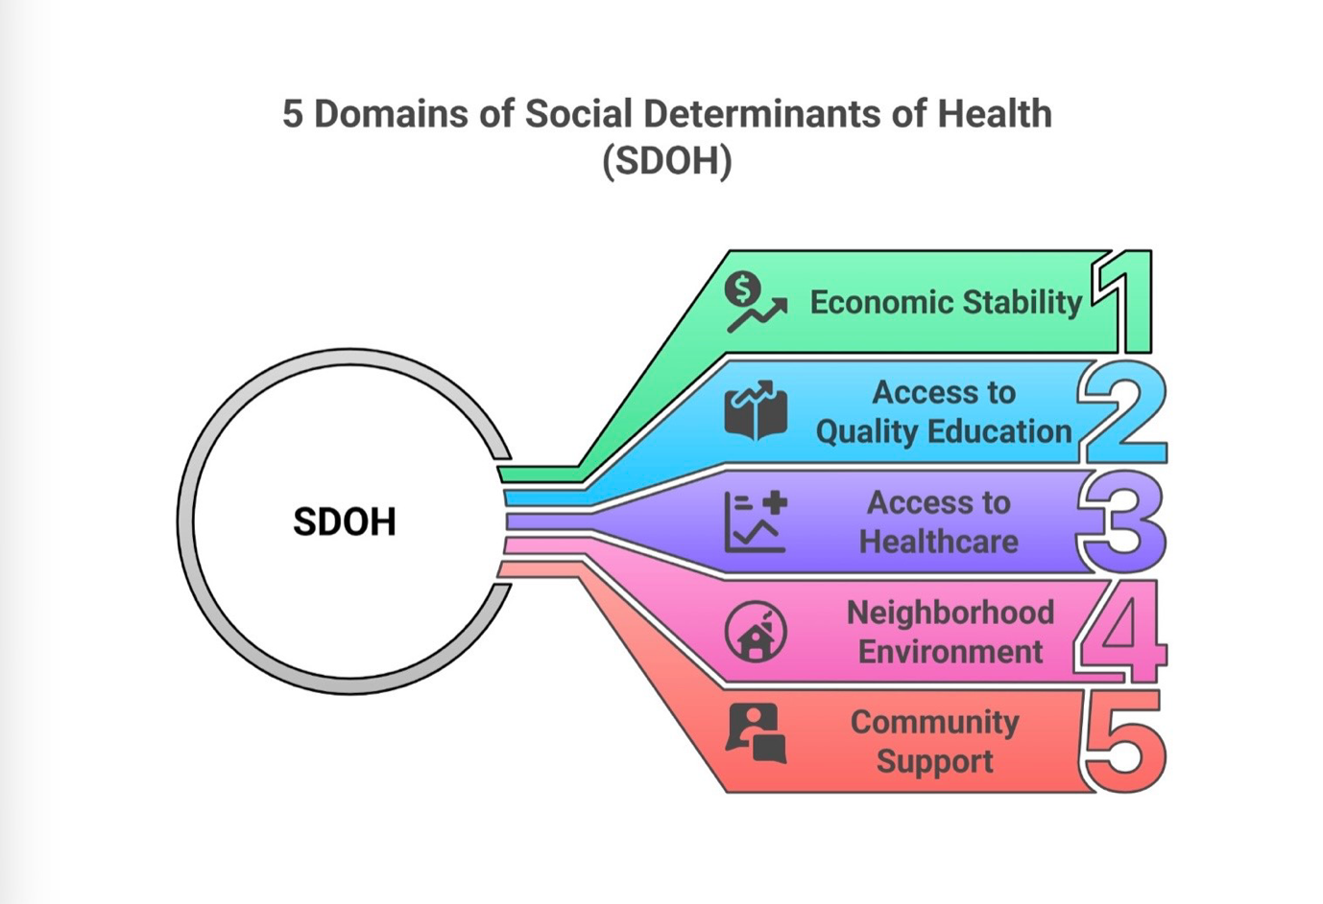

Figure 1. Five Domains of Social Determinants of Health (SDOH). Adapted from Healthy People 2030, U.S. Department of Health, and Human Services.

1.2 Rationale of the Study

Health inequalities are still a major public health issue within the United Kingdom and continue to affect vulnerable and disadvantaged populations disproportionately. Despite improvements in healthcare services and increased public health awareness, significant differences in health outcomes still exist between affluent and deprived communities. Individuals living in poorer areas are more likely to experience chronic illness, mental health conditions and lower life expectancy compared to those living in wealthier communities (Public Health England, 2025).

The increasing prevalence of health inequalities places considerable pressure on healthcare systems, particularly the National Health Service (NHS). Research has shown that wider social determinants such as poverty, unemployment, poor housing and limited educational opportunities contribute significantly to poor health outcomes and increased healthcare demands (Local Trust, 2023). As a result, understanding the relationship between social and economic conditions and public health outcomes has become increasingly important within health and social care research.

This study is important because it will explore the causes of health inequalities and evaluate how these inequalities affect public health within the UK. The research will also examine current public health strategies and policies designed to reduce inequalities and improve healthcare outcomes among disadvantaged populations. By analysing existing literature and policy documents, the study aims to contribute to a better understanding of the challenges associated with reducing health inequalities in modern society.

1.3 Aim of the Study

The aim of this study is to examine the causes of health inequalities in the United Kingdom and analyse how these inequalities affect public health outcomes. The study will also explore current public health policies and strategies aimed at reducing health inequalities within the UK healthcare system.

1.4 Objectives of the Study

* To examine the concept of health inequalities in the United Kingdom.
* To identify key social determinants that contribute to health inequalities.
* To analyse the impact of health inequalities on public health outcomes.
* To explore strategies and policies aimed at reducing health inequalities in the UK.

1.5 Structure of the Dissertation

This dissertation is divided into five chapters. Chapter One introduces the research topic and outlines the main concepts, rationale, aim, and goals of the study. Chapter Two provides the background and literature review related to health inequalities, including the historical, theoretical, international, and national context of the topic.

Chapter Three explains the method used in the research, including data collection, data analysis, and ethical considerations. Chapter Four presents the findings and discussion based on the analysis of the selected literature and public health evidence. Finally, Chapter Five provides recommendations and the overall conclusion of the study, summarising the key findings and discussing the implications for public health policy and future research.

CHAPTER 2: BACKGROUND

2.1 Introduction
This chapter reviews the existing literature on health inequalities and their impact on public health outcomes. It examines the theoretical background, international perspectives, and the national and local UK context. The chapter also explores the main social determinants of health and the evidence about their influence on health inequalities.

2.2 Historical Background

Health inequalities have been recognised as a significant public health issue in the United Kingdom for many decades. Although the establishment of the National Health Service (NHS) in 1948 aimed to provide universal healthcare that was free at the point of use, differences in health outcomes between socioeconomic groups continued to persist. While the NHS improved access to healthcare services, it became increasingly clear that medical care alone could not drop the wider social and economic factors responsible for health inequalities.

One of the earliest and most influential reports on health inequalities was the Black Report, published in 1980. Commissioned by the UK Government, the report showed that substantial inequalities in health remained despite the existence of the NHS. It concluded that people from lower socioeconomic groups experienced higher rates of illness, disability, and premature mortality than those from more affluent backgrounds. The report highlighted poverty, unemployment, poor housing and limited educational opportunities as major contributors to these inequalities and recommended broader social policies to improve population health.

The Acheson Report (1998) further developed understanding of health inequalities by emphasising the importance of the wider determinants of health. The report concluded that reducing inequalities required coordinated action across several sectors, including education, employment, housing, transport, and healthcare. It also recommended prioritising policies that improve the health of disadvantaged groups while addressing inequalities throughout the population.

A major milestone in the development of UK public health policy was the publication of the Marmot Review, Fair Society, Healthy Lives (2010). Led by Professor Sir Michael Marmot, the review introduced the concept of the social gradient in health, proving that health outcomes progressively worsen with increasing socioeconomic disadvantage. The review found six policy aims, including giving every child the best start in life, improving education, creating fair employment opportunities, ensuring healthy living standards, developing healthy communities, and strengthening disease prevention. These recommendations have had a considerable influence on public health policy in the United Kingdom.

Ten years later, the Marmot Review 10 Years On (2020) assessed progress since the original report. The findings wrote down those improvements in life expectancy had slowed, while health inequalities had widened in many parts of England. The review concluded that reductions in public spending, increasing poverty and regional deprivation had contributed to worsening health outcomes among disadvantaged populations. These findings reinforced the importance of addressing the wider social determinants of health rather than relying solely on healthcare services.

More recently, the NHS and the UK Government have introduced strategies aimed at reducing health inequalities. The NHS Long Term Plan (2019) showed reducing health inequalities as a key priority, while the Core20PLUS5 programme was developed to improve healthcare access and outcomes among the most deprived communities and other vulnerable population groups. These initiatives reflect growing recognition that effective action on health inequalities requires collaboration between healthcare services, public health organisations, and wider social policies.

Overall, the historical development of health inequalities in the United Kingdom proves that, despite significant improvements in healthcare provision, inequalities in health outcomes continue to persist. Historical reports and public health policies consistently show that reducing health inequalities requires long-term action addressing poverty, education, housing, employment, and other social determinants of health. These historical developments provide the foundation for understanding current public health strategies and the continuing challenge of achieving health equity in the United Kingdom.

2.3Theoretical Background

Theoretical perspectives on health inequalities have developed significantly over recent decades, particularly through increased recognition of the relationship between social and economic conditions and population health outcomes. One of the most influential theories associated with health inequalities is the concept of the social determinants of health. According to the World Health Organization (WHO), social determinants refer to the conditions in which people are born, grow, live, work and age, including factors such as income, education, employment, housing, and social support (WHO, 2023). These determinants are believed to have a substantial influence on physical and mental health outcomes throughout an individual’s life.

The theory of social determinants challenges the traditional biomedical model of health, which focuses on disease treatment and individual lifestyle behaviours. Instead, this approach suggests that wider social and environmental conditions play a significant role in shaping health outcomes and healthcare inequalities. Research has consistently proven that individuals living in deprived communities are more likely to experience chronic illness, mental health disorders and lower life expectancy compared to those from more affluent socioeconomic backgrounds (Department of Health and Social Care, 2021).

Another important theoretical concept associated with health inequalities is the social gradient in health, introduced in the Marmot Review Fair Society, Healthy Lives (Marmot, 2010). The social gradient theory suggests that health outcomes progressively worsen as socioeconomic disadvantage increases. In other words, health inequalities do not only affect the poorest populations but exist across the entire social hierarchy. Marmot (2010) argues that inequalities in education, employment, income, and living conditions significantly contribute to unequal health outcomes within society.

The life-course approach also provides an important theoretical framework for understanding health inequalities. This theory suggests that experiences during early childhood can have long-term effects on health and wellbeing throughout adulthood. Evidence writes down that poor nutrition, poverty, limited educational opportunities and adverse living conditions during childhood can increase the risk of chronic illness and poor health outcomes later in life (Conti, Mason, and Poupakis, 2019). The theory further suggests that health inequalities may continue across generations, particularly among disadvantaged populations.

In addition, human capital theory has been used to explain the relationship between socioeconomic status and health outcomes. Human capital theory proposes that education, skills, and health are forms of personal investment that can influence an individual’s economic and social opportunities throughout life. Research has shown that individuals with higher levels of education are more likely to experience better health outcomes, healthier lifestyles, and increased access to healthcare services (Conti, Mason, and Poupakis, 2019).

Health equity theory is another important framework relevant to this study. Health equity refers to the principle that every individual should have a fair opportunity to achieve their full health potential regardless of social or economic background. The WHO argues that reducing health inequalities requires addressing avoidable and unfair differences in healthcare access and wider living conditions (WHO, 2023). However, despite public health interventions and universal healthcare systems such as the NHS, significant inequalities continue to persist across different communities within the United Kingdom.

More recent public health theories increasingly support a multidimensional approach to reducing health inequalities. Rather than focusing solely on healthcare services, modern public health strategies emphasise the importance of prevention, early intervention and cross-sector collaboration involving healthcare, education, housing, and employment policies. This broader approach reflects growing recognition that health inequalities are influenced by a combination of biological, social, economic, and environmental factors rather than individual behaviours alone.

Overall, these theoretical perspectives prove that health inequalities are complex and multifactorial. The theories discussed highlight the importance of addressing wider social determinants to improve public health outcomes and reduce inequalities across the United Kingdom.

2.4 International Context

Health inequalities are recognised as a global public health challenge, affecting both high-income and low- and middle-income countries. Although the nature and extent of these inequalities vary across nations, evidence consistently proves that people with lower socioeconomic status experience poorer health outcomes, shorter life expectancy, and reduced access to healthcare services. The World Health Organisation (WHO) names health inequalities as unfair and avoidable differences in health that arise from the conditions in which people are born, grow, live, work and age (WHO, 2023).

Many countries have developed national strategies to reduce health inequalities by addressing the social determinants of health. In the Nordic countries, including Sweden, Norway and Finland, policies promoting universal healthcare, comprehensive social welfare systems and investment in education have contributed to relatively good population health outcomes. However, health inequalities persist, particularly among disadvantaged groups and migrant populations, proving that universal healthcare alone cannot eliminate inequalities (Mackenbach, 2019).

In the United States, health inequalities are more pronounced due to significant socioeconomic disparities and unequal access to healthcare. Individuals with lower incomes and those from minority ethnic communities experience higher rates of chronic diseases, lower life expectancy, and greater barriers to accessing healthcare services. Research has shown that factors such as income inequality, limited health insurance coverage and structural discrimination contribute to these disparities (Braveman and Gottlieb, 2014).

International organisations such as the WHO and the Organisation for Economic Co-operation and Development (OECD) emphasise that reducing health inequalities requires action beyond the healthcare sector. Policies that improve education, employment opportunities, housing conditions, social protection, and environmental quality are considered essential for improving population health and achieving health equity. These organisations advocate a “Health in All Policies” approach, encouraging governments to consider the health implications of decisions made across all sectors (WHO, 2023; OECD, 2023).

The COVID-19 pandemic further highlighted the global nature of health inequalities. Evidence from many countries showed that disadvantaged populations experienced higher infection rates, greater mortality, and more severe social and economic consequences. These differences reflected existing inequalities related to poverty, overcrowded housing, insecure employment, and limited access to healthcare. The pandemic reinforced the importance of addressing the wider determinants of health through coordinated national and international public health policies.

Overall, international evidence shows that health inequalities are a worldwide challenge. Despite differences in healthcare systems and economic development, countries face similar issues relating to poverty, education, employment, and access to healthcare. Lessons from international experience support the need for comprehensive public health strategies that address the underlying social determinants of health while promoting health equity for all populations.

2.5National/Local UK Context

Health inequalities continue to stand for a significant public health challenge within the United Kingdom, despite the existence of universal healthcare services through the National Health Service (NHS). Evidence suggests that individuals living in deprived communities are more likely to experience poorer physical and mental health, increased rates of chronic illness and lower life expectancy compared to populations living in more affluent areas. These inequalities are strongly associated with wider social determinants such as poverty, unemployment, housing conditions, education, and social exclusion.

Regional inequalities in health outcomes are still highly visible across England and other parts of the UK. Research has shown that people living in deprived urban areas often experience significantly lower life expectancy than those living in wealthier regions. According to public health evidence, individuals living in disadvantaged communities are also more likely to develop long-term conditions such as cardiovascular disease, obesity, diabetes, and respiratory illnesses (Department of Health and Social Care, 2021).

Poverty is widely recognised as one of the most important contributors to health inequalities in the UK. Individuals and families experiencing financial hardship may face difficulties accessing healthy food, safe housing and other essential resources that support good health and wellbeing. In addition, unemployment and insecure employment are associated with increased levels of stress, anxiety, and poor mental health outcomes. Research has consistently proven that socioeconomic disadvantage can negatively influence both physical and mental health throughout the life course.

Housing conditions also play a vital role in shaping health outcomes. Poor-quality housing, overcrowding, and homelessness are linked to respiratory illnesses, mental health conditions, and increased vulnerability to infectious diseases. Individuals living in unsafe or unstable housing environments may also experience higher levels of stress and social exclusion, which can further contribute to poor health outcomes. Public health research suggests that housing inequalities are still a major challenge within many deprived areas across the UK.

Ethnicity is another principal factor associated with health inequalities. Studies have shown that some ethnic minority groups experience higher rates of poverty, reduced access to healthcare services and poorer health outcomes compared to the wider population. These inequalities became particularly visible during the COVID-19 pandemic, when evidence proven that ethnic minority communities were disproportionately affected by infection rates, hospital admissions, and mortality.

Health inequalities also place considerable pressure on the National Health Service. Areas with prominent levels of deprivation often experience increased healthcare demands, higher hospital admission rates, and greater prevalence of preventable diseases. According to the British Medical Association (BMA), health inequalities affect not only life expectancy but also the quality of healthcare access, treatment experiences, and long-term health outcomes among disadvantaged populations. BMA – Health Inequalities and Their Effects on the NHS

The King’s Fund further argues that inequalities in income, education and living conditions continue to contribute significantly to differences in population health outcomes across England. These inequalities are considered avoidable and unfair because they are strongly influenced by social and economic conditions rather than biological differences alone. The King’s Fund – Health Inequalities Briefly

In response to these challenges, the UK government and NHS England have introduced several policies aimed at reducing health inequalities and improving public health outcomes. Initiatives such as the NHS Long Term Plan and the Core20PLUS5 approach focus on reducing healthcare disparities among deprived communities and vulnerable population groups. However, despite these interventions, significant inequalities continue to persist across different regions and socioeconomic groups within the United Kingdom.

Overall, the national and local context shows that health inequalities are still deeply connected to wider social and economic conditions within the UK. Addressing these inequalities requires long-term public health strategies that extend beyond healthcare services alone and involve collaboration across sectors such as education, housing, employment, and social care.

CHAPTER 3: METHODOLOGY

3.1 Research Design
This study adopted a qualitative secondary research design based on a literature review. Existing academic literature was systematically reviewed to explore health inequalities in the United Kingdom and their impact on public health outcomes. A thematic analysis approach was used to identify and analyse recurring themes across the selected studies.

3.2 Data Collection

This study adopted a qualitative secondary research methodology based on the analysis of existing academic literature, public health reports and policy documents related to health inequalities within the United Kingdom. Secondary research was considered the rightest approach for this study because it allowed the researcher to examine a wide range of existing evidence, theories and public health data without the need to collect primary data directly from participants. This approach also supported a broader understanding of the social, economic, and environmental factors contributing to health inequalities and their impact on public health outcomes.

The research was conducted using a literature review approach in order to name and evaluate relevant academic and public health sources. Literature reviews are commonly used within health and social care research to explore existing knowledge, show patterns and examine relationships between different concepts and public health issues. In this study, the literature review focused on the causes of health inequalities, the role of social determinants of health and the impact of inequalities on healthcare systems and public health within the UK.

Data for this study was collected from a range of reliable academic databases, government publications, and public health organisations. Electronic databases used during the research process included Google Scholar, PubMed, and ScienceDirect. In addition, reports, and policy documents from organisations such as the World Health Organization (WHO), NHS England, The King’s Fund, the Department of Health and Social Care and Public Health England were also included in the study. These sources were selected because they provide credible and evidence-based information related to public health and health inequalities.

Several keywords were used throughout the literature search process to name relevant studies and reports. These keywords included “health inequalities,” “social determinants of health,” “public health inequalities”, “health disparities in the UK,” “poverty and health,” “NHS health inequalities” and “health equity.” Different combinations of these terms were used to ensure that a broad range of relevant literature was shown.

Specific inclusion and exclusion criteria were also applied during the data collection process to improve the relevance and quality of the selected sources. The inclusion criteria focused on peer-reviewed journal articles, government reports and public health publications related to health inequalities and public health within the United Kingdom. Sources published within the last ten years were prioritised to ensure the use of recent and relevant evidence. However, some older sources, including the Marmot Review and key public health reports, were included due to their importance and influence within the field of health inequalities research.

Sources were excluded if they were not related to the research topic, lacked academic credibility, or had insufficient evidence. Non-academic websites, opinion-based articles, and unreliable online sources were avoided throughout the research process. The selected literature was then organised according to major themes associated with health inequalities, including poverty, housing, education, healthcare access, and public health outcomes.

Overall, the data collection process aimed to ensure that the study was based on credible, relevant, and evidence-based literature that supported a comprehensive understanding of health inequalities and their impact on public health within the United Kingdom.

Figure 3.1: Literature search and study selection process (PRISMA flow diagram). Source: Author’s own adaptation.
A systematic literature search was conducted using Google Scholar, PubMed, and ScienceDirect. The retrieved studies were screened according to the inclusion and exclusion criteria described above. After title and abstract screening, full-text articles were assessed for eligibility. Following the selection process, ten studies met the inclusion criteria and were included in the thematic analysis.
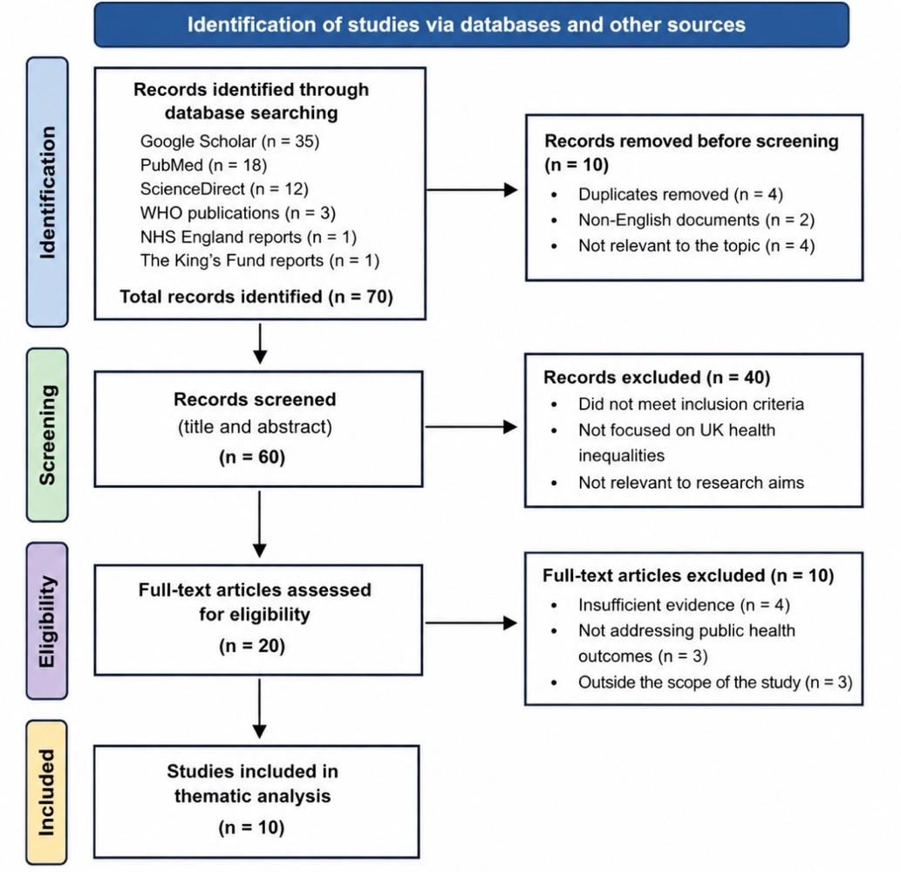

3.3 Data Analysis

The data collected for this study was analysed using a thematic analysis approach. Thematic analysis is a qualitative research method commonly used to name, examine, and interpret patterns or themes within selected literature and research data. This method was considered proper for the study because it allowed the researcher to explore recurring issues and relationships associated with health inequalities and public health outcomes within the United Kingdom.

Following the data collection process, the selected literature and policy documents were reviewed carefully to name common themes and key findings related to the research topic. The analysis focused on understanding how social, economic, and environmental factors contribute to health inequalities and influence population health outcomes. Particular attention was given to themes associated with poverty, education, employment, housing conditions, healthcare access, and mental health inequalities.

The thematic analysis process involved organising the selected literature into categories based on similar concepts and findings. Studies discussing comparable issues were grouped together to name patterns, similarities and differences between authors and public health reports. This approach supported a clearer understanding of the major factors contributing to health inequalities within the UK and helped name areas where researchers shared similar or contrasting perspectives.

In addition, the analysis considered how government policies and public health strategies tried to address health inequalities within the UK healthcare system. Reports from organisations such as NHS England, the World Health Organization and The King’s Fund were compared alongside academic journal articles to evaluate current approaches to reducing inequalities and improving public health outcomes.

A critical approach was also used throughout the analysis process. Rather than simply describing the literature, the study examined the strengths, limitations and overall relevance of dissimilar sources and public health arguments. Comparing different studies and policy perspectives allowed the research to develop a broader understanding of the complexity of health inequalities and their impact on public health.

The themes named during the analysis process formed the basis of the findings and discussion presented in Chapter Four of the dissertation. Overall, thematic analysis provided a structured and organised approach for interpreting the selected literature and examining the relationship between social determinants and health inequalities within the United Kingdom.

The data were analysed using Braun and Clarke’s (2006) six-phase thematic analysis. This method was used to name and organise recurring themes from the selected literature.
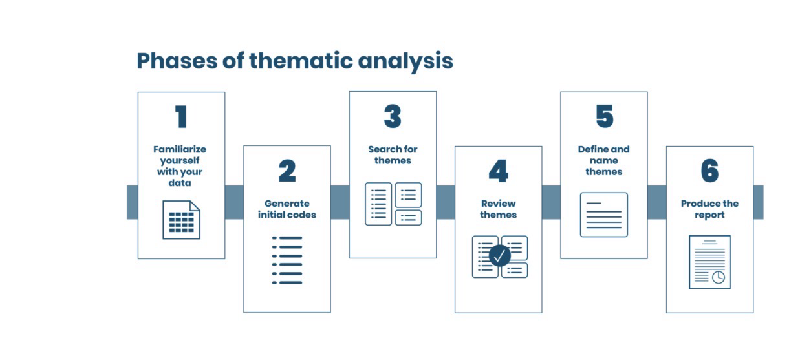

familiarisation with the literature, generating initial codes, searching for themes, reviewing themes, defining, and naming themes, and finally producing the report

3.4 Ethical Considerations

Ethical considerations are an important aspect of all research studies, including secondary research projects based on literature reviews and document analysis. Although this study did not involve direct participation from human subjects, ethical principles were still considered throughout the research process in order to support academic integrity, credibility, and professionalism.

This study was conducted using secondary research methods and therefore did not require interviews, questionnaires, or direct data collection from participants. As a result, issues relating to participant consent, confidentiality and anonymity were not applicable within this research. However, the study ensured that all information used throughout the dissertation was obtained from publicly available and credible academic sources, including peer-reviewed journal articles, government reports, and public health publications.

Academic integrity was supported throughout the research process by ensuring that all sources were appropriately referenced using the Harvard referencing style recommended by the university. Proper citation of authors, public health reports and academic literature was essential to avoid plagiarism and acknowledge the original work of researchers and organisations used within the study.

In addition, the researcher aimed to present the findings accurately and objectively without misrepresenting evidence or selectively interpreting information to support individual opinions. A balanced approach was supporting throughout the literature review and analysis process by considering a range of academic perspectives and public health evidence related to health inequalities and public health outcomes.

The reliability and credibility of sources were also considered during the research process. Priority was given to peer-reviewed journal articles, official government publications, and reports from recognised organisations such as the World Health Organization (WHO), NHS England, and The King’s Fund. Non-academic websites and unreliable online sources were avoided to ensure the quality and accuracy of the information included in the dissertation.

Data protection and confidentiality were supported by securely storing electronic research materials and ensuring that all downloaded articles and reports were used solely for academic purposes. Furthermore, the study followed university guidelines on ethical research practice and academic conduct.

Overall, although this research did not involve direct human participation, ethical principles remained important throughout the study. Maintaining honesty, transparency, exact referencing, and responsible use of evidence helped ensure the academic quality and ethical integrity of the dissertation.

CHAPTER 4: RESULTS AND DISCUSSION

4.1 Introduction
This chapter presents the findings obtained from the thematic analysis of the selected literature on health inequalities in the United Kingdom. The chapter begins by summarising the characteristics of the literature included in the review. The findings are then organised into five themes shown through thematic analysis: poverty and health outcomes, education and health inequalities, housing and living conditions, mental health inequalities, and NHS and healthcare access. Finally, the findings are discussed in relation to earlier research and public health policy.

4.2 Characteristics of the Selected Articles

Author(s) | Year | Country | Study Design | Main focus | Key findings
Marmot et al. | 2010 | Uk | Review report | Social determinants | Health inequalities are strongly linked to socioeconomic status
Marmot et al. | 2020 | Uk | Review report | Health inequalities | Inequities in England have widened
WHO | 2023 | Global | Report | Health inequalities | Social determinants influence outcomes
HNS ENGLAND | 2023 | Uk | Policy report | Core20plus5 | Priority groups identified for reducing inequalities
The king’s fund | 2023 | Uk | Report | Health inequalities | Explains causes and impacts on NHS
British Medical Association | 2023 | Uk | Report | NHS | Health inequalities increase pressure on healthcare services
Wilkinson& Pickett | 2018 | International | Book | Income inequality | Income inequality is associated with poorer health
Braveman & Gottlieb | 2014 | USA | Journal ARTICLES | Social determinants | Health is influenced by social conditions
Dahlgren&whitehead | 1991 | Sweden | Framework | Social determinants | Introduced the SDOH model
Acheson | 1998 | Uk | Government reports | Health inequalities | Recommended strategies to reduce inequalities

4.3 Results

This chapter presents the findings obtained from the thematic analysis of the selected literature on health inequalities in the United Kingdom. A qualitative secondary research approach was adopted, and the findings were organised into five key themes that emerged consistently across the reviewed academic literature, government reports and policy documents. These themes reflect the main social determinants influencing health inequalities and their impact on public health outcomes in the UK.

The literature selected for analysis included peer-reviewed journal articles, government publications and reports from recognised organisations such as the World Health Organisation (WHO), NHS England, the Department of Health and Social Care, the British Medical Association (BMA), The King’s Fund and the Institute of Health Equity. The selected sources consistently highlighted poverty, education, housing, mental health and access to healthcare as the most significant factors contributing to health inequalities.

The thematic analysis shown the following five themes:

* Poverty and Health Outcomes
* Education and Health Inequalities
* Housing and Living Conditions
* Mental Health Inequalities
* NHS and Healthcare Access

These themes are presented and discussed in the following sections.

4.3.1 Poverty and Health Outcomes

Poverty is widely recognised as one of the most significant factors contributing to health inequalities within the United Kingdom. Research has consistently shown that individuals living in poverty are more likely to experience poorer physical and mental health outcomes compared to those from more affluent socioeconomic backgrounds. Poverty can influence health in several ways, including limited access to nutritious food, poor housing conditions, financial stress and reduced opportunities for education and employment (Marmot, 2010).

Evidence suggests that people living in deprived communities are at greater risk of developing chronic illnesses such as cardiovascular disease, diabetes, respiratory conditions, and obesity. In many cases, individuals experiencing financial hardship may struggle to support healthy lifestyles due to the inflated cost of nutritious food, limited recreational opportunities and reduced access to health-promoting resources. According to the World Health Organization (2023), socioeconomic disadvantage is still strongly associated with increased disease prevalence and reduced life expectancy across populations.

Mental health outcomes are also linked to poverty and financial insecurity. Studies have shown that individuals experiencing unemployment, debt and unstable living conditions are more likely to develop anxiety, depression, and stress-related disorders. Financial pressures can negatively affect psychological wellbeing and may also contribute to social isolation and reduced quality of life. These issues became increasingly visible during recent economic challenges and the COVID-19 pandemic, particularly among vulnerable groups and low-income households.

Marmot (2010) argues that poverty should not be viewed simply as a lack of income but as a broader form of social disadvantage affecting education, employment opportunities, housing quality, and overall life chances. This perspective highlights the relationship between poverty and the wider social determinants of health. Similarly, Wilkinson and Pickett (2018) suggest that societies with higher levels of income inequality often experience poorer health and social outcomes across the population.

The impact of child poverty on long-term health outcomes has also received considerable attention within public health research. Evidence writes down that children raised in deprived households are more likely to experience poor nutrition, lower educational attainment, and reduced access to healthcare services, all of which can negatively influence health throughout adulthood. Research on the developmental origins of health inequalities further suggests that adverse childhood experiences and early-life socioeconomic disadvantage may contribute to long-term physical and mental health problems later in life (Conti, Mason, and Poupakis, 2019).

Poverty additionally places significant pressure on healthcare services and public health systems. Areas with prominent levels of deprivation often experience greater healthcare demands, increased hospital admissions, and higher rates of preventable illness. The British Medical Association (BMA) states that health inequalities associated with poverty continue to affect healthcare access, treatment experiences, and health outcomes across the NHS. BMA – Health Inequalities and Their Effects on the NHS

Despite various public health interventions and government policies aimed at reducing poverty and improving healthcare access, substantial inequalities continue to persist within the UK. Some researchers argue that healthcare services alone are insufficient to drop the negative health effects associated with poverty without broader structural improvements in housing, education, and employment opportunities. This suggests that reducing health inequalities requires long-term social and economic strategies alongside healthcare interventions.

Overall, the findings show that poverty is still a major contributor to unequal health outcomes within the United Kingdom. The relationship between poverty and health inequalities reflects the broader influence of social determinants on public health and highlights the importance of
addressing socioeconomic disadvantage through coordinated public health and social policy approaches.

4.3.2 Education and Health Inequalities

Education is widely recognised as an important social determinant of health and plays a significant role in shaping health outcomes across different populations. Research has consistently proven that individuals with higher levels of education are generally more likely to experience better physical and mental health, longer life expectancy and improved access to healthcare services compared to those with lower educational attainment. Educational inequalities can therefore contribute directly to wider health inequalities within society.

One of the main reasons education influences health outcomes is because it affects employment opportunities, income levels, and health literacy. Individuals with higher educational qualifications are often more likely to secure stable employment, achieve higher incomes and access healthier living conditions. In contrast, limited educational opportunities are often associated with unemployment, low-income occupations, and increased exposure to social and environmental disadvantages (Marmot, 2010).

Health literacy is another principal factor linking education and public health outcomes. Health literacy refers to an individual’s ability to understand health information, access healthcare services and make informed decisions about health behaviours and treatment options. Research suggests that individuals with lower levels of education may experience difficulties understanding medical information, navigating healthcare systems, and adopting preventative health behaviours. As a result, they may face increased risks of chronic disease and poorer long-term health outcomes.

Educational inequalities often begin during early childhood and may continue throughout the life course. Children from disadvantaged socioeconomic backgrounds are more likely to experience barriers to educational achievement, including poverty, unstable housing conditions, and reduced access to educational resources. These disadvantages can negatively affect academic performance, future employment opportunities, and overall wellbeing. According to Conti, Mason and Poupakis (2019), socioeconomic disadvantage during childhood can have long-term consequences for both physical and mental health throughout adulthood.

Research has also proven a strong relationship between education and lifestyle behaviours associated with health outcomes. Individuals with higher levels of education are more likely to engage in healthier behaviours such as regular physical activity, balanced nutrition and reduced smoking or alcohol consumption. In contrast, lower educational attainment has been associated with increased rates of smoking, obesity and other risk factors linked to chronic illness.

Mental health inequalities are also connected to educational disadvantage. Limited educational opportunities may contribute to unemployment, financial insecurity and reduced social mobility, all of which can negatively influence psychological wellbeing. In some cases, individuals with lower educational attainment may experience higher levels of stress, anxiety and social exclusion compared to more educated populations.

Within the United Kingdom, public health policies increasingly recognise the importance of education in reducing health inequalities and improving long-term population health outcomes. The Marmot Review highlighted the significance of early childhood development and educational support as essential strategies for reducing social and health inequalities (Marmot, 2010). Similarly, public health organisations continue to emphasise the importance of improving educational opportunities among disadvantaged communities as part of wider efforts to promote health equity.

However, despite various educational and social policies, inequalities in educational attainment continue to persist across different regions and socioeconomic groups within the UK. Some researchers argue that structural inequalities associated with poverty and social deprivation continue to limit educational opportunities for many vulnerable populations. This suggests that improving education alone may not fully drop health inequalities without broader action addressing housing, employment, and income inequality.

Overall, the findings show that education has a substantial influence on health outcomes and public health inequalities within the United Kingdom. Educational disadvantage can contribute to long-term social and economic inequalities that negatively affect physical and mental health throughout the life course. Addressing educational inequalities therefore is still a critical part of public health strategies aimed at reducing health disparities and improving population wellbeing.

4.3.3 Housing and Living Conditions

Housing and living conditions are important social determinants that significantly influence health outcomes and contribute to health inequalities within the United Kingdom. Research has consistently shown that individuals living in poor-quality or unstable housing are more likely to experience both physical and mental health problems compared to those living in safe and secure environments. Factors such as overcrowding, damp housing, homelessness and poor sanitation can negatively affect overall wellbeing and increase vulnerability to illness.

Poor housing conditions are strongly associated with a range of physical health problems, particularly respiratory illnesses, and infectious diseases. Dampness, mould and inadequate ventilation within homes have been linked to asthma, bronchitis, and other respiratory conditions, especially among children and older adults. In addition, overcrowded housing environments may increase the spread of infectious diseases and reduce individuals’ ability to support healthy living conditions. According to the Department of Health and Social Care (2021), disadvantaged populations are more likely to experience inadequate housing and poorer health outcomes compared to more affluent communities.

Housing insecurity and homelessness also represent major public health concerns within the UK. Individuals experiencing homelessness often face significant barriers to healthcare access, employment, and social support. Homeless populations are more likely to experience mental health disorders, substance misuse, and chronic physical illnesses. In many cases, unstable housing conditions can contribute to social exclusion and reduced quality of life, further increasing health inequalities among vulnerable groups.

Mental health outcomes are particularly influenced by housing conditions and neighbourhood environments. Living in overcrowded, unsafe, or deprived areas may contribute to stress, anxiety, and depression. Financial pressures related to housing costs and insecurity can also negatively affect psychological wellbeing and family relationships. Research suggests that individuals living in deprived neighbourhoods often experience increased exposure to crime, environmental pollution, and limited access to green spaces, all of which may negatively influence mental and physical health outcomes.

The relationship between housing and health inequalities became especially visible during the COVID-19 pandemic. Evidence showed that individuals living in overcrowded households and deprived communities were more vulnerable to infection, self-isolation difficulties, and economic hardship. The pandemic highlighted how inadequate housing conditions can increase public health risks and widen existing inequalities among disadvantaged populations.

The Marmot Review (2010) named housing as one of the key social determinants influencing health outcomes within the UK. Marmot argued that safe, secure and affordable housing is essential for improving population health and reducing inequalities. Similarly, public health organisations such as The King’s Fund continue to emphasise the importance of addressing housing inequalities as part of wider public health strategies aimed at improving health equity and reducing pressure on healthcare services.

Housing inequalities also place more pressure on the National Health Service. Individuals living in poor housing conditions are more likely to require healthcare interventions, hospital admissions, and long-term treatment for preventable illnesses. This increases healthcare costs and contributes to growing demands on NHS services, particularly within deprived regions.

Despite various housing policies and public health initiatives, housing inequalities continue to persist across the UK. Rising housing costs, homelessness and shortages of affordable housing remain major challenges affecting vulnerable populations. Some researchers argue that improving healthcare access alone cannot fully reduce health inequalities without addressing broader social issues such as housing and poverty.

Overall, the findings show that housing and living conditions have a substantial influence on health outcomes and public health inequalities within the United Kingdom. Poor-quality housing and housing insecurity can negatively affect both physical and mental health, particularly among disadvantaged communities. Addressing housing inequalities therefore stays essential for improving population health and reducing long-term health disparities across the UK.

4.3.4 Mental Health Inequalities

Mental health inequalities have become an increasingly important public health concern within the United Kingdom. Research has consistently shown that mental health outcomes are strongly influenced by wider social and economic conditions, including poverty, unemployment, education, housing, and social exclusion. Individuals living in disadvantaged communities are more likely to experience mental health disorders such as anxiety, depression and stress-related conditions compared to those from more affluent socioeconomic backgrounds.

One of the major factors contributing to mental health inequalities is financial insecurity and poverty. Individuals experiencing unemployment, debt and low income often face increased levels of stress and emotional pressure, which may negatively affect psychological wellbeing. Long-term financial hardship can also contribute to feelings of hopelessness, reduced self-esteem, and social isolation. Marmot (2010) argues that socioeconomic disadvantage significantly influences both physical and mental health outcomes throughout the life course.

Research suggests that mental health problems are often more prevalent among vulnerable populations, including unemployed individuals, ethnic minority groups and people living in deprived neighbourhoods. Social exclusion, discrimination, and limited access to support services may further increase the risk of poor mental health among these groups. In some cases, individuals experiencing mental health difficulties may also face barriers when trying to access healthcare services and psychological support.

Housing insecurity and poor living conditions are also associated with mental health inequalities. Overcrowding, homelessness, and unsafe neighbourhoods can contribute to anxiety, stress, and depression. Individuals living in deprived areas may experience increased exposure to crime, environmental stressors, and social instability, all of which can negatively influence emotional wellbeing and quality of life.

Educational inequalities additionally play a vital role in mental health outcomes. Limited educational opportunities can affect employment prospects, income levels, and social mobility, increasing the likelihood of stress and psychological distress later in life. Research has shown that individuals with lower educational attainment are more likely to experience unemployment and financial insecurity, which are strongly associated with poor mental health outcomes.

The COVID-19 pandemic further highlighted existing mental health inequalities across the UK. Evidence proved that disadvantaged communities and vulnerable populations experienced greater levels of anxiety, isolation, and emotional distress during the pandemic. Financial uncertainty, bereavement, unemployment, and social restrictions negatively affected mental wellbeing, particularly among younger people and low-income households. The pandemic also increased pressure on mental health services and exposed inequalities in access to psychological support and healthcare services.

Mental health inequalities place considerable pressure on public health systems and healthcare services within the UK. According to NHS England (2023), demand for mental health services has increased significantly in recent years, particularly among vulnerable and disadvantaged populations. Delays in accessing treatment and limited availability of mental health support may further widen inequalities and negatively affect long-term wellbeing.

Public health organisations increasingly recognise the importance of prevention and early intervention in reducing mental health inequalities. Strategies focusing on community support, early childhood development, education, and employment opportunities are considered essential for improving mental wellbeing and reducing social disadvantage. However, despite ongoing public health initiatives, significant inequalities in mental health outcomes continue to persist across different socioeconomic and ethnic groups within the UK.

Overall, the findings prove that mental health inequalities are strongly associated with wider social determinants and socioeconomic disadvantage. Poverty, unemployment, housing insecurity, and social exclusion continue to influence mental wellbeing and access to support services across the United Kingdom. Addressing these inequalities therefore requires long-term public health strategies that focus not only on healthcare services but also on improving wider social and economic conditions.

4.3.5 NHS and Healthcare Access

Access to healthcare services is a principal factor influencing health outcomes and public health inequalities within the United Kingdom. Although the National Health Service (NHS) was proven to provide universal healthcare that is free at the point of use, evidence suggests that inequalities in healthcare access and treatment experiences continue to exist across different socioeconomic and ethnic groups. Individuals living in deprived communities often experience greater healthcare needs while simultaneously facing barriers related to healthcare accessibility, availability, and quality of care.

The NHS was created in 1948 with the aim of reducing inequalities in healthcare access and improving population health outcomes regardless of income or social class. The introduction of universal healthcare represented a major public health achievement and significantly improved access to medical services for many disadvantaged populations. However, despite these improvements, substantial inequalities in health outcomes have continued to persist across the UK.

Research suggests that individuals from deprived socioeconomic backgrounds are more likely to experience chronic illnesses, mental health disorders and preventable diseases compared to more affluent populations. As a result, disadvantaged communities often place greater demands on NHS services, including higher rates of hospital admissions, emergency care, and long-term treatment. According to the British Medical Association (BMA), health inequalities continue to affect not only life expectancy but also treatment experiences and healthcare outcomes among vulnerable groups. BMA – Health Inequalities and Their Effects on the NHS

Geographical inequalities also influence healthcare access across different regions of the United Kingdom. Rural communities and deprived urban areas may experience shortages of healthcare professionals, longer waiting times and reduced access to specialist services. In some cases, individuals living in disadvantaged areas may delay seeking medical support due to transportation difficulties, financial pressures, or limited healthcare availability. These barriers can contribute to delayed diagnosis and poorer long-term health outcomes.

Ethnic inequalities within healthcare access have also become a significant concern in recent years. Research has shown that some ethnic minority populations experience unequal treatment, reduced healthcare accessibility and poorer health outcomes compared to the wider population. Language barriers, cultural differences, and experiences of discrimination may negatively affect healthcare experiences and reduce trust in healthcare services among some communities.

The COVID-19 pandemic further exposed healthcare inequalities within the NHS and wider public health system. Evidence showed that disadvantaged communities and ethnic minority groups experienced disproportionately higher infection rates, hospital admissions, and mortality during the pandemic. The crisis highlighted existing structural inequalities affecting healthcare access, employment conditions, and living environments across the UK.

In response to these challenges, NHS England introduced several initiatives aimed at reducing healthcare inequalities and improving access among vulnerable populations. Programmes such as the NHS Long Term Plan and the Core20PLUS5 approach focus on improving healthcare outcomes within deprived communities and reducing disparities affecting ethnic minority groups and socially excluded populations. These initiatives aim to strengthen prevention strategies, improve early intervention, and ensure fairer access to healthcare services.

Despite these efforts, some researchers argue that healthcare access alone cannot fully drop health inequalities without addressing wider social determinants such as poverty, housing, and education. While the NHS plays a significant role in supporting population health, broader structural inequalities continue to influence disease prevalence and healthcare demands across disadvantaged communities.

Overall, the findings demonstrate that healthcare inequalities remain a significant public health issue within the United Kingdom. Although the NHS has improved healthcare access for millions of people, social and economic inequalities continue to affect treatment experiences, healthcare outcomes, and population wellbeing. Reducing healthcare inequalities therefore requires continued collaboration between healthcare services, public health organisations and wider social policies aimed at addressing the root causes of disadvantage.

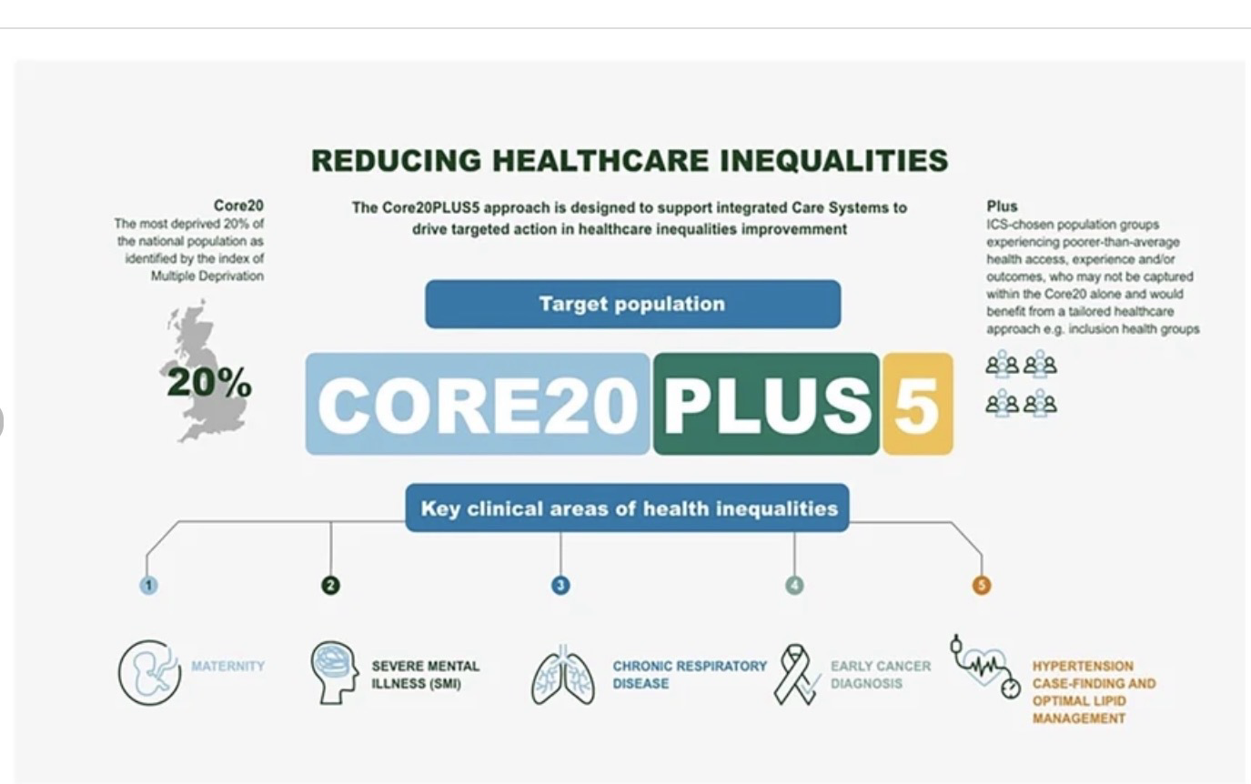
NHS Core20PLUS5 approach to reducing healthcare inequalities. Adapted from NHS England.

4.4 Discussion

The findings of this study prove that health inequalities in the United Kingdom are strongly influenced by wider social determinants rather than healthcare access alone. Across the selected literature, poverty, education, housing, mental health, and healthcare accessibility consistently appeared as interconnected factors affecting population health.

The findings support the conclusions of Marmot et al. (2010), who argued that the social gradient in health means that health outcomes progressively worsen with increasing socioeconomic disadvantage. Similarly, the World Health Organization (2023) emphasises that avoidable differences in health are intricately linked to the conditions in which people are born, grow, live, work and age.

The results also agree with Wilkinson and Pickett (2018), who found that societies with greater income inequality experience poorer health and social outcomes. Evidence reviewed throughout this dissertation proves that individuals living in deprived communities are more likely to experience chronic illness, poor mental health, and reduced life expectancy than those living in more affluent areas.

The study further highlights that although the NHS provides universal healthcare, healthcare services alone cannot end health inequalities. Current initiatives such as the NHS Long Term Plan and Core20PLUS5 represent important steps towards reducing inequalities; however, long-term improvements also require action across housing, education, employment, and wider social policy.

Strengths of the Research

One of the main strengths of this study is the use of a wide range of credible and up-to-date sources, including peer-reviewed journal articles, government reports, and publications from recognised organisations such as WHO, NHS England and The King’s Fund. The thematic analysis provided a structured method for finding common patterns across the literature, enabling a comprehensive understanding of health inequalities in the UK.

Limitations of the Research

This study has several limitations. As a secondary research project, it relied entirely on previously published literature and did not include primary data collection such as interviews or questionnaires. The findings therefore depend on the quality and scope of the available evidence. In addition, the study focused on the United Kingdom, meaning that the findings may not be fully applicable to other countries with different healthcare systems or social policies.

Overall, the findings prove that reducing health inequalities requires long-term collaboration between healthcare services, government agencies, and wider public services. Addressing the social determinants of health is still essential for improving health equity and achieving better public health outcomes in the United Kingdom.

CHAPTER 5: RECOMMENDATIONS AND CONCLUSION

5.1 Recommendations

The findings of this study prove that health inequalities within the United Kingdom remain strongly associated with wider social and economic inequalities. To reduce these disparities and improve public health outcomes, several recommendations can be made for healthcare organisations, policymakers, and public health services.

Firstly, greater investment in poverty reduction strategies is essential. Poverty was consistently named throughout the research as one of the major contributors to poor physical and mental health outcomes. Government policies aimed at improving employment opportunities, increasing financial support for low-income households, and reducing child poverty may help improve long-term population health and reduce inequalities across disadvantaged communities.

Secondly, improving access to education and early childhood support services should remain a public health priority. Educational inequalities continue to influence employment opportunities, income levels, and health literacy throughout the life course. Increased investment in early intervention programmes, educational support and community development initiatives may contribute to improved health outcomes and greater social mobility among vulnerable populations.

Another important recommendation is the improvement of housing conditions and access to affordable housing. Poor-quality housing and housing insecurity were strongly associated with both physical and mental health problems throughout the study. Public health strategies aimed at reducing homelessness, improving housing standards, and supporting disadvantaged communities could help reduce health inequalities and improve overall wellbeing.

Mental health support services should also be strengthened, particularly within deprived communities and vulnerable population groups. The findings showed that poverty, unemployment, and social exclusion significantly affect mental wellbeing and increase demand for psychological support services. Expanding access to early mental health intervention, counselling services and community-based support programmes may help reduce long-term mental health inequalities within the UK.

In addition, NHS England and public health organisations should continue to focus on reducing inequalities in healthcare access and treatment outcomes. Although the NHS provides universal healthcare, barriers related to geographical location, ethnicity and socioeconomic disadvantage continue to affect healthcare experiences among some populations. Expanding preventative healthcare services and improving accessibility within deprived communities may help reduce avoidable health disparities.

The study also suggests that reducing health inequalities requires collaboration across multiple sectors rather than relying solely on healthcare services. Greater cooperation between healthcare providers, educational institutions, housing authorities, and local governments may support more effective public health interventions and long-term improvements in population wellbeing.

Finally, future research should continue to explore the long-term impact of social determinants on public health outcomes within the United Kingdom. More research focusing on mental health inequalities, ethnic disparities and the effects of post-pandemic economic challenges may further improve understanding of current public health issues and support more effective policy development.

5.2 Conclusion

This study examined the causes of health inequalities within the United Kingdom and explored how these inequalities continue to affect public health outcomes across different populations and communities. The research proven that health inequalities are still a significant public health concern despite the existence of universal healthcare through the National Health Service (NHS). The findings highlighted that wider social determinants such as poverty, education, housing conditions, unemployment, and healthcare accessibility continue to influence physical and mental health outcomes throughout the UK.

The first aim of the study was to examine the concept of health inequalities within the United Kingdom. The research showed that health inequalities refer to unfair and avoidable differences in health outcomes between different social groups and communities. Evidence reviewed throughout the dissertation showed that disadvantaged populations consistently experience poorer health outcomes, increased prevalence of chronic illness and lower life expectancy compared to more affluent groups.

The second goal focused on naming key social determinants contributing to health inequalities. The findings confirmed that poverty, educational disadvantage, poor housing conditions, and limited healthcare access are major factors influencing public health outcomes. The study also showed that these determinants are closely interconnected and may continue to affect individuals throughout the life course. Marmot’s theory of the social gradient in health further supported the argument that health outcomes progressively worsen as socioeconomic disadvantage increases.

The third aim examined the impact of health inequalities on public health outcomes. The findings showed that disadvantaged communities experience increased rates of physical illness, mental health disorders, and preventable disease. In addition, health inequalities place significant pressure on healthcare systems through increased hospital admissions, greater healthcare demands, and higher long-term treatment costs. The COVID-19 pandemic further exposed existing inequalities affecting vulnerable populations and highlighted the importance of addressing wider social determinants of health.

The final goal explored current strategies and policies aimed at reducing health inequalities within the UK. The research named several public health initiatives introduced by NHS England and government organisations, including prevention strategies and programmes targeting vulnerable populations. However, the findings suggested that healthcare interventions alone are insufficient to drop inequalities without broader improvements in housing, education, employment opportunities, and social support systems.

Overall, the study concluded that health inequalities are still deeply connected to wider social and economic inequalities within the United Kingdom. Although progress has been made through public health policies and healthcare reforms, significant disparities continue to persist across different regions and socioeconomic groups. Reducing these inequalities therefore requires long-term and collaborative public health strategies that address both healthcare access and the wider determinants influencing population health.

In conclusion, the research showed that tackling health inequalities is essential for improving public health outcomes and achieving greater health equity within the United Kingdom. Continued investment in prevention, education, housing support, and accessible healthcare services will remain important in reducing inequalities and supporting healthier communities in the future.

Overall, the findings of this study highlight the importance of addressing health inequalities as a long-term public health priority within the United Kingdom. While healthcare services such as the NHS continue to play a significant role in improving population health, the research shows that wider social determinants including poverty, education, housing, and employment remain central factors influencing health outcomes across different communities. Tackling these inequalities therefore requires a collaborative and preventative approach involving healthcare organisations, policymakers, and wider social services. If effective long-term strategies are implemented, there is greater potential to improve health equity, reduce pressure on public health systems and support healthier and more sustainable communities across the UK.

References :

1. Acheson, D. (1998) Independent Inquiry into Inequalities in Health. London: The Stationery Offices [accessed 10/07/2026]
2. Bambra, C. (2016) Health Divides: Where You Live Can Kill You. Bristol: Policy Press. [accessed 10/07/2026]
3. Bambra, C., Riordan, R., Ford, J. and Matthews, F. (2020) ‘The COVID-19 pandemic and health inequalities’, Journal of Epidemiology and Community Health, 74(11), pp. 964–968. [accessed 10/07/2026]
4. Black, D. et al. (1980) Inequalities in Health. London: DHSS. [accessed 10/07/2026]
5. Braveman, P. and Gottlieb, L. (2014) ‘The social determinants of health’, Public Health Reports, 129(Suppl. 2), pp. 19–31. [accessed 10/07/2026]

6. British Medical Association (2023) Health Inequalities and the NHS. [accessed 11/07/2026]
7. Commission on Social Determinants of Health (2008) Closing the Gap in a Generation. Geneva: WHO. [11/07/2026]
8. Conti, G., Mason, G. and Poupakis, S. (2019) Developmental Origins of Health Inequalities. London: Institute of Health Equity. [11/07/2026]
9. Dahlgren, G. and Whitehead, M. (1991) Policies and Strategies to Promote Social Equity in Health. Stockholm: Institute for Futures Studies. [11/07/2026]
10. Department of Health (2010) Healthy Lives, Healthy People. London: DH.
11. Department of Health and Social Care (2021) Health Inequalities: Place-Based Approaches. London: DHSC. [11/07/2026]
12. Faculty of Public Health (2022) Health Inequalities. [11/07/2026]
13. Green, J. and Tones, K. (2018) Health Promotion. 3rd edn. London: Sage. [11/07/2026]
14. Local Government Association (2022) Health Inequalities: Local Action. [11/07/2026]
15. Local Trust (2023) Health Inequalities in England. [11/07/2026]
16. Mackenbach, J.P. (2019) Health Inequalities: Persistence and Change in European Welfare States. Oxford: Oxford University Press. [11/07/2026]
17. Marmot, M. (2015) The Health Gap. London: Bloomsbury’s [08/05/2026]
18. Marmot, M. et al. (2010) Fair Society, Healthy Lives. London: Institute of Health Equity. [08/05/2026]

19. Marmot, M. et al. (2020) Health Equity in England: The Marmot Review 10 Years On. London: Institute of Health Equity.
20. Marmot, M. and Allen, J. (2014) Social Determinants of Health Equity.
21. National Institute for Health and Care Excellence (2018) Community Engagement: Improving Health and Wellbeing. [08/05/2026]
22. National Institute for Health and Care Excellence (2022) Health Inequalities: NICE Impact Report.
23. NHS Digital (2022) Health Survey for England.
24. NHS England (2019) The NHS Long Term Plan.
25. NHS England (2021) Core20PLUS5 – An Approach to Reducing Health Inequalities.
26. NHS England (2023) Core20PLUS5 for Adults.
27. Office for National Statistics (2021) Health State Life Expectancies by National Deprivation Deciles. [08/05/2026]

28. Office for National Statistics (2022) Health Inequalities Dashboard. [08/05/2026]
29. Office for National Statistics (2023) Health State Life Expectancies.
30. Organisation for Economic Co-operation and Development (2023) Health at a Glance 2023. Paris: OECD. [08/05/2026]
31. Public Health England (2017) Health Profile for England. [08/05/2026]
32. Public Health England (2018) Health Profile for England. [10/05/2026]
33. Public Health England (2019) Health Profile for England. [11/07/2026]
34. Public Health England (2020) Disparities in the Risk and Outcomes of COVID-19.
35. Public Health England (2021) Health Inequalities Dashboard. [08/05/2026]
36. The Health Foundation (2020) Health Equity in England. [08/05/2026]
37. The Health Foundation (2022) Health Inequalities in 2040. [08/07/2026]
38. The King’s Fund (2020) The NHS Long Term Plan Explained. [10/05/2026]
39. The King’s Fund (2023) Health Inequalities in a Nutshell. [08/05/2026]
40. Townsend, P. and Davidson, N. (1982) Inequalities in Health: The Black Report. Harmondsworth: Penguin. [08/05/2026]
41. Whitehead, M. (1992) ‘The concepts and principles of equity and health’, International Journal of Health Services, 22(3), pp. 429–445. [08/05/2026]
42. Wilkinson, R. and Pickett, K. (2018) The Inner Level. London: Penguin. [11/07/2026]
43. World Bank (2022) Poverty and Shared Prosperity. [10/05/2026]
44. World Health Organization (2008) Closing the Gap in a Generation. Geneva: WHO.
45. World Health Organization (2021) Health Promotion. [08/05/2026]
46. World Health Organization (2023) Health Inequality Data Repository. Geneva: WHO.
47. World Health Organization (2024) Social Determinants of Health. Geneva: WHO. [08/05/2026]
48. UK Health Security Agency (2022) Health Inequalities and Prevention. [08/05/2026]
49. NHS Confederation (2023) Reducing Health Inequalities. [08/05/2026]
50. Office for Health Improvement and Disparities (2023) Health Inequalities: Place-Based Approaches. [08/05/2026]

