4. Analysis
A data analysis is designed to systematically analyse data by describing what is shown and presenting it in a manner where it can be condensed down and evaluated (Sharma 2018). Within this chapter, it will analyse the findings from the research survey that was conducted online and interpret them as well as link them back to the literature used within the literature review. All data will be presented where necessary in a graph or chart where necessary, analysed, and then synthesised. The results of the research will be coded into one of the three objectives:

- To identify the prevalence of criminality in care experienced and looked after children and young people.
- Evaluate the long-term effects adverse childhood experiences have on children and young people who are in care or are care experienced.
- Evaluate public perception on the link between adverse childhood experiences and crime as well as what can be done to reduce criminality.

4.1. Findings:
While conducting the research survey the idea was to get around 100 to 200 responses, although due to the vast number of surveys that were sent out during the same period, it only had a total of 87 participants. Participants were asked their age and gender, allowing for those under the age of 18 to be stopped from participating in accordance with the ethical considerations within this research study.
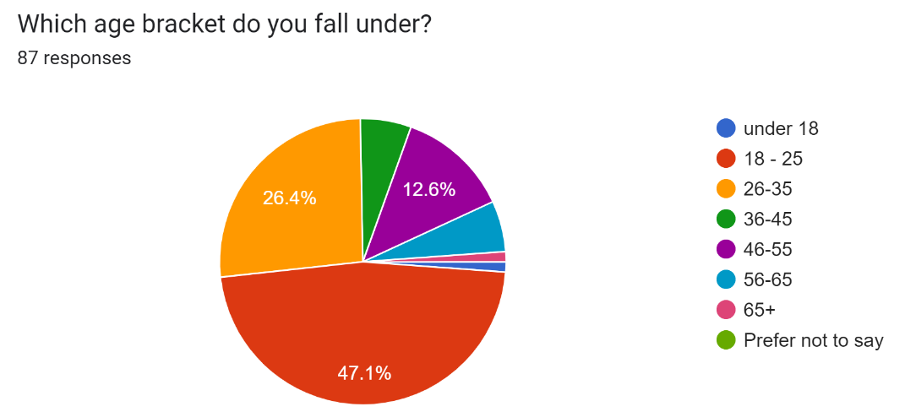
The pie chart above displays the response given by participant when asked their age. It shows that 47.1% (41) of participants were aged 18 to 25, 26.4% (23) were aged 26 to 35, 5.7% (5) were aged 36 to 45, 12.6% (11) were aged 46 to 55, 5.7% (5) were aged 56 to 65, 1.1% (1) were 65+ and only 1.1% (1) were under 18 although they did not complete the survey. Due to the use of the exponential non-discriminative snowball sampling, the age range of those who answered, depended upon who the survey was shared to, showing that those aged 18 to 25 were more willing to complete and share it with other.
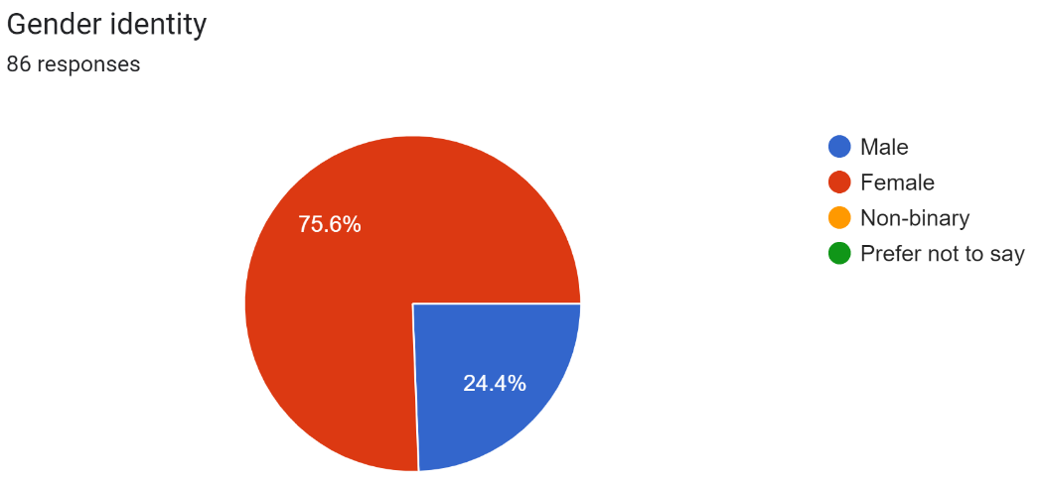
The pie chart above shows the percentages of the gender of the participants within the survey. These results showed that 75.6% (65) of the participants were female and 24.4% (21) of them were male. This shows that females were more willing to complete the survey than men, meaning that there could be bias due to having a predominantly female perspective.
4.2. Objective 1:
The first objective of this study is, to identify the prevalence of criminality in care experienced and looked after children and young people.
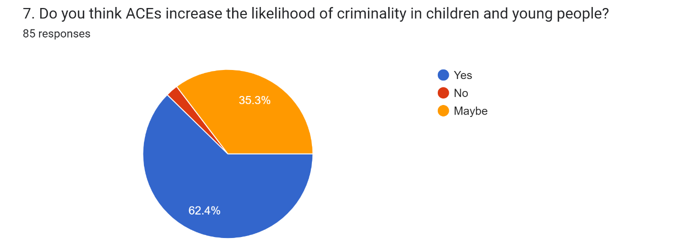In response to the first objective, this question was used to identify if the participant’s thought crime was prevalent in children and young people. 35.3% (30) of respondents answered maybe, 62.4% (53) of respondents answered yes and 2.4% (2) of respondents answered no; showing that there is a significant number of participants that believe ACEs increases the likelihood of someone turning to crime, although there is also a significant number of participants that are unsure if it has any effect. In correspondence with the literature review of this study, the National Child Traumatic Stress Network (2023) said that around 80% of those involved in juvenile justice had experienced some form of traumatic event. This shows that the findings of the survey correlate with existing literature, showing that ACEs can be seen throughout within the criminal justice system.

4.3. Objective 2:
The second objective of this study is to evaluate the long-term effects adverse childhood experiences have on children and young people who are in care or are care experienced.
Question 4:
This question asks the participants “Why do you think children and young people turn to crime”. The results of this question several themes were identified, predominantly negative factors such as negative behaviours, poverty, past experiences such as ACEs, and being in care as well as negative influences. Some of these themes can be seen in the following responses from the participants:
- “It's what they've seen growing up, so they've seen it as normal, so their brain normalises it”.
- “Poverty, abuse, mental health problems”.
- “Peer pressure - substance misuse.”
The response that was given by the participants show the idea that the reason a child or young person may turn to crime is due to negative influences, poverty, ACEs and a handful of other issues. Within the literature used in this study, the Scottish Government (2023) said that those who have experienced an ACE are more likely to partake in risky behaviour, which can impact health as well as criminality. This shows that negative implications such as influences, and abuse can be more inclined to turn towards criminal activities due to the risk involved.
Question 17:
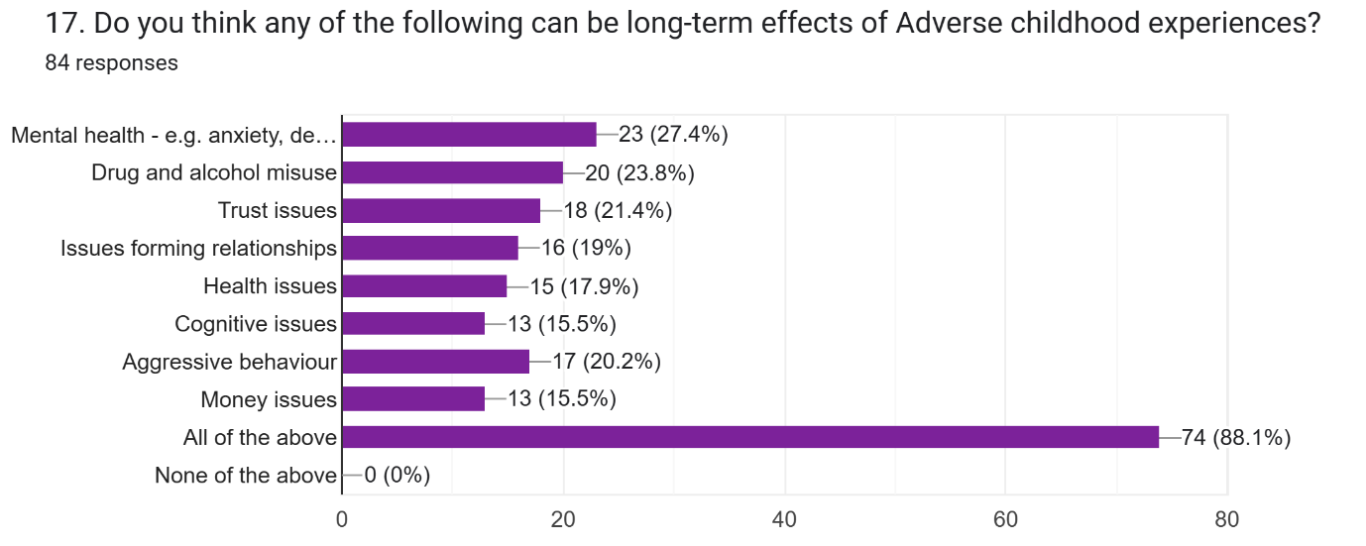
The graph above shows the responses to question 17, this question was used to identify what the respondent’s thought the long-term effects of adverse childhood experiences were. The issue with this question was that the participants could select more than one answer meaning that there would be an overlap in responses; regardless, it shows a clear distinction that many saw all the options as long-term effects. The option of mental health was selected 23 times; drug and alcohol misuse were selected 20 times; trust issues were selected 18 times; issues forming relationships were selected 16 times; health issues were selected 15 times; cognitive issues were selected 13 times; aggressive behaviour was selected 17 times; money issues were selected 13 times and the answer all of the above was selected 74 times. In terms of the literature review, Crandell et al (2019) that some of the long-term effects of ACEs can include Alcohol and drug addiction, a poor lifestyle and lower life expectancy due to the abuse experienced. This backs up what is being shown on the graph as drug and alcohol misuse the most selected, after the option, all the above.

Question 18:
This question asks: “What do you think can be done to reduce the long-term effects of ACEs?”. In terms of the research this is trying to understand how the participants think long-term impact criminality in children and young people can be reduced. Throughout the responses to this question there have been a handful of themes identified, they are therapy or counselling, support, interventions and awareness. These themes can be seen in the following responses from the participants:
- “More mental health support for care leavers and trauma informed practice”.
- “Support and therapy”.
- “Create awareness about it all. Work with families, staff, friends to find ways to help children in day-to-day activities and encourage them with opportunities for their future”.
The participants clearly state in their perspectives showing that they believe that there is a need for awareness, support such as therapy, trauma-informed practices as well as creating a level of awareness. Within the literature review, Gooch et al., (2022, p 5) say that care leavers have a greater risk of being exploited which increases the chance of victimisation, they also have greater chances of harming others and themselves. While this does not show that there is support, it does show the need for some type of support and intervention to help prevent self-inflicted injury as well as victimisation for those in care.

4.4. Objective 3:
The third objective of this study is to evaluate public perception on the link between adverse childhood experiences and crime as well as what can be done to reduce criminality.
Question 6:
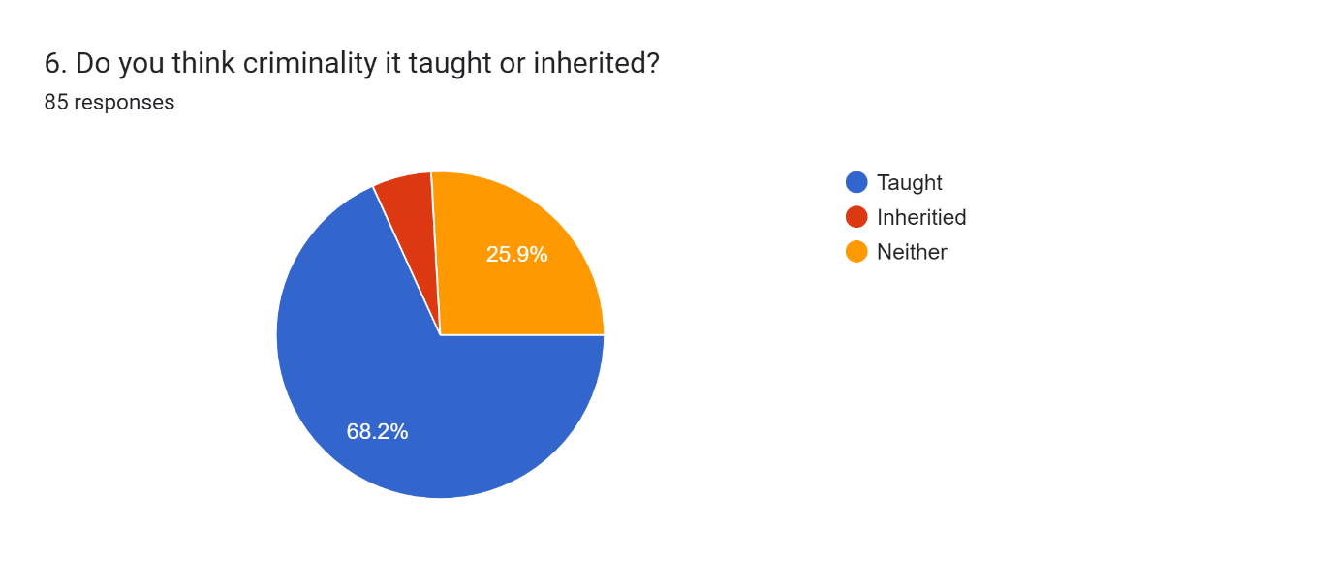
In response the third objective, this question was used to determine if the participants thought that criminality was taught or inherited. 68.2% (58) of respondents said that they thought it was taught, 25.9% (22) of respondents said that it was neither and 5.9% (5) of respondents said that it was neither. This question brought about the idea of nature vs nurture; the responses showed that a sizeable proportion of respondents thought that criminality can be taught compared to the small amount that said it was inherited. In context to the literature review, the way that can prove that a child or young person is often taught behaviour is the 1961 Bobo doll experiment by Bandura, it showed how children could be taught to be violent; those who observed violence can be elicited to more aggressive behaviour out of children (Galanaki and Malafantis 2022, p 1). This supports the idea that behaviour can be taught and therefore suggests that criminality can be taught to a child or young person.

Question 10:
This question asks the participant to “Following on from the previous question. What do you think has the most significant influence and why?”. Question 9 gave ideas of themes for this question such as parents, parents who have separated, friends or peers, teacher or lecturers, being in care, siblings and wider family. Through the responses to this question 10, it shows that the most predominant themes that the participants think influences a child the most is parents and friends and peers. Some of the participant responses that support the theme of parents and friends say:
- “Parents, because they nurture your first experiences.”
- “I believe parents or parents that are separated, and friends has a massive influence because until you’re 18 you spend majority of your time around these two significant figures”.
- “Parents and peers influence behaviour a lot”.
These responses convey that from the participants perspective both parent and peers have a significant influence on what children and young people do and how they behave. While parents are seen to have a significant influence towards children and young people its important to understand that a parent’s behaviour can often be the cause of trauma. Corsaro (2015, p 289) supports this by stating that child neglect refers to a parent not meeting the needs of their child or young person when it comes to their health, development or even safety. These certain behaviours from parents can negatively impact a child or young person and cause them to act in the same way and have a disregard for their safety and well as others.

Question 11:
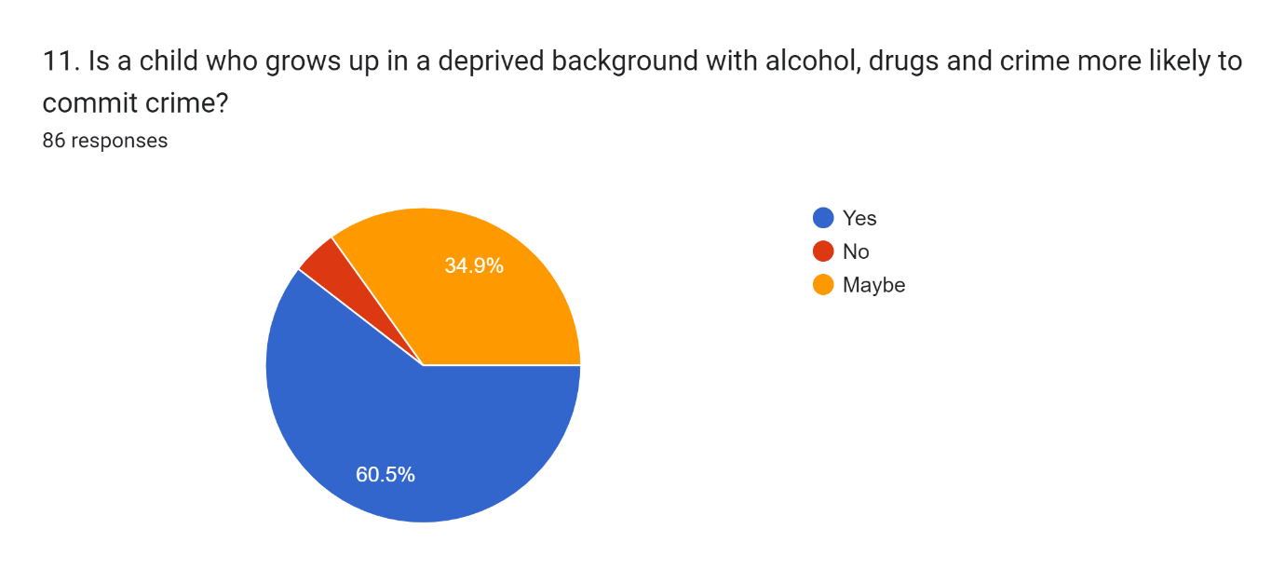
The pie chart above represents question 11’s results, this question was used in the survey to gain the perspective of the participants when it comes to the effect and impact that drugs, alcohol, and crime has on a child or young person and if it means they are likely to commit crime. 60.5% (52) of the respondents said yes, 34.9% (30) of the respondents said maybe and 4.7% (4) of the respondents said no. These percentages show that based on the perception of the participants most of them believe that these factors will influence if a child turns to crime or not. Within the literature review, it states that trauma can have many effects on a person, they can be affected by flash backs, have panic attacks, suffer from dissociation and have thought that of inflicting harm or even causing death as well as potentially turning to drugs and alcohol (Mind 2023). As many of the respondent said that drugs and alcohol can have an effect it can also be turned into a coping mechanism used by those who suffer for ACEs.

Question 14:
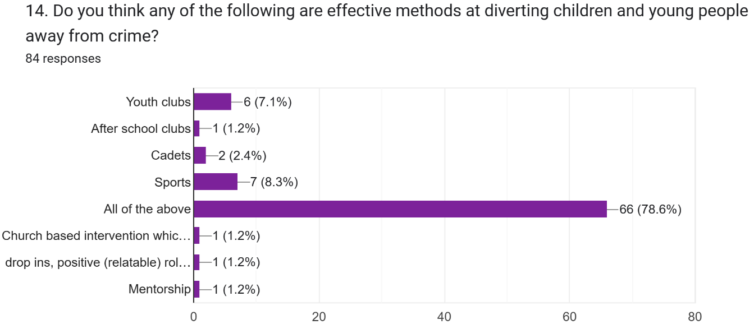
In response to the final part of the third objective, the graph above looks at what can be done to help divert and reduce criminality in children and young people. 7.1% (6) of respondents picked youth clubs; 1.2% (1) of respondents picked after-school clubs; 2.4% (2) of respondents picked cadets; 8.3% (7) of respondents picked sports; 78.6% of respondents picked all of the above. The participants in the study were given the option to add another option if they wanted therefore, 1.2% (1) selected church-based interventions that can give value to the young people; 1.2% (1) picked drop-ins, positive (relatable) positive role model speakers in school. The added options add value to the research, but the results of this question show that the participants believe that all the given options for this question are useful when looking to deter or prevent children and young people from turning to criminality. As previous stated in the literature review, the Violence Prevention Unit (2023) states that having a trusted adult or friend who can support them as well as getting engaged with community sports can help to prevent criminality in children and young people.

4.5. Summary
This chapter highlighted the prevalence of adverse childhood experiences having an impact on increasing criminality or not. For the second objective this chapter found key themes that could impact the likelihood of children and young people turning to crime as well as the long-term affects and what could be done to reduce them. Objective three was based on the public perception therefore it looked at whether the public thought criminality could be taught or inherited; if certain influences could affect if they will turn to crime as well as looking at ways that children and young people can be deterred away from crime. The key finding that have been identified will be discussed within the next chapter.

References:
Sharma, B. (2018). ‘Processing of Data and Analysis’. Biostatistics and Epidemiology International Journal. Vol 1(1). Available at: https://ologyjournals.com/beij/beij_00003.pdf (Accessed 18/03/2024)

References from Lit review:
Corsaro, W (2015). The sociology of childhood. 4th edition. California: Sage publications, Inc.
Crandall, A. Miller, J. Cheung, A. Novilla, L. Glade, R. Novilla, N. Lelinneth, B. Magnusson, B. Leavitt, B. Barnes, M. Hanson, C. (2019) ‘ACEs and counter-ACEs: How positive and negative childhood experiences influence adult health.’ Child abuse & neglect: the international journal. Vol 96. Available at: https://doi-org.ezproxy.uwtsd.ac.uk/10.1016/j.chiabu.2019.104089 (Accessed 15/10/2023).
Galanaki, E. Malafantis, K. (2022). ‘Albert Bandura's experiments on aggression modeling in children: A psychoanalytic critique’. Frontiers in psychology, 13, 988877. Available at: https://doi.org/10.3389/fpsyg.2022.988877 (Accessed 19/03/2024)
Gooch, K. Masson, I. Waddington, E. Owens, A. (2022) ‘After Care, After Thought?: The Invisibility of Care Experienced Men and Women in Prison’. Prison Service Journal. Issue 258, pages 4-12. Available at: PSJ 258, After care, after thought.pdf (crimeandjustice.org.uk) ( accessed 07/12/2023)
Mind (2023) Trauma. Available at: Effects of trauma - Mind(Accessed 8/12/2023).
National Child Traumatic Stress Network (2023) Essential elements. Available at: Essential Elements | The National Child Traumatic Stress Network (nctsn.org) (accessed 06/12/2023)
Scottish Government (2023). UNDERSTANDING CHILDHOOD ADVERSITY, RESILIENCE AND CRIME. Available at: https://www.gov.scot/binaries/content/documents/govscot/publications/research-and-analysis/2018/05/understanding-childhood-adversity-resilience-crime/documents/00535550-pdf/00535550-pdf/govscot%3Adocument/00535550.pdf. (Accessed 6/12/2023).
Violence Protection Unit (2023). Adverse Childhood Experiences (ACEs). Available at: https://www.violencepreventionwales.co.uk/research-evidence/adverse-childhood-experiences-aces (Accessed 3/12/2023).

