Ewa Kazimierska
Rate of reaction – Ellie Martin

Table of Contents
1 Abstract 1
2 Introduction 2
3 Main Body 3
3.1 Topic 1 3
3.1.1 Topic 1a 3
3.1.2 Topic 1b 3
3.2 Topic 2 4
4 Conclusion 5
5 Recommendations 6
6 Bibliography 7

Table of fi
Figure 1: sad emoji (Stephens, 2022) 4

Introduction
The concept of rate of reaction is fundamental in understanding how quick a chemical reaction occurs turning reactants into products. The change in concentration of reactants or the products are measured over time. Understanding the rate of reaction is fundamental within OME to correctly classify propellants based of the rate of detonation and deflagration [1]. In this report the rate of reaction between hydrochloric acid (HCL) and magnesium (Mg) and the volume of hydrogen gas which is produced is affected when the concentration of HCL, Temperature and the surface area of Mg is changed.
The controlled variables that can be changed to affect the rate of reaction: temperature, surface area, pressure and the introduction of a catalyst to reduce the activation energy of the reaction [4]. The dependent variable is the rate of reaction, and the controlled variables will vary depending on what is being changed but can include, initial temperature, catalyst which is being used, the volume of the solution.

Results

Effect of HCL concentrations on the speed of H2 gas evolution

0.5M HCl
Time, s | V H2, ml | Time, s | V H2, ml | Time, s | V H2, ml | Time, s | V H2, ml
0 | 0 | 220 | 26 | 440 | 42 | 660 | 45
10 | 1 | 230 | 27 | 450 | 42 | 670 | 45
20 | 1 | 240 | 28 | 460 | 43 | 680 | 45
30 | 2 | 250 | 29 | 470 | 43 | 690 | 45
40 | 4 | 260 | 30 | 480 | 43 | 700 | 45
50 | 6 | 270 | 30 | 490 | 44 | 710 | 45
60 | 7 | 280 | 31 | 500 | 44 | 720 | 45
70 | 8 | 290 | 32 | 510 | 44 | 730 | 45
80 | 11 | 300 | 33 | 520 | 44 | 740 | 45
90 | 13 | 310 | 33 | 530 | 44 | 750 | 46
100 | 14 | 320 | 33 | 540 | 44 | 760 | 46
110 | 14 | 330 | 34 | 550 | 44 | 770 | 46
120 | 15 | 340 | 34 | 560 | 44 | 780 | 46
130 | 16 | 350 | 35 | 570 | 45 | 790 | 46
140 | 17 | 360 | 36 | 580 | 45 | 800 | 46
150 | 18 | 370 | 37 | 590 | 45 | 810 | 46
160 | 20 | 380 | 38 | 600 | 45 | 820 | 46
170 | 20 | 390 | 38 | 610 | 45 | 830 | 46
180 | 22 | 400 | 39 | 620 | 45 | 840 | 46
190 | 24 | 410 | 41 | 630 | 45 | 850 | 46
200 | 24 | 420 | 41 | 640 | 45 | 860 | 46
210 | 26 | 430 | 41 | 650 | 45

1.0M HCl |  |  | 1.5M HCl |  |  | 2.0M HCl
Time, s | V H2, ml |  | Time, s | V H2, ml |  | Time, s | V H2, ml
0 | 0 |  | 0 | 0 |  | 0 | 0
10 | 15 |  | 10 | 23 |  | 10 | 38
20 | 25 |  | 20 | 40 |  | 20 | 49
30 | 30 |  | 30 | 49 |  | 30 | 60
40 | 40 |  | 40 | 55 |  | 40 | 65
50 | 47 |  | 50 | 58 |  | 50 | 70
60 | 50 |  | 60 | 61 |  | 60 | 71
70 | 55 |  | 70 | 63 |  | 70 | 72
80 | 60 |  | 80 | 65 |  | 80 | 72
90 | 62 |  | 90 | 66 |  | 90 | 72
100 | 63 |  | 100 | 67
110 | 64 |  | 110 | 68
120 | 64 |  | 120 | 68
130 | 64

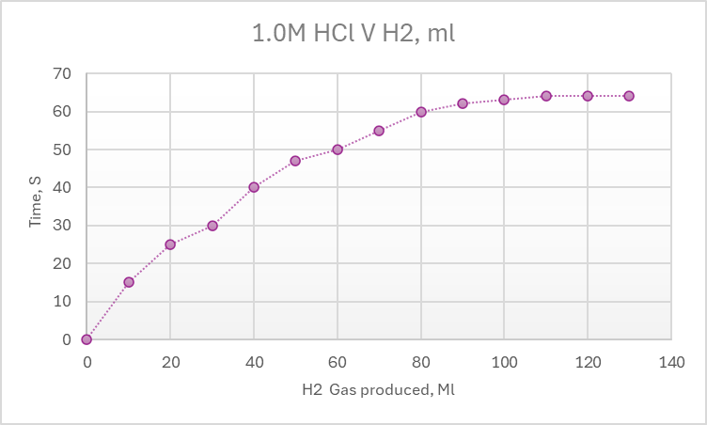
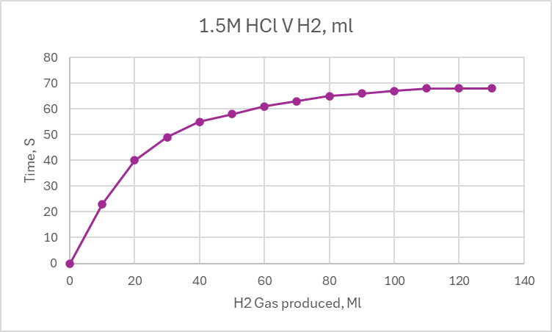
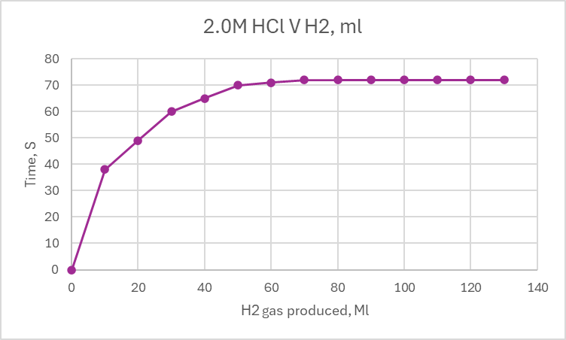

Effect of temperature on the speed of H2 gas evolution

T1 = 46.6 |  | T2 = 24.1
Time, s | V H2, ml | Time, s | V H2, ml
0 | 7 | 0 | 0
10 | 14 | 10 | 15
20 | 17 | 20 | 25
30 | 19 | 30 | 30
40 | 23 | 40 | 40
50 | 25 | 50 | 47
60 | 31 | 60 | 50
70 | 35 | 70 | 55
80 | 38 | 80 | 60
90 | 41 | 90 | 62
100 | 41.5 | 100 | 63
110 | 42 | 110 | 64
120 | 42 | 120 | 64
130 | 42 | 130 | 64

T3 = 38.2 |  |  | T4 = 48.1
Time, s | V H2, ml |  | Time, s | V H2, ml
0 | 0 |  | 0 | 0
10 | 18 |  | 10 | 20
20 | 29 |  | 20 | 30
30 | 37 |  | 30 | 37
40 | 43 |  | 40 | 42
50 | 49 |  | 50 | 47
60 | 52 |  | 60 | 51
70 | 56 |  | 70 | 53
80 | 59 |  | 80 | 54
90 | 60 |  | 90 | 54
100 | 61 |  | 100 | 44
110 | 62 |  | 110 | 55
120 | 62 |  | 120 | 55
130 | 63 |  | 130 | 56
140 | 63 |  | 140 | 57
150 | 63 |  | 150 | 57
160 | 63 |  | 160 | 58
170 | 64 |  | 170 | 59
 |  |  | 180 | 60
 |  |  | 190 | 61
 |  |  | 200 | 62
 |  |  | 210 | 62
 |  |  | 220 | 62
 |  |  | 230 | 63
 |  |  | 240 | 64
 |  |  | 250 | 64

Effect of the surface area of Mg on the speed of H2 gas evolution
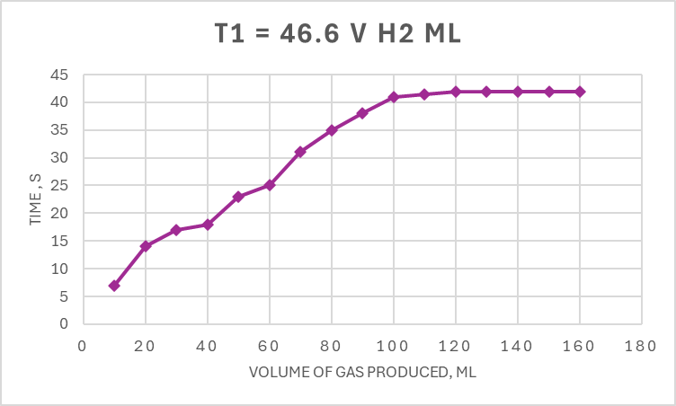
T1 = 46.6
Time S | V H2 Ml
10 | 7
20 | 14
30 | 17
40 | 18
50 | 23
60 | 25
70 | 31
80 | 35
90 | 38
100 | 41
110 | 41.5
120 | 42
130 | 42
140 | 42
150 | 42
160 | 42

Discussion
In section 2.1 the effect of change in concentration on the rate of reaction displayed that as the concentration of the solution increases the rate of reaction also increases. This is due to the particles have more energy and they will have more successful collisions which will surpass the amount of activation energy which is required for a successful reaction this is known as collision theory.[4]
In section 2.2 this demonstrates the effect of increasing the temperature, however the results which were obtained do not fully support the hypothesis that as temperature increases so does the rate of reaction. The results show that the temperature does influence the rate of reaction however, after a certain temperature this is no longer a limiting factor as once all the particles are moving faster due to having more energy due to being heated-more successful collision occur over coming the activation energy [4]
In 2.3 the rate of reaction should have been increased due to the smaller surface area of the particles however this wasn’t the case which could have been due to clumping in the material which meant the inequal distribution of masses through out the Mg reduces how fast the rate of reaction increased. This doesn’t support the hypothesis which was introduced as the rate of reaction should have decreased.
In all of these experiments the gas syringe method was used as outlined in the methodology in appendix 1- this disadvantage of this method is that is common for gas leaks to occur within the system due to a poor seal or bung not being in place correctly which will affect the results obtained. To reduce this, it is important to ensure there are no leaks in the seals and when placing the bungs on the tests tubes this is done efficiently and ensure tight seal is achieved.
It is important to understand the rate of reaction when selecting what explosives is required depending on the type of result which is required. If the intended mission requires a faster reaction with propagation wave faster than the speed of sound is needed a high explosive which detonates is required [1] such as TNT. This differs to the reaction which occurs with a low explosive such as nitrocellulose as this will cause deflagration which still propagates however this process is slower than the speed of sound [2]. A combination of the two types for explosive is often used in attempt to use less of high explosives which are hard to confine once ignited in comparison to low explosives. [3]

Conclusion
In this report the effect that temperature, surface area and concentration was investigated to determine if this would increase the rate or reaction. As hypothesises these factors did increase the rate of reaction as the particles had more energy resulting in more successful collisions. There were errors in our results which effected how accuracy of our data such as potential clumping in the Mg which would affect the rate of reaction negatively.
The rate of reaction is important within OME as the allows different explosives to be tested and qualified to best suit the mission objective with one of the factors being rate of reaction as well the amount of energy or yield which can be produced when formulated with other substances. Another important aspect of this technique is understanding the limiting factors of an explosive and if when subjected to increased atmospheric temperatures if this likely to cause earl detonation or deflagration.

Appendix 1- Methodology
Chemical used:
- Magnesium ribbon 4cm in length and weighed
- Magnesium powder- same mass as ribbon
- Hydrochloric acid (HCL) 2.0M
- Deionised water

Apparatus used
- Pipette
- Test tubes x4
- Test tube with arm?
- Large beaker
- Bunsen burner

Procedure Effect of HCL on the speed of H2 gas evolution
- Four solutions of HCL were prepared with the concentrations :2.0M (stock), 1.5M, 1.0M and 0.5M. Done by using 2.0M HCL solution and deionised water.
- HCL with lowest concentration poured into test tube with arm.
- 4cm strip of Mg Ribbon was added to the test tube and bung quickly put in place. Stopwatch started.
- Volume of hydrogen given off was recorded in 10 second intervals until no more gas was being given off.
- Once reaction is completed the reaction mixture is discarded into waste beaker.
- This methodology was then followed for the three other concentrations.

Procedure -Effect of temperature on the speed of H2 gas evolution
- Set up water bath and heat up beaker of water until temperature of water has increased by approx. 10.C for initial temperature.
- Pipette 20ml of 1.0M stock solution into three test tubes, wait until temperature of acid is the same as water bath.
- Transfer warm HCLinto tube with arm and put 4cm of Mg ribbon inside and place the bung on top of test tube and start stopwatch.
- Time the reaction until no more gas is produced.
- Repeat for 2 more temperatures 10 degrees apart.

Bibliography

[1]
J. Akhavan, The chemistry of explosives. Cambridge: Royal Soc. Of Chemistry, 2012.
[2]
B. O’Connor, “Explosions, Deflagrations, and Detonations,” Nfpa.org, Mar. 27, 2023. https://www.nfpa.org/news-blogs-and-articles/blogs/2023/03/27/explosions-vs-deflagrations-vs-detonations (accessed May 13, 2025).
[3]
E.-C. Koch, High Explosives, Propellants, Pyrotechnics. 2021.
[4]
A. Burrows and E. Al, Chemistry3 : introducing inorganic, organic and physical chemistry. Oxford: Oxford University Press, Cop, 2013.

