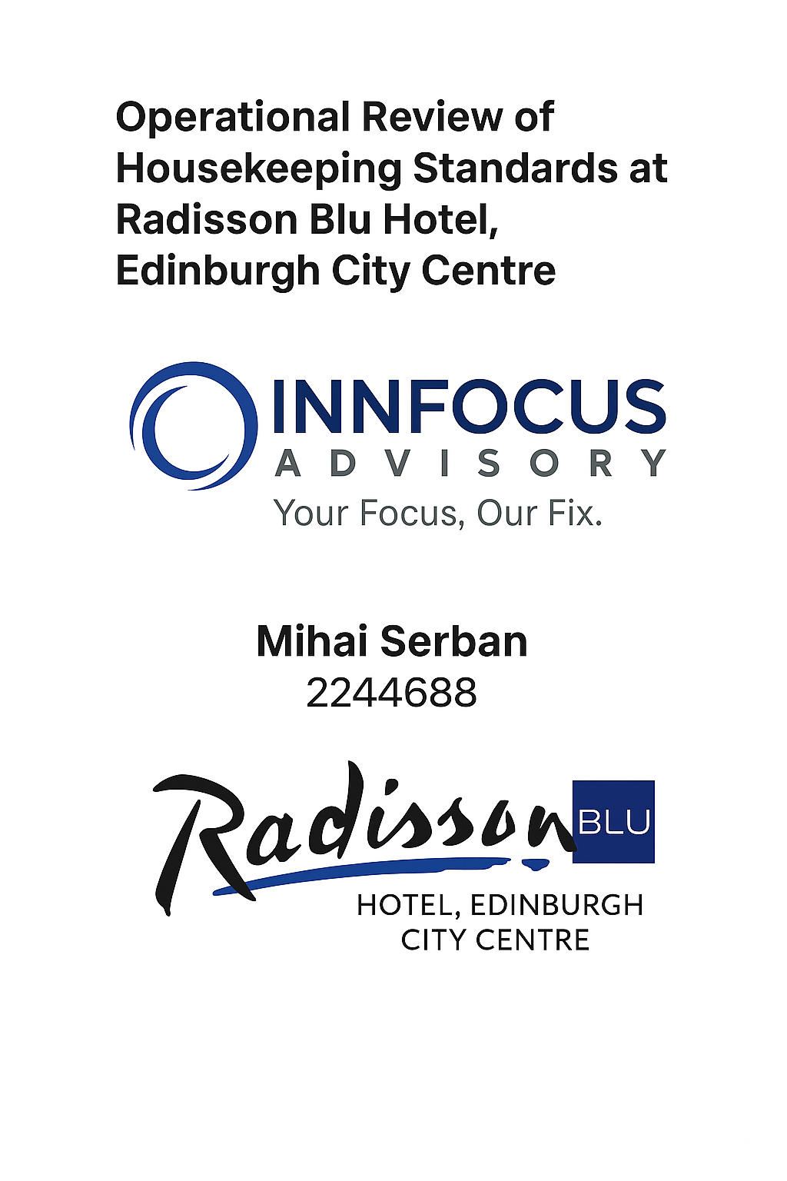
I confirm that I have not used any AI tools in the research and creation of this assignment. I confirm that I have not presented any AI generated materials as my own work. I confirm I have copies of my drafts, notes, and other resources I used, which I may be asked to provide in evidence.

Table of Contents
1. Executive Summary 3
2. Introduction 5
3. Analysis 7
3.1 Description of the Identified Issue: Inconsistent Housekeeping Standards 7
3.2 STEEPLED Analysis 9
3.3 SWOT Analysis 11
3.4 TOWS Matrix 12
4. Recommendations and Change Management 15
4.1 Strategic Focus: Enhancing Housekeeping Performance 15
4.2 Recommendation 1: Digitise Housekeeping Operations with a Real-Time Management System 16
4.3 Recommendation 2: Deliver Structured, Multilingual Training for Housekeeping Staff 19
4.4 Recommendation 3: Introduce KPI Dashboards and Performance Accountability Tools 21
4.5 Recommendation 4: Boost Staff Retention through Incentives and Flexible Scheduling 22
4.6 Recommendation 5: Improve Guest Communication on Eco-Cleaning Options 24
4.7 Summary of Benefits 25
4.8 Implementation Timeline 26
5. Action Plan 28
6. Conclusion 30
7. References 32

- Executive Summary
This consultancy report, commissioned by Radisson Blu Hotel Edinburgh City Centre, explores the root causes and strategic solutions for persistent inconsistencies in housekeeping performance. Despite being positioned as a premium 4.5-star property under the globally recognised Radisson brand, guest feedback via TripAdvisor and Booking.com revealed recurring issues with cleanliness, room readiness, and in-room amenity replenishment.
To diagnose the underlying drivers, a multi-method approach was used. Root Cause Analysis (via the 5 Whys), SWOT, STEEPLED, and the Star Model identified key internal shortcomings, such as informal training, lack of standardised quality checks, and low task accountability. These internal gaps are exacerbated by external pressures — including post-pandemic expectations, labour shortages, and evolving sustainability demands.
Five evidence-based recommendations were developed to address these issues:
1. Implementation of a digital housekeeping management system (e.g., Flexkeeping) for real-time task oversight;
2. Delivery of structured, multilingual training to ensure consistent service standards;
3. Rollout of KPI-based dashboards and monthly performance reviews;
4. Incentivised retention strategies, including flexible scheduling and peak-period bonuses;
5. Clear guest communication regarding eco-cleaning policies, supported by opt-in signage and optional incentives.
Each recommendation was underpinned by theoretical models such as Kotter’s 8-Step Model, Lewin’s Change Theory, and the McKinsey 7S Framework. Estimated budgets and timelines were provided in a phased 12-month Gantt chart and detailed action plan. Implementation milestones span from digital system launch (Month 1–4) to training, KPI embedding, and cultural reinforcement extending through Month 12.
Benefits of this strategy include a projected reduction in housekeeping-related complaints, improved guest satisfaction, stronger audit scores, and enhanced staff morale. Integrating a digital housekeeping system is expected to streamline room readiness and improve accountability; in fact, hotel teams using Flexkeeping have reported up to 40% higher productivity and a 45% drop in guest complaints (Flexkeeping, 2024; Hotel Tech Report, 2024). Moreover, aligning environmental communications with Radisson’s ESG framework supports broader corporate responsibility objectives. Transparent sustainability messaging has also been shown to influence consumer trust and brand engagement positively — with research indicating up to a 33% increase in consumer intent when eco-practices are clearly communicated (NYU Stern Center for Sustainable Business and Edelman, 2023).
In conclusion, the consultancy has delivered a cost-effective, actionable strategy to raise housekeeping standards and restore brand credibility. The recommendations balance immediate service recovery with long-term operational resilience.
We thank the management team at Radisson Blu Edinburgh for the opportunity to support their journey toward service excellence, and we remain available for further collaboration as implementation progresses.

- Introduction
In the contemporary hospitality industry, service consistency is a vital determinant of guest satisfaction and brand loyalty. Housekeeping, often considered the backbone of operational excellence in hotels, plays a pivotal role in maintaining hygiene, comfort, and the overall guest experience (Bryson, 2018). This consultancy report addresses a recurring issue at the Radisson Blu Hotel, Edinburgh City Centre: inconsistent housekeeping standards that are negatively impacting guest satisfaction. Numerous reviews on platforms such as TripAdvisor and Booking.com highlight specific concerns regarding incomplete room servicing, non-replenishment of toiletries, and delays in housekeeping response times (Tripadvisor, 2024; Booking.com, 2024).
The Radisson Blu Hotel in Edinburgh is part of the internationally renowned Radisson Hotel Group, which operates over 1,700 hotels worldwide (Radisson Hotel Group, 2024). This specific property is located in the heart of the city on the historic Royal Mile. It comprises 238 guest rooms and suites, meeting spaces, a fitness centre, and an on-site restaurant. Its central location attracts a diverse clientele, including business travellers, international tourists, and event delegates. Given the hotel’s premium brand affiliation, guests typically expect a high standard of service across all departments. However, inconsistencies in the quality and reliability of housekeeping have emerged as a significant operational weakness, threatening both the hotel's online reputation and its return guest rate.
To address this issue, Radisson Blu has engaged the services of Innfocus Consulting—a bespoke organisational consultancy firm specialising in hospitality service optimisation. Innfocus Consulting’s mission is to transform service inconsistencies into competitive advantages by providing tailored, research-driven recommendations. The firm has a proven track record in supporting four- and five-star hotels across the UK in restructuring operations and elevating service standards. With a foundation in evidence-based practice and a commitment to measurable results, Innfocus Consulting approaches each assignment with a blend of industry knowledge, analytical rigour, and change management expertise.
This report will apply a range of diagnostic and strategic models to evaluate the root causes of housekeeping inconsistencies at the Radisson Blu Hotel. Firstly, a SWOT analysis will be conducted to capture an internal snapshot of the hotel’s strengths, weaknesses, opportunities, and threats. This will be complemented by a TOWS matrix, which will aid in formulating practical strategies to convert weaknesses into opportunities. Secondly, the Star Model by Galbraith (2002) will be used to analyse the alignment of organisational components such as strategy, structure, people, processes, and rewards. This will help to identify internal misalignments contributing to service breakdowns.
To explore underlying operational issues, root cause analysis will be conducted using the ‘5 Whys’ technique, allowing the report to distinguish between surface-level symptoms and deeper systemic causes. Furthermore, the implementation of proposed solutions will draw on Kotter’s (2012) 8-Step Model for Leading Change and Hiatt’s (2006) ADKAR model, ensuring that the recommended improvements are sustainable and supported by the hotel’s workforce. These models offer structured approaches for introducing changes, managing resistance, and embedding new practices into organisational culture.
By the conclusion of this report, Radisson Blu Hotel, Edinburgh City Centre will be equipped with a clear, actionable roadmap to standardise and enhance its housekeeping operations. The goal is not only to resolve the current inconsistencies but also to future-proof the hotel's operational capacity by aligning people, processes, and performance metrics. Through strategic intervention and professional guidance, Innfocus Consulting aims to support Radisson Blu in restoring its operational excellence and strengthening its position in the highly competitive Edinburgh hospitality market.

- Analysis
This section applies diagnostic models and structured frameworks to explore the root causes of inconsistent housekeeping at Radisson Blu Hotel Edinburgh City Centre. By using tools such as the 5 Whys, STEEPLED, SWOT, and TOWS, the analysis uncovers how both internal operations and external pressures contribute to the issue. These insights lay the foundation for the targeted recommendations presented in Section 4.
3.1 Description of the Identified Issue: Inconsistent Housekeeping Standards
A key operational weakness at Radisson Blu Hotel, Edinburgh City Centre is the inconsistency of housekeeping standards, which has emerged as a frequent source of guest dissatisfaction. Despite its 4.5-star positioning and central location, multiple guest reviews indicate that cleanliness and service reliability fall short of expectations.
One reviewer described their experience as “far from luxury but with a steep price tag”, adding: “There was a piece of trash near the bin when we first entered our room… It makes you question the cleanliness and care given to the rooms” (TripAdvisor, 2023). Another guest complained of disorganisation, writing: “Cleanliness was not up to standard and had to complain on a number of occasions for housekeeping to resolve. Room service was completely disorganised and took ages to arrive with a missing key item” (TripAdvisor, 2024a).
A third review was even more critical, stating: “The hotel in general has the worst housekeeping service. The staff either forget to replace towels, tea, coffee etc., or they forget cleaning used cups and glasses. It was so incapable!” (TripAdvisor, 2024b). These accounts reflect more than isolated lapses—they suggest systemic breakdowns in standard operating procedures, quality assurance, and internal staff communication.
Consistency in housekeeping is essential not only for guest comfort but for maintaining online ratings and return bookings—both of which influence long-term revenue. In a competitive city like Edinburgh, where many alternatives exist, even occasional lapses in room cleanliness can significantly damage brand reputation. As such, this issue warrants structured investigation using models such as the 5 Whys or McKinsey 7S, which can help uncover root causes and guide realistic, operationally aligned improvements.
Root Cause Analysis: 5 Whys
To investigate the underlying causes of inconsistent housekeeping standards at Radisson Blu Hotel, Edinburgh City Centre, the 5 Whys method was applied. This structured tool is widely used in operations and service management to trace problems back to their root causes by repeatedly asking “why” (Ohno, 1988; MindTools, 2024). It complements broader frameworks like SWOT and TOWS by identifying the internal procedural breakdowns behind guest dissatisfaction.
Problem: Guests frequently report inconsistent room cleanliness, missing amenities, and general dissatisfaction with housekeeping quality (TripAdvisor, 2023; 2024a; 2024b).
- Why are rooms not being cleaned properly or consistently?
➡ Because housekeeping tasks are not being executed uniformly across all shifts and rooms.
- Why is task execution inconsistent?
➡ Because there is limited monitoring, no formal quality audits, and no daily performance checks (Baum, 2019).
- Why is there no structured monitoring in place?
➡ Because standard operating procedures (SOPs) are either absent or poorly enforced, and tasks are not linked to measurable KPIs (CIPD, 2023).
- Why are SOPs and KPIs lacking or unenforced?
➡ Because staff training is informal, and managers rely on verbal instruction rather than systems-based accountability (Kotter, 2012; PwC, 2023).
- Why is training informal and systems underdeveloped?
➡ Due to high staff turnover, resource limitations, and a reactive culture prioritising short-term coverage over long-term improvement (Baum, 2019; CIPD, 2023).
This analysis reveals that the core issue is not isolated staff performance but deeper organisational deficiencies in structure, consistency, and operational strategy. These findings align with the Star Model’s emphasis on aligning people, process and performance systems to achieve consistent outcomes (Galbraith, 2014). The identified root causes therefore guide the evidence-based recommendations presented in Chapter 4.
  - STEEPLED Analysis
To understand the external environment influencing the housekeeping issues at Radisson Blu, a STEEPLED analysis is used. This provides insight into macro-level forces affecting staffing, guest expectations, and operational performance.
Social
Since the COVID-19 pandemic, cleanliness has become a non-negotiable priority for hotel guests. According to TrustYou (2023), 87% of travellers now view cleanliness as the most critical review factor. Inconsistencies in room presentation, as seen in guest complaints, directly undermine the social trust and perceived hygiene essential for post-pandemic guest satisfaction. This cultural shift places greater scrutiny on housekeeping performance and amplifies the impact of even small lapses in quality.
Technological
The hospitality sector increasingly relies on real-time task management systems to standardise service and improve accountability. Hotels that fail to adopt such systems often face issues with task allocation, monitoring, and follow-up (Noordzyfe, 2014). At Radisson Blu, guest reviews noting missing amenities and delayed room cleaning reflect the absence of these tools — a technological gap that contributes to service inconsistency. Digital housekeeping platforms could bridge this operational weakness
Economic
The UK hospitality industry continues to face labour shortages and wage inflation, making it difficult to recruit and retain housekeeping staff. UKHospitality (2024) reports that 61% of hotels struggle to fill these roles, leading to understaffed teams and operational fatigue. These conditions often result in rushed or incomplete cleaning, particularly during peak periods. Addressing this economic pressure through automation and improved retention policies is critical.
Environmental
Sustainability initiatives such as optional towel and linen changes are increasingly common, but if poorly communicated, they can be misinterpreted as service failures. Several guests at Radisson Blu complained about infrequent room servicing, unaware it was part of an environmental policy. According to VisitBritain (n.d.), clear messaging is essential for sustainability to enhance — not damage — guest perception. Environmental policies must therefore be aligned with transparency and choice.
Political
Post-Brexit immigration reforms have severely affected access to low-wage labour pools, particularly in housekeeping. The Migration Observatory (Sumption and Walsh, 2022) notes that these roles are among the hardest to fill following the end of free movement. This has placed pressure on hotels to adapt with higher wages, automation, or more flexible roles, reinforcing the need for strategic workforce planning to ensure service standards.
Legal
Under UK Health and Safety law, hotels are required to maintain clean and hygienic environments for all guests. Failures in housekeeping could result in complaints, reputational damage, or even regulatory action (Health and Safety Executive, 2024). This legal imperative makes it essential to introduce systems and standards that not only improve service quality but also ensure compliance and traceability.
Ethical
There is growing scrutiny around the treatment of cleaning staff, particularly regarding low pay, workload, and a lack of training. UNISON (2021) highlights that ethical employment practices — including fair wages, recognition, and upskilling — are directly linked to morale and retention. Radisson Blu must therefore align its housekeeping practices with a more ethical, supportive model to reduce turnover and improve consistency.
Demographic
An ageing UK population and declining interest in physically demanding roles among younger workers mean that housekeeping talent pipelines are shrinking. The British Hospitality Association (2022) reports increasing reliance on migrant and part-time workers. This demographic shift reinforces the need for multilingual training, clearer SOPs, and digital tools that support efficiency regardless of staff turnover or background.
3.3 SWOT Analysis
This SWOT analysis outlines Radisson Blu Hotel, Edinburgh City Centre’s current position, with a focus on how internal and external factors contribute to the identified issue of inconsistent housekeeping standards.
Strengths
Affiliation with the Radisson Hotel Group ensures strong brand recognition, access to a loyalty base, and established service expectations (Radisson Hotel Group, n.d.). The hotel’s central location on the Royal Mile secures high guest traffic, and its broad range of amenities supports diverse customer needs. These advantages provide a solid foundation for improving operational consistency, especially in housekeeping.
Weaknesses
Persistent guest complaints highlight lapses in room cleanliness, delayed service, and missing amenities (TripAdvisor, 2024; Booking.com, 2024). These reflect deeper gaps in staff training, supervision, and the absence of real-time task monitoring. The hotel’s limited use of digital housekeeping tools and informal onboarding processes further contribute to inconsistent service delivery.
Opportunities
Adopting digital housekeeping systems and performance tracking tools could significantly improve task execution and oversight (UKHospitality, 2024). Guest interest in sustainable practices offers an additional opportunity — opt-in cleaning schemes, if clearly communicated, can reduce workload while appealing to eco-conscious travellers (VisitBritain, n.d.).
Threats
Staff shortages — intensified by Brexit and the rising cost of living — undermine service consistency and increase turnover (Sumption and Walsh, 2022). Additionally, poor online reviews related to housekeeping erode trust and influence future bookings, especially in a competitive hospitality market.
3.4 TOWS Matrix
The TOWS matrix applies the SWOT framework to generate strategic responses that address Radisson Blu Edinburgh’s core operational issue — inconsistent housekeeping standards. Each quadrant proposes targeted actions based on how internal capabilities can be aligned with external conditions.
Figure 1 – TOWS Matrix
Source: Created by author using Canva (2025)
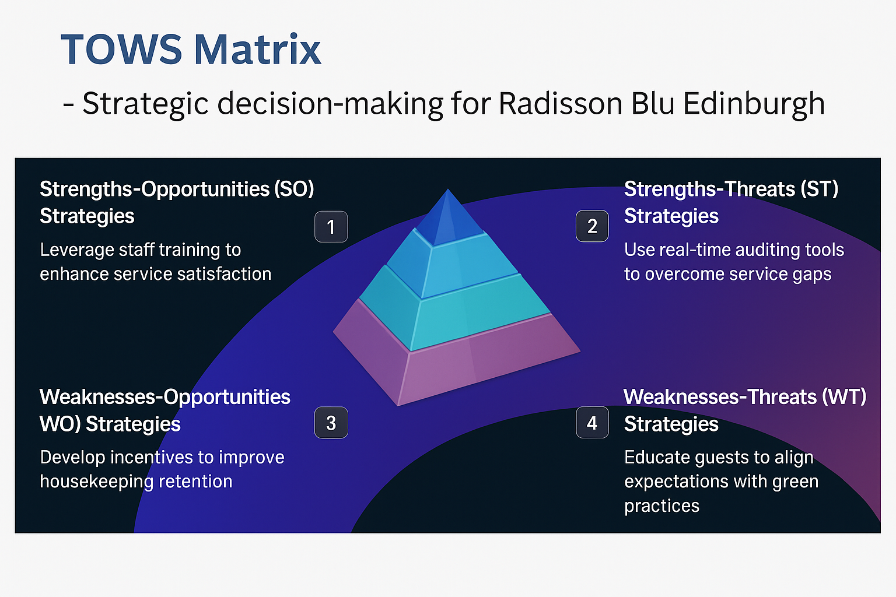
SO Strategies (Strengths–Opportunities): Leverage brand and location to support service transformation
- Use Radisson’s global reputation to launch a “Premium Clean Promise” campaign that restores guest trust after cleanliness complaints.
- Align this with a Green Cleaning Initiative using sustainable products and linen reuse incentives to appeal to eco-conscious travellers (VisitBritain, n.d.).
- Promote the hotel’s central location and amenities (spa, dining) alongside enhanced service quality in marketing messages.

WO Strategies (Weaknesses–Opportunities): Resolve gaps through tech and training
- Implement a digital housekeeping audit system (e.g., Flexkeeping) to improve oversight and task consistency (UKHospitality, 2024).
- Introduce structured training focused on hygiene, sustainability, and service communication.
- Communicate cleaning frequency and service flexibility during check-in and booking to prevent misaligned expectations.

ST Strategies (Strengths–Threats): Differentiate the brand to absorb reputational risks
- Use Radisson Rewards to retain loyal guests during service recovery periods (e.g., upgrades, late checkout).
- Highlight full-service amenities (conference rooms, spa, breakfast) in advertising to differentiate from Airbnb and boutique competitors.
- Monitor online feedback to respond rapidly and protect brand image.

WT Strategies (Weaknesses–Threats): Improve stability and accountability
- Establish KPIs and accountability structures for housekeeping supervisors to reduce performance variability.
- Offer seasonal bonuses and flexible shifts to retain staff during peak periods (Unite the Union, 2024).
- Conduct external benchmarking (e.g., mystery audits) to monitor service gaps and standard compliance.

Figure 2 – TOWS Matrix – The 4 Quadrants
Source: Created by author using Canva (2025)

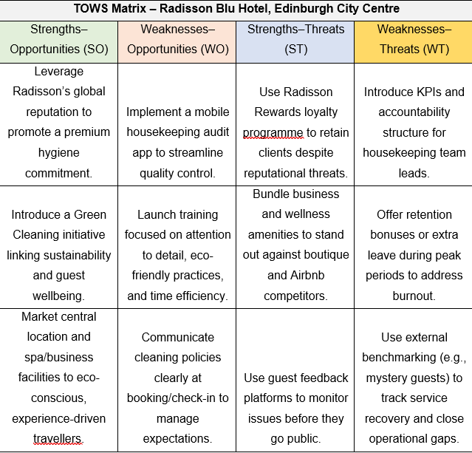

- Recommendations and Change Management
Building on the root causes identified in the previous chapter, this section outlines a series of targeted interventions to address inconsistent housekeeping performance at Radisson Blu Hotel Edinburgh City Centre. Each recommendation is grounded in industry evidence, supported by strategic change models, and designed to be both practical and sustainable. The proposed actions are aligned with broader organisational priorities such as service quality, employee retention, and environmental responsibility.
4.1 Strategic Focus: Enhancing Housekeeping Performance
The Radisson Blu Hotel Edinburgh City Centre, a prominent member of an internationally recognised hospitality brand, is currently facing a critical operational challenge: inconsistent housekeeping performance. This issue has become a primary source of dissatisfaction among guests, frequently cited in online reviews as a factor diminishing the overall guest experience (Tripadvisor, 2024; Booking.com, 2024). Common themes include delayed room servicing, cleanliness oversights, and lack of consistency in the replenishment of in-room amenities. Such deficiencies can undermine the brand’s reputation, increase refund rates, and decrease return business.
Housekeeping is a fundamental pillar of hotel operations. It not only influences first impressions but also contributes significantly to online review ratings and net promoter scores (UKHospitality, 2024). Inconsistencies in this area suggest broader problems within the organisational system — including gaps in staff training, lack of technological integration, unclear performance expectations, and insufficient communication both internally and with guests.
To address these challenges, a targeted and integrated change strategy is required. This report proposes five interconnected interventions:
- The introduction of a digital housekeeping task management system;
- Development of a structured training and upskilling programme;
- The implementation of a KPI-led performance accountability framework;
- Staff retention initiatives and flexible scheduling;
- Transparent communication of eco-cleaning and service expectations to guests.
These recommendations are informed by a combination of theoretical models and sector-specific data. Key frameworks guiding this response include Kotter’s (2012) Eight-Step Change Model, Burnes’ (2014) interpretation of Lewin’s Three-Step Model, and the McKinsey 7S Framework (Whittington et al., 2020). The strategic logic is further supported by the Star Model for organisational alignment, ensuring that changes in people, structure, rewards, and processes are mutually reinforcing.
Furthermore, this section draws upon findings from the SWOT and TOWS analyses presented in the previous chapter. These tools highlighted the internal weaknesses (such as high turnover and operational gaps) and external threats (such as rising guest expectations and competitive pressure from alternative accommodations) that must be addressed. They also identified strengths (brand reputation and location) and opportunities (digitisation, sustainability) that can be strategically leveraged.
The recommendations have been designed with practical feasibility in mind. Cost considerations, implementation timelines, and change management requirements are embedded into each proposal. Moreover, they aim to align not only with immediate service recovery goals but also with the broader priorities of the Radisson Hotel Group, including sustainability, operational efficiency, and employee engagement.
In summary, this section outlines a proactive and research-informed roadmap to tackle the identified housekeeping issue. By combining technological solutions with human-centred management approaches, the strategy is designed to improve both service quality and internal organisational resilience.
  - Recommendation 1: Digitise Housekeeping Operations with a Real-Time Management System
Digital transformation in the hospitality industry significantly improves operational efficiency and guest experience, with studies showing cloud-based property management systems can boost efficiency by up to 30%” (Anwar et al., 2024).
Implementing a digital housekeeping management platform will address the root causes of inconsistency by bringing structure, visibility, and accountability into daily operations. This solution addresses the root causes of the issue — inconsistent cleaning practices, communication breakdowns, and lack of performance oversight — by integrating technology into day-to-day housekeeping operations. Such systems are already widely used across the hospitality sector, particularly within premium hotel chains, and are considered best practice in enhancing service delivery (UKHospitality, 2024).
Digital housekeeping platforms such as Flexkeeping, RoomChecking, or ALICE Housekeeping offer real-time task assignment, progress tracking, and quality assurance tools. These systems allow supervisors to assign cleaning tasks, monitor progress, and ensure compliance via digital checklists (UKHospitality, 2024; Buttrick, 2009). See Figure 3 for an illustrative cost breakdown of this solution.
Integration with existing property management systems (PMS), such as Opera, enables streamlined communication between housekeeping, front office, and maintenance departments (Buttrick, 2009). By digitising these workflows, the hotel can significantly reduce delays, avoid miscommunication, and ensure cleaning quality is verifiable and logged.
Implementing such a system also supports a culture of transparency and accountability. Digital checklists and audit trails eliminate reliance on verbal briefings and paper logs, both of which are prone to error and inconsistency. According to a benchmarking study by Flexkeeping (2023), hotels that adopt digital housekeeping systems typically experience a 30–40% reduction in room readiness delays and a measurable uplift in guest review scores.
From a change management perspective, Kotter’s (2012) Eight-Step Model offers a structured approach to successful implementation. The first step involves creating urgency, using internal quality audit results and negative guest reviews as compelling evidence of the need for change. A guiding coalition should then be formed, comprising the housekeeping manager, IT specialist, front office representative, and HR support to oversee system rollout.
The third step is to develop and communicate a clear vision — that technology is an enabler rather than a surveillance tool. Staff buy-in is crucial, particularly in service roles where digital transformation may be perceived as a threat. Through workshops, interactive demos, and peer-led training, the vision should be reinforced consistently. Short-term wins could include public recognition of staff who achieve high digital checklist completion rates or whose rooms pass inspection consistently.
To anchor change into organisational culture, the new digital system should be integrated into standard operating procedures (SOPs), performance reviews, and onboarding materials. As Burnes (2014) notes, sustainable organisational change depends on embedding new practices within the routines and values of the team. Over time, this digital infrastructure can also facilitate integration with broader sustainability goals, such as reporting water or chemical use per room, which contributes to ESG (Environmental, Social, Governance) objectives.
This mid-range projection aligns with operational budgets of comparable UK hotel properties and has been benchmarked against supplier data and hospitality IT procurement trends (Flexkeeping, 2023; Buttrick, 2009).
Figure 3 – Estimated Cost Breakdown - Digital Housekeeping System
Source: Created by author using Canva (2025)
The cost estimates for implementing a digital housekeeping management system are grounded in pricing models from leading hospitality software vendors such as Flexkeeping and RoomChecking. These platforms typically charge between €2.50 and €3.00 per room per month, which equates to approximately £5,000 to £7,000 per year for a 200–250 room property (Flexkeeping, 2023; GetApp UK, 2025).
Hotels implementing digital housekeeping software report a 37% increase in operational efficiency and a 40% decrease in administrative costs, making this not only a service improvement but a financial win as well (Acropolium, 2025).
The estimate for mobile devices (£1,500) assumes the procurement of 6 to 7 smartphones, priced around £200–£250 each, based on UK retail listings for mid-range Android business devices (Currys, 2024).
Training and onboarding costs are projected at £500, covering vendor-led sessions and internal rollout support. This estimate reflects common onboarding costs seen in comparable hospitality software implementations in the UK (UKHospitality, 2024).
Success Indicators
- Average room turnaround time (pre- vs post-implementation)
- Compliance rate with digital housekeeping checklists
- Guest feedback on room cleanliness (via Booking.com and Tripadvisor)
- Internal audit pass/fail rates
- Supervisor satisfaction with task visibility and response time
This recommendation offers a high-impact, measurable intervention that addresses the core issue of inconsistency while promoting efficiency, employee empowerment, and guest satisfaction.
4.3 Recommendation 2: Deliver Structured, Multilingual Training for Housekeeping Staff
While the adoption of technology can streamline operations, it cannot fully replace the human element at the heart of housekeeping. Feedback from guests frequently mentions basic oversights — unclean bathrooms, bins left full, or unrefreshed towels — indicating that the issue is not simply time pressure, but gaps in training and communication (Tripadvisor, 2024; Booking.com, 2024). These problems persist even when staffing levels are adequate, which points to a lack of structured, ongoing skills development.
Training in many UK hotels often consists of informal shadowing or brief induction sessions. While this may suffice for basic orientation, it does not ensure a consistent standard across a diverse workforce, particularly in roles with high turnover and language diversity. Structured training programmes, backed by visual aids and accessible materials, are essential in addressing service quality at scale (Burnes, 2014; Baron and Armstrong, 2007).
To ensure reliable service delivery, Radisson Blu should introduce a structured induction and refresher training programme tailored to its operational needs. These sessions should include hands-on demonstrations, video training (multilingual where required), and practical walkthroughs in guest rooms. In addition, daily team briefings or “huddles” can help to reinforce key messages, provide updates, and build team cohesion.
Training content should focus not only on technical skills (e.g., how to clean specific surfaces or fold linens) but also on service awareness. For example, recognising the signs of a VIP guest, knowing when to escalate maintenance issues, or how to handle in-room guest encounters all contribute to an elevated guest experience.
The delivery of this initiative can be supported by Lewin’s Three-Step Change Model, as interpreted by Burnes (2014). The first phase, unfreezing, involves identifying knowledge gaps and building awareness of the need for change, often through guest complaint analysis and feedback from supervisors. The change phase includes the delivery of interactive, scenario-based training, ideally facilitated by experienced team members or external consultants. Finally, the refreezing phase embeds new expectations into SOPs and appraisal processes, ensuring that high standards are not just taught, but sustained.
Implementing training in this way also supports wider staff development and morale. In sectors like hospitality, where many roles are low-paid and undervalued, structured learning communicates investment in people — a key factor in retention and performance (CIPD, 2024). Employees are more likely to take pride in their work when they are clear on expectations and feel competent in their roles.
Figure 4 – Estimated Cost Breakdown - Training and Skills Development
Source: Created by author using Canva (2025)
The projected training budget of £2,000–£3,000 per year includes materials development, video content, and the cost of an external facilitator for biannual refresher training. This aligns with average spending reported in UK-based hospitality organisations for in-house training programmes, particularly those focused on service quality and operations (CIPD, 2024).
Briefings are integrated into staff schedules and incur no additional cost, while training rooms are assumed to be hotel-owned facilities used during off-peak hours, which is standard practice in the sector. The estimates provided are therefore scalable and reflective of best practice in the UK hotel industry (UKHospitality, 2024).
Success Indicators
- Reduction in cleanliness-related guest complaints
- Increase in housekeeping audit pass rates
- Staff survey feedback on training clarity and confidence
- Supervisor reports on post-training performance consistency
With the right delivery approach, this intervention offers not just improved cleaning outcomes, but also a more confident, motivated workforce. In a people-centred industry like hospitality, that outcome is a return on investment in itself.
  - Recommendation 3: Introduce KPI Dashboards and Performance Accountability Tools
Introducing clear performance indicators and a feedback loop will allow housekeeping standards to be tracked, reinforced, and continuously improved. Without clear performance indicators, it’s difficult for supervisors to track standards or give constructive feedback. Establishing a set of key performance indicators (KPIs) — such as room readiness rates, re-clean frequencies, and guest satisfaction scores — would help create a shared understanding of expectations within the team.
These KPIs should be introduced gradually, supported by monthly one-to-one sessions between supervisors and staff. Using visual dashboards or digital tracking systems (integrated into tools like Flexkeeping or even simple spreadsheets) will provide transparency. In addition, peer recognition schemes — such as “Housekeeper of the Month” — can reinforce morale while promoting consistency.
The McKinsey 7S Framework offers a suitable change strategy. The “System” and “Structure” elements support process-based accountability, while “Style” and “Shared Values” point to a cultural shift from top-down control to collaborative improvement (Whittington et al., 2020). Leaders must foster an atmosphere of coaching and development rather than surveillance.

Figure 5 – The McKinsey 7S Framework
Source: Created by author using Canva (2025)
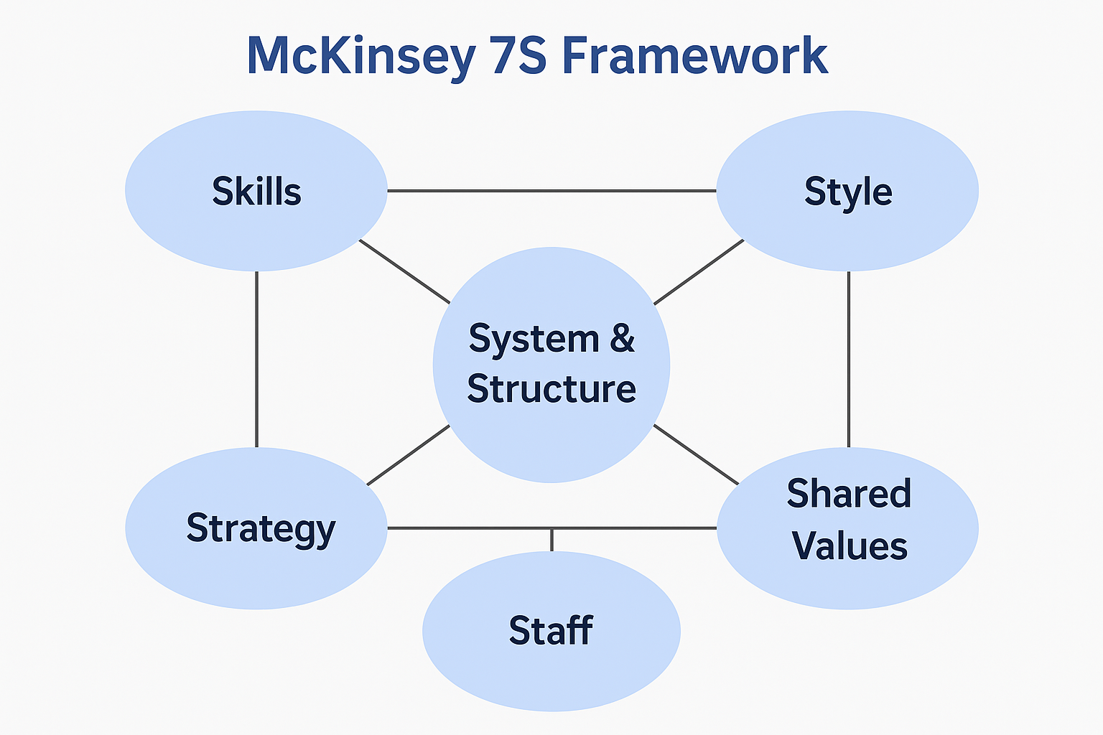
Estimated Cost:
- Training and materials: £1,000 for supervisor coaching and documentation.

Success Indicators:
- Monthly performance score trends
- Audit pass rates
- Feedback from both supervisors and team members
  - Recommendation 4: Boost Staff Retention through Incentives and Flexible Scheduling
High staff turnover is a chronic issue in hospitality, particularly in housekeeping, where long hours and low flexibility often drive dissatisfaction. In Radisson Blu’s context, high seasonal demand during events such as the Edinburgh Festival can exacerbate stress and burnout. Retaining experienced staff should be a strategic priority.
Introducing seasonal performance bonuses — for example, £100 per month during peak periods — could serve as an immediate motivator. Longer-term incentives like allowing every third weekend off for staff who have been with the hotel for over 12 months could boost loyalty. Additionally, offering flexible, part-time shifts aimed at carers, students, or semi-retired individuals may broaden the hiring pool and reduce strain on full-time staff.
According to Baron and Armstrong’s (2007) Human Capital Management theory, employers should view staff not as costs to be minimised, but as assets to be nurtured. By focusing on employee well-being and work-life balance, Radisson Blu is more likely to retain a motivated and productive workforce.
Estimated Cost:
- Bonus fund: £5,000 annually
- Flexible rota design: negligible cost
Success Indicators:
- Staff retention rate
- Shift fulfilment rate
- Staff morale surveys

Figure 6 – Retention Strategy Breakdown
Source: Created by author using Canva (2025)
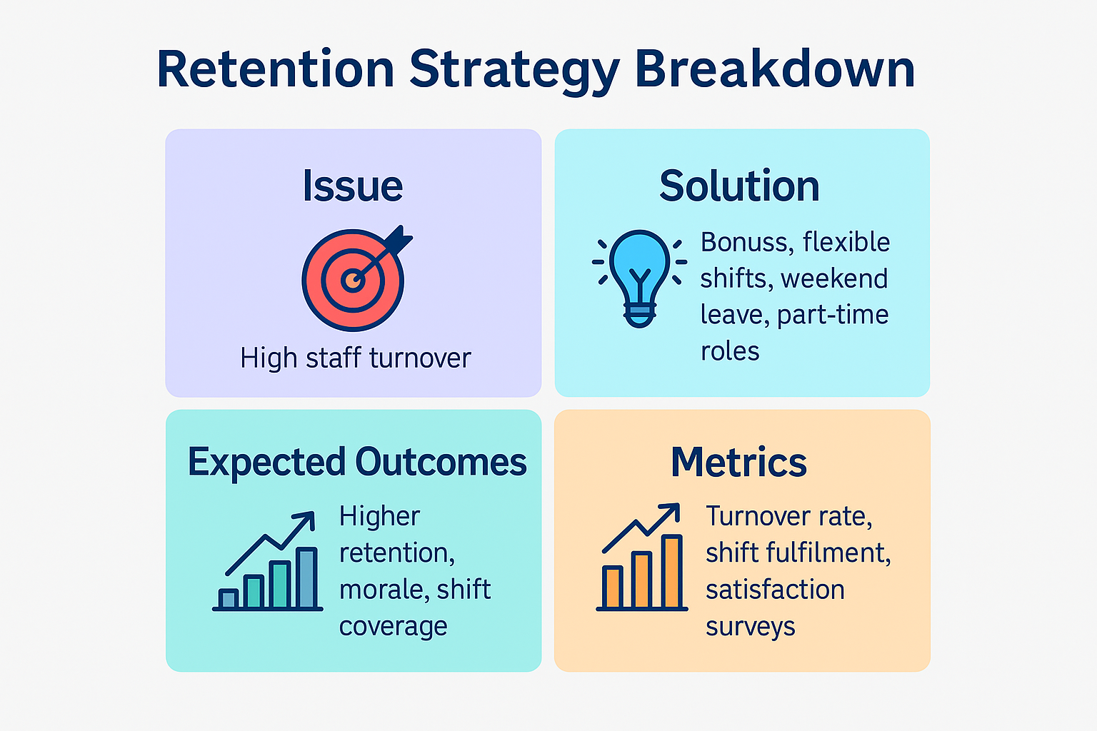
4.6 Recommendation 5: Improve Guest Communication on Eco-Cleaning Options
Guests often misinterpret sustainability policies as cost-cutting. A proactive communication strategy will clarify choices and reduce negative perceptions. In some cases, guests were unaware that they could request daily cleaning or misunderstood the hotel’s efforts to be more environmentally conscious.
To address this, the hotel should clearly communicate cleaning frequency and guest choices at check-in and in-room. Small interventions — like door tags, welcome notes, or a brief message during digital check-in — can go a long way. Offering small incentives such as a £5 bar credit for opting out of daily cleaning may further reinforce the message in a positive light.
Newton (2010) argues that for such changes to be accepted, they must be positioned as enhancements to the guest experience — not as cost-cutting measures. Moreover, studies show that when green initiatives are seen as community- or ethically-motivated rather than cost-cutting, guest satisfaction significantly improves (Zareh et al., 2024).
Staff training on how to communicate these changes empathetically will also be critical.
Estimated Cost:
- Signage and materials: £500
- Digital integration: internal resource (minimal external cost)
Success Indicators:
- Participation rate in eco-initiatives
- Guest understanding (via exit surveys)
- Reviews mentioning cleaning clarity
4.7 Summary of Benefits
The integrated recommendations presented in this report offer Radisson Blu Edinburgh City Centre a targeted, evidence-based roadmap to address the root issue of inconsistent housekeeping while improving long-term operational resilience. Each intervention aligns with sector-wide trends and best practices, providing both immediate performance gains and strategic value.
The digitalisation of housekeeping operations will improve service consistency and operational oversight. With real-time room tracking, task delegation, and audit trails, management can respond to issues proactively and ensure higher standards of cleanliness. This data-driven approach encourages a culture of accountability and efficiency, supporting ongoing quality improvements and allowing supervisors to act on performance trends more effectively. It also strengthens the hotel’s legal compliance, aligning with the Health and Safety Executive’s (HSE) guidance on safe and documented cleaning practices in the hospitality sector (Health and Safety Executive, 2017).
Structured training and KPI frameworks translate service expectations into measurable behaviours, creating consistency across shifts and staff levels. As Whittington et al. (2020, p. 96) explain, successful performance systems must link people, processes, and culture — all of which are addressed through these aligned interventions.
Retention-focused incentives — such as seasonal bonuses and flexible scheduling — are supported by industry research. According to CIPD data cited by ActionCOACH, hospitality turnover is extremely high, at 52% annually (Philip Chantry, 2024). Furthermore, UKHospitality reports that 42% of new hires leave within their first 90 days (QX Global Group, 2024). These findings confirm that targeted reward structures and improved work flexibility can significantly reduce early attrition and build service consistency.
Guests increasingly care about sustainability — but only when it’s clearly explained and easy to opt into. Research by Booking.com (2023) shows that nearly three-quarters of travellers prefer hotels with visible green policies. Simple steps, like offering bar credits for reduced cleaning, not only build trust but also reflect Radisson’s broader commitment to responsible business (Radisson Hotel Group, 2024).
In summary, the proposed strategy strengthens housekeeping performance, improves guest experience, supports staff well-being, and contributes to long-term profitability. When embedded effectively, it positions the hotel not just to recover from operational weaknesses — but to compete more effectively in a post-pandemic, labour-constrained market.
4.8 Implementation Timeline
To ensure the proposed recommendations are delivered without operational disruption, a structured 12-month implementation timeline is outlined below. The sequence supports a phased approach to change, allowing sufficient time for training, testing, and engagement. It aligns with Kotter’s (2012) step-based change process, particularly in securing short-term wins and embedding long-term behavioural shifts.
By Month 6, foundational changes will be operational, enabling review of early indicators such as complaint reduction and audit success rates. Full integration is expected by Month 12, with continued reinforcement through performance monitoring and staff feedback.
This timeline also supports early measurement of impact through short-term wins (Kotter, 2012) — such as increased audit pass rates and cleaner guest feedback — which will help reinforce staff engagement and encourage sustained behavioural change.
For a detailed breakdown of how these strategic phases translate into operational execution, please refer to Section 5: Action Plan.

Figure 7 – Implementation Timeline – Gantt Chart (Generic Format)
Source: Created by author using Canva (2025)

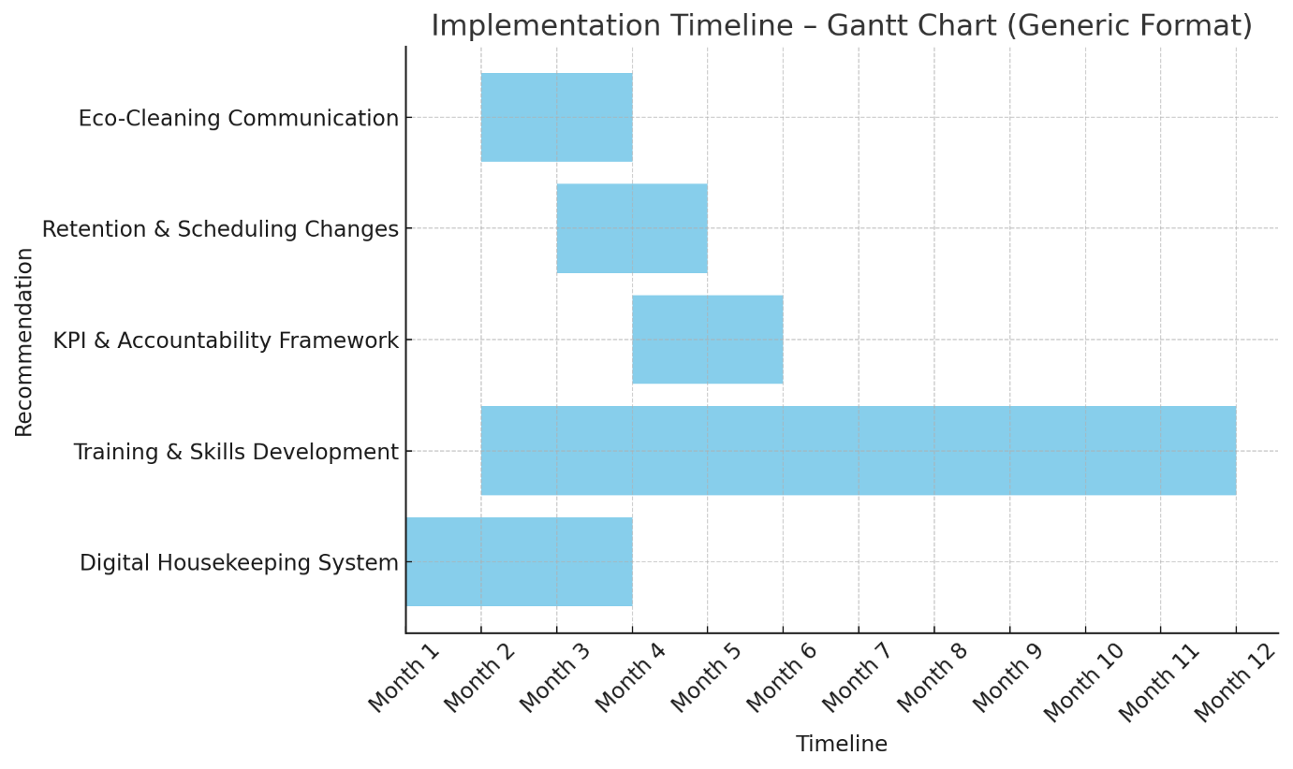

- Action Plan
While Section 4.8 outlines the timeline for phased implementation and cultural embedding, the table below offers a clear operational snapshot for client-side planning. It summarises each problem, proposed solution, expected outcome, implementation period, and associated cost — enabling actionable follow-through on the recommended strategy.

Figure 8 – Action plan
Source: Created by author using Canva (2025)
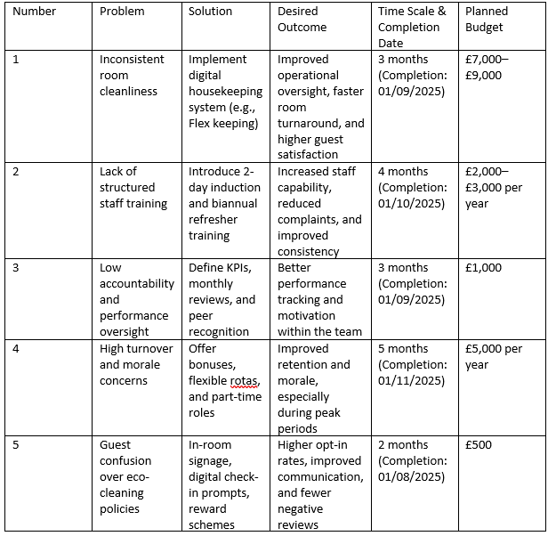

These focused actions translate strategic intent into practical delivery. By aligning solutions with specific timelines, outcomes, and budgets, this plan supports Radisson Blu in executing change with clarity, control, and minimal disruption to day-to-day operations.

- Conclusion
This consultancy report has examined the root causes behind inconsistent housekeeping performance at the Radisson Blu Hotel, Edinburgh City Centre — a critical issue affecting both guest satisfaction and operational efficiency. Using a blend of industry evidence and analytical frameworks, the report has identified that lapses in cleanliness and service reliability are not isolated failures, but symptoms of wider systemic gaps in training, performance oversight, and communication.
Diagnostic models such as the 5 Whys and STEEPLED analysis revealed that informal training processes, high staff turnover, and a lack of task monitoring tools are central to the problem. Meanwhile, external pressures — including labour shortages, rising guest expectations, and increasing demand for visible sustainability practices — have intensified the operational strain on housekeeping teams.
To respond to these findings, five integrated recommendations were proposed. These include: the introduction of a digital housekeeping platform; structured, multilingual staff training; the establishment of KPI-led accountability; a retention strategy featuring flexible shifts and performance bonuses; and clearer communication of eco-cleaning choices to guests. Each intervention was supported by industry data and best practice models to ensure both practicality and impact.
Hotels using digital housekeeping platforms such as Amadeus HotSOS have processed over 56 million room cleans and 42 million guest service orders in a 12‑month period—demonstrating how real‑time task visibility and audit trail features can significantly enhance room readiness and service quality. Transparent communication around sustainability choices not only builds credibility but also influences booking decisions—70% of global travellers say they’re more likely to choose a hotel with visible sustainable practices, such as eco-cleaning options (Booking.com, 2022). These insights align closely with Radisson’s broader environmental and governance ambitions.
Importantly, all recommendations were embedded in structured change management frameworks — including Kotter’s Eight Steps and the McKinsey 7S model — to ensure they are not only implemented effectively but sustained over time. The accompanying implementation timeline and action plan provide the hotel with a step-by-step blueprint for turning strategic intent into practical execution.
In closing, Innfocus Consulting would like to thank the management team at Radisson Blu Edinburgh for the opportunity to collaborate on this project. We trust that the insights and proposals offered in this report will support the hotel in restoring operational consistency and reinforcing its premium brand reputation. We look forward to the possibility of future collaboration as you continue to strengthen your competitive position in a demanding hospitality environment.

- References
- Acampora, A., Preziosi, M., Lucchetti, M.C. and Merli, R. (2022) ‘The role of hotel environmental communication and guests’ environmental concern in determining guests’ behavioral intentions’, Sustainability, 14(18), article 11638. Available at: https://www.mdpi.com/2071-1050/14/18/11638 (Accessed: 08 June 2025).
- ACAS (2023) Brexit and the workforce: impacts on staffing in the UK hospitality sector. Available at: https://www.acas.org.uk/brexit-and-the-workforce (Accessed: 29 May 2025).
- ACAS (2023) Improving staff retention. Available at: https://www.acas.org.uk/improving-staff-retention (Accessed: 02 Jun 2025).
- Acropolium (2025) Hotel housekeeping software drives operational excellence and guest satisfaction, 5 January. Available at: https://acropolium.com/blog/how-hotel-housekeeping-software-drives-operational-excellence-guest-satisfaction/ (Accessed: 05 June 2025).
- Amadeus IT Group and affiliates (n.d.) Meet the New HotSOS Housekeeping: service optimisation overview. Available at: https://connect.amadeus-hospitality.com/hubfs/Amadeus_Service_Optimization_HotSOS_Housekeeping.pd f (Accessed: 10 June 2025).
- Anwar, F.A., Deliana, D. and Suyamto, S. (2024) Digital Transformation in the Hospitality Industry: Improving Efficiency and Guest Experience. Available at: https://www.researchgate.net/publication/385653120_Digital_Transformation_in_the_Hospitality_Industry_Improving_Efficiency_and_Guest_Experience (Accessed: 08 June 2025).
- Baron, A. and Armstrong, M. (2007) Human Capital Management: Achieving Added Value Through People. London: Kogan Page.
- Baum, T. (2019) Hospitality, Tourism and the Workforce: A Global Perspective. Oxford: Goodfellow.
- Booking.com (2022) Sustainable Travel Report. Available at: https://www.gstcouncil.org/booking-com-2022-sustainable-travel-report/ (Accessed: 10 June 2025).
- Booking.com (2023) How Europe's accommodation sector is approaching sustainability. Available at: https://partner.booking.com/en-gb/click-magazine/trends-insights/how-europe’s-accommodation-sector-approaching-sustainability (Accessed: 05 Jun 2025).
- Burnes, B. (2014) Managing Change. 6th edn. Harlow: Pearson Education Limited.
- CBI (2023) Net zero: A roadmap for hospitality and leisure. Available at: https://www.cbi.org.uk/articles/net-zero-hospitality-roadmap/ (Accessed: 02 Jun 2025).
- Chantry, P. (2024) What’s a good staff turnover rate? ActionCOACH. Available at: https://actioncoach.co.uk/whats-a-good-staff-turnover-rate/ (Accessed: 04 Jun 2025).
- CIPD (2024) Resourcing and Talent Planning Survey. Available at: https://www.cipd.org/globalassets/media/knowledge/knowledge-hub/reports/2024-pdfs/8662-resource-and-talent-planning-2024-report-web.pdf (Accessed: 03 Jun 2025).
- Currys (2025) Samsung Galaxy A25 5G Smartphone SIM Free – Black. Available at: https://www.currys.co.uk/products/samsung-galaxy-a25-5g-smartphone-sim-free-128-gb-black-40874763.html (Accessed: 03 Jun 2025).
- Deloitte (2023) Hospitality industry outlook UK. Available at: https://www2.deloitte.com/uk/en/pages/consumer-industrial-products/articles/uk-hospitality-outlook.html (Accessed: 03 Jun 2025).
- DEFRA (2023) Environmental guidance for hospitality and food service. Available at: https://www.gov.uk/government/collections/hospitality-environment (Accessed: 03 Jun 2025).
- Flexkeeping (2023) Housekeeping management software. Available at: https://www.flexkeeping.com (Accessed: 04 Jun 2025).
- Fourth Ltd (2023) The Hospitality Workforce Report: H2 2023. UK: Fourth Ltd. Available at: https://uk.fourth.com/white-paper/the-hospitality-workforce-update (Accessed: 10 June 2025).
- Galbraith, J. (2014) Designing Organizations: Strategy, Structure, and Process at the Business Unit and Enterprise Levels. 3rd edn. San Francisco: Jossey-Bass.
- Green Tourism (2024) Certification and best practices. Available at: https://www.green-tourism.com (Accessed: 03 Jun 2025).
- Health and Safety Executive (2017) CAIS22 – Safe use of cleaning substances in the hospitality industry. Bootle: HSE. Available at: https://www.hse.gov.uk/pubns/cais22.pdf (Accessed: 04 Jun 2025).
- HotelBee (2025) HotelBee Review 2025: Pricing, Features, Pros & Cons, Ratings. Available at: https://research.com/software/reviews/hotelbee (Accessed: 12 June 2025).
- HotelTechReport (2023) Best housekeeping software 2023. Available at: https://www.hoteltechreport.com/operations/housekeeping-software (Accessed: 04 Jun 2025).
- Hotel Tech Report (2024) Strawberry chooses Flexkeeping to completely automate its operations, 6 November. Available at: https://hoteltechreport.com/news/strawberry-chooses-flexkeeping (Accessed: 11 June 2025).
- Kaplan, R. and Norton, D.P. (1996) The Balanced Scorecard: Translating Strategy into Action. Boston: Harvard Business School Press.
- Kipping, M. and Clark, T. (2012) The Oxford Handbook of Management Consulting. Oxford: Oxford University Press.
- Kotter, J. (2012). Leading Change. Boston, MA: Harvard Business Review Press.
- Lewin, K. (1951) Field Theory in Social Science. New York: Harper & Row.
- Mavridopoulou, E. and O’Mahoney, J. (2020) Elitism in strategy consulting: how institutional prestige influences recruitment. Management Consulting Journal, 3(1), pp.12–22.
- Mews (2024) 10 housekeeping technologies – The future of tech in hotel. Available at: https://www.mews.com/en/blog/future-hotel-housekeeping (Accessed: 07 June 2025).
- MindTools (2024) How to use the 5 Whys for root-cause analysis. Available at: https://www.mindtools.com/ah6mdtg/5-whys-infographic (Accessed: 06 June 2025)
- Mintel (2024) Hotel accommodation in the UK: industry overview. Available at: https://www.mintel.com/uk (Accessed: 05 Jun 2025).
- MoldStud (2024) Enhancing operational efficiency with digital task management tools in hospitality, available at: https://moldstud.com/articles/p-enhancing-operational-efficiency-with-digital-task-management-tools-in-hospitality (Accessed: 04 June 2025).
- Newton, R. (2010) The Management Consultant: Mastering the Art of Consultancy. Harlow: FT Prentice Hall.
- NYU Stern Center for Sustainable Business (2021) Review of ESG impact studies: corporate sustainability and business returns. NYU Stern Center for Sustainable Business Report. Available at: https://www.stern.nyu.edu/sites/default/files/assets/documents/NYU-RAM_ESG-Paper_2021.pdf (Accessed: 12 June 2025).
- NYU Stern Center for Sustainable Business (no date) A Best Practice Guide for Effective Sustainability Communications. [online] New York: NYU Stern Center for Sustainable Business. Available at: https://www.stern.nyu.edu/experience-stern/about/departments-centers-initiatives/centers-of-research/center-sustainable-business/research/research-initiatives/best-practice-guide-effective-sustainability-communications (Accessed: 12 June 2025).
- NYU Stern Center for Sustainable Business and Edelman (2023) New research by NYU Stern Center for Sustainable Business and Edelman identifies most effective sustainability messages, 21 June. Available at: https://www.edelman.com/news-awards/new-research-nyu-stern-center-sustainable-business-and-edelman-identifies-most-effective (Accessed: 10 June 2025).
- O’Mahoney, J. (2021) How small consultancies grow: challenging problem-based theorising. Management Consulting Journal, 4(1), pp.5–20.
- ONS (2023) Labour market overview – UK hospitality. Available at: https://www.ons.gov.uk/employmentandlabourmarket (Accessed: 04 Jun 2025).
- People 1st (2019) State of the nation: hospitality workforce. Available at: https://www.people1st.co.uk (Accessed: 04 Jun 2025).
- Porter, M.E. (2008) The five competitive forces that shape strategy. Harvard Business Review, 86(1), pp.78–93.
- PwC (2023) UK Hotels Forecast 2023–2024. Available at: https://www.pwc.co.uk/industries/hospitality-leisure/insights/uk-hotels-forecast-2023.html (Accessed: 04 Jun 2025).
- QX Global Group (2024) How do rising staffing costs impact the hospitality industry? Available at: https://www.qxglobalgroup.com/blog/how-do-rising-staffing-costs-impact-the-hospitality-industry/ (Accessed: 05 Jun 2025).
- Radisson Hotel Group (2024) About Us. Available at: https://www.radissonhotels.com/en-us/about-us (Accessed: 29 May 2025).
- Radisson Hotel Group (2024) Responsible Business Report 2023. Brussels: Radisson Hotel Group. Available at: https://media.radissonhotels.net/asset/responsible-business/miscellaneous/16256-115895-m30206765.pdf (Accessed: 05 Jun 2025).
- RoomChecking (2024) Housekeeping optimisation for hotels. Available at: https://www.roomchecking.com (Accessed: 05 Jun 2025).
- Statista (2024) Occupancy rate of hotels in the UK. Available at: https://www.statista.com/statistics/576955/occupancy-rate-of-hotels-in-the-uk/ (Accessed: 29 May 2025).
- STR Global (2023) Hotel performance data – UK. Available at: https://str.com/data-insights (Accessed: 04 Jun 2025).
- Subramaniam, N., Collier, P., Phang, M. and Burke, G. (2011) The effects of perceived business uncertainty, external consultants and risk management on organisational outcomes. Journal of Accounting & Organizational Change, 7(2), pp.132–157.
- TripAdvisor (2023) A far cry from luxury with a steep price tag – Radisson Blu Hotel, Edinburgh City Centre. 8 July. Available at: https://www.tripadvisor.com/ShowUserReviews-g186525-d189363-r901528347 (Accessed: 05 June 2025).
- Tripadvisor (2024) Radisson Blu Edinburgh Guest Reviews. Available at: https://www.tripadvisor.co.uk/Hotel_Review-g186525-d189266-Reviews-Radisson_Blu_Hotel_Edinburgh_City_Centre-Edinburgh_Scotland.html (Accessed: 03 Jun 2025).
- TripAdvisor (2024a) Excellent location but poor value for money – Radisson Blu Hotel, Edinburgh City Centre. 26 December. Available at: https://www.tripadvisor.com/ShowUserReviews-g186525-d189363-r986434238-Radisson_Blu_Hotel_Edinburgh_City_Centre-Edinburgh_Scotland.html (Accessed: 03 Jun 2025).
- TripAdvisor (2024b) The worst housekeeping hotel – Radisson Blu Hotel, Edinburgh City Centre. 7 July. Available at: https://www.tripadvisor.com/ShowUserReviews-g186525-d189363-r958433565-Radisson_Blu_Hotel_Edinburgh_City_Centre-Edinburgh_Scotland.html (Accessed: 03 Jun 2025).
- TrustYou (2023) UK guest review analysis for hotels. Available at: https://www.trustyou.com/resources (Accessed: 04 Jun 2025).
- TrustYou (2023) 2023 Hospitality Performance Report. Available at: https://resources.trustyou.com/2023-hospitality-performance-report (Accessed: 04 Jun 2025).
- UKHospitality (2022) Building the hospitality workforce of the future. Available at: https://www.ukhospitality.org.uk/page/WorkforceStrategy (Accessed: 04 Jun 2025).
- UKHospitality (2023) Hospitality Workforce Strategy. Available at: https://www.ukhospitality.org.uk/work/hospitality-workforce-strategy/ (Accessed: 11June 2025)
- UKHospitality (2024) Hospitality workforce insights report. Available at: https://www.ukhospitality.org.uk/page/Reports (Accessed: 02 Jun 2025).
- UNISON (2023) Fair hospitality campaign: hotel workers’ rights. Available at: https://www.unison.org.uk/our-campaigns/fair-hospitality (Accessed: 02 Jun 2025).
- VisitBritain (2024) Sustainability trends in UK tourism. Available at: https://www.visitbritain.org/sustainability (Accessed: 04 Jun 2025).
- VisitScotland (2023) Sustainable tourism research. Available at: https://www.visitscotland.org/research-insights (Accessed: 04 Jun 2025).
- Whittington, R., Regnér, P., Angwin, D., Johnson, G. and Scholes, K. (2020) Exploring Strategy: Text and Cases. 12th edn. Harlow: Pearson Education Limited.
- Zareh, N., Nassar, A., Barakat, M. and Ramzy, H. (2024) Impact of green practices on hotel guests’ satisfaction: The role of perceived motives, Pharos International Journal of Tourism and Hospitality. Available at: https://pijth.journals.ekb.eg/article_287371_2b325fc5ac9911fd0914531f684262ae.pdf (Accessed: 05 June 2025).

