Electrical and electronic principles

Lucy Henson
Student No: 2418593

L4 – Electrical and electronic principles
ACDA4022
Embedded Electronic systems Engineering Degree Apprenticeship

Contents
Abstract 3
Introduction 3
Simulation 5
Real circuit 6
Results 6
Discussion 10
Conclusion 10
References 11
Bibliography 11

Abstract
The report contains the results from both a simulated and built circuit of a band pass filter. A filter which is designed to only allow a narrow band of frequencies to not be attenuated. The range of frequencies depends on the bandwidth and the steepness of the peak depends on the Q factor. The circuit consisted of an inductor, resistor and capacitor of values 1mH,1K and 1uF. With the inductor and capacitor being in parallel with each other a resistor of value 1K. was added in series. The Frequency and both input and output voltages were measured using an oscilloscope with the input voltage being set at 1.99V for both versions. The signal generator was set to 100Hz at the start and went up to 100000Hz for both experiments. The results of both the simulation and real can be seen in the results section. Both demonstrate the band pass filter in use. Both versions performed as bandpass filters however the real circuit performed significantly worse compared to the simulation with a difference in the Q factor of 23.9 and a bandwidth difference of 1760Hz.The difference in bandwidths and Q factors between the circuits were due to the simulation using ideal components which weren’t subject to deviations in manufacturing and that in the real circuit the capacitor and inductor both produced heat losses in the circuit as they weren’t 100% efficient like they would be in the simulator.

Introduction
The circuit is this report is an RLC filter circuit which has been designed to only allow specific frequencies to pass through the circuit. The specific type of filter circuit is called a bandpass filter. The bandpass filter is a combination of a low pass and high pass filter meaning that it will filter both frequencies which are too low and high. The terminology to describe the frequency bands which are passed through is called the passband [1].The passband is defined by its centre frequency and bandwidth. The bandwidth is the range of frequencies around the centre frequency which are not significantly attenuated. The centre frequency is the midpoint of the passband where the filter provides the maximum gain. The gain is the ratio of the output signal amplitude to the input signal amplitude. The gain is high in the passband which allows the signal to pass through without being changed much [2].The frequency at which the power level of the signal decreases by 3dB from its maximum value is called the 3dB bandwidth. It’s important as it helps to pinpoint the upper and lower cutoff frequencies of a filter. Which allows you to work out the bandwidth as it is calculated by taking the difference between the upper cutoff frequency and lower cutoff frequency. The Q factor defines the strength of the damping in the system. The Q factor is inversely proportional to the resistance for a series RLC circuit but increases with the resistance in a parallel RLC circuit. If the Q factor is higher than 10 the filter is classes as a narrow passband filter. Narrow passband filter is tuned to select only specific frequencies which makes them more sensitive. In an ideal bandpass filter, it would have a completely flat passband all frequencies within the passband would be passed to the output without any amplification or attenuation and would completely attenuate all frequencies outside the passband. In an ideal circuit the combination of the impedance of both the capacitor, inductor and resistor forms a voltage divider. The inductor internal coil resistance is one of the main sources of resistive losses. At the resonant frequency the circuits impedance will be at a maximum. Above the resonance frequency the inductive reactance increases while the capacitive reactance decreases this is opposite to the behaviour of the circuit below resonance. [3] In the real world no filter is perfect due to losses in both the capacitor and inductor limiting the sharpness of the peak this also means not all frequencies outside the range are rejected just outside the range there is a region called the roll off which is attenuated but not rejected. [4] They are commonly used in wireless communication.

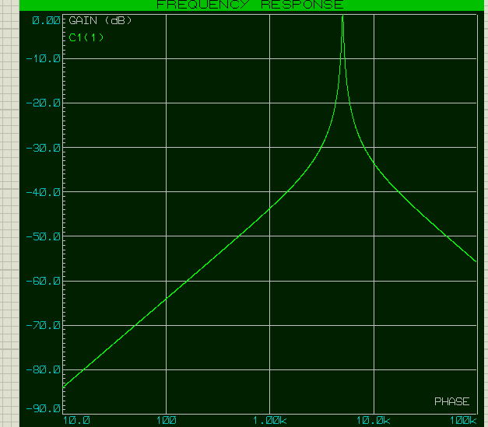
Figure 1 Frequency response curve of RLC circuit in proteus

In the rest of the report, I will test both a simulated and real circuit of the bandpass filter. the circuit will consist of a capacitor and inductor being in parallel with each other and the resistor being placed in series. The simulation section will explain how the circuit was simulated and what parameters were being used. The real circuit section will also show how the circuit was made, and the parameters being used. The results section will show the data collected from both the versions and the discussion section will explain any differences in the data and conclude on if the circuit design is optimal for a bandpass filter.

Simulation

Component | Value | Quantity
Resistor | 1K | 1
Capacitor | 1uF | 1
Inductor | 1mH | 1

The circuit was simulated in proteus the circuit diagram can be seen below in figure 1. The components used can be seen above in the table they were all simulated as ideal components. A virtual signal generator was used as a voltage source with the input pk-pk voltage of 1. 99V.The frequency of the voltage source was changed throughout the experiment using the virtual signal generator in proteus with the frequencies used ranging from 100 to 100000Hz.The input voltage of 1.99v was kept consistent throughout the different frequencies and the frequency at the start was set at 100Hz. A voltage probe was used to measure the voltage across the capacitor to see when it would be at its maximum. The oscilloscope was used to measure both the input and output pk-pk voltages.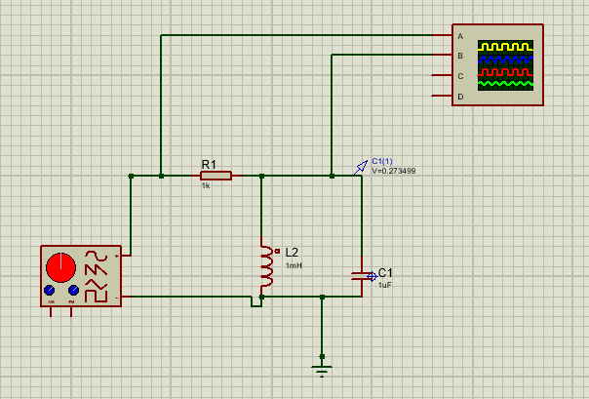
Figure 2 Proteus circuit diagram

The voltages and frequency were recorded in a spreadsheet in excel and can be seen in figure 3.The equation was used to work out the gain of the circuit Using the equation for attenuation $A=20×\log_{10}{\frac{V_{out}}{V_{In}}}$ a graph of attenuation against frequency was plotted this can be seen in figure 5.A graph of frequency against output voltage was plotted with both the upper and lower frequency boundaries added to it to work out the Q value and bandwidth which can ben seen in figure 6

Real circuit
Component | Value | Quantity
Resistor | 0.981K | 1
Capacitor | 0.985uF | 1
Inductor | 1.001mH | 1

The circuit was then replicated on a breadboard. The real components values are shown in the table above, the inductor had an internal resistance of 7. 15ohms.These values were all taken using a calibrated multimeter. An oscilloscope and signal generator were used to measure the output pk-pk voltage. The oscilloscope probes were placed across the capacitor. The input pk-pk voltage slightly fluctuating between 1.92 and 1.96 volts from the signal generator. The input voltage was kept as consistent as possible, and the start frequency was set to 100Hz. The oscilloscope was used to measure the input and output pk-pk voltages and the frequency, output voltage and input voltage were all recorded on a spreadsheet and the attenuation equation was also used to plot a graph of frequency against attenuation. This can be seen in figure 8.

Results
The graphs of both the simulation and real circuit can be seen below along with the data tables. Simulations upper and lower cutoff frequencies of 4885Hz for lower and 5075Hz for higher compared to the real circuit’s cutoff frequencies of 4450Hz and 6400Hz. The simulation circuit had a resonant frequency of 5033Hz this was calculated by using the equation $Fc=\frac{1}{2π\sqrt{LC}}$ . compared to the real circuit centre frequency of 5069Hz.The simulation had a Q factor of 26.5. The real circuit had a Q factor of 2.6. The Q factor was calculated using the equation $Q=\frac{fC}{fU-fL}$ .The simulation had a bandwidth of 190Hz this was calculated by taking the difference between the upper and lower frequencies boundaries. The real circuit had a bandwidth of 1950Hz.

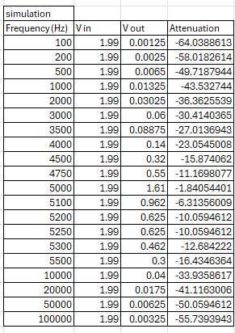
Figure 3 table of results from the simulation
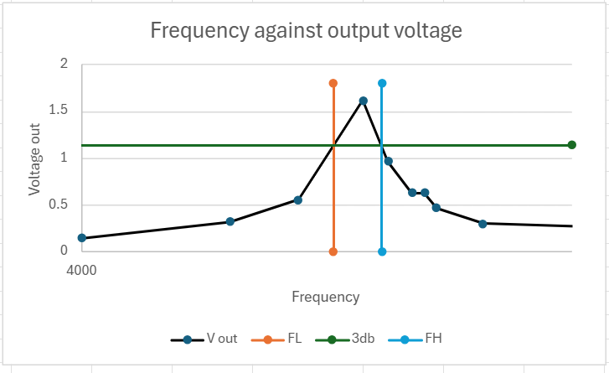
Figure 4 graph of frequency against output voltage results from the simulation
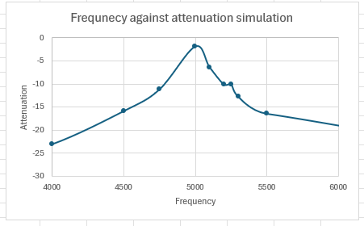
Figure 5 Graph of frequency against attenuation simulation
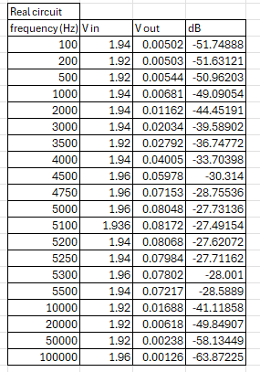
Figure 6 results table from real circuit
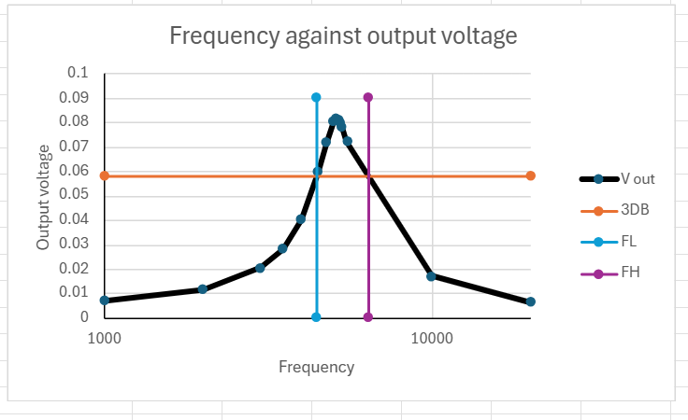
Figure 7 graph of frequency against output voltage real circuit results

Figure 8 Graph of attenuation against frequency real circuit

Discussion
Comparing the Q factors calculated for both the real and simulated circuit we can see that the simulation had a much larger Q factor which meant it had a much narrower passband, so the simulation attenuated a larger range of frequencies compared to the real circuit. This can be backed up by the larger difference in bandwidths between both circuits as the simulation circuits bandwidth of 190Hz is a much smaller compared to the real circuit’s bandwidth of 1950Hz.Both circuits still performed as bandpass filters with them having the characteristic peak and cutoff frequencies which are similar as both the circuits lower cutoff frequency are very similar with a difference of 435Hz the upper cutoff frequency does have a larger difference of 1325Hz. One of the reasons why the real circuit behaved much worse compared to the simulation would be due to the simulation using ideal components which weren’t subject to defects and changes in manufacturing as the components were at slightly different values to what was listed of them. Another reason would be due to losses in both the capacitor and inductor through heat as the resistance of the inductor was measure at 7.15ohms this loss would affect the sharpness of the peak. The simulation also didn’t take into consideration the voltage fluctuations of the signal generator as in the real generator the voltage fluctuated slightly although this would not have produced such a large difference in results. The real circuit would also have been subject to noise interference from the wires connecting both the components and the probes which the simulation wouldn’t have.

Conclusion
The report concludes that the circuit behaves as expected of a bandpass filter by attenuating all frequencies which aren’t in the passband range. the real circuit not performing as optimally due to a variety of reasons, but the mains ones would be due to deviations in the manufacturing processes and heat losses in both that capacitor and inductor. These issues would affect the sharpness and range of the filter causing it to not attenuate and amplify more signals.

References

Bibliography

[1] | “wikapedia bandpass filters,” [Online]. Available: https://en.wikipedia.org/wiki/Band-pass_filter. [Accessed 07 03 2025].
[2] | “analog circuit design,” 21 september 2024. [Online]. Available: https://analogcircuitdesign.com/bandpass-filters/. [Accessed 13 march 2025].
[3] | P. s. a. S. monk, Pratical electronics for inventors, Mcgraw Hill, 2016.
[4] | P. H. a. W. Hill, Art of Electronics 3rd edition, Cambridge university press, 2015.

