Component 2:
Academic Poster & Written Pitch
Changemakers: Creativity and Value Creation (BMHP5014)

Tutor Name: Danielle Dunne
Syed Mudassar Hussain (2407258)
2 April 2026

Contents
Reducing GP Appointment Inequality Through Ethical AI Integration in the NHS App 2
1 Academic Poster 3
2 Pitch 4
2.1 Introduction and Problem Statement 4
2.2 The Innovation 4
2.3 Impact and Relevance 5
2.4 Implementation Plan 5
2.5 Value, Feasibility and Recommendations 6
2.6 Conclusion 7
3 References 8

Reducing GP Appointment Inequality Through Ethical AI Integration in the NHS App

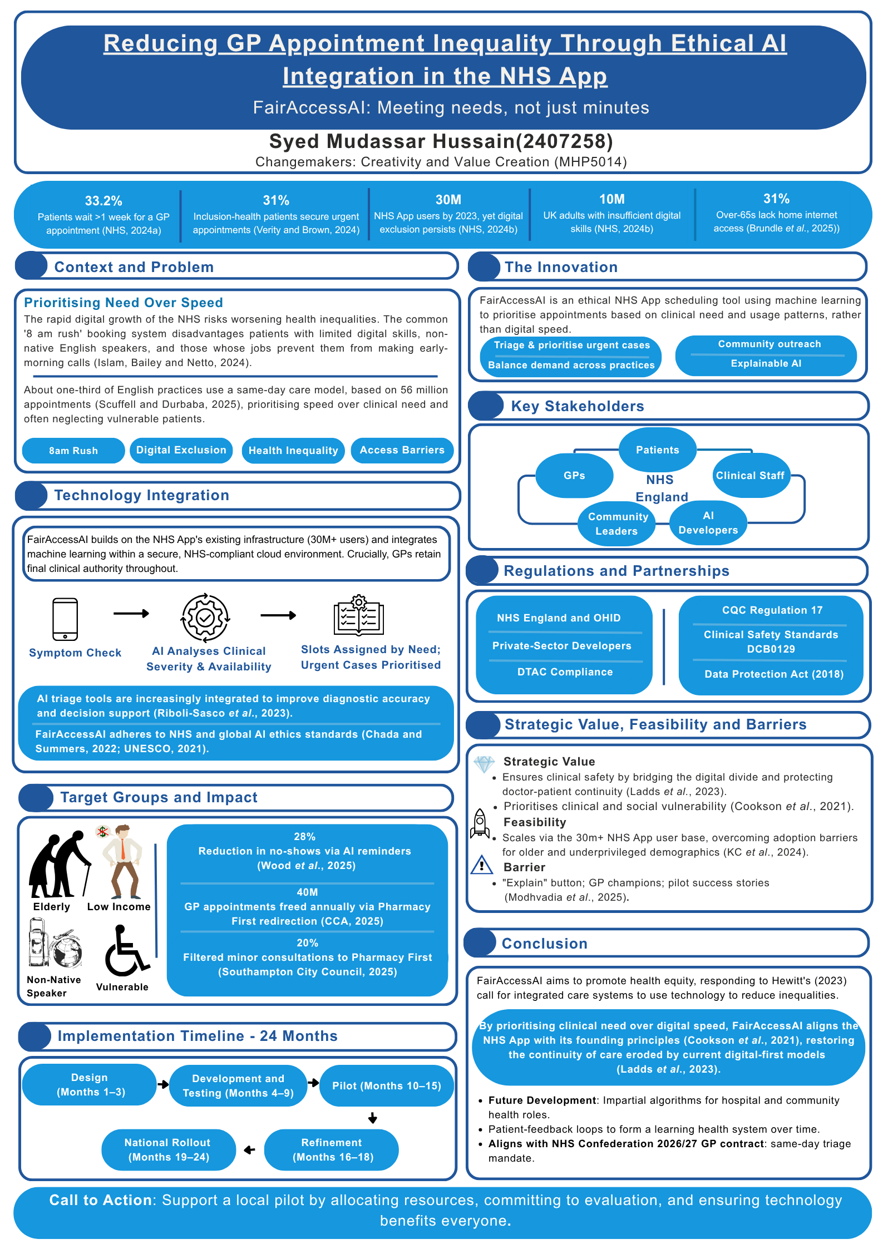
1 Academic Poster

2 Pitch

2.1 Introduction and Problem Statement
As an NHS GP speaking to NHS leaders and policymakers, I am concerned that the use of the NHS App and digital-first pathways may unintentionally widen inequalities in access to GP appointments. According to the GP Patient Survey 2024, one-third (33.2%) of patients in England now wait more than a week to be seen (NHS, 2024a). The '8 am Rush' booking system is common in English general practice. Scuffell and Durbaba (2025) analysed 56 million appointments across 3,480 practices and found that about one-third use a 'same-day care' model. This system poses challenges for patients with low digital literacy, non-native English speakers, and those with conflicting work schedules (Islam, Bailey and Netto, 2024). Vulnerable patients face significant challenges accessing healthcare: for instance, a study found that only 31% of inclusion-health patients (e.g. homeless or refugees) registered for an urgent appointment (Verity and Brown, 2024). The NHS's 'digital-first' approach increased the NHS App users from 2 million in 2021 to 30 million in 2023 (NHS, 2024b). However, 31% of over-65s lack home internet access (Brundle et al., 2025), and around 10 million adults have insufficient digital skills (NHS, 2024b). To address these inequalities, I propose FairAccessAI, an ethical Artificial Intelligence (AI) layer within the NHS App to promote equitable access.

2.2 The Innovation
I will integrate an ethical AI scheduler into the NHS App using machine learning models to analyse availability, identify vulnerable patients, and track digital usage patterns. The process is divided into AI-assisted triage and scheduling: patients complete a symptom check, allowing the AI to align slots, prevent the "8 am rush" overbooking, and prioritise urgent cases such as suspected abuse. This strategy draws on successful outcomes in various contexts: AI scheduling tools automate tasks, enhance efficiency, and reduce no-shows by about 28% through intelligent reminders (Wood et al., 2025). Secondly, digital inclusion safeguards recognise individuals who rarely use digital services, encouraging GPs to offer telephone booking and link patients to local digital hubs. I will enhance this approach with community outreach, including phone hotlines and leaflets in surgeries for those without internet access. Ethical design ensures transparency and fairness through explainable algorithms and diverse data sets to prevent bias. This aligns with NHS and international safety and equity guidelines (Chada and Summers, 2022; UNESCO, 2021).

2.3 Impact and Relevance
FairAccessAI addresses Hewitt’s (2023) challenge for integrated care systems to utilise data in reducing inequalities. By filtering 20% of minor condition consultations (Southampton City Council, 2025) toward the Pharmacy First initiative (NHS pharmacy-based GP alternative), the system could redirect 40 million annual appointments nationwide (CCA, 2025), significantly enhancing outcomes for high-risk individuals. Similar remote monitoring in UK care homes achieved a 25% reduction in emergency admissions and an 11% drop in A&E visits (Lancaster University, 2024). By triaging high-risk patients within 24 hours, FairAccessAI aligns with the 2026/27 GP contract mandate for same-day triage to reduce avoidable hospitalisations (NHS Confederation, 2026). Finally, at scale, the system provides granular data on high-demand communities, guiding equitable future resource distribution and systemic intelligence.

2.4 Implementation Plan

2.4.1 Timeline
Design (Months 1–3): Assemble a multidisciplinary team (GPs, data scientists, designers). Conduct stakeholder workshops to refine requirements, ensuring alignment with General Data Protection Regulation (GDPR) and NHS Digital standards like DCB0129.
Development and Testing (Months 4–9): Build an AI prototype integrated with the NHS App. Train models using encrypted historical data, prioritising NHS identity verification and accessibility.
Pilot (Months 10–15): Implement across 3–5 Integrated Care Boards to evaluate clinical safety and real-world user experience.
Refinement (Months 16–18): Mitigate algorithmic bias, optimise usability, and finalise privacy and fairness governance.
National Rollout (Months 19–24): Scale across England under NHS England oversight, maintain non-digital booking, and monitor outcomes per NHS AI Lab standards.

2.4.2 Key Stakeholders
FairAccessAI requires collaboration between clinical, technical, and community partners, including patients, GPs, developers, and leaders. Patients co-design to equitably address social factors, including economic disadvantage (Wills, Mistry, and Gowar, 2025). GPs use augmented decision-making models to ensure that clinical staff retain final authority and to prevent professional displacement (Moldt et al., 2025). Collaborations with researchers at the Alan Turing Institute conduct ethical audits, while community leaders work to bridge the digital divide (Modhvadia et al., 2025). This ensures the innovation is clinically safe, technically robust, and socially equitable (NHS Providers, 2025).

2.4.3 Regulations and Partnerships
To succeed, FairAccessAI must comply with and implement legal frameworks to address digital health inequalities. Adherence to the GDPR and the Data Protection Act 2018 ensures lawful use of data, while DCB0129 embeds clinical risk management (NHS Digital, 2025). Alignment with Regulation 17 and Digital Technology Assessment Criteria (DTAC) further reinforces accountability, transparency, and safe innovation (CQC, 2025; NHS, 2026). Collaboration among NHS England, the Office for Health Improvement and Disparities (OHID), and private-sector AI developers complies with DTAC.

2.5 Value, Feasibility and Recommendations
FairAccessAI emphasises "continuity of care" to address gaps in digital-first approaches. Limited remote access can exacerbate health inequalities, particularly for those who depend on stable doctor-patient relationships (Ladds et al., 2023). By leveraging AI to prioritise clinical severity over user speed, I align with the NHS principle that care should be based on need (Cookson et al., 2021). This innovation is viable as it utilises the NHS App's infrastructure, which serves over 30 million users, although older populations and underprivileged areas show low usage (KC et al., 2024). AI technology is feasible, with many digital health applications using algorithms for symptom analysis and triage advice, enhancing diagnostic accuracy and decision support (Riboli-Sasco et al., 2023). The key barrier to this innovation is "Digital Mistrust." FairAccessAI will include an "Explain" button to clarify patient priorities. Training staff and engaging GP champions, along with sharing pilot success stories, will foster buy-in and prevent further exclusion.
This approach could extend beyond GP bookings to hospital clinic slots and community health services, utilising patient feedback to create a learning health system.

2.6 Conclusion
In conclusion, this proposal positions FairAccessAI as a catalyst for health equity. By implementing it carefully within the NHS App, the current digital divide can be transformed into a digital bridge, ensuring that technology benefits all individuals. Decision makers are encouraged to initiate this project by supporting a small-scale pilot in their local area, allocating appropriate resources for development, and committing to evaluating the outcomes. Collectively, this approach shows that combining advanced technology with a commitment to inclusivity can enhance GP services, making care more equitable and efficient for everyone.

3 References

Brundle, C., Johansson, J.F., Best, K., Clegg, A., Forster, A., Atkinson, T., Foster, M., Humphrey, S., Iliff, A., Inglis, J., Walker, C. and Graham, L. (2025) 'Development of methods to identify digitally excluded older people, and tailoring of interventions to meet their digital needs: a protocol for a mixed-methods study (the INCLUDE study)', BMJ Open, 15(9), p.e102723. Available at: https://doi.org/10.1136/bmjopen-2025-102723.
Care Quality Commission (CQC) (2025) Regulation 17: Good Governance. Available at: https://www.cqc.org.uk/guidance-providers/regulations-enforcement/regulation-17-good-governance (Accessed: 20 March 2026).
Chada, B.V. and Summers, L. (2022) 'AI in the NHS: a framework for adoption', Future Healthcare Journal, 9(3), pp.313-316. Available at: https://doi.org/10.7861/fhj.2022-0068.
Company Chemists' Association (CCA) (2025) Pharmacy First expansion could free up 40m GP appointments a year, CCA report finds. Available at: https://thecca.org.uk/pharmacy-first-expansion-could-free-up-40m-gp-appointments-a-year-cca-report-finds (Accessed: 03 March 2026).
Cookson, R., Doran, T., Asaria, M., Gupta, I. and Mujica, F.P. (2021) 'The inverse care law re-examined: a global perspective', The Lancet, 397(10276), pp.828-838. Available at: https://doi.org/10.1016/S0140-6736(21)00243-9.
Data Protection Act 2018, c.12. Available at: https://www.legislation.gov.uk/ukpga/2018/12/contents/enacted (Accessed: 20 March 2026).
General Data Protection Regulation (EU) 2016/679. Available at: https://eur-lex.europa.eu/eli/reg/2016/679/oj (Accessed: 20 March 2026).
Hewitt, P. (2023) The Hewitt review: an independent review of integrated care systems. Available at: https://assets.publishing.service.gov.uk/media/642b07d87de82b00123134fa/the-hewitt-review.pdf (Accessed: 13 March 2026).
Islam, F., Bailey, S. and Netto, G. (2024) 'Digitalised primary care in the UK: a qualitative study of the experiences of minoritised ethnic communities', British Journal of General Practice, 74(749), pp. e823–e831. Available at: https://doi.org/10.3399/BJGP.2024.0308.
KC, S., Papoutsi, C., Reidy, C., Gudgin, B., Powell, J., Majeed, A., Greaves, F. and Laverty, A.A. (2024) 'Differences in use of a patient portal across sociodemographic groups: observational study of the NHS app in England', Journal of medical Internet research, 26, p.e56320. Available at: https://doi.org/10.2196/56320.
Ladds, E., Khan, M., Moore, L., Kalin, A. and Greenhalgh, T. (2023) 'The impact of remote care approaches on continuity in primary care: a mixed-studies systematic review', British Journal of General Practice, 73(730), pp. e374-e383. Available at: https://doi.org/10.3399/BJGP.2022.0398.
Lancaster University (2024) Data-driven app results in 25% fewer emergency hospital admissions from care homes. Available at: https://www.lancaster.ac.uk/health-and-medicine/news/data-driven-app-results-in-25-fewer-emergency-hospital-admissions-from-care-homes (Accessed: 03 March 2026).
Modhvadia, R., Sippy, T., Reid, O.F. and Margetts, H. (2025) How do people feel about AI? Available at: https://www.turing.ac.uk/sites/default/files/2025-09/how-do-people-feel-about-ai-2025_the-alan-turing-institute_ada-lovelace-institute.pdf (Accessed: 10 March 2026).
Moldt, J.A., Festl-Wietek, T., Fuhl, W., Zabel, S., Claassen, M., Wagner, S., Nieselt, K. and Herrmann-Werner, A. (2025) 'Exploring the social dimensions of AI integration in healthcare: a qualitative study of stakeholder views on challenges and opportunities', BMJ Open,15(6), p.e096208. Available at: https://doi.org/10.1136/bmjopen-2024-096208.
NHS (2024a) GP Patient Survey 2024. Available at: https://www.england.nhs.uk/statistics/2024/07/11/gp-patient-survey-2024 (Accessed: 02 March 2026).
NHS (2024b) Inclusive digital healthcare: a framework for NHS action on digital inclusion. Available at: https://www.england.nhs.uk/long-read/inclusive-digital-healthcare-a-framework-for-nhs-action-on-digital-inclusion (Accessed: 02 March 2026).
NHS (2026) Digital Technology Assessment Criteria (DTAC). Available at: https://transform.england.nhs.uk/key-tools-and-info/digital-technology-assessment-criteria-dtac (Accessed: 20 March 2026).
NHS Confederation (2026) GP contract 2026/27: what you need to know. Available at: https://www.nhsconfed.org/publications/gp-contract-202627-what-you-need-know (Accessed: 03 March 2026).
NHS Digital (2025) DCB0129: Clinical Risk Management: its Application in the Manufacture of Health IT Systems. Available at: https://digital.nhs.uk/data-and-information/information-standards/governance/latest-activity/standards-and-collections/dcb0129-clinical-risk-management-its-application-in-the-manufacture-of-health-it-systems (Accessed: 20 March 2026).
NHS Providers (2025) Beyond data – why community engagement must be central to digital inclusion. Available at: https://nhsproviders.org/resources/beyond-data-why-community-engagement-must-be-central-to-digital-inclusion (Accessed: 09 March 2026).
Riboli-Sasco, E., El-Osta, A., Alaa, A., Webber, I., Karki, M., El Asmar, M.L., Purohit, K., Painter, A. and Hayhoe, B. (2023) 'Triage and diagnostic accuracy of online symptom checkers: systematic review', Journal of Medical Internet Research, 25, p.e43803. Available at: https://doi.org/10.2196/43803.
Scuffell, J. and Durbaba, S. (2025) 'Patterns in GP Appointment Systems: a cluster analysis of 3480 English practices', British Journal of General Practice, 75(757), e541-e548. Available at: https://doi.org/10.3399/BJGP.2024.0556.
Southampton City Council (2025) Pharmaceutical Needs Assessment (PNA). Available at: https://data.southampton.gov.uk/health/pharmaceutical-needs-assessment (Accessed: 03 March 2026).
UNESCO (2021) Recommendation on the Ethics of Artificial Intelligence. Available at: https://www.unesco.org/en/artificial-intelligence/recommendation-ethics (Accessed: 02 March 2026).
Verity, A. and Brown, V.T. (2024) 'GP access for inclusion health groups: perspectives and recommendations', BJGP Open, 8(3). Available at: https://doi.org/10.3399/BJGPO.2024.0021.
Wills, E., Mistry, P. and Gowar, C. (2025) Designing inclusive and trusted digital health services with people and communities. Available at: https://www.kingsfund.org.uk/insight-and-analysis/long-reads/inclusive-digital-services-people-communities (Accessed: 10 March 2026).
Wood, K.V., Frings, D., Flood, C. and Thomas, N. (2025) 'Artificial intelligence machine learning-driven outpatient appointment management: A qualitative study on acceptability', Digital Health, 11, p.20552076251321016. Available at: https://doi.org/10.1177/20552076251321016.

