

Certificate in Higher Education
Business Skills for the Workplace

Executive Summary

I plan to open a coffee shop in Birmingham called Kurdish Pistacia Coffee, specialising in traditional Kurdish coffee made from wild pistachios sourced from the Kurdish region. I want to introduce this unique drink to the UK and share Kurdish coffee culture with a wider audience. I believe the coffee shop could offer customers something different from the drinks already available in Birmingham.

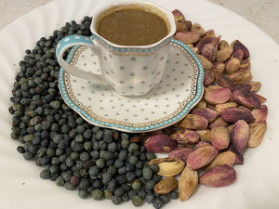

I believe the UK’s people already having a coffee culture will help to successful my business, as people are typically interested in trying new kinds of coffee and learning about other cultures. The biggest point of interest for me is being able to combine a unique drink with my Kurdish culture.

I also have a passion for creating an open space, whether it be through social media, or through other community activities, while also trying to minimize environmental impact and garbage through different methods.
In this business plan, I will talk more specifically about the target market and customers, competition. I will also explain how I plan to market and advertise Kurdish Pistacia Coffee, choose its legal structure, cover the start-up costs and finance the business.

Ultimately, my goal with this business is to present Kurdish coffee to different communities and in the process make a safe and pleasant environment for customers. I also want to leave a positive impact on the community by employing and creating opportunities for locals and engaging the community with various cultural events.

Table of Contents

Title Page 1
Executive Summary 2
Table of Contents 3
Overview of the Business Idea 4
Market Research (including PESTEL and competitors) 5-6
Marketing Communications 7
Competitor Comparison 8
Financials 8
Reference List 9

Business Overview
My business idea is to open a Kurdish coffee shop called Pistacia Coffee in Birmingham city centre. I want to introduce traditional Kurdish coffee, made from roasted and ground wild pistachio, to people in the UK. I believe coffee is an important part of daily life in Britain, and I want to share Kurdish coffee culture with a wider audience.
The historical French product label Chicorée au Kurde, shown on the SARA Distribution website, provides a historical connection between Kurdish identity and this type of drink. This inspires my idea of introducing traditional Kurdish coffee to a wider audience in Birmingham and sharing Kurdish cultural heritage.
I plan to offer traditional Kurdish coffee, Kurdish tea, homemade cakes, biscuits and natural fruit juice. I want to provide customers with a choice of drinks and food made with natural ingredients. I also hope to attract people who enjoy trying new flavours and discovering different cultures.
My target customers will include young people, office workers, tourists, people from different cultural backgrounds and those who enjoy trying new drinks. I prefer Birmingham city centre because it has offices, shopping areas and tourist attractions. I believe this location could help me reach a wide range of customers, although I will need to research local demand and competitors.
I plan to manage the business myself and employ around three staff members to help with daily operations, customer service, preparing drinks and keeping the shop clean. I prefer a limited company because I want to develop my brand, employ local people and potentially open more branches in the future. I understand that this legal structure involves additional paperwork and responsibilities.
I also want to support the local community by employing local people and promoting Kurdish culture. I plan to combine modern decoration with Kurdish cultural symbols on cups and plates to create a welcoming atmosphere. I would also like to promote Kurdish events, including Newroz, and explore ways to reduce waste.
PESTEL ANALYSIS
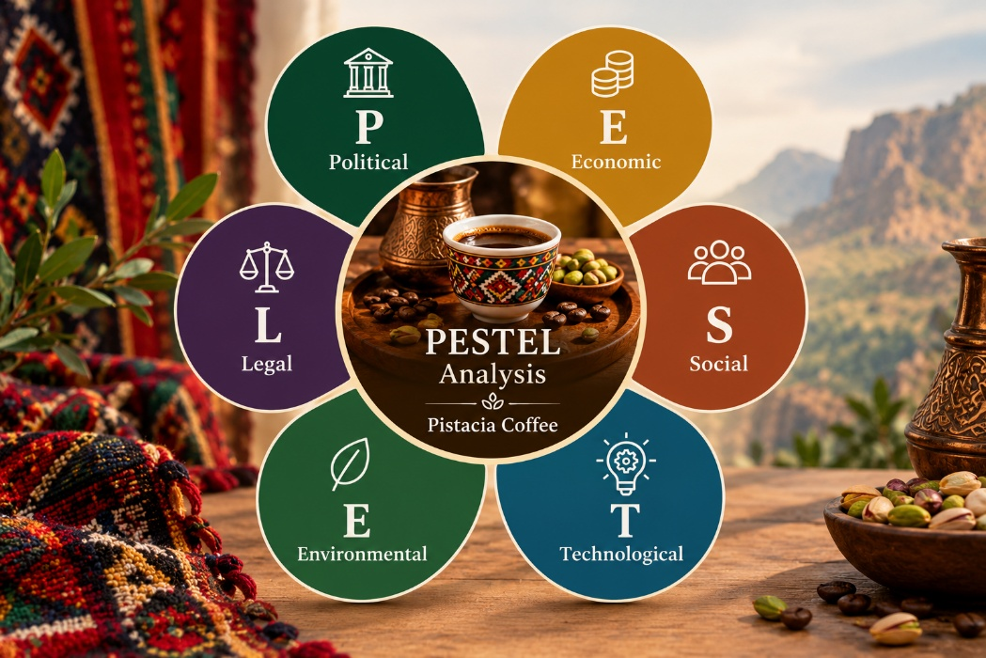
Pistacia Coffee | Birmingham
POLITICAL   Consider how political instability, international relations and trade restrictions could affect the supply of wild pistachios from the mountains of Kurdistan. Delays at borders or changes to import rules could interrupt supplies and increase transport costs. Explain why identifying reliable suppliers and checking UK import requirements before opening would help reduce these risks. | ECONOMIC   High commercial rent in Birmingham city centre, energy bills, wages, inflation and ingredient costs could put pressure on the business. Your proposed selling price of £4–£5 per drink needs to be compared with prices at competing cafés. If costs rise, profit margins may fall; however, increasing prices could discourage customers. Careful budgeting and supplier comparisons would therefore be important.
SOCIAL   Some customers may be interested in trying unfamiliar drinks and discovering Kurdish culture. Traditional Kurdish decorations and a welcoming atmosphere could distinguish Pistacia Coffee from other cafés. However, customers may find the taste unfamiliar and decide not to return. Tasting sessions and customer surveys could help assess demand, customer preferences and willingness to pay. Kurdish coffee's cultural history could help Pistacia Coffee stand out from other cafés. Some customers may enjoy trying unfamiliar drinks and learning about Kurdish culture. The historical label could provide an interesting story to share with customers. However, customer tasting sessions and surveys would help me understand whether people enjoy the drink and would buy it again. | TECHNOLOGICAL   TikTok and Instagram could introduce Kurdish coffee to new audiences through short videos and cultural content. Google Maps could help customers locate the shop, while online reviews could influence their decisions. LinkedIn may help reach nearby businesses and office workers. However, marketing effectiveness should be measured through customer visits and sales rather than social media engagement alone.
ENVIRONMENTAL   The business could reduce its environmental impact by encouraging reusable cups, selecting recyclable packaging and reducing food waste. It could also investigate responsible wild-pistachio sourcing and purchase suitable ingredients locally where possible. These actions may appeal to environmentally conscious customers, although their costs and practical availability should be considered. | LEGAL   Pistacia Coffee would need to follow food-safety, hygiene and allergen requirements, employment law and company obligations. Food-business registration is normally required at least 28 days before trading in England. Import requirements must also be checked for the ingredient's actual country of origin and product type. Non-compliance could cause financial losses and damage the business's reputation.  Important: Add reliable evidence and Harvard references to support your claims. For each factor, explain not only what might happen, but also how it could affect Pistacia Coffee and what action you could take.

Marketing Communications
Target customers and brand identity

I intend to attract office workers, shoppers, tourists and young people in Birmingham city centre. I want to differentiate Pistacia Coffee from established chains, such as Starbucks and Costa Coffee, by promoting traditional Kurdish coffee, Kurdish cultural decoration and a welcoming atmosphere.
Digital marketing
I plan to use TikTok and Instagram to promote my products, share videos of Kurdish coffee preparation and introduce customers to Kurdish culture. I also intend to create a Google Business Profile so that customers can find my location, check opening times and read reviews. I will monitor customer engagement and sales to evaluate the effectiveness of these methods.


.
Promotions and customer loyalty
I would consider offering introductory promotions, coffee-tasting sessions and a loyalty scheme to encourage customers to try my products and return. Although established competitors benefit from strong brand recognition, multiple locations and substantial advertising resources, I aim to build customer loyalty by offering a distinctive cultural experience and high-quality products.

COMPETITOR COMPARISON
Comparison factor | Large chains  (e.g. Starbucks / Costa) | Independent cafés | Pistacia Coffee  (proposed concept) | Evidence to collect
Brand recognition | Established, widely recognized brands | Recognition differs between cafés. | Build awareness for a new brand. | Brand websites; customer survey
Branches and convenience | Many locations may make them easy to access. | Often locally based. | Initially one Birmingham city-centre shop. | Official store locators; map search
Advertising | May use national campaigns and larger marketing resources. | Often use local promotion; varies by business. | Focus on local social media and targeted promotion. | Campaign examples; social media pages
Customer loyalty | May have established loyalty schemes and repeat customers. | May build loyalty through personal service and community. | Test a loyalty card and coffee-tasting events. | Official loyalty pages; customer reviews
Products and identity | Familiar coffee, tea and snacks; check each menu | Menus and atmosphere vary. | Kurdish coffee and tea, cultural details and a distinctive story. | Current menus; product descriptions
Price | Record prices for comparable drinks. | Record prices for comparable drinks. | Proposed drinks: £4–£5; compare like-for-like | Current menus or in-store prices
Customer experience | Customers may value familiarity, speed and consistency. | Some compete through atmosphere and personal service. | Aim for a welcoming modern UK café with subtle Kurdish identity. | Recent reviews; visit observations
Main challenge / opportunity | Strong recognition and convenience can make competition difficult. | Local reputation may attract regular customers. | Explain the unique offer and test demand for Kurdish coffee. | Customer survey; tasting feedback

Reference: one book, journal paper, one website
Use intext ref: How is your reference used?
Tell me your understanding (like by diagraph shapes)

LEagl format LMT Company? (Compared with another)
Marketing strategy. (I want to use TikTok,)
Examples

Page: References.

PASTEL Anlysis

Can mention these topics:
Marketing, Financial,

And diagram:
Cash follow.

Advise:

