Module Code: LCHS4003
Module Title: Introduction in Health and Social Care
Lecturer: Wafa Nasir
Assignment Title: Portfolio – Two Tasks
Student Name: Fatoumata Diabate soropogui
Student ID: 2505200
Table of Contents
Task 1: Poster 1
Task 2: Essay 6
Introduction 6
Main Body 6
Conclusion 7
Reference List 8

Task 1: Poster
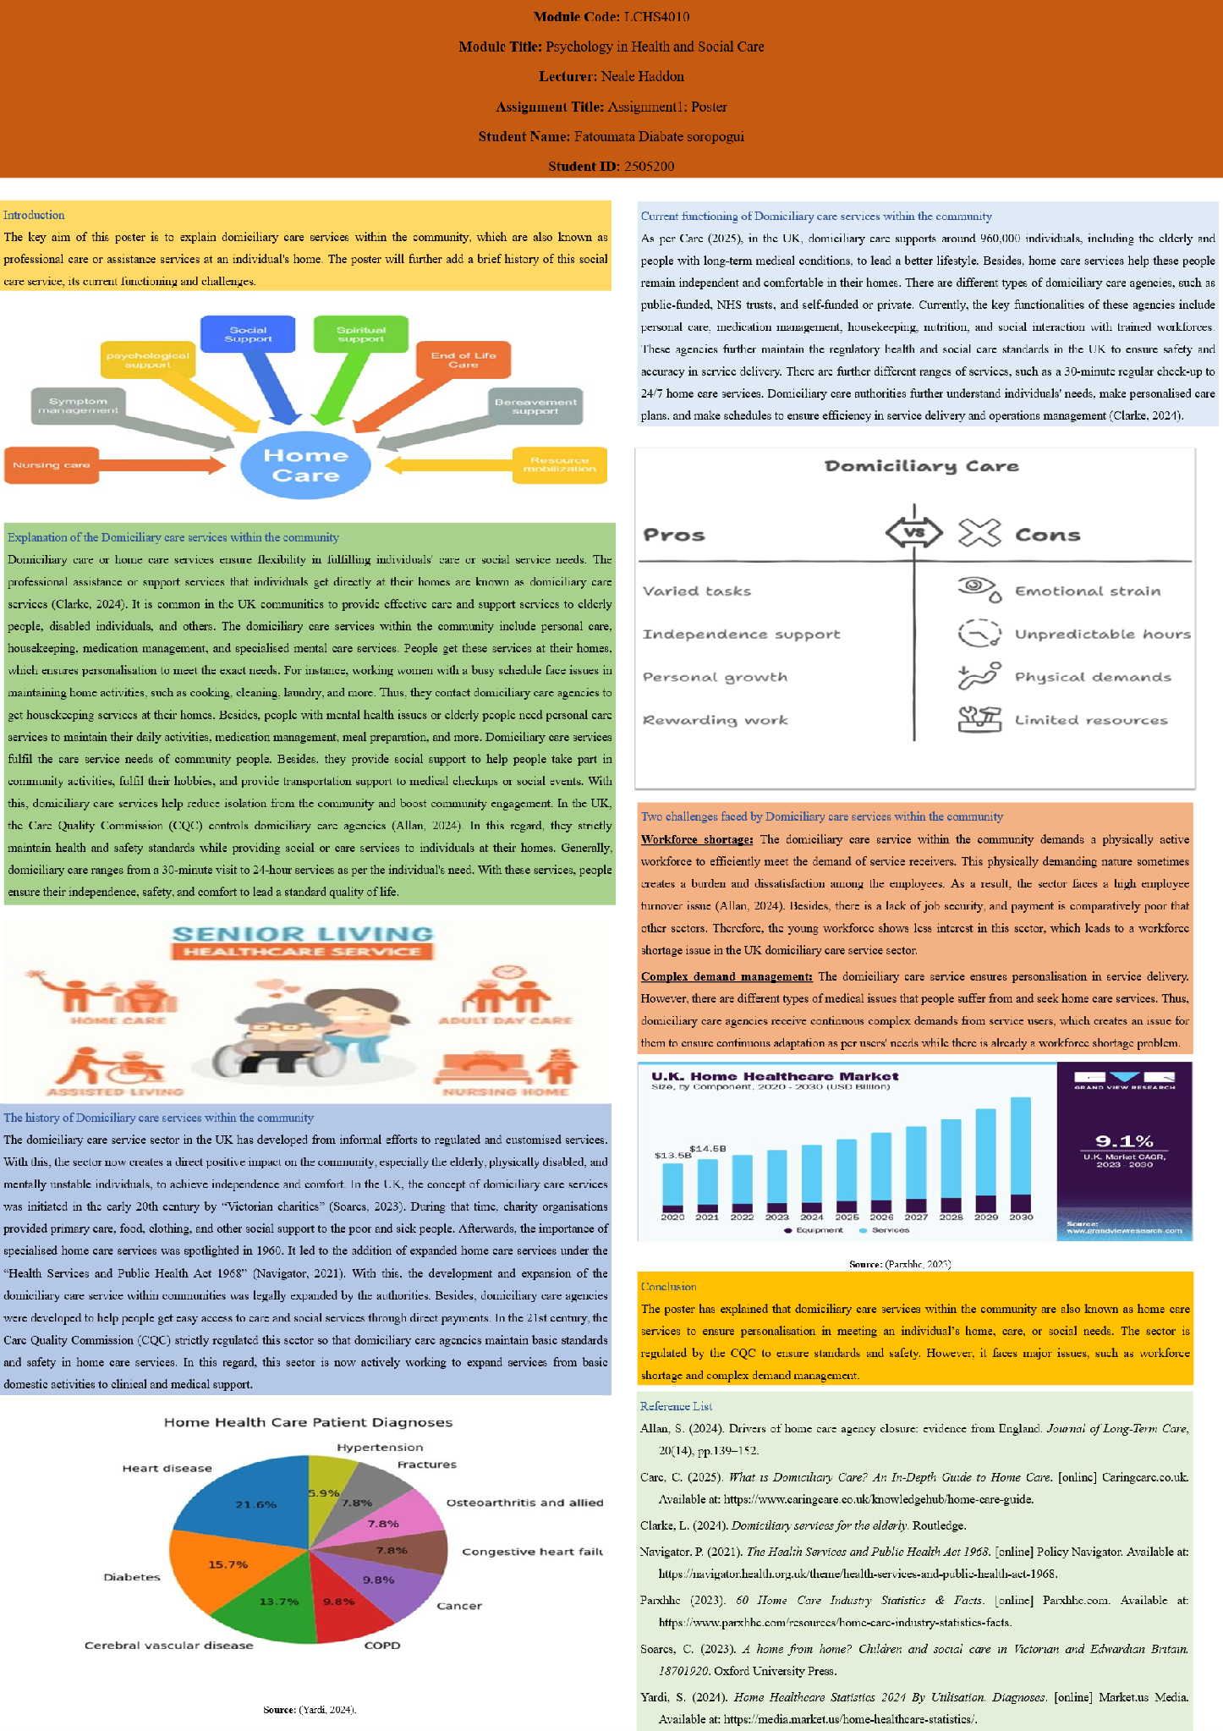
Introduction
The key aim of this poster is to explain domiciliary care services within the community, which are also known as professional care or assistance services at an individual's home. The poster will further add a brief history of this social care service, its current functioning and challenges.
Explanation of the Domiciliary care services within the community
Domiciliary care or home care services ensure flexibility in fulfilling individuals' care or social service needs. The professional assistance or support services that individuals get directly at their homes are known as domiciliary care services (Clarke, 2024). It is common in the UK communities to provide effective care and support services to elderly people, disabled individuals, and others. The domiciliary care services within the community include personal care, housekeeping, medication management, and specialised mental care services. People get these services at their homes, which ensures personalisation to meet the exact needs. For instance, working women with a busy schedule face issues in maintaining home activities, such as cooking, cleaning, laundry, and more. Thus, they contact domiciliary care agencies to get housekeeping services at their homes. Besides, people with mental health issues or elderly people need personal care services to maintain their daily activities, medication management, meal preparation, and more. Domiciliary care services fulfil the care service needs of community people. Besides, they provide social support to help people take part in community activities, fulfil their hobbies, and provide transportation support to medical checkups or social events. With this, domiciliary care services help reduce isolation from the community and boost community engagement. In the UK, the Care Quality Commission (CQC) controls domiciliary care agencies (Allan, 2024). In this regard, they strictly maintain health and safety standards while providing social or care services to individuals at their homes. Generally, domiciliary care ranges from a 30-minute visit to 24-hour services as per the individual's need. With these services, people ensure their independence, safety, and comfort to lead a standard quality of life.
The history of Domiciliary care services within the community
The domiciliary care service sector in the UK has developed from informal efforts to regulated and customised services. With this, the sector now creates a direct positive impact on the community, especially the elderly, physically disabled, and mentally unstable individuals, to achieve independence and comfort. In the UK, the concept of domiciliary care services was initiated in the early 20th century by “Victorian charities” (Soares, 2023). During that time, charity organisations provided primary care, food, clothing, and other social support to the poor and sick people. Afterwards, the importance of specialised home care services was spotlighted in 1960. It led to the addition of expanded home care services under the “Health Services and Public Health Act 1968” (Navigator, 2021). With this, the development and expansion of the domiciliary care service within communities was legally expanded by the authorities. Besides, domiciliary care agencies were developed to help people get easy access to care and social services through direct payments. In the 21st century, the Care Quality Commission (CQC) strictly regulated this sector so that domiciliary care agencies maintain basic standards and safety in home care services. In this regard, this sector is now actively working to expand services from basic domestic activities to clinical and medical support.
Current functioning of Domiciliary care services within the community
As per Care (2025), in the UK, domiciliary care supports around 960,000 individuals, including the elderly and people with long-term medical conditions, to lead a better lifestyle. Besides, home care services help these people remain independent and comfortable in their homes. There are different types of domiciliary care agencies, such as public-funded, NHS trusts, and self-funded or private. Currently, the key functionalities of these agencies include personal care, medication management, housekeeping, nutrition, and social interaction with trained workforces. These agencies further maintain the regulatory health and social care standards in the UK to ensure safety and accuracy in service delivery. There are further different ranges of services, such as a 30-minute regular check-up to 24/7 home care services. Domiciliary care authorities further understand individuals' needs, make personalised care plans, and make schedules to ensure efficiency in service delivery and operations management (Clarke, 2024).
Two challenges faced by Domiciliary care services within the community
Workforce shortage: The domiciliary care service within the community demands a physically active workforce to efficiently meet the demand of service receivers. This physically demanding nature sometimes creates a burden and dissatisfaction among the employees. As a result, the sector faces a high employee turnover issue (Allan, 2024). Besides, there is a lack of job security, and payment is comparatively poor that other sectors. Therefore, the young workforce shows less interest in this sector, which leads to a workforce shortage issue in the UK domiciliary care service sector.
Complex demand management: The domiciliary care service ensures personalisation in service delivery. However, there are different types of medical issues that people suffer from and seek home care services. Thus, domiciliary care agencies receive continuous complex demands from service users, which creates an issue for them to ensure continuous adaptation as per users' needs while there is already a workforce shortage problem.
Conclusion
The poster has explained that domiciliary care services within the community are also known as home care services to ensure personalisation in meeting an individual’s home, care, or social needs. The sector is regulated by the CQC to ensure standards and safety. However, it faces major issues, such as workforce shortage and complex demand management.

Task 2: Essay
Introduction
Ambulance services are one of the key entry points between the broader health and social care system and the community. It offers immediate and pre-hospital care services while ensuring safe transportation. This essay aims to investigate the origin of ambulance services and their historical context of development. This essay will further critically evaluate the functions of ambulance services currently. At last, the essay will discuss the importance of this service to improve the quality of life of service users.
Main Body
Ambulance services originated in the field of battle during ancient times to quickly move injured soldiers in horse-drawn vehicles. There was no formal medical support during that time. Thus, soldiers often died on the battlefield due to injury and heavy blood loss. In the late 15th century, an emergency military hospital was established in Spain named “ambulancias” (Milowski et al., 2024). It was the first hospital that transported injured soldiers to hospitals through vehicles. However, there were major operational issues. Later, in the late 18th century, a civilian ambulance service was introduced by Dr Edward Dalton. With the development of the automobile sector, the first motor-vehicle-based ambulance service was introduced in the early 19th century. With rapid improvements and developments, ambulances transformed into refined flying clinics with pre-hospital services and fast transportation to the hospital. In 1937, the UK introduced an emergency telephone number (999) for emergency ambulance services (Murphy, Wankhade, and Lakoma, 2020).
In modern times, ambulance services operate in the public, private, and volunteer sectors. Generally, ambulance services operate with the triage, response, and outcome model (Goldman et al., 2020). The triage stage is when people call for emergency ambulance services; the authorities categorise these calls based on urgency. Afterwards, in the response stage, they send ambulance vehicles as per the category. In the outcome stage, the group of ambulance service providers hears the overall problem and provides the best solution by transporting patients to the hospital or nearby medical care hubs. The key functions of modern ambulance services include pre-hospital care, telemedicine consultancy, transportation, and emergency services. In pre-hospital care, ambulances provide advanced life support services, such as CPR, oxygen, blood control, and more (Thaijiam, 2022). Other than these, ambulance services play a vital role in responding to disasters by providing emergency field care, transportation, and more. As per Murphy, Wankhade and Lakoma (2020), in the UK, ambulance services handle over 10 million emergency calls every year. However, the rising number of emergency calls leads to overcrowding in hospital emergency departments. Besides, rural areas are less technologically advanced than urban areas. Thus, people in rural areas face inequalities in accessing ambulance services. On top of these, the stressful environment in ambulance services leads to employee burnout issues.
For the service users, the advanced life support technologies in ambulance services work like lifesavers. Besides, with emergency responses, ambulance services provide urgent aid, which helps to improve the rate of survival. In addition, it ensures the development of long-term physical recovery rates. Aside from these, ambulance services help the service users reduce anxiety and stress. In this modern era, ambulance services utilise high-tech GPS to track location accurately and improve the traffic management system (Thaijiam, 2022). Thus, ambulance services play a crucial role in improving the quality of life of service users.
Conclusion
The essay has talked about ambulance services, which originated in the field of battle during ancient times. With this, the services became broad and advanced with the development of automobiles and technologies. However, the stressful environment in ambulance services creates employee burnout issues. Yet, these services are significant for service users to reduce anxiety, stress and improve long-term recovery rates.

Reference List
Allan, S. (2024). Drivers of home care agency closure: evidence from England. Journal of Long-Term Care, 20(14), pp.139–152.
Care, C. (2025). What is Domiciliary Care? An In-Depth Guide to Home Care. [online] Caringcare.co.uk. Available at: https://www.caringcare.co.uk/knowledgehub/home-care-guide.
Clarke, L. (2024). Domiciliary services for the elderly. Routledge.
Goldman, S., Doetzer, G., Parekh, A., Carr, B. and Alley, D. (2020). Right care, right place, right time: the CMS innovation centre launches the emergency triage, treat, and transport model. Annals of Emergency Medicine, 75(5), pp.609–611.
Milowski, T., Marek, M.K., Celinski, D., Perlowski, T. and Jastrzebski, P. (2024). Emergency medical service through the centuries—the Polish perspective. Medical Research Journal, 9(1), pp.113–119.
Murphy, P., Wankhade, P. and Lakoma, K. (2020). The strategic and operational landscape of emergency services in the UK. International Journal of Emergency Services, 9(1), pp.69–88.
Navigator, P. (2021). The Health Services and Public Health Act 1968. [online] Policy Navigator. Available at: https://navigator.health.org.uk/theme/health-services-and-public-health-act-1968.
Parxhhc (2023). 60 Home Care Industry Statistics & Facts. [online] Parxhhc.com. Available at: https://www.parxhhc.com/resources/home-care-industry-statistics-facts.
Soares, C. (2023). A home from home? Children and social care in Victorian and Edwardian Britain, 18701920. Oxford University Press.
Thaijiam, C. (2022). A smart ambulance with information system and decision-making process for enhancing rescue efficiency. IEEE Internet of Things Journal, 10(8), pp.7293–7302.
Yardi, S. (2024). Home Healthcare Statistics 2024 By Utilisation, Diagnoses. [online] Market.us Media. Available at: https://media.market.us/home-healthcare-statistics/.

