CREATIVITY AND VALUE CREATION
by Emilian Kunz (2021041)

Course
Changemakers: Creativity and Value Creation
Professor’s Name
Dr Jamiu A. Dauda
Institution

Date
06/07/2021

Creativity and Value Creation
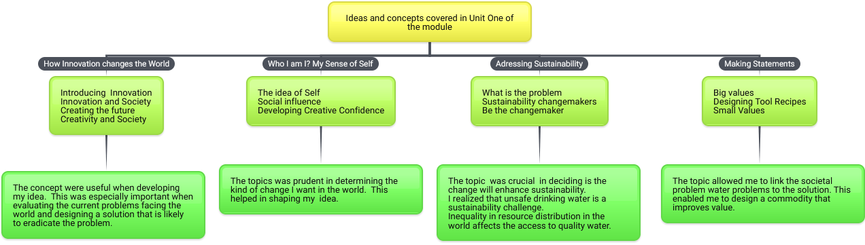

References
Bubbl.us. 2021. Mind Mapping Online - Bubbl.us - Brainstorming Made Simple!. [online] Available at: <https://bubbl.us/12346084> [Accessed 2 July 2021].

