

Component 1
Incidence of disease in communities

Student name: Noemi Canu
Student ID:2124164

Module name: Introduction to Public Health
Module code: LCHS4004
Lecturer name: Bianca Sanfilippo

Contents:
Introduction of Poliomyelitis 1
Strategies used in the UK to measure the incidence of the disease the Poliomyelitis and critically evaluate it 2
Strategies used in the UK to monitor the incidence of the Poliomyelitis and critically evaluate it 3
Strategies used in the UK to control the incidence of the Poliomyelitis and critically evaluate it 4
Conclusion 5
Reference List

- Introduction of the Poliomyelitis (100 words)
Polio, or poliomyelitis, is a disabling and life-threatening disease caused by poliovirus. (Center of Disease Control and Prevention, August 11,2022)
The consequence of contracting the Poliovirus are paralysis of the spine and of the eyes. Death occurs when paralysis reaches the lungs.(News,History of Polio, 25 September 2015)
Usually, the 75% of the patients does not present any symptoms and is not aware about the contagion.(News,History of Polio, 25 September 2015)
The Polio Virus has existed as long as human society, but become a major public heath issue in Late Victorian times with major epidemics in Europe and United States. There is evidence proving the existence of Poliomyelitis as early as the days of the distant Egyptian regime.(News,History of Polio, 25 September 2015)


Source: https://www.cdc.gov/polio/what-is-polio/index.htm

- Strategies used in the UK to measure the incidence of the Poliomyelitis and critically evaluate it (250 words)

Collecting and analysing data on Mortality and morbidity are the two strategies used to measure the incidence of the disease.Morbidity refers to an illness or disease. Mortality refers to death. Both terms are often used in statistics about health, such as the incidence or rate with which diseases and death occur.
In 1916 New York suffered the largest polio epidemic in history, with more than 9000 cases and 2343 deaths. Most of the patients were children and they were suffering of eyes paralysis.(News,History of Polio, 25 September 2015)
In 1928, it was created the “iron lung” to save the lives of those left paralysed by polio and unable to breathe. By 1939, 1000 iron lung were in use in US.
Now the iron lungs have disappeared, rendered superfluous by vaccination and modern mechanical ventilators.(News,History of Polio, 25 September 2015)
In 1952, the first effective vaccine against polio was created. It had an immediate effect. Despite of this, in the 1961, the UK accused 707 cases and 79 deaths.
In the year 1962, the Great Britain, started to use the Sabin’s vaccine. There have been no other domestically cases in the UK since 1982.(News,History of Polio, 25 September 2015)
By 1988, Polio has disappeared from the US,UK, Australia and much more of Europe, but it still prevalent in other 125 countries. Nowadays, Polio remains endemic in only two countries: Pakistan and Afghanistan.(News,History of Polio, 25 September 2015)

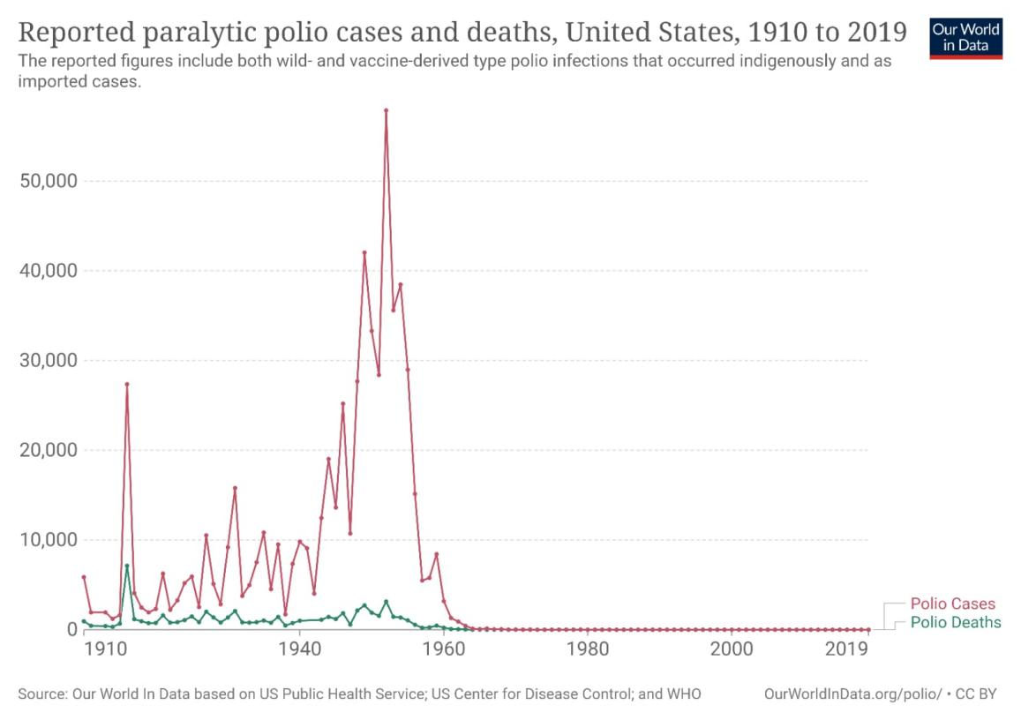

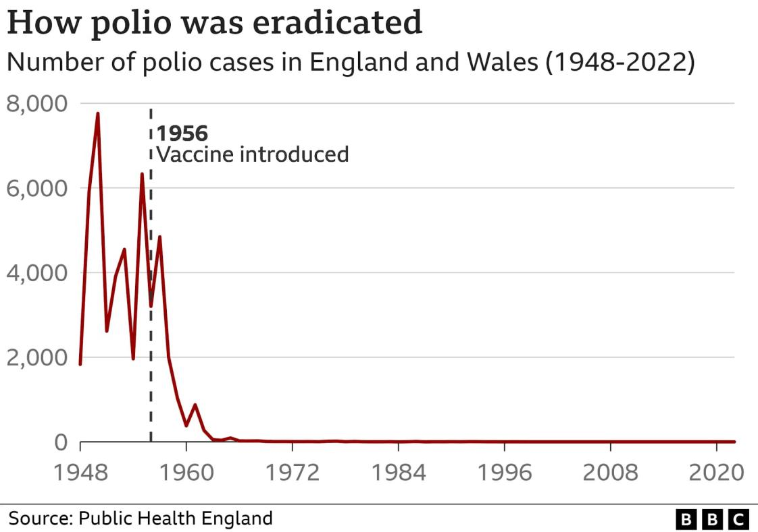
(Our World in Data)
Most people who get infected with poliovirus will not have any visible symptoms.
About 1 out of 4 people with polio infection will have symptoms as the flu:
- Sore throath
- Fever
- Tiredness
- Nausea
- Headache
- Stomach pain
These symptoms usually last 2 to 5 days, then go away on their own.
A smaller proportion of people with Poliovirus infection will develop other, more serious symptoms that affect the brain and spinal cord:
- Meningitis: infection of the covering of the spinal cord and/or brain
- Paralysis: cannot move parts of the body. Paralysis is the most severe symptom associated with Poliovirus because it can lead to permanent disability or death. Most of the patients died because the paralysis reached the lungs.(What is Polio, August 11, 2022)

- Strategies used in the UK to monitor the incidence of the Poliomyelitis and critically evaluate it (250 words)

Public health surveillance provides and interprets data to facilitate the prevention and control of disease. To achieve this purpose, surveillance for a disease or other health problem should have clear objectives. These objectives should include a clear description of how data that are collected, consolidated, and analyzed for surveillance will be used to prevent or control the disease.(Polio Global Eradication Initiative)
The four stages of the surveillance are:
- Timeliness, to implement effective control measures;
- Representation, to provide an accurate picture of the temporal trend of the disease;
- Sensitivity, to allow identification of individual persons with disease to facilitate treatment; quarantine, or other appropriate control measures; and
- Specificity, to exclude persons not having disease. (Centers of Disease Control and Prevention, May 18 2012)

One of the surveillance methods is environmental surveillance.
Since the transmission route of polio is oral-fecal, contaminated water sources and poor sewage systems is a major environmental factor in the risk of polio transmission.
Environmental surveillance by testing wastewater samples has been a valuable tool for tracking the distribution of viruses such as polio or for monitoring the prevalence of different SARS CoV-2 variant during COVID-19 pandemic.
Another method of surveillance is the AFP (acute flaccid paralysis) surveillance, that is the gold standard for detecting cases of poliomyelitis. The four steps of surveillance are:
- finding and reporting children with acute flaccid paralysis (AFP)
- transporting stool samples for analysis
- isolating and identifying poliovirus in the laboratory
- mapping the virus to determine the origin of the virus strain.(National Library of Medicine)

- Strategies used in the UK to control the incidence of the Poliomyelitis and critically evaluate it (300 words)

The immunisation is the action of making a person or animal resistant to a particular infectious disease or pathogen, typically by vaccination. There is no cure for polio, but it can be prevented with safe and effective vaccination.
In 1955, Salk2 developed the inactivated poliovirus vaccine; thus began widespread immunisation. This was followed in 1960 by a live, attenuated oral vaccine developed by Sabin.3 The effect was impressive. From 28 000 reported cases of polio in 1955, in 1956, one year after immunisation, there were only 15 000 cases.
Inactivated polio vaccine (IPV) is the only polio vaccine that has been given in the United States since 2000. It is given by shot in the arm or leg, depending on the person’s age. Oral polio vaccine (OPV) is used in other countries.(Journal of Neurology, Neurosurgery & Psychiatry, 2022)
CDC (Centers Disease Control and Prevention) recommends that children get four doses of polio vaccine. They should get one dose at each of the following ages:

2 months

4 months

6 through 18 months

4 through 6 years( Center of Disease Control and Prevention)
Accordingly the GPEI (Global Polio Eradication Initiative) this are the Four Pillars of Eradication:
- Routine immunization: high infant immunization coverage with four doses of oral polio vaccine (OPV) in the first year of life in developing and endemic countries, and routine immunization with OPV and/or IPV elsewhere.
- Supplementary immunization: Organization of “National immunization days” to provide supplementary doses of oral polio vaccine to all children less than five years of age.
- Surveillance: Active surveillance for wild poliovirus through reporting and laboratory testing of all cases of acute flaccid paralysis among children less than fifteen years of age.
- Targeted “mop-up” campaigns: Targeted “mop-up” campaigns once wild poliovirus transmission is limited to a specific focal area.(Center of Disease Control and Prevention)

Health Campaign represent another important strategy to control the disease.
The campaign are used to raise awareness of important health issues and stimulate groups or individuals to seek information and services. Through any increase in knowledge, people can over time change attitudes and longer term, particularly when other intervention programmes are used, change their behaviour (Public Health Agency)
Here I have shared two examples of Poliomyelitis Health Campaign:

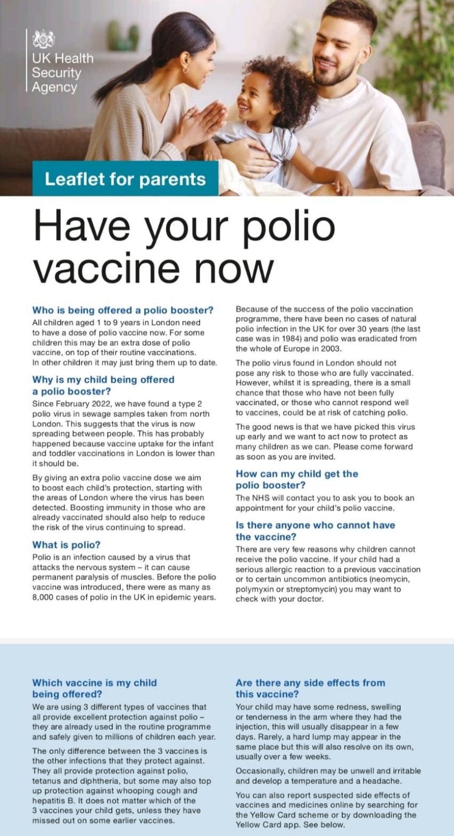(GOV.UK)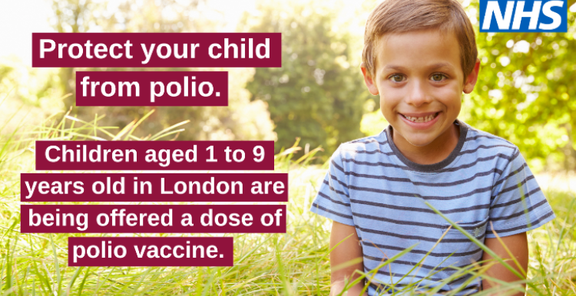
- Conclusion
In conclusion, Poliomyelitis has been defeated in most of the world’s countries.
All this thanks to the study, the evolution of science, vaccines tested on patients and thus improved over the years. The Health Campaign has also contributed to improving the knowledge and awareness of the world population on how to prevent the contagion and spread of Poliomyelitis, not only through vaccination, but also by changing one’s own habits and above all those of one’s children.
Because, as we have learned over the years, Polio can only prevented, not cured.

Reference List
- News, History of Polio, 25 September 2015
Available at https://www.bbc.co.uk/news/health-17045202 (Accessed: 2 January 2023)
- Our World in Data Available at: Reported paralytic polio cases and deaths, United States, 1910 to 2019 (ourworldindata.org) (Accessed:2 January 2023)
- What is Polio, August 11 2022, Available at: What is Polio? (cdc.gov)
(Accessed:4 January 2023)
- Polio Global Eradication Initiative, Available at: Surveillance Indicators – GPEI (polioeradication.org)(Accessed at 2 January 2023)
- Centers of Disease Control and Prevention, Available at Principles of Epidemiology: Lesson 5, Section 2|Self-Study Course SS1978|CDC (Accessed: 2 January 2023)
-National Library of Medicine, Available at Environmental surveillance of poliovirus and non-polio enterovirus in urban sewage in Dakar, Senegal (2007-2013) - PMC (nih.gov)(Accessed: 2 January 2023)
- Centers of Disease Control and Prevention, Available at: Polio Vaccination | CDC (Accessed: 2 January 2023)
- Center of Disease Control and Prevention, Available at: CDC Global Health - Polio - Who We Are: CDC and the Global Polio Eradication Initiative
(Accessed: 2 January 2023)
- Journal of Neurology, Neurosurgery & Psychiatry, 2022 Available at:Salk and Sabin: poliomyelitis immunisation | Journal of Neurology, Neurosurgery & Psychiatry (bmj.com) (Accessed: 2 January 2023)
- Public Health Agency,2022, Available at:Public information campaigns | HSC Public Health Agency (hscni.net) (Accessed: 2 January 2023)
- GOV.UK, 23 October 2013, Available at: Polio: guidance, vaccination, data and analysis - GOV.UK (www.gov.uk)(Accessed: 2 January 2023)

