ACBA 6003
Integrate the group project
Project
Liam Morgan:1806324
Lecturer: Alan Nantel,Deborah Hughes,Gavin Taylor
Keerthi Ranasinghe
Deadline: 26/04/21
Word count: 3632

Table of Contents
Table of Figures 2
1.0 Introduction 3
2.0 Social aspects 3
3.0 Economic Comparisons for the Client 5
4.0 Aesthetics’ 10
5.0 Site layout at different stages of works 12
6.0 Conclusion 18
7.0 Reference list 19
8.0 Bibliography 21
9.0 Acknowledgement 23

Table of Figures
Figure 1 Actual Estimate 7
Figure 2 Comparison Estimate 7
Figure 3 Actual Estimate 8
Figure 4 Comparison Estimate 8
Figure 5 Actual estimate 9
Figure 6 Comparison Estimate 9
Figure 7 Actual Estimate total 10
Figure 8 Comparison Estimate 10
Figure 9 Building design 12
Figure 10 site location 13
Figure 11 Site layout stage1 15
Figure 12 Site layout stage 2 16
Figure 13 Site layout stage 3 17
Figure 14 Site layout stage 4 18

Introduction

This assignment will be a group project with five members on the team with allocated individual tasks. These team members are Luke hart, Daniel stone, Aidan smith, Will Williams and Liam Morgan. The group has been assigned to design and build a three-story building with two floors of student accommodation. The lower floor is required to be used as a multi-functional retail space. The project has been split into different sections and has been allocated to various members of the group. The task allocated to the author are social aspects, economic comparisons for the client, Aesthetics of the building, and different site layouts at various stages of works.

Social aspects

The project has been designed to have a multi-functional retail space on the ground floor; this is great because it will allow for more jobs in the local community, and there is also the possibility that there could be an opportunity to offer part-time employment for the students that will reside there.
The team has discussed the area's landscape and will develop areas with seating and tables for use by the community; it will also allow students to integrate with locals bringing diverse communities together. It was important when designing the project that consideration of the surroundings was implemented to fit in with the rest of the local area.
The student accommodation was designed to allow large communal areas for the students to socialize and relax in their free time. When the team got together to give ideas about the design, it was decided that the student accommodation had to allow students to have their own private space. So, for this reason on-suite Bathrooms will be placed in every room so students have the option not to leave if they are too anxious as for many this will be their first time away from home, and they will be anxious. However, for students that do want to socialize they will be able to use the large communal areas inside or outside to develop new relationships throughout their residence.

The team have also discussed that there needs to be some protection when it comes to pollution and contaminants in the local area. The project will be constructed near the local river; no contaminants from the building's construction or life cycle must find their way into the river. To help aid the protection the scaffolding will have dust protector going around the scaffolding to minimize risk of dust and contaminates getting to the river. All waste material will be separated and reused or recycled where possible. All hazardous materials will be looked away to avoid any leaving the site.
Understanding the impact of new building will have on the surrounding area is vital because constructing without social consciousness could inadvertently create a dysfunctional place with unhappy locals. We need to be building sustainable communities for better health and well-being of residents and the local economy. It is paramount when carrying new construction, we take the economic and environmental sustainability into account we need to think about how our buildings will be powered and maintained and what the impact will have on the local area (kallistostairs,2021).
For this project the team have decided that they will register for considerate contractors’ scheme when carrying out the construction work. This is a national initiative created to improve the construction industries appearance and help construction companies minimise the effects on the surrounding area (Ccscheme,2021). This will include protecting and enhancing the local environment whilst ensuring the safety of everyone involved including local residents. This is a great scheme for the contractor as it builds trust within the local communities and allows for improvement where necessary. Keeping the area clean and tidy is essential when considering the effect building has on the surrounding area. there will need to be road sweepers and wheel cleaners for the trucks to keep the roads clean after deliveries or waste removal has taken place to ensure the contractor is doing as much as possible to minimise their effect on the community.
When the team got together it was discussed that it was important to interact with the local community by setting up a meeting with local residents and business owners to answer any questions and resolve any issues that they feel would affect them throughout this project. This is beneficial to the client and contractor as this could help ease any conflict between the community and themselves. This could result in the community being more optimistic with any future projects the client or contractor undertake.
One of the big areas of concern when carrying out a project of this magnitude is car parking (Creative Car Park, 2020). Not only for when construction is in progress but for use when completed. As there is going to be student accommodation and retail units adequate parking is essential. The SA1 Is a built-up area with lots of offices, hotels, retail units, university, and housing so car parking is usually at full capacity throughout the working day and has a huge social impact. This is why the team have allocated a substantial amount of area so there can be adequate car parking around the building. Another consideration was made to make bicycle security hock up points available around the exterior of the buildings to encourage cycling to cut down on pollution from cars.

3.0 Economic Comparisons for the Client

As a team, we have been comparing different materials to use on this project by comparing prices and the sustainability of the different material choices. When choosing a foundation, the group decided that a pile foundation was the best option and most cost-effective due to its installation speed and long-life span and would not be affected by groundwater as positioned next to the sea (Understand Building Construction, 2021). To finish, the piles would top with reinforced pile caps so that any deviation that has occurred from driving the piles into the ground will be corrected. Taking all the factors into account, there was not any other comparison to use for the foundation as the team believed this was the only option available to use in the circumstances as stated in the excel spreadsheet provided.

When it came to choosing a structural frame, we considered two material options; firstly, was the reinforced concrete frame; this has the advantage of strength, fire resistance, affordability, and less skilled labor needed (Civiltoday, 2021). It is also widely available and unlikely to be affected by any shortages that would occur a price rise.
Secondly was steel; this has strength, durability, affordability, and sustainability; However, the price of steel has been rising in Europe due to its shortage. This could mean a more considerable risk for the client (Tanatar, Bone and Bolotova, 2021). The team compared both and believed that steel would be the best way to meet the client’s requirements and be most cost-effective. When comparing a price difference between them both, it was decided that it was irrelevant due to the environmental differences between both materials as steel was 100% reusable. The advantages outweighed any upfront cost savings that concrete frame had to offer. When it came to the superstructure, we decided to differentiate the external cladding for the ground floor and the first and second floors because they will be used for various purposes. We decided to go with a more traditional brickwork outer skin for the ground floor with a cavity block fitted between the steel frame alongside curtain walling to the front of the building to allow for a more open look to entice customers into the building (Tom Brown, 2017). The team initially did contemplate using brickwork cladding for the external facade to reduce initial costs. However, after comparing traditional brickwork with brickwork cladding, the team decided that traditional brickwork would be considerably cheaper to supply and install. It was also decided that it would be better for maintenance as traditional brickwork would require less maintenance than the brickwork cladding, and no comparison was as cost-effective as stated in the excel spreadsheet provided. These considerations, alongside the revenue gained from enticing customers through the door, would be most cost-effective. When it came to the remaining two upper floors, we decided to use blockwork infill between the steel frame and external skin of blockwork and rain screen cladding. Below is a comparison of prices between different cladding types. The tongue and grooved walling is substantially cheaper; however will require more maintenance at a cost.

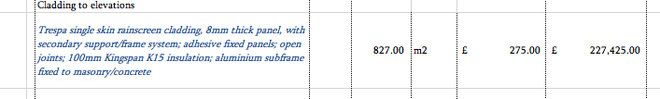
Figure 1 Actual Estimate
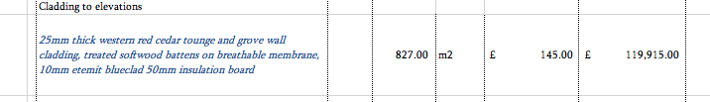
Figure 2 Comparison Estimate
When it came to considering a roof type, the team discussed many options by assessing the advantages and disadvantages of each option. Tile roof advantages are durability as they do not weather as quickly as other systems. They are fire-resistant, and class rated A the highest fire rating (Formisano, 2021). They have a life expectancy from 50 to 100 years, giving them a long-life span compared to other options. They are also eco-friendly as made from natural resources and can be recycled. The disadvantages of tiles are that they are expensive compared to other options available they are fragile and not a very cost-effective option. The advantages of a flat roof are they have space available so that services like AC can be put there to save room inside. They are cheaper than pitched roofs, can have a roof garden for relaxation and faster installation. Some disadvantages are that drainage problems can quickly occur, especially if not planned or installed correctly and are not aesthetically pleasing. There is also the risk that maintenance wise that a flat roof can become costly with repairs and damages due to leaks (Lifetimeroofing,2021). Another option is the standing seam roof; it is made out of steel or aluminum, meaning it is 100% recyclable, durable, built to last, does not rust or fade in the sun, and do not require any maintenance. For these reasons, the team have decided that the standing seam roof would be the best option for the roof. The initial outlay might be more expensive, but the long-term savings along with the advantages make this option most cost-effective (Rubio, 2020) Below is a screenshot of the price comparisons made between the flat roof and seam roof.
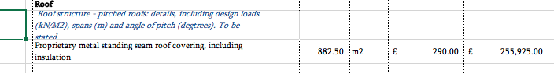
Figure 3 Actual Estimate
.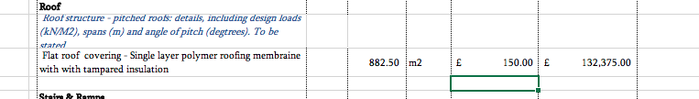
Figure 4 Comparison Estimate
The floor finishes the team decided on were ceramic tiles for the ground floor as it is going to be used for retail and will be subject to heavy foot traffic. They are low maintenance, heavy-duty, stylish and cost-effective (British Ceramic Tile, 2021). The second and third floor of the student accommodation will use heavy-duty carpet. This is based on trying to reduce noise transfer. Carpet is an excellent sound absorber and can reduce the sound of footsteps by 25 to 34 decibels (Acoustical Surfaces, 2020). The bathrooms and kitchens will have anti-slip vinyl as it is durable, easy to install, waterproof, no maintenance and cost-effective (Hall and Hall, 2020). Because of the advantages of the materials used in the floor finishes, there were no price comparisons. Below is a comparison between the cost of different staircases as shown in the excel sheet provided.
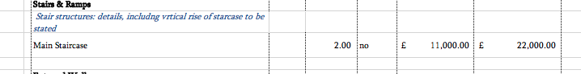
Figure 5 Actual estimate
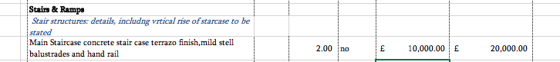
Figure 6 Comparison Estimate

Above has shown a lot of different materials and the options the team had to choose from. When it came to making comparisons for the client, the team decided that other considerations were more significant, like life span, durability, environmental impact, and function of the building over the cost. So, comparisons were not made on cost if the other considerations would outweigh the cost. Below is the price of the Actual estimate provided to the client and the available comparisons. For the full list of comparisons please refer to the attached excel sheet provided on submission.
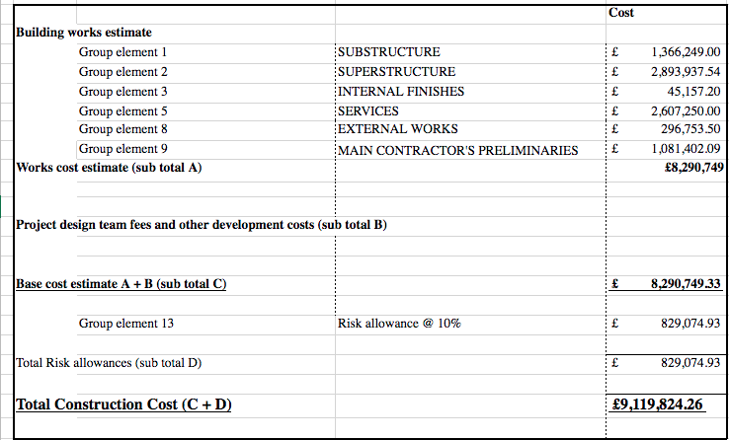
Figure 7 Actual Estimate total
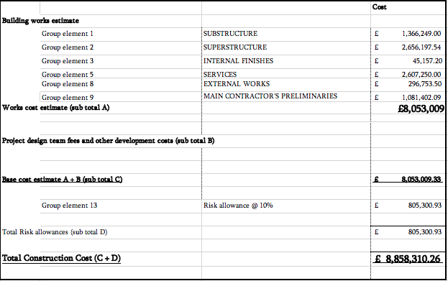
Figure 8 Comparison Estimate

4.0 Aesthetics’

Aesthetics is one of the main principal aspects considered in architecture that students and professionals alike have to worship (BRE Group, 2020). Architecture is a design process that involves planning, designing, creating, constructing and executing construction projects. It covers the effect of the appeal of a building by its shape, size, color, symmetry, pattern, balance, texture, culture and context. Aesthetics influences how we feel about a product or a building, giving a negative or positive emotional feel (Psychology Today, 2019). When it comes to the building's aesthetics, there needs to be a balance because a building is designed for durability, safety, serviceability; these need to be considered along with the building's Aesthetics. It is also essential to understand aesthetics' performance because that of the life of the chosen materials will have. For example, weathering, if the wood were chosen as a material, then over time, the wood would get damaged and lose its appearance if not maintained; this will have a negative impact on the aesthetics of the building. It is essential to understand the materials and how they degrade whilst ensuring the construction can be carried out to the required specification. Aesthetics are important because people will feel pleasure if the building's aesthetics is correct. This project will have a retail unit; the building's appearance is essential for these businesses to draw in customers. If the customers feel happy with their surroundings, then they will likely keep returning. However, if the building's aesthetics are not correct, this will undoubtedly result in a loss of business. There is a lot of student accommodation in the area, so making it appealing to students is essential to maximizing profit. Student accommodation is quite expensive, so there needs to be a good reason for the students to consider living in this accommodation compared to other alternatives. This is why the team has chosen the design and aesthetics shown below to give that clean, modern look to the building.
Figure 9 Building design

It was also decided that it would have to be compatible with the surrounding area but also needed to take into consideration the function of the building; when it came to the design, we realized that the ground floor would need to have a large open area to be appealing to the customers that is why we decided on curtain walling and brickwork as we believe this would be aesthetically pleasing to customers. as the other function of the building was for student accommodation, a contemporary, modern aesthetic building would be best suited.

5.0 Site layout at different stages of works

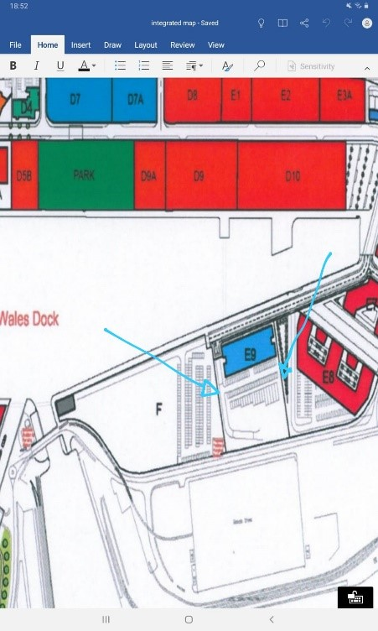
Figure 10 site location
Above is the location of the proposed building; as can be seen, it is positioned next to the docks. Planning a site layout is essential to maximize environmental efficiency and ensure safe construction activities. Below is a list of factors that the team considered when producing the construction site layout plan.
- Site offices and welfare facilities
- Temporary services (water, drainage, power)
- Site access
- Where the materials will be stored
- Crane position
- Site security
- How much space is available?
- Impact on the surrounding area
- Traffic management
- How plant will get around
- Pedestrian paths

A poor site layout can be detrimental to the success of a project and can incur extra costs and cause delays. For example, suppose materials are not positioned in the right place. It could result in double or triple handling of the materials resulting in a longer time to complete the task. It could also delay the delivery process if the storage is hard to access when deliveries are made (Moran, 2017). They need to be positioned in an area that will not impact carrying out the construction process without being too far from the working area. When it comes to positioning the site accommodation, it needs to be away from the noisy and dusty environment but have a good overview of the site. For this project, a crane will be needed to carry out the construction of the building. It will need to be placed where it will be able to reach the materials and building but out of the way of hazards (R Chudley and Greeno, 2016). These are just a few of the considerations that need planning for, as these will cause substantial delays and cost. However well-planned site layout will likely reduce cost and raise productivity by raising morale in the workforce by providing the correct facilities and ensuring their safety. The site layout will depend on its complexity and location of the construction project. As this project is based in a city centre and is surrounded by many operational buildings and busy roads, the site layout plan must use the allocated space wisely. It was decided that the site accommodation will need to be stacked to allow for extra room on site. It will also need to be close to the main gate to ensure that visitors are away from the construction work. A path will be placed and barriered off to ensure pedestrians and workers can move around the site without the risk of injury from the plant.

Below is the site layout for the first stages of construction work to be carried out. The excavation will need to be completed first using the plant to remove the earth and fill up trucks to take the earth away from the site. As seen below, the trucks will use a one-way system to minimize the risk to workers and pedestrians. The plant will drive the piles into the ground and reinforced pile caps positioned on top. All facilities will need to be on-site for the ground workers to have areas to dry their workwear and have a clean area to relax.

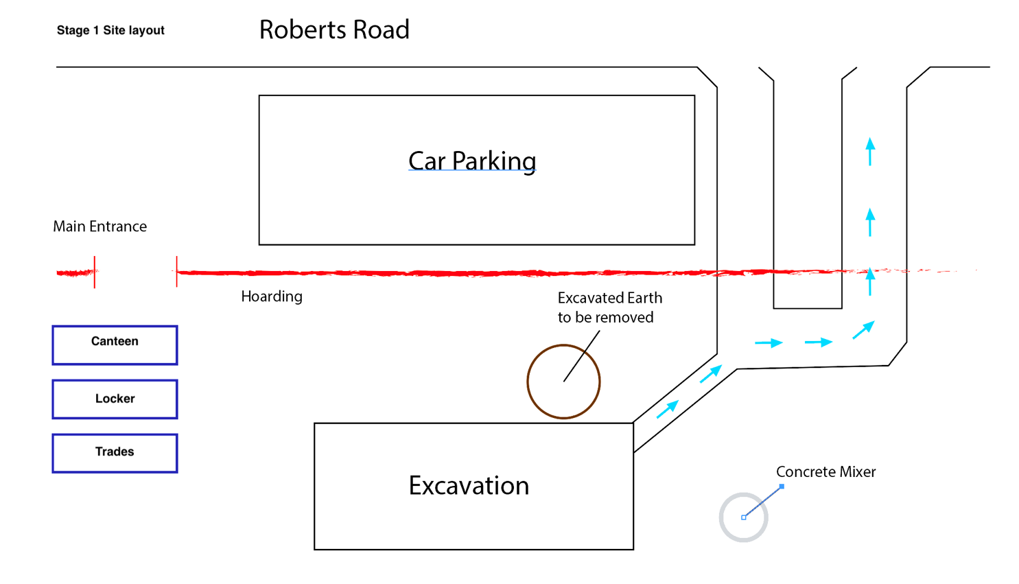
1.office. 4. Dry room
2. First aid. 5. Security
3. Toilets
3. Toilets

1111
5
4
3
2
Figure 11 Site layout stage1
Below is the second stage of construction works to be carried out. This is where a crane will be needed to lift the steel into position. The crane has been placed away from other hazards but can reach the building and the materials easily. There is no need for any plant to be anywhere near the crane; this will again reduce the risks on site. At this stage, materials can now be placed on-site, ready for construction works to begin. They have been positioned away from the building area but close enough that they can be easily used. They are also positioned in a good area for when deliveries come, and they do not have to go all the way through the construction area, again reducing the risk of injuries on site. When deliveries are made, a wheel washer is available to help reduce contaminants leaving the construction site and reducing the impact on the surrounding area.

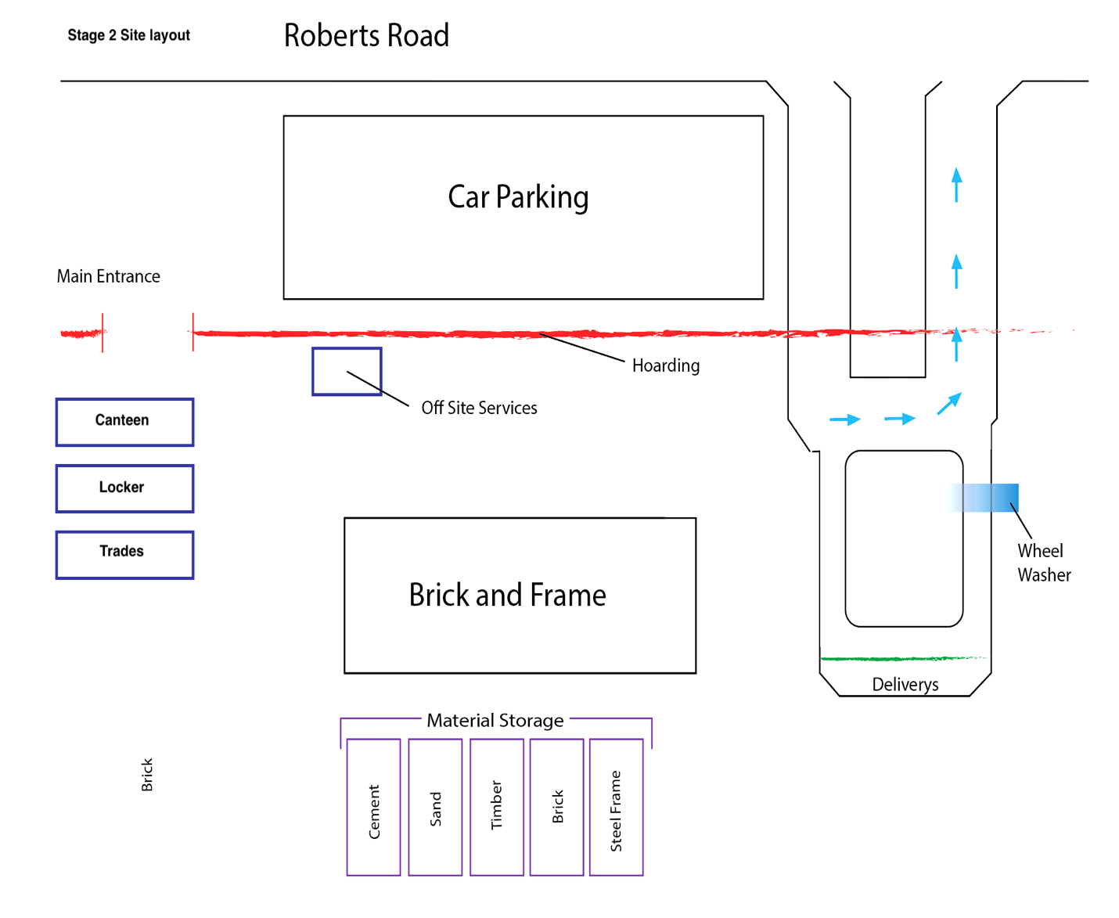
Crane
1.office
2.first aid
3.Tiolet
4. dry room
5. Security

5
4
3
2
1.hfhffhfffhfh
Figure 12 Site layout stage 2
Below is the third stage of the site layout and has had scaffolding placed around the building, so work on the second and third floor can now commence. Due to the site being so close to the dock and operational buildings, a dust sheet will be placed around the scaffolding to minimize the risk of contaminants leaving the site. It will also have kickboards placed around the scaffolding to ensure no items can fall from height, again reducing the risk of injury on site.
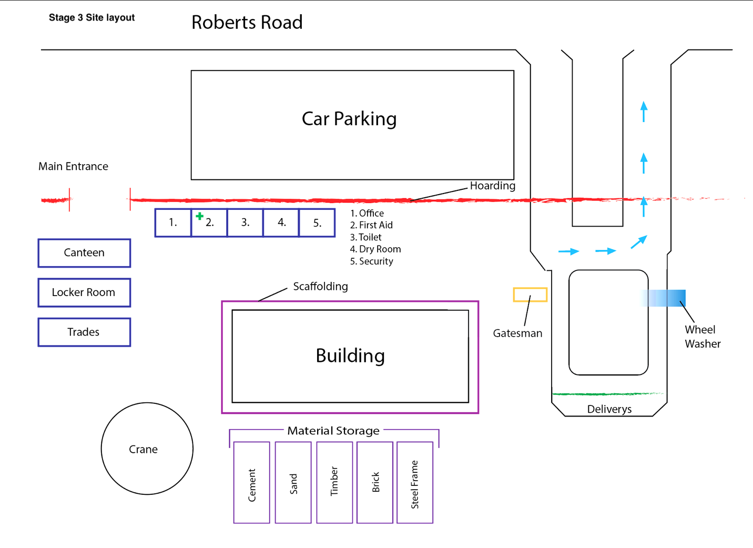
Figure 13 Site layout stage 3

This is the final stage when everything has been removed and handed over to the client.

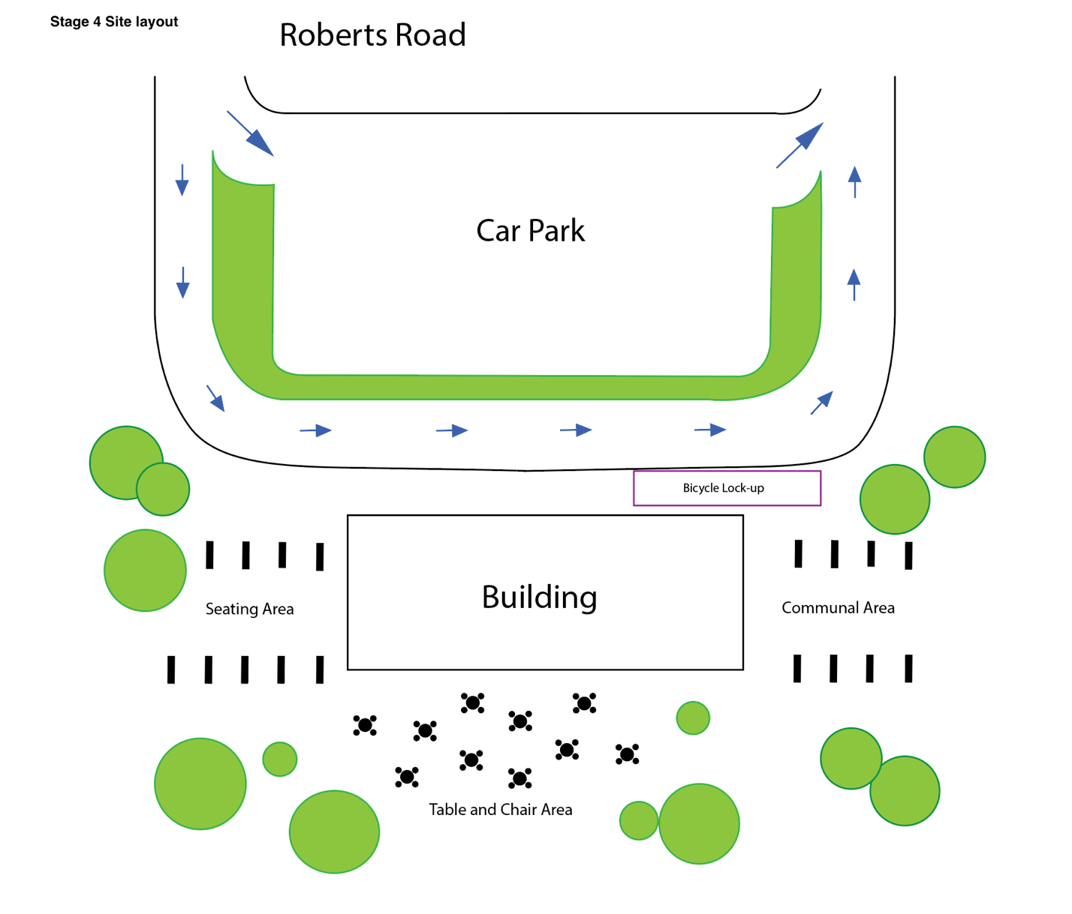
Figure 14 Site layout stage 4
Below is a list of considerations made by the team when deciding the site layout
- The crane needs to be positioned away from building works, plant and sailing issues.
- The first aid room needs to be placed away from the dangerous area so assistance can be given safely.
- Toilets positioned in a safe area with easy access
- The drying room is positioned away from building works to ensure clothes stay clean and dry and give the workers somewhere to change without going back through the site risking getting dirty.
- Security will monitor the area to ensure public safety and prevent financial loss.
- Canteen placed in a quiet area away from construction works to allow workers to relax
- Lock up storage is used to protect equipment and hold dangerous items.
- There will be trade containers for the sub-contractors
- Cement is stored in a dry area in bags ready for use
- Sand is positioned next to cement for ease of access
- Bricks stored on pallets away from construction work
- A wheel washer will be placed to protect the local area
- Gates man will be positioned to make deliveries safely
- Topsoil is kept away from construction work but can be easily accessed
- The site will have pedestrian paths that are barried off

6.0 Conclusion

When it came to the social aspects of the project, it is easy to see the importance of considering the surrounding area. The impact the construction of a building has on the environment, and people's well-being has to be considered. It shows that initiatives like considerate contractors are essential for the future of construction.
The client's economic comparisons are difficult because the cheapest option is not always the best option. Considerations need to be made by comparing the life span of materials, client’s specification, the building's function, and environmental impact. That is why the team weighed up all the options with advantages and disadvantages to give the client the best advice.
The building's aesthetics was a fascinating topic due to realizing the impact aesthetics have on people's emotions. Knowing that a well-designed aesthetic building can draw many customers into a building and then a building with bad aesthetics could lose a lot of business.
Producing site layout plans gave a better understanding of the importance of planning ahead. The way a site is set up does have a considerable impact on the success of the project. Not only is it financially better to have a good site setup, but it reduces the risk of injuries and death on site considerably.

7.0 Reference list
Acoustical Surfaces. (2020). Soundproofing vs Sound Absorbing - the difference - ASI. [online] Available at: https://www.acousticalsurfaces.com/blog/soundproofing/soundproofing-vs-sound-absorbing [Accessed 16 Apr. 2021].
BRE Group. (2020). Aesthetics in architecture - how beauty and design are inspiring each other | BRE Group. [online] Available at: https://www.bregroup.com/insights/aesthetics-in-architecture-how-beauty-and-design-are-inspiring-each-other/#:~:text=beauty%20or%20taste.-,The%20aesthetics%20of%20a%20building%20is%20one%20of%20the%20principal,%2C%20decoration%2C%20culture%20and%20context. [Accessed 15 Apr. 2021].
British Ceramic Tile. (2021). British Ceramic Tile: The Home of Designer Tiles Online. [online] Available at: https://www.britishceramictile.com/how-to-tile/ceramic-vs-porcelain-tiles [Accessed 16 Apr. 2021].
Ccscheme. (2021). ccscheme. [online] Available at: https://www.ccscheme.org.uk/ [Accessed 16 Apr. 2021].
Civiltoday.com. (2021). Advantages and Disadvantages of Reinforced Concrete - Civil Engineering. [online] Available at: https://civiltoday.com/civil-engineering-materials/concrete/23-advantages-and-disadvantages-of-reinforced-concrete [Accessed 16 Apr. 2021].
Creative Car Park. (2020). Your Car Park Design Guide | Creative Car Park. [online] Available at: https://www.creativecarpark.co.uk/your-car-park-design-guide/ [Accessed 16 Apr. 2021].
Formisano, B. (2021). Pros and Cons of Tile Roofing. [online] The Spruce. Available at: https://www.thespruce.com/pros-and-cons-of-tile-roofing-1824684 [Accessed 16 Apr. 2021].
Glass Times. (2021). Perfect storm of steel shortages and increased prices - Glass Times. [online] Available at: https://glasstimes.co.uk/news/perfect-storm-of-steel-shortages-and-increased-prices/ [Accessed 16 Apr. 2021].
Hall, J. and Hall, J. (2020). Eric Wright Carpets. [online] Eric Wright Carpets. Available at: https://www.ericwrightcarpets.co.uk/news/advantages-disadvantages-of-vinyl-flooring/ [Accessed 16 Apr. 2021].
Lifetimeroofing.com. (2021). Flat Roof Advantages and Disadvantages | Lifetime Roofing. [online] Available at: https://lifetimeroofing.com/flat-roof-advantages-and-disadvantages/ [Accessed 16 Apr. 2021].
Moran, S. (2017). Site Layout Principles 1 | SciTech Connect. [online] Elsevier.com. Available at: http://scitechconnect.elsevier.com/site-layout-principles-1/ [Accessed 16 Apr. 2021].
Psychology Today. (2019). 9 Factors that Influence Aesthetic Choice. [online] Available at: https://www.psychologytoday.com/gb/blog/science-choice/201907/9-factors-influence-aesthetic-choice [Accessed 16 Apr. 2021].
R Chudley and Greeno, R. (2016). Building construction handbook. London: Routledge.
Rubio, P. (2020). 10 Benefits Of A Standing Seam Metal Roof. [online] Westernstatesmetalroofing.com. Available at: https://www.westernstatesmetalroofing.com/blog/standing-seam-metal-roofing-benefits [Accessed 16 Apr. 2021].
Tanatar, M., Bone, C. and Bolotova, J. (2021). FOCUS: EU steel shortage to persist throughout 2021 | Metal Bulletin.com. [online] Metalbulletin.com. Available at: https://www.metalbulletin.com/Article/3978380/FOCUS-EU-steel-shortage-to-persist-throughout-2021.html [Accessed 15 Apr. 2021].
Tom Brown Inc. (2017). Advantages of Curtain Walls | Tom Brown Inc. [online] Available at: https://tombrowninc.com/blog/advantages-curtain-walls/ [Accessed 16 Apr. 2021].
Understand Building Construction. (2021). Pile Foundations | Types of Piles | Cassions. [online] Available at: http://www.understandconstruction.com/pile-foundations.html [Accessed 16 Apr. 2021].
Zuerita (2018). 10 benefits of these mineral fibre ceiling tiles. [online] Building & Decor. Available at: https://www.buildinganddecor.co.za/10-benefits-of-these-mineral-fibre-ceiling-tiles/ [Accessed 16 Apr. 2021].

8.0 Bibliography
Abbasian-Hosseini, A. (2015). Social and Engineering Aspects of Construction Site Management using Simulation and Social Network Analysis. [online] ResearchGate. Available at: https://www.researchgate.net/publication/293333198_Social_and_Engineering_Aspects_of_Construction_Site_Management_using_Simulation_and_Social_Network_Analysis [Accessed 16 Apr. 2021].
Architecture Student Chronicles. (2010). Aesthetic Components of Architecture | Architecture Student Chronicles. [online] Available at: http://www.architecture-student.com/architecture/aesthetic-components-of-architecture/ [Accessed 16 Apr. 2021].
BRE Group. (2020). Aesthetics in architecture - how beauty and design are inspiring each other | BRE Group. [online] Available at: https://www.bregroup.com/insights/aesthetics-in-architecture-how-beauty-and-design-are-inspiring-each-other/#:~:text=beauty%20or%20taste.-,The%20aesthetics%20of%20a%20building%20is%20one%20of%20the%20principal,%2C%20decoration%2C%20culture%20and%20context. [Accessed 16 Apr. 2021].
Ciob.org. (2021). Architecture, Build Aesthetics and Design | CIOB. [online] Available at: https://www.ciob.org/industry/policy-research/policy-positions/architecture-build-aesthetics-design [Accessed 16 Apr. 2021].
CivilEngineeringBible.com. (2021). Construction Site Layout Planning Elements - CivilEngineeringBible.com. [online] Available at: https://civilengineeringbible.com/subtopics.php?i=59 [Accessed 16 Apr. 2021].
Dixon, G. and Manchester Metropolitan University. Institute Of Advanced Studies (1992). Building site layout planning. Manchester: Institute Of Advanced Studies, Manchester Metropolitan University.
DOLGOVA, E.D. (2016). AESTHETICS OF ANONYMOUS ARCHITECTURE. Urban construction and architecture, 6(2), pp.91–95.
eddyhrbs (2021). SITE LAYOUT CONSIDERATIONS. [online] Buildersengineer.info. Available at: http://www.buildersengineer.info/2013/12/site-layout-considerations.html [Accessed 16 Apr. 2021].
Feagin, S.L. and Maynard, P. (1997). Aesthetics. Oxford ; New York: Oxford University Press.
Identifying the key factors in construction projects that affect neighbourhood social sustainability | Emerald Insight. (2019). Facilities. [online] Available at: https://www.emerald.com/insight/content/doi/10.1108/F-11-2019-0121/full/html [Accessed 16 Apr. 2021].
Journal of Environmental Planning and Management. (2014). Housing areas — factors that need to be considered in the site layout and design process. [online] Available at: https://www.tandfonline.com/doi/abs/10.1080/00320718408711721 [Accessed 16 Apr. 2021].
Levinson, J. (2005). The Oxford handbook of aesthetics. Oxford: Oxford University Press.
Small, E.P. and Baqer, M. (2016). Examination of Job-site Layout Approaches and their Impact on Construction Job-site Productivity. Procedia Engineering, 164(2), pp.383–388.

9.0 Acknowledgement

The author has completed this assignment with the help and aid of many different people. They would like to thank the lecturers for providing them with the valuable information and resources needed to complete this report. They would also like to thank their university colleagues Luke Hart, Aiden Smith, Daniel Stone, and Will Williams for helping with research and sharing their knowledge. The author would also like to thank their wife for all her encouragement and support throughout the assignment. Lastly, they would like to thank the student support, Cherry, for all her help and guidance throughout this year at university.

