Student Name: | Nadia Phillips
Student Number: | 1705457
Module No: | Bmsk5006
Module Title: | Knowledge and Information management Skills for the Workplace

Statement of Confirmation of Authenticity
By the act of making this submission, the student declares that this is the work of the student named above. The work has not, in whole or in part, been y presented elsewhere for assessment, or where assessment has been built on a previous assessment, this has been identified. Where materials have been used from other sources it has been properly acknowledged. If this statement is untrue, the student acknowledges that an assessment offence has been committed.
Attention is drawn to the plagiarism and unfair practice policies of both the University and of ILM.
Permission for ILM to use this script
ILM uses learners’ submissions – on an anonymous basis – for assessment standardisation. By submitting, both the centre and the learner agree that ILM may use this script on condition that identifying information is removed. However, if you are unwilling to allow ILM use this script,

Table of Contents
List of Abbreviations (if used) 3
Introduction 4
What is the relationship between information, data, knowledge and wisdom? 4
What relationship between individual and organsitianal knowledge? 4
Technique models that indentify knowledge assets 4
SWOT analysis 4
Evaluate actual and potential knowledge 4
What is required to create, store, appy and intergrate knowledge 4
The importance of intellectual knowledge 4
What knowledge assets does an organisation have? 4
What are knowledge requirments for Apple? 4
Evaluate Apples framework for enabling knowledge sharing 5
Recommendation to improve the current framework
Conclusion 5
References 6
Books 6
Websites 7
Bibliography 8
Appendices 9
Appendix A - 9
Appendix B - 10
Appendix C – 11

List of Abbreviations (if used)

Knowledge Management (KM)
Data Information Knowledge and Wisdom (DIKW)

Introduction

“The translation of concepts from organization science and organizational psychology and sociology into a management discipline” (Maier, 2007) (Appendix A). A simplified definition by Romizen (2002) “[KM is] the systematic process by which knowledge needed for an organization to succeed is created, captured, shared and leveraged”. Knowledge management (KM) has developed and evolved largely, the idea of the owners being in the above office looking down at workers is gradually becoming more distant within organisations (Verna, 1997). Knowledge management tries to really exert expertise from different areas within the business in order to internalise and share for the purpose of expanding and perfecting objectives and targets.

For knowledge management to utilise the expertise it is essential that organisations small or large, they constantly stride forward, regularly updating and improving systems for the business and customers. KM, ultimately creates, researches data that is shared and saved for the benefit of the company to learn, develop and grow. Using KM in the workplace increases the knowledge capital, specifically problem-solving, strategic direction, creativity and the most modern technique within businesses is influencing the market or individual customers (Grifftihs, 2012).

There are significant differences between businesses that apply KM effectively compared to businesses that do not. KM continuously strives for excellent communication between departments, using adequate research and innovation, knowledge management effects leadership, strategic provocateur, functional expert, value creative, funding going to the correct areas etc (Griffiths, 2012). Businesses benefit greatly whether big or small from having a knowledge and expertise regardless of how profits and financial gains (Alle, 1997).

What is the relationship between data, information, knowledge and wisdom?

The relationship between data, information and knowledge is extremely efficient when combined together (Ackoff, Gharajedaghi and Finnel, 1984) (Appendix B). To define data “Data is raw and it simply exists as symbols, figure or numbers, it has no significance beyond its existence, it does not have any meaning” (Ackoff, 1989) it is the first stage of the process. An example of this is seeing 774397, to the average person this means nothing.

Information is the next step that gives an understanding of what the data is for, the perception and categorisation of the numbers/measurements/statistics so on. Following on from the example above, the numbers 774397, the information could potentially be the understanding or awareness that is a telephone number.

Leading onto knowledge, Knowledge is the next step, “Knowledge means the familiarity and awareness of a person, place, events, ideas, issues, ways of doing things or anything else, which is gathered through learning, perceiving or discovering” (Subrhi, 2018). Knowledge is what can be taken from the data and information, what was learnt from both. Again from the example the knowledge could be the recognition that the telephone number is a Llanelli based number. Gaining a more understanding, the data becomes stronger and more relevant through the process.

Wisdom is the extra step that is the progress from the knowledge learnt from the data and information, what good would it is to have all of the outcomes but not do anything with it? Wisdom is what really is proactive and determines the direction for knowledge (Berlinga, Castro & Mills, 2004). To finish the example the wisdom could be knowing who’s house number it is and with a reason to call it.

Data, information, knowledge and wisdom within an organisation enable team members to have in depth research to benefit the departments within organisations for direction, what has worked what has not worked. Data, information, knowledge and wisdom can provide the evidence for both successes and failure, all of which being a learning curve. This information can then be stored, expanded, shared and transferred to other areas within organisations to have an overall benefit along with a plan ahead for the next steps.

The relationship between individual and organisational knowledge

Individual knowledge is the analyses from experiences, it is a natural human reaction to store essential and important pieces of information in life in order to be safer, smarter, happier and braver or the mind can store information of negative reactions to different elements that occur for example touching boiling water will store in your memory not to do it again (Schacter, 2011).

This can greatly benefit the organisation if had experience before in a similar job role, university/academia experience or even just interested in the topic area. The knowledge gained and stored maybe completely different from the person already in the role, can also be explained as tacit knowledge or sometimes known as experiential knowledge (Appendix, C), a person internally can be aware or know something but may be difficult to vocalise or explain it to others (Whelan and Carcary, 2011). Whether it is things that have worked or that have failed, these are lessons learned and can be beneficial moving forward. For example, the experience from being brought up in car sales, there is experience in knowing/feeling when to approach a customer to pitch to and when not too, this may not be a factual recognition but it is from experience within the car sales industry but this tacit knowledge is transferable to another sales position.

An individual’s knowledge has the advantage if it is explicit knowledge then can be easily shared within a group of people through meetings, phone calls or presentations, this information can be forwarded.

However, the negative of individual knowledge that is tacit can be hard to explain the exacts, for example having the awareness of when to pitch a sale of a car to a customer, having to vocalise the explanation for the knowing the right time can be extremely difficult. Another reason that individual knowledge may be a negative is down to the individual, potential exploitation of not wanting to diverge or share information that could be beneficial and instead uses it for self-gain. Continuing with the example about car sales, that could easily be used for the benefit of one person rather than for the whole team to meet targets (Webb, 2017). To continue with example above if there is potential to turn the tacit knowledge of knowing when to pitch to a customer was available the explicit knowledge could be stored and shared on a database and made an assessment criterion for new employees or guide for the sales teams.

Organisational Knowledge is usually structured and can be integrated into regulations or rules, for instants required to attend training days or meetings. Organisational knowledge is a way of having a collective of data and information that is provided for the whole team that can be added too by employers or employees. A wide range of tacit, implicit and explicit information is essential in any organisation especially for innovation in a business like Apple that are consistent is developing technology, new hardware’s, software’s. The organisational knowledge would acknowledge all areas from sales team, marketing, creative, repair and support centres; this creates communication and the benefit of developing better products (Becerra-Fernand, Sabherwal, 2014).

Both are extremely important combined, one obvious reason that both individuals knowledge is important is to work, control and expertise the organisational knowledge. The advantage of having individual knowledge within Apple would be that the experience from the employees having a product and regular use will increase ideas of what is missing from the products (Appendix D), what could be better, what is the main factor for having the product and so on, Apple say that it is user innovation. This is detrimental to Apple to be able to keep up with the market and continuously hit the target areas. The individual knowledge combined with organisational knowledge creates expertise in different areas whilst encouraging everyone to be motivated and feel a part of a movement, individual and organisational knowledge is excreted together in a business this is how originality is created through tacit knowledge and the organisational through explicit knowledge.

Technique Models that identify knowledge assets

The “know how” within an organisation, one definition of knowledge assets is “the knowledge regarding markets, products, technologies and organisations, that a business owns or needs to own and which enable its business processes to generate profits, add value. Knowledge management is not only about managing these knowledge assets but managing the processes that act upon the assets” (Knowledge Management, 2021).

Assets are continuously being measured and reviewed in order to share with investors, shareholders, directors etc. Establishing profits, expenditures and the revenue, but to measure the knowledge assets is more complex. It is having human knowledge, market knowledge and knowing when the product is ready for the market.

There are three seven key processes for organisations to try to understand and measure knowledge assets they are, knowledge storing, mapping knowledge assets, Knowledge application, knowledge codification, knowledge generation, knowledge transfer and knowledge sharing (Appendix E) . Appreciating these processes is where the margin can grow between competitors. (Mentzas, Apostolou, Abecker, Young, 2012).

The two key factors knowledge management refers to on the knowledge map, level of structure and diffusion.
There are two forms of structure internal and external, to measure both is dependent on how explicit the information is, the more codified the information is the easier it is to share and focus on. The more tacit the information is the harder it is to share internally or externally and whether it can transition into the market place. Then diffusion, this is the level of how many people know this information, is there a few high up people who know? Or is it mandatory for all employees to know? Is the information public knowledge?

An example of codified knowledge asset would be a patent, which is a licensed design that is officially owned by a business/someone. Apple have a patent design of face recognition on the iPhones, Apple also has a licensed trademark on the Apple sign (Appendix F) this is very significant and can be recognised anywhere as it is situated centre of the back of all of its products, cleverly for when people use their phone or laptops in social areas the apple is visual to others. Patents and copyrights are securing the companies creations.

SWOT Analysis

The strength and advantages in knowledge management outweighs the weaknesses, Knowledge management can be saved, stored, shared and copyrighted to the company. Knowledge management is also very people focused on abilities, communication and what can be brought to the particular organisation or product. Knowledge management identifies the importance of what individuals can bring to organisational knowledge. In the business Apple for example, the coded and structured data/information is second to none, however, that came from tacit and unstructured origins, the users innovation.

The weaknesses in knowledge management are the expertise depends on the team employed, it is crucial to have passionate and driven employees for that particular organisation. The failures reflect the management which effectively control everything.

Opportunities in knowledge management can mean bigger, better innovation, benefiting the organisation as a whole leading to more job opportunities and new marketing techniques. Whereas, the threats in knowledge management can be to lose momentum ultimately will have the opposite affect and potential job losses, profit loss and lack of interest in the target areas.

(The SWOT and PESTEL table referring to Apple Appendix G)

Evaluate actual and potential knowledge assets

Actual knowledge defined as “the state of knowing the material facts at issue” (Collins Dictionary, 2006) and potential knowledge assets is an estimate, what may be? What could happen? The future aims, goals, targets or objectives for the business.
The actual knowledge consists of structural assets whether it is physical or virtual. This considers relationships with stake holders or customers, the current employee’s expertise, understanding of the product, knowing the market and target areas.

What is required to create, store, apply and integrate knowledge

To create information for a particular subject or product would begin with research; this could involve speaking to customers/public, business partners, team members, reviewing the market and previous products etc. Gathering and understanding the demands and needs for the target market and finding all of the information is to create new knowledge for the innovation to be successful; this is called data mining (Han, J, Micheline, K, Pei, J, 2012).
After gathering data and discovering what is relevant for the product or new development, it is crucial to store the information instantly and archived, either by recording the meetings/feedback with the public, business partners, and team members. Recording can consist of voice or video recordings, written or typed up. The storing of information must comply with the 2018 regulations; on the Gov.uk site it states that the data “must be used for specified and explicit purposes, kept up to date, handled in a way that ensures appropriate security, including protection against unlawful or unauthorised processing, access, loss, destruction or damage”. Another reason for storing information is to have something to refer to and easily accessible saving time and money.
Applying the data, is to use the information and transfer the stored ideas or information into the product or development, for example, apple hypothetically could have asked the creative team to create a trademark, then a few people would meet to design a few ideas, this would be saved and the best design for the company would be secured legally in order for the design to be applied to products.
Then integrating is important to familiarise the other team members with the new creation, by send newsletters with the trademark, explaining how it became created, the theme behind it and extra information. Apple are very good at keeping everyone up to date and integrating the information to everyone with news letters on their websites, regular emails and team meetings.

The importance of intellectual property rights

Intellectual property rights are a form of legal IP protection for inventors or creators. Businesses rely on this on enforcement of the creations and ideas formed from individual and organisational knowledge to secure patents, trademarks, trade secrets and copyrights (Anderson, B, 2006). Without have intellectual property rights, information could leak and it would be a case of anyone’s product, having competitors with more money to produce the product and hit the target market first. Whereas with the property rights regardless of money if there is a patent or trademark licence it cannot be toughed even if leaked. Intellectual property rights increases the motivation to keep developing economic growth and products, allows all companies to have the confidence to invest in ideas and enables growth for even small business (Mc John, M, S, 2009). Another reason that this form of security is essential for organisations is for the knowledge capital from individuals to have the ideas or inventions remain in the organisation if the employer was to leave for a competitor’s vacancy then the information is saved at the organisation, reducing employment turnover and long/short term conflicts. (Anderson, B, 2006).

What knowledge assets does an organisation have?

The organisations knowledge assets, the importance of this is crucial, if there are no knowledge management or knowledge assets the business will be at a standstill with little or no progression.
The continuous ideas, creativity and design to upkeep the information for innovation and progress.
Knowledge assets are to obtain and store the knowledge of the organisation and “the knowledge is preserved using different risk management techniques and the process ensures the competitive advantage for the organisation from the rivals” (Easterby-Smith and Lyles, 2011)

- The sharing and transferring of information to develop all staff members
- The expertise within employees required.
- The relationships between investors, stake holders, employees and customers.

Apples knowledge assets are human focused, claiming that ‘user’s innovation’ is what has allowed to progress knowing what the user desires and needs in a product for ultimate goal to have high sales. Apple designer Jonathan Ive stands by this statement, “Our goals are very simple — to design and make better products. If we can’t make something that is better, we won’t do it.” Jonathan Ive alone is a knowledge asset for Apple he has been a part of the creative team for twenty seven years. He was an expert in knowing what people wanted and creating it, if it could not be improved it would remain the same until it could, for example the Ipods (ear phones) remained the same for over five new concepts until the wireless ones got released in 2020 (apple, 2021). All of his designs and creations are stored securely however his tacit knowledge is owned by himself, in order to for Jonathan to remain an asset to Apple is to keep him employed and that is for knowledge management to control.

What are the knowledge requirements for Apple?

Apple is the most valuable brand in the world, the products or expensive, with people wanting limited editions costing more and prepared to be on waiting lists for the products. What are the knowledge requirements for Apple?
Market/competitor knowledge, analysing not only what sells well for Apple but there will be a team that will do research on the other competitors and what sells well for them? Being aware of what is selling well for others gives the opportunity to better their own products. For example if Samsung is selling well and showing positive feedback for the camera, then apple can try to transfer some of their customers over to Apple by having the competitors edge by designer a better camera.

- A positive customer relationship, in order to be the most valuable in the world has to be reflected in happy customers and high sales. There are many ways of interacting through the use of social media Apple promise to respond to any query within 24 hours, options to subscribe to newsletters, competitions and feedback for good and back.

- Employee inclusion, this is important as all employees own at least one product of Apple and their feedback is valued by team leaders, management and higher in order for critic or praise. This creates involvement and feeling a part of the movement.

- Legally protected and secured items that will be owned by apple, this enables rights for publishing, leasing, sales and so on. Enabling the product to evolve and create momentum in the tech world.

- Cyber security, data management and using the data effectively. “Apple can hire employees or train employees to develop the knowledge of cyber-security for the organisation and the cyber-security knowledge will help Apple to manage the risks of data theft. The preservation of data will provide the organisation competitive advantage in the market” (Wang, Z, Wang, N, 2012).

Evaluate Apple’s framework for enabling knowledge sharing

There are a few adopted and created knowledge sharing techniques that Apple use.
Apple Culture
- Apple have a working culture and a background culture, they believe that their long standing achievements is because everyone has a place and can get heard (Apple, 2021). They are focusing on making the discriminated gender, races and religions more equal, on the same Apple website it states in the diversity section “it takes all types of people to make a phone so personal”.
- Social Media/communication
The promise rapid response to hundreds of thousands of customers by using social media increases communication levels, making it accessible for everyone and Apple notices the need for trust between a business and an individual customer.
- Advanced Technology
The advanced technology is expectant from a business that designs technology, they are advanced in all areas, acknowledging and interrupting the cloud in their products to demonstrate the importance of storage for all.
- Expertise in marketing
Apple’s marketing is second to none, the creative team make information easy to read for the consumer, advertisements of new products are always simple and clear, the website and prices are always straight forward, this is a website that can reach all ages and nationalities to aspire to have the next product.
- Incentives to improve
The incentives to work and help Apple grow by sharing information, discounts, fitness memberships, employee stock purchase plans, free health and life insurance. Apple encourages employees to share experiences and knowledge of products through seminars, training days, regular feedback questions via emails. This is detrimental to keep Apple employees healthy, happy and involved. This is the main technique to keeping Apples reputation positively and progressing in the right direction.

Recommendations to improve the current framework

There are always risks when you’re the leader in the industry; every move is under a microscope for all the competition to see, risk asses or copy the direction. Increasing employment discretion could be an improvement to allow all staff to feel even more involved but cannot release any information or knowledge to competitors.
Increase the social media response from twenty four hours to twelve maybe, it would have to be realistic, however, it is creating an even better level of communication between consumers and Apple care department. Mainly the only advice towards Apple would be to keep up the momentum, as the consumers are waiting for the next big thing, whether or not it is Apple or a competing brand in the industry.

Conclusion

Knowledge is power, the more tacit and explicit knowledge gained the more valuable the organisation is. Having knowledge and information skills in a workplace naturally develops the process of creating, storing, and sharing and integrating the knowledge is vital in developing a product or business. The innovation is really about having the common objectives and aims, for all departments in the organisation everyone being on the same page and feeling involved in the movement. The knowledge and information management has to control and work towards creating good relationships with all partners, consumers, employees and shareholders whilst having the duty of obtaining the right amount of security on creation and information being developed. Apple has demonstrated that they cover all of the factors within knowledge management and this is reflected in the ranking of number one most valuable company in the world.

References

Books

- Ackoff, R., Gharajedaghi, J. and Finnel, E., 1984. A guide to controlling your corporation's future. New York, NY: Wiley.
- Alle, V. (1997). The Knowledge Evolution: Expanding Organizational Intelligence. United Kingdom: Butterworth-Heinemann
- Anderson, B. (2006). Intellectual Property Rights: Innovation Governance and the Institutional Environment. Cheltenham: Edward Elgar Publishing Ltd
- Becerra-Fernandez, I., & Sabherwal, R. (2014). Knowledge management: Systems and processes. Routledge
- Dent, M and Whitehead, S. eds., 2013. Managing professional identities: Knowledge, performativities, and the‘new’professional (vol 19). Routlage
- Griffiths, D. (2012). Organizational Learning and Knowledge: Concepts, Methodologies, Tools and Applications. United States of America: IGA Global
- Han, J, Micheline, K, Pei, J. (2012). Data Mining Concepts. USA: MK Publishers
- Maier, R. (2007). Knowledge Management Systems: School of Management Information Systems. New York: Springer
- Mc John, M,S. (2009). Intellectual Property: Examples & Explanations: New York: Aspen Publishers
- Mentzas, G, Apostolou, D, Abecker, A, Young, R. (2012), Knowledge Asset Management: Beyond the Process-centred and Product-Centred Approaches. London: Springer London
- Rumizen, C, M. (2002) The Complete Idiot’s Guide to Knowledge Management. USA: Penguin Group
- Schatcter, D. (2011). How the Mind Forgets and Remembers: The Seven Sins of Memory.Washington DC: Souvenir Press
- Schwartz, G, D. (2006). Encyclopedia of Knowledge Management. Hershey: Idea Group References.
- Von Krogh G, Ichijo K, Nonaka I. (2002). Enabling knowledge creation: how to unlock the mystery of tacit knowledge and release the power of innovation. New York: Oxford University Press
- Webb, S.P., (2017). Knowledge management: Linchpin of change. Routledge
- Whelan, E. and Carcary, M., (2011). Integrating talent and knowledge management: where are the benefits? Journal of knowledge management, 15(4), pp.675-6
- Dent, M and Whitehead, S. eds., 2013. Managing professional identities: Knowledge, performativities, and the‘new’professional (vol 19). Routlage

Websites

- Aiai.ed.ac.uk. 2021. Knowledge Management. [online] Available at: <http://www.aiai.ed.ac.uk/~alm/kamlnks.html> (Accessed 18 May 2021)
- Apple. (2021). Apple. [Online] Available at: https://www.apple.com/ (Accessed at: 18 May 2021)
- Bellinger, G., Castro, D., & Mills, A. (2004). Data, information, knowledge, and wisdom. [Online] Available from: http://www.systems-thinking.org/dikw/dikw.htm (Accessed at: 10 May 2021)
- Dataminingblog.com. 2021. Data, Information, Knowledge and Wisdom | Data Mining Blog - www.dataminingblog.com. [online] Available at: http://www.dataminingblog.com/data-information-knowledge-and-wisdom/ (Accessed 18 May 2021).
- Stewart, J. (2006). Collins Dictionary. [online] Available at: <a href="https://legal-dictionary.thefreedictionary.com/actual+knowledge">actual knowledge</a> (Accessed 21 May 2021)
- Subrhi, S. Difference Between Information and Knowledge. [Online] Available from: https://keydifferences.com/difference-between-information-and-knowledge.html. (Accessed at: 10 May 2021)
- Wang, Z. and Wang, N., (2012). Knowledge sharing, innovation and firm performance. Expert systems with applications, 39(10), pp.8899-8908
- Wang, Z., Wang, N. and Liang, H., (2014). Knowledge sharing, intellectual capital and firm performance. Management decision, 52(2), pp.230-258.

Appendices

Appendix A –
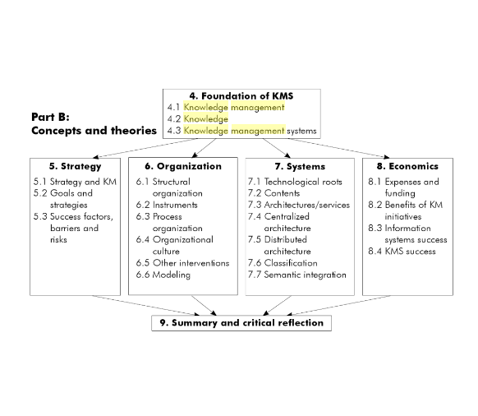

Appendix B – DIKW Pyramid

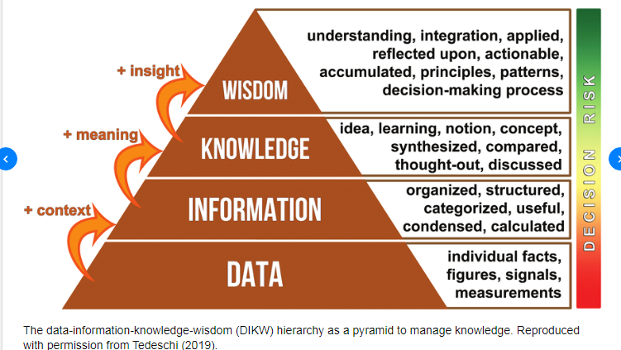

Appendix C – Title

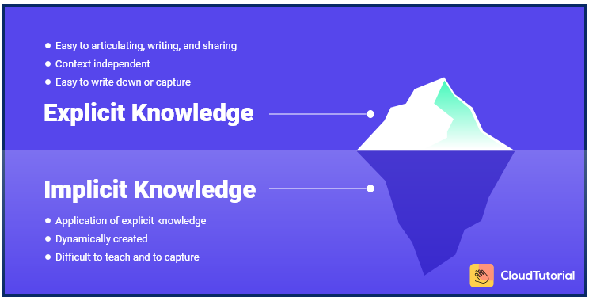

Appendix D

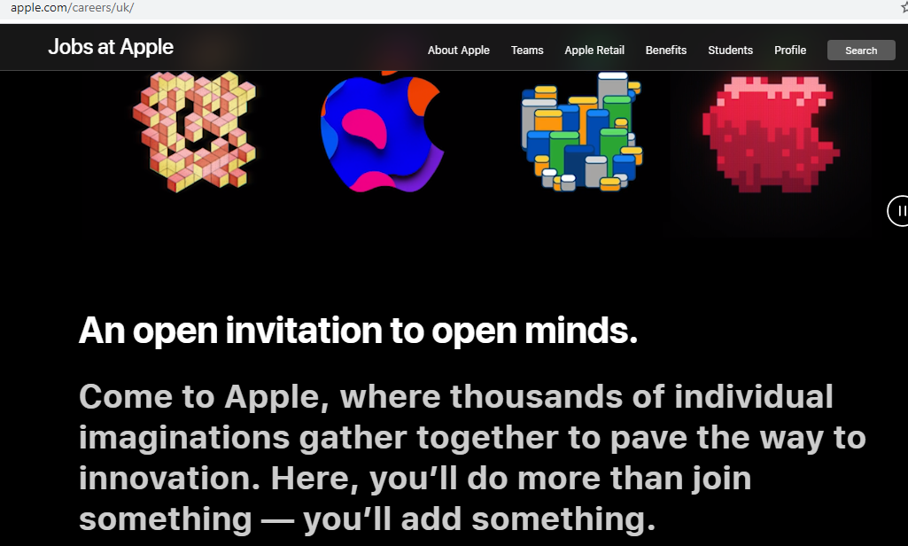
Appendix E

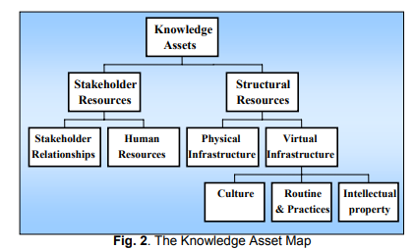
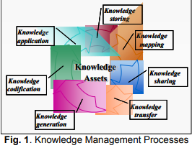

Appendix F



Appendix G

Strengths | Weaknesses | Opportunities | Threats
Rapid Innovation | Can be seen as too controlling | Consumers are excited for new products | Lower priced products with the same technology
Over 7,000 patents |  | Expand into the computer or media market | Iphones being produced too often
High Consumer Interaction and knows the demands |  | Have a good reputation to produce different items that consumers would follow
High Employee Interaction
Respective of tacit knowledge
One of the world’s strongest brands
One of the most influential brands for marketing

LEGAL  - Being up to date with polices and regulations  - Maintain storage under data protection 2018  - Securing creations legally through patent licenses, trademark and copyright legalities | ENIRONMENTAL  - Apple have responded to the environmental cause for concern by creating a ‘Liam’ policy, claiming they will buy back your phone for small price to recycle parts of the phone.
SOCIAL  - Apple pride themselves on creating high communication with employees  - Apple also claim that the communication held with consumers is what enable the understanding in the market for mass progression in innovation | TECHINICAL  - Apple obtains the technical geniuses in the industry, keeping up to date with what consumer needs which ultimately to make their life easier and better.  - Technical revelations are apple pay, face recognition, imaps, all with the intention of customers relying on the product.

