Module Name: Professional Career Development
Module Code: BMSW4012
Part 1
Student Name:
Student ID:

Table of Contents
Introduction 3
Discussion 4
Gibb’s Reflective Model 4
Conclusion 8
References 9

Introduction
The particular study will cover insights into the professional career development of an individual from higher education in employability skills. By utilising an effective reflective model which is Gibb’s model to reflect skills and knowledge within the area. The individual will share the overall experience after attending the professional career development lecture in the module. Below is the detailed reflection of the individual from Certificate of Higher Education in Employability Skills.

Discussion

Gibb’s Reflective Model
Gibb’s reflective cycle is a six-stage framework which is created by Graham Gibbs in 1988, the stages are description, feeling, evaluation, analysis, conclusion and action plan. It is mainly used by learners, teachers, and employers to improve their skills via experiences in diverse areas (Adeani et al., 2020). In this case, the framework is used by higher education students in systematically reflecting on experiences, from Certificate of Higher Education in Employability Skills. It will help in deeper understanding and continuous enhancement of their learning and decision-making processes. Below is the detailed reflection of the individual from the employability skills lectures certificate of HE.
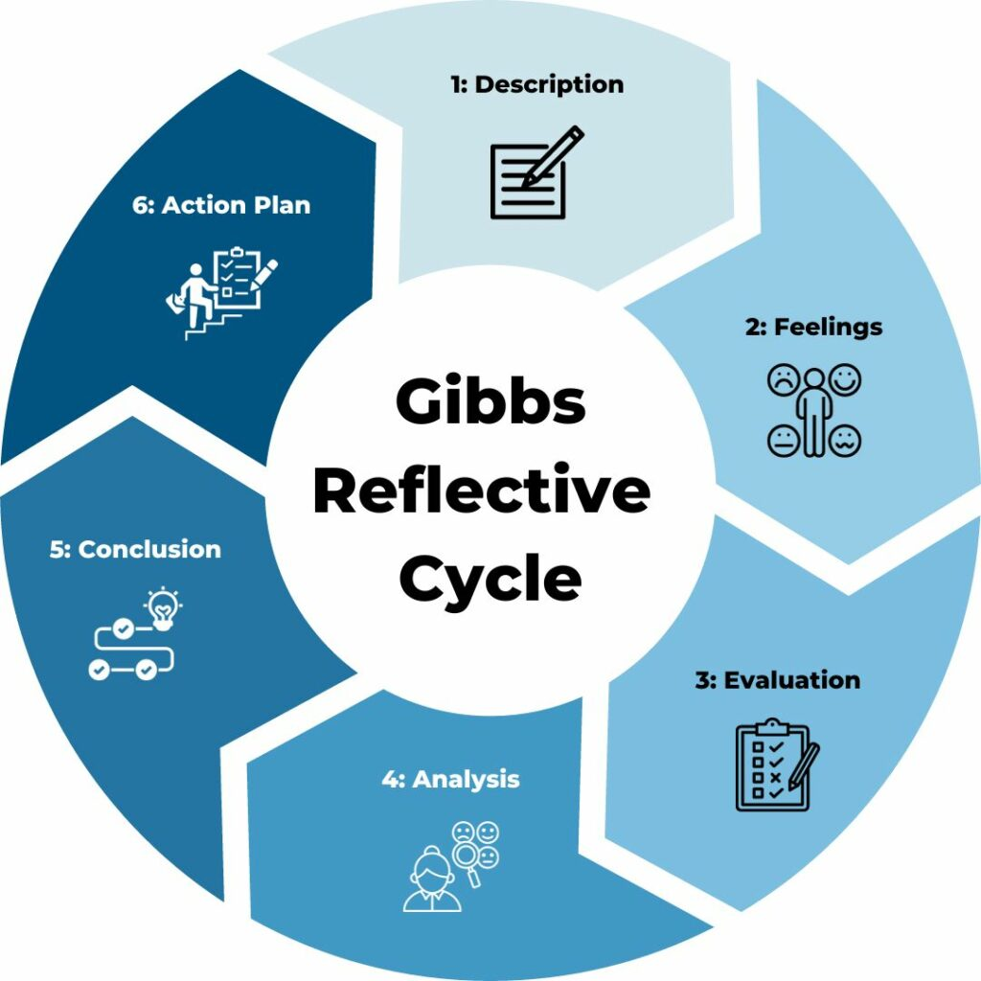
Figure 1: Gibb’s Reflective Cycle
(Source: Adeani et al., 2020)
Description
At the time of the professional career development lecture, I have explored diverse key models which has allowed me to grow in this area effectively. I have also gained some relevant skills and also understood my areas of improvement. Additionally, the models include The Career Anchors Model, Holland’s Theory of Career Choice and The Skills Framework for the Information Age (SFIA). Each of these has helped me to provide unique perspectives on career development. Career development is a very significant aspect which demands gaining relevant skills and knowledge to get diverse opportunities in several industries (P.J. Robertson et al., 2020). It also assisted me in understanding how personal values, interests and skills align with professional opportunities. However, the lectures also incorporated interactive discussion, significant group activities, and speakers from diverse industries. Additionally, these aspects foster an engaging learning environment where I can actively take part and reflect on my overall career aspirations. Moreover, I have also understood some of my strong skills i.e. good communication, emotional intelligence, creative and innovative thinking, problem-solving and leadership skills. Despite these, I have also shed light on areas of improvement i.e. poor time management, organising skills, project management, and ICT skills. These need to be improved over time for a better future approach.
Feeling
The particular stage is all about feelings at the time of experiencing the situation. These allow one to understand one's emotional and cognitive behaviour in diverse situations (Markkanen et al., 2020). At first, I felt overwhelmed by the diverse amount of information which was presented in the lectures. The diversity of career models allowed me to ask questions about my own career path and whether I had effectively prepared myself for future challenges and opportunities. Additionally, later I engaged deeply with the lecture's content and took part in discussions with peers, and my overall anxiety transformed into a little excitement. I began to experience the relevance of these models to my own situations and aspirations. However, a majorly influential moment was developed at the time the guest speaker sessions where started sharing their industry career journeys. They have shared both their success and failures with us, which helped me to have a more calculated approach and build ideas for career development. All of these are in continuous learning processes and adaptation. However, skills have contributed to the overall development of one’s overall thinking and success in professional settings (Cottrell, 2022). These areas help to boost my emotional intelligence and cognitive growth after getting in-depth insights about career development journeys.
Evaluation
Reflecting on the efficiency of the certificate of higher education in employability skills as indulged in professional career development lectures. I identified different strengths and areas for improvement. Additionally, the interactive nature of the sessions encouraged active participation and highlighted peer learning. The overall engagement with class peers enabled me to achieve diverse perspectives on career development, improving my understanding of diverse sectors. I also believe that more practical applications have been incorporated into the curriculum which will help to improve the overall skills and knowledge in the employability area. However, achieving effective employability skills will help to boost the overall approach towards business management careers for the learners (Gallagher, 2022). Additionally, the theoretical framework is essential, incorporating more hands-on activities like mock interviews and networking events within the area. All of these will provide me with some valuable real-world experiences within the area which is helpful in long-term future growth. The particular session on employability skills and the speaker’s also shared real-world examples has allowed me to gain insightful information about the industry. Additionally, there are the good aspects that happened within the situation that I have experienced within the area. Despite this, my poor skills and knowledge in employability skills like ICT and limited knowledge about project management lower my confidence and approach. These are the bad aspects of the situation that happened to me in this program.
Analysis
The incorporation of the effective model which has been taught and used within the area. The Career Anchors Model, after reflecting on my own anchors, majorly the autonomy and technical competencies. I realised that these aspects important impact my career selections. Additionally, when considering internship opportunities, I gravitated to positions that allowed independent project work where I could apply my strong skills. The individual also needs a strong mind-set which will help to tackle the initial challenges learners face while suffering in career development (Dweck, 2017). Additionally, Holland’s Theory of Career Choice, this model categorises careers based on six personality types, Realistic, Investigative, Artistic, Social, Enterprising and Conventional (RIASEC) (Hoang and Huy, 2022). Via the process of self-assessment exercises conducted in lectures, I learned strongly with the investigation type. Moreover, this realisation prompted me to seek an internship in research-oriented roles where creative and innovative thinking is paramount. The other model i.e. SFIA helped me to identify gaps in areas like project management and ICT, this insight motivated me to enrol in online courses to improve these skills in the future. However, throughout this effective process, I encountered several challenges that tested my resilience and adaptability. I have applied Gibb’s cycle to this module evaluating my application materials and looking for regular feedback.
Conclusion
The professional career development lectures have effectively influenced my overall understanding of career development models and their practical applications. The utilisation of effective models has enabled me to critically analyse my experiences and recognise areas of improvement. I have also planned to continue applying these models as I navigate my overall carer journey. The individual has reflected on his own experiences in the professional career development lectures, allowed to identify skills and areas of improvement (Bassot, 2024). All of these have assisted me in cultivating a strong mind-set of continuous enhancements. Additionally, the overall development via workshops and networking events to improve my skills in the future. However, this reflective process has equipped me with some valuable insights into aligning my personal values with professional aspirations and development in professional settings. I feel more confident in making informed decisions, that resonate with my passions and strengths within the area for a longer period of time.
Action Plan
The particular stage makes sure the ongoing personal and professional development continues by taking relevant steps by utilising the aspects of the action plan. I have outlined an action plan which will allow me to build and polish my skills and areas of improvement very effectively. Additionally, skill development, enrolling in courses online which will mainly focus on project management and ICT within the next four months. Taking significant steps and using the internet to improve skills will help to save time and costs for learners in HE (Paudel, 2021). Moreover, in networking, I have to attend around three industry-related events each semester to expand my network in the professional area. Career exploration, conducting informational interviews with diverse professionals in fields of interest to gain insights into diverse career paths effectively. Taking regular feedback from peers and teachers will help me to improve my skills and also help me to gain techniques which will continually refine my skills and approach. Feedback works very effectively for learners it helps to shape their understanding and allows them to approach differently in diverse settings (Hooda et al., 2022). By committing to this significant action plan, I will aim to build upon the foundation at the time of the professional career development lectures while fostering a proactive approach to my career advancement.

Conclusion
Overall, it is understood that career development needs proper incorporation in learning sessions and the development of skills and knowledge within the area. The above study highlights an individual of higher education in an employability skills program who has indulged in lectures on professional career development. By utilising the Gibbs reflective model, the individual has identified strong skills and areas of improvement within the lecture sessions. An action plan has also been developed to enhance areas of improvement which will help the individual in future professional roles within diverse industries.

References
Adeani, I.S., Febriani, R.B. and Syafryadin, S., 2020. Using GIBBS’reflective cycle in making reflections of literary analysis. Indonesian EFL Journal, 6(2), pp.139-148.
Bassot, B., 2024. The reflective journal. Bloomsbury Publishing.
Cottrell, S. 2021. Skills for success: personal development and employability . 4th edition. London :, Red Globe Press.
Dweck, C.S. 2017. Mindset . Updated edition. London :, Robinson.
Gallagher, K. 2022. Essential study and employment skills for business and management students . Fourth edition. Oxford :, Oxford University Press.
Hoang, N.T. and Huy, D.T.N., 2021. Determining factors for educating students for choosing to work for foreign units: Absence of self-efficacy. Jett, 12(2), pp.11-19.
Hooda, M., Rana, C., Dahiya, O., Rizwan, A. and Hossain, M.S., 2022. Artificial intelligence for assessment and feedback to enhance student success in higher education. Mathematical Problems in Engineering, 2022(1), p.5215722.
Markkanen, P., Välimäki, M., Anttila, M. and Kuuskorpi, M., 2020. A reflective cycle: Understanding challenging situations in a school setting. Educational Research, 62(1), pp.46-62.
P.J. Robertson, T. Hooley, and P. McCash (eds.) 2020. The Oxford handbook of career development / [electronic resource]. New York :, Oxford University Press.
Paudel, P., 2021. Online education: Benefits, challenges and strategies during and after COVID-19 in higher education. International Journal on Studies in Education (IJonSE), 3(2).

