5/1/2019
Callum Cross
Student number: 1705149
Research Proposal
Design & Implement a Node.js Web Application using REST Web Based Services and MongoDB.
Table of Contents
Type chapter title (level 1) 1
Type chapter title (level 2) 2
Type chapter title (level 3) 3
Type chapter title (level 1) 4
Type chapter title (level 2) 5
Type chapter title (level 3) 6

Introduction / Background to the proposed research
Introduction
In this section of the project proposal, we will be showing the type of project that is going to be assumed and the location that project will be focused towards. Briefly we will show the current research that we will be directing our project towards and the results that we would be expecting. We will finally be showing the objectives that we would expect to be accomplished whilst with the outcome of the project we would like to have.
- Give your research a working title
The title for the research project will be Design & Implement a Node.js Web Application using REST Web Based Services and MongoDB.
- Describe clearly the background to the subject area of study.
In Computer Science, web applications or web apps are a client-server computer program which the end-user (client-side visuals) run in a supported web browser. The main differences between a website and a web application is that a web site is statically formatted meaning that the information will be shown the same with every user whilst a web application will customise data shown to the end-user making the web application a lot more interactive.
Web applications are used around the globe and are a huge percentage of the web as they allow end-users to do multiple tasks in an efficient time whilst also being a visual website for the user, this is immensely helpful in business environments as applications can store and display information in a rapid amount of time and display the information in a readable or statistical technique.
The second area web applications can be useful are for Multi-Platform apps, applications like Facebook, Instagram and Twitter are all created as Web Applications this allows these types of platforms to be compatible and makes it easier when they transition to a different platform as most web applications can be supported for such devices like Mobiles, iPads, iPods.
A web service is any piece of software that makes itself available over the internet and uses a standardized XML messaging system. XML is used to encode all communications to a web service. For example, a client invokes a web service by sending an XML message, then waits for a corresponding XML response. As all communication is in XML, web services are not tied to any one operating system or programming language—Java can talk with Perl; Windows applications can talk with Unix applications.
To design a web application there are 3 rules you can take during the design phase. The first rule is understanding the problems that the potential users that could face in your web application daily, the second rule is understand what you expect the web application to be used for as this would drastically change the design depending what needed to be achieved. The third and final rule you should look at who will be using the web application as someone who is young will presumably understand a web application quicker than someone who might not use computers often, this refers to more elderly people.
When designing a web application there are fundamentals and protocols that should be followed to make sure the application can safely and securely deal with personal/private data as these applications will have to deal with storing and retrieving huge amounts of information in a small amount of time without the risk of loss of data and the integrity of the data.
Leon Shklar and Richard Rosen say in section 1.5.4 that the main principles of creating web applications are learning the fundamentals of web pages and the languages used to develop the HTML pages and interact with them. They also go on to say that you should also learn basic network protocols like SMTP (Simple Mail Transfer Protocol), TCP/UDP (Transmission Control Protocol, User Datagram Protocol) and IMAP (Internet Message Access Protocol).
‘What do we mean when we discuss the general languages and protocols that need to be understood to properly design and develop Web applications?
We mean the core set of protocols and languages associated with Web applications. This includes, of course, HTTP (HyperText Transfer Protocol) and HTML (HyperText Markup Language), which are fundamental to the creation and transmission of Web pages. It also includes the older Internet protocols like Telnet and FTP, protocols used for message transfer like SMTP and IMAP, plus advanced protocols and languages like XML.’
They also go on to the importance of security within web applications and how you should always build web applications with security in mind even if it’s adding a simple text box for input as this can give access to exploits that the creator might not be aware of.

- Provide the reader with an understanding of the field in which your study lies and an idea of where and how your study fits into this field.
The aim of this project is to design and implement a Node.js web application using a REST based web service and MongoDB. Once the web application has been completed and the feedback has been collected, we should find that the user experience has been improved with both usability and website performance should have increased. After that we can then compare the feedback results and do a slight cross-check to see if there were any advantages and disadvantages using Node.js than the typical PHP which includes processing JSON data.
- If relevant, introduce the industry/organisation/context that is being investigated.
The location for this research is the University of Wales, Trinity Saint David, Swansea Metropolitan. The Academia currently provides higher vocational degrees for all types of study within Swansea and the surrounding areas.
- Define one overarching aim of the study (the research purpose). Construct a series of objectives that specify what you will do to achieve the aim (typically 3 or 4 objectives).
The aim of this study is design and implement a Node.js web application with a REST based web service and MongoDB that can be used to test the performance and usability over other general-purpose programming languages like PHP and extract results that will show the benefits and drawbacks of using JSON data within these languages and what are the differences between them.
- To design and implement a Web Application using the objectives and aims.
- Analyse the differences between general-purpose languages that are used within web applications.
- Display the advantages and disadvantages of using JSON data with the chosen languages and were there any major effects when using this type of data.
- To write a Requirements and Systems specification for the web application.
- Investigate the major modifications of a web application over web sites and web applications functions and protocols.

- Expected outcomes and/or deliverables
At the end of the research project we would expect to have a good understanding into how a web application is designed and implemented and what are the benefits and drawbacks of using Node.js over other languages and if there are any major differences between them.
Additionally, a Requirements and Systems specification will be created which will include observation results and feedback from users that would go towards usability and could possibly be used as research evidence as it would give an in-sight to how all types of users thought of the web application and in their opinion how it could be improved.
Finally, a report will be created showing the results of the web application and will include a user manual. This report will consist of the results of performance testing of the web application, comparisons between the general-purpose programming languages and lastly the usability of the web application shown through user feedback.
Conclusion
In conclusion we have looked at the background of the project and outlined the research that would need to be looked at beforehand so that the project would not be compromised. We looked at the rules and protocols that would need to be looked at and learned carefully to make sure that there would be no comprise in data and its integrity. The location for the project was beheld and what results and expectations we expect to gain from the project and the objectives that have been set for the project to be achieved.

Research and Development Methods
Introduction
In this previous section we looked at the types of outcomes and objectives we would like from the research project and the location we would be using to undertake the research. In this part of the report we will be considering the potential research methods that can be chosen and the method that would be best suited for this project, furthermore we will be looking at the ethical and legal issues that could occur during the implementation of the project and the risks and limitations within the project. Finally, we will be looking at the objectives and goal of the project has been accomplished.
• Research Philosophies
Before any research can be started a method of research must be chosen to allow us to structure and break down problems that would need to be solved in the future. Below a figure is shown containing the `Research Onion` this breaks down all types of research to be done before continuing a project, these types include Techniques and Procedures, Time Horizons, Choices, Strategies, Approaches and to finish Philosophies.
Using the `Research Onion` we can determine what type of path we would like to take to create our project and what choices and approaches would be best suited towards our project.
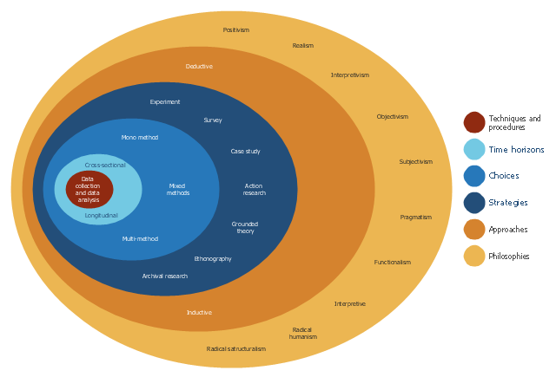
For this project that’s developing a web application we found that the best philosophy to choose that would meet our aims would be realism. This philosophe shows that every method must fit into the subject around the project, the project can also be a mix of quantified data or qualitive data depending on the project, this allows us to have great flexibility when collecting information.
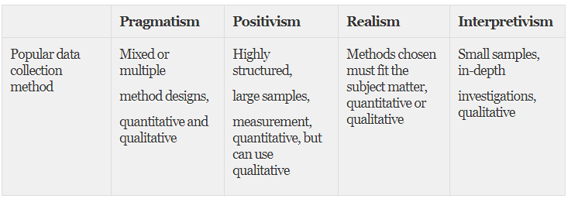
A substitute to this philosophy would be Positivism as it would allow a for a highly structured data collection method and would allow us to collect a large sample of data at one time, this philosophy is pushed more towards quantitative data but can also be qualitive if the data collection process is correctly monitored.
The only two methods that can be used within the `Research Onion`, firstly the deductive method, it can be used to develop a hypothesis from existing theory’s that already exist and then designing a strategy for research to test the hypotheses.
Secondly the Inductive approach can be used to focus on a current researched phenomenon and look at it from a completely different perspective or it can be used to create your very own research phenomena, Inductive approaches is normally associated with more qualitive research than quantified research.
• Strategies
Strategy is the third layer in the `Research Onion` and are used to create a style towards gathering and analysing data. Every choice has benefits and weaknesses. That makes it important that you understand your choices before choosing a specific strategy towards data collection.
Action Research has been chosen as the strategy for this project as it allows us to collect information whilst finding problems and solutions to those problems. It would be good for this web application project because it allows us to collect data whilst working with an in-complete implementation as some features can be disabled whilst they are being worked on when all the other features can be enabled and be used.
Finally, the Cross-sectional technique and procedure has been chosen as it allows us to collect data from a lot of users in a short amount of time and would be great for a short-term project. Longitudinal is for collecting data over longer periods of time which would not be acceptable in this kind of project.
• The study population and sample
The study sample for the project will consist of current students at the University and a small number of past students, it will also include staff from the Faculty of Computing and Engineering. current students could give feedback on the system that could give them more in sight in to how they can achieve the results they need for their current vocational course. The past students would be able to give good insight as to how this application could have helped them if they had the opportunity to use it whilst in study.
The staff within the faculty have a good understanding of the modules that are needed to be completed with each vocational course this will give us a good in-sight into what courses would be most important to focus for this project.
A further sampling could be from forums like “TheStudentRoom” which allows students to query information for their current course or courses that they would like to investigate. This can also be filtered to specific levels of study so you can ask pre-grad and post-grad students to use the software and give their feedback and how they could compare it to their past/current university.
• Data collection methods
As a web application to help students understand their current results and can compare what they may need to do go the extra step a Mixed Methodology Research will be incorporated as this will have both a qualitive and quantitative amount of data that will allow us to get a more accurate feedback data.
For us to identify where students think they need the most comprehensive data in their study a one to one interview will be taken place to make sure that we understand what data a student is looking for in their specific study as this could be different for other vocational courses.
Once the web application has been built both staff and students will asked to test the new system to make sure that they have the correct information they need and displayed to and to make sure the students know what they might need to do to increase their chances of a higher degree at the end of their course. The staff input would be very useful as it would allow us to gain information on what staff think is very important to a student during their university degree.

• Reliability and validity
Reliable and valid data is necessary to show accurate data, there are a couple of ways to make sure that you have valid data and not only have to do with collecting data with the necessary subject. To have consistent data there are a few procedures you can follow to do this.
- Cleanse Data Regularly
- Segment your data
- Regular checks on the collection data method
- Take your time to get reliable data (rushed data will not be consistent)
Validity of data can be in-accurate if the data being collected is not harvested in the correct manner which can lead to in-consistent results which will then follow the points we have just started leading to a longer process of data collection or even a start over of data collection.
These are some of the procedures you can do to your data to make it have validity
- Non-bias data
- Check for any participant or any author errors
- Check for any author or participant bias
All these points should be followed to make sure that all data can be both consistent and valid without influencing the whole project as this can lead to loss of time which could be crucial in both the early and final stages of development.

• If relevant, identify and justify any development methods and techniques that you will use as part of systems development. Consider an evaluative framework (such as Avison and Fitzgerald) to compare methods or to justify your selection.
Creating a web application can be a very big task if it’s not planned out in a methodical way therefore the chosen method for the project would be a basic but organised Web Application Development Process Flow that breaks down each task into their own content and allows the developer to create a web application in a logical and mapped out technique.
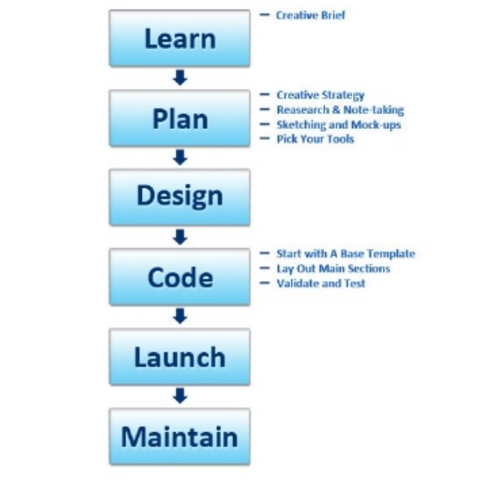
Learn & Discuss
The first step aims to give an overview of the problem we want to be solved and/or our needs. If the needs aren’t well understood it will lead to a failure in building a web application that aims to serve the purposes. The following questions must be answered once this first step is done:
- What are the underlying needs behind the application to be built?
- What problems should the application solve?
- What needs do the application fill? What will be the impact on our business?
- How will the application be used?
- What could be the consequences of the delay in building the application for our business?

Requirements Analysis
In the previous step, the goal was to identify the objectives of web application implementation. The objectives can be complex, the business logic being often quite complex in general. It is then important at this stage that these complex objectives can be broken down into more manageable tasks and therefore easier to implement, validate, and test.
At the end of this step, the following tasks should have been completed:
- Reformulate the underlying objectives and goals
- Think in terms of steps needed to complete the project
- Identify each different feature and module
- Break down every goal into simple tasks
- Consolidate the different analysis and approaches in a document so that a validation can be carried out.
Development
This is the most well-known step. Once the product requirements document is established, the development phase can start. The goal of the development phase is to create an application that meets the needs identified in the previous steps, and as the needs generally evolve and new ideas of implementation may arise during the implementation phase the development phase could possibly be adjusted.
The product requirements documentation should be used to implement all features, an efficient development approach should be chosen in order to make sure the codes are behaving as expected by the specification document. TDD (Test-driven Process) is one approach that aims to make sure that tests are dressed to test and simulate real behaviour. Testing helps all involved in the development process understand the code purposes and makes the hand out process easier.
Testing
Testing is probably the most routine part of a process. Every single link should be tested to make sure that there are no broken parts of the web application among them. You should check every form, every script, run a spell-checking software to find possible typos. Use code validators to check if your code follows the current web standards. Valid code is necessary, for example, if cross-browser compatibility is important for you.
Maintenance
What’s important to remember is that a web application is more a service. It’s not enough to “deliver” a web application to a user. You should also make sure that everything works fine, and everybody is satisfied and always be prepared to make changes in another case.
Feedback system added to the app will allow you to detect possible problems the end-users face. The highest priority task in this case is to fix the problem as fast as you can.
• How will you analyse the data/evaluate your results?
The final evaluation of the web application can be split into multiple methods the first one could be a re-look at the requirements and analysis to make sure that the website had met the goals and objectives it was created for. Secondly the data for both performances will be tested among other web applications that can-do similar tasks and see which website better performs this is both with websites with Node.js developed and others that does not use this type of platform.
Usability of the website can be mainly evaluated from the end-user’s feedback as this where most of the data will be collected and evaluated to see if the users have a better or worse time both navigating the web application and reaching their specific goals in a short and relaxed time.
• Identify risks/limitations/ethical/legal issues and ways that you might deal with those risks.
When designing web applications several issues need to be identified so if something is to go wrong then there would be a back-up plan in place for one of those unlikely events. These events could be
- Poor time organisation
- Not meeting all goals & objectives for the project
- Inconsistent Data / Validity of Data
- In-complete interviews and analysis
- Choosing in-compatible library’s/frameworks
These risks can be reduced by using 3rd party applications like Gannt Charts and calendars to make sure that all sections of the project have been planned with realistic time-frames, secondly the inconsistent data or meeting all goals and objectives can be alleviated with a considerable amount of research and analysis before starting the project.

There are not many legal and ethical issues other than working with student results/statistics which could be easily populated with fake information for testing purposes, doing so could alleviate the issue of any information that the students wouldn’t like to be displayed/calculated in the process.
Lastly, the limitations that would be introduced by the project, mostly from learning the languages and syntax needed to create a web application with Node.js and a REST based web service. These skills of course can be learned over time through self-learning. The best approach to this would be to start small with a web application and progressively build the web application as you gain more knowledge in the specific areas needed.
Conclusion
In this section we have discussed the techniques and methods that would be used to develop and research this project and how we would produce the data that would be needed for the final research. Finally, we identified the ethical and legal issues that would come with designing a web application and how we could reduce this as much as possible.
Resources and Planning
Introduction
In the previous section we looked at the techniques and methods that would give us the most reliable data with our project at the end of the research and analysis. We also looked at the ethical and legal issues that could occur with web applications and would that could result in. Finally, we looked at the main philosophies and development processes that would need to be chosen before the project has been started.
In this section we will consider the resources and planning requirements that would be needed for the forthcoming project. To conclude we will look at the management skills that would be needed to successfully complete this project in the time-frame.
• Identify any resources required
- PC/Laptop – used to build the web application.
- Visual Studio Code – IDE for developing the web application.
- Node.js – used as the framework for the web application
- REST Web Services – used as the back-end web service.
- MongoDB – used for the database of the project.
- Books on the subjected areas – Node.js, REST Web Services, MongoDB.
- Join a forum – TheStudentForum etc.
- Access to online surveys – Google Surveys, Survey Monkey etc.

• Construct a Gantt chart that demonstrates evidence of project planning and management. Identify the timescales for each component of the study.
In order to plan and manage each step of the project a Gantt chart has been constructed (see figures 4-8). The plan has been divided into two distinct sections that of Requirements & Specification and Implementation. Each task has been listed in order under the appropriate section before assigning dependencies to appropriate tasks. Finally, realistic completion dates have been assigned to each task.
Resources needed for the project (see figure 9) have been considered and entered the Resource sheet and assigned to each individual task.
The use of the PERT analysis tool can be used to work out the pessimistic, optimistic and expected dates. The weighting on the PERT can be set to favour one more than another. Using this will alter the dates to hopefully give a more realistic task completion date.





