
HUMAN POWERED MACHINE
ACMA5009: GROUP PROJECT

May 23, 2025
University of Wales Trinity Saint David

Table of Contents
Index of Figures 2
Index of Tables 3
Index of Equations 3
Project Planning and Organisation 4
Introduction 6
Mechanical Analysis – Joe Shankland​ 8
Design – Owen Bell 15
Materials Research – Catrina Morgan 28
Procurement – Luke John 43
Legislation – Julian Edwards 60
Conclusion / Critical Review of Project 63
Bibliography 65
Appendix A 77
Appendix B 78
Appendix C 82
Appendix D 87
Appendix E 91

Index of Figures
Figure 1 - Gantt Chart 5
Figure 2 - Simple Diagram of Mechanical System - Joe Shankland 8
Figure 3 - 3D Design of Final Mechanical System - Luke John 9
Figure 4 - Graph displaying Torque Required as Air Tank is filled - Joe Shankland 12
Figure 5 - Graph displaying Available System RPM as Air Tank is filled - Joe Shankland 13
Figure 6 - G LE Recumbent Bike - NordicTrack (2025) 15
Figure 7 - G LE Upright Bike - NordicTrack (2025) 15
Figure 8 - Average of Body Size Table - (Mukhtar et al., 2022) 17
Figure 9 - Bike Model - Owen Bell 18
Figure 10 - Bike Assembly Engineering Drawing No.1 - Owen Bell 19
Figure 11 - Bike Assembly Engineering Drawing No.2 - Owen Bell 19
Figure 12 - Bike Assembly Engineering Drawing No.3 - Owen Bell 20
Figure 13 - Bike Assembly Engineering Drawing No.4 - Owen Bell 20
Figure 14 - Bike Assembly Engineering Drawing No.5 - Owen Bell 21
Figure 15 - Bike Assembly Engineering Drawing No.6 - Owen Bell 21
Figure 16 - 9/16 Bike Pedal, (ROCKBROS, 2025) 22
Figure 17 - Shaft Engineering Drawing - Luke John 23
Figure 18 - Bearing Stand Engineering Drawing - Luke John 24
Figure 19 - Skid Engineering Drawing - Luke John 25
Figure 20 - Final Assembly Model - Luke John 25
Figure 21 - Adjustable Mechanisms - (Precor Incorporated, 2016) 26
Figure 22 - Alternative Pedals - (High on Bikes, 2025) 26
Figure 23 - Handcycle - (British Cycling, 2025) 27
Figure 24 – Galvanic Potential of materials in the Ansys Granta database 33
Figure 25 – Galvanic potential vs price of materials 33
Figure 26 – The Stages of database limitations for ideal material choice per component, using the Ansys Granta software. 39
Figure 27 – CO2 vs Price 40
Figure 28 – Final material choices vs price 41
Figure 29 - Final material choices: price vs CO2 footprint 42
Figure 30 Hydraulic Megastore (Hydraulic Megastore, 2021) 43
Figure 31 NC Air Store (Ncairstore.co.uk, 2025) 44
Figure 32 Duncan Rodgers Engineering (Duncanrogers.com, 2025) 45
Figure 33 Compressor Pump (CNCEST, 2025) 46
Figure 34- ZTTO MTB Bike 11 Speed Group set (AliExpress, 2019) 47
Figure 35 Pillow Block Bearings (Bolton Engineering Products Ltd - Bearing, Power Transmission & Workwear Supplier, 2025) 48
Figure 36 Make or Buy Analysis 49
Figure 37 Compressor shaft ISO 50
Figure 38 Compressor Pump Shaft Drawing 51
Figure 39 Skid ISO 52
Figure 40 Skid Drawing 53
Figure 41 Bearing Stand 54
Figure 42 Bearing Stand Drawing 55
Figure 43 Drawing of Bike by Owen Bell (Design) 56
Figure 44 Bike Assembly ISO 57
Figure 45 Bike Assembly with Parts List 58

Index of Tables
Table 1 - Real pedalling frequency (rpm) and mechanical external power (WEXT) at different target RPM for both bicycles – Telli (2014) 16
Table 2 – Summary of the general properties desired for each main component. 31
Table 3 – Air Tank Potential Materials 32
Table 4 – Bearing Stand Potential Materials 34
Table 5 - Information Summarised from Paul Cycles (2024) and Minarik (2025). 35
Table 6 – Compressor Pump Shaft Potential Materials 36
Table 7 – Flywheel Potential Materials 37
Table 8 – Skid Potential Materials 38
Table 9 – Final material recommendations 42

Index of Equations
Equation 1 - Torque Equation 10
Equation 2 - Torque Input Equation 11
Equation 3 - Available RPM Equation 11
Equation 4 - Highest Gearing Calculations 12
Equation 5 - Compressor Output Equation 13
Equation 6 - Fill Time Calculations 14

Project Planning and Organisation

Allocation of Roles and Responsibilities

Catrina Morgan (2405745)

Project Collator
Responsible for preparing and organising the final submission documents; report and PowerPoint.

Materials Engineer (Pages 28 - 42)
Responsible for evaluating the properties and selection of materials for use in the project, considering product functionality and longevity, based on material performance, raw cost and manufacturability.

Luke John (2320124)

Procurement Specialist (Pages 43-59)
Responsible for sourcing product and materials for use in the project, considering cost efficiency and Design.

Julian Edwards (2315607)

Legislation Analyst (60-62)
Responsible for ensuring the project complies with legal regulations to ensure safe and proper use when producing and using the final product.

Owen Bell (2316885)

CAD Designer (Pages 15 - 27)
Responsible for creating technical drawings and digital models to support product development with considerations to anthropometrics and ergonomics.

Joe Shankland (2317772)

Mechanical Design Engineer (Pages 8 - 14)
Responsible for creating and developing the function design of the product. Also responsible for analysing the efficiency and function of the mechanical system.

Time Management
Some of the key milestones achieved during this project were the completion of the Analysis section, where a fuller understanding of how the product will function and the requirements in regard to how much power is required. Suitable materials and components that will enable the product to achieve its function and the impact that it could have on the design were also considered. This helped to progress the project in a collaborative manner with each member aware of the requirements that needed to be achieved to make the product functional. This can be seen in Figure 1 which displays the Gantt chart followed during this project. Moreover, the Gantt chart aided the project ensuring that each member was able to track what outstanding actions needed to be completed and the associated deadline to help continue progress. Important dates were also used to arrange group meetings to ensure deadlines were met on time.
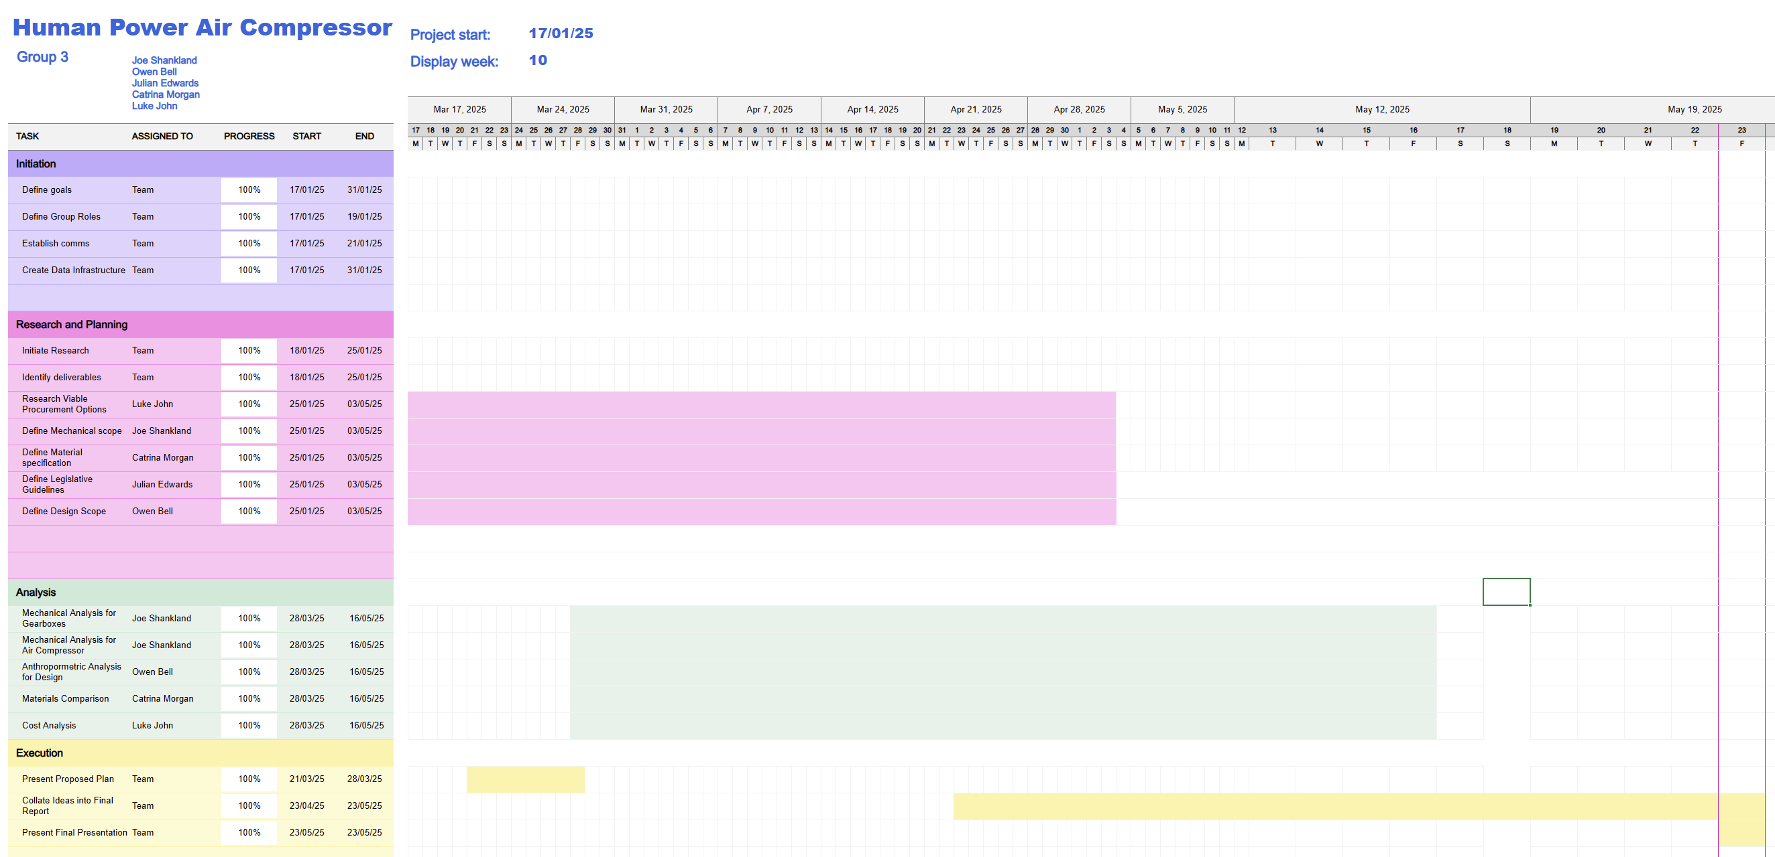
Figure 1 - Gantt Chart

Introduction
The product conceptualised in this report is a human-powered machine capable of pressurising and storing air, which can power air tools. The idea behind the product is to provide an alternative to electricity or gas-powered tools in more rural parts of the world where the infrastructure may not be fully developed. Whilst reducing cost and emissions. The chosen machine is a bicycle; whereby pedalling power can be generated to operate the air compressor. To create mechanical power is important, but being able to store it is the next important step in the development of this project. As not only does this mean energy will not be wasted, as it can be stored, but it means energy is always available through stores.
To ensure the product is not only functional, but viable in real a real-world setting, a number of design considerations must be addressed. The system must consider efficiency, ergonomics, cost, durability and legislation. To ensure efficiency, the drive train that powers the air compressor must be designed to provide sufficient RPM and Torque values, using the mechanical advantage of gears. This is important to ensure that a natural cadence and realistic power output are accounted for. To be able to use the stored energy, the air tank must be configured correctly, taking advantage of pressure valves and gauges to ensure safe and consistent operation. Analysing materials and manufacturing methods ensures that the tank is robust enough to withstand repeated pressure cycles and changing environmental conditions. Cost must also be considered in this however, to ensure the system is accessible and maintainable for the targeted audience, which can be achieved by using commonly available materials and components to keep repair costs to a minimum. Finally, the entire system must consider safety, ensuring that any product promote injury, ensuring moving parts are guarded or moved away from the user, as well as ensuring the whole construction follows relevant legislation and standards. Health and safety are the most important considerations when developing a product so it is important to consider legislation and standards for both the UK and EU for the manufacturing and use of this product due to the intention of being used in more rural areas. It is also important to accurately identify and mitigate any possible risks for the end user and when manufacturing the product, providing any warnings as necessary.
​To achieve this, the product must meet the following specifications:
- ​The bike must be designed to accommodate the operator so that the user can comfortably use the product over extended periods.
- The design must consider anthropometric data to ensure the product is suitable for operators of various sizes
- The design must consider anthropometric data
- ​The system must incorporate a mechanical gearing system to manipulate RPM and Torque where necessary.
- ​Efficiently and smoothly convert the users' exerted energy into pressurised air, which can be safely stored.
- ​Must be compatible with common air tools.
- ​Pressure must be maintained and not lost between pressurising the tank and powering air tools.
- ​The product must be suitable for all environments.
- ​Must be self-sufficient and not require electricity or gas.
- ​The overall design should minimise reliance on proprietary parts, favouring components that are readily available globally.
- The systems operation must be safe and intuitive, ensuring all legislation and standards are adhered to.
The materials researched will focus on the main elements of the design and will not consider real world effects on materials and their availability or pricing. The general properties of the components chosen will be outlined and used to base further work around. The research will consider which material properties are best suited for the component and data shall be evaluated and summarised for the convenience of the reader. A conclusion on a material recommendation per component will be summarised.
Reliable suppliers will be used where possible to procure the items needed for this project. Items will be chosen based on factors such as quality, function, and suitability for the project, not only price. A make or buy analysis will be carried out to determine if it would be more cost-effective to produce the fabricated items in-house or to outsource them. Necessary fabricated items will be designed, and from these fabrication drawings, will be produced and used to estimate the price of these items, and send to engineering companies to obtain quotes. The importance of planning and its relation to lead times will be investigated. Along with different opinions to reduce the production cost of the project, these range from recycling items to outsourcing production to lower-cost countries.

Mechanical Analysis – Joe Shankland​

System Design
After deciding on the method for energy creation and storage, the next step was to design a system that would be able to carry out this process smoothly and efficiently. As shown below in Figure 2, the mechanical system design included:
- Pedal Assembly
- Chain
- Bicycle Cassette/Gearbox
- Drive Shaft
- Flywheel
- Air Compressor
- Air Tank (and associated valves)
Air Tank
Air Compressor
Output Valve
Pedal Assembly
Input Valve
Flywheel
Drive Shaft
Gearbox
Drive Belt/Chain

Figure 2 - Simple Diagram of Mechanical System - Joe Shankland

These components were selected both for their mechanical compatibility and simplicity, but also their availability in the market. The simple design follows the specification, ensuring that the mechanical aspects are compliant. However, after further analysis and 3D design, it was found that the system could become more compact by stacking the air compressor on top of the air tank, which would require a re-configuration of the drive train. This is shown in Figure 3.

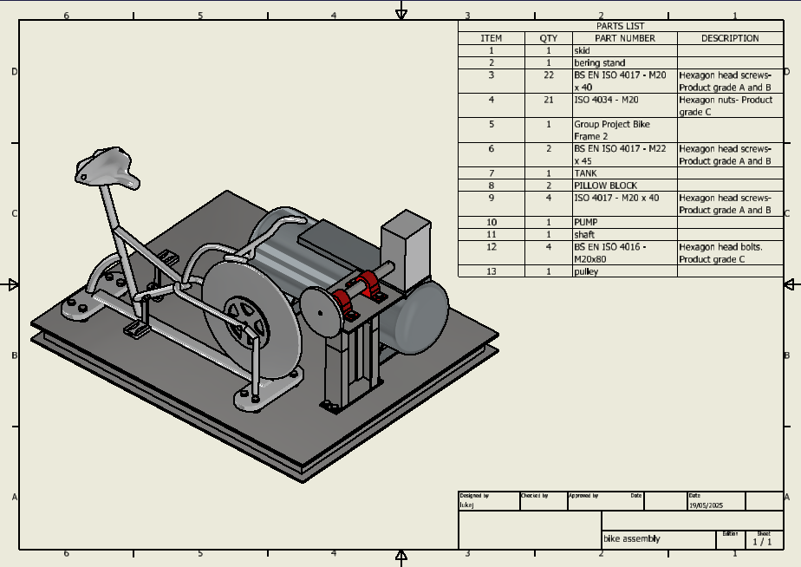
Figure 3 - 3D Design of Final Mechanical System - Luke John
The new drive train consists of:
- Pedal Assembly
- Drive Chain
- Bicycle Cassette
- Drive Pulley
- Drive Belt
- Driven Pulley
- Drive Shaft
- 2 x Pillow Block Bearings
- Flywheel
- Air Compressor
Each of these changes were important to ensure the system worked efficiently and appropriately. The introduction of a Drive Belt and Pulleys meant that the power could be transferred to a second level, on top of the air tank, where the air compressor would now sit, decreasing the overall footprint of the system. Due to the introduction of a second level, a new drive train was required up to the air compressor, which consists of a driven pulley, drive shaft, a flywheel, and two pillow block bearings. This setup allowed for smooth and stable power transmission, as the flywheel stores rotational kinetic energy, promoting the smooth transition of power through the drive train (Testbook, 2023), and the Pillow Block Bearings provide support to the shaft, and reduces the mechanical wear impacting the air compressor. To adhere to the design specification, an air compressor was chosen with suitable specifications to allow it to be powered by a human, this included a CFM high enough to provide adequate power for tools and to fill the tank in an appropriate time, as well as being low enough to be created by human power.

Power Considerations
Using sources, that take input from users to calculate cycling efforts, it was decided that to ensure the system would be usable for the majority of the population, the average power data would be used from the bottom 5% of amateur cyclists. According to (Johnstone, 2018), this meant that the average user would be able to output an average 202W over a 20 minute session as seen in Appendix A. Additionally, according to (Team Peloton, 2023)and (Hurley, 2021), beginner cyclist pedal with a cadence of 65-85RPM, whereas more advanced cyclists have a cadence of 75-95RPM. To ensure that both beginner and more advanced cyclists were accounted for, the average cadence was selected at 80RPM. To calculate the RPM which can be provided to the air compressor, the needed torque must first be found. When the air tank is empty, the torque required to spin the compressor is low, meaning, at the same power output, the gear ratio can be changed so that the output speed is increased, and the output torque is low. However, when the air tank fills up, the torque required to spin the compressor increases, to estimate this, we can take the recommended motor size for the compressor, and calculate the recommended torque. This simply assumes that the maximum torque needed when the tank is full, will be contained in the recommended horsepower.
Therefore, using the specifications of the chosen air compressor, we can use the recommended horsepower to calculate the maximum needed torque.
$$Recommended Horsepower=2hp$$
$$Required RPM=960$$
$$Torque\left(Nm\right)= \frac{Torque\left(ft/lbs\right)}{0.7375621493}$$

$$Horsepower= \frac{RPM*Torque(ft/lbs)}{5252}$$
$$Torque(ft/lbs)=\frac{Horsepower*5252}{RPM} \\ =\frac{2*5252}{960} \\ =10.94167 \\ Torque\left(Nm\right)=\frac{10.94167}{0.7375621493} \\ =14.843$$
Equation 1 - Torque Equation

Using this method, it shows that, the torque recommended for this air compressor is 14.8Nm, however, for the user to be able to provide 14.8Nm of torque while still maintaining the average of 202W, the gearing will have to be changed down to accommodate this. Initially however, as previously mentioned, when the tank is empty, the torque required will be low, allowing for the use of the highest gear to run at a high RPM and reduced torque. The calculations below consider the max RPM from the drive train, which can be used when the tank is empty, as well as the RPM needed to provide sufficient torque as the tank fills up.

$$Selected Chainset=38 tooth \\ Selected Cassette=52-11 tooth \\ Largest Gear Ratio=38:11 \\ =3.45:1$$Input Power
$$Input RPM=80 \\ Average Power Input=202W$$
$$Torque\left(Nm\right)=\frac{Power\left(kW\right)*9550}{RPM} \\ =\frac{0.202*9550}{80} \\ =24.11$$
Equation 2 - Torque Input Equation
$$Average Torque Input=24.11Nm$$

Drive Train Specifications for Full Tank
To calculate the necessary gearing to ensure full torque when the tank is full, the power must be considered. Using the formula for power generation below, this can be calculated.
$$Required Torque=14.8Nm \\ Average Power Input=202W$$
$$RPM= \frac{Power\left(kW\right)*9550}{Torque\left(Nm\right)} \\ =\frac{0.202*9550}{14.8} \\ =130.3$$
Equation 3 - Available RPM Equation
These calculations show that, to ensure adequate torque is provided to the compressor, while considering the user’s output power, the RPM should be set at 130. In the system this can be achieved using the bicycle cassette and changing the gear ratio to roughly 1.6:1. This would mean the chain would run from the first 38 tooth sprocket to a chainring with 24 teeth.
Drive Train Specifications for Empty Tank
Considering the Calculations for when the air tank is empty, it can be assumed that the required torque is minimal, meaning the gears can be utilised to provide the highest RPM possible.
$$Largest Gear Ratio=3.45:1 \\ Input RPM=80 \\ Average Input Power=0.202kW$$

$$Highest Output RPM=3.45*80 \\ =276$$
$$Torque\left(Nm\right)= \frac{Power\left(kW\right)*9550}{RPM} \\ =\frac{0.202*9550}{276} \\ =6.99$$
Equation 4 - Highest Gearing Calculations
Assuming that the torque required when the tank is empty is below 6.99Nm, this means the RPM can be increased, with the system allowing for an increase in RPM with the ratio of 3.45:1.
Analysing this data, along with the specifications of the air compressor chosen, the time taken to fill can be estimated. The following calculations simplify the this by assuming that the air compressor needs a torque input which is directly proportionate to the volume of compressed air in the tank. However, this isn’t accurate as this example is closer to a polytropic process where temperature is created in the system. The graphs below display the relationship between the air compressors demand for Torque as the Air Tank is filled and the available RPM based on the average power input of the user as the Air Tank is filled.

Figure 4 - Graph displaying Torque Required as Air Tank is filled - Joe Shankland

Figure 5 - Graph displaying Available System RPM as Air Tank is filled - Joe Shankland
Figure 4 and 5 further demonstrates the inversely proportionate relationship between Torque and RPM. Figure 5 also allows for the estimated fill time to be calculated, by finding the average compressor RPM, which is 203.15. The following logic demonstrates how the fill time is estimated, by calculating the air compressors output at the average RPM.

$$Compressor Output @ 960RPM=\frac{170L}{min}$$
$$Compressor Output at average RPM=\frac{203.15}{960}*170 \\ =36 L/min$$
Equation 5 - Compressor Output Equation
Assuming atmospheric air is at 1bar of pressure, the volume of atmospheric air needed to fill a 100 litre tank to 8 bar can be calculated using Boyle’s Law (Monahan, 2019).
$$Initial Pressure=1bar \\ Final Pressure=8bar \\ Final Volume=100litres$$
$$Boyle^{'}s Law \\ P_{1}V_{1}=P_{2}V_{2} \\ 1*V_{1}=8*100 \\ V_{1}=800litres$$

Now using the average output, the estimated fill time can be calculated.
$$Fill Time=\frac{800}{36} \\ =22mins$$
Equation 6 - Fill Time Calculations

Calculations Analysis
Using commonly known formulas for power, pressure, volume, RPM, and torque. The user power input can be used to calculate the performance of the compressor, including estimating fill time of the air tank. However, in using these calculations, a lot of assumptions were made, the biggest of which being the torque required and the relationship between the torque required and the volume of air in the tank. Assuming that the relationship between these two variables is linear is unlikely to be true due to the nature of the process, as well as the introduction of heat generation, which causes waste. To obtain an accurate value for the relationship between these two variables, real-world testing of the equipment would have to be carried out to assess how each component impacts the efficiency. One example of inefficiency could be due to a lack of maintenance of the air compressor, incorrect oil could cause a lack of compression in the cylinder, or a blocked air filter could cause a reduced intake. Another consideration could be of the build quality of the air compressor, as simple design mistakes or tolerance errors could cause energy loss through turbulent flow or air leaks.
Another assumption that was made, was that the recommended horsepower for the motor, was also the required horsepower for the motor. However, in most cases, manufacturers often recommend using larger motors than required to account for inefficiencies, as previously mentioned. This could mean that, while the motors are capable of producing the calculated torque values, the air compressor may not need torque values that high to work as intended.
It is also observed that, the gearing system is only able to multiply the inputted RPM by a factor of 3.45, meaning for the air compressor to run at a full 960 RPM, the user would have to be cycling with a cadence of 278 RPM, which is not suited for this application. As observed previously, there is minimal torque required at startup, meaning that, for this instance, it would be beneficial to improve the gearing system to amplify the RPM closer to 960. This could be achievable by changing the ratios between the chainring and cassette sprockets, or by changing the ratio between the pulleys.

Design – Owen Bell

Design Research
When designing the bike for this project, an understanding of what type of bike should be designed, with exercise bikes being available in both upright and recumbent designs as shown in Figures 6 & 7.
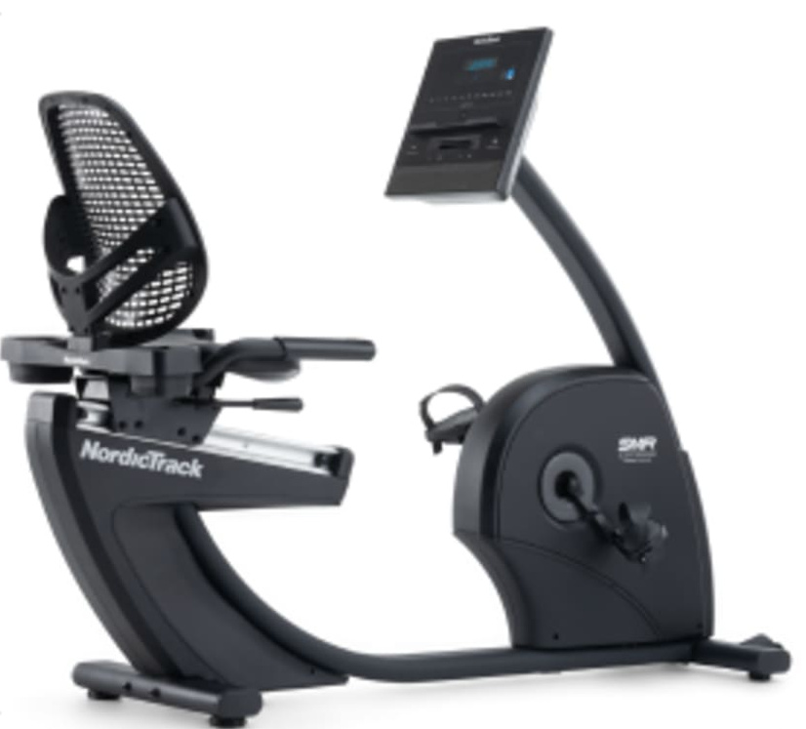
Figure 6 - G LE Recumbent Bike - NordicTrack (2025)
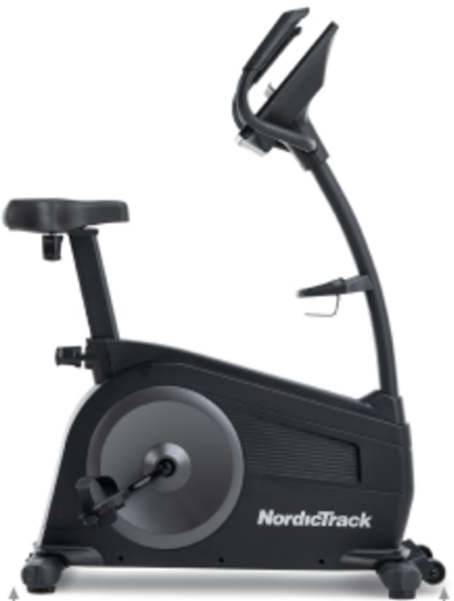
Figure 7 - G LE Upright Bike - NordicTrack (2025)
It is often viewed that the recumbent design requires less energy than its upright counterpart, with Puig (2014) stating that “many riders switch to recumbents to alleviate the chronic back from riding upright bicycles. In addition, the fact that recumbent riders are not bent over as are conventional bike riders, makes breathing easier”. This suggests that a recumbent design would be better suited based on the purpose of the product, which is to pressurise a tank capable of supplying pressurised air for tooling, which could become a strenuous and tedious activity when using the bicycle over a prolonged period. However, a study conducted by Telli (2014) investigated the external mechanical work (WEXT), referring to it as “the work due to overcome rolling and air resistance and the metabolic energy spent against these components”, in Tellis (2014) study the following results are displayed as seen in table 1.
Table 1 - Real pedalling frequency (rpm) and mechanical external power (WEXT) at different target RPM for both bicycles – Telli (2014)
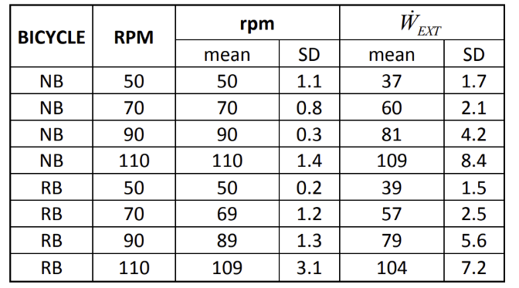
With Telli (2014) further stating, “the same target pedalling frequency (RPM) could be considered constant, maintaining similar values for the two bicycles with a difference always lower than 5% between them”. Proving that the difference in WEXT between the two bicycle designs was negligible. Furthermore, the design requires a pulley mechanism to convert the operators pedalling into pressurised air resulting in the design choice between recumbent and upright being largely determined by the pedal locations, as seen in figures 6 & 7, the recumbent's pedals are located on the front wheel of the bike where the pulley system would be located, alongside posing a risk to the operator's safety with the pulley system being in close proximity to where the operators legs would be. In contrast, the upright bicycle design allows for easier and safer integration with the pulley mechanism without a risk of coming into contact with the operator.
Additionally, both the upright and recumbent bicycles opted for an I-frame structure to provide support for the operator when using the apparatus and enabling it to be self-supported and bump stops at the base to allow for use on most surfaces whilst preventing the bike to slide when in use, which was incorporated into the final design. Moreover, other aspects of the design, such as the front wheel and the size of the pedals used in the design, are taken from those of a typical bike, Hurst et al. (2016) claiming that “the standard mountain bike wheel diameter has long been 26 inch. However, in the past 10 years two more wheel size standards have been introduced, 29 inch and more recently 27.5 inch”.
However, the remainder of the bicycle's design main features are driven by ergonomics and anthropometric data in mind. Bridger (2008) defined ergonomics as “the study of the interaction between people and machines and the factors that affect the interaction. Its purpose is to improve the performance of systems by improving human–machine interaction”, Bridger (2008) expands on his definition stating that “the way this interface is designed determines how easily and safely we can use the machine” with the main focus and purpose of ergonomics is to “call for a better interface and better interaction between the user and the machine, and better task design”. Additionally, anthropometrics and its application in ergonomics “generally include the design and layout of the spaces in which people live and work, with particular reference to anthropometric considerations, such as reach (e.g. the ability to grasp and operate controls, such as switches, buttons, knobs, etc.)” (Dianat, Molenbroek and Castellucci, 2018). Despite anthropometrics enabling a more user-centred design and product it has its limitations with the collection of data as it relies on the person who has collected the data to do so accurately alongside the data representing a sample size of a population. In addition, designers make two main assumptions according to Vasu and Mital (2000) being “that if an individual's stature is a certain percentile of the population, his/her other body dimensions will also be the same population percentile (the population percentile invariation assumption)” and the other assumption is “to use the normal distribution”. By making these assumptions it can lead to unsuitable designs and potentially cause discomfort as a person’s body will vary in size. This was concurred by Vasu and Mital (2000) who concluded based on their results gathered “that it is inappropriate to make either the population percentile invariability assumption or the normality assumption”. In spite of the results from Vasu and Mital (2000), A book by Stack, Ostrom and Wilhelmsen (2016) refers to three ergonomic principles when applying anthropometric data “design for a range, design for the extreme, and design for the average”. Stack, Ostrom and Wilhelmsen (2016) expand on these principles, stating that design for range is based on “allowing for adjustments in position, size, intensity and duration of the product or system, to accommodate unexpected circumstances and maximise use”. Whereas, design for the extreme focuses on designing for those within the “1^{st-}5th or 95th-100th percentiles of population group” (Stack, Ostrom and Wilhelmsen, 2016) and design for the average focuses on “design for the 50th percentile” also known as the average, when designing the bike, the principle which will be considered is design for average as this will best accommodate the most operators without the inclusion of adjustable components.
Whilst designing the bicycle, reports from Gordon (2006), which provides a variety of anthropometric data for male and female Americans taken initially gathered in 1988, and a report from Mukhtar et al. (2022), who have collected anthropometric data relevant for designing an E-Bike with the results found shown in Figure 8.
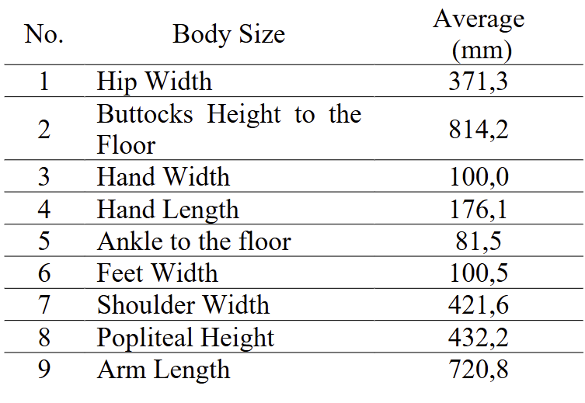
Figure 8 - Average of Body Size Table - (Mukhtar et al., 2022)
Mukhtar et al. (2022) also discuss how this data can be used for several areas,
“1. The length of the arm used to measure the distance from the saddle to the handlebar.
2. Height of the butt to the floor to measure the distance from the saddle to the floor.
3. Popliteal height is used to measure the distance from the saddle to the footrest.
4. The ankle to the floor is used to measure the height of the footrest
5. Foot width is used to measure the width of the footrest.
6. The width of the palm is used to measure the width of the hand grip on the handlebar.
7. Hip width is used to measure the width of the saddle to be used.
8. Shoulder width is used to measure the width of the handlebar.
9. The length of the hand is used to measure the width of the handlebar grip”.

Designs
By using Mukhtar et al. (2022) guidelines for what dimensions should drive the dimensions of the bike, alongside Mukhtar et al. (2022) and Gordon's (2006) anthropometric data, the model shown in Figure 9 and the accompanying engineering drawings shown in Figures 9 -14 were created.
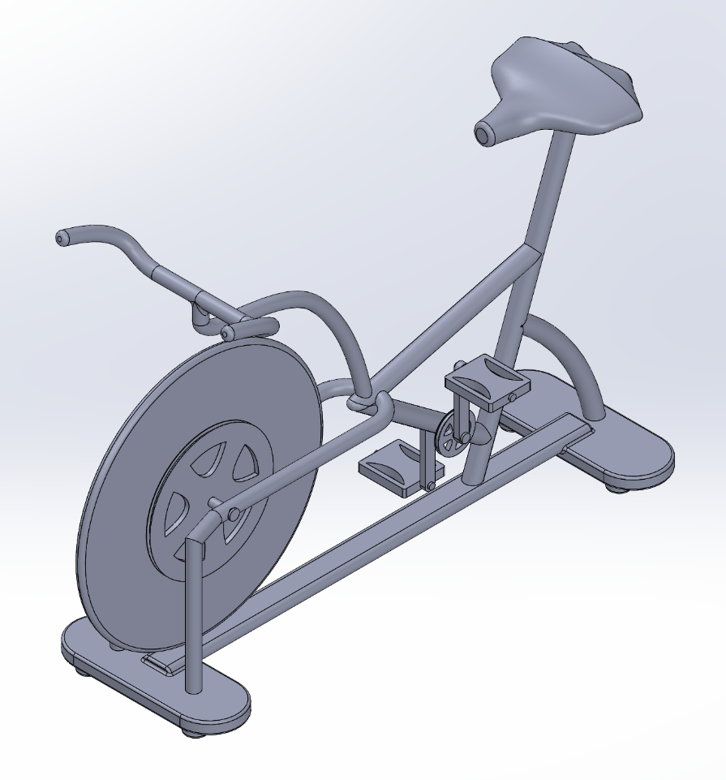
Figure 9 - Bike Model - Owen Bell
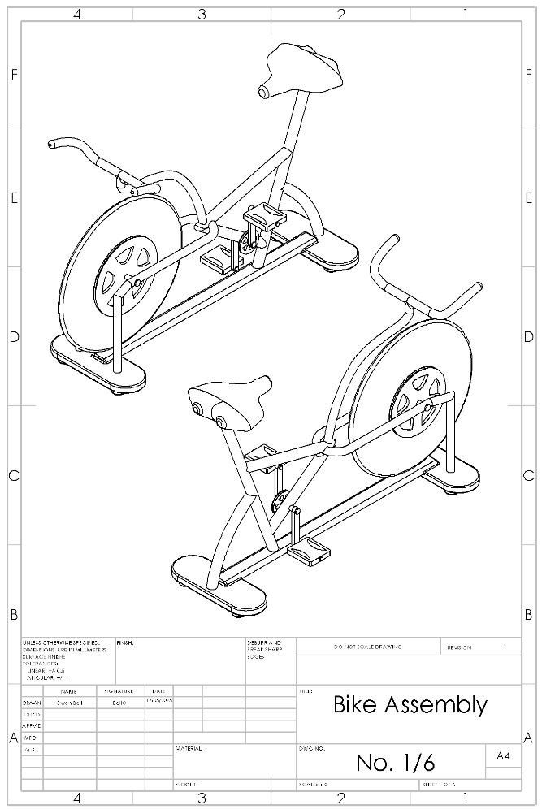
Figure 10 - Bike Assembly Engineering Drawing No.1 - Owen Bell
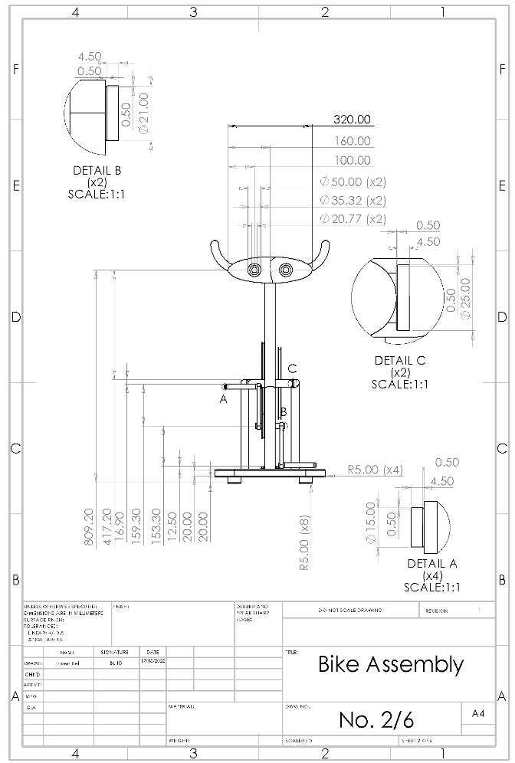
Figure 11 - Bike Assembly Engineering Drawing No.2 - Owen Bell
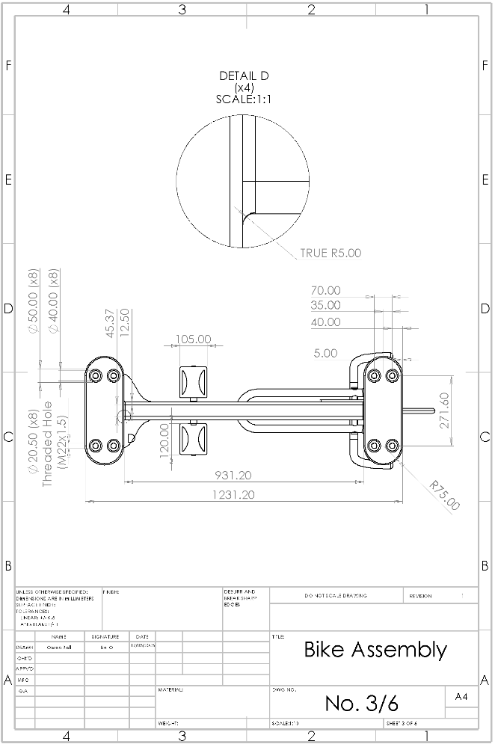
Figure 12 - Bike Assembly Engineering Drawing No.3 - Owen Bell
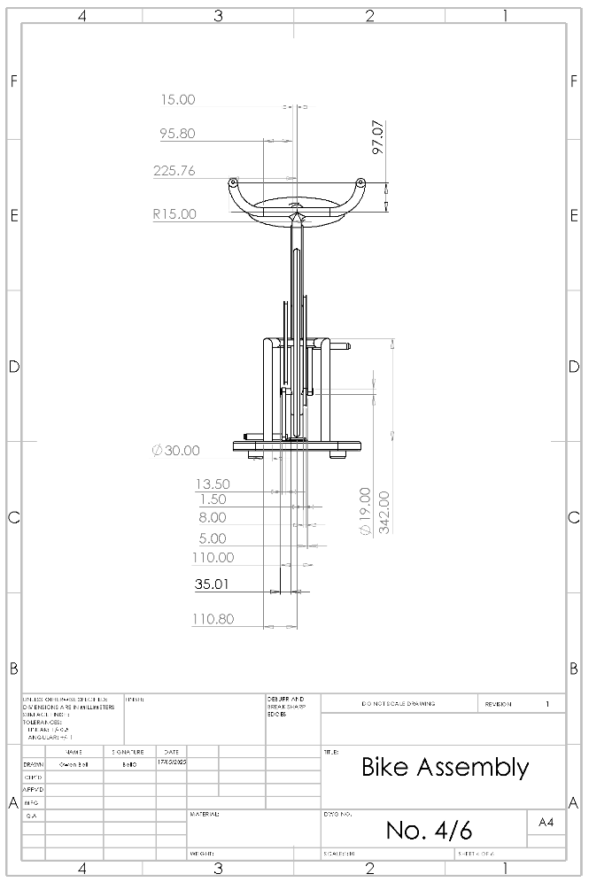
Figure 13 - Bike Assembly Engineering Drawing No.4 - Owen Bell
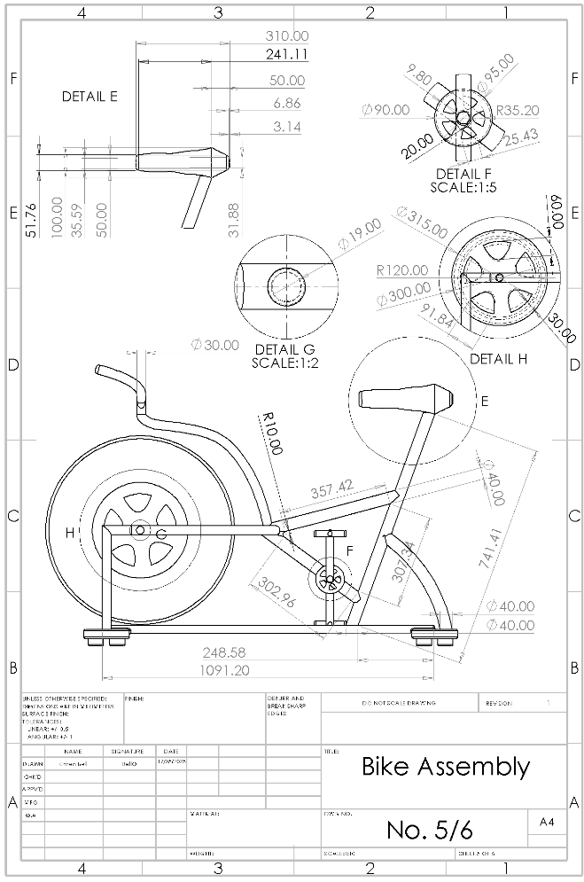
Figure 14 - Bike Assembly Engineering Drawing No.5 - Owen Bell
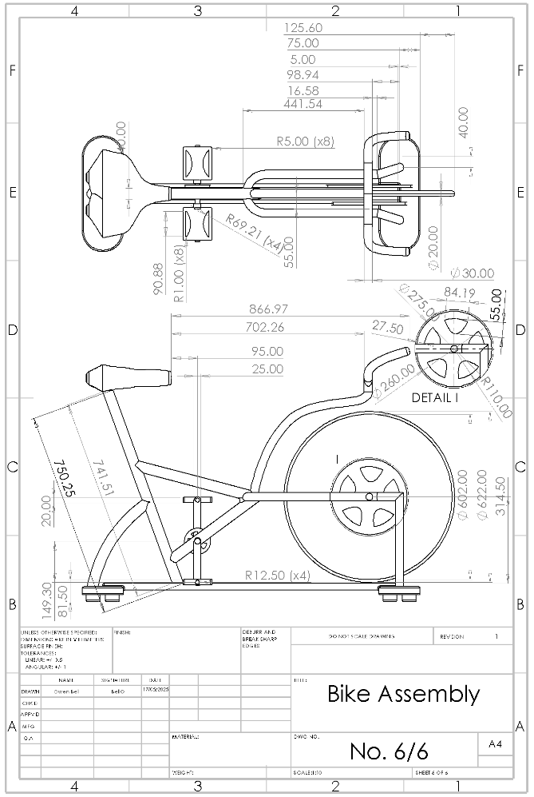
Figure 15 - Bike Assembly Engineering Drawing No.6 - Owen Bell
Reviewing the engineering drawings, the application of anthropometric data can be seen with the width of the handlebars shown in Figure 13, with the total width being 450mm, equivalent to the average shoulder width found in Mukhtar et al. (2022) reported once the diameter of 30mm of the handlebar is considered which was determined from Gordon’s (2006) data for wrist-centre of grip length which when halved is roughly 30mm for the 1st percentile to ensure everyone is able to comfortably hold the handlebars. Moreover, this can be seen in Figure 11, with the popliteal height from both Muktar et al. (2022) & Gordon (2006) being roughly that of the difference in height from the seat to the highest point of the pedals, alongside the ankle to floor height from Muktar et al. which relates to the where the foot would rest when the pedal is at its closest point to the ground shown in Figure 13. Additionally, the height of the seat is based on Muktar et al. (2022), Buttocks height to the floor being 814.2mm, which is the ride height of the bike shown in Figure 11.
Whilst there are other components of the bike for which have been determined anthropometric data there are various aspects of the design which have been taken from general bike components. As previously mentioned, Hurst et al. (2016) stated that the bicycle wheels are typically between 26-29 inches in diameter. According to Montague Bikes (2019), “The actual ISO diameter of a traditional 26″ wheel is 559 millimetres” and “both 29″ and 700c wheels is the same at 622mm”, as seen in Figure 15, this is the diameter of the front wheel. Moreover, the pedal dimensions are taken from those of a 9/16” pedal, as seen in Figure 16 below, which are commonly found on most adult bikes.
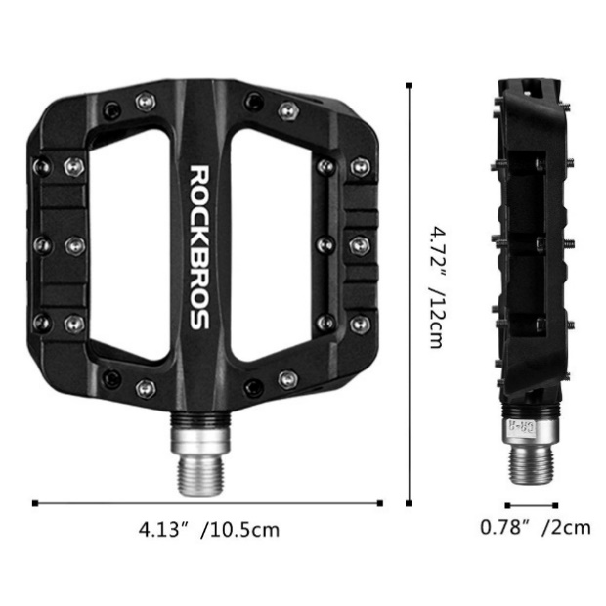
Figure 16 - 9/16 Bike Pedal, (ROCKBROS, 2025)
As seen in Figure 14, the dimensions of the bikes pedal pulley system can be seen where noted in detail F and H it can be seen the pedals pulley is 90mm in diameter and is connected to a pulley located near the front wheel, which is 300mm in diameter making this pulley system a step up system and having a mechanical advantage of roughly 3:1. Additionally these pulley are designed with guides of an additional 5 and 15mm respectively, this is to minimise the likelihood of the drive system becoming loose from the pulleys with the bike being designed for two kinds of drive systems being chain and belt drive due to the screw on caps shown in Figure 10 in detail A-C. Čepon and Boltežar (2009) state that “belt drives are commonly used to transmit power in many engineering applications, such as automotive engines, industrial machines, etc.” this is reiterated by Chowdhury and Yedavalli (2016) who expand on some the advantages of a belt drive system over a chain system being that the belt drive system is “low cost, light weight, quiet operation, easy maintenance, and flexible locations of the driver and driven shafts”. However, Čepon and Boltežar (2009) contradict this, claiming “belt drives can exhibit complex dynamic behaviours such as transverse vibrations of the belt spans, tension fluctuations, sliding of the belt over the pulley, etc. This can lead to fatigue of the belt, sliding wear and unexpected angular speed loss between the driver and the driven pulleys”. Similarly, a chain drive system according to Rackov et al. (2019) “are used in the transmission of mechanical energy, from driving shaft to the driven, for wider centre distances, for the transmission of higher power and for a constant transmission ratio, at usually lower speeds and for the same direction of rotation” who continue to state that “chain drive systems have high efficiency of transmission, requires no initial tension and can transmit power over distances larger than gear drives”.
Displayed in Figures 14 & 15, both detail H and I are connected on a bar 19mm in diameter through the centre of the front wheel, which enables the rotational force generated from the pedals to be transferred to the pulley mechanism noted H dimensioned at 260mm in diameter, this is to match the pulley provided with the bought in compressor in order to, not create a step change from the produced force.
The bought-in flywheel is connected to the compressor from a shaft as shown in Figure 17 which is supported from a bearing stand shown in Figure 18, designed to ensure that the pulley mechanism does not interfere with the operator when pressurising the tank and ensuring it is at a safe distance when in use.
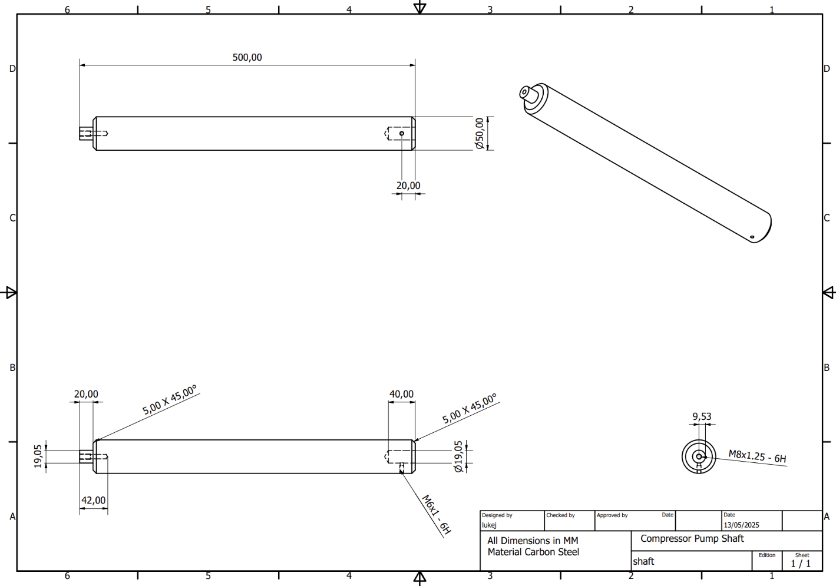
Figure 17 - Shaft Engineering Drawing - Luke John
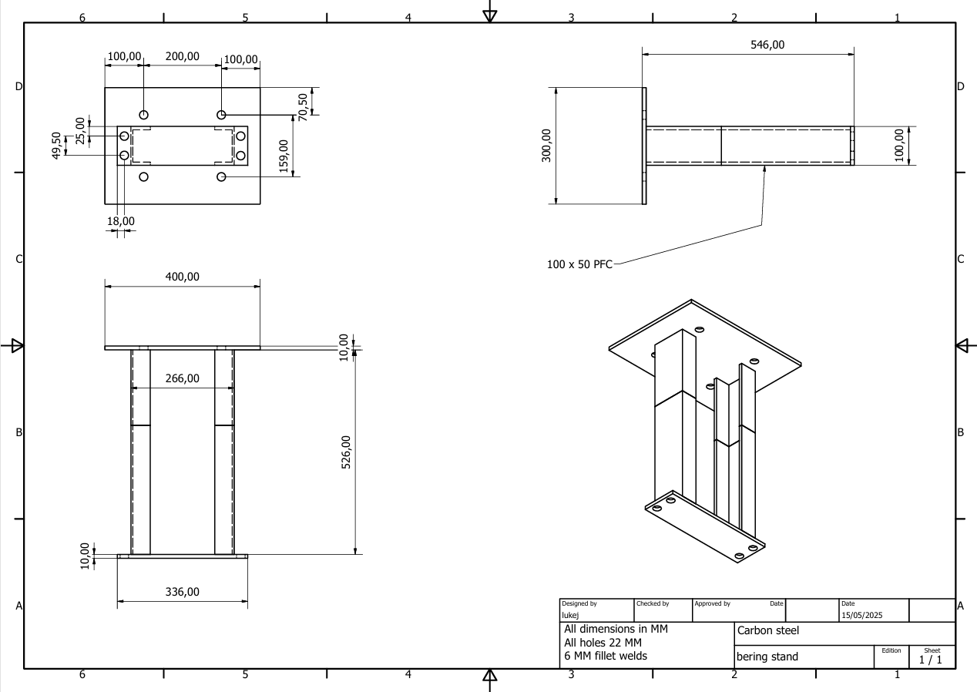
Figure 18 - Bearing Stand Engineering Drawing - Luke John
This is further displayed in Figure 19, illustrating a floor plan of where each component of the system will be located, with a gap of around 300mm between the bike frame and the pressurised tank, providing space for the operator to pedal without difficulties, further illustrated in the CAD model shown in Figure 20.
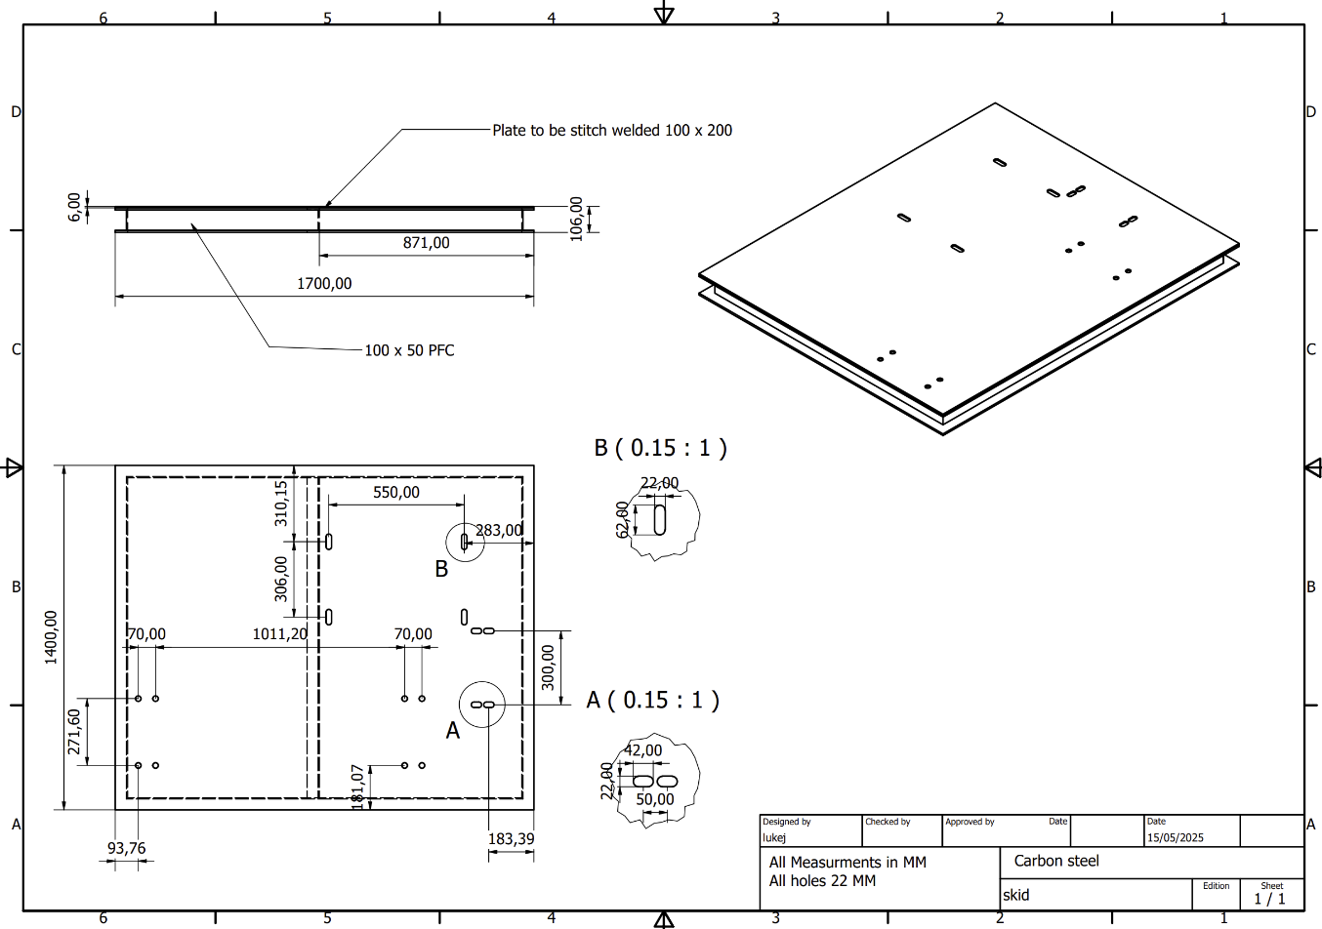
Figure 19 - Skid Engineering Drawing - Luke John
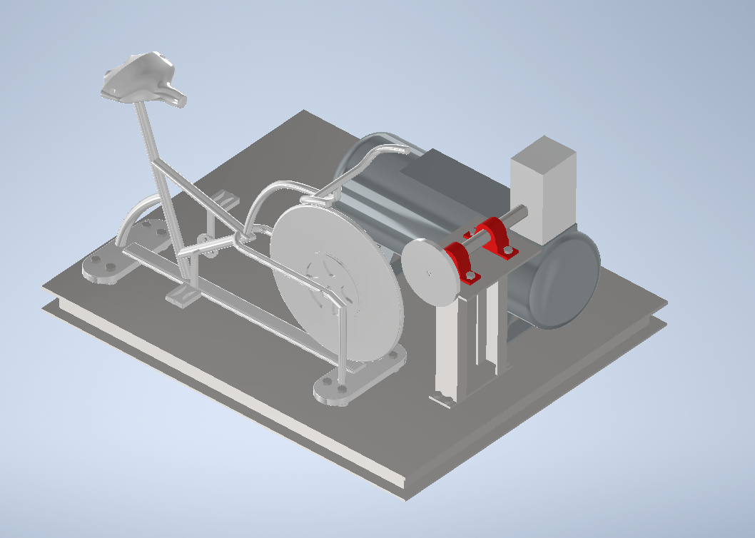
Figure 20 - Final Assembly Model - Luke John
To ensure each component is properly secured to the skid, fixings are secured through the bottom of the skid using fixings, including the bike assembly with threaded holes in the bump stops in the base of the bike assembly shown in Figure 12.

Analysis
The bike assembly design could be further improved by incorporating adjustable features for the handlebars and the seat height, which could be achieved by designing for range as mentioned by Stack, Ostrom and Wilhelmsen (2016), making the seat height and handlebars adjustable at various percentile intervals based on the anthropometric data gathered by Muktar et al. (2022) & Gordon (2006) where instead of a solid bike frame the frame becomes a housing for a separate seat or handle bar component fitted on a bar with holes at the intervals for a pin to hold the position of these components commonly seen on gym apparatus (Figure 21) which would accommodate a greater number of consumers.
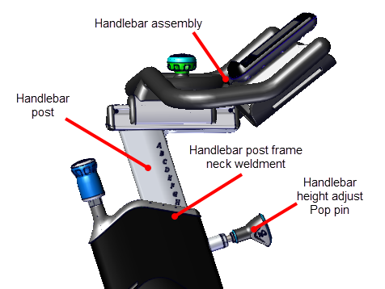
Figure 21 - Adjustable Mechanisms - (Precor Incorporated, 2016)
Additionally, the design has further limitations, being unsuitable for those who are disabled. This could be combated by modifying the pedals or providing an alternative set of pedals which can be interchangeable due to the screw caps like the drive system. The alternative pedals could incorporate a strap-in system where the user's prosthetic is secured to the pedal to reduce difficulty when using the product an example of the alternative pedal can be seen in Figure 22.
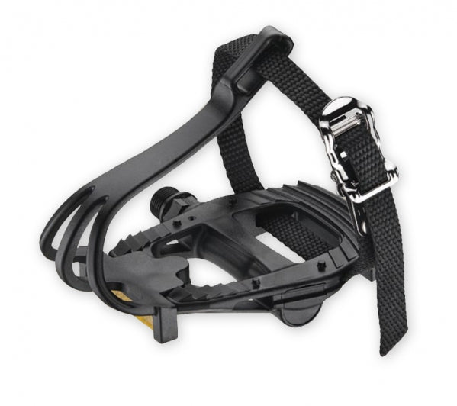
Figure 22 - Alternative Pedals - (High on Bikes, 2025)
However, this still only enables those who have prosthetic legs to use the product. To further accommodate those who are disabled, a change to the design would be required where the upright bike design becomes similar to a handcycle used in the Paralympics, where the handlebars will replace the pedals to power the system, as seen in Figure 23.
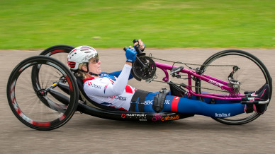
Figure 23 - Handcycle - (British Cycling, 2025)

Materials Research – Catrina Morgan
This section focuses on the research into potential materials which could be used to produce the product as previously described. The majority of the components are purchasable parts, and they should not have to be specially made, however, a few of the components have been highlighted and their potential material choices researched in this section, for the event they are fabricated. This research should be used as a guide for the procurement process and will enable the Procurement Specialist to make informed decisions when sourcing and purchasing the required materials for the project.
The following components are assumed to be purchased parts and detail into their material choice was not taken, the seat, pedals, and gear system. Priority consideration was given to the bicycle frame (including the base and handlebars), flywheel and skid, with some consideration and advice being given for the air tank, compressor pump shaft, and bearing stand.

General Properties Desired for each Component

Air Tank
According to Airpressa (2024) and Anna (2024), the following material properties are vital for safety and functionality, they are:
- Fatigue Resistance
- High Strength
- Impact Resistance
- Corrosion Resistance
- Thermal Stability
- Weldability
Air tanks need to cope with multiple internal pressurisations and kept their structural integrity. It must be strong enough to withstand accidental damage and be resistant to corrosion due to environmental factors. Good weldability will enable the tank to be secured effectively at the joins and a thermally stable material will protect the device when being used in multiple environments.
For the purposes on this project the air tank would need to be semi portable because it would not need to be wearable, but it would need to be light enough to move with the aid of machinery on a skid. Consequently, lightweight characteristics would be preferable, however due to the varying environments the project is designed to be based in, the durability and functionality would take precedence.

Bearing Stand
According to Lee (2025), AST Bearings (2017) and Engineering Area (2012), the most desirable material properties are:
- High strength
- Impact Resistance
- Thermal Stability
- Corrosion Resistance
- Wear Resistance
- Machinability
Good wear resistance and thermal stability would enable the device to function as designed despite constant use, couple this with sufficient corrosion resistance and the sand should have a long lifespan. The device must be string to cope with loading and ideally it would resist deformation due to impact.

Bicycle (Frame, Base and Handlebars)
For the purposes of this section, the bicycle frame, base and handlebars are to be made from the same material. The bicycle frame is a large section of this design, in terms of material purchase, so it could potentially be costly. There will be a few options when it comes to material choice but once functionality is served, cost will be a deciding factor. According to Novović (2025), the key properties for a stationary bicycle frame are:
- Lightweight
- Stiffness
- Corrosion Resistance
- High Strength
- Fatigue Resistance
- Impact Resistance
To avoid unnecessary flex and potential loss in energy output, the frame should be sufficiently stiff and resistance to fatigue due to repeated use. It must be strong enough to hold the rider without negatively impacting the functionality and sufficient impact resistance would prolong the products life during transportation. The varying environments and sweat exposure would mean the frame will have to be suitably corrosive resistant, and it would be beneficial for the product to be lightweight, which would support the process of transporting to different work environments. Having said that, too little weight could result in the bicycle becoming unstable during use.

Compressor Pump Shaft
According to Zhang (2025), Thorat (2021) and Engineering Learn (2025), the ideal properties for a compressor pump shaft would be:
- Low Notch Sensitivity
- Wear Resistance
- Heat Treatment Capability
- High Strength
- Machinability
- Corrosion Resistance
A suitable corrosion resistance is vital for use in varying environments, likewise the wear resistance would impact the lifespan of the product. The chosen material must be strong enough to function under the stresses and forces crated during use.

Flywheel
According to Crescent Foundry (2023) and Engineering Learn (2025), the desired properties for the flywheel of a stationary bicycle are:
- High Strength
- Corrosion Resistance
- High Density
- Wear Resistance
- Fatigue Resistance
- Thermal Stability
The chosen material must be strong enough to withstand forces at speed and dense enough not to wobble when being used which would allow for greater energy efficiency. A stationary bicycle will benefit from a heavier flywheel; however, this is likely to result in the user experiencing greater resistance from standstill, Will (2022). Once the user is moving, a heavier flywheel will result in a smoother experience which will enable them to put more effort and speed into producing energy, Rustically (2025). The device will need to function in multiple environments and thus need to be corrosive resistant with sufficient thermal stability. Fatigue and Wear resistance will allow the device to have an increased lifespan.

Skid
According to Reliable Building Materials (2025), metal skids require the following material properties:
- Corrosion resistance
- High Strength
- Machinability
- Wear Resistance
- Thermal Stability
- Impact Resistance
The skid will need to endure a variety of environmental factors, have thermal stability and resist corrosion in as many of these environments as possible. It will need to be heavy duty and resist wear in various remote locations and multiple surface types. It will need to be strong enough to resist deforming during impacts when being transported and positioned on location.

Summary
The table below is an overview of the general properties desired for each of the components.
Table 2 – Summary of the general properties desired for each main component.
Material Property | Component
Material Property | Air Tank | Bearing Stand | Bicycle  (Frame, Base and Handlebars) | Compressor Pump Shaft | Flywheel | Skid
Weight |  |  | Moderate |  | Heavy
Density |  |  |  |  | High
Strength | High | High | High | High | High | High
Fatigue Resistance | High |  | High |  | High
Wear Resistance |  | High |  | High | High | High
Corrosion Resistance | High | High | High | High | High | High
Thermal Stability | High | High |  |  | High | High
Impact Resistance | High | High | High |  |  | High
Weldability | High
Machinability |  | High |  | High
Stiffness |  |  | High
Heat Treatment Capability |  |  |  | High
Low Notch Sensitivity |  |  |  | High
Friction Control |  |  |  |  |  | High

Potential Material Choices

Air Tank
According to Airpressa (2024) and Anna (2024), common material choices for air tanks include: aluminium, stainless steel, carbon steel and composite materials. Aluminium is ideal for portable applications as it is lightweight and corrosive resistance. Steel is robust and long lasting. Carbon fibre has an extremely good high strength to low weight ratio. Galvanised steel is also a common material choice for industrial applications and ideal for this project due to its strength and corrosion resistance.
Table 3 – Air Tank Potential Materials
Information summarised from VMT (2024), G&S (2025), and John (2025).
Property | Aluminium | Carbon Steel | Galvanised Steel | Stainless Steel | Composites
Cost | Moderate | Low | Moderate | High | High
Durability | Moderate | High | High | Very High | Moderate
Weight | Light | Heavy | Heavy | Moderate | Very Light
Strength | Moderate | High | High | High | Moderate
Corrosion Resistance | High | Low (unless coated) | High (due to zinc coating) | Very High | Very High
Weldability | Good | Good | Moderate | Moderate | Limited
Thermal Stability | High | High | High | High | Moderate
Fatigue Resistance | Moderate | High | High | High | Moderate

As you can see from the above table, the materials with the most ideal cost are, aluminium, carbon steel, and galvanised steel. The durability of carbon steel and galvanised steel are high, which further narrows the choice. Finally, an important factor in material choice for the air tank would be corrosion resistance, resulting in an ideal choice of galvanised steel. According to Airlink Compressors (2025), The Compressor Warehouse (2025), and Rep Air Services (2025), G90 (ASTM A653) is a “hot-dip galvanised steel with high corrosion resistance”.
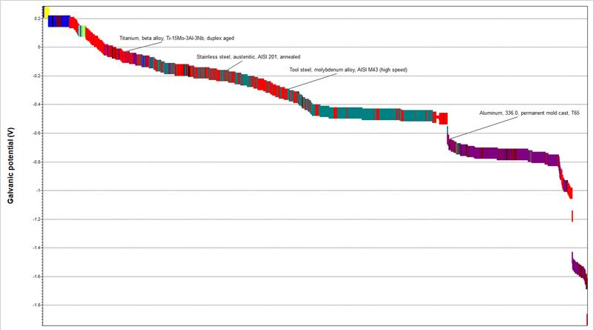
Figure 24 – Galvanic Potential of materials in the Ansys Granta database

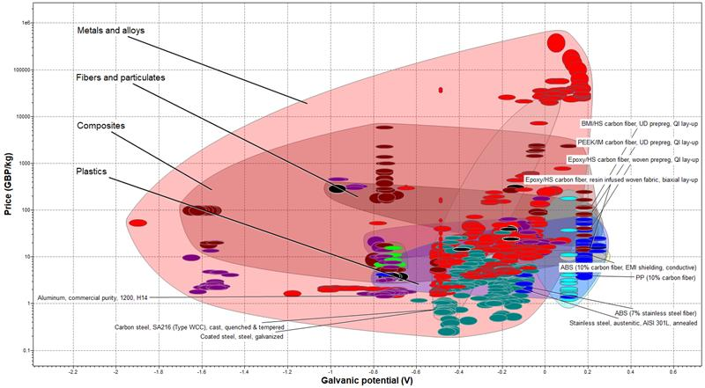
Figure 25 – Galvanic potential vs price of materials
The above figure plots the galvanic potential against the price of potential air tank materials in the Ansys Granta database.

Bearing Stand
According to Lee (2025), AST Bearings (2017-2025) and Engineering Area (2012-2025), bearing stands are often made from the following: cast iron, steel alloys and reinforced polymers.
Table 4 – Bearing Stand Potential Materials
Information summarised from ULMA (2023), Blake (2025), and McHone Industries (2020).
Property | Cast Iron | Steel Alloys | Reinforced Polymers
Strength | Moderate | Very High | Moderate
Wear Resistance | High | Very High | Moderate
Impact Resistance | Low | Very High | Moderate
Corrosion Resistance | Moderate | High | Very High
Fatigue Resistance | Low | Very High | Moderate
Machinability | Good | Moderate | Limited
Weight | Heavy | Moderate | Light
Cost | Low | High | Moderate

According to the above table, Steel alloys have performed the best in each of the highlighted property categories. Even though they cost more on average, it may be worth paying more to use a material which is best suited to the desired application. According to ULMA (2023), Blake (2025), and McHone (2020), AISI 1050 is a medium grade carbon steel which is a suitable choice.

Bicycle (Frame, Base and Handlebars)
According to Novović (2025), stationary bike frames are commonly made from steel, aluminium and carbon fibre composites. Carbon fibre is light and strong and is generally used for road racing, however the precision required for this application does not warrant the spend on such a material. Steel would offer greater durability and strength but would add unnecessary weight and cost to the product. Aluminium is a lighter choice and is also suitably strong.
Table 5 - Information Summarised from Paul Cycles (2024) and Minarik (2025).
Property | Aluminium | Stainless Steel | Chromoly Steel | High-Tensile Steel | Carbon Steel | Low Alloy Steel | Magnesium Alloy | Titanium | Carbon Fiber | Composites | Scandium Alloy
Strength | Moderate | High | Very High | High | High | High | Moderate | Very High | High | Moderate | High
Weight | Light | Heavy | Mod | Heavy | Heavy | Moderate | Very Light | Light | Very Light | Light | Light
Corrosion Resistance | High | Very High | Moderate | Low | Low | Moderate | High | Very High | Very High | High | High
Fatigue Resistance | Moderate | High | Very High | Mod | Mod | High | Moderate | Very High | High | Moderate | High
Stiffness | Moderate | High | High | High | High | High | Moderate | High | Very High | Moderate | High
Shock Absorption | Moderate | Low | High | Low | Low | Moderate | High | High | Very High | High | High
Machinability | Excellent | Moderate | Moderate | Mod | Mod | Moderate | Limited | Difficult | Limited | Limited | Moderate
Weldability | Good | Moderate | High | High | High | High | Limited | Difficult | Limited | Limited | High
Thermal Stability | Moderate | High | High | High | High | High | Moderate | Very High | High | Moderate | High
Durability | Moderate | Very High | High | High | High | High | Moderate | Very High | High | Moderate | High
Impact Resistance | Moderate | High | High | High | High | High | Moderate | High | Very High | Moderate | High
Density | Low | High | Moderate | High | High | Moderate | Very Low | Low | Very Low | Low | Low
Cost | Moderate | High | Moderate | Low | Low | Moderate | High | Very High | Very High | High | High

As shown in the table above, many materials have the potential to be used for the bicycle frame, however, a good candidate would be aluminium. This is due to its lightweight and average price, thermal stability and high corrosion resistance.
Carbon fibre although with comparably suitable material properties according to Gernitex (2025), does not support such low costs and as such is less appealing.
Woodcock (2013) and Koch (2021), suggest that the most common grades of aluminium are 6061 and 7005. Due to aluminium 6061 being most widely suited to corrosion resistance, weldability and strength, this is the preferred grade for our bicycle frame. See Appendix C for the datasheet of Aluminium 6061 according to the Ansys Granta software.
An overview of some potential bicycle frame materials can be found in Appendix D: such as aluminium, carbon steel, alloy steel, stainless steel, and titanium.

Compressor Pump Shaft
According to Zhang (2025), Thorat (2021) and Engineering Learn (2025), and Engineering Tips (2009), compressor pump shafts are often made from the following: carbon steel, stainless steel and alloy steels.
Table 6 – Compressor Pump Shaft Potential Materials
Property | Carbon Steel | Stainless Steel | Alloy Steel
Strength | High | Moderate | Very High
Wear Resistance | Moderate | High | Very High
Corrosion Resistance | Low | Very High | High
Fatigue Resistance | High | Moderate | Very High
Machinability | Good | Moderate | Moderate
Thermal Stability | High | High | Very High
Impact Resistance | Moderate | High | Very High
Cost | Low | High | Moderate

As described in the table above, carbon steel generally has a low cost and high strength combination. This is ideal for the project when trying to save on costings, however, a surface coating will be needed to extend the life of the component when it comes to corrosion resistance.

Flywheel
According to Crescent Foundry (2023) and Engineering Learn (2025), bicycle flywheels are commonly made from cast iron, steel, aluminium alloys and carbon fibre composites.
Table 7 – Flywheel Potential Materials
Information summarised from Sweileh (2024).
Property | Cast Iron | Steel | Aluminium Alloys | Carbon Fiber Composite
Density | High | Moderate | Low | Very Low
Strength | High | Very High | Moderate | High
Weight | Heavy | Moderate | Light | Very Light
Wear Resistance | High | High | Moderate | Moderate
Fatigue Resistance | Low | High | Moderate | High
Corrosion Resistance | Moderate | Moderate | High | Very High
Energy Storage Efficiency | High | High | Moderate | Very High
Machinability | Moderate | Good | Excellent | Limited
Cost | Low | Moderate | High | Very High

Steel has a high strength with moderate cost and corrosion resistance and gives high energy storage efficiency which is what is required for a flywheel.

Skid
According to Reliable Building Materials (2025), the following materials are often used to produce metal skids: stainless steel, aluminium, carbon steel, alloy steel and cast iron.
Table 8 – Skid Potential Materials
Information summarised from Torch Off Road (2024), and Lux Metal (2024).
Property | Aluminium | Stainless Steel | Carbon Steel | Alloy Steel | Cast Iron
Strength | Moderate | High | High | Ver High | Moderate
Wear Resistance | Moderate | High | High | Very High | Very High
Impact Resistance | Moderate | High | High | Very High | Low
Corrosion Resistance | High | Very High | Low | Moderate | Mod
Fatigue Resistance | Moderate | High | High | Very High | Low
Machinability | Excellent | Moderate | Good | Moderate | Good
Weigt | Light | Mod | Heavy | Moderate | Heavy
Cost | Moderate | High | Low | High | Low

Carbon steel performs highly in each category for potential skid materials, except cost. However, it may be worth paying for a material which is best suited to the task, especially when the product is to be used in multiple locations and in varying environments.

Final Recommendations (Summary)
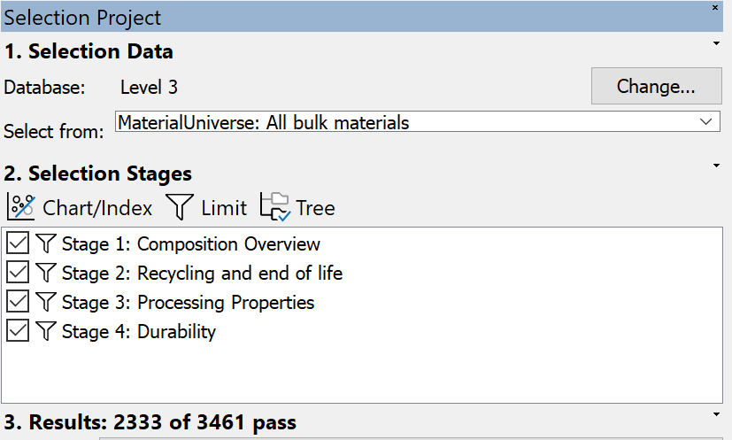
Figure 26 – The Stages of database limitations for ideal material choice per component, using the Ansys Granta software.
Stage 1, composition overview, allowed the material family to be limited to metals. Stage 2, recycling and end of life allowed filtering for recyclability and downcycling. Stage 3, processing properties, allowed a weldability quality of excellent to be selected. Stage 4, durability, allowed limitations to be placed on the following corrosive properties: water (salt/fresh), acids, organic solvents, oxidisation, UV radiation, galling resistance and flammability.
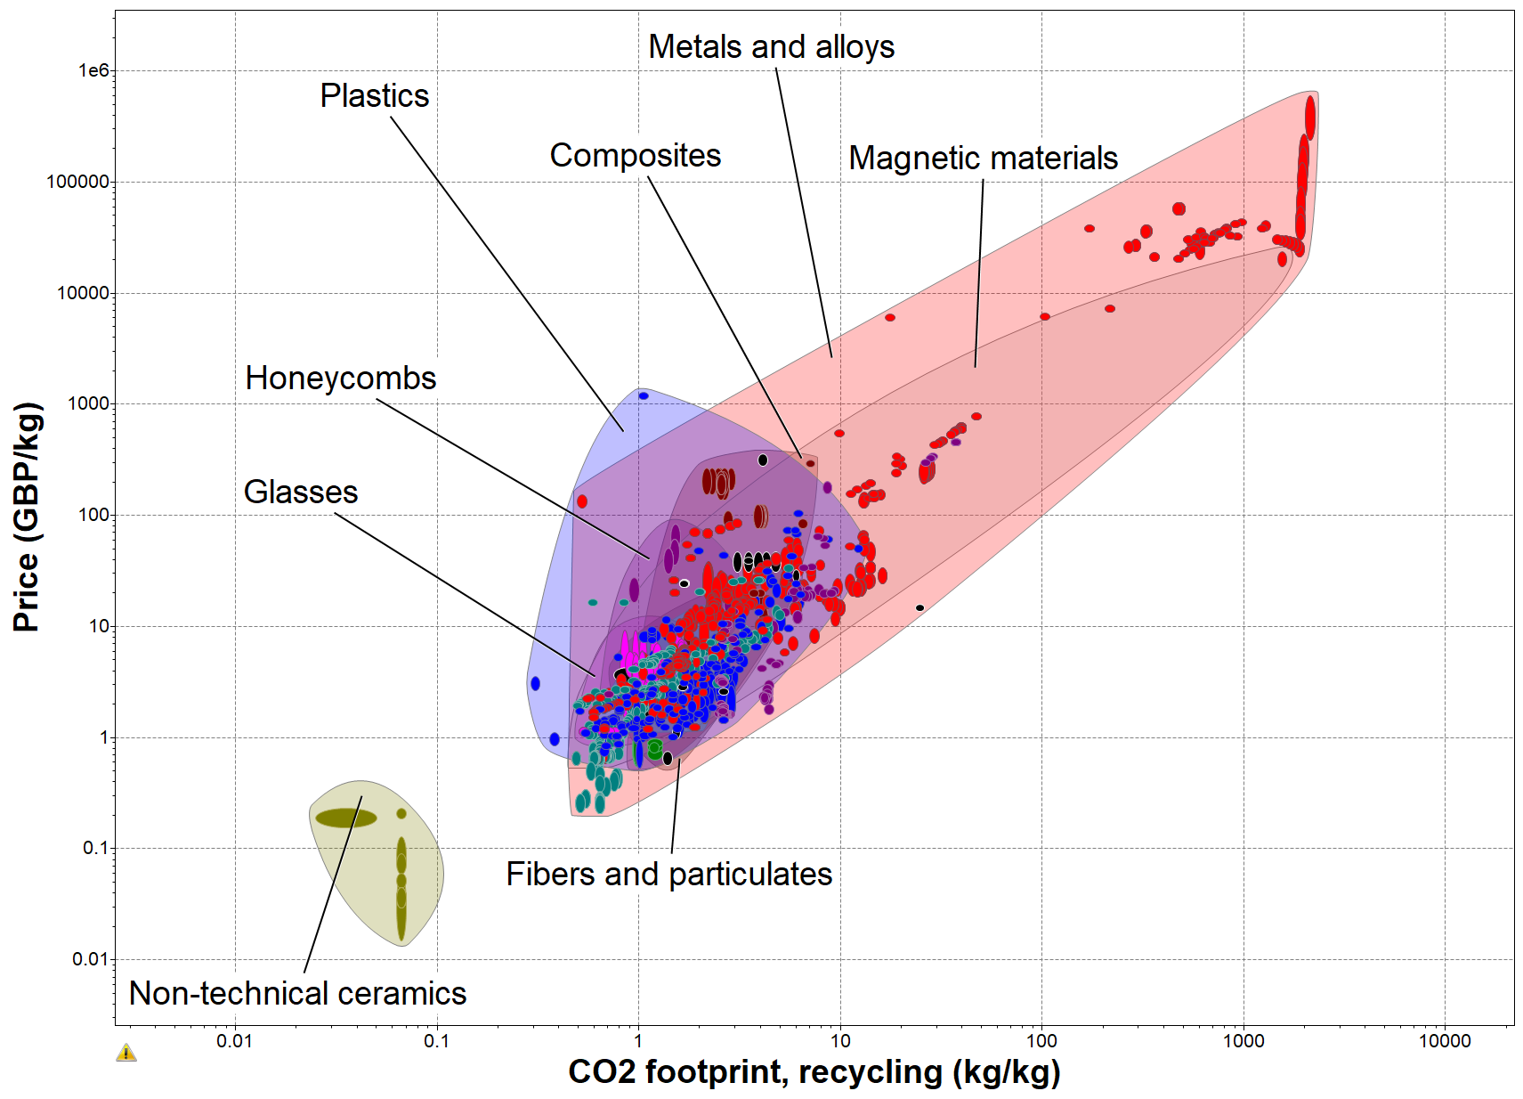
Figure 27 – CO2 vs Price
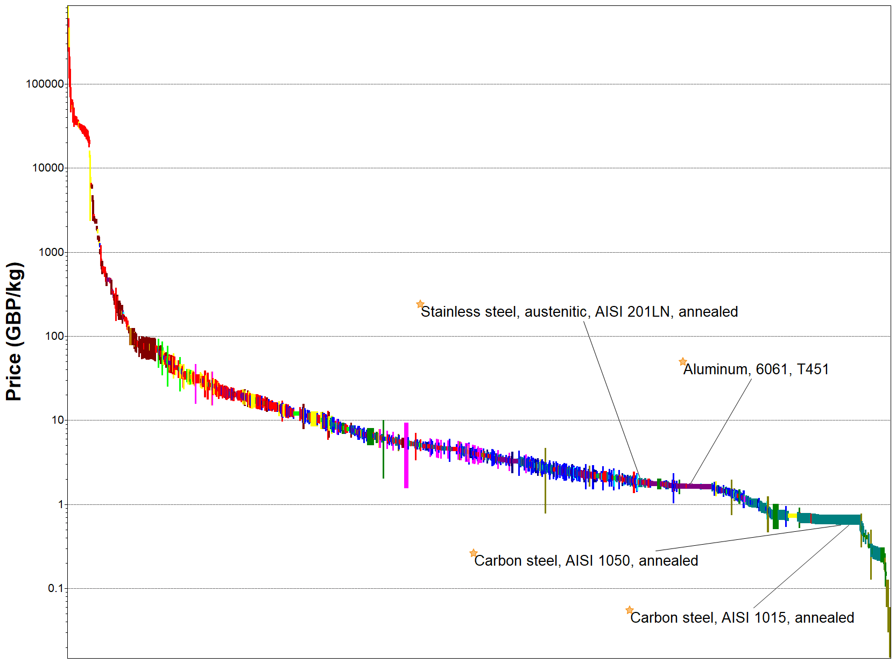
Figure 28 – Final material choices vs price
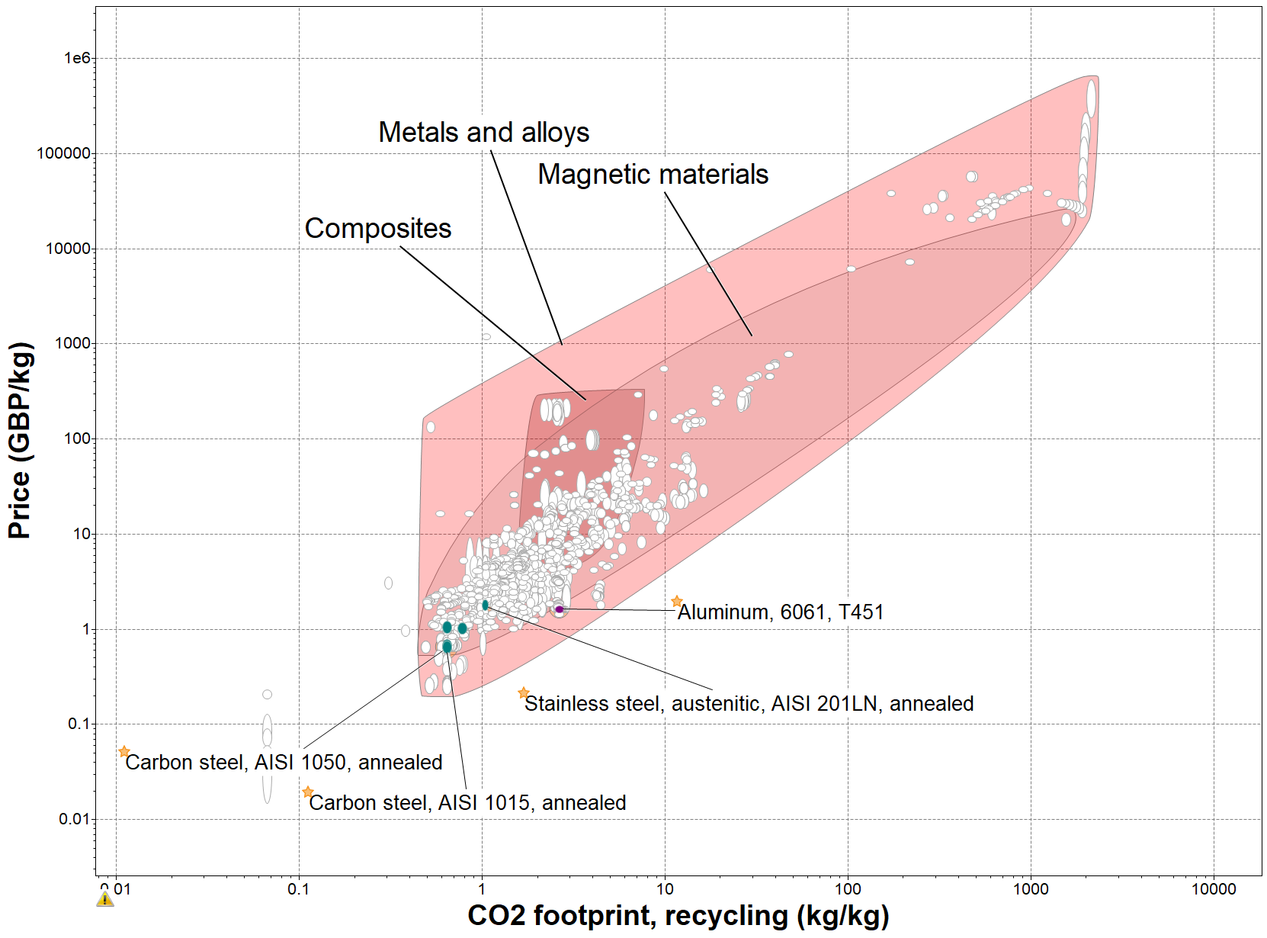
Figure 29 - Final material choices: price vs CO2 footprint

Table 9 – Final material recommendations
 | Air Tank | Bearing Stand | Bicycle Frame | Compressor Pump Shaft | Flywheel | Skid
Material Recommended | Galvanised Steel (Carbon steel, AISI 1015) | Carbon Steel (AISI 1050) | Aluminium (6061) | Carbon Steel (AISI 1050) | Stainless Steel (AISI 201N) | Carbon Steel (AISI 1050)

The final materials were chosen decided based on their property compliance with the qualities we perceived to require for the product. Further depth could have been taken into the compositions of each material and their pricing based on the quantity needed.

Procurement – Luke John

Pressure Tank
Starting with the pressure tank, the mechanical department directed me to look for horizontal tanks with a 100-liter capacity. Materials department gave me a few viable options for tanks. Out of these, carbon steel was by far the cheapest and most readily available in 100 litres, so this was the material that was decided on. Numerous options were available, but it was decided that a large stockist or wholesaler would be the best option if this project expanded to supplying multiple units. Then, there would be less unexpected delays to lead time or a chance of being stuck without a supply. This narrowed down the choice of suppliers. After researching, the final three were Hydraulic Mega Store, Duncan Rodgers Engineering Ltd, and NC Air Stores.
- Duncan Roderger Engineering - £772.53
- Hydraulic Mega Store - £680.35
- NC Air Store - £389.23
The tank and stockist selected was Duncan Rodgers Engineering, even though it is the most expensive. This is because the tank is painted and hot-dipped galvanized inside and out. This is a massive advantage, as it means in harsh and remote conditions, such as deserts, jungles, or tundras, where this compressor is designed to be used, it will be far more hardwearing and corrosion resistant, giving it a longer life and usefulness. In addition, it has an operational temperature of -10°C to +120 °C. This operational temperature range gives this tank a far greater safety factor in the heat over other tanks. It also comes with the advantage of a mounting plate already fitted to mount the compressor. Another desirable feature of the Duncan Rodgers Engineering tank that helped its selection is that a fitting kit is supplied with the tank, and if this project were to expand to supplying multiple units, the cost of the tank would be reduced to £713.11.

Pressure Tank Data Sheets
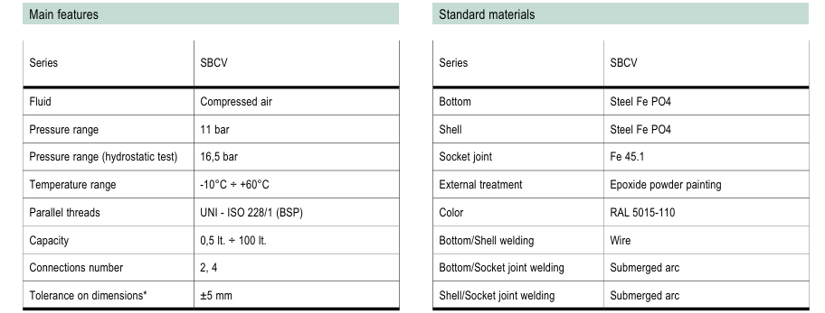
Figure 30 Hydraulic Megastore (Hydraulic Megastore, 2021)
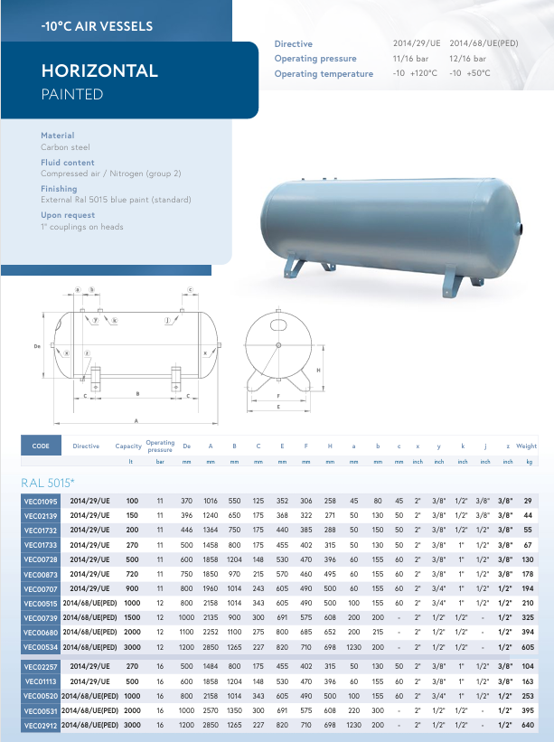
Figure31 NC Air Store (Ncairstore.co.uk, 2025)

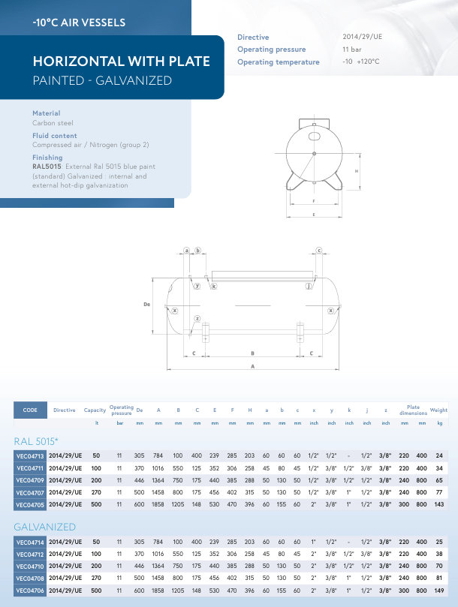
Figure 32 Duncan Rodgers Engineering (Duncanrogers.com, 2025)

Compression Pump
The criteria for the compressor pump were that it had to be two-horsepower and have a CFM (cubic feet per minute) of 5 to 6. The compressor chosen for use was a CNCEST two-horsepower compressor head. This was chosen mainly due to the price, as it was the cheapest at £112.00. The supplier CNCEST is a large Chinese company with international warehouses. They claim delivery within 6 to 7 business days, and the compressor comes with a 12-month warranty (CNCEST, 2025).
This is a relatively low-quality and inefficient compressor, but that is an advantage in this case, as it keeps the CFM, horsepower, and rpm low. As a result, it is ideal for the compressor as larger, more efficient pumps would be too challenging to make human-powered due to their compression. Consideration was also given to fitting the compressor with sound-reducing valves. These come at a substantial markup, where standard valves for this compressor range from £5 to £10. The sound-reducing valves are in the region of £35 to £80. After discussing this with the legislation department, it was decided that due to the compressor running at full speed, it only produces 79 DB, so this would be lower on the human-powered compressor. Also, hearing protection isn’t required until 85 DB; fitting signs to the machine advising that hearing protection is worn would be sufficient. In addition to the pump galvanised tube ½” , ½” 90° elbow, and 3/8” to ½” reducer will be required. This would be an addition of £20 for all these components for a one-off build cost, which would reduce if put into production.

Specifications
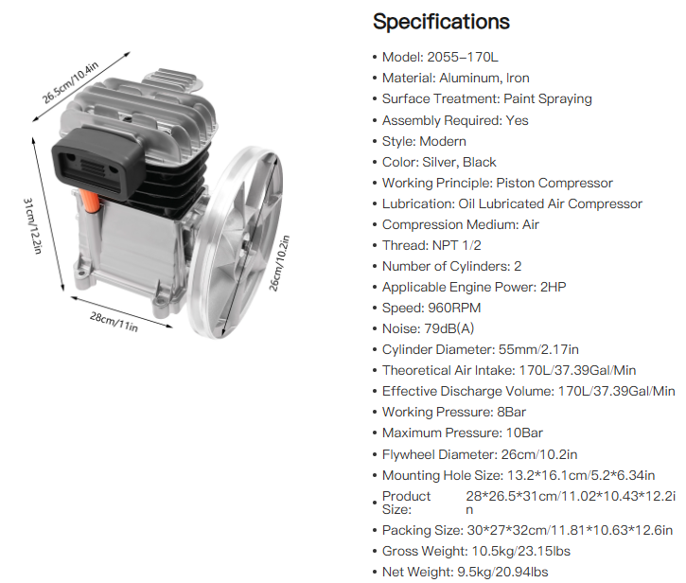
Figure33 Compressor Pump (CNCEST, 2025)

DRIVE COMPONENTS

11 – 52 CASSETTE
11 – 52 cassettes are available in a range of prices, ranging from £300 to £32, depending on the supplier and quality. For instance, this is a one-off build; the ZTTO MTB Bike 11 Speed Group set from Ali Express would suffice, as it is a full setup and is low cost at £78.39 and of decent quality. This comes with all the required gears, derailleur, gear change, cable and drive chain. If this product were to go into production of multiple units, then contacting manufacturers would be advantageous to enquire if a large quantity of units were purchased, would the price be lower? If this were the case, it would also reduce the lead time as they could be kept in stock for when needed. Crank sprocket and pedals are also available on the same site for £53.31. This would bring the total cost of the drive system to £53.31 + £78.39 = £131.70.
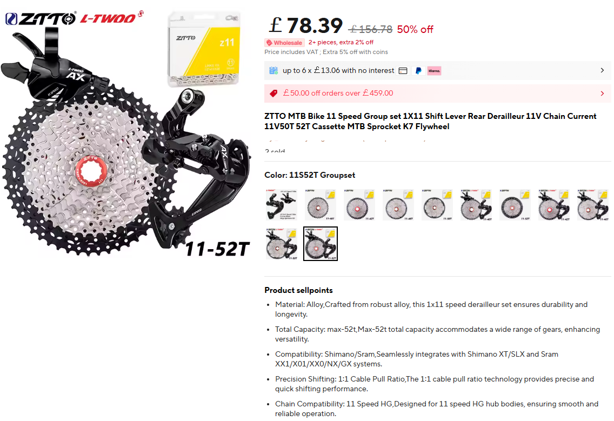
Figure 34 - ZTTO MTB Bike 11 Speed Group set (AliExpress, 2019)

PILLOW BLOCK BEARINGS
There are many suppliers of pillow block bearings in the required size on the market. The cost can vary from £120 to £20. As with most items, a reliable supplier has been used; the ones selected for this project were Bolten Engineering Products, and the pair of bearings cost £41.74. They are middle-of-the-road in quality but will be suited for this project as they won't be under any heavy loads. The cost of these bearings also reduces by up to 10% with bulk orders.
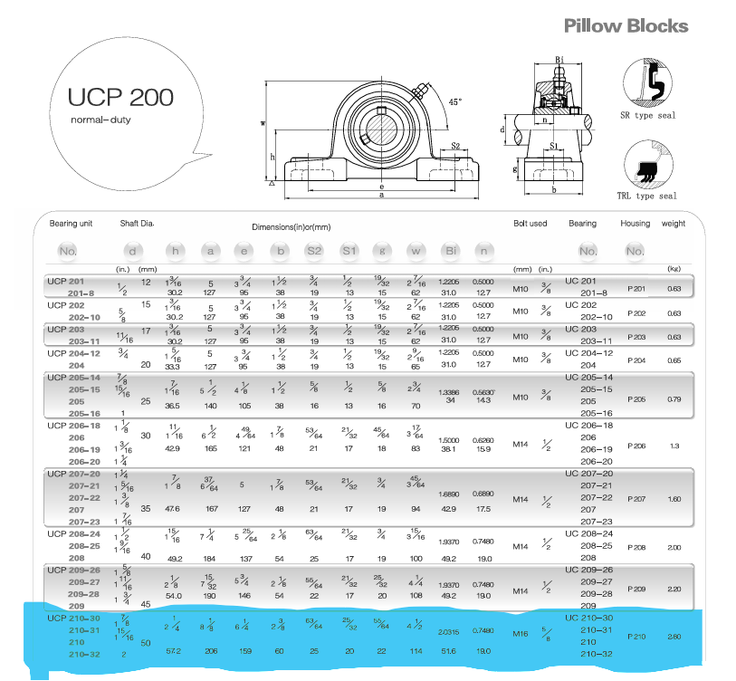
Figure 35 Pillow Block Bearings (Bolton Engineering Products Ltd - Bearing, Power Transmission & Workwear Supplier, 2025)

Designs For Fabrication

Make or Buy Analysis
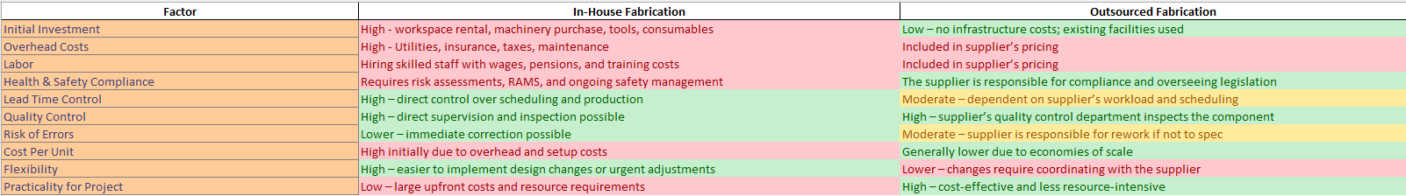
Figure36 Make or Buy Analysis
A make or buy analysis was used to determine whether it would be more cost-effective to produce the custom-fabricated parts in-house or outsource them to an external engineering company. If these items were to be fabricated in-house, a unit to carry out the work would need to be found and rented, which would come with overheads such as utilities and taxes. The necessary machinery would need to be purchased. Staff with the required skills would need appropriate wages and pension contributions. Risk assessments and RAMS must be carried out to comply with health and safety legislation. This would be a massive outlay at the start of the project, probably running into tens of thousands before one unit had been produced or tested. The benefit of making these products in-house is that we would have more control over lead times, and the product quality could be closely checked.
If the fabrication were to be outsourced to an existing engineering firm, the infrastructure to produce this product is already in place. The overhead costs, materials, and wages for producing the compressor are passed on to the client; it would be a fraction of the price the company is paying overall and work out far cheaper. With outsourcing, you also get a comeback if a component is fabricated incorrectly and not to spec. Most large engineering firms have a Q/C department that checks the components and picks up any mistakes before delivery. For these reasons, it is far more practical to outsource the fabrication side of the project. The result of the analysis showed that it would be more cost-effective to outsource.

Compressor Pump Shaft
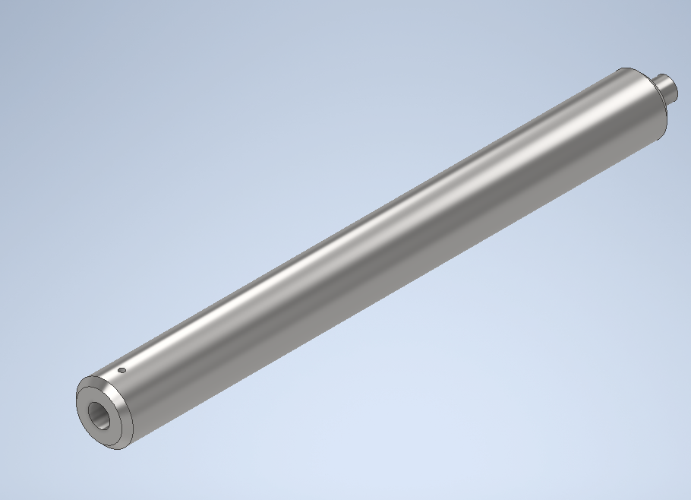
Figure 37 Compressor shaft ISO
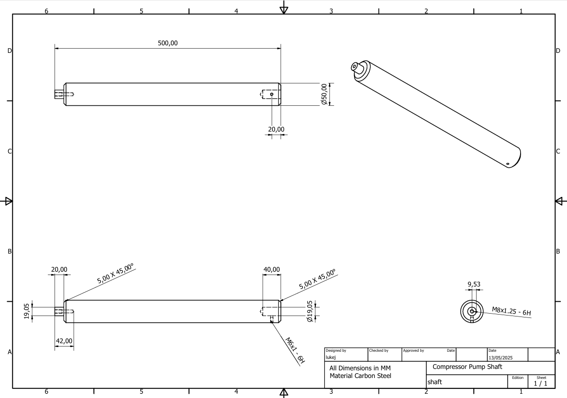
Figure 38 Compressor Pump Shaft Drawing
This shaft was designed with a ¾” (19.05 mm) blind hole in one end to fit onto the existing shaft exiting the compressor pump where the pulley would mount, securing on to the compressor shaft with a 6mm grub screw. On the opposite end, it will be turned down to ¾” (19.05 mm) to utilise the existing pulley from the compressor pump, which fixes to the shaft using an M8 bolt as it would on the compressor. It is designed to be turned out of a 50 mm carbon steel bar as per the instructions from the mechanical department and graphs produced by the materials department.
The cost to machine the shaft has been priced at £114
- 50 x 500 carbon steel bar £60
- Labour £54

Skid
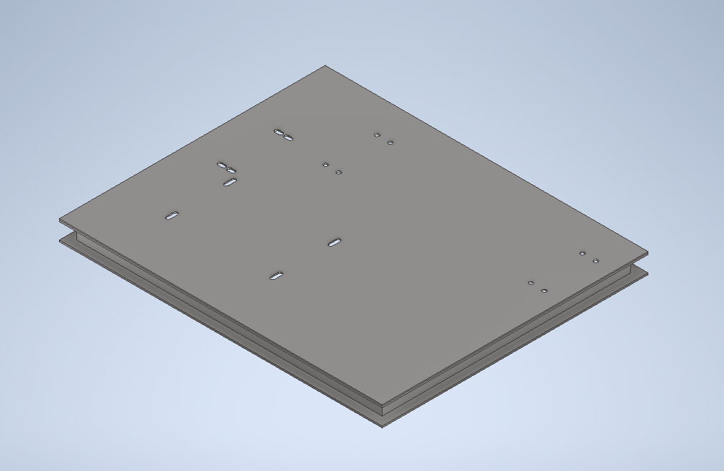
Figure39 Skid ISO

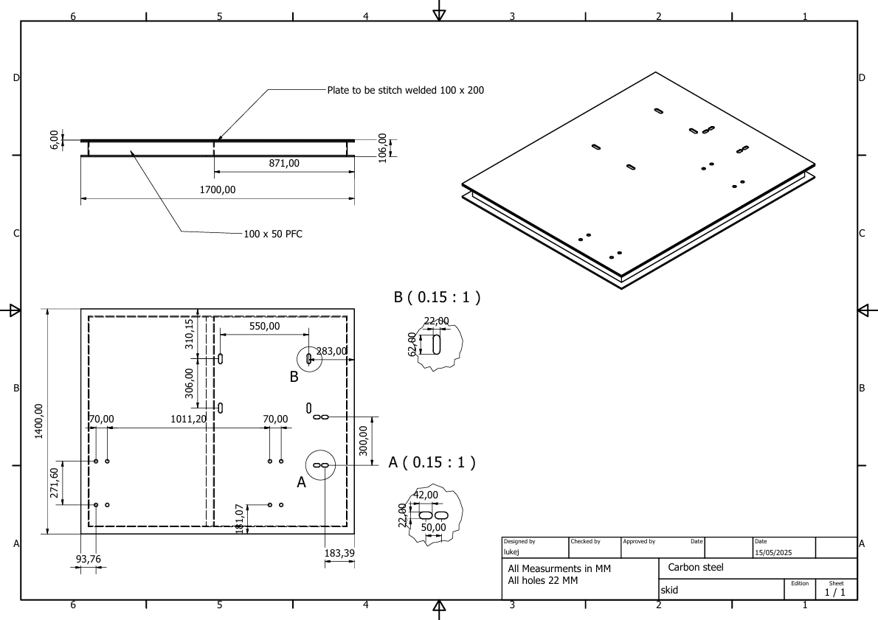
Figure40 Skid Drawing
This skid was designed to mount the bike and tank in place so the pulleys between them would stay in line. The frame is made of 100 x 50 PFC with a 6mm plate that is stitch-welded to the top. Keeping the weight down to 183 kg plus 47.5 kg (tank and pump) + 25 kg (bike and pulley system) + 3.15 kg (bearing stand). This equates to a total weight of 259 kg, easily within the range of any forklift. Using the drawings of the bike produced by the design department and the data sheet of the tank, the holes were marked out in such a way that the belt would run forward and clear of the handlebars. The distance between the tank and the shaft was also deliberately thought out to ensure there is space to get on and comfortably use the bike.
The estimated price to fabricate the skid is £1483
- 7.5 metres of 100 x 50 PFC £241
- 3 meters squared 6mm plate £810
- 24 hours labour £432

Bearing Stand
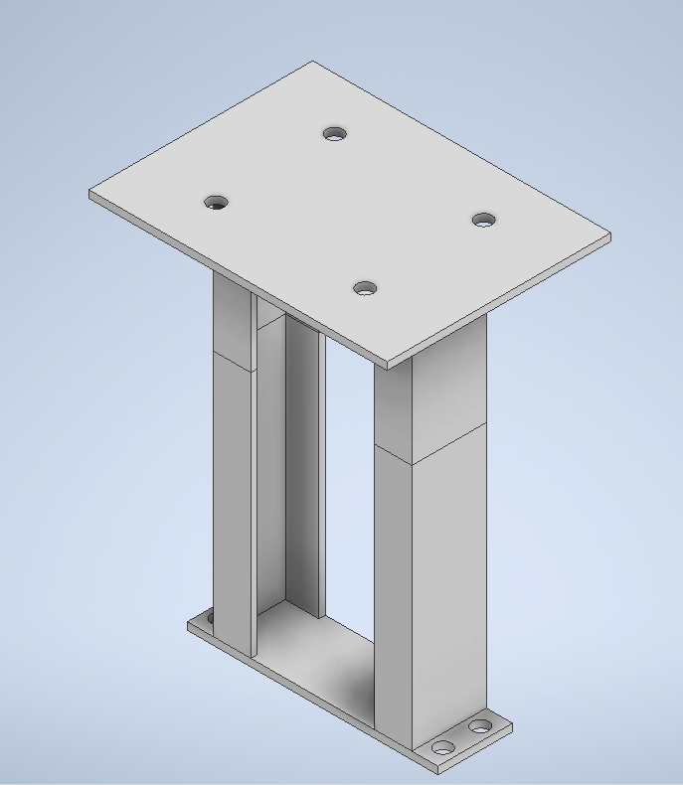
Figure41 Bearing Stand

Figure42 Bearing Stand Drawing
This stand has been designed to hold the shaft mounted in the pillow bearings in line with the shaft coming out of the pump. To get the correct height, the total height of the tank and the height of the shaft from the bottom of the pump were used. Once this measurement was known, the height of the hole centres of the pillow bearings were removed to give the overall height of the stand. The stand has been deliberately designed to be heavy-duty and able to withstand the force imparted by the bike when working, without moving or flexing, which could cause damage to the pump or shaft.
The estimated price to fabricate this is £453.42
- 2.5 metres of 100 x 50 PFC £40.42
- 1 square meter of 10 mm plate £305
- 6 hours labour £108

Bike
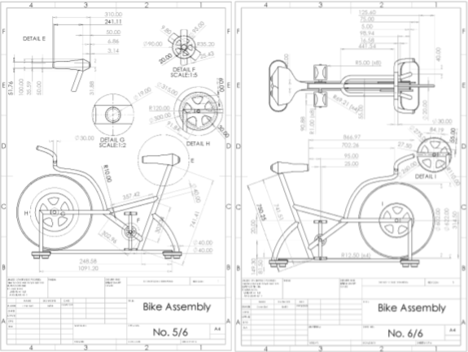
Figure43 Drawing of Bike by Owen Bell (Design)
The materials department has decided to use aluminium for the bike's frame and austenitic stainless steel annealed for the flywheel. The cost to fabricate the bike frame, plus buy in the pulley and saddle, has been worked out to £1327.94
- 4.5 meters of 40mm tube £19.00
- 2 meters of 30mm tube £15.40
- 500mm squared 30mm plate £90.54
- 700 x 700 x 20 plate stainless steel. £125
- Pulley wheel £60
- Labour £ 1008
- Saddle £10

Full Assembly
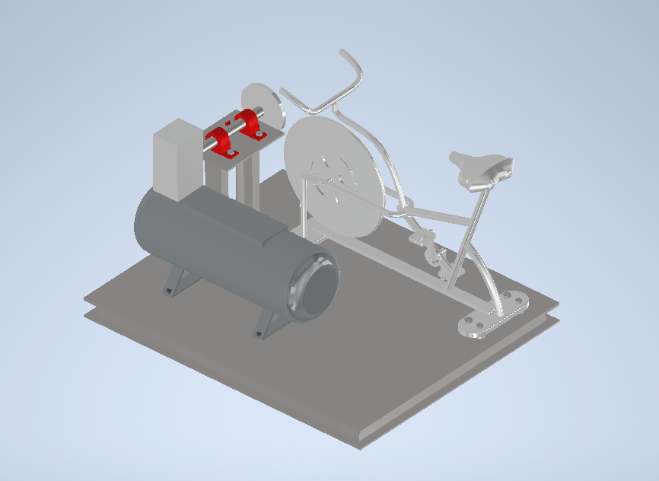
Figure44 Bike Assembly ISO

Figure 45 Bike Assembly with Parts List
All the separate parts to be fabricated were assembled using CAD software to ensure that there were no issues or clashing parts. The parts being bought, such as the pressure tank, pillow block bearings, and compressor pump, were modelled to size using their data sheets and added to the assembly. An assembly drawing with a parts list was then produced to send to engineering companies. It will be used as a general arrangement overview in case any issues are encountered and to seek quotes for the assembly.
The total cost to produce a one-off human-powered compressor has been calculated to be £4466.33. This was calculated by researching the prices of off-the-shelf components that would best suit the project. To price the fabricated parts, the cost of the different materials was researched and used depending on the quantity required. An average rate for skilled labour of £18 was used, and years of experience in the fabrication industry was used to determine the time required to produce each item. This figure will more likely increase when engineering companies reply with quotes, as overhead charges, haulier costs, and cost of consumables will also be added, and the cost of wages for skilled labour could also differ from the used value see Appendix B.

Lead Times
Lead times refer to the time between initiating the project and its completion. For this project to succeed, it is crucial that it is well organised and planned out, and that components arrive on time and are there when needed (Mohammed and Mandal, 2024). Where possible, reliable suppliers have been used to help ensure prompt and trouble-free delivery. The parts that will take the longest are the ones that need fabricating, as, depending on who fabricates them and how busy they are, this could potentially take weeks. These require planning and implementation first. The engineering company should also be asked to give a time scale of how long it will take for the components to be ready. If this is an unacceptable amount of time, it would be advantageous to look at another company. Once the fabricated parts are arranged and the order has been placed, the off-the-shelf parts can be ordered. This way, all the parts should be in place and ready to assemble.

Cost Reduction
The overall cost of producing the human-powered compressor could be reduced if it were to go into large-scale production. The cost of off-the-shelf items such as the air tank, compressor and pillow bearings could be reduced if the suppliers or manufacturers were approached, and volume pricing could be negotiated. This would, in theory, reduce the cost of each item, reducing the overall cost of the entire assembly. Better delivery times could also be negotiated, improving the lead time for each unit (Finio and Downie, 2025).
To reduce the costs of the fabricated items, if put into large-scale production, it would be worth looking into setting up a fabrication shop with specialised tooling. Specifically designed for this project, this would significantly reduce the production time and save time and money in the long run (Fox Valley Stamping, 2024). Another option would be to outsource the production to India or China, as wages, materials, energy prices and overall production costs are far lower. If this were to be done, likely, the bought-in items could also be produced at a far cheaper price (Chakraborty, Mitra and Sundaram, 2024). The negatives of this are that shipping costs would be much higher, and import duties would have to be paid on each unit. The lead times for receiving the items would also be increased. To save on this, it would be necessary to investigate whether the units could be shipped directly from the country where they are produced to the client. Another downside of this is that the quality of the items and production would also likely suffer; an analysis to see if it is worth the cost savings would have to be carried out beforehand.
If this project is to stay in small-scale production, the cost of producing it could be reduced by using less exotic materials to make the bike frame and instead using a protective coating to make it resistant. Another option would be to utilise old second-hand bikes, retrofit them to the skid, and coat them in a uniform colour to look uniform and in keeping with the rest of the parts. This method would also save on buying in the drive gear for the bike.

Legislation – Julian Edwards
A human-powered air compressor can offer many benefits, such as its use in remote and rural regions, especially those with limited or inconsistent power infrastructures. It can also provide a more environmentally friendly alternative to traditional gas or electric-powered compressors typically used in industry. However, several legislative requirements and guidance must be followed when producing or distributing this product. Legislation from the United Kingdom and the European Union must be adhered to ensure this product's safe and legal operation in most areas. It is also important to ensure the consumer's safety when using this product, particularly around exposure to noise that may be produced while in operation.

Health and Safety Legislation
When designing any product, especially machinery, the most important considerations are the health and safety of the consumer and producers. While many of the components will be procured rather than produced and will already adhere to standards, it is still important to assess the health and safety of each component, production of the final product, and operation of the final product to ensure all risks are known and can be made aware to the producers and users of the product.
UK Legislation
One example of UK health and safety legislation is the Health and Safety at Work etc. Act 1974 states, 'It shall be the duty of every employer to ensure, so far as is reasonably practicable, the health, safety and welfare at work of all his employees' (Health and Safety at Work etc. Act 1974). This act forces employers to ensure that the health and safety of employees are heavily considered and methods such as risk assessments are carried out to ensure risks are identified and appropriately reduced where possible. While this does not obligate employers to consider the safety of product users, any measures identified to reduce employee risk could also be applied to the customer.
A second example of UK health and safety legislation is the Supply of Machinery (Safety) Regulations 2008, which forbids a product's placement on the market if it has not been deemed safe (The Supply of Machinery (Safety) Regulations 2008). The regulation details the steps a "responsible person" can take to place the item on the market, such as carrying out conformity assessments, producing instructions for use, and compiling a technical document to make available to the user.
Another example of UK health and safety legislation is the Dangerous Substances and Explosive Atmosphere Regulations, which apply to this product due to using an air compressor and tank to store the pressure. The regulation requires employers to 'control the risks to safety from fire, explosions and substances corrosive to metals' (Health and Safety Executive, 2019). It achieves this by requiring employers to identify dangerous substances, identify risks, introduce new controls for prevention, and prepare plans in case of accidents or emergencies. While this regulation does not enforce the sharing of this information, it can be used to develop instructions and identify the safe limitations of the product for the end user.
EU Legislation
Due to its intended use in more rural areas, EU legislation, such as the General Product Safety Regulation (EU) 2023/988, must also be considered for health and safety. This regulation again forces manufacturers to produce suitable instructions for their products. It includes an additional requirement of being in an easily understood language (European Union, 2023), meaning that a version would have to be available for each targeted area’s preferred languages. This regulation would also suggest that clear diagrams would be a practical option, reducing the need for translation and avoiding all language barriers when communicating safety and how to operate the product.
Another example of EU health and safety legislation is the EU Directive 89/391/EEC - OSH "Framework Directive", similar to the UK's Health and Safety at Work etc. Act 1974 aims to encourage employers to 'encourage improvements in the safety and health of workers at work' (Directive 89/391/EEC - OSH ‘Framework Directive’). It details the responsibilities of both the employer and employee, stating that the employer is responsible for identifying and mitigating risks, and the workers are responsible for correctly using any machinery. It is essential to consider when the final product will be assembled in-house.

Legislation Regarding Noise Exposure and Warnings
A significant concern with this product is the exposure to noise from the compressor near the bike, so it is essential to consider legislation surrounding noise exposure, such as acceptable noise levels. It is also important to consider what warnings are required on the supplied devices to warn the user of possible risks.
UK Legislation
One UK legislation that details acceptable noise exposure levels is the Control of Noise at Work Regulations 2005. It forces employers to accurately measure noise emissions from machinery, such as an air compressor, and assess the need for ear protection (The Control of Noise at Work Regulations 2005). This regulation states that 'lower exposure action values' are 80 decibels daily (The Control of Noise at Work Regulations 2005). (The Control of Noise at Work Regulations 2005). Given the context of the air compressor used in this product, which produces 79 decibels (see procurement) under a full load, it suggests that the compressor is barely within safe levels. However, the noise emissions should be minimised to prevent discomfort, which will require testing to accurately measure the noise emitted when a part of this product is not electrically powered.
Another UK piece of legislation regarding noise emissions is The Noise Emission in the Environment by Equipment for use Outdoors Regulations 2001, which explains the requirements for outdoor equipment, such as compressors, noise emission (The Noise Emission in the Environment by Equipment for use Outdoors Regulations 2001). It requires manufacturers to include a 'CE marking and the indication of the guaranteed sound power level' that is easily legible and in plain view (The Noise Emission in the Environment by Equipment for use Outdoors Regulations 2001). This means noise emissions must be accurately measured to be legally distributed within the UK. Due to the intended use of this product in more rural regions, there will be little noise pollution already existing in the area, which means that this product will have to minimise its noise emission to not negatively impact its environment.
Another UK legislation to consider is the Health and Safety (Safety Signs and Signals) Regulations 1996, which details the employer's duty to identify and reduce all foreseeable risks and appropriate signs or hazard symbols must be in place (The Health and Safety (Safety Signs and Signals) Regulations 1996). The legislation then dictates the types of signs for each risk (The Health and Safety (Safety Signs and Signals) Regulations 1996). For the compressor in this product, high-pressure, noise hazard, and moving mechanical part warnings will have to be included to ensure safety during the product's manufacturing. It can then be applied to documentation or directly attached to the product for the customer to ensure their safety. The markings must be clearly visible and easily identified as to which part of the product they apply.

EU Legislation
It is essential that EU legislation is also considered for noise exposure and warnings, as many rural areas within Europe are more likely candidates for the deployment of this product.
The EU Machinery Directive 2006/42/EC details the requirements of markings and instructions for the operation of produced machinery (European Union, 2006). The marking requirements stated in the regulation include the business name and address, CE Marking, year of construction, and ‘potentially explosive atmosphere must be marked accordingly’ (European Union, 2006). This statement is important in this context where a compressor and air tank are involved, where possibly high pressure is involved. The directive later states the requirement and need for instructions with the machinery, such as including instructions in the ‘official Community language or languages of the Member State’ (European Union, 2006). The directive also directly states the content requirements in the instructions, such as diagrams and descriptions for using the product, as well as maintenance instructions.
Another EU directive, EU Pressure Equipment Directive 2014, details marking and labelling requirements similar to the EU Machinery Directive 2006/42/EC whilst including more information on safety requirements in the designing and manufacturing process, particularly around pressure equipment (European Union, 2014). This directive details the required marking and labelling of pressure equipment to include the year of manufacture, minimum and maximum allowable limits, the volume of the equipment, intended use, etc. (European Union, 2014). The legislation further elaborates on the requirements of operating instructions for a machine, such as directions of use, maintenance, and necessary safety information. The EU Machinery Directive 2006/42/EC later emphasises the need for conformity assessments and certification, including notifying the relative authorities to verify compliance and ensure the product's safety before it can be operated.

Conclusion / Critical Review of Project

In conclusion, the design can be further enhanced by providing alternative pedals to accommodate those who may have prosthetics and the inclusion of the adjustable components alongside an overall review of the design with shift in design principle being to design for range rather than average. Moreover, with the design being based on anthropometric data that was initially gathered in the 1980s in America and a more recent sample of data from Indonesia which could result in dimensional inaccuracy and a greater range and variety of anthropometric data should be considered. Additionally, an alternative bike design that resembles a hand cycle would allow those who are unable to use their legs to operate the system increasing the number of potential consumers.
The calculations conclude that the mechanical system will be able to compress air at a rate of 36L/min, ensuring an efficient filling of the air tank in approximately 22 minutes. The air compressor manufacturer recommends an input of two horsepower, which equates to 14.8Nm of torque at 960RPM, which can be assumed as the maximum torque required. With an input power of 202W, the RPM must be manipulated to 130 to achieve this torque towards the end of the operation. While this RPM is achievable from the current gearing system, the ability to provide a large RPM is not possible. This consideration could lead to future developments in the gearing system, which make the manufacture recommended RPM of 960, a more attainable figure, which could be done by changing the pulley size ratio. Further to these improvements, the calculations were completed with the use of assumptions regarding torque and power. These assumptions simplified the calculations by creating linear relationships between variables. However, in reality these values would be better represented by a polytropic process, with the introduction of heat to the process. The compression ratio, and efficiency of the compressor would also impact these relationships, as well as increasing power losses through the process.
After detailed product selection, supplier consideration and evaluation, research and fabrication pricing, as well as using make or buy analysis to determine which would be the better option, the total cost of a single unit has been estimated to be £4,466.33. To reduce the cost of each unit, it would be a good idea to put the project into large-scale production and utilise volume pricing where possible and specialised tooling. If this can significantly reduce the cost, this would be far more advantageous than outsourcing to a low-cost region, as lead time would be significantly reduced and control over production and quality could be maintained. For this project to be a success, the different avenues of cost reduction need to be explored, as the lower the price for a unit, the greater the chance of succeeding.
The final materials chosen were based on most common materials used for each application balanced against the most sensible choice for each component. These choices did not take into consideration availability, real word pricing such as obtaining quotes from companies or labour hours. For example, according to the Ansys Granta database, Low alloy steel AISI 9310, was the preferred choice for the bicycle frame, see appendix D for the datasheet. This nickel-chromium alloy has a material composition summary of: Fe94-95 / Ni3-3.5 / Cr1-1.4 / Mn0.45-0.65 / Si0.08-0.35 / Mo0.08-0.15 / C0.08-0.13 (impurities: P<0.025, S<0.025). These qualities mean the material has an excellent weldability and metal formability. It has a decent durability to corrosives, except acids, good sustainability, toughness, and other mechanical properties. According to the Ansys Granta software, carbon steel costs about £0.5-0.7 per kg and the more ideal nickel-chromium alternative would cost approximately £0.9-1.2 per kg. The price difference is not too substantial but, in the end, a cheaper alternative was chosen. Further work could include comparing potential material coatings in detail rather than focussing on pure materials.
After considering some of the legislative requirements, it is not only important to carefully manage health and safety, but also a legal requirement in both the UK and EU. One of the largest concerns is the exposure to noise over extended periods, which the compressor in this product theoretically produces below the legal limit considerably. Risk assessment is also something to consider when producing the produce, even being a legal standard that is required to allow the product to be placed on the market. The sources in this section are reliable and trustworthy as the are from the relevant government bodies and is important to consult their legislations throughout the entirety of the production and distribution of the product. In the future, it would be beneficial to identify more rural areas and their applicable governments and legislation to identify where this product could be distributed safely and improve the range of areas considered. Another possible improvement would be to develop a set of instructions and maintenance instructions which would include diagrams as part of EU legislation standards and reduce the risk of improper use and reduce the risk of an accident occurring.
Despite these drawbacks and aforementioned improvements, the product can convert the operator's energy into pressurised air efficiently to be stored in a tank without the use of electricity and gas. It also allows the use of air powered tools to become more viable in the more rural parts of the globe and can do so safely deeming the product a success. The analysis of applicable legislations and standards also ensured that the product was safe for use internationally. In addition, the group was able to work to the proposed time plan, with the aid of the Gantt Chart shown in Figure 1.

Bibliography

Mechanical (Joe)
DataCranker (2018). Cycling Power to Weight Ratio Calculator. [online] Data Cranker. Available at: https://datacranker.com/cycling-power-to-weight-ratio-calculator/.
Farrell, D. (2021). Torque, Power and Speed -basics of power sources. [online] Available at: https://thompsoncouplings.com/wp-content/uploads/2021/05/TECHNICAL-UPDATE-003-Torque-Power-and-Speed.pdf.
Lagzdins, A. (2023). Human Powered Air Compressor and Energy Storage System. [online] LOW←TECH MAGAZINE. Available at: https://solar.lowtechmagazine.com/2023/07/human-powered-air-compressor-and-energy-storage-system/ [Accessed 22 May 2025].

References
Hurley, S. (2021). Cycling Cadence: What Is It, What’s Most Efficient, and Cadence Drills To Make You Faster - TrainerRoad Blog. [online] www.trainerroad.com. Available at: https://www.trainerroad.com/blog/whats-the-most-efficient-cycling-cadence-and-how-cadence-drills-can-make-you-faster/.
Johnstone, D. (2018). How does your cycling power output compare? [online] www.cyclinganalytics.com. Available at: https://www.cyclinganalytics.com/blog/2018/06/how-does-your-cycling-power-output-compare.
Monahan, C. (2019). Boyle’s Law — Overview & Formula. [online] Expii. Available at: https://www.expii.com/t/boyles-law-overview-formula-8155.
Team Peloton (2023). How to Use Cycling Cadence to Meet Your Fitness Goals. [online] @onepeloton. Available at: https://www.onepeloton.com/en-GB/blog/cycling-cadence [Accessed 22 May 2025].
Testbook (2023). Flywheel - Construction, Working Principle, Types, and Advantages. [online] Testbook. Available at: https://testbook.com/mechanical-engineering/flywheel-definition-diagram-and-applications.

Design (Owen)
Bridger, R. (2008). Introduction to Ergonomics. 3rd ed. [online] Boca Raton: CRC Press, pp.1–808. doi:https://doi.org/10.1201/9781439894927. [Accessed 15 Mar. 2025].
British Cycling (2025). About para-cycling. [online] British Cycling. Available at: https://www.britishcycling.org.uk/aboutpara-cycling?c=EN [Accessed 22 May 2025].
Čepon, G. and Boltežar, M. (2009). Dynamics of a belt-drive system using a linear complementarity problem for the belt–pulley contact description. Journal of Sound and Vibration, [online] 319(3-5), pp.1019–1035. doi:https://doi.org/10.1016/j.jsv.2008.07.005. [Accessed 19 Mar. 2025].
Chowdhury, S. and Yedavalli, R.K. (2016). Dynamics of belt-pulley-shaft systems. Mechanism and Machine Theory, [online] 98, pp.199–215. doi:https://doi.org/10.1016/j.mechmachtheory.2015.11.011. [Accessed 19 Mar. 2025].
Dianat, I., Molenbroek, J. and Castellucci, H.I. (2018). A review of the methodology and applications of anthropometry in ergonomics and product design. Ergonomics, [online] 61(12), pp.1696–1720. doi:https://doi.org/10.1080/00140139.2018.1502817. [Accessed 15 Mar. 2025].
Gordon, C.C. (2006). Anthropometric Data. [online] NC State University. Raleigh, North Carolina, United States: North Carolina State University. Available at: https://multisite.eos.ncsu.edu/www-ergocenter-ncsu-edu/wp-content/uploads/sites/18/2016/06/Anthropometric-Detailed-Data-Tables.pdf [Accessed 6 Mar. 2025].
High on Bikes (2020). VP Components VP-335T - Pedals with Toe Clips & Straps. [online] High on Bikes. Available at: https://www.highonbikes.com/products/vp-components-vp-335t-pedals-with-toe-clips-straps [Accessed 22 May 2025].
Hurst, H.T., Sinclair, J., Atkins, S., Rylands, L. and Metcalfe, J. (2016). Influence of wheel size on muscle activity and tri-axial accelerations during cross-country mountain biking. Journal of Sports Sciences, [online] 35(14), pp.1342–1348. doi:https://doi.org/10.1080/02640414.2016.1215497. [Accessed 14 Mar. 2025].
Montague Bikes (2019). Bicycle Wheel Sizes Explained. [online] Montague Bikes. Available at: https://www.montaguebikes.com/folding-bikes-blog/2019/06/bicycle-wheel-sizes-explained/ [Accessed 18 May 2025].
Mukhtar, M.N.A., Umma, N., Kartika, A.D.C. and Diharja, A.M.P. (2022). Applied Ergonomic Design Of E-Bike With Antropometric Approach. Tibuana, [online] 5(2), pp.127–134. doi:https://doi.org/10.36456/tibuana.5.2.5975.127-134. [Accessed 17 Mar. 2025].
NordicTrack (2025a). G LE Recumbent Bike. [online] NordicTrack. Available at: https://www.nordictrack.co.uk/exercise-bikes/nordictrack-g-le-recumbent-bike?g_acctid=593-862-8093&g_adgroupid=154340912378&g_adid=673374243722&g_adtype=pla&g_campaign=NT-UK+%7C+RSC+%7C+Margin+%7C+HIGH+%7C+MOFU-BOFU&g_campaignid=20538214723&g_ifcreative=&g_ifproduct=product&g_keyword=&g_keywordid=pla-2403605998021&g_merchantid=9559380&g_network=g&g_partition=2403605998021&g_productchannel=online&g_productid=NTEX99025-INT&gclsrc=aw.ds&gad_source=1&gad_campaignid=20538214723&gclid=CjwKCAjw_pDBBhBMEiwAmY02NmHjg8-E1_YJandSrthcHxr8xx73jYoXGnBdeiwJMwId2HFcm6Qu-hoCrFoQAvD_BwE#specs [Accessed 17 May 2025].
NordicTrack (2025b). G LE Upright Bike. [online] NordicTrack. Available at: https://www.nordictrack.co.uk/exercise-bikes/nordictrack-g-le-upright-bike?g_acctid=593-862-8093&g_adgroupid=154340912378&g_adid=673374243722&g_adtype=pla&g_campaign=NT-UK+%7C+RSC+%7C+Margin+%7C+HIGH+%7C+MOFU-BOFU&g_campaignid=20538214723&g_ifcreative=&g_ifproduct=product&g_keyword=&g_keywordid=pla-2403605999701&g_merchantid=9559380&g_network=g&g_partition=2403605999701&g_productchannel=online&g_productid=NTEX77025-INT&gclsrc=aw.ds&gad_source=1&gad_campaignid=20538214723&gclid=CjwKCAjw_pDBBhBMEiwAmY02Nqd3Ru1dfP210eeCaJkgE--3f5VGSCcYzJDFGJCfgCX3cKTARvGWahoCqrAQAvD_BwE [Accessed 17 May 2025].
Precor Incorporated (2016). Handlebar Post Removal. [online] Amazonaws.com. Available at: https://precor-articulate.s3.amazonaws.com/ServiceManuals/SM-HTML5Output/SBK800SpinnerChrono/Content/SourceTopics/Replacement-HandlebarPost.htm [Accessed 19 May 2025].
Puig, B. (2014). Recumbent bicycle design. [online] Upc.edu, Universitat Politècnica de Catalunya, p.1+80. doi:http://hdl.handle.net/2099.1/24669. [Accessed 14 Mar. 2025].
Rackov, M., Kuzmanović, S., Knežević, I., Čavić, M., Penčić, M., Čavić, D. and Cofaru, N.F. (2019). Analysis of Outpatient Service Queue of Public Hospital in Jakarta. Analysis of Possible Concept Solutions of Chain Drives, [online] 290, pp.1–7. doi:https://doi.org/10.1051/matecconf. [Accessed 19 Mar. 2025].
ROCKBROS (2017). ROCKBROS Nylon Bike Pedals 9/16 Cycling Flat Pedals Widened Type (Pair). [online] ROCKBROS-UK. Available at: https://rockbrossport.co.uk/products/rockbros-nylon-bike-pedals-9-16-cycling-flat-pedals-widened-type [Accessed 18 May 2025].
Stack, T., Ostrom, L.T. and Wilhelmsen, C.A. (2016). Occupational Ergonomics: A Practical Approach. [online] Google Books, John Wiley & Sons, pp.1–560. Available at: https://books.google.co.uk/books?id=zT3hCgAAQBAJ&printsec=frontcover&redir_esc=y#v=onepage&q&f=false [Accessed 15 May 2025].
Telli, R. (2014). RECUMBENT VS UPRIGHT BICYCLES: OPERATIVE RANGE OF PROPULSIVE MUSCLES, 3D TRAJECTORY OF BODY CENTRE OF MASS AND LIMB MECHANICAL WORK. [PhD Thesis] Unimi.it, Università degli Studi di Milano, pp.1–71. doi:https://doi.org/10.13130/telli-riccardo_phd2014-11-26. [Accessed 14 Mar. 2025].
Vasu, M. and Mital, A. (2000). Evaluation of the validity of anthropometric design assumptions. International Journal of Industrial Ergonomics, [online] 26(1), pp.19–37. doi:https://doi.org/10.1016/s0169-8141(99)00060-8. [Accessed 15 Mar. 2025].

Materials (Catrina)
All graphs were created by Catrina using the Ansys Granta software,
(Ansys Granta Materials Data | Unrivaled Materials Data Library)
Robson (2023) What Are The Different Types Of Air Tanks?,
Available at: What Are The Different Types Of Air Tanks? - ToolingIdeas,
(Accessed: 10/05/2025).
Redriver (2025) Air Receiver Tank Materials Used,
Available at: Air Receiver Tank Materials: Steel, Stainless, Aluminum,
(Accessed: 10/05/2025).
Jean (2024) What is the Function of a Compressor Pump?, [Blog],
Available at: What is the Function of a Compressor Pump? - BODENFLO Factory,
(Accessed: 10/05/2025).
BikeExchange Team (2024) Bike Frame Materials Explained, [Blog],
Available at: Bicycle frame materials explained | BikeExchange Blog,
(Accessed: 10/05/2025).
Hersey (2022) Bike frame material: everything you need to know,
Available at: Bike frame material: everything you need to know | Bike Perfect,
(Accessed: 10/05/2025).
Norman (2024) Bike frame materials explained: carbon vs aluminium vs steel vs titanium,
Available at: Bike frame materials compared: alloy vs carbon vs steel vs titanium,
(Accessed: 10/05/2025).
Novović (2025) Bicycle frame materials – explained,
Available at: Bicycle frame materials - explained | BikeGremlin US,
(Accessed: 10/05/2025).
Airpressa (2024) What is The Compressed Air Tank and How to Choose,
Available at: What is The Compressed Air Tank and How to Choose? - Airpressa,
(Accessed: 21/05/2025).
Anna (2024) What Are Air Compressor Tanks Made Of? Understanding Materials,
Available at: What Are Air Compressor Tanks Made Of? Understanding Materials - Ourmechanicalcenter.com,
(Accessed: 21/05/2025).
Lee (2025) Bearing Materials: Types, Properties, and Applications, [Blog],
Available at: Bearing Materials: Types, Properties, and Applications,
(Accessed: 21/05/2025).
AST Bearings (2017) Bearing Material Grade & Composition,
Available at: Bearing Materials - Bearing Material Grade & Composition | AST Bearings,
(Accessed: 21/05/2025).
Engineering Arena (2012) Bearing Materials And Their Desirable Properties,
Available at: Bearing Materials And Their Desirable Properties | Engineering Arena,
(Accessed: 21/05/2025).
Engineering Learn (2025) Shafts: Definition, Types, Application, Materials, Size, Used, Design, Advantages & Disadvantages, Available at: Shafts: Definition, Types, Application, Materials, Size, Used, Design, Advantages & Disadvantages - Engineering Learn
(Accessed: 21/05/2025).
Zhang (2025) Shaft for pump: Material Grade, Types, Application, [Blog],
Available at: Shaft for pump:Material Grade,Types,Applications - WELLE SHAFT,
(Accessed: 21/05/2025).
Thorat (2021) Shaft Design: Material, Types, How to Design Shaft, [Blog],
Available at: Shaft Design | Material , Types , How to Design Shaft,
(Accessed: 21/05/2025).
Crescent Foundry (2023) Shaft Design: Material, Types, How to Design Shaft, [Blog],
Available at: The Different Types of Flywheel Material and Their Advantages - Crescent Foundry,
(Accessed: 21/05/2025).
Engineering Learn (2025) What is a Flywheel? – Types, Parts, Function, Materials, Applications, Working Principle, Advantages & Disadvantages,
Available at: What is a Flywheel? - Types, Parts, Function, Materials, Applications, Working Principle, Advantages & Disadvantages - Engineering Learn,
(Accessed: 21/05/2025).
Will (2022) Exercise Bikes And Flywheels,
Available at: Exercise Bikes And Flywheels – Everything You Should Know -,
(Accessed: 12/05/2025).
Rustically (2025) Exercise Bikes And Flywheels, [Blog],
Available at: https://www.rusticaly.com/what-is-flywheel-cycling/,
(Accessed: 12/05/2025).
Reliable Building Materials (2025) Steel Skids,
Available at: Steel Skids - Reliable Metal Buildings Ltd,
(Accessed: 21/05/2025).
VMT (2024) Galvanized Steel: A Comprehensive Guide, [Blog],
Available at: Galvanized Steel: A Comprehensive Guide - China VMT,
(Accessed: 23/05/2025).
G&S (2025) Galvanized Steel Properties, Uses & Benefits,
Available at: Galvanised Steel Properties | Key Uses & Benefits,
(Accessed: 23/05/2025).
John (2025) Common Uses You Must Know About Galvanized Steel,
Available at: Common Uses You Must Know About Galvanized Steel - SteelPRO Group,
(Accessed: 23/05/25)
ULMA (2023) Carbon Steel in Industry,
Available at: Carbon steel in industry,
(Accessed: 23/05/2025).
Blake (2025) Steel Grades: 10 Most Common Types & Their Uses (2025 Guide),
Available at: Steel Grades: 10 Most Common Types & Their Uses 2025 Guide,
(Accessed: 23/05/2025).
McHone Industries (2020) A Guide to Carbon Steel Grades,
Available at: A Guide to Carbon Steel Grades (Plus a Chart),
(Accessed: 23/05/2025).
Zhang (2025) Shaft for Pump: Material Grade, Types, Applications,
Available at: Shaft for pump:Material Grade,Types,Applications - WELLE SHAFT,
(Accessed: 23/05/2025).
Engineering Tips (2009) Materials Selection for Pum Shaft, [Forum],
Available at: Materials selection for pump shaft - Metal and Metallurgy engineering | Eng-Tips,
(Accessed: 23/05/2025).
Torch Off Road (2024) The Great Skid Plate Debat: Aluminium vs. Steel, [Blog],
Available at: The Great Skid Plate Debate: Aluminum vs. Steel – Torch Off Road,
(Accessed: 23/05/2025).
Lux Metal (2024) Metal Comparison: Stainless Steel vs. Other Metals: Aluminium, Carbon Steel, Copper, [Blog],
Available at: Metal Comparison: Stainless Steel vs. Other Metals: Aluminium | Carbon Steel | Copper - LUX METAL,
(Accessed: 23/05/2025).
Sweileh (2024) Flywheel Material Impact on Durability: Best Housing Materials and Design Tips (2025),
Available at: Flywheel Material Impact on Durability: Best Housing Materials and Design Tips,
(Accessed: 23/05/2025).
Paul Cycles (2024) Bike Frame Materials – What’s the Difference?, [Blog],
Available at: Bike Frame Materials Guide | Pauls Cycles Blog,
(Accessed: 23/05/2025).
Minarik (2025) Bike Frame Materials: Carbon vs. Aluminium vs. Steel vs. Titanium (Pros and Cons EXPLAINED),
Available at: Carbon vs. Aluminum vs. Steel vs. Titanium Bikes (EXPLAINED),
(Accessed: 23/05/2025).
Airlink Compressors (2025) Galvanised 500Ltr Vertical Compressed Air Receiver Tank & Fittings,
Available at: Galvanised 500Ltr Vertical Compressed Air Receiver Tank & Fittings - 4101000910 | airlinkcompressors.com,
(Accessed: 20/05/2025).
The Compressor Warehouse (2025) ABAC Vertical Air Receiver 1000Ltr - Galvanized,
Available at: ABAC Vertical Air Receiver 1000Ltr - Galvanized – The Compressor Warehouse,
(Accessed: 20/05/2025).
Rep Air Services (2025) Air Receivers, Tanks & Pressure Vessels,
Available at: Air Receivers, Tanks & Pressure Vessels | Rep Air Services Ltd,
(Accessed: 20/05/2025).
Woodcock (2013) Frame Materials and What to Buy [Blog],
Available at: Frame Materials and What to Buyhttps://www.reliablemetalbuildings.com/metal-building-applications/steel-skids/https://bike.bikegremlin.com/11144/bicycle-frame-materials-explained/,
(Accessed: 21/05/2025).
Koch (2021) What aluminium alloys are best for bicycle frames?,
Available at: What aluminium alloys are best for bicycle frames?https://www.reliablemetalbuildings.com/metal-building-applications/steel-skids/https://bike.bikegremlin.com/11144/bicycle-frame-materials-explained/,
(Accessed: 21/05/2025).
Gernitex (2025) Carbon Fiber Properties,
Available at: Carbon fiber properties - Gernitexhttps://www.reliablemetalbuildings.com/metal-building-applications/steel-skids/,
(Accessed: 21/05/2025).
Newji (2025) Bicycle Frame Manufacturing Procedure and Processing Methods,
Available at: Bicycle Frame Manufacturing Procedure and Processing Methods | newjihttps://www.reliablemetalbuildings.com/metal-building-applications/steel-skids/https://bike.bikegremlin.com/11144/bicycle-frame-materials-explained/,
(Accessed: 21/05/2025).
Chakraborty (2024) The alloy of choice: Aluminium’s dominance in the bicycle industry, [Article],
Available at: The alloy of choice: Aluminium’s dominance in the bicycle industry,
(Accessed: 15/05/2025).
Marquez (2019) Deciding between hi-tensile and chromoly fixed gear bikes?, [Blog],
Available at: Deciding between hi-tensile and chromoly fixed gear bikes? – Loco Cycles,
(Accessed: 15/05/2025).
Zaripov (2025) Bike Frames: Explanation, Materials, Geometry, [Blog],
Available at: Bike Frames: Explanation, Materials, Geometry – Lebel Bicycles,
(Accessed: 15/05/2025).
Wikipedia (2025) Bicycle Frame, [Article],
Available at: Bicycle frame - Wikipedia,
(Accessed: 15/05/2025).
Bone (2023) Bicycle Buying Guide for Beginners,
Available at: Bicycle Buying Guide for Beginners - Road Bicycles,
(Accessed: 15/05/2025).
Chabanov and Bernstein (2024) The 13 Best Road Bikes to Buy Right Now, [Article],
Available at: The 13 Best Road Bikes of 2024 — Road Bike Reviews by Price,
(Accessed: 15/05/2025).
Koch (2021) What aluminium alloys are best for bicycle frames?, [Article],
Available at: What aluminium alloys are best for bicycle frames?,
(Accessed: 15/05/2025).
Zaripov (2025) Bike Frames: Explanation, Materials, Geometry, [Blog],
Available at: Bike Frames: Explanation, Materials, Geometry – Lebel Bicycles,
(Accessed: 15/05/2025).
Nehr (2024) Bike Frame Materials Compared: Here's How to Choose,
Available at: Bike Frame Materials Compared: Here's How to Choosehttps://www.reliablemetalbuildings.com/metal-building-applications/steel-skids/https://bike.bikegremlin.com/11144/bicycle-frame-materials-explained/,
(Accessed: 21/05/2025).
Rehook (2025) Chromoly Frame Definition & Meaning, [Blog],
Available at: Chromoly Frame DEFINITION AND MEANING – Rehook,
(Accessed: 15/05/2025).
Wikipedia (2025) Bicycle wheel, [Article],
Available at: Bicycle wheel - Wikipedia,
(Accessed: 15/05/2025).
Dongxu, Xingiian, Wen, Yangli, Xuehui, Haisheng and Zhilai (2023) ‘A review of flywheel energy storage rotor materials and structures’ Journal for Energy Storage, Volume 74, Part A,
Available at: A review of flywheel energy storage rotor materials and structures - ScienceDirect,
(Accessed: 12/05/2025), 109076.
Koohi-Fayegh and Rosen (2020) ‘A review of energy storage types, applications and recent developments’ Journal of Energy Storage, Volume 27,
Available at: Flywheel Energy Storage - an overview | ScienceDirect Topics,
(Accessed: 12/05/2025), 101047.
Wikipedia (2025) Flywheel, [Article],
Available at: Flywheel - Wikipedia,
(Accessed: 15/05/2025).
Patel (2025) Quality Assurance in the Design of Mechanical Systems for Energy Storage in Flywheel Technology, [Article],
Available at: Flywheel QA for Energy Storage,
(Accessed: 15/05/2025).
Houseman, Usman and Phillips (2025) How can you optimize flywheel performance in power systems?,
Available at: How to Optimize Flywheel Performance in Power Systems,
(Accessed: 15/05/2025).
Shankar (2024) Fly wheel, [Article],
Available at: Fly wheel,
(Accessed: 12/05/2025).
Wikipedia (2025) Flywheel, [Article],
Available at: Flywheel - Wikipedia,
(Accessed: 15/05/2025).
Crescent Foundry (2023) The Different Types of Flywheel Material and Their Advantages, [Blog],
Available at: The Different Types of Flywheel Material and Their Advantages - Crescent Foundry,
(Accessed: 12/05/2025).
Engineering Learn (2025) What is a Flywheel? – Types, Parts, Function, Materials, Applications, Working Principle, Advantages & Disadvantages,
Available at: What is a Flywheel? - Types, Parts, Function, Materials, Applications, Working Principle, Advantages & Disadvantages - Engineering Learn,
(Accessed: 21/05/2025).
Jiyuan Steel (2024) How to Choose the Right Steel Billet Specification,
Available at: How to Choose the Right Steel Billet Specification - JIYUAN,
(Accessed: 12/05/2025).
British Steel (2020) Billet Direct cast billets for long steel products, [PDF],
Available at: british-steel-billet-brochure.pdf,
(Accessed: 12/05/2025).
Abraham, Mathew, Scaria and Paul (2018) ‘Flywheel Bicycle’ International Journal for Innovative Research in Science & Technology, Volume 5, Issue 1, Pages 87-90,
Available at: Flywheel Bicycle
(Accessed: 12/05/2025), ISSN (online): 2349-6010.

Procurement (Luke)
aalco (2025). Aalco - The UK’s largest independent multi-metals stockholder. [online] www.aalco.co.uk. Available at: https://www.aalco.co.uk/ [Accessed 2025].
AliExpress (2019). AliExpress - Online Shopping for Popular Electronics, Fashion, Home & Garden, Toys & Sports, Automobiles and More. - GLOBAL SHOPPING FESTIVAL_11.11_Double 11_Singles’ Day. [online] AliExpress. Available at: https://www.aliexpress.com [Accessed 13 May 2025].
bepltd (2025). Bearing, Workwear & Power Transmissions Supplier based in Bolton, UK. [online] Bolton Engineering Products Ltd - Bearing, Power Transmission & Workwear Supplier. Available at: https://bepltd.com/ [Accessed 13 May 2025].
Chakraborty, P., Mitra, D. and Sundaram, A. (2024). Import competition, labor market regulations, and firm outsourcing. Journal of Development Economics, [online] 168, p.103272. doi:https://doi.org/10.1016/j.jdeveco.2024.103272.
CNCEST (2025). Air Compressor Pump Head, Air Compressor Head with 2 Cylinders, Air Compressor Head with Belt Pulley. [online] CNCEST. Available at: https://www.cncest.com/uk/products/air-compressor-pump-head-air-compressor-head-with-2-cylinders-air-compressor-head-with-belt-pulley?gad_source=1&gclid=Cj0KCQjwkN--BhDkARIsAD_mnIraNqfQ7MHqlEYSAwXJF9Up7V59q_z9vqxkbmBeGa_azF5nv_sMNn4aAsC4EALw_wcB [Accessed 11 May 2025].
Colotla, I., Zhou, Y., Wong, J., Walters, J., Rose, J. and Lars Maecker (2018). China’s Next Leap in Manufacturing. [online] BCG Global. Available at: https://www.bcg.com/publications/2018/china-next-leap-in-manufacturing?utm_source=chatgpt.com [Accessed 21 May 2025].
Duncanrogers (2025). Horizontal Air Receiver With Saddle 11 bar 50-500 Litre. [online] Duncanrogers.com. Available at: https://www.duncanrogers.com/pneumatics/air%2Dcompressors%2Dand%2Ddryers/air%2Dreceivers/air%2Dreceiver%2Dhorizontal%2Dwith%2Dsaddle%2D50%2D500%2Dlitre/S0201059 [Accessed 11 May 2025].
Finio, M. and Downie, A. (2025). Procurement Cost Reduction Strategies. [online] Ibm.com. Available at: https://www.ibm.com/think/insights/procurement-automation/procurement-cost-reduction-strategies?utm_source=chatgpt.com [Accessed 21 May 2025].
Fox Valley Stamping (2024). In-House Tooling: Improve Efficiency and Reduce Costs. [online] Foxvalleystamping.com. Available at: https://foxvalleystamping.com/in-house-tooling-improve-efficiency-and-reduce-costs/?utm_source=chatgpt.com [Accessed 21 May 2025].
Hydraulic Megastore (2021). Air Reservoir ø350 X 1115 H - G 1/2 | Hydraulic Megastore. [online] Hydraulic Megastore. Available at: https://www.hydraulicmegastore.com/product-category/pneumatic-products/air-reservoirs/air-reservoir-o350-x-1115-h-g-1-2/ [Accessed 11 May 2025].
metals4u.co.uk (2025). 10mm Thick Mild Steel Sheets. [online] Metals4u.co.uk. Available at: https://www.metals4u.co.uk/materials/mild-steel/mild-steel-sheet/115110-p [Accessed 2025].
Millard, R. and Parker, G. (2025). Industrial strategy aims to tackle UK’s sky-high energy costs. [online] @FinancialTimes. Available at: https://www.ft.com/content/7c49ea15-cf40-42ef-a44c-07adf7dd74a0?utm_source=chatgpt.com [Accessed 21 May 2025].
Mohammed, I. and Mandal, J. (2024). The Impact of Lead Time Variability on Supply Chain Management. International Journal of Supply Chain Management, [online] 8(2), pp.41–55. doi:https://doi.org/10.47604/ijscm.3075.
Ncairstore (2025). Horizontal Air Receivers 100-3000 Litre 11-16 bar - Northern Compressed Air. [online] Ncairstore.co.uk. Available at: https://www.ncairstore.co.uk/detprod.asp?ProductCode=S0201058 [Accessed 11 May 2025].
www.aluminiumwarehouse (2025). UK’s First Online Metal Supplier - Aluminium Warehouse. [online] www.aluminiumwarehouse.co.uk. Available at: https://www.aluminiumwarehouse.co.uk [Accessed 2025].

Legal (Julian)
Directive 89/391/EEC - OSH ‘Framework Directive’. Available at: https://osha.europa.eu/en/legislation/directives/the-osh-framework-directive/1 [Accessed 22 May 2025].
European Union (2006). Directive 2006/42/EC - machinery directive. [online] Available at: https://osha.europa.eu/en/legislation/directives/directive-2006-42-ec-of-the-european-parliament-and-of-the-council [Accessed 22 May 2025].
European Union (2014). Directive 2014/68/EU - pressure equipment. [online] Available at: https://osha.europa.eu/en/legislation/directive/directive-201468eu-pressure-equipment [Accessed 22 May 2025].
European Union (2023). REGULATION (EU) 2023/988 OF THE EUROPEAN PARLIAMENT AND OF THE COUNCIL. [online] Available at: https://eur-lex.europa.eu/eli/reg/2023/988/oj/eng [Accessed 22 May 2025].
Health and Safety at Work etc. Act 1974.2 [online] Available at: https://www.legislation.gov.uk/ukpga/1974/37/section/2 [Accessed 22 May 2025].
Health and Safety Executive (2019). The Dangerous Substances and Explosive Atmospheres Regulations 2002 - Fire and explosion. [online] Hse.gov.uk. Available at: https://www.hse.gov.uk/fireandexplosion/dsear.htm [Accessed 22 May 2025].
The Control of Noise at Work Regulations 2005.4 [online] Available at: https://www.legislation.gov.uk/uksi/2005/1643/regulation/4 [Accessed 22 May 2025].
The Health and Safety (Safety Signs and Signals) Regulations 1996.4 [online] Available at: https://www.legislation.gov.uk/uksi/1996/341/regulation/4 [Accessed 22 May 2025].
The Noise Emission in the Environment by Equipment for use Outdoors Regulations 2001.11 [online] Available at: https://www.legislation.gov.uk/uksi/2001/1701/regulation/11/made [Accessed 22 May 2025].
The Noise Emission in the Environment by Equipment for use Outdoors Regulations 2001.Schedule_11 [online] Available at: https://www.legislation.gov.uk/uksi/2001/1701/schedule/11/made [Accessed 22 May 2025].
The Supply of Machinery (Safety) Regulations 2008.7 [online] Available at: https://www.legislation.gov.uk/uksi/2008/1597/regulation/7 [Accessed 22 May 2025].

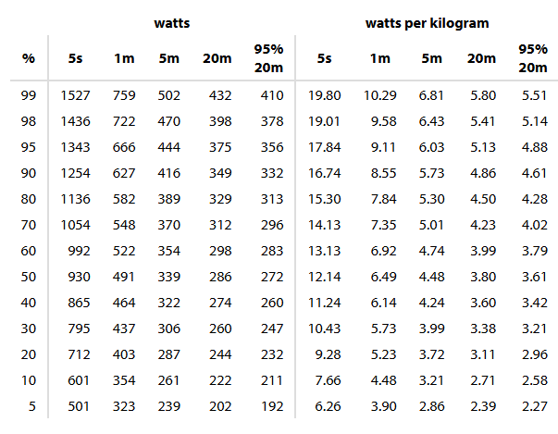
Appendix A

Appendix B
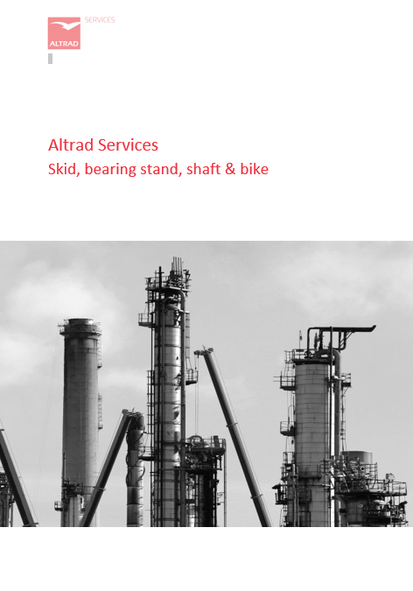

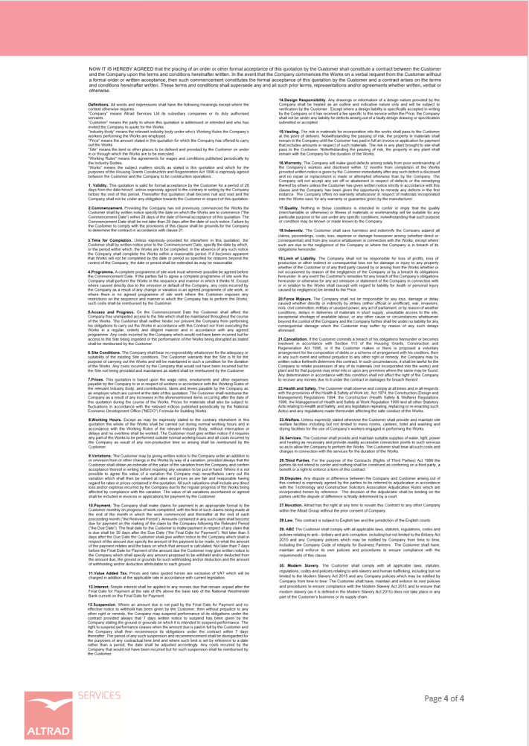

Appendix C
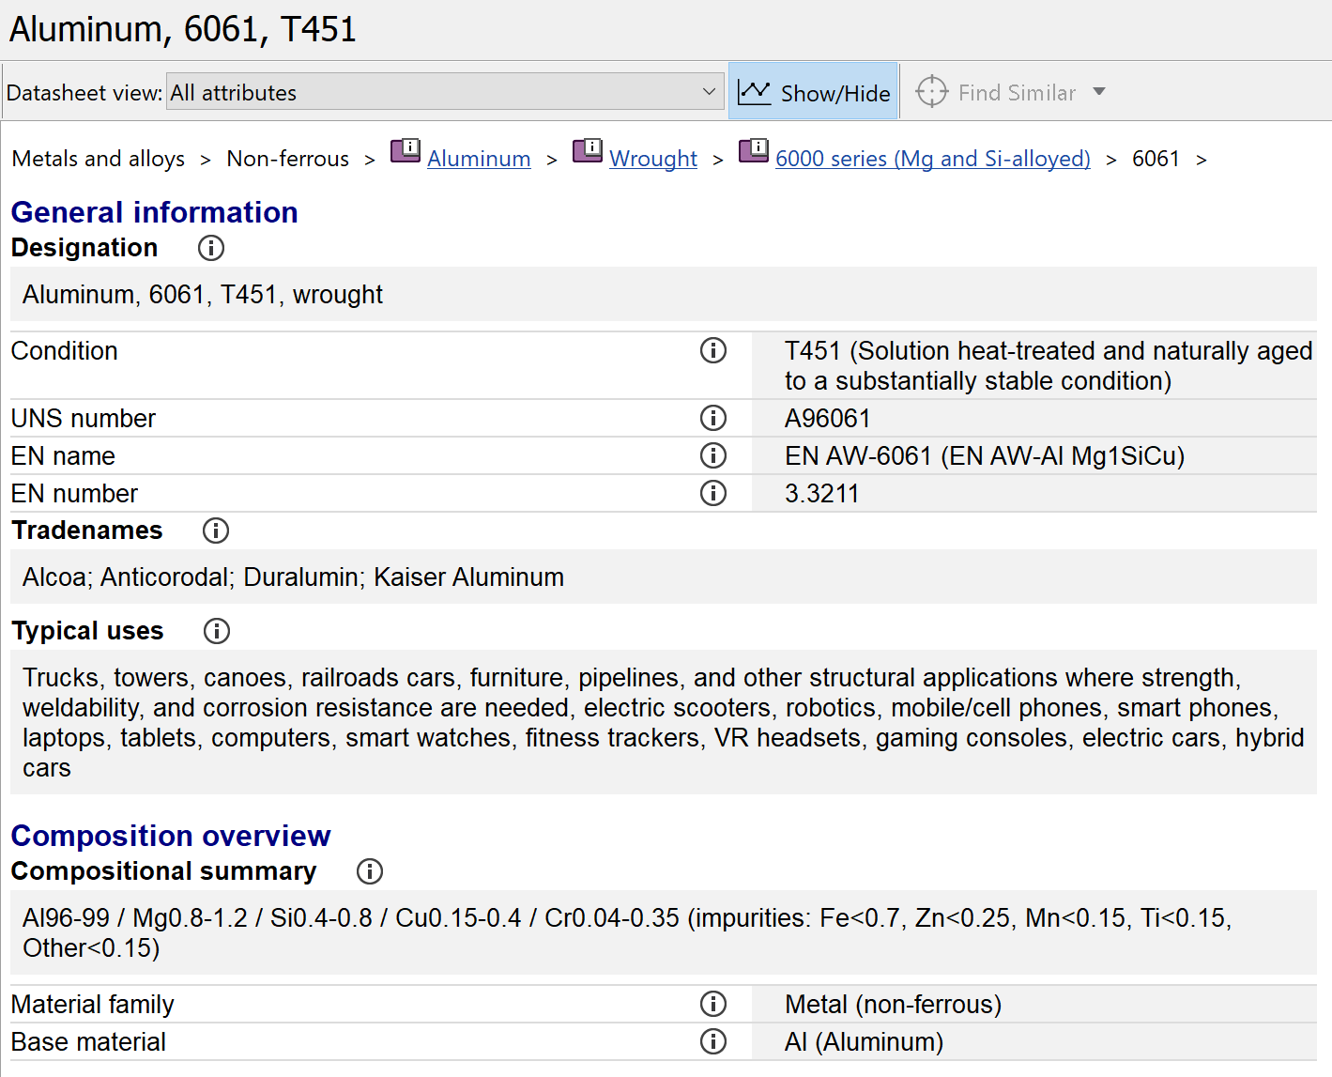
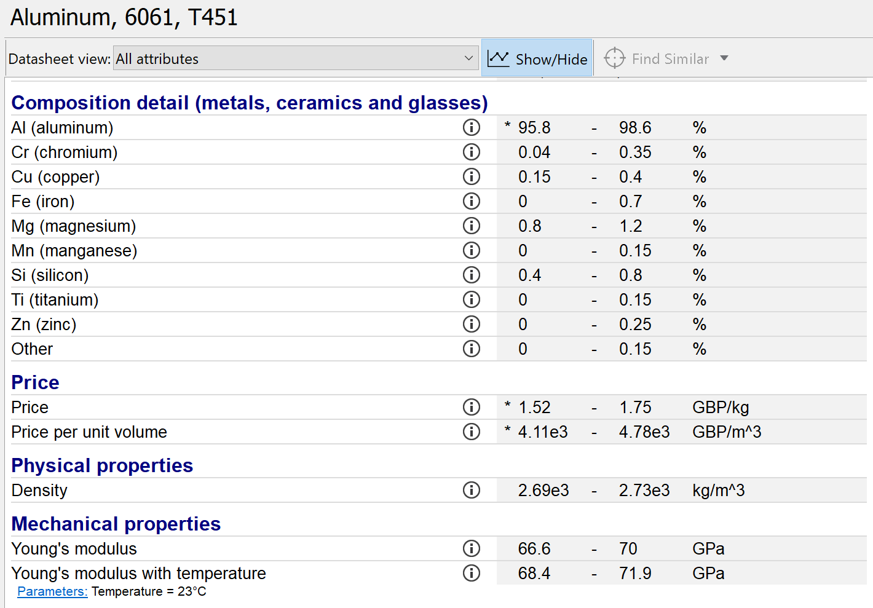
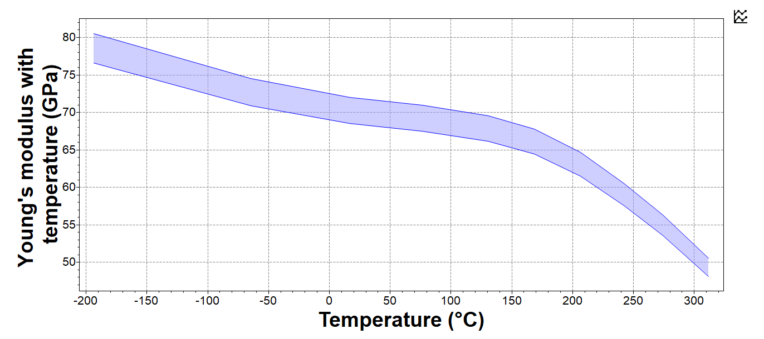
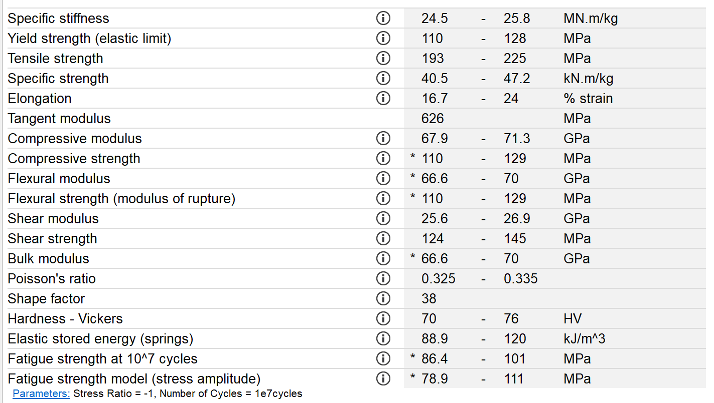
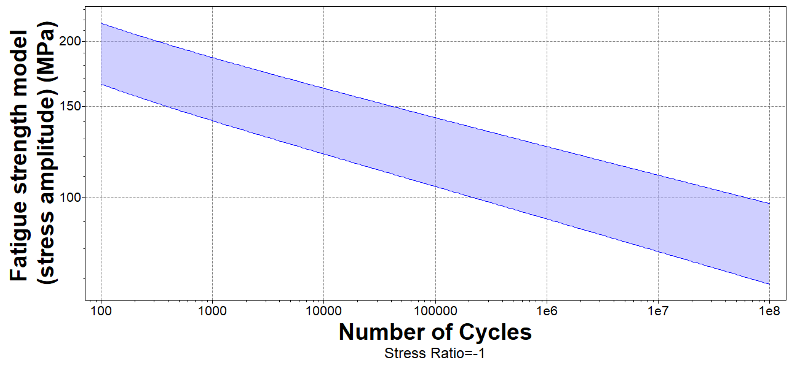
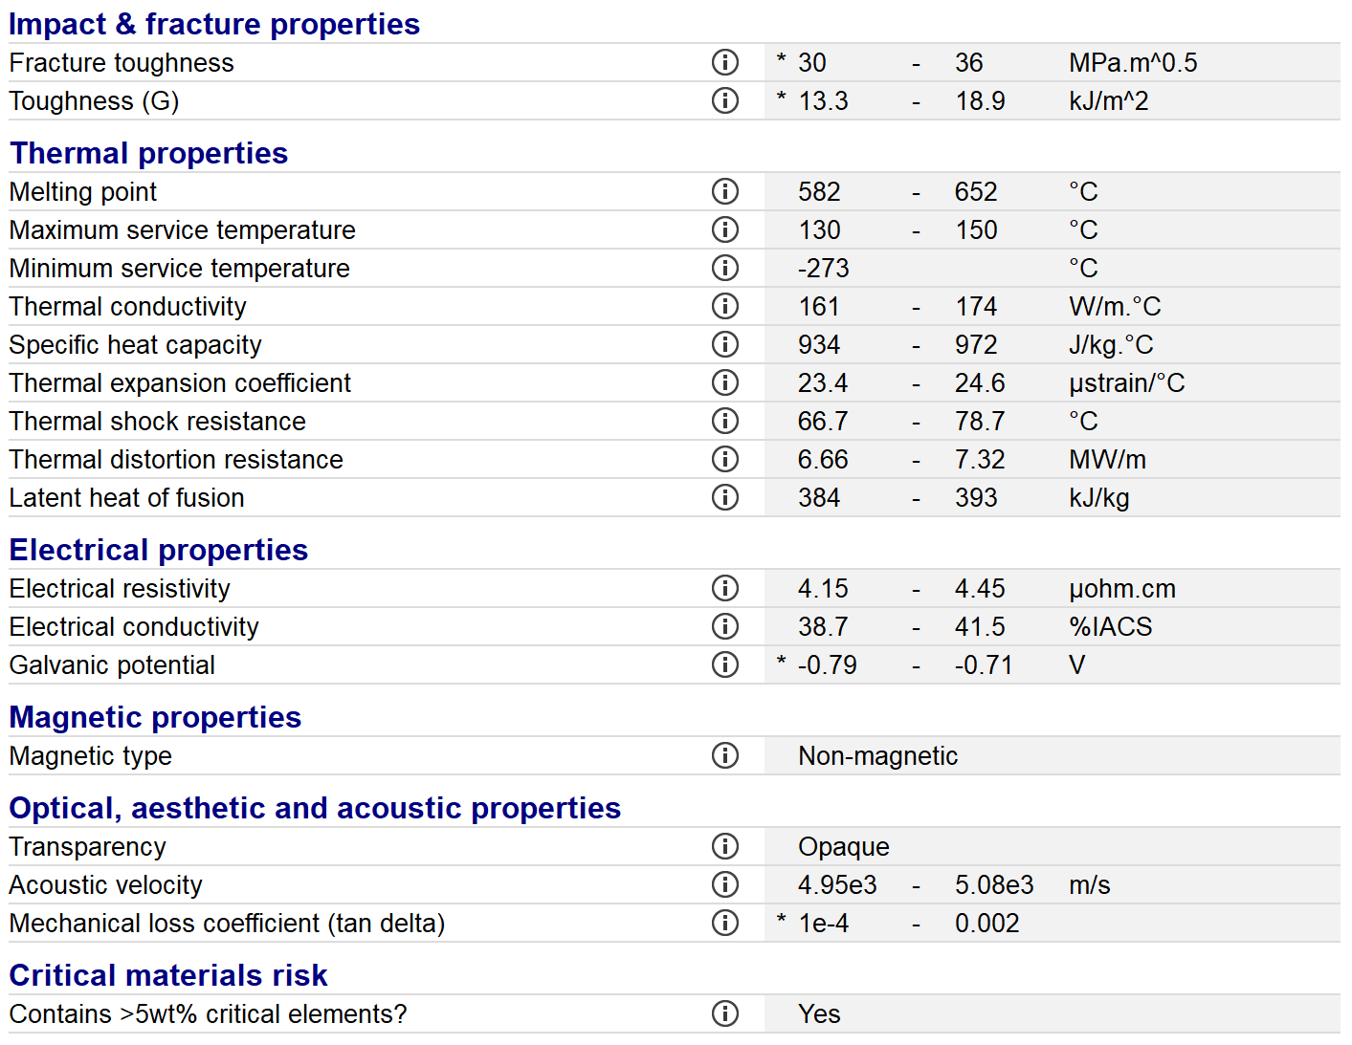
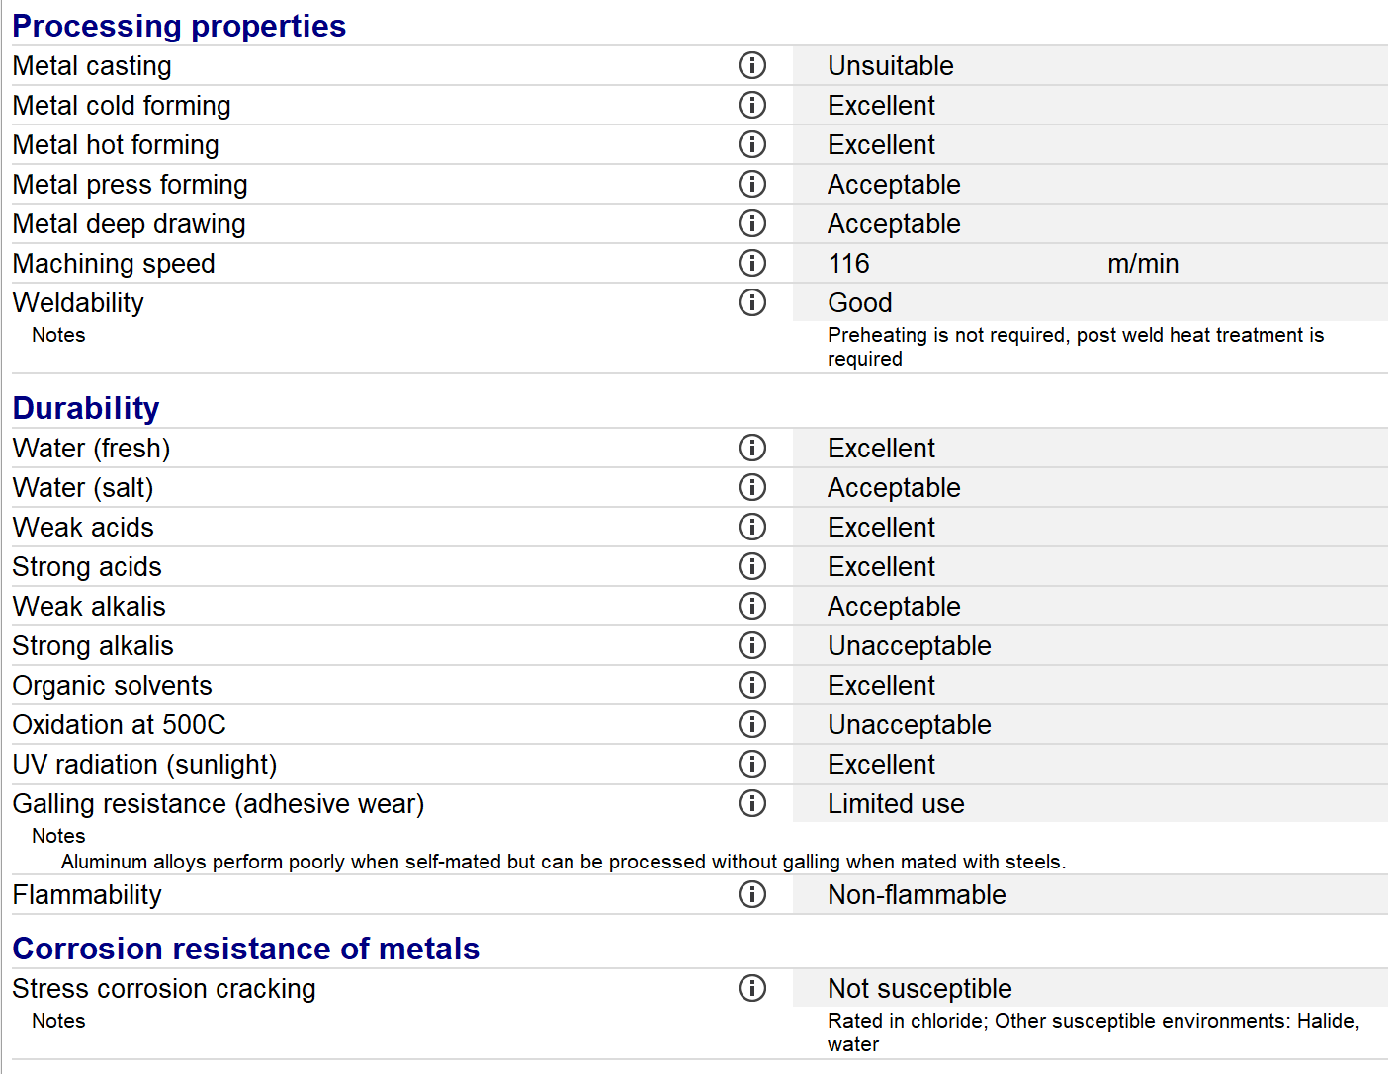
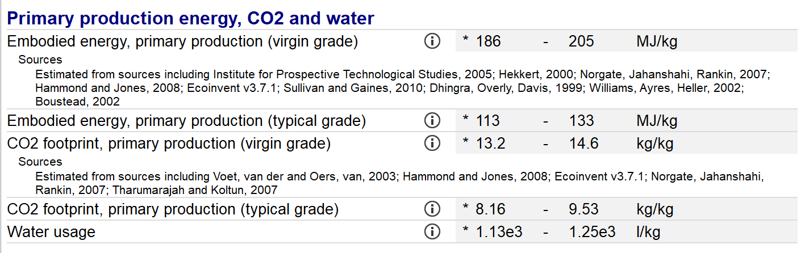
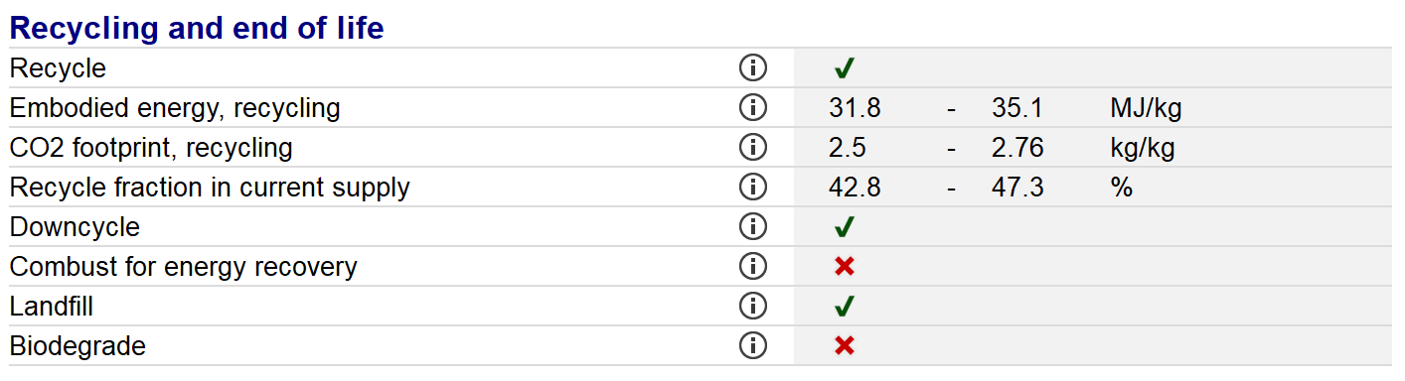

Appendix D
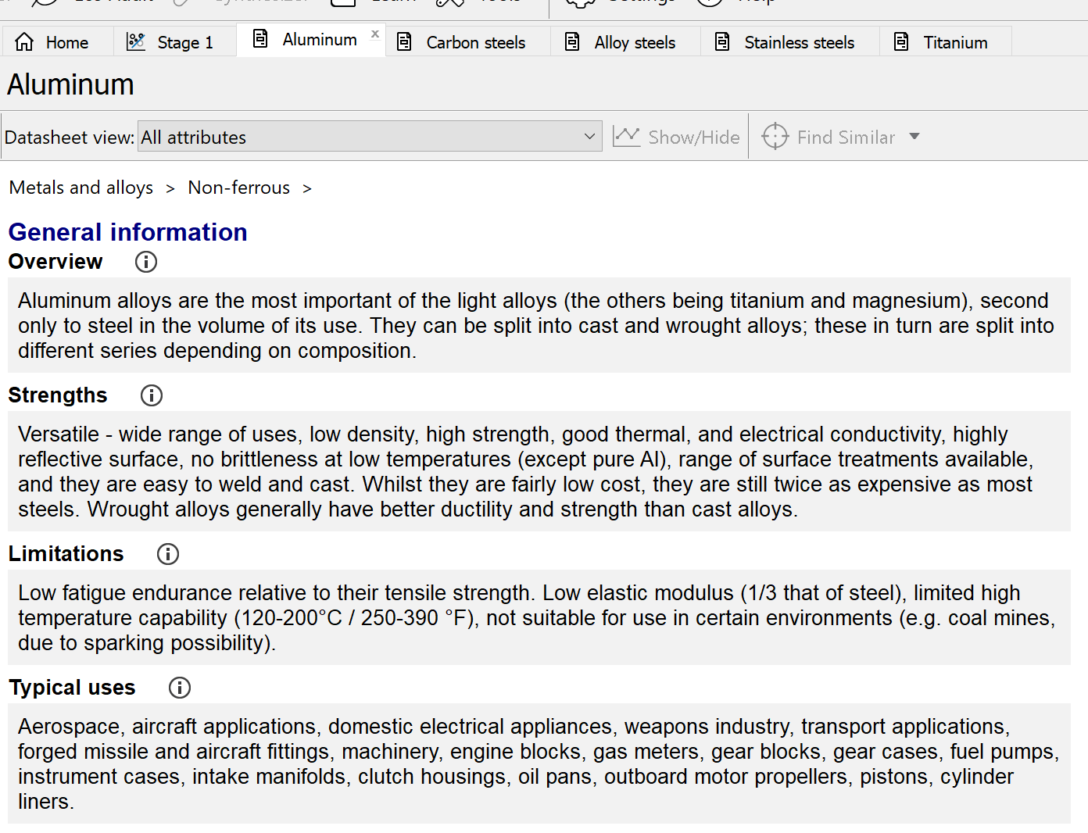
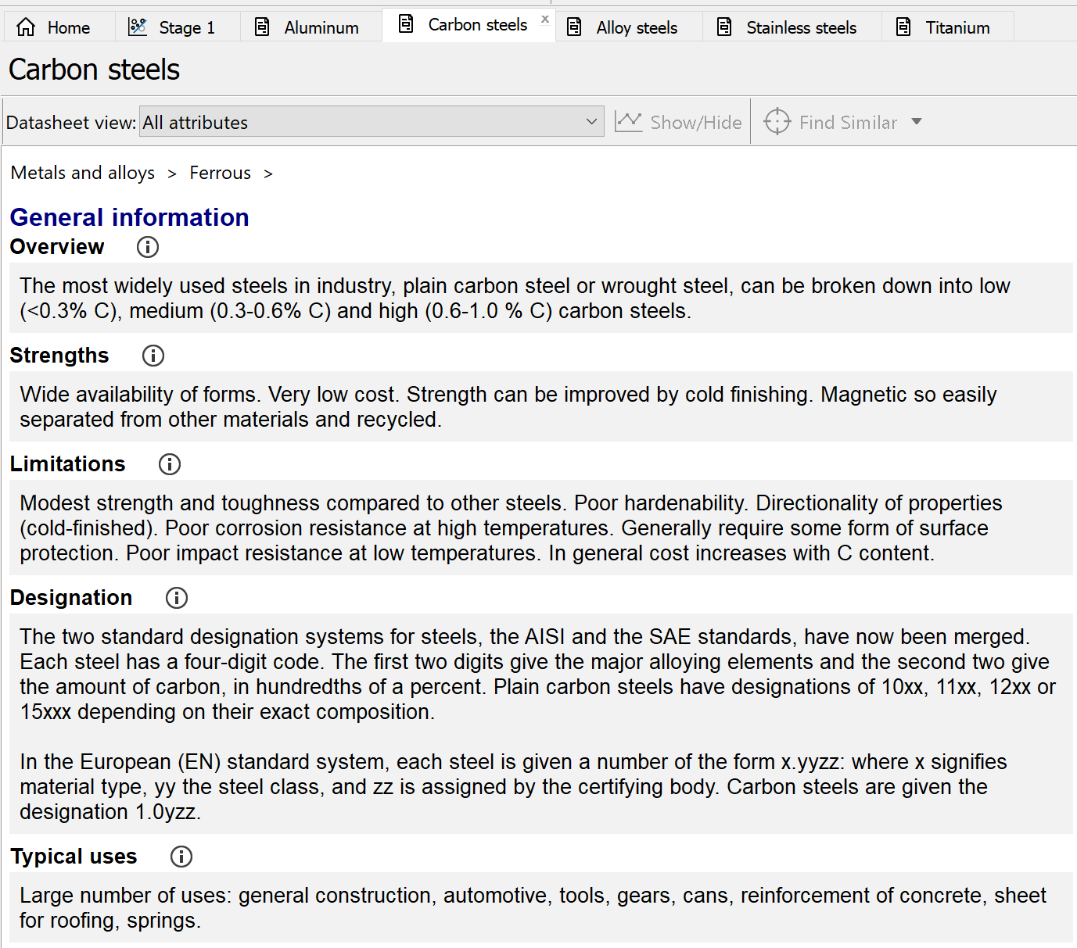
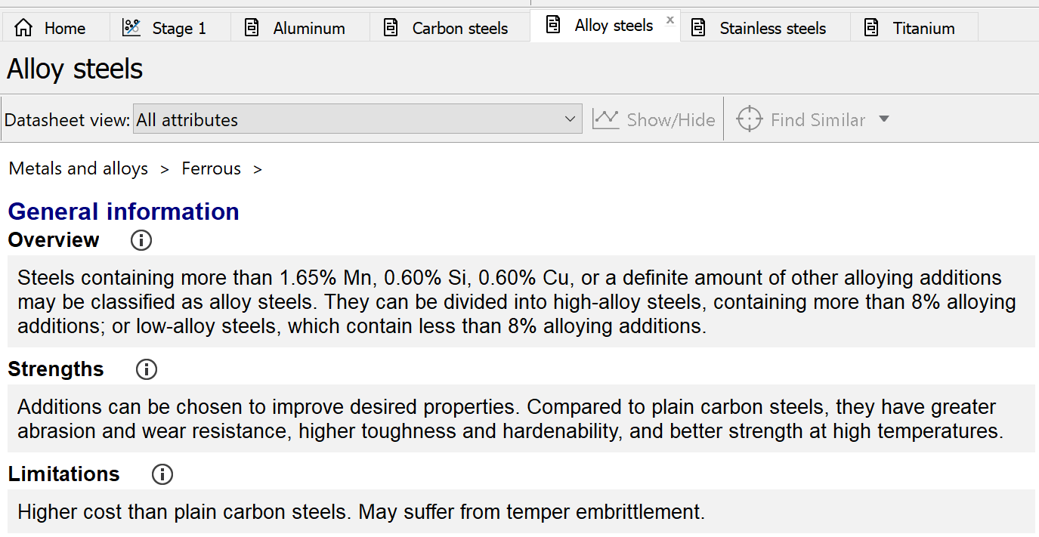
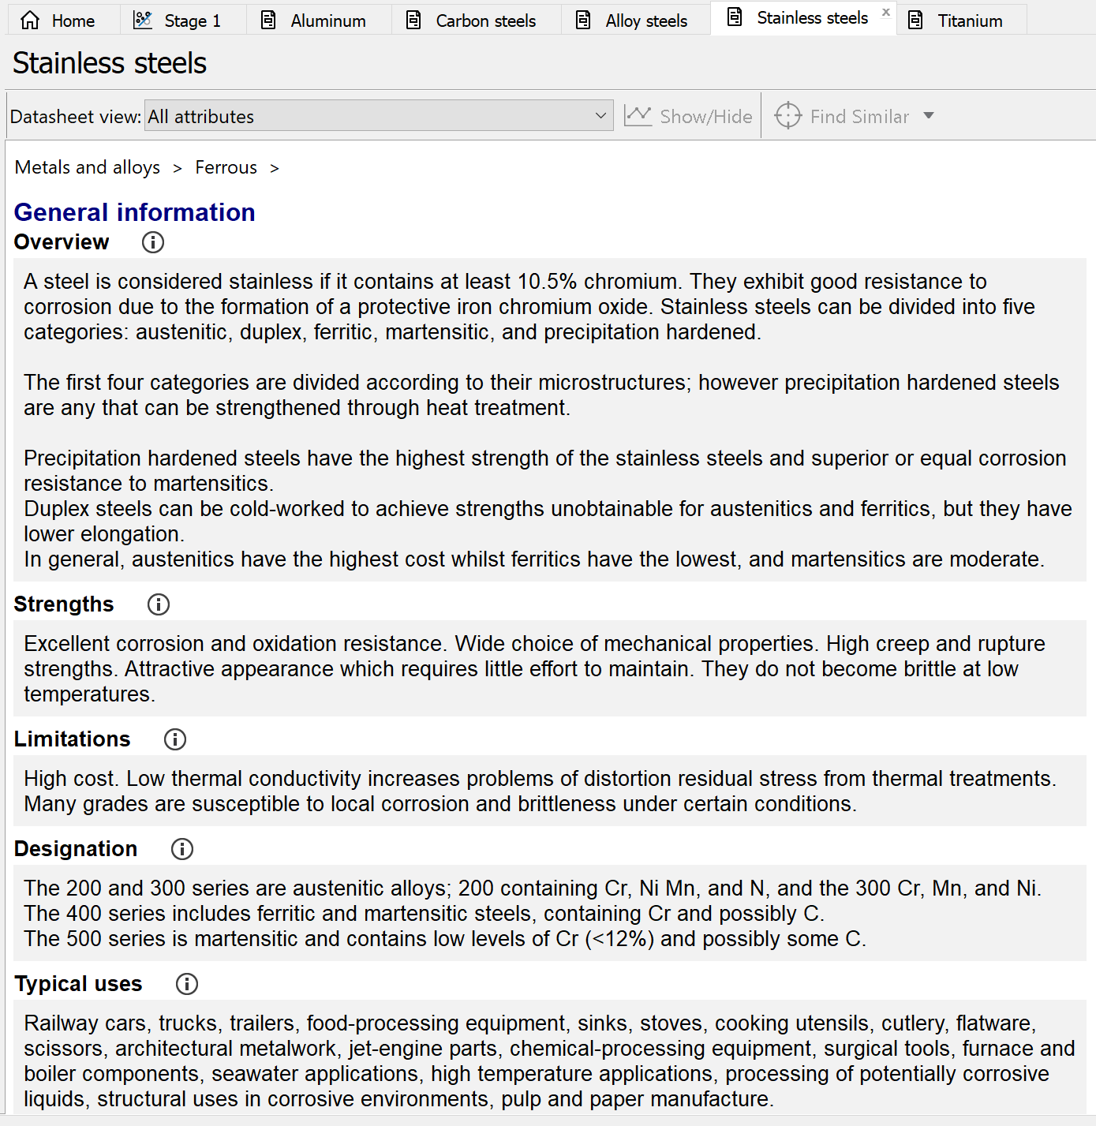
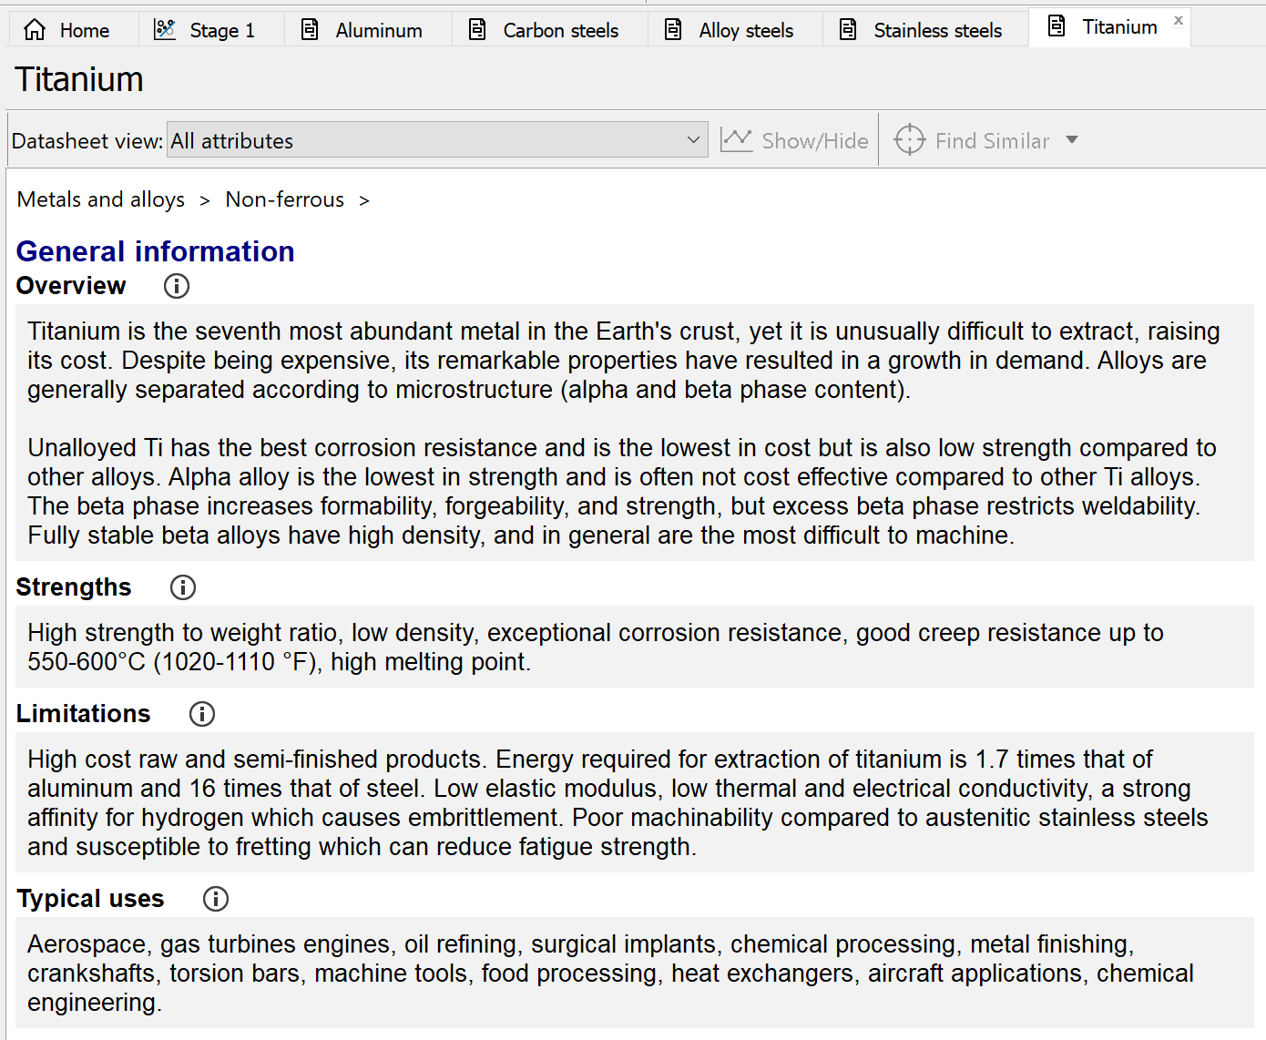

Appendix E


