

Postgraduate/Distance Learning
Assignment coversheet & feedback form

THIS SHEET MUST BE THE FIRST PAGE OF THE ASSIGNMENT YOU ARE SUBMITTING (DO NOT SEND AS A SEPARATE FILE)

For completion by the student:
Student Name: Shannon Louise Wakeling

Student University Email: 2115400@student.uwtsd.ac.uk
Module code: HPCA7028  Module title: Sacred Skies | Student ID number: 2115400 |  |  | Educational support needs:  No
Assignment title: Essay

Assignment due date: 4th May 2023
This assignment is for the 3rd module of the degree
I confirm that this is my original work and that I have adhered to the University policy on plagiarism.
Signed: S. L. Wakeling
Email submission:if you are submitting this form via email, please tick this box 
(as a substitute for your signature) to confirm that you agree to the above declaration.
Assignment Mark
1st Marker’s Provisional mark
2nd Marker’s/Moderator’s provisional mark
External Examiner’s mark (if relevant)
Final Mark

NB. All marks are provisional until confirmed by the Final Examination Board.

ALL COMMENTS ARE ON THE PDF OF YOUR PAPER IN TURNITIN

For completion by Marker 1 :
Comments:

Marker’s signature: |  |  | Date:
For completion by Marker 2/Moderator:

Comments:

Marker’s Signature: |  | Date:
External Examiner’s comments (if relevant)

External Examiner’s Signature: |  | Date:

Introduction

This essay will critically examine the cultural expression of the sky in the following three artworks: ‘Music – A Sequence of Ten Cloud Photographs, No. I’ by Alfred Stieglitz, ‘Sky above Clouds IV’ by Georgia O’Keeffe and ‘Cloud Music’ by Robert Watts, David Berhman and Bob Diamond.

This paper will explore how the depiction of the sky within these three artworks is representative of their respective cultures. Through examining the evidence, this paper will aim to answer the question: ‘Are the expressions of the sky in the three artworks impacted by the cultures within which they were created?’.

‘Music – A Sequence of Ten Cloud Photographs, No. I’ by Alfred Stieglitz was created in 1922, it is a photograph of clouds, printed in gelatin silver. It was taken in Lake George, New York, U.S.A and features Stieglitz’ country home in the bottom on the image as shown in Figure 1.

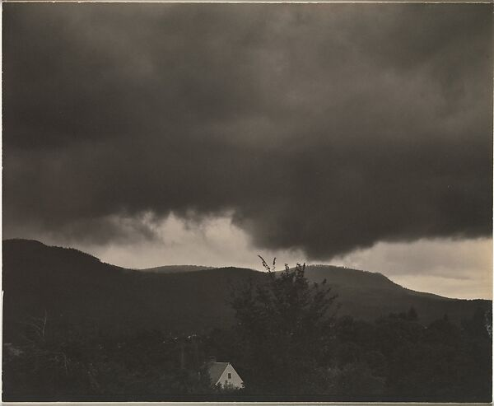
Figure 1. Alfred Stieglitz 1864 - 1946, ‘Music – A Sequence of Ten Cloud Photographs, No. I’, 1922, [Platinum print], 19.2 x 24.1 cm, The Metropolitan Museum of Art, New York, U.S.A

‘Sky above Clouds IV’ by Georgia O’Keeffe was painted in 1965 and is an oil painting on canvas as shown in Figure 2. O’Keeffee wanted to capture the endless expanses of clouds she had observed from aeroplane windows during trips all over the world. She stated that she had this idea in her head for years.

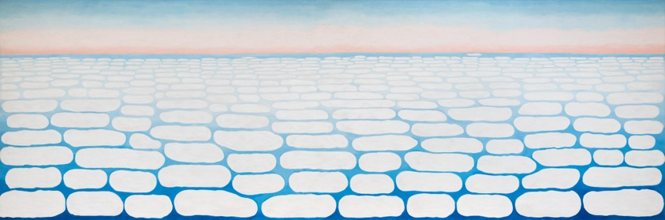
Figure 2. Georgia O'Keeffe 1887-1986,
Sky above Clouds IV, 1965, [Oil on canvas], 243.8 × 731.5 cm, The Art Institute of Chicago, Chicago U.S.A

‘Cloud Music’ by Robert Watts, David Berhman and Bob Diamond was produced between 1974 and 1979. It is a piece of digital art as shown in Figure 3. The Smithsonian Museum, where it is on permanent exhibit, described the piece as:

A closed-circuit video camera (which) is directed through a window to the sky. A video analyzer and audio synthesizer read the image on a TV monitor, transforming the movement of clouds and changing light into an original score of music…The result is an electronic score that fills the space with subtly shifting harmonics.

According to Dr. Janine Randerson the system that was created to transform cloud movements into music as shown in Figure 3, was referred to as the ‘Cloud Machine’ by Watts, Diamond and Behrman. The blueprint for the creation of ‘Cloud Machine’ is shown in Figure 4.

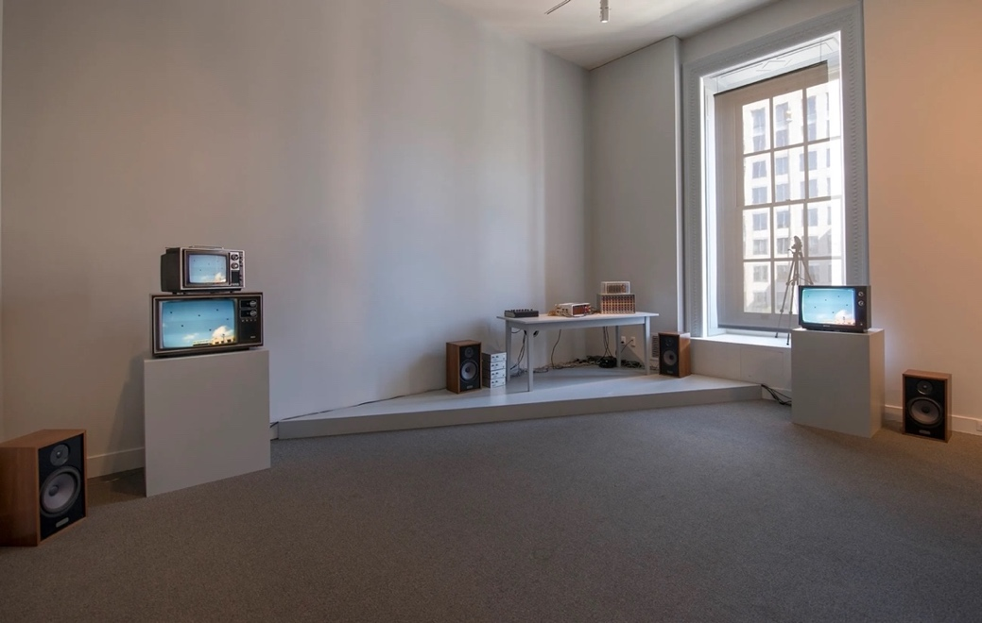
Figure 3. Robert Watts, David Behrman, Bob Diamond, Cloud Music, 1974-1979, [hybrid sound/video installation with custom electronics], dimensions variable, Smithsonian American Art Museum, Washington, U.S.A

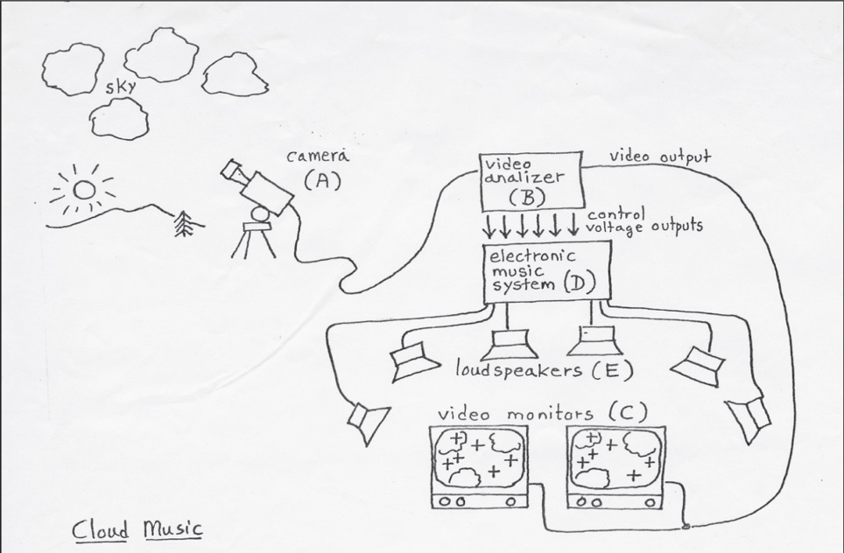
Figure 4. David Behrman (1937-), Cloud Music, 1975, Smithsonian American Art Museum, Washington U.S.A <https://www.si.edu/tbma/work/cloud-music> [Accessed 5 April 2023]

For the purposes of this essay, it is first necessary to define the terms culture and art. This paper will draw from two definitions of culture as given by Clifford Geertz. Firstly, Geertz argued that culture is:

‘an historically transmitted pattern of meanings embodied in symbols, a system of inherited conceptions expressed in symbolic forms by means of which men communicate, perpetuate, and develop their knowledge about and attitudes toward life.’

Secondly, Geertz claimed that ‘culture is the fabric of meaning in terms of which human beings interpret their experience and guide their action’. Geertz argued that art can be characterized ‘as a language; a structure; a system; an act; a symbol; a pattern of feeling.’ Rami Gabriel agreed and added to this notion, explaining that ‘art materializes experience, bringing a cast of mind into the world of objects.’

Cultural contexts of the three artworks

Christoph Redies argued that it is necessary to first understand the cultural circumstances under which the artwork was made in order to understand the intention of the artist and the meaning of the work itself. In agreeance with this statement, it is important to first analyze the individual cultural contexts of each of the three artworks in order to examine the cultural significance of the sky as depicted within them.

According to Frederick Lewis Allen, the cultural context within which Stieglitz created ‘Music – A Sequence of Ten Cloud Photographs, No. I’ was one of constant change. Stieglitz produced his photograph in 1922 in New York U.S.A. Allen argued that the 1920’s in America both began and ended with catastrophic events, commencing in the aftermath of First World War and ending with collapse of stock market. Allen claimed that in response to the war a ‘changing state of the public mind’ was experienced. This change he stated, was a shift from idealism to realism or disillusionment. He described disillusionment as a comforting interpretive framework for the uncertainties of the foreboding Great Depression.

As an artist whose career spanned more than six decades it is important to start the examination of the cultural influences of ‘Sky above Clouds IV’ by beginning with O’Keeffe’s early career influences. This is in accordance with the idea of culture as defined by Geertz as encompassing historical patterns of meaning. Sarah Whitaker Peters referred to the period from 1915 – 1930 as O’Keeffe’s ‘formative years’. O’Keeffe met Stieglitz in New York in 1916. She was the subject of his photographs for many years before the two married in 1924. At the time when the two met, Stieglitz had formed a group of modernist artists who are referred to as the ‘Stieglitz circle’. The group was comprised of all men, aside from O’Keeffe, the only female member. The group was said to have defined modern art in New York City in the 1930’s. Kathleen Pyne claimed that the Stieglitz circle were ‘the new patriarchs of modernism’ and that they found it impossible to forget the maternal security and domesticity of women. Pyne’s arguments outlined the cultural paradigms of the role of women of 1920’s in the U.S.A. that O’Keeffe would have been faced with early on in her career.

After going back and forth between New Mexico and New York for years, following the death of Stieglitz, O’Keeffe settled in Abiquiu, New Mexico in 1942. Edyta Frelik claimed that O’Keeffe maintained her connection to a selection of east coast ideas despite residing in the southwest, particularly that of Ralph Waldo Emerson and Henry David Thoreau. Frelik suggested that her move to the southwest was as if to head the call of Thoreau ‘Eastward I go only by force; but westward I go free’. Frelik claimed that O’Keeffe’s move to the southwest was ‘in keeping with Emerson’s conviction that to experience “the whole of nature” one needs to disentangle oneself from society.’ This shows how the cultural influences of her time in New York with Stieglitz carried on to become the foundations of her cultural influences during the time when ‘Sky Above the Clouds IV’ was created. Robert Nicholas Norwood added that the time when O’Keeffe created this painting was one of great upheaval and change.

Similarly to Stieglitz’ photograph, ‘Cloud Music’ was created in the northeastern part of the U.S.A, in Montrose, Pennsylvania, from the years 1974-1979. The culture of this time is important to examine in order to further understand its impact on the artwork. Bruce J. Schulman argued that in 1973 the end of the Vietnam war brought about a declining faith in the government in the northeastern part of the U.S.A. He claimed that ‘the calm, rational, polite observances of the northeast… declined during the seventies’. Schulman concluded that popularization of ecological action groups during the seventies in the northeastern part of America, radicalized the view of the relationship between humanity and nature. Groups like ‘Earth First!’ he claimed, expressed contempt towards the western ideal of the conquest of humankind over nature. These concepts can be seen as influential on the artwork ‘Cloud Music’.

Geertz’ and Gabriel’s definitions of art in relationship to the three artworks

Geertz argued that art is a ‘as a language; a structure; a system; an act; a symbol; a pattern of feeling.’ Gabriel claimed that ‘art materializes experience, bringing a cast of mind into the world of objects.’ In classifying the artworks within the frameworks of these two definitions, a context will be provided with which to examine the cultural significance of the sky in each artwork.

Allen confounded that the years during which ‘Music – A Sequence of Ten Cloud Photographs, No. I’ was created was a time of disillusionment. Stieglitz described the experiences he was going through at the time he created it, echoing Allen’s idea:

My mother was dying. Our estate was going to pieces. The old horse of 37 was being kept alive by the 70-year-old coachman I, full of the feeling of today: all about me disintegration—slow but sure: dying chestnut trees—all the chestnuts in this country have been dying for years: the pines doomed too—diseased: I, poor, but at work: the world in a great mess.

The conditions which Stieglitz described surrounding his creation of the artwork are in congruence with the argument of Gabriel, that art materializes experience. This concept also solidified Stieglitz’ photograph as a symbol of the times, supporting Geertz’ definition of art.

In examining the experiences of the artists in line with the argument of Gabriel, it is useful to investigate O’Keeffe’s time in New Mexico. After being diagnosed with macular degeneration, she was partially blind, and at 77 years of age she began the monstrous undertaking of painting ‘Sky above Clouds IV’ on a canvas that stretched 243.8 × 731.5cm as shown in Figure 2. Gatson Bachelard argued that ‘the clouds help us to dream of transformation’. In agreeance with this idea, painting the sky may have been a part of O’Keeffe’s dream of transforming the hardships of her current personal lived experience and/or the collective experience of upheaval of the 1960’s as described by Norwood. Through this it could be indicated that she had brought her ‘cast of mind into the world of objects’ as Gabriel suggested art can do.

According to Norwood, the integration of cultures of the 1960’s in the southwest U.S.A brought about an open-mindedness through a blending of east and west religious ideals.. The cultural ideology of open-mindedness is seen to have influenced ‘Sky above the Clouds IV’. O’Keeffe, despite having an intense fear of flying, at the age of 66 decided to embark on a world tour. Emily C. Watson claimed that this new perspective of the world from the air, alleviated O’Keeffe’s flight anxieties, as she scribbled the views from the air on cocktail napkins, to draw her focus from her fears. In this way the painting confirmed Gabriel’s notion as it became a way for O’Keeffe to further materialize her experience. Alexandra Harris suggested that ‘inner weather creates outer weather; we find the external image of the thing we need to express’. In accordance with this idea, the sky for O’Keeffe became the image by which she could express her fear of flying. In line with the definition of art as a symbol by Geertz and the arguments of Gabriel and Harris, the sky within the painting was to be symbolic of a source of fear, as well as a place of overcoming her fears.

In examining Geertz’ definition of art, it is useful to look at the structure of the artwork ‘Cloud Music’. Randerson claimed that as ‘Cloud Music’ is a construction whereby audio and visual technologies work together to produce a musical score, the artwork can be classified as a ‘system’ in line with Geertz’ definition of art.

Culture as a system of symbolic forms

Geertz argued that culture was as a process of taking on symbolic forms, to express historic patterns of meaning which resulted in becoming a vehicle to express one’s comprehension and point of view of life itself. Redies added to this definition that symbols were used by artists to display their intentions and access the cognitive processes of the observer which turns symbols into information. In accordance with this idea, to understand the impact of the culture on the expressions of the sky in the artworks, it is important to consider the role of symbols within them.

Stieglitz’ ‘attitudes towards life’, are necessary to examine when considering the symbolic forms in his photograph. Joseph Shiffman claimed that as a result of the disillusionment of the 1920’s many modern artists, including Stieglitz, were experiencing feelings of alienation. Shiffman argued that this feeling of alienation, sparked Stieglitz’ transition away from photographing human life, and into photographing non-human subjects. John Beck described Stieglitz as one of the first abstract photographers, he claimed that Stieglitz’ photograph was a ‘natural abstraction of the sky’ which transitioned ‘into the cultural abstraction of the modernist image’. The sky as the ‘non-human’ subject of the photograph is shown to be a symbol of the alienation felt by Stieglitz. This both supports Geertz’ definition of art as a symbol, and culture as a pattern of meaning is embodied in a symbols.

Judith Zilczer argued that cultural abstraction in Stieglitz’ photography inspired him to conflate parallels between art and music, and in turn this musical analogous became his form of cultural abstraction. Stieglitz stated that he had intended this series of photographs to inspire his friend and composer Ernest Bloch. He exclaimed:

. . . I wanted a series of photographs which when seen by Ernest Bloch (the great composer) he would exclaim: Music! music! Man, why that is music! How did you ever do that? And he would point to violins, and flutes, and oboes, and brass, full of enthusiasm, and would say he’d have to write a symphony called ‘Clouds.’. . . And when finally I had my series of ten photographs printed, and Bloch saw them – what I said I wanted to happen happened verbatim.

Stieglitz showed how he wished for the clouds to inspire his friend to write a symphony. The sky in the artwork would thereby become symbolic inspiration of the music itself. In accordance with the definition given by Geertz, the sky in the artwork is suggested to be culturally informed as the pattern of meaning, to influence a musical symphony, which is embodied in the clouds in the sky as symbols within the artwork.

John Pultz agreed with Zilczer and added that the clouds themselves had little meaning for Stieglitz and that it was the endless amounts of associations and interpretations that could ensue by looking at the clouds that was where the real meaning came from. Harris concurred and continued that clouds were a creative source for many artists because ‘like a much redrafted poem there is no single authoritative version of a cloud. The cloud-form is constantly revised and never finished.’ She suggested that when looking at clouds, the observer fills out the image with their own preconceptions and the cloud becomes a symbol which represents what the observer thinks they see. In accordance with the defintion of culture given by Geertz, as well as the arguments of Pultz and Harris, clouds can be seen in the photograph once again as a feature of the artwork, acting as a symbol in a larger pattern of meaning.

Stieglitz argued that he wanted his viewers to understand how nature could be emotionally and philosophically expressive rather than just taking photographs of literal representations of nature. He exclaimed:

Through clouds (I wanted) to put down my philosophy of life—to show that my photographs were not due to subject matter—not to special trees, or faces, or interiors, to special privileges, clouds were there for everyone—no tax as yet on them—free.

Here the sky in the photograph is also shown as a symbolic means to communicate Stieglitz’ attitude towards life. Harris added to this idea and claimed that the connection between clouds and minds is commonplace. She argued that clouds can become a projection of the artists mind and that they can become representative of the vastness of the artists mental space. As symbolic of the artists mind, clouds in the photograph become congruent with Geertz’ definition of culture.

Geertz’ definition of culture as a means by which one can communicate their knowledge about life can also be considered in relation to ‘Sky above the Clouds IV’. Rita Donagh argued that the exploration of the abstract theme of the aerial perspective can be thought of as an inclusion of O’Keeffe’s modernist roots, and that she was among the first to paint from this new perspective. Donagh claimed that the painting created stillness amidst the perpetual change of the time. If culture is to be considered a system of inherited conceptions expressed in symbolic forms as argued by Geertz, then the inherited modernist thinking of O’Keeffe can be seen to have inspired ‘Sky above the Clouds IV’ and framed the painting as a symbol of the times.

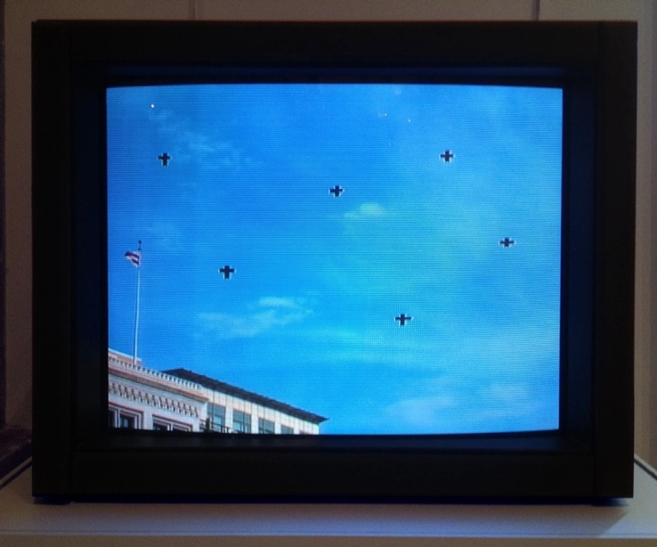
Figure 5. Robert Watts, David Behrman, Bob Diamond, 'Cloud Music, 1974-1979, [hybrid sound/video installation with custom electronics], dimensions variable, Smithsonian American Art Museum, Washington, U.S.A

In examining the artwork ‘Cloud Music’, as symbolic of the perpetuation of knowledge and attitudes towards life it is important again to look at the construction of the ‘Cloud Machine’ as shown in Figures 3, 4 and 5. Randerson argued that the seventies was a period whereby people were exploring the connection between computers and the weather. Diamond is a former systems engineer for NASA, he worked on the Apollo project. Randerson concluded that his work at NASA can be traced to the use of military grade materials in the construction of the ‘Cloud Machine’. According to Randerson the cross hairs that appear on the monitor shown in Figure 5 are similar to those used in ground based artillery as marking targets. She argued that using materials of destruction, as a passive tool of subversion was a bold statement. She claimed that the subversion of technological instruments was a sign of the cultural paradigms of the time within which ‘Cloud Music’ was created.

Randerson argued that Cybernetics was an influential concept in the 1970’s and that Diamond had a deep understanding of Cybernetics. Frances Heylighen and Cliff Joslyn described Cybernetics as the scientific study of complex organization systems and the abstract principles to which they abide. They suggested it is concerned with the role of the observer as agent for building these systems. Diamond’s experience at NASA and his understanding of Cybernetics constellated his way of thinking. These inherited conceptions, as argued by Geertz, when expressed through symbolic forms become a part of culture. If ‘Cloud Music’ is to be considered as art in line with Geertz’ definition as a symbol of these modes of though in itself, then it is apparent how the production of the artwork could be culturally informed.

As a continuation of the analysis of ‘Cloud Music’, in considering David Behrman’s knowledge base, Geertz’ ideas are further supported. Randerson claimed that his previous work with John Cage greatly influenced his involvement in the creation of ‘Cloud Music’. Randerson specified that Cage’s work included ‘interpretations of disorder, order, probability, randomness, freedom and indeterminacy’. She described that during the seventies, disorder was a concept which was an integral part of many artworks. Harris built on this idea by suggesting that clouds represent a system of order which is not static, but constantly changing, a form of disordered order. In considering disorder as a pattern of meaning that was emerging during the seventies as Randerson suggests, the link between ‘Cloud Music’ as an artwork that is culturally influenced in line with Geertz’ definition of culture is proposed.

Randerson argued that as a continuation of the initial theory of Cybernetics, Second-Order Cybernetics signaled a new paradigm in science in the 1970’s that was being applied in meteorological art at the time. Randerson claimed that Cybernetics prompted Watts, Diamond and Behrman to explore the relationship between the living organism and the environment. Schulman argued that the relationship between humans and nature was a focus in the seventies. Randerson claimed that in Cybernetics the observer is part of the cycle of information exchange. ‘Cloud Music’ exemplifies this concept as the restraints of the circuit and the timing of the encounter of the viewer push both the observer and the ‘Cloud Machine’ into the cycle of information exchange as shown in Figure 4. Randerson explained that through this, the observer is the participant. Influenced by the concept of Cybernetics, Watts, Diamond and Behrman allowed the observer to be an active participant in their artwork. The music that ‘Cloud Music’ created was subject to the exact moment when which the observer encountered the artwork, and the position of the clouds themselves. Thereby, making the observer and the clouds co-creative participants in the creation of music. Randerson argued that this exemplified the cultural shift that was occurring during the seventies from ontology to ontogenesis. Cybernetics and Cagean philosophy, can be viewed as cultural ideologies in terms with Geertz’ definition of culture, as historically transmitted patterns of meaning. Randerson argued these patterns informed the creation of ‘Cloud Music’, suggesting that the culture of the time had influence over the artwork, as it emerged as a ‘system of inherited conceptions’.

Gabriel claimed that ‘an artist will engage their audience's well of symbols, their cultural epistemic niche, through the capacity to gain acquaintance knowledge through aesthetic comprehension.’ The presence of symbols in these artworks suggested that all three may be culturally informed representations of the sky through confirming the argument of Geertz’ that culture is ‘pattern of meanings embodied in symbols.’

Culture as a fabric of meaning that interprets human experience and guides human action

Redies argued that ‘the cultural context and the previous personal experience of the artists are of paramount importance for the creation of artwork’. In agreeance with this idea, the three artworks will be examined in relation to Geertz’ definition of culture as ‘culture is the fabric of meaning in terms of which human beings interpret their experience and guide their action’. Gabriel agreed with Geertz’ definition and added that art can be a cultural catalyst for the experiential interpretations woven together by the fabric of meaning that is culture, she suggested that ‘art is a form of self-knowledge that equips us with a motivated understanding of ourselves in the world’.

The influence of culture on the actions of individuals can be explored in relation the Stieglitz’ photography. Pultz stated that Stieglitz renamed ‘Music – A Sequence of Ten Cloud Photographs, No. I’ in the late 1920’s with the name ‘Equivalents’, as a part of a larger a photographic collection. Pultz argued that the term ‘equivalent’ referred to the process of moving from object to interpretation. Beck claimed that the objective of the photographs in the collection ‘Equivalents’ was to move away from the realistic and from the pictorial function of photography ‘to produce images that are closer to music in their lyrical abstraction’. A part of the fabric of meaning of the time is marked by the the transition from idealism to realism and the movement of modernists towards including a musical analogy. In guiding Stieglitz’ actions to change the name of the photograph, it is shown how, through Geertz’ definition of culture, ’Music – A Sequence of Ten Cloud Photographs, No. I’ the representation of the sky may have been culturally influenced.

Similarly, the actions of O’Keeffe can be explored as a product of the cultural fabric of meaning of the time. Frelik argued that the control Stieglitz had over O’Keeffe’s was restrictive. Frelik claimed that O’Keeffe tried to free herself from the grasp of the Stieglitz circle and the modernist perspective overshadowing her work in New York by relocating to the desert to reinvent her artistic persona and construct ‘an image of herself as a self-reliant desert hermit’. The direct action O’Keeffe took to move to the desert to create ‘Sky Above Clouds IV’ suggested that the her treatment as a women, informed the fabric of meaning in her life, and drove her to take action to retreat to a life of solitude in order to create the artwork. Pyne stated ‘in the silence of her private world she made an ordered universe with herself at its center and her voice and her will as its ordering principles’. Fitting in line with Geertz’ definition of art as a ‘pattern of feeling’, this pattern of feeling was influenced by a greater fabric of meaning of the time, which in turn guided her actions, suggesting that representation of the sky in the artwork may be culturally influenced.

Harris argued that ‘weather gathers association and, in a constant exchange of subject and object, our associations shape our experience of weather’. ‘Cloud Music’ explored this exchange between subject and object, as the role between humans and nature was investigated in the artwork. This relationship was a frame of interpretation of the time the art was created, as Schulman suggested the rise of the ‘Earth First!’ movement sparked this sensibility. This association according to Harris’ argument would have helped to shape Watts Diamond and Behrman’s experience of the sky and of weather. As a product of the cultural paradigms of the time, Randerson concluded that Watts wanted to explore the relationship between humans and nature. She suggested that ‘Cloud Music’ was intended to inspire ecological consciousness and a sense of connection to the skyscape in any person that engages with the artwork. Randerson claimed that ‘Cloud Music’ was born out of the poetic idea that Watts had, that one might be able to hear the clouds. Randerson added that this idea built upon the cultural reasoning of transformation of the time, and claimed that ‘these works suggest an analogy between changes of state in physical systems and the possibility of shifting or rethinking human-technology-nature relations’. In collaboration with Watts, Diamond added a somatic element to this dialectic saying he wanted people to be able to feel the shapes that the clouds make through listening to the music that ‘Cloud Music’ produced. Here it is shown that conception of ‘Cloud Music’ was largely driven by the relationship between humans and nature. The artwork can be seen as symbolic of this relationship, in line with Geertz’ description of art as a symbol. This symbol was informed by the fabric of meaning of the times which influenced Watts, Diamond and Behrman to create ‘Cloud Music’ indicating the cultural significance of the sky in the artwork.
Conclusion

The aim of this essay was to answer the question: ‘Are the expressions of the sky in the three artworks impacted by the cultures within which they were created?’. From the investigation of this question, three main points arose as signifiers of the cultural impact on the expression of the sky within the three artworks.

Firstly, as a foundation for the investigation the three artworks were examined as forms of art in terms of the definition given by Geertz and Gabriel. In accordance with Geertz’ definition, Stieglitz’ photograph was able to be viewed as a symbol of the disillusionment of the 1920’s and ‘Cloud Music’ was also able to be viewed as a system. In line with Gabriel’s definition O’Keeffe’s painting interpreted as a materliaization of her lived experience.

Secondly, the artworks were examined in relationship to Geertz’ definition of culture as a symbolic system which perpetuates ones knowledge and attitudes. ‘Music – A Sequence of Ten Cloud Photographs, No. I’ was shown to be a symbol in itself of the alienation Stieglitz felt. The photograph also emerged as a symbol for the cultural abstraction which paralleled art with music and was shown to portray Stieglitz’ philosophy of life. The sky was shown to be culturally impacted in ‘Sky above Clouds IV’ as it symbolized how O’Keeffe could develop her modernist way of thinking and explore new perspectives, such as an aerial view. ‘Cloud Music’ appeared to be a symbolic form of the inherited conceptions of the time, such as Cagean philosophy and Cybernetics. All three artworks were shown to encompass examples of cultural phenomenon, in line with the definition of culture as given by Geertz.

Thirdly, by examining the artworks in relationship to Geertz’ definition of culture as a the ‘fabric of meaning in terms of which human beings interpret their experience and guide their action’, all three artworks were shown to be examples of culture. When Stieglitz changed the name of ‘Music – A Sequence of Ten Cloud Photographs, No. I’ to ‘Equivalents’, this signified actions which were taken because of the fabric of meaning of the time. When O’Keeffe moved to the desert to paint ‘Sky above Clouds IV’ Geertz’ definition was further exemplified. Watts, Diamond and Behrman explored the relationship of humans and nature, a prevalent part of the fabric of meaning of the time, through which they interpreted their experience and used it to guide their actions in creating ‘Cloud Music’.

Through examining the evidence presented in this essay all three artworks emerged as representations of culture and art in accordance with the definitions of art and culture given by Geertz and the definition of art as given by Gabriel. As embodiments of culture and visual representations of the sky, it is indicated that the expression of the sky in the three artworks is impacted by the culture within which they were created.

Bibliography

Primary Sources

Behrman, David (1937-), Cloud Music, 1975, Smithsonian American Art Museum, Washington U.S.A <https://www.si.edu/tbma/work/cloud-music>. [Accessed 5 April 2023].
O'Keeffe, Georgia 1887-1986, Sky above Clouds IV, 1965, [Oil on canvas], 243.8 × 731.5 cm, The Art Institute of Chicago, Chicago U.S.A.

Stieglitz, Alfred, ‘How I Came to Photograph Clouds’, The Amateur Photographer and Photography, 25, (1923) p. 255.

Stieglitz, Alfred 1864 - 1946, ‘Music – A Sequence of Ten Cloud Photographs, No. I’, 1922, [Platinum print], 19.2 x 24.1 cm, The Metropolitan Museum of Art, New York, U.S.A.
Watts, Robert, David Behrman, and Bob Diamond, Cloud Music, 1974-1979, [hybrid sound/video installation with custom electronics], dimensions variable, Smithsonian American Art Museum, Washington, U.S.A.

Secondary Sources

The Art Institute of Chicago, ‘Sky above Clouds IV’, <https://www.artic.edu/artworks/100858/sky-above-clouds-iv> [Accessed 5 April 2023].

Beck, John, ‘Signs of the Sky, Signs of the Times’, Theory, culture & society, 28.7–8 (2011), <https://doi-org.ezproxy.uwtsd.ac.uk/10.1177/026327641142377> [Accessed 5 April 2023].

Biel, Steven, ‘Frederick Lewis Allen’s Only Yesterday and the Idea of the Decade’, Journal of American studies, 25.2 (1991), pp.259–66.

Chalard, Maud, ‘Understanding Georgia O’Keeffe and Alfred Stieglitz’, Artsper, 2022 <https://blog.artsper.com/en/lifestyle/georgia-okeeffe-and-alfred-stieglitz/> [Accessed 5 April 2023].

Donagh, Rita, ‘Georgia O’Keeffe in Context’, Oxford Art Journal: Women in Art, 3.1, (1980) pp. 44 – 50.

Frelik, Edyta, ‘She Did Know a Few Things: Georgia O’Keeffe as an Intellectual’, Polish journal for American studies, 11 (2017), pp. 41-58.

Gabriel, Rami, ‘Affect, Belief, and the Arts’, Frontiers in psychology, 12, (2021), <doi: 10.3389/fpsyg.2021.757234>.

Geertz, Clifford, ‘The Interpretation of Cultures; Selected Essays’, (New York: Basic Books inc., 1973).

Geertz, Clifford, ‘Art as a Cultural System’, MLN, 91.6, (1976), pp. 1473-99.

Harris, Alexandra, ‘Weatherland’ (London: Thames & Hudson, 2016).

Heylighen, Francis, and Cliff Joslyn, ‘Cybernetics and Second-Order Cybernetics’, ed. by Robert A. Meyers, Encyclopedia of Physical Science and Technology, 3, (2003), pp. 155–70.

The Metropolitan Museum of Art, ‘Music - A Sequence of Ten Cloud Photographs, No. 1’, (2020) <https://www.metmuseum.org/art/collection/search/267447#:~:text=New%20York%3A%20Random%20House%2C%201973,pl.> [Accessed 5 April 2023].

Museum of Fine Arts Boston, ‘Music: A Sequence of Ten Cloud Photographs (No. 1)’, <https://collections.mfa.org/objects/4657> [Accessed 5 April 2023].

Norwood, Robert Nicholas, ‘The American Southwest in Literature, 1940-1960’ (Arizona: Arizona State University Press, 1998).

Pultz, John, ‘Equivalence, Symbolism, and Minor White’s Way into the Language of Photography’, Record of the Art Museum: Princeton University, 39.1-2 (1980), pp. 28–39.

Pyne, Kathleen A., Modernism and the Feminine Voice (Berkley, Los Angeles, University of California Press: 2007), pp. i – 296 .

Randerson, Janine, ‘Cloud Music : A Cloud System’, ed. by K. Cleland, L. Fisher, and R. Harley, Proceedings of the 19th International Symposium of Electronic Art (Sydney, Australia: ISEA International, Australian Network for Art & Technology, University of Sydney, 2013).

Randerson, Janine, Weather as Medium: Toward a Meteorological Art, (Cambridge USA: Leonardo, 2018),

Redies, Christoph, ‘Combining Universal Beauty and Cultural Context in a Unifying Model of Visual Aesthetic Experience’, Frontiers in Human Neuroscience, 9 (2015) < doi.org/10.3389/fnhum.2015.00218>.

Schulman, Bruce J., ‘The Seventies’ (New York: The Free Press, 2001).

Shiffman, Joseph, ‘The Alienation of the Artist: Alfred Stieglitz’, American quarterly, 3.3 (1951), pp. 244 – 258.

Smithsonian Museum: Smithsonian Time Based Media and Digital Art ‘Cloud Music’, <https://www.si.edu/tbma/work/cloud-music> [Accessed 5 April 2023].

Watson, Emily C., ‘Still, Sky, Girl, and Marriage’, Agni, 69, (2009), pp. 16-30.

Whitaker Peters, Sarah ‘Georgia O’Keeffe and Photography: Her Formative Years, 1915-1930’, (Unpublished PhD thesis, University of New York, 1987). pp. i -xxi.

Zilczer, Judith, ‘“Color Music”: Synaesthesia and Nineteenth-Century Sources for Abstract Art’, Artibus et historiae, 8.16 (1987), pp. 101–26.

The Metropolitan Museum of Art, ‘Music - A Sequence of Ten Cloud Photographs, No. 1’, (2020) <https://www.metmuseum.org/art/collection/search/267447#:~:text=New%20York%3A%20Random%20House%2C%201973,pl.> [accessed 5 April 2023].
Museum of Fine Arts Boston, ‘Music: A Sequence of Ten Cloud Photographs (No. 1)’, <https://collections.mfa.org/objects/4657> [accessed 5 April 2023].
The Art Institute of Chicago, ‘Sky above Clouds IV’, <https://www.artic.edu/artworks/100858/sky-above-clouds-iv> [accessed 2023].
The Art Institute of Chicago, ‘Sky Above Clouds IV’
The Art Institute of Chicago, ‘Sky Above Clouds IV’
Smithsonian Museum: Smithsonian Time Based Media and Digital Art ‘Cloud Music’, <https://www.si.edu/tbma/work/cloud-music> [Accessed 5 April 2023].
Janine Randerson, ‘Cloud Music : A Cloud System’, ed. by K. Cleland, L. Fisher, and R. Harley, Proceedings of the 19th International Symposium of Electronic Art (Sydney, Australia: ISEA International, Australian Network for Art & Technology, University of Sydney, 2013), p. 2.
Clifford Geertz, ‘The Interpretation of Cultures; Selected Essays’ (New York: Basic Books inc., 1973), p. 89.
Geertz, ‘The Interpretation of Cultures; Selected Essays’, p.145.
Clifford Geertz, ‘Art as a Cultural System’, MLN, 91.6, (1976), pp. 1473-99, (p.1474)
Rami Gabriel, ‘Affect, Belief, and the Arts’, Frontiers in psychology, 12, (2021), <doi: 10.3389/fpsyg.2021.757234>.
Christoph Redies, ‘Combining Universal Beauty and Cultural Context in a Unifying Model of Visual Aesthetic Experience’, Frontiers in Human Neuroscience, 9 (2015) < doi.org/10.3389/fnhum.2015.00218>.
Fredrick Lewis Allen, ‘Only Yesterday’, (New York: Harper and Bros, 1931) cited in Steven Biel, ‘Frederick Lewis Allen’s Only Yesterday and the Idea of the Decade’, Journal of American studies, 25.2 (1991), pp.259–66, (p. 260).
Allen cited in Biel, ‘Frederick Lewis Allen’s Only Yesterday’ p. 260.
Allen cited in Biel, ‘Frederick Lewis Allen’s Only Yesterday’, p. 260.
Allen cited in Biel, ‘Frederick Lewis Allen’s Only Yesterday’, p. 259–66.
Allen cited in Biel, ‘Frederick Lewis Allen’s Only Yesterday’. p. 261.
Allen cited in Biel, ‘Frederick Lewis Allen’s Only Yesterday’, p. 263.
Maud Chalard, ‘Understanding Georgia O’Keeffe and Alfred Stieglitz’, Artsper, 2022 <https://blog.artsper.com/en/lifestyle/georgia-okeeffe-and-alfred-stieglitz/> [Accessed 5 April 2023]
Geertz, ‘The Interpretation of Cultures; Selected Essays’, p. 89.
Sarah Whitaker Peters, ‘Georgia O’Keeffe and Photography: Her Formative Years, 1915-1930’, (Unpublished PhD thesis, University of New York, 1987). pp. i -xxi (p. ii).
Chalard, ‘Understanding Georgia O’Keeffe and Alfred Stieglitz’.
Chalard, ‘Understanding Georgia O’Keeffe and Alfred Stieglitz’.
Kathleen A Pyne, ‘Modernism and the Feminine Voice’ (Berkley, Los Angeles: University of California Press: 2007), pp. I – 296, p. xxvii.
Pyne, ‘Modernism and the Feminine Voice’, p. xxvii.
Pyne, ‘Modernism and the Feminine Voice’, p. xxvii.
Pyne, ‘Modernism and the Feminine Voice’, p. xxxi.
Pyne, ‘Modernism and the Feminine Voice’, p. xxxi.
Pyne, ‘Modernism and the Feminine Voice’, p. xxix.
Edyta Frelik, ‘She Did Know a Few Things: Georgia O’Keeffe as an Intellectual’, Polish journal for American studies, 11 (2017), pp. 41-58, (p. 56).
Frelik, ‘She Did Know a Few Things: Georgia O’Keeffe as an Intellectual’, p. 57.
Frelik, ‘She Did Know a Few Things: Georgia O’Keeffe as an Intellectual’, p. 57.
Frelik, ‘She Did Know a Few Things: Georgia O’Keeffe as an Intellectual’p. 57.
Robert Nicholas Norwood, ‘The American Southwest in Literature’, 1940-1960’ (Arizona: Arizona State University Press, 1998) p. iii.
Janine Randerson, ‘Weather as Medium: Toward a Meteorological Ar’t, (Cambridge USA: Leonardo, 2018), p.183.
Bruce J Schulman, ‘The Seventies’ (New York: The Free Press, 2001), p. xii .
Schulman, ‘The Seventies’, p. xiv.
Schulman, ‘The Seventies’, p. 91.
Schulman, ‘The Seventies’, p. 91.
Geertz, ‘Art as a Cultural System’, p. 1474.
Gabriel, ‘Affect, Belief, and the Arts’
Allen cited in Biel, ‘Frederick Lewis Allen’s Only Yesterday’, p. 261.
Alfred Stieglitz, ‘How I Came to Photograph Clouds’, The Amateur Photographer and Photography, 25, (1923) p. 255.
The Art Institute of Chicago, ‘Sky Above Clouds IV’.
The Art Institute of Chicago, ‘Sky Above Clouds IV’.
Gatson Bachelard, ‘L'Air et les songes. Essai sur l'imagination du mouvement’, (Paris: Libraire Corti,1943) cited in John Beck, ‘Signs of the Sky, Signs of the Times’, Theory, culture & society, 28.7–8 (2011), <https://doi-org.ezproxy.uwtsd.ac.uk/10.1177/026327641142377> [ccessed 5 April 2023].
Norwood, ‘The American Southwest in Literature’, 1940-1960’, p. iii.
Gabriel, ‘Affect, Belief, and the Arts’.
Norwood, ‘The American Southwest in Literature, 1940-1960’, p. iii.
Emily C. Watson, ‘Still, Sky, Girl, and Marriage’, Agni, 69, (2009), pp. 16-30 (p. 21).
Watson, ‘Still, Sky, Girl, and Marriage’, p. 21.
Alexandra Harris, ‘Weatherland’ (London: Thames & Hudson, 2016), p. 16.
Randerson, ‘Cloud Music : A Cloud System’, p. 1.
Geertz, ‘The Interpretation of Cultures; Selected Essays’, p. 89.
Redies, ‘Combining Universal Beauty and Cultural Context in a Unifying Model of Visual Aesthetic Experience’, p. 218.
Geertz, ‘The Interpretation of Cultures; Selected Essays’, p. 89.
Joseph Shiffman, ‘The Alienation of the Artist: Alfred Stieglitz’, American quarterly, 3.3 (1951), pp. 244 – 258, p. 257.
Shiffman, ‘The Alienation of the Artist: Alfred Stieglitz’, p. 255.
Beck, ‘Signs of the Sky, Signs of the Times’, pp. 123–39.
Beck, ‘Signs of the Sky, Signs of the Times’, pp. 123–39.
Geertz, ‘Art as a Cultural System’, p. 1474.
Geertz, ‘The Interpretation of Cultures; Selected Essays’, p. 89.
Judith Zilczer, ‘“Color Music”: Synaesthesia and Nineteenth-Century Sources for Abstract Art’, Artibus et historiae, 8.16 (1987), pp. 101–26. (p. 113-114)
Stieglitz, ‘How I Came to Photograph Clouds’, p. 255.
John Pultz, ‘Equivalence, Symbolism, and Minor White’s Way into the Language of Photography’, Record of the Art Museum: Princeton University, 39.1-2 (1980), pp. 28–39 (p.28).
Harris, ‘Weatherland’, p. 192.
Harris, ‘Weatherland’, p. 192.
Stieglitz, ‘How I Came to Photograph Clouds’, p. 255.
Stieglitz, ‘How I Came to Photograph Clouds’, p. 255.
Harris, ‘Weatherland’, p. 15.
Harris, ‘Weatherland’, p. 201.
Geertz, ‘The Interpretation of Cultures; Selected Essays’, p. 89.
Rita Donagh, ‘Georgia O’Keeffe in Context’, Oxford Art Journal: Women in Art, 3.1, (1980) pp. 44 – 50, (p.44).
Donagh, ‘Georgia O’Keeffe in Context’, p. 44.
Geertz, ‘The Interpretation of Cultures; Selected Essays’, p. 89.
Geertz, ‘The Interpretation of Cultures; Selected Essays’, p. 89.
Randerson, ‘Cloud Music : A Cloud System’, p.1.
Randerson, ‘Cloud Music : A Cloud System’, p. 2.
Randerson, ‘Cloud Music : A Cloud System’, p. 3.
Randerson, ‘Cloud Music : A Cloud System’, p. 3.
Randerson, ‘Cloud Music : A Cloud System’, p. 3.
Randerson, ‘Cloud Music : A Cloud System’, p. 3.
Randerson, ‘Cloud Music : A Cloud System’, p. 2.
Francis Heylighen and Cliff Joslyn, ‘Cybernetics and Second-Order Cybernetics’, ed. by Robert A. Meyers, Encyclopedia of Physical Science and Technology, 3, (2003), pp. 155–70. (p. 155).
Heylighen and Joslyn, ‘Cybernetics and Second-Order Cybernetics’ p. 155.
Randerson, ‘Cloud Music : A Cloud System’, p. 2.
Randerson, ‘Cloud Music : A Cloud System’, p. 1.
Randerson, ‘Cloud Music : A Cloud System’, p. 1.
Harris, ‘Weatherland’, p. 199.
Randerson, ‘Cloud Music : A Cloud System’, p. 1.
Randerson, ‘Cloud Music : A Cloud System’, p. 1.
Schulman, ‘The Seventies’, p. xvii.
Randerson, ‘Cloud Music : A Cloud System’, p. 3.
Randerson, ‘Cloud Music : A Cloud System’, p. 1.
Randerson, ‘Cloud Music : A Cloud System’, p. 1.
Geertz, ‘The Interpretation of Cultures; Selected Essays’, p. 89.
Randerson, ‘Cloud Music : A Cloud System’, pp. 3–4.
Randerson, ‘Cloud Music : A Cloud System’, pp. 3–4.
Gabriel, ‘Affect, Belief, and the Arts’.
Geertz, ‘The Interpretation of Cultures; Selected Essays’ p.145.
Geertz, ‘The Interpretation of Culture; Selected Essays’, p. 145.
Redies, ‘Combining Universal Beauty and Cultural Context in a Unifying Model of Visual Aesthetic Experience’, p. 218.
Geertz, ‘The Interpretation of Cultures; Selected Essays’, p. 145.
Gabriel, ‘Affect, Belief, and the Arts’.
Pultz, ‘Equivalence, Symbolism, and Minor White’s Way into the Language of Photography’, pp. 28–39.
Pultz, ‘Equivalence, Symbolism, and Minor White’s Way into the Language of Photography’, pp. 28–39.
Beck, ‘Signs of the Sky, Signs of the Times’, pp. 123–39.
Allen cited in Biel, ‘Frederick Lewis Allen’s Only Yesterday and the Idea of the Decade’, p. 261.
Frelik, ‘She Did Know a Few Things: Georgia O’Keeffe as an Intellectual’, p. 45.
Frelik, ‘She Did Know a Few Things: Georgia O’Keeffe as an Intellectual’, p. 45.
Pyne, ‘Modernism and the Feminine Voice’.
Geertz, ‘Art as a Cultural System’, p.1474.
Harris, ‘Weatherland’, p. 17.
Schulman, ‘The Seventies’, p. 91.
Randerson, ‘Cloud Music : A Cloud System’, p. 1.
Randerson, ‘Cloud Music : A Cloud System’, p. 4.
Randerson, ‘Cloud Music : A Cloud System’, p. 2.
Randerson, ‘Cloud Music : A Cloud System’, p. 1.
Randerson, ‘Cloud Music : A Cloud System’, p. 2.
Geertz, ‘The Interpretation of Cultures; Selected Essays’, p. 89.
Geertz, The Interpretation of Cultures; Selected Essays, p. 145.

