Component 2 - Research Report 2000
Stephanie Whelan
2029726
Seyed Nasirpourogoei
BMSW4003_BIRM
Digital Skills and Research Methods.

Abstract

The purpose of this report is to demonstrate if there is a need to provide training on technology to collaborate here at UWTSD. To collect data and analyse results a questionnaire was created for students to respond to on how important training was and how they feel about technology and their current digital skills. We already know technology is key tool in enhancing and promoting collaboration skills and is a valuable life skill as previous research has shown this. We collected our data from seven participants who are students at UWTSD to gain a better insight on the training they have received and if the was a need to provide more. It is important to examine this topic to address if there is a potential gap in this area and results showed that students were not completely satisfied with the level of training received and this has a direct effect on their confidence and collaboration abilities.

Contents
Abstract 2
1. Introduction 4
2. Research design 5
2.1 Research Question 5
2.2 Method 5
2.3 Ethical Considerations 7
3.Results 8
4. Discussion 11
5. Conclusion 13
6. Reference List 14
Appendix A – Blank Questionnaire 15

1. Introduction

The chosen research question was ‘Is there any need to provide training on how to use technology to collaborate at UWTSD?.’ This report will identify if there is a need to provide training on technology at UWTSD and why it is important to receive sufficient training on our digital skills to help us to collaborate effectively. “Information and Communication Technologies have become integral to personal and professional life; individuals, businesses and governments are increasingly inter-connected" (Kispeter, 2018, p.3).
Technology is a key tool to promote and enhance collaboration skills. A student's ability to work with others is a valuable life skill for the future. With technology, collaborating and working together is easy. Collaboration is a fundamental part of learning in class or at home and is available on many platforms. These platforms are a virtual workplace where resources and tools are centralised to facilitate communication which allows the teacher to extend the classroom walls and accommodate different modes of learning by utilising technology. Students can complete work in class or at home. Moersch (2014) demonstrates that by promoting collaboration, fostering purposeful inquiry, and ensuring students are anchoring their learning, digital pedagogies optimise learning outcomes.
Students can use online collaboration tools to negotiate content among themselves and to enhance the overall appearance and quality of their presentations by incorporating visual elements. Using these enhanced learning tools also allow students to contribute, revise and edit, comment, reference, and study. Gan et al (2015) reviews several examples of web technology-enabled teaching and learning approaches at undergraduate level and concludes that Web-based teaching and learning approaches have been recognised as important tools to enhance the educational experience of students and their collaborative learning curve.
In a study McCarthy (2010) explores blending virtual and physical learning environments to enhance the experience of first year by immersing students into university culture through social and academic interaction between peers. The outcome shows benefits of the blended learning environment and Students noted the ability to gain “informative and rewarding” feedback from multiple sources as an advantage of the online environment.

2. Research design

2.1 Research Question

Saunders et al (2019) explains that your research design is general plan of how you will go about answering your questions. For this research we decided to use the question ‘Is there any need to provide training on how to use technology to collaborate at UWTSD?’ to understand what student's abilities are and if they would benefit from receiving training to improve their digital and collaboration skills. UWTSD offers hybrid teaching and students may not feel digital advanced to use all the online tools available. Technology is widely used on all platforms here at the University and it is crucial to advance in your learning so that you are comfortable and competent in your Digital skills.

2.2 Method

There are three common research approaches, Williams (2007) discusses quantitative, qualitative, and mixed methods along with various research designs commonly used when conducting research within the framework of each approach. We used a quantitative analysis as our method to collect our primary data. A quantitative approach measures the quantity of the information rather than the quality. This method uses Statistics, mathematics, and numerical value to analyse data collected through polls, surveys, or by modifying existing statistics (Campbell 2014). As highlighted by Rahman (2020) there are advantages and disadvantages to the quantitative research method however for our task this was the preferred approach to reach an accurate generalised conclusion. Primary data is an original data source which is gathered directly by the researcher for a specific research purpose or project. This can be accomplished through a variety of methods. Most commonly, however, self-administered questionnaire's, interviews, and field observation are used (Salkind 2010).

A questionnaire is a form provided by the researcher, which consists of a list of questions along with the choice of answers on a form which is used for acquiring specific information from the respondents. For our primary data source, we conducted a questionnaire and we recruited participants by contacting them via email with a link and a QR code to access the survey. The participants could then give a response however everyone had the option to decline or to opt out at any time. Our questionnaire consisted of 9 questions which were:
- I consent to take part voluntarily
- Age
- Gender
- I am confident using technology to collaborate at UWTSD
- Do you think training is important for technology collaboration?
- As a student do you think training will enhance your engagement and collaboration abilities?
- Have you used technology before?
- How satisfied are you with the training provided at UWTSD?
- What is your level of training?
Asking these set of questions will help us to decide what people thought of the training available was and if they would benefit from additional training on technology. As UWTSD students, it is important that we included a ‘I consent to take part voluntarily’ tick box on our questionnaire.

There are different types of questions, and they are Open, Closed, Rank order and Likert Scale questions. We used Closed questions as this type of question can be used to get a quick response with answers that are easily compared such as yes or no. We also chose to include Likert scale questions which are essentially a statement that the participants can respond to by indicating how much they agree or disagree with that statement. We had a timescale of 7 days to collect our data with a required minimum of 5 responses.

2.3 Ethical Considerations

Before submitting our research proposal and carrying out our research involving data collection, we had to make sure that we considered ethics and applied them to our research. A person's conduct is ethical when it is aligned with their obligations to others or to those who are affected by their actions. There are a number of key principles that need to be applied and they have been designed to help you recognise ethical issues that can occur during research. Saunders et al (2019) outlines these principles as a guide that you can consult with and apply to your research and practices.
Data collection involving people should adhere to this code of conduct in order to avoid poor practice. These considerations will serve to protect participants and the researcher, validate the study, and maintain its integrity. By following these ethical principles, we ensured that our study subjects have volunteered, been fully informed, they are safe and have the option to opt out at of the study at any time. In violation of these ethics, our study may have lacked credibility and could have been morally questionable. Ethical issues can become apparent at any point during research therefore they need to be considered from the very start of the research project.

3.Results

To get accurate results we ensured that everyone was asked if participation was voluntary, which complies with the code of conduct. 100% of respondents answered yes. Age and gender questions were included to monitor equality and diversity and help identify current and future needs, possible inequalities including problems accessing or using services and information.

Figure 1 shows the age range of students that participated in study, there where no responses from anyone age 50 and over.

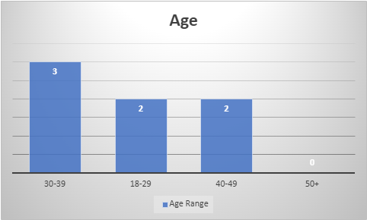
Figure 1. A column chart to show the age range of participants.

There were only female respondents to the survey.
The remaining six questions were then asked to obtain a result.

Figure 2 shows the results for the response to question 4. 43% of participants strongly disagreed with the statement to identify whether they are confident using to technology to collaborate at UWTSD.

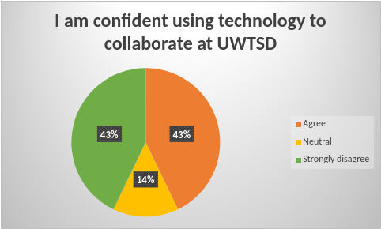
Figure 2. a pie chart to show the results to question 4.

All students agreed that training on technology is important to collaborate for question five and again for question six, all students agreed that that training would enhance their engagement and collaboration abilities.

Figure 3 shows the results for the response to question 7. With the exception of one all participants said they had used technology before.

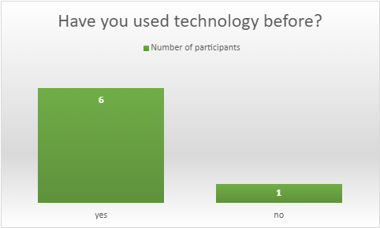
Figure 3. A column chart to show results from question 7.

The final two questions where on a rating scale of 1-9, 1 being unsatisfied and 9 being extremely satisfied. The results show that 5.57 was the average number for how satisfied participants are with the training provided at UWTSD and when responding to what they believe is their own level of training 5.14 was the average number given.

4. Discussion

We wanted to find out if there was any need to provide training on technology to collaborate at UWTSD. The results show that in total seven participants took part in our questionnaire voluntarily and all were female. No one from the age 50+ category gave feedback in the results. The results indicate that student's confidence using technology and collaboration abilities are directly related to the amount of training they have received based on their experience of using technology prior to studying at UWTSD.
Although 43% of students agreed they were confident using technology to collaborate, 43% strongly disagreed and 14% were neutral which indicates almost half lack confidence. As Moersch (2014) study demonstrates that by promoting collaboration, teaching on how to use digital technologies, optimises learning outcomes and if we apply this to training here at UWTSD, students will gain the confidence to use technology to collaborate their work.
The student's responses demonstrate a correlation between the importance of training on technology to collaborate and how training would enhance their engagement and collaboration abilities. When reviewing several examples of web technology-enabled teaching and learning approaches at undergraduate level, Gan et al (2020) concluded that both approaches were important tools to enhance students educational experience and collaborative learning. In line with the hypothesis the results from these questions agree with current studies .
When giving an answer to ‘have you used technology before?’, six out of seven respondents said yes. Technology provides students with easy-to-access information, accelerated learning, and fun opportunities to practice what they learn. It also provides opportunities for teachers to meet the needs of students with various learning styles using multiple media (Bryant & Hunton 2000).
According to the Office for National statistics 92% of adults in the UK were recent internet users in 2020, up from 91% in 2019. These figures show that most adults in the UK have used some form of technology and websites or online resources to make tasks easier to complete. A lot of these can be accessed in web browsers from anywhere you could be either at home or work.

The average number for the rating questions from 1-9 was 5. Participants were asked to rate how satisfied they are with the training provided at UWTSD and how good they felt their own technology skills were by rating their level of training. By measuring data this way we can see the central trend of that dataset, we now have baseline to measure changes overtime if we were to collect more primary data by asking the same questions after students have received training.

Overall the results confirm existing theories highlighted in the report that technology can help encourage teamwork and collaboration abilities, although training on technology to collaborate seems to be an overlooked aspect for improving students confidence and engagement.

The results met expectations and supported the hypothesis however they would be more widely applicable if we did not limit the questionnaire to only students, we also could have also asked staff and collected a larger number of responses differing in age and gender. Nonetheless the results are still valid as they show although students have used technology before the is an opportunity to enhance their knowledge through training, so they become confident in their digital skills.

5. Conclusion

The results supported by the hypothesis have shown how important technology is to promote and enhance collaboration skills. The have provided us with a clearer understanding of how students at UWTSD feel about their own digital abilities and that they agree there is a need for training. Although most students have used technology before, almost half do not feel confident when using technology to collaborate and felt they could improve on their own level of training. The answer to our research question is yes, but to get a clearer indication on what level there is a need for training on technology to collaborate here at UWTSD, we would need to ask a wider range of students from all ages and genders. As mentioned before Moersch (2014) demonstrates that by promoting collaboration we can optimise learning outcomes so we can apply this through offering training programmes at various levels from beginner to advanced. In Kispeter (2018) research shows a considerable number of medium- or high-skilled occupations require advanced digital skills, and digital skills play a crucial role in many of them. If students want to excel in their future careers training therefore is vital for them to achieve their best outcome.

6. Reference List

Bryant, S & Hunton, J. 2000. The Use of Technology in the Delivery of Instruction: Implications for Accounting Educators and Education Researchers. Issues in Accounting Education. 15. 10.2308/iace.2000.15.1.129.
Campbell, S. 2014. What is Qualitative Research? Clinical Laboratory Science.
Gan, B, et al. 2015. Enhancing students’ learning process through interactive digital media: New opportunities for collaborative learning. Computers in Human Behaviour.
Kispeter, E. 2018. ‘What digital skills do adults need to succeed in the workplace now and in the next 10 years?’ Warwick Institute for Employment Research University of Warwick.
McCarthy, J. 2010 “Blended learning environments: Using social networking sites to enhance the first-year experience”, Australasian Journal of Educational Technology. Melbourne, Australia, 26(6). doi: 10.14742/ajet.1039
Moersch, C. 2014. Introduction. In: 2014. Improving Achievement With Digital Age Best Practices, 55 City Road, London: SAGE Publications, Ltd.
Office for National Statistics (6th April 2021) Internet users, UK: 2020. [online] Available from:https://www.ons.gov.uk/businessindustryandtrade/itandinternetindustry/bulletins/internetusers/2020 [Accessed: 03/04/2022].
Rahman, M.S. 2020. The advantages and disadvantages of using qualitative and quantitative approaches and methods in language “testing and assessment” research: A literature review. Journal of Education and Learning. Canadian Centre of Science and Education.
Salkind, N. J. 2010. Encyclopedia of research design, vol. 0, SAGE Publications, Inc., Thousand Oaks, CA, [Accessed 30 March 2022], Doi: 10.4135/9781412961288.
Saunders, M, Lewis, P, & Thornhill, A 2019. Research methods for business students Ebook. Pearson Education, Limited, Harlow.
Williams, C. 2007. “Research Methods,” Journal of Business & Economics Research.

Appendix A – Blank Questionnaire



