Table of Contents

Introduction 4
Fundamental Accounting Concepts 5
Principles of Accounting 12
Financial Statement 13
Task 1 13
Task 2 13
Task3 13
Task4 13
Task 5 13
Conclusion 15
Reference List 16

Introduction

Fundamentals of accounts are helpful to keep record of transaction in accurate format. We prepare an accurate financial statement which record the entire transaction of the organization and published it in newspaper, so stakeholders of the company know about the position. On the basis of the financial statement, annual reports are prepared, which plays a crucial role in annual reports of the company. Annuals reports of the company present a sound financial position of the organization (Loughran, 2011). We also describe the nature, behaviors, purpose, tools and techniques of cost accounting. We also explain principles and methods of business transaction (Lunt, 2009).

Fundamental Accounting Concepts
Cost Accounting
Recording, analyzing and summarizing are the function which are included in the cost accounting system. This system helps to determine cost related to product and services. Cost accounting is the part of accounting in which all the cost are included for doing any process, projects or products. (Horngren, 2009) It constitute of cost and accounting. The cost means the total expenses which is included in the production. For making the records of every expenditure and income the process of cost accounting is included. It regulates the process of the business. (Horngren, 2009) The main concepts of cost accounting are:
- Cost:
It refers to the amount of goods and services which are exchanged in place of one another. It is the amount which is acquired on or mature able to a given thing or to determine the cost of any elements. Cost is not same as the value because it is measured in terms of money.
- Expense:
These are the cost which has to be paid against the revenue of period of accounting in conformity with the assumption of comparing the cost with revenue. Examples of expenses are- amount of sold goods, salaries of office members etc (Horngren, 2009).
- Loss:
It means the weakening in the purchasing equity other than from capital of withdrawal for which not any value of compensation has been accepted. Damage to the business organization by fire is an example of loss.
- Cost Centre:
It is the smaller part of the area and responsibility for which costs are acquired. It is defined as the departments of the organization in which the costs are possessed for the ascertainment of the cost.
- Profit centre:
It is the responsibility for both the revenue and expenses and publishes the profits of operations. Profit centers are made to authorize the authority to the people and to measure the people performance. Cost centre is not same as the profit centre (Horngren, 2009).

Nature of cost accounting
There are various different nature and characteristics of cost accounting which are described below:
- Accounting should have specialized accounting-
Specialized branch of accounting is included in the topic of cost accounting. The specialized branches involve collection related to covers, necessary classifications, recording related to transactions, apportionment, cost determination and controls related to costs. (Graves, 1971) It has its own concept concepts although its function is based on system of double entry.
- Related with both science and art-
Cost accounting is related with Science because it has its own principles and norms, and that should be followed by every company in order to form all the activities of the company in a systematic order. Further it is related with art because all the principles of it are used in evaluating the problems with the help of cost information.
- Recognized as a process-
As cost accounting is a knowledge which has specialized knowledge, thus it is also recognized as a profession (Loughran, 2011). Cost institute and accountants of UK gives professional advices related to cost accounting and rules and approaches involved in accounting.
- Determination of different total cost components-
Total cost includes material, labor and expenses. It is a process of accumulation, classification and analyzing the cost of product. The main objective is to identify cost per unit to complete our cost determination of work.
- Helps management-
This system of accounting provides data and controlling measures which provide guidance for different levels of management (Lunt, 2009).
- Application of computing profit and loss-
The use of this system is extended to application which involves statistical data, methods related to control, and techniques which determines profit. The information related to statistical helps company in preparing sheet related to cost, statements of cost, other different cost accounts and it is also used in comparing purpose of costs.

Behavior of Cost
Behavior of cost means to analyze the operating cost varied with any variation in the level of activity of the organization. Product may include the following cost such as direct materials, direct labor and overheads cost. Organization analyzes the behavior of cost by performing mathematical cost function. It developed a relationship between the total cost and activity level. Cost behavior is divided into fixed, variable and mixed cost.

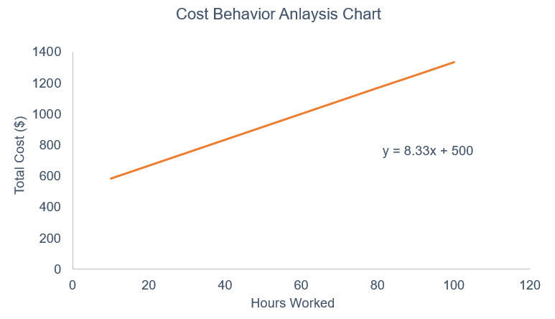
Fixed Cost: It is not changes with variation in the level of activity. It is constant at relevant range of activity. These cost are incurred when they company cannot produce a single unit. Fixed cost per unit reduces with the enhancement in the production units.
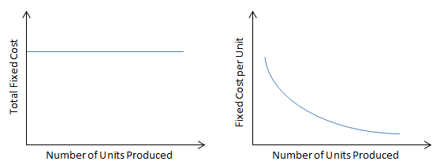

Variable Cost: It is the direct relationship with the level of production. It increases when the production units enhanced or decrease with reduce in the units produce. But a variable per unit cost is constant.

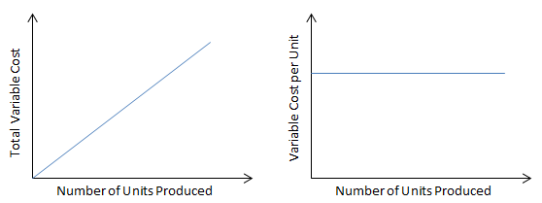

Mixed Costs: Both fixed and variable cost is mix is considered as semi variable cost or mixed cost. There are several examples of mixed cost such as telephone expense, telecommunication cost, senior management cost and delivery cost.

Purpose of cost accounting:
- To ascertain the cost :
The objective is to determine the cost of business at every level like at job level, process level, operation level, department level and services level. The methods for ascertain the cost is known as costing. For ascertain the cost all the expenses have to be classified and analyzed.
- Cost control:
To know the effectiveness of the company or of the cost centers, then some activities are included in the production of products are to be clearly done. Some budgets for the material consumption, use of labor, and increasing the overhead cost sets and compared with the performance of other.
- Reduction in cost:
It means the savings from decreasing the cost of production without damaging to the quantity and without affecting to its purposes for which it is used. It is need to reduce the cost of the products by researching the new technology and developing activities .The cost reduction area covers plant design , layout , production method , wastages as well as new innovating marketing strategies etc.
- Ascertainment of profitability:
Cost accounting main object ascertain the profit by plant activities and compare the actual profit made by their profitability.
- Determination of price for selling goods :
It provides whole data or information of composition of total cost for identify selling price. It also provides information for deciding reduction and differentiates variable cost and fixed cost.
- Business policies and decisions making:
The main aim of cost accounting provides formulation of decision process and helpful for management to take decision process. Profit planning, gross profit analysis, breakeven point is used to deciding the new business policies.

Methods of cost accounting for business transactions:
Costing methods refers to the methods for ascertaining the cost of the products that are manufactured and the services which are rendered. The nature of the industries depends on the costing methods which are follows as:
- Job costing:
The cost is ascertained by job costing method for the each work separately which have its own scope. This method is practiced where work is done as per the desires of the customers. The jobs are sometimes performed outside of the factory which depends on the nature of the job. Examples: job of plumbering, painting, improvement of buildings.
- Contract costing :
The work under this method is done according to the requirements of the customers. It is the costing which is done for jobs which contain heavy expenditure and each and every order is of long period. It is known as the terminal costing. Examples: construction of house building, ship building, construction of roads and bridges.
- Batch costing:
The batch of same or different products is considered as the job. The batch and groups of the products is the unit of the cost. In this method according to the batch numbers, the cost are analyzed, collected and ascertain .Examples: medicines.
- Process costing:
Those industries used this method, in which the production is done on the basis of process. For manufacturing of cloths, different process are involved like weaving, spinning, and finished good. Input gives the output named as the finished products which is then sold in the market. Examples: vegetable ghee, edible and non-edible oils, paints and varnishes.
- Multiple costing:
This method is involved where the output has different parts. The production process that involves more than one method is known as multiple methods. Example: For the televisions, motor cars and radio production more factors are used, some of which are based on one method and some based on other methods to make the finished goods.
- Operating costing:
This method is used by those organizations which do make the production of goods but provides the services only. For ascertaining the cost of particular service this method is applied by the members. Examples: public buses, electricity, hospitals, canteens etc. these all involves the large amount.
Techniques of cost accounting:
- Historical costing technique:
These costs are referred to as the post mortem cost because in this technique all the investments that are made for the production are first only made and then the ascertainment of cost is done. This cost helps to the company for looking to the property piece and to see what will be paid to it. The values of historical cost do not change from year to year and there are some risks also in this cost.
- Standard cost technique:
For comparing the labor and materials which are applied in the manufacturing process of a product the standard cost made the use of ratios. In this first the standards are set then they are matched with the actual performance. It is the important cost for producing the products. It is the fixed cost in obedience with the most efficient function.
- Marginal cost technique:
The costs which do not changes but remain the fixed with the increase or decrease in the production is called as fixed cost. The cost which is not fixed is called variable cost. The marginal cost takes into account only the variable cost. It refers to as the analysis of cost –volume profit. The marginal cost is the technique to see impacts of changes in volume of output on the profits.
- Direct cost technique:
This technique is same as the marginal cost but in this some fixed cost are included in the direct cost in some cases. The cost of supplier is directly used for production of the products which is considered as the direct cost. Cost of material, labor and variable expenses are the examples of direct cost.
- Uniform costing:
It is the operation of accounting principles, methods, and procedures uniformly by different organizations in the uniform industry. It is the technique which is used in standard costing method, marginal costing method, etc. The same method is adopted when the same organizations join together.

Principles of Accounting

Basic accounting principles are developed on the basis of accounting standards. (Graves, 1971) Following are the basic principles of accounting use some appropriate software are:

- Accrual Principles: It records all the transaction in the period of accounting which is actually occur whether are transaction held in cash or on credit basis. Accrual accounting is the foundation on basis of accounting. It is helpful for financial statement construction, it shows those transaction which actually happened in the accounting period.

- Conservatism Principle: In this concept, company said that they recorded all the expense and liabilities as possible as and revenue and assets are recorded when they sure it actually occur by company. This principle also defines to encourage for recording losses and as earlier as possible.

- Consistency Principle: This principle explains that, any accounting principle adopt by the company should also continue for better principle. (Graves, 1971) It means the company cannot follow consistency principle for accounting treatment which results in long term financial results which difficult to compare it.

- Materiality Principle: In materiality principle define the basic accounting principles for the correct judgment of the transaction. Accountant is reconciling the set of books and completing the tax return is shown under the materiality principle. Immaterial information cannot record but the material expenses are depreciated over time.

- Matching Principle: In this principle, when the accountant records any revenue expenses, they also record all the expense at similar time. (Graves, 1971)It helpful for charging inventory to price of the product sell at similar time when they revenue record for selling of stock items to consumer. The accrual accounting is based on accounting as cornerstone. When the accountant records all transaction in cash, they cannot use the matching principles.

Financial Statement

Task 1

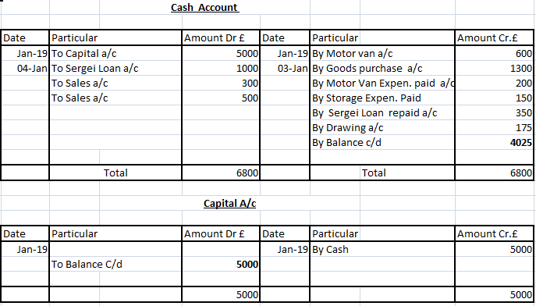

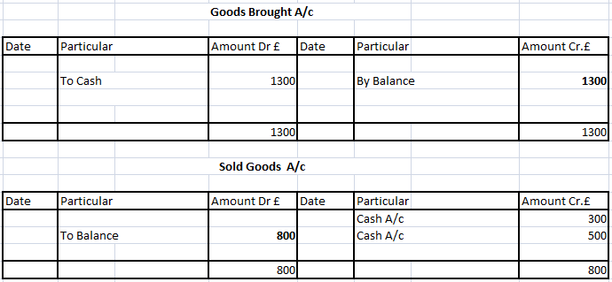

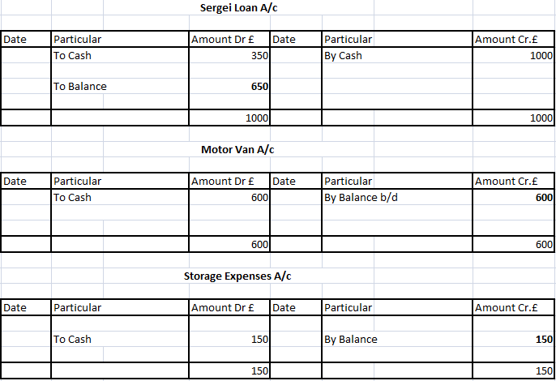

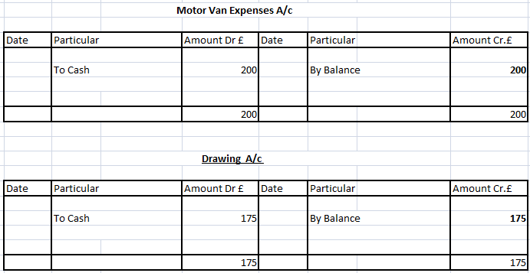

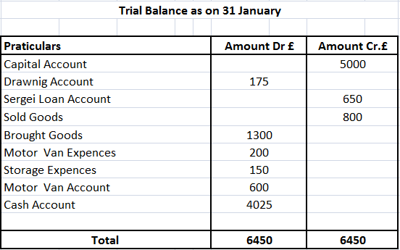

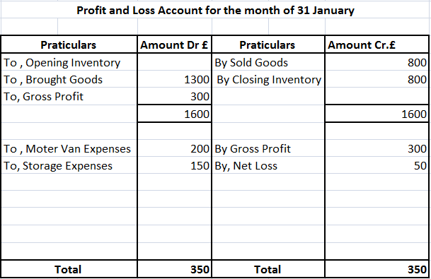

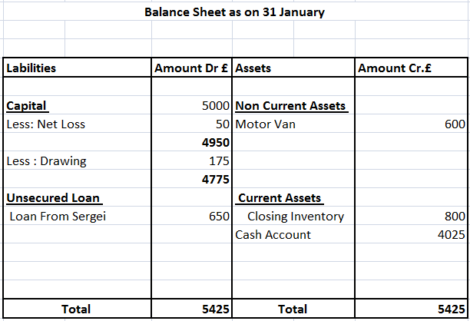

Task 2

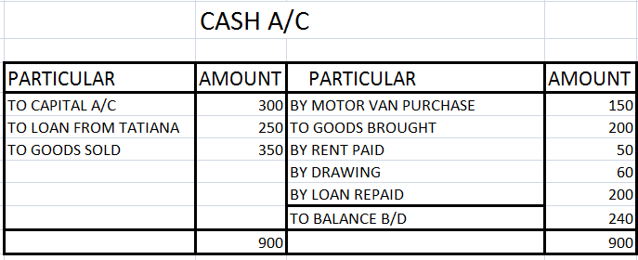

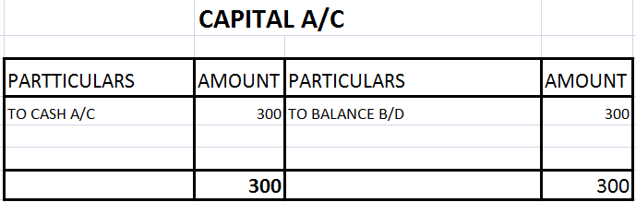

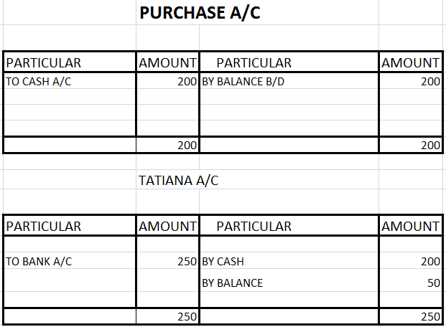

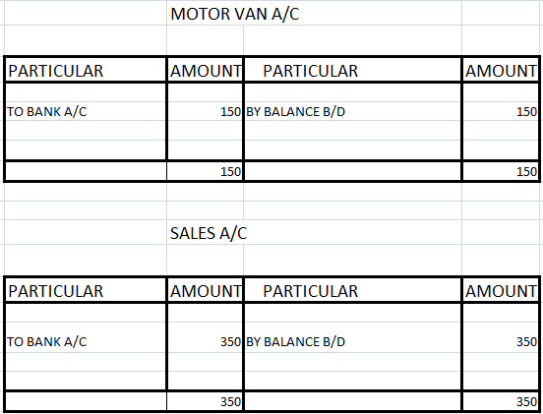

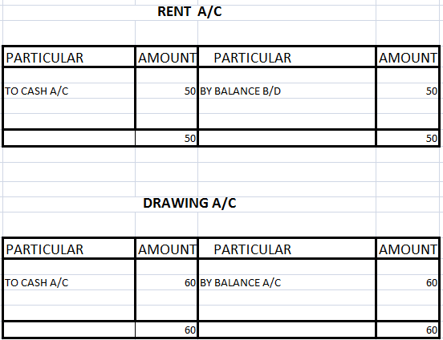

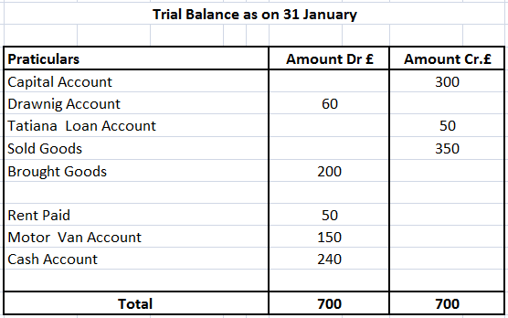

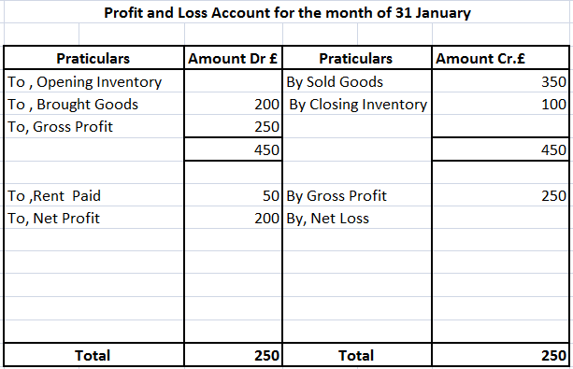

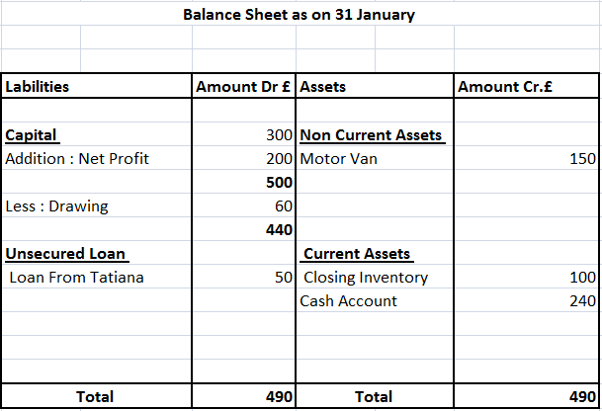

Task3

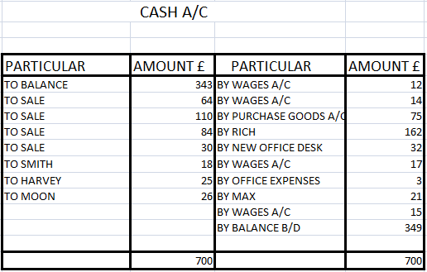

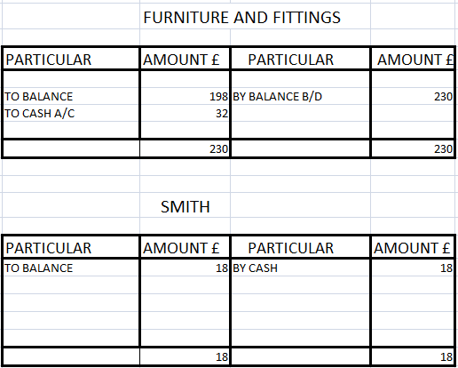

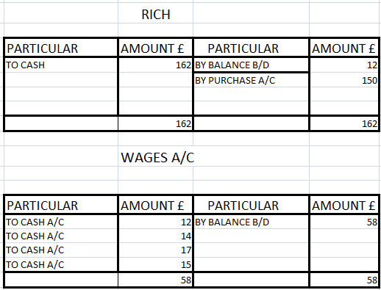

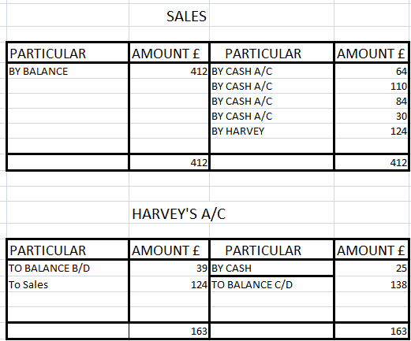

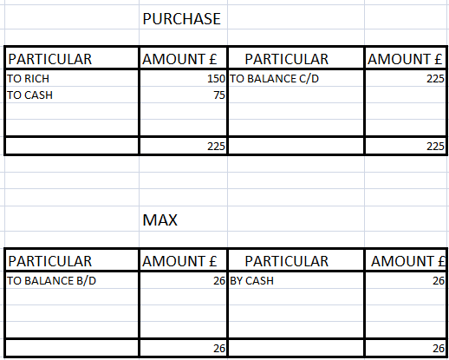

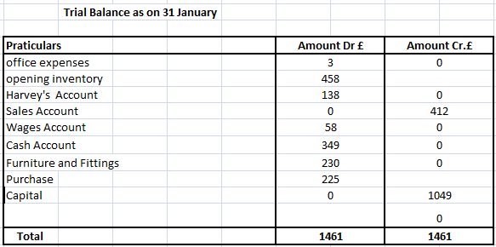

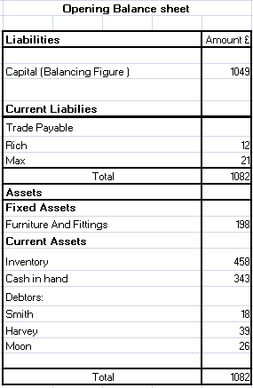

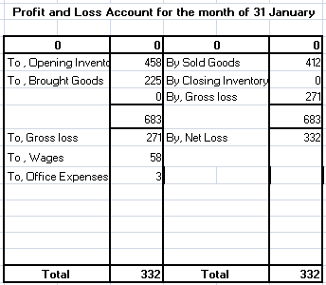

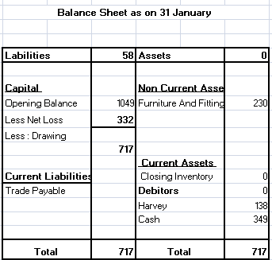

Task4

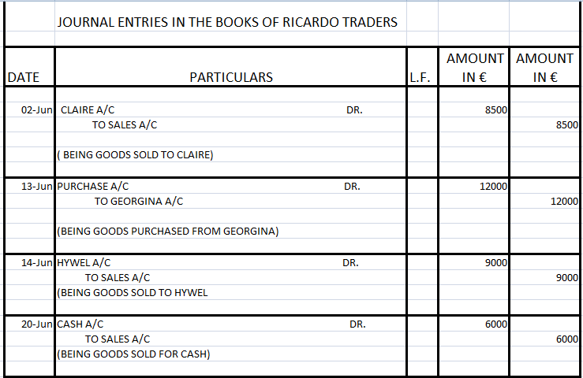

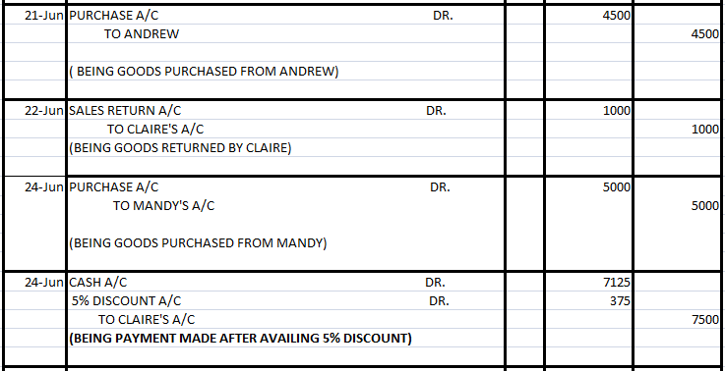

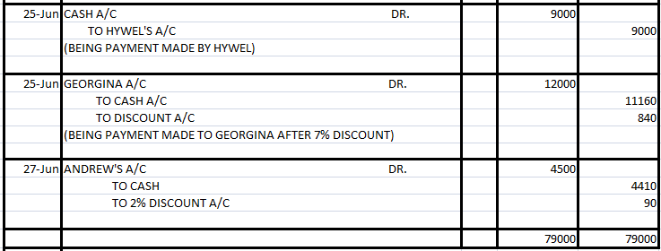

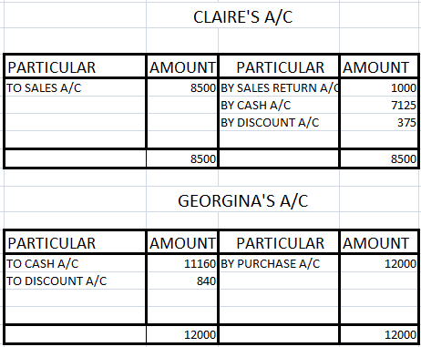

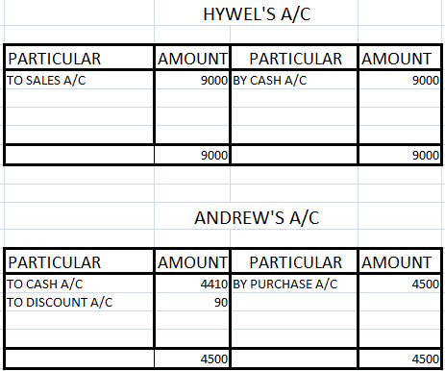

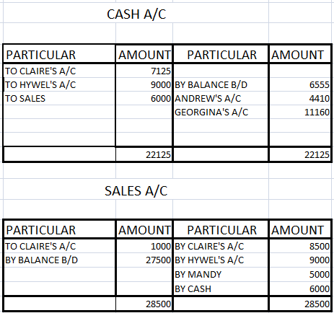

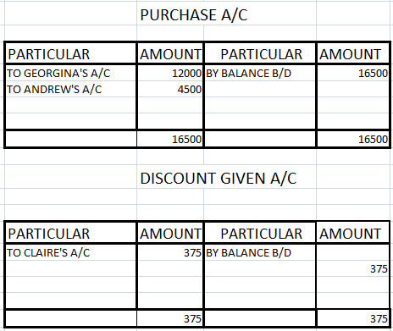

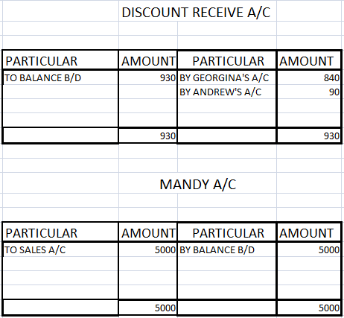

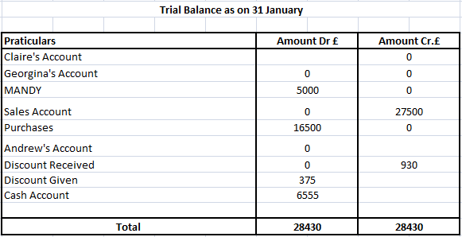

Task 5
Revenue Expenditure: Expenses which are incurred on daily basis for running the business activities is called revenue expenditure such as buying of inventory, carriage and freight. On the basis of accrual accounting assumption, it recognized the revenue which is earned or expenditure incurred is recognized. When the expense is occur it is charge to income statement. It is benefited for present accounting year. Some examples of revenue expenditure are wages and salary, printing and stationary, electricity expense and taxes.
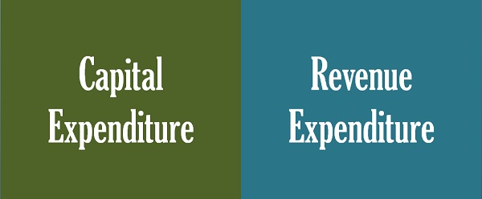

Capital Expenditure: when the company spends for long term capital assets for increase the efficiency of the company or enhances the cash flow or decrease the production. When a company spends a huge amount is considered as capitalized which means improve the life of the assets. Some examples of capital expenditure are purchase of machinery, or installation of equipment of machine which increase the efficiency of production.

Difference between Revenue Expenditure and Capital Expenditure

Basis | Revenue Expenditure | Capital Expenditure
Concept | Expense which are occur in acquiring for capital assets or improve the efficiency of existing one, it results in expanding of life. | Expenditure occurs for regulating the daily operation of the business.
Term | It is incurred for long term. | It incurred for short term.
Capitalization | Required | Not required
Shown in | Income statement and Balance Sheet | Income Statement
Nature | Non-recurring nature | Recurring nature
Benefit | It is benefited for more than one year. | It provides benefit for current accounting year.
Earning Capacity | It improves the capacity of earning. | It maintains the capacity of earning.
Matching Concept | It not required matching with the capital receipts. | It necessary to matched with revenue receipts.

Conclusion

We conclude this assignment, we explain about concept, nature, behavior and purpose of cost accounting. We also identified tools and techniques for providing facilities to the company. It also provides accuracy for small and large organization for monitor their inventory, product produce and sold for provides an appropriate reporting to organization. We also explain some practical question with given initial data and prepared a financial statement.

Reference List

Brown, M.W., Dutta, R., Paolini, M.A. and Smith Jr, N.J., International Business Machines Corp, 2003. Cash register and method of accounting for cash transactions. U.S. Patent 6,550,671.

Dearden, J., 1978. Cost accounting comes to service industries. Harvard business review, 56(5), pp.132-140.

DRURY, C.M., 2013. Management and cost accounting. Springer.

Graves, J.H., 1971. Commission on accounting principles. Journal of Accountancy (pre-1986), 131(000005), p.61.

Horngren, C.T., 2009. Cost accounting: A managerial emphasis, 13/e. Pearson Education India.

