

Fherhsef

ALTERNATIVE PROPULSION SYSTEMS

Sophie Reed
2000492
ACHA5010

Table of Contents
1.0 Introduction 3
2.0 What is a WLTP test? 4
3.0 WLTP Test Results 6
3.1 Equations 6
4.0 KERS Systems 11
5.0 Kinetic energy 13
6.0 Conclusion 14
7.0 References 15
A.Gabriel-Buenaventura, (2015). 2.3.1 Spring and elastomers KERS [online] Available at: 15

1.0 Introduction

On the 1st September 2017 the new Worldwide Harmonised Light Vehicle Test Procedure (WLTP) came into force (DVLA, 2020) WLTP stands for Worldwide Harmonised Light Vehicle Test Procedure, it tests the efficiency of the vehicle and how environmentally friendly it is. The vehicle I have chosen is a 2010 Scirocco 2.0 TSI. The reason I have chosen this vehicle is because it is a vehicle I’m looking to purchase in the future and thought it would be good to learn some more about it. The class of WLTP is based off the characteristics of the car, so every car is individually tested, allowing for more accuracy within results.

2.0 What is a WLTP test?

A WLTP test is a Worldwide Harmonised Light Vehicle Test Procedure which ‘was developed with the aim of being used as a global test cycle across different world regions’ (WLTP facts, 2023). It measures, fuel consumption, CO2 emissions, pollutant emissions and energy consumption values of alternative powertrains. The old version of this test is the NEDC test, this was designed in the 1980s and was based on theoretical driving. This quickly became outdated which is when the WLTP test came into force in 2017. The WLTP test cycle is slightly longer but is over a bigger distance and a higher average speed.
The WLTP test is split into various driving phases, this includes stopping, braking and accelerating, this allows for a full wide spread of results (more realistic driving behaviour). These dynamic phases are split into urban and non-urban, urban is 52% and non-urban is 48%. The biggest difference between the NEDC and the WLTP is the gearchanges, in the NEDC there were fixed points for this whereas, in the WLTP there are different gearshift points for each individual vehicle.
The WLTP test results have already influenced vehicle sales due to poor results, for example ‘Audi sales in the UK fell by a fifth in 2018… Porsche almost halved its sales in the first half of 2019’ (Autocar, 2022).

The main characteristics and dynamics of the car that are necessary for working out which class the car will be tested in is;
- Test weight – 1344 kg (including people, luggage and some fuel)
- Frontal area (this was calculated by using the height and width and multiplying this by 0.85 to allow for the curves of the bonnet) – (1.55*1.05)*0.85 – 1.383
- Rolling resistance coefficient – 0.014
- Coefficient of aerodynamic drag – 0.29
  - A higher drag coefficient is generally found in cars searching for high cornering speeds influenced by downforce. SUVs typically achieve 0.35-0.4 due to their boxy shapes.
- Weight to power ratio (W/kg) – 88.6 - this means that the car is in Class 3

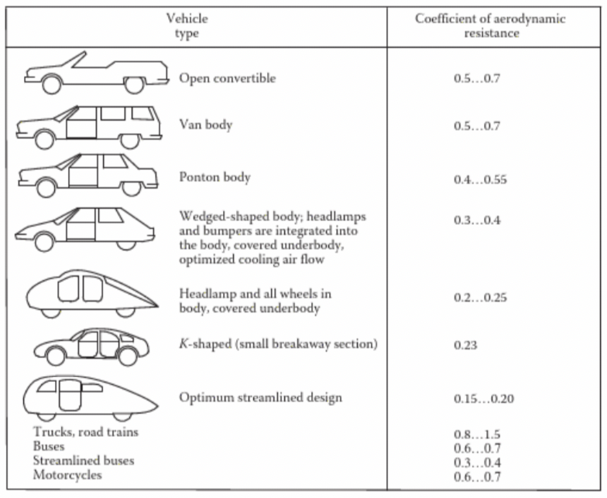

Image 1 (M. Ehsani, Y. Gao, S. Longo, K. Ebrahimi, 2018)

The image to the left shows the average aerodynamic resistance coefficient. It shows that the Scirocco is average for this. Which is surprising as it is supposed to be quite a sporty looking car.

3.0 WLTP Test Results

3.1 Equations
- Aerodynamic Resistance (N) – 0.5 x area x cd x density of air (1.2kg/m^2) x velocity^2
- Rolling Resistance (N) – mass x gravity x coefficient of rolling resistance
- Acceleration (N) – mass x acceleration (m/s^2)
- Total – Acceleration + Rolling Resistance + Aerodynamic Resistance
- Power (kw) – Total x (Velocity / 1000)
Figure 1

Above is figure 1 this is a graph that represents the figures used in phase 1. From this graph you can see that acceleration is the biggest changing differential variable. From the graph you can see that acceleration starts at 0 and rises quickly, from this graph we can see that there is plenty of area to recover any energy lost. This is when the car is decelerating, this can be seen in figure 2 below. The results of Roll and Aero don’t change, the cars aerodynamic abilities don’t change as it is the main shape of the car.

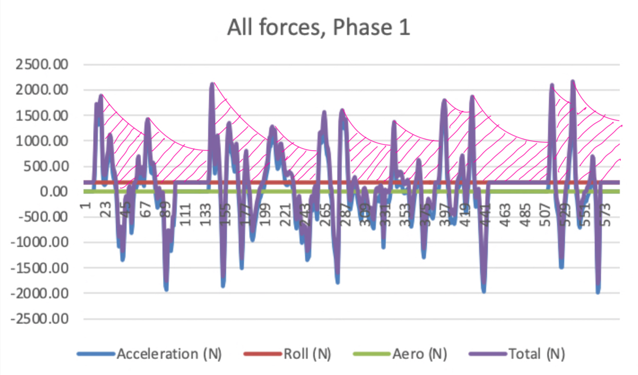
Figure 2

Figure 2 shows where the energy can be recovered within phase one. The pink areas are where the energy can be recovered the most. These are the parts when the vehicles are braking. Energy can also be recovered when the required drive force goes negative.

Figure 3

Figure 3 shows the variables from phase 2 as you can see the acceleration between phase 1 and 3 are ever so slightly different.

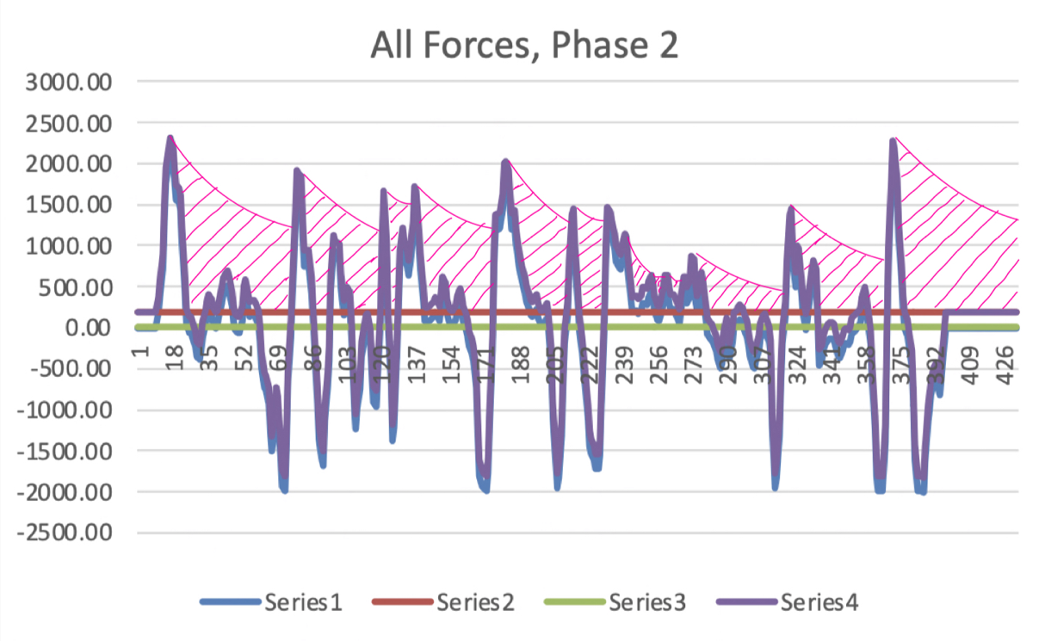
Figure 4

Figure 4 shows where the energy can be recovered within phase two.

Figure 5

This graph shows the forces within phase 3, as you can see by the graph the acceleration behaves in a very different way to the other phases. There is a break in the high acceleration jumps around the middle of the phase. This tests the vehicle in a different way. And allows for a longer energy recovery period too, this can be seen in figure 6.

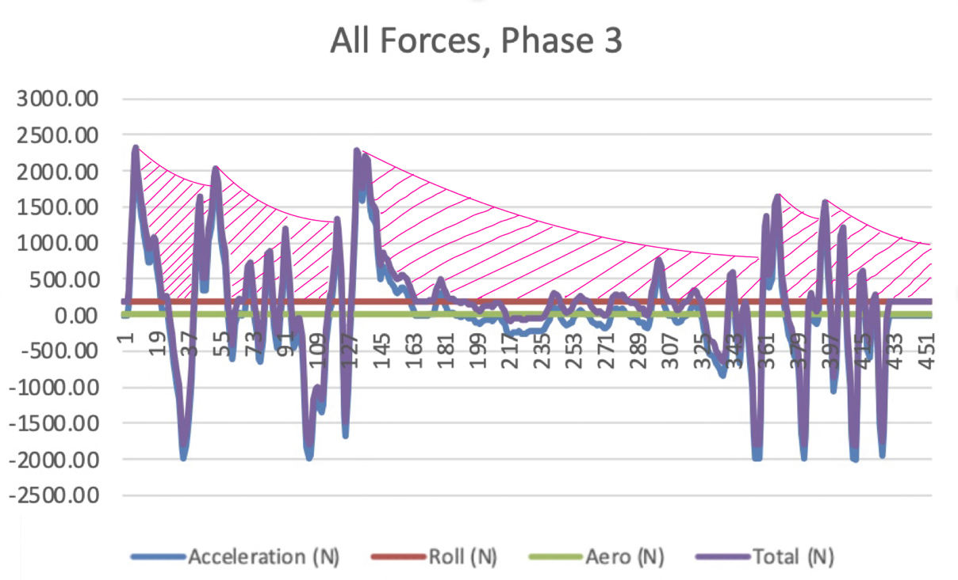

Figure 6

As you can see from figure 6 that in phase 3 there are plenty of opportunities to restore energy within a KER system. This is mostly due to the break in hard acceleration around the middle of the phase.

Figure 7

This graph shows the final phase of the WLTP test, from this you can see that the acceleration isn’t as hard in this compared to others. There is a lot more deceleration and smaller bouts of acceleration.
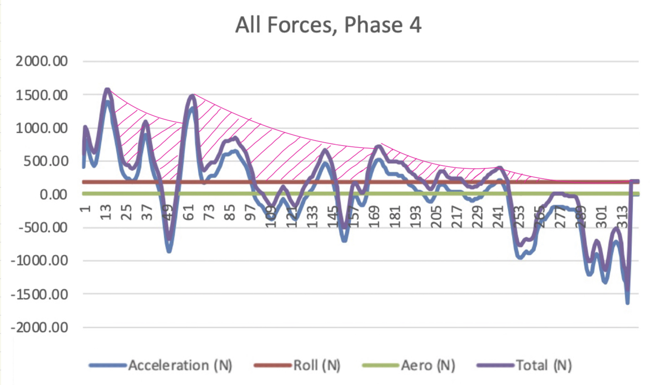
Figure 8

As you can see from the graph above the KERS system has a lot of potential for recovering some energy, however due to the smaller acceleration peaks the recovery period is smaller.
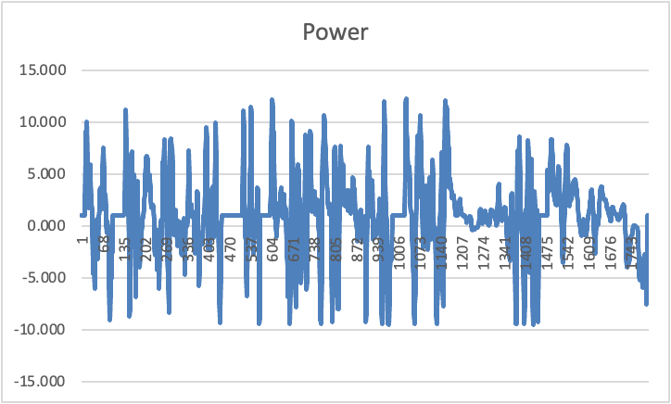

Figure 9

This graph shows the power at the every stage of the WLTP test, this has been calculated by Power = Force x Velocity. Velocity has been given for every part of the test (low, medium and high), low = 5.25 m/s, medium = 10.98m/s, high = 15.73m/s. From the graph you can see that the power drops and rises a lot this allows to see exactly how the KERs systems works at different speeds.

4.0 KERS Systems

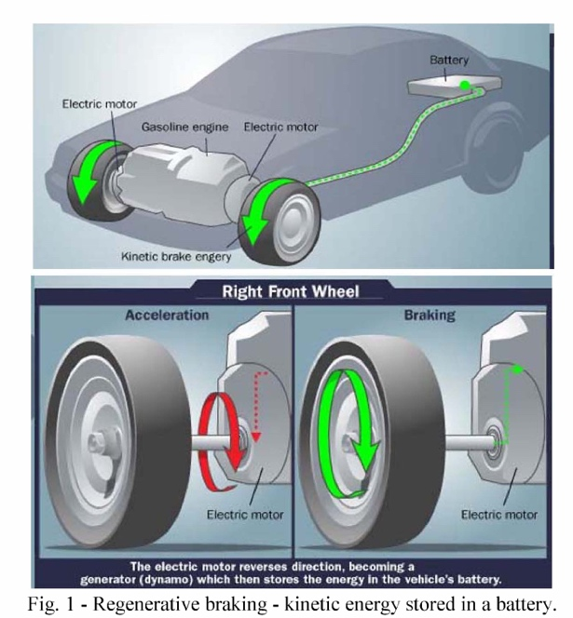
‘The KERs operate by recuperating part of the vehicle’s kinetic energy mainly during braking operations’ (A. Gabriel-Buenaventura, 2015). There are two main types of KERs systems, Electronic and Electro-Mechanical (A. Gabriel-Buenaventura, 2015). The Electronic system is very popular within F1, but there are limitations to this system, it mainly stems from the Lithium ion battery. This is because it can get hot and will need additional ducting to keep the system cool. The way this system works is ‘when the brake is applied to the car a small portion of the kinetic energy is captured by the electric motor’ (I. Tudor, 2013). The electric motor then transforms this energy into electrical energy that is stored in high voltage batteries. The Electro-Mechanical KERS system was invented by Ian Foley, this system is based on a carbon flywheel in a vacuum which is linked through a CVT transmission to the differential. A big storage reservoir stores the mechanical energy and is independent from the gearbox.
There are a couple drawbacks to KERs systems,
for example only one can be utilized to an engine meaning a maximum of 60kw can be withdrawn at one time. The systems can only be controlled by the drivers, meaning training of normal road car drivers will have to be done so they could fully utilise the system. KERs can also only work in cars that are equipped with only one braking system, therefore many older cars that have both discs and pads this wouldn’t work. However, the KERs system can work independently from the friction brakes.
Between these two KERs systems I think the electronic system would be more appropriate for the Scirocco. This is because a cooling system would be easy to implement to the scirocco, adding air vents to the body work where the battery is, this allows for the wind to cool the battery. This system would connect to the brakes to collect the kinetic energy and transform it to electrical energy. The battery could go in the engine bay as there is enough room and this allows for the air vents to be in the bonnet so it wouldn’t affect the overall look of the car too much. However, this KERs system will impact the price of repairs, this is because of the complexity of the system.
KERs can positively impact a cars performance, particularly with fuel efficiency and overall power delivery. By harnessing the heat lost during braking and converting it into electricity the system can reduce the load on the engine therefore improving fuel efficiency. In terms of an acceleration boost, stored energy in the KERs system provides additional power during acceleration. So, when the driver need that extra power stored energy is released

5.0 Kinetic energy
Kinetic energy is the energy that an object uses due to its motion. To see what the maximum amount of kinetic energy that can be recovered is I have used the equation – ½ x mass x velocity^2. This equation shows that the kinetic energy of an object is directly proportional to its mass therefore an object with more mass or a higher velocity will have greater kinetic energy. Kinetic energy is also a scalar quantity, meaning it has no direction. When the vehicle under goes acceleration or declaration there is a transfer between potential and kinetic energy. The results for each phase of the WLTP test can be seen below;
- Kinetic Energy from phase 1 – 18645.91 j
- Kinetic Energy from phase 2 – 81491.62 j
- Kinetic Energy from phase 3 – 167172.84 j
- Kinetic Energy from phase 4 – 441127.22 j

This is the total amount of Kinetic energy that is used within the entire phase. The kinetic energy recovered is a lot smaller. Due to the limitations of the KERs system chosen only 60kw can be recovered and then used at one time. This can be recovered as shown in figures 2, 4, 6, 8. This looks at when the car would normally cruise but it is braking therefore restoring energy into the KERs system.

6.0 Conclusion

The exploration of KERs and kinetic energy reveals their profound impact on the performance and efficiency within a WLTP test. KERs, captures and reuses the kinetic energy created during braking and plays a crucial role in enhancing fuel efficiency, providing acceleration boosts, and contributing to a more sustainable approach.
The biggest principle behind kinetic energy expressed by the equation KE = ½ x m x v^2, shows the relationship between an objects mass and velocity. The electrical KERs system is the most appropriate for the scirocco due to the simplicity of the design and how that will be easier to fit onto the vehicle. However, this does come with its challenges. The added weight and complexity of these systems, along with costs and maintenance consideration, cause for a look into the benefits.

7.0 References

WLTP facts, (2016). What is WLTP and how will it work? [online] Available at: https://www.wltpfacts.eu/what-is-wltp-how-will-it-work/

R. Burgess, (2020). The Autocar guide to WLTP emissions testing [online] Available at:
https://www.autocar.co.uk/car-news/features/autocar-guide-wltp-emissions-testing

A.Gabriel-Buenaventura, (2015). 2.3.1 Spring and elastomers KERS [online] Available at:
https://www.sciencedirect.com/topics/engineering/kinetic-energy-recovery-system#:~:text=The%20KERSs%20operate%20by%20recuperating,of%20conventional%20friction%2Dbased%20brakes.

I.Tudor, (2013). KERS DYNAMICS [online] Available at: https://automotive.upit.ro/index_files/2013/2013_A_5_.pdf

Gov.UK, 2020. The worldwide harmonised light vehicle test procedure [online] Available at: https://www.vehicle-certification-agency.gov.uk/fuel-consumption-co2/the-worldwide-harmonised-light-vehicle-test-procedure/

M. Ehsani, Y. Gao, S. Longo, K. Ebrahimi (2018). Modern Electric, Hybrid Electric, and Fuel Cell Vehicles [online] Available at: https://ebookcentral.proquest.com/lib/trinity/reader.action?docID=5264494&ppg=44

