Nickai Marriott (2613266)

Digital Skills 1 Assignment:

1
Outlook:
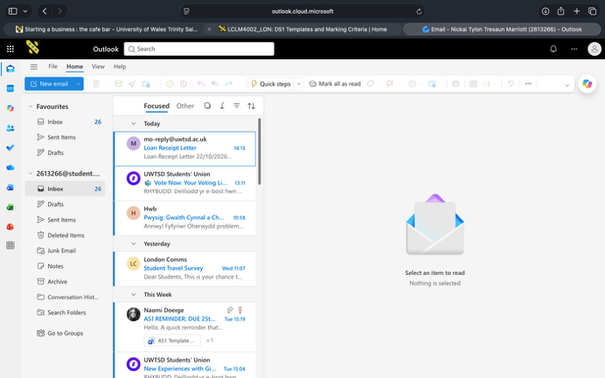
This is Outlook. An alternative tool for stuff like Gmail. I use this tool for looking up at deadlines for certain assignments and to keep up to date if there have been any changes along the way in this academic year.

2
Google:
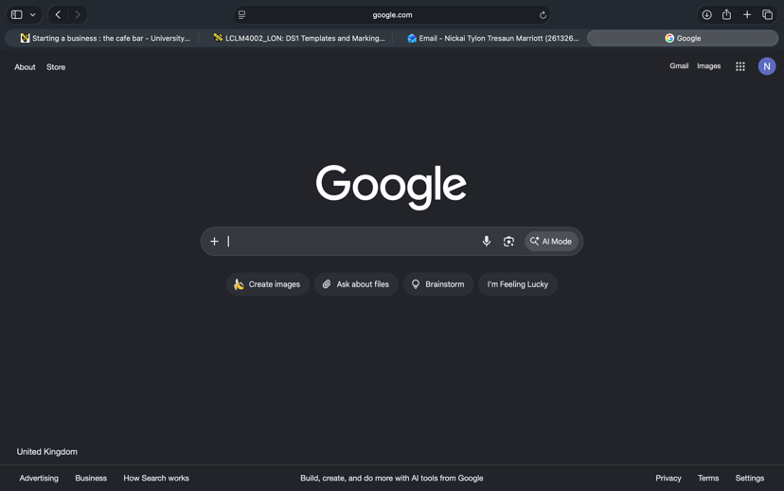
Thus is Google, a search engine that is reliable to quickly find the references or solutions to what you’re searching for. I use this tool every day for looking up/asking questions about what pops up in my head or reading a section of an article and I don’t understand what it means.

3
YouTube:
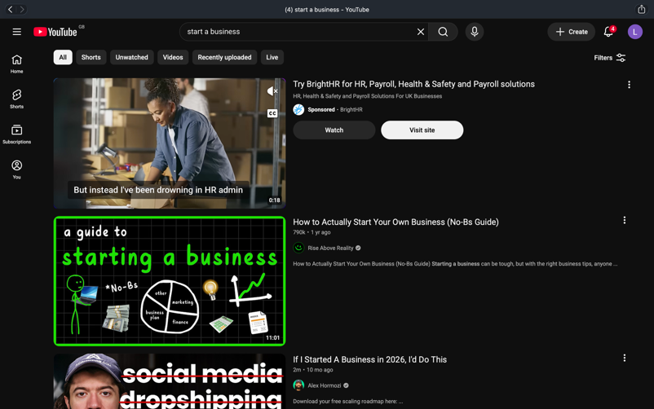
This is YouTube. A trademarked online video-sharing platform. I use YouTube mainly for my entertain, whether if its to watch football highlights form the day before or I would search up tutorials to show me what to do ig: how to put a toilet seat on top of a toilet.

4
Spotify:
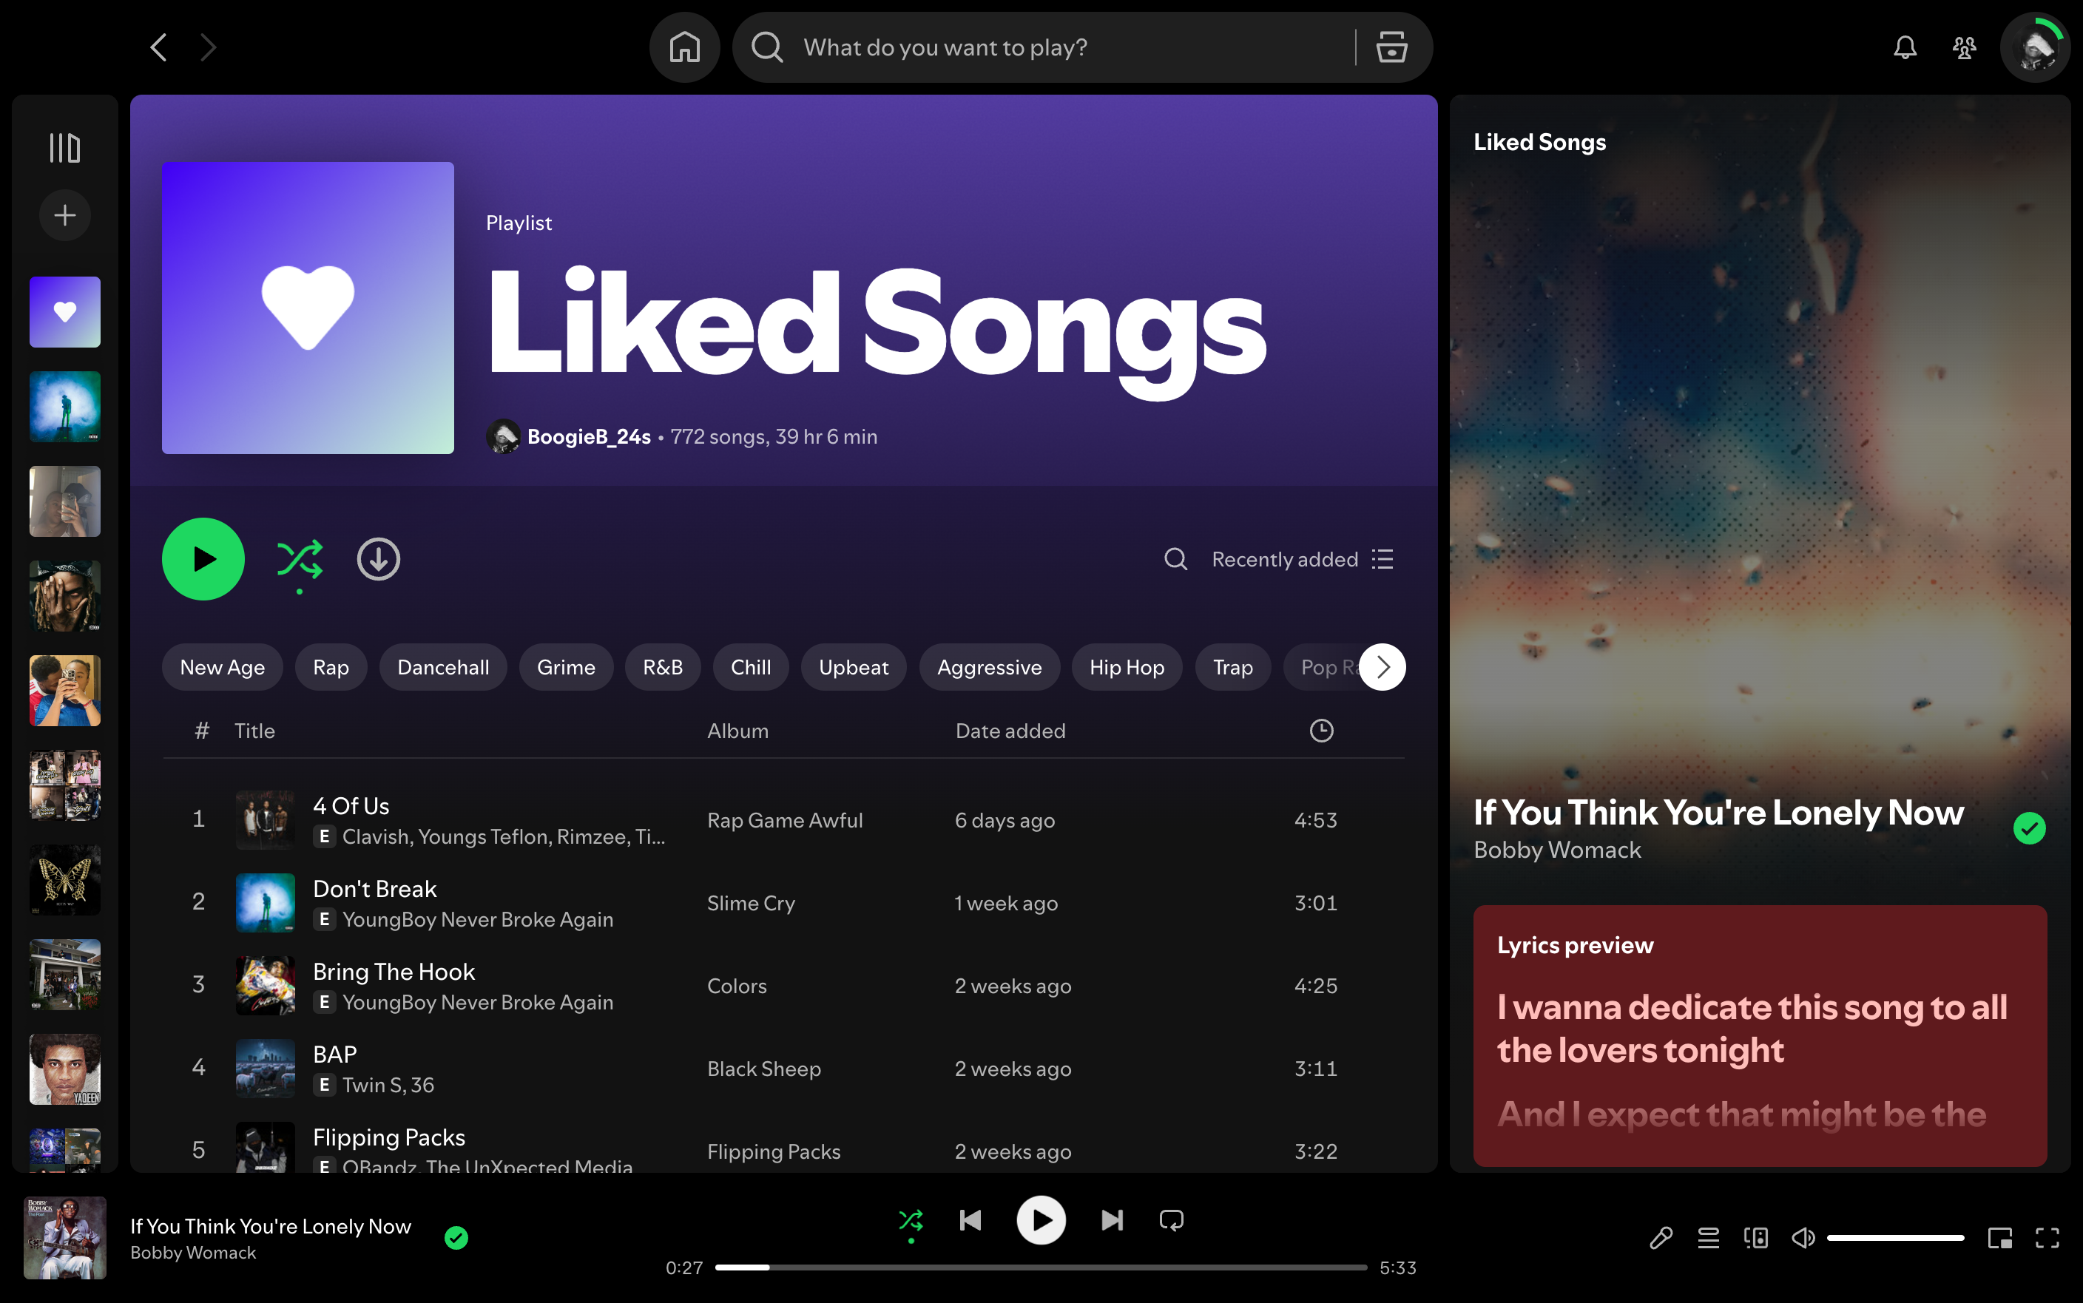
This is Spotify. A music platform where people can listen to music, upload music and make a playlist to keep it organised. I use this app on a day-to-day basis to listen to music. As shown in the picture, I’ve made a playlist that has all my favourite songs. The reason why is because I like to keep what I like away from a random playlist. In other words, keeping things organised.

5
Mobile Banking:
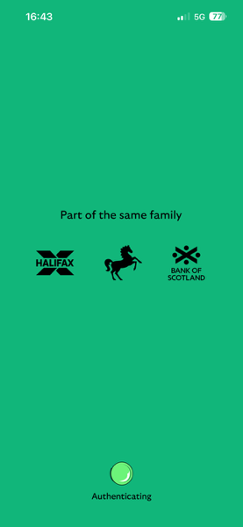
This is my online banking app. This keeps me updated on any money losses and if I’ve received any money from anyone. I use this to check my bank balance every two days and to send money to people. Also use this app to put money into my savings account which have been made using the app.

6
Trainline App:
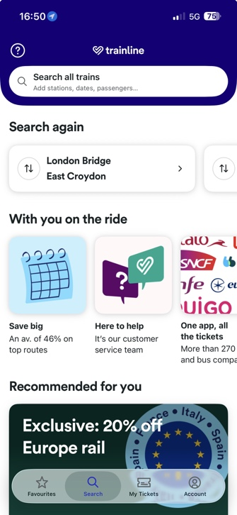
This is Trainline. A travel app where you can know what route to take from A to B. I use this app to research how long it would take for me to get from London Bridge to Milton Keynes and what time to get the train. Whilst searching, I’m also able to see the price of how much the travel is going to cost.

My Short Reflection
My digital life plays an important role in my everyday activities, as I use different digital tools to communicate, find information and manage my daily responsibilities. I use Outlook to send and receive emails, Google to search for information, and YouTube to watch videos for entertainment and learning. I also use Spotify to listen to music during my free time and when travelling. Lloyds mobile banking allows me to check my balance, monitor my spending and manage my finances securely. Additionally, I use Trainline to check train times, plan journeys and purchase train tickets. These digital tools make my life easier by saving me time, providing convenient access to information and helping me stay organised. Overall, using these tools has helped me develop my digital skills and become more confident in using technology in my everyday life.

