Business Environment

Student Name: HAFIZ ALI
Student ID: S219146

Contents
Introduction 1
Task 1 Presentation 2
Introduction 2
Company overview 3
PEST Analysis 4
Porter’s Five Factor Analysis 8
Task 2 Report 13
A) Overview of The Different Types of Organizations from Different Sectors 13
B) Different Legal Structures of Business, Advantages, and Disadvantages 14
C) Differences Between Public and Private Ownership, Usage of Finance, Impact on The Management 16
D) UK Competition Policy and The Legislative Framework Surrounding Anti-Competitive Practices 17
E) The Competition and Markets Authority to Review Business Practice and Impact on The Consumer 18
F) The Objectives, Fiscal and Monetary Policy Instruments to Regulate the Economy During the Recession and The Impact 19
G) Globalization Affecting Business, Competition, and the Economy 19
Conclusion 20
Reference 21

Introduction
Determining the business environment is important for any business decision making. it helps the management to forecast the fluctuation of various elements within the economy. The internal environment can be managed through inter control and decision making, but the external environment is something over which the organisation don’t have any control. Through PEST analysis and Porters’ five-factor analysis, the idea of the external environment of a particular organisation can be derived. The assignment demonstrates the importance of the legal structure of businesses, differentiate the types of market competition, analyses the source of finance, impact of globalisation.

Task 1 Presentation

Introduction
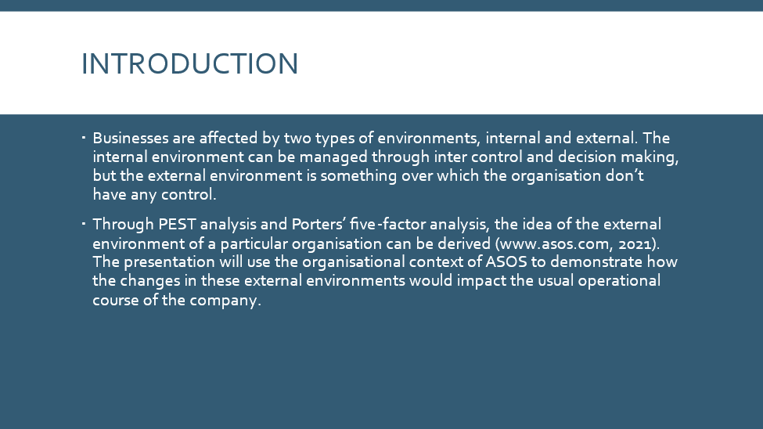
Businesses are affected by two types of environments, internal and external. The internal environment can be managed through inter control and decision making, but the external environment is something over which the organisation don’t have any control. Through PEST analysis and Porters’ five-factor analysis, the idea of the external environment of a particular organisation can be derived (www.asos.com, 2021). The presentation will use the organisational context of ASOS to demonstrate how the changes in these external environments would impact the usual operational course of the company.

Company overview
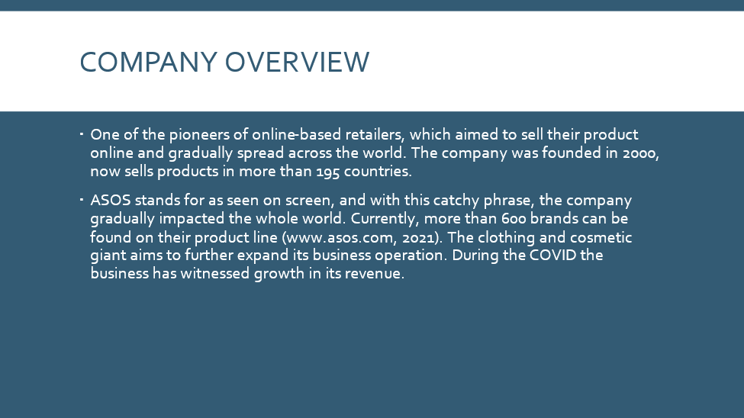
One of the pioneers of online-based retailers, which aimed to sell their product online and gradually spread across the world. The company was founded in 2000, now sells products in more than 195 countries. ASOS stands for as seen on screen, and with this catchy phrase, the company gradually impacted the whole world. Currently, more than 600 brands can be found on their product line (www.asos.com, 2021). The clothing and cosmetic giant aims to further expand its business operation. During the COVID the business has witnessed growth in its revenue.

PEST Analysis
Political
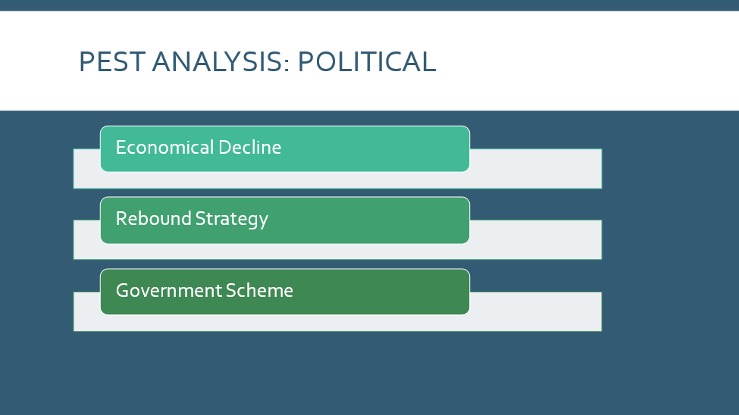
To support the post COVID economy, the UK government has introduced a range of new policies and schemes. Sick pay for the employees, cash grants, COVID 19 corporate fiancé schemes etc. are offered to different target groups who are subject to the risk of being affected by these. Apart from the COVID issue, ASOS have experienced financial turmoil due to Brexit (H Kimerer, 2020). Leverage in accessing the European market has been subject to fluctuation.

Economical
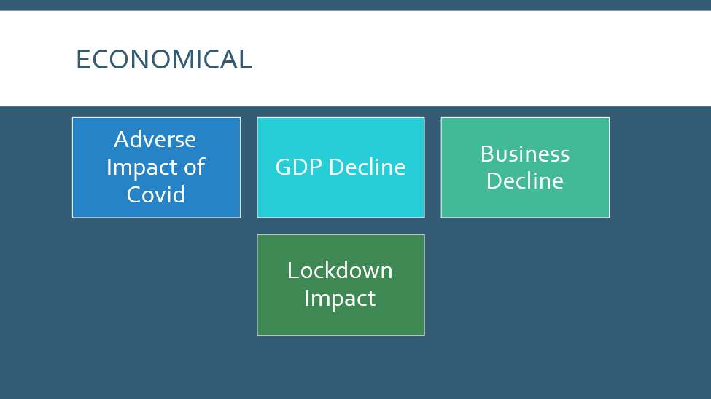
UK was among those countries which have been severely exposed to the intense COVID. The intense lockdown and other precautionary activities have affected the UK economy adversely (H Kimerer, 2020). The GDP declined more than 9%. It also impacted the business as well. As they had to halt their usual operation during the lockdown, the production process, sourcing was also stopped.

Social
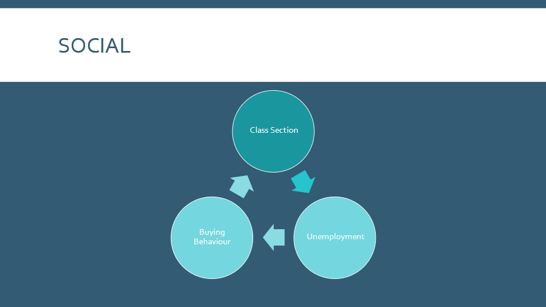
The social environment is another important issue that is very impactful for the business. ASOS operates in the retail, cosmetic and fashion sector, which is subject to the high influence of consumer demand and taste. The COVID also created havoc in this particular element (Campisi, 2019). The high unemployment rate, living on government aid, low cash influx influenced their buying behaviour as well. Which ultimately impacted the usual business of the ASOS.

Technological
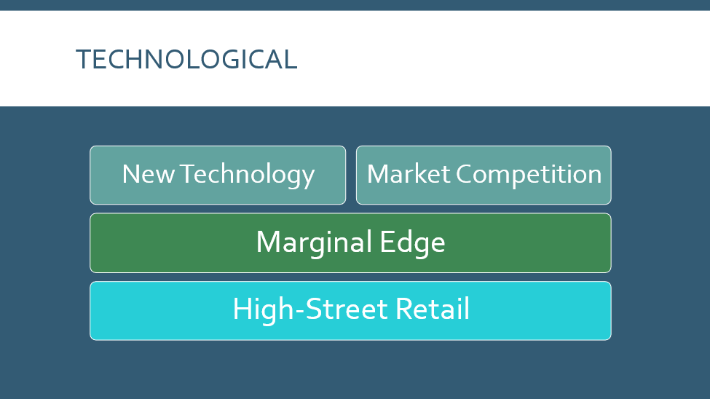
ASOS concentrates on the online-based retail business. COVID forced many businesses to shut down their high-street retails and go online. This eventually increased the market competition (Campisi, 2019). The implication of technology can avail the organisation to exploit marginal edge over the competitors.

Porter’s Five Factor Analysis
Threats to new entrants
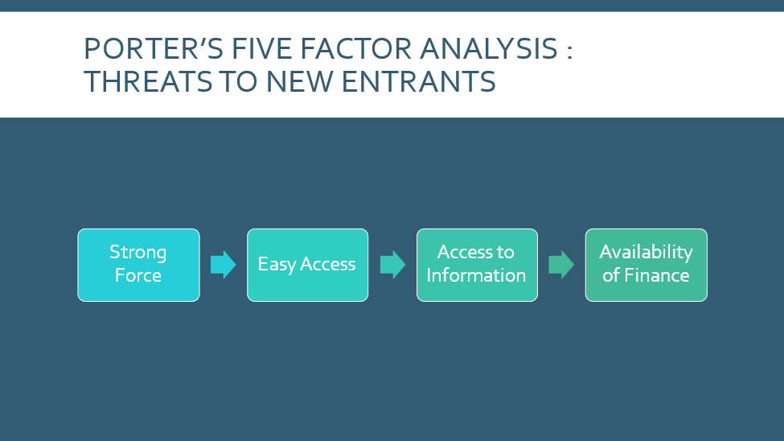
Access to funds, business-friendly government regulation, access to information has made the industry easy for the new entrants. Thus, ASOS face probable threats from the new entrants (Apriyanti, 2021). To exploit that they can use their expertise, use scale of economy and diverse product portfolio.

Bargaining power of the suppliers
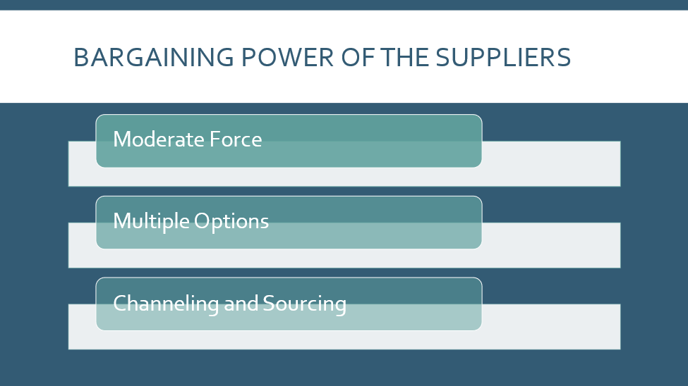
Clothing, retail and cosmetics products have a huge range of suppliers. Hence the souring and channelling of those products are easy as ASOS can enjoy the range of options. The force of buyers is weak.

Bargaining power of the buyers
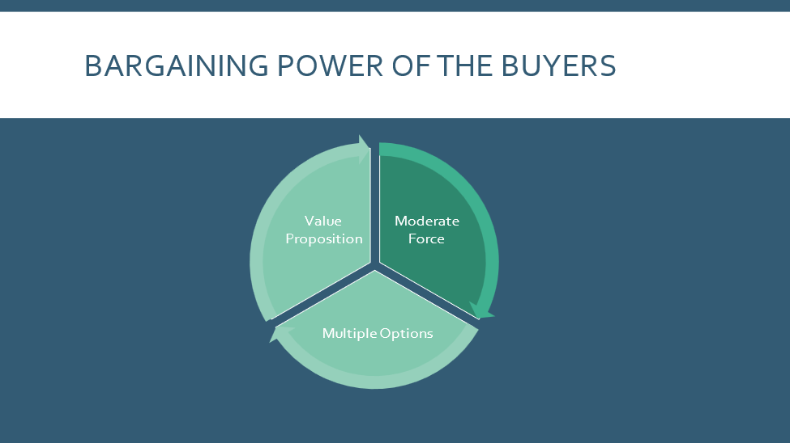
Buyers have moderate force in the industry. As there are various similar options within the industry, hence the buyer's power is considerable (Apriyanti, 2021). Pricing strategy, availability, accessibility, design can be big factors to dominate the big behaviour.

Threats of substitute products
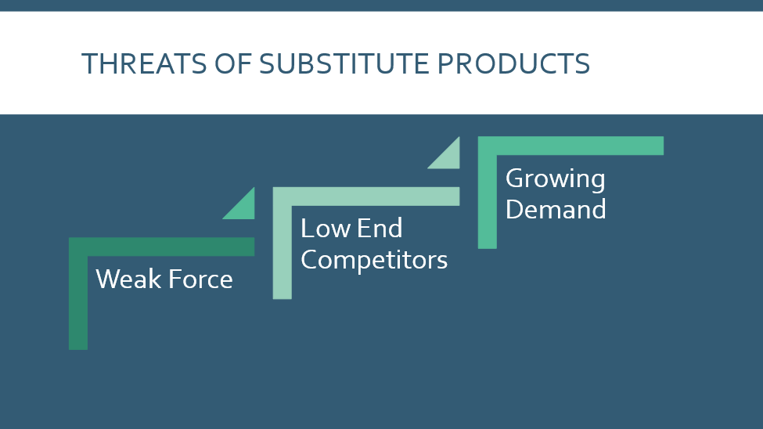
ASOS mainly sells fashion, cosmetics and clothing’s related products, and most importantly there are very substitute options for the customer (Apriyanti, 2021)r. Those substitutes come from low end-productions, which don’t really create any competition. ASOS products have growing demand I the market.

Rivalry within the existing firms
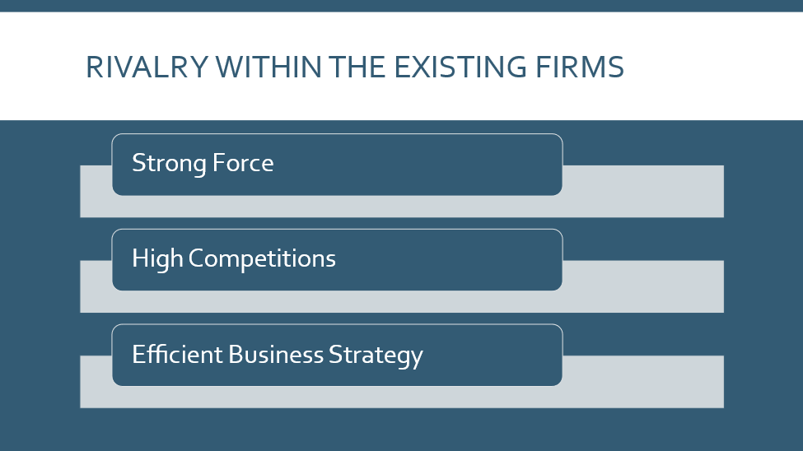
The clothing and retail sector is very competitive. Along with some small and medium-sized businesses, some giants dominate the world market (Campisi, 2019). Hence ASOS must efficiently choose their strategy to exploit the utmost opportunities.

Task 2 Report

A) Overview of The Different Types of Organizations from Different Sectors
Organizations can be differentiated in several ways based on the modes of operation, organizational structure, objective, and style of financing. Profit, not-for-profit, nonprofit are examples of the different businesses (Diefenbach and Sillince, 2020). Using actual examples, differentiating the sources of finance, and assessing the aims and goals of organizations are given below:
For-profit: The main objective and purpose of conventional business are to gain profit by its business operation selling goods or providing services. The business corporation aims at earning profit and maximizing its wealth. Sole proprietorship, partnership, LLC, and corporations are examples belonging to this sector. Like, TESCO is a profit-oriented business, a multinational grocery and general merchandise retailer, petrol retailer, software provider, financial service provider, and telecoms and internet service, provider. A hierarchical structure is maintained by distributing the share of power within the CEO, management, and board of directors (Mercier and Deslandes, 2020). Shareholders are the owner of this corporation. For financing, it takes both debts from banks and equity by issuing shares in the market.
Not-for-profit: Not-for-profit organizations are under the public sectors are similar to the non-profit organizations. These organizations do not seek profit by their operation. If any profit is gained from the operations, they may distribute the profit to the charity works although there are no certain rules and regulations regarding the charity work of these organizations. Seeders are one of the examples of these kinds of business organizations, it is online-based crowdfunding organizations that assist to accumulate business investments (Fallon, 2020). The main objective of this firm is to help its members by this online platform without any profit.
Non-profit: Instead of concentrating only on profit those business organizations earn profit to serve the public welfare purpose by donations and charity works. These types of organizations are not under the tax regulation of the government, but the regulations ensure they serve the public welfare (Ibadoghlu, 2020). Anti-Slavery International is one of the examples of a non-profit business organization that aims to end all the slavery in the world. Other non-profit organizations are Amnesty International UK, The Aegis Trust, etc (Campisi, 2019). these types of organizations are always supported by the government of the UK and donations from the public.

B) Different Legal Structures of Business, Advantages, and Disadvantages
Business structure refers to the legal structure of an organization that is granted in a given rule. The legal structure is the key determinant of the activities that the business can perform and undertake, such as raising capital, the responsibility of the obligations, as well as the taxation procedure of the business firm (Endo, 2020). Here is a demonstration of different types of legal structure with their advantages and disadvantages:
Sole proprietorship: This is the simplest form of business involving one individual who is responsible for the day-to-day operation of the business. It does not exist as a separate entity from its owner. So, it is not required for the business to file separate income tax forms, and the income and expenses of the business are included in the tax return of the owner (Behnke, 2020).

Partnership: An organization between two or more people forming any business seeking profit is referred to as a partnership business. This business can be formed with little formality but since more than two people are involved, a partnership agreement should be created, specifying the profit or loss share ratio and capital contribution (Campisi, 2019).
Advantages | Disadvantages
Easy format, simple initiation process and comparative are easy to maintain. | Comparatively complex decision making as partners need to be agreed upon
Business decision making is solely dependent on the owner, hence it is simple. | Shared profit can be a matter of concerns
Profit and losses are passed along with the partners and individual income are taxed. | Subject to huge liability

Corporation: A complex business structure that separates the ownership from the business entity. Shareholders are the owner of these types of business organizations. Corporations are more suitable for larger established companies (Cornell, 2020).
Advantages | Disadvantages
Limited liability and obligation allow the shareholders or possible investors to buy as much stock as they wish. | The decision-making process is time-consuming which often lead to futility.
Investors find this as a secured scope for investing | Businesses are exposed to a double tax bracket.
Business security, longevity, continuity is the biggest advantage of this type of business and ownership structure. | Rigid formality and process to imitate and maintain the business operation.

C) Differences Between Public and Private Ownership, Usage of Finance, Impact on The Management
Although public and private corporations are separating their ownership from the business entity and same size to some extent there are distinctive differences between these two corporations in terms of decision-making, modes of operation, and sources of funds (Mujalde and Kandari, 2018). Here are some major differences between these two types of business organization:
Public company | Private company
It is listed in the authorized stock exchange commission and the shares can be traded in the secondary market. | Are not listed in the share market and shares are not tradable publicly.
The minimum paid-up capital is much higher than the private company. | It is lower compared to the public company.
The financial statements must be disclosed to third or interested parties. | No need for disclosure of any kind.
The management of this kind of corporation is quite rigid and inflexible. | Owners are the management of this kind of organization.
Any common investor can buy the shares of this corporation. | Corporate buyers buy the share of this kind of organization.
The financing can be done by issuing shares or taking loans. | The financing of this type of corporation is mainly from the owners and structured financing.
The distinctive and distinguishing features of these two types of corporations impact the management differently. The private company management does not require to answer to the stockholders since they are the owners of the corporation. On the other hand, the management of the public company is must answer the board of directors and the shareholders regarding the performance of the organization (H Kimerer, 2020). In a public corporation, there might be agency problems between the management and owners. They must publish a financial report every year.

D) UK Competition Policy and The Legislative Framework Surrounding Anti-Competitive Practices
Based on the market participants, the level of competition, the rules, and regulations regarding the product serving and entering the market, the nature of the consumers in the market, are categorized into different classes (Ogaku, 2019). here is an analysis of competition-based markets:
Monopoly: A market situation while another seller is absent in the market and only one seller supplies a particular product is called a monopoly. The existence of a monopolistic market is rare in the modern-day, and the price is selected based on the supplier business.
Oligopoly: A market situation where a small number of big companies dominate the market and supply a particular product is known as an oligopoly market. Based on the market demand and supply it is competitive and less competitive (Mujalde and Kandari, 2018).
Competitive: A market where numerous producers competes with one another to provide goods and services the consumers want, and needs is known as a competitive market. Based on the demand-supply the price of the products is determined in this market (Behnke, 2020). There are two types of completive market:
- Monopolistic competition: This is a market situation where the producers produce similar to each other, but not exactly similar products and they can be a substitute for each other.
- Perfect competition: This is a market situation where all the companies produce and supply kind of similar products. Buyers have the right and ability to choose any products with available information from the market.
The competition Act 1998 and the Enterprise Act 2002, define the structure of the market competition within the UK. This regulation promotes healthy market competition and cuts out the practice that undermines the prospects of the market Acts (Campisi, 2019). The main objective of these two Acts is to protect the consumer's interest and maintain a sustainable market.

E) The Competition and Markets Authority to Review Business Practice and Impact on The Consumer
The standard of market competition and market authority is to maintain healthy competition among the suppliers of the goods. A system should be followed which benefits both the producers and the common consumers (SSnchez Graells, 2020). The market competition law 1998 provides the rules and regulations to control the market. The foundations of the regulations and the impact on the consumers are given below:
Antitrust & cartels: Eradicating the market syndicate. This will reduce the tendency of price-fixing and will ensure a sound market condition.
Market Liberalisation: Open the barrios of entry in the monopolistic market to ensure flexibility in prices. State aid control: proper control will reduce the industry's need for government subsidy and allow the market to avoid possible distortion (YUNOME, 2020). Marge control: Government must look after the merger and acquisition process and find out if it impacts the market or not.

F) The Objectives, Fiscal and Monetary Policy Instruments to Regulate the Economy During the Recession and The Impact
The macro-economic objective is to ensure economic development by improving or contributing speech parameters. It is concerned with the development growth of certain countries. The objectives and differences are:
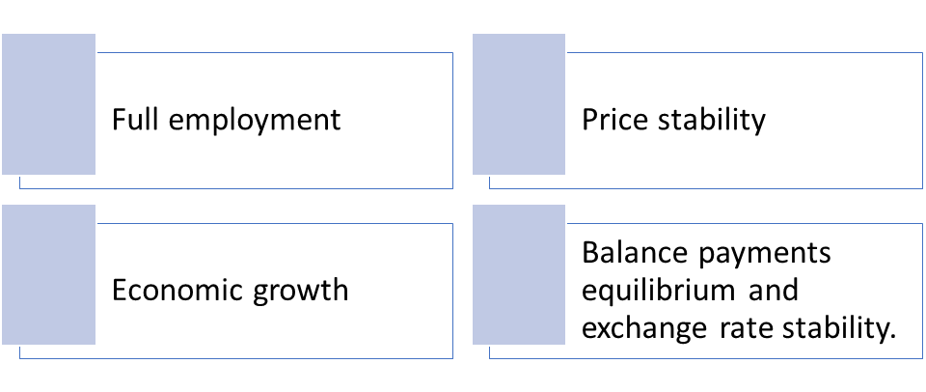
Figure 1: Elements of fiscal and monetary policy
source: (SSnchez Graells, 2020)
Tools like GDP target growth, corporate tax, individual tax, the interest rate is used by the government to attain a healthy unemployment rate, stable price level, sustainable economic growth (H Kimerer, 2020). The government also intervenes in the economy using some policies like fiscal policy, monetary policy, and supply-side policies.

G) Globalization Affecting Business, Competition, and the Economy
Globalization is a process where trade and culture are exchanged across borders. It leads to increased competition. This competition can affect the business operating the one country since it reduces the price and increases the product quality. People can buy products and services at a much cheaper rate. It affects the economy positively. It increases the investments in the market along with its GDP growth and reduces the unemployment rate (YUNOME, 2020). So, it can be said that globalization is very helpful for any economy seeking sustainable growth.

Conclusion
Before starting a new business, many factors should be considered. Different types of legal structures consist of different benefits and obligations. For any business growth plan, capital management and suitable options must be chosen. Different economic factors must be considered before starting any business. The conditions must be analysed properly using tools like PEST analysis and the peters five-factor model. Market competition should also be considered.

Reference
Apriyanti, E., 2021. Business Strategy Using Porter's Five Force Model Approach. Journal of International Business, 4(2), pp.192-198.
Behnke, C., 2020. Organisational Structure and Sole Proprietorship. Business Perspectives, 14(1), pp.63-65.
Campisi, J., 2019. Social and Political Risks: Factors Affecting Retail Industry. International Business Review, 59(6), pp.709-724.
Cornell, T., 2020. The legitimacy of the business corporation. Business Horizons, 20(6), p.4.
Diefenbach, T. and Sillince, J., 2020. Formal and Informal Hierarchy in Different Types of Organization. Organization Studies, 32(11), pp.1515-1537.
Endo, T., 2020. Legal structure, business organisations and lobbying: The UK publishing sector, 1990–2001. Business History, 60(4), pp.492-511.
Fallon, R., 2020. Not- for-profit No profit: Profitability planning in not-for- profit organizations. Management Review, 16(3), pp.47-61.
H Kimerer, D., 2020. Internal and External Factors Impacting Sales Turnover. Business Review, 4, pp.081-084.
Ibadoghlu, G., 2020.Taxation of NGOs, Public Funding for NGOs and Ngo Participation in Decision-Making, Azerbaijan. SSRN Electronic Journal,
Mercier, G. and Deslandes, G., 2020. Formal and Informal Benevolence in a Profit-Oriented Context. Journal of Business Ethics, 165(1), pp.125-143.
Mujalde, D. and Kandari, M., 2018. A Comparative Study between Public and Private Company. International Journal of Trend in Scientific Research and Development, Volume-2(Issue-2), pp.1289-1296.
Ogaku, M., 2019. Monopoly, Heterogeneous Beliefs and Imperfect Information: SSRN Electronic Journal,
SSnchez Graells, A., 2020. Monitor and the Competition and Markets Authority. SSRN Electronic Journal,
www.asos.com, 2021. Online Shopping for the Latest Clothes & Fashion. [online] ASOS. Available at: <https://www.asos.com/> [Accessed 2 November 2021].
Yunome, H., 2020. Glabalization. Journal Of the Brewing Society of Japan, 85(2), Pp.76-81.

