Student Name: Vasile Pitirici  Student ID:2213442  Module Title:Foreign Languages & Cultural Awareness  Module Code: BMIH5003  Lecturer: Heidi Prosser  Date: 09/02/24 | 
ASSIGNMENT 1: PORTFOLIO
(4 Components)

Component 1: Professional Reflection (500 words +/- 10%)

Weighting: 25%
According to Koc (2020), in the hospitality sector, there is a chance of unforeseen cultural misunderstanding, even for those people who are analytically strong, good command of the language, and has the ability to solve the problem in an effective manner. In context with reflecting on my professional experience, here I will demonstrate a scenario, that remains distinct in my memory – highlighting the complex nature of cross-cultural interactions. Emphasizing more on the significance of flexibility in a diverse professional environment.
Throughout my internship at a prestigious hotel, I experienced and went through a situation where my preconceptions were tested and the surroundings emphasised thinking about the importance of increased cultural awareness. The incident revolve around a member of Food and Beverage named Maria (hypothetical name) and a hotel visitor from a distinct cultural heritage. Maria is a person who holds exceptional service abilities and a person with a pleasant nature. Due to this, she earned a reputation as a beloved staff member amongst all her colleagues.
One busy evening, a guest from a culture renowned for its restrained and formal manner of communication approached Maria, expressing his discontentment with the service provided by the hotel. Maria, in her expected good-natured manner, attempted to initiate a conversation with the guest, with the purpose of understanding and resolving the issue as quickly as possible.
While witnessing the encounter, instead of being normal the situation got worsened, as the guest perceived Maria’s behaviour as disrespectful and unprofessional, anticipating a more official and earnest reaction to their complaints. However, it was evident that Maria had good intentions, but the disparity in the culture between her approach and the guest’s expectations resulted in a breakdown in communication, resulting in increasing irritation for both parties.
Considering the situation, I contemplated my suggestion to promote intercultural understanding of the efficient problems. With the utilisation of my analytical abilities, I examined the cultural aspects involved and, therefore, acknowledged the significance of Hofstede’s cultural dimensions theory (Nazarian et al., 2023). This will be helpful in understanding the variations in the communication methods and expectations.
In addition, being a good communicator, I engage myself with both Maria and the guest, fostering a productive conversation, so that the prime focus could be on addressing the misunderstanding. Therefore, after actively listening to the conversation, I came to the conclusion that the prime reason for the misunderstanding is because of the cultural differences, resulting in chaos. Moreover, by using my problem-solving abilities, I tried to generate viable solutions so that, if any situation like this occurs in the future, it can be handled effectively. Furthermore, this entailed that there is a need for proper culture sensitivity training for staff members, this will allow them to distinguish between what kind of behaviour is appropriate in the Hotel industry and tourism (Viken et al., 2021).
As a whole, the scenario provided me with a valuable chance to experience and learn from this, causing me to think about my beliefs and adjust my approach so as to be better at tolerating the issues related to cultural disparities in the workplace. I managed to learn about the complexities of cross-culture and made some valuable contributions towards fostering an inclusive and pleasant work atmosphere for people who are working within the company.
In conclusion, it can be critically analysed that the cultural misunderstanding can be both challenging and beneficial for the hospitality industry. This not only provides the opportunity to develop the personal and professional aspects, but also helps engage in introspecting things like what went wrong, and what could have been done better for greater results.
References:
Koc, E., 2020. Cross-cultural aspects of tourism and hospitality: A services marketing and management perspective. Routledge.
Nazarian, A., Shabankareh, M., Ranjbaran, A., Sadeghilar, N. and Atkinson, P., 2023. Determinants of Intention to Revisit in Hospitality Industry: A Cross-Cultural Study Based on Globe Project. Journal of International Consumer Marketing, pp.1-18.
Viken, A., Höckert, E. and Grimwood, B.S., 2021. Cultural sensitivity: Engaging difference in tourism. Annals of Tourism Research, 89, p.103223.
Component 2: Training Plan (500 words +/- 10%)

Weighting: 25%

Identified cultural misunderstanding (in a few words) :
Based on the scenario explained in Component 1, where a cultural misinterpretation occurred between Maria and the visitor hails from a culture renowned for its restrained manner of speaking, resulting in frustration and discontent. Therefore, to address the cultural misunderstanding, here is a suggested action (training) plan that will focus entirely on providing training to hotel workers so that they will be able to provide better services according to the varied cultures proficiently. As a result, the purpose of this plan will be to facilitate cultural sensitivity, improve communication tactics, and develop a more inclusive working environment.
Training plan (Why/What//Who/Where/When):
 | Why | What | Who | Where | When
Cultural Sensitivity Training | While working in the hotel industry, where the staff members encounter guests and people belonging to different cultures (Nguyen et al., 2022). Therefore, cultural sensitivity training is important for staff members to know about the diverse cultural landscape. | In order to accomplish this training session, Hofstede’s cultural dimension theory will be taken into consideration throughout the training session (Alqarni, 2022). Through this interactive seminars, the employees, will be able to develop empathy, perspective taking and cultural knowledge. | All staff members. | In a conducive environment, where people can interact in a better manner. | According to the availability of staff members.
Communication skills development | In the hospitality industry, effective communication skills is very important. This helps the service provider foster a positive guest experience, assists in resolving conflicts, and builds a relationship with the customers (Rahimian et al., 2021).  Therefore, by providing effective communication training, the company will be able to equip its staff members with the necessary manners and etiquette for attending to guests who hail from diverse cultural backgrounds. | The training session will include a wide range of elements including verbal and non-verbal communication techniques, and active listening skills.  In addition, the training session will include a session where the staff members can learn about the strategies for adapting communication styles to align with the preferences of guests and cultural norms. | The training session is designed for staff members from various departments.  For example, frontline employees, managers, and staff members, who are the first to communicate with the guests on a daily basis. | The training sessions will be held in the conference room within the hotel premises. | Based on the availability of the staff members, the training session will be schedule on regular intervals.  Sessions will be conducted during the off-peak hours in order to ensure maximum participation.
Conflict resolution strategies | Conflict resolution strategies training is important for an individual to de-escalate tensions between two or more individuals if this happens (Raub et al., 2021). This allows the staff members to provide a better guest experience. | The component that will be included in this training session is developing strategies that emphasize patience, and flexibility. Therefore, from the expertise the staff members will gain training and guidance on managing the cultural difference in conflict resolutions to effectively address the concerns of the guests. | All the staff members. | The training will be conducted in the training facility, moreover, inter-active learning and role play will be taken into consideration. | Staff members can take regular training according to their free slots.

References:
Alqarni, A.M., 2022. Hofstede's cultural dimensions in relation to learning behaviours and learning styles: A critical analysis of studies under different cultural and language learning environments. Journal of Language and Linguistic Studies, 18(S1), pp.721-739.
Nguyen, N.T., Yadav, M., Pande, S., Bhanot, A. and Hasan, M.F., 2022. Impact of diversity management on organizational performance in hotel organizations: a conceptual framework. International Journal of System Assurance Engineering and Management, pp.1-11.
Rahimian, S., ShamiZanjani, M., Manian, A. and Esfidani, M.R., 2021. A framework of customer experience management for hotel industry. International Journal of Contemporary Hospitality Management, 33(5), pp.1413-1436.
Raub, S., Borzillo, S., Perretten, G. and Schmitt, A., 2021. New employee orientation, role-related stressors and conflict at work: Consequences for work attitudes and performance of hospitality employees. International journal of hospitality management, 94, p.102857.

Component 3: Student Self-Reflection (500 words +/- 10%)

Weighting: 25%
Being a student of international Hotel Management, my educational journey has been transformative and culturally aware. The entire course enhanced by understanding of the factors that are important in the hospitality sector. For example, to be aware of the norms of people from different cultural backgrounds, because a certain kind of behaviour may be demonstrated as an offensive behaviour by the other individual. Reflecting upon my personal growth, I have observed a comprehensive transformation, as now I have a more refined and deep knowledge of cultural sensitivity.
If I analysed my knowledge before working in the hospitality industry, my understanding would have been fairly restricted. Although I was aware that working in the hospitality industry needs to be courteous so that guests from different cultures can be attended to properly, but had limited knowledge. However, I relied on observing people, whenever I used to visit a hotel, furthermore, the academic framework or the structured education programme, helped me develop a clear understanding of the factors that possess a greater priority.
In terms of cultural awareness, Hofstede’s cultural dimensions theory presents a profound impact, as it increases my thoughtfulness towards cultural awareness. I acquired knowledge about several aspects such as power distance, individualism versus collectivism, masculinity versus femininity, uncertainty avoidance, long-term versus short-term orientation, and indulgence versus restraint (Alqarni, 2022). Using the structure provides a comprehensive understanding of cultural disparities, which further plays an important role in communication and other aspects.
The class debate that revolves around the communication approaches used because of different cultural dimensions caught my attention. We tried to understand how many cultures are exhibited when it comes to direct communication and indirect communication. Moreover, after having one-on-one communication, I got to know about the possible drawbacks of miscommunication and emphasised the importance of developing effective communication strategies in order to accommodate various cultural preferences.
As I write this self-reflection, I can say that there is a huge difference regarding the knowledge I use to have, and the knowledge I acquired in the entire process, since I began the course. The cross-cultural relationship and the importance of cultural sensitivity is one of the factors that is given much importance, and in this process, communication plays a very important role.
In consideration of the future perspective, I am planning to further enhance my understanding and abilities in cultural awareness by pursuing continuous education and engaging in practical experience. Moreover, by incorporating cultural sensitivity into my professional approach, I am looking forward to facilitating the creation of inclusive and hospitable settings for visitors who come from various cultural origins.
References:
Alqarni, A.M., 2022. Hofstede's cultural dimensions in relation to learning behaviours and learning styles: A critical analysis of studies under different cultural and language learning environments. Journal of Language and Linguistic Studies, 18(S1), pp.721-739.

Component 4: Training Presentation (6 Slides)

Weighting: 25%
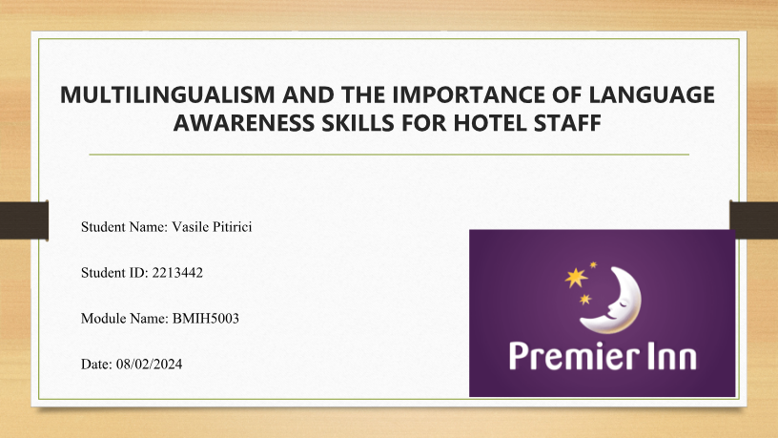
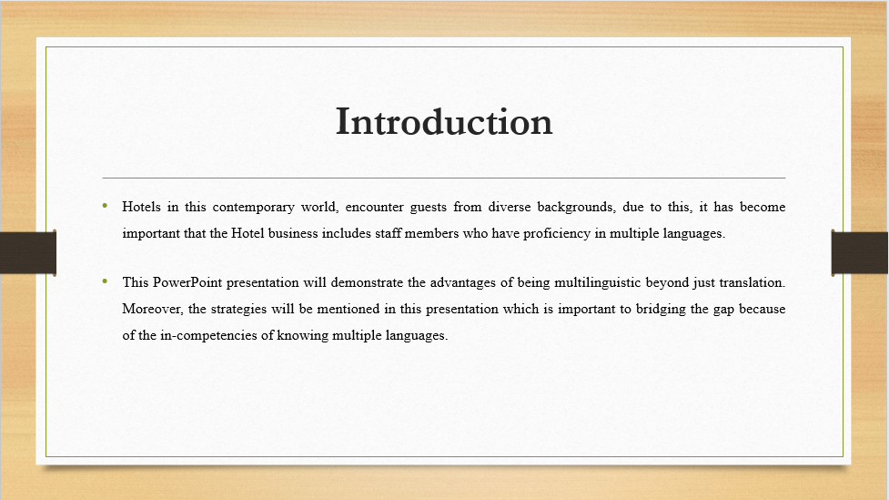
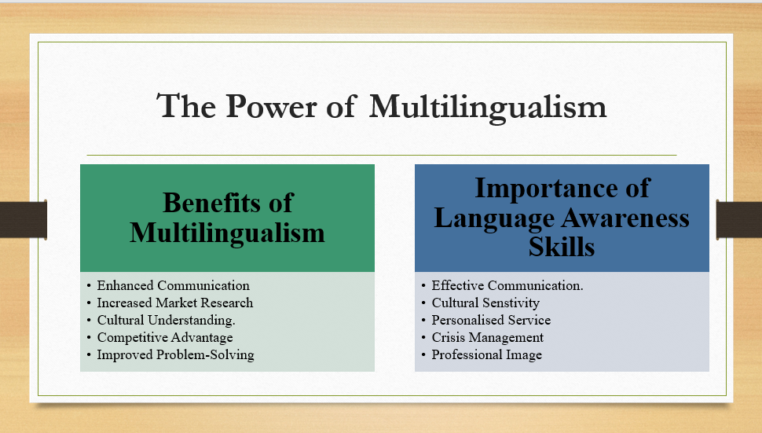
Speaker Notes:
Benefits of Multilingualism
It is clearly evident that Hotel business that has staff members who can speak multiple languages are at a clear advantage (Manoharan et al., 2021). With the help of their skilful interactions, the Hotel establishes an atmosphere where visitors, feel welcomed.
This not only allows the Hotel business to attract a wide range of international customers but also helps the business in penetrating its market position and enhance benefits.
Therefore, it can be critically analysed that providing exceptional service requires skilful staff members who are capable enough of attending to guests from diverse linguistic backgrounds.
Importance of Language Awareness
Hotel business that has proficiency in language awareness has the leverage to engage in communication, guaranteeing that all the requirements of guests will not merely be fulfilled but also be provided excellent services (Nguyen et al., 2022).
If the staff members is aware of the language awareness, then, the staff member will be able to customise the interaction according to the customer’s language preferences. For example, in case of emergencies, the ability to have language awareness, the staff member will be able to precisely communicate vital information to guarantee the safety and welfare of guests.
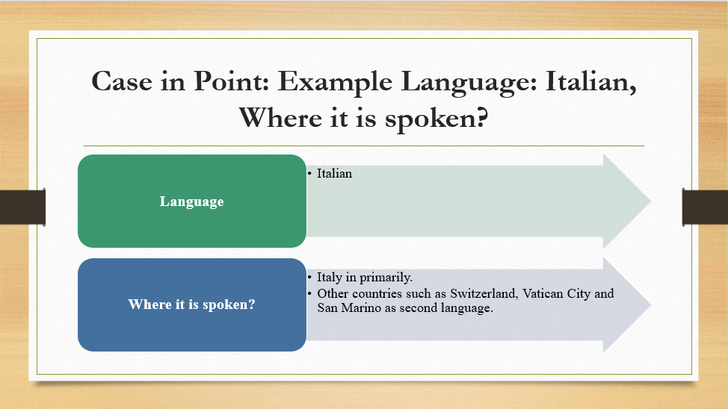
Speaker Notes:
The Italian language is spoken primarily in Italy, but there are other neighbouring countries as well such as Switzerland, San Marino, and Vatican City that uses the Italian language as their second spoken language.
Learning this language is difficult however, the difficulty level may vary from person to person depending upon the background of a person. For example, for English speakers, learning Italian can be challenging, and the reasons can be multiple like changes in grammar, vocabulary, and pronunciation.
From a hospitality sector’s point of view, it is advised to use the polite form of speaking when greeting the guests for instance, “Buongiorno” (Good Morning) or “Buonasera” (Good Evening). In addition, “Signore” (Sir) or “Signora” (Madam) is demonstrated as respect and politeness in the hotel business.
Moreover, in terms of impolite expressions in the hotel business, addressing guests with name without their permission is considered to be impolite. Therefore, in the Hotel business, it is crucial that all the staff members maintain a level of professionalism by using appropriate titles and formal language.
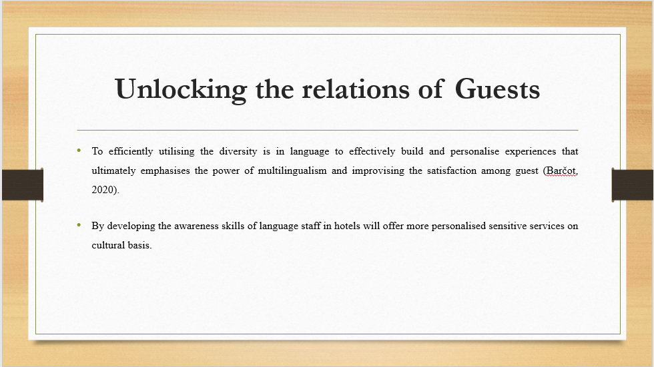
Speaker Notes:
The slide will focuses on introducing the concept of benefits and advantages of leveraging the diversities in language within the hotel industry. Multilingualism is not about overcoming the barriers and challenges in language it is about building a transparent connexion with the guest from all around the world. With the help of equipping staff with the skills of language awareness it would be helpful in understanding and anticipating the requirements of guests ineffective manner that helps ensures a tailored services.
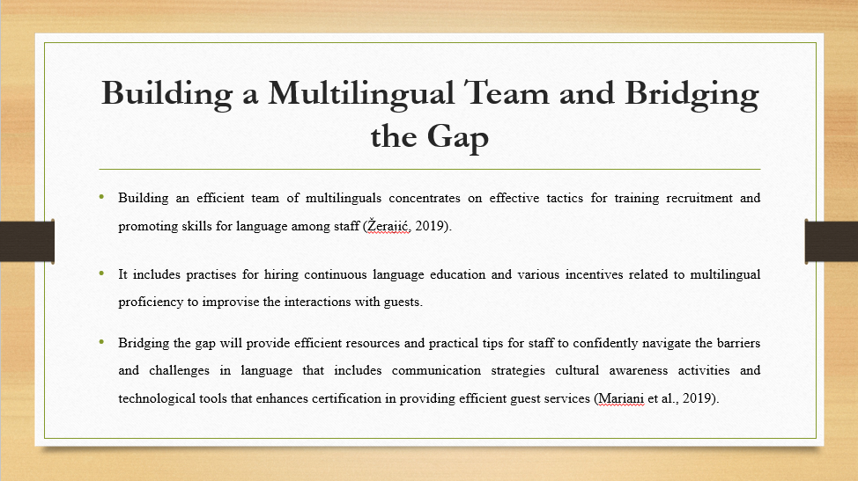
Speaker Notes:
The slides focuses on outlining the strategic approach that helps cultivate multilingual staff and emphasis recruitment and promotion of skills. It will explore how targeted process of hiring can prioritise the skills for language at initial level. Training programmes Has been designed in a manner that not just for language acquisition but also for sensitivity in cultures that makes sure staff will communicate efficiently with their guest.
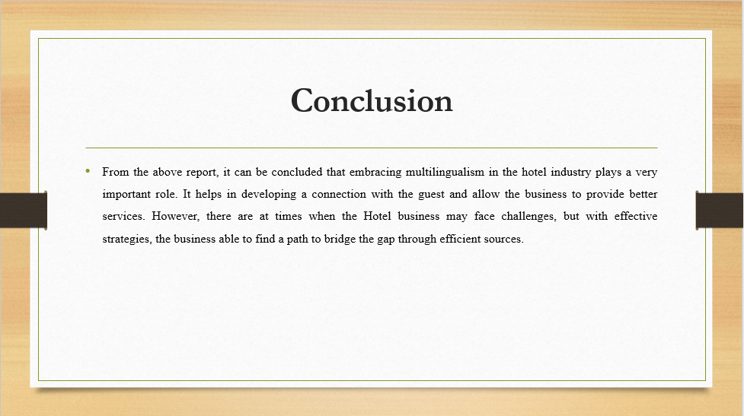
References (no screenshots):
- Barčot, K., 2020. THE EFFECT OF MULTILINGUALISM ON PERSONALITY (Doctoral dissertation, RIT Croatia).
- Manoharan, A., Gross, M.J. and Sardeshmukh, S.R., 2021. Antecedents and outcomes of a culturally diverse workforce in hotels. Journal of Hospitality & Tourism Research, 45(8), pp.1383-1416.
- Mariani, M.M., Borghi, M. and Kazakov, S., 2019. The role of language in the online evaluation of hospitality service encounters: An empirical study. International Journal of Hospitality Management, 78, pp.50-58.
- Nguyen, N.T., Yadav, M., Pande, S., Bhanot, A. and Hasan, M.F., 2022. Impact of diversity management on organizational performance in hotel organizations: a conceptual framework. International Journal of System Assurance Engineering and Management, pp.1-11.
- Žerajić, A., 2019, June. Intercultural management and the importance of foreign languages in modern hotel industry. In Tourism International Scientific Conference Vrnjačka Banja-TISC (Vol. 4, No. 1, pp. 360-377).

