1. Amenhotep III Lion hunt scarab (Dynasty 18): mid-14th century BC,
Found in an Iron Age tomb at Palaepaphos Skales, Cyprus, dating to 11th century BC. Several burials (fragmentary); wealthy tomb: 2 iron knives, 1 iron dagger, 2 bronze spearheads, several bronze and gold items of personal adornment, 13 stone weights, clay spindlewhorls, 121 ceramic vessels.

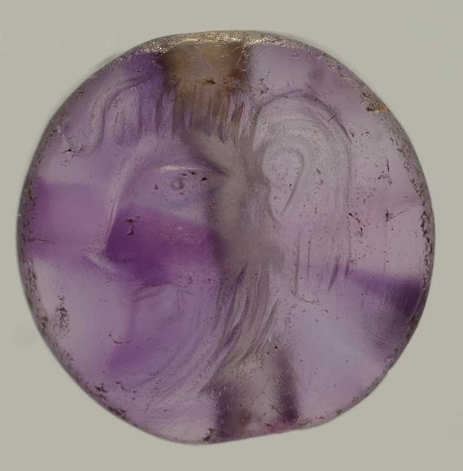
2. Minoan lentoid seal of amethyst (16th century BC): typical Minoan motif of bearded male.
Found in Tomb Gamma, Grave Circle B Mycenae. One female and three male burials. Other grave goods include electrum mask, two gold cups and bronze weapons.

Gaming stone found at Arediou (farming site, central Cyprus supporting copper mines). Senet: Egyptian game of passing.
This was made from a broken rubber (grinding stone used with quern) and was walled into the foundations of Building 1 (a large communal building with workrooms and storerooms associated with centralised agricultural production.

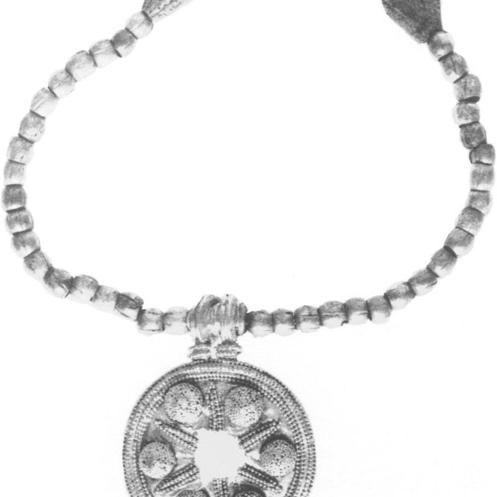

Gold & faience necklace with gold pendant from Babylonia, made c.2000 BC found in 10th century BC (Early Iron Age) burial at Lefkandi (island of Euboea, Greece).
Found with wealthy female burial, wearing a gold pectoral and gold breast plates, numerous bronze and iron gilt pins. Had an iron knife with ivory handle by her head. Double burial with wealthy male cremation and horse burials inside a large chieftain’s house, which was destroyed and covered with tumulus.

