
Master of Business Administration
International Business Pathway

Assessment 1: Individual report. Weight: 100%
Module name: International Business Concepts
Module code: (LCMB7034_LON)
Lecturer name: Charles Oham
Student name: Md Nebir Miah
Student ID: 2516200
Word count: 5491
Submission date: 11 August 2026
AI use acknowledgement
I acknowledge the use of Chatgpt (https://chatgpt.com/ on 15th July, 2026 to research, planning and development of my assignment. I used the prompt:
1. Provide a detailed, evidence-based foundation for examining JD Sports Fashion plc’s potential entry into Brazil.
I confirm that I have not presented any AI generated text as my own work. I confirm I have copies of my drafts, notes, and other resources I used before, and after the use of AI tools which I may be asked to provide in evidence.
Contents
Section 1: International Market-Entry Report 5
Introduction 5
Organisational Classification and Global Strategy 6
Macro-Environmental Appraisal and Market Attractiveness 9
Host Country Analysis 9
Political environment 9
Economic environment 10
Legal and regulatory environment 14
Cultural environment and consumer-market adaptation 15
VUCA Assessment 17
Industry structure and market attractiveness 19
Market Entry 19
Dunning’s OLI synthesis 19
Entry Mode Strategy and Strategic Synthesis 22
Historical Pattern Recognition 22
Strategic Fit and Justification 22
Recommendations 24
Conclusion 25
Section 2: Reflective Account 26
Description 27
Feelings 27
Evaluation 27
Analysis 28
Conclusion 29
Action Plan 29
Reference 30

Figure 1: Brands of JD Sport. Source: JD Sports Fashion plc (2026c) 6
Figure 2: Bartlett and Ghoshal (1989) Integration, Responsiveness Positioning on JD Sports. Source: Own Contribution. 8
Figure 3: Nominal GDP (in Billion) and Population (in million) of Brazil. Source: IMF (2026). 10
Figure 4: Real GDP growth of of Brazil. Source: IMF (2026). 11
Figure 5: Gini index of Brazil. Source: World Bank (2026). 12
Figure 6: Unemployment rate of Brazil. Source: World Bank (2026). 13
Figure 7: Brazil Benefit–Cost–Risk Appraisal for JD Sports. Source: Own Contribution. 16
Figure 8: VUCA Assessment of JD Sports’ Potential Entry into Brazil. Source: Own Contribution. 18
Figure 9: Eclectic Paradigm. Source: Dunning (1988; 1993). 20
Figure 10: OLI Synthesis — JD Sports and Brazil. Source: Own Contribution. 21
Figure 11: Indicative Weighted Entry-Mode Decision Matrix based on Giachetti and Peprah (2022) and Jacob (2022). Source: Own Contribution. 24
Figure 12: Phased Brazilian Entry Roadmap. Source: Own Contribution. 25
Figure 13: Reflective Account using Gibbs' (1988) Reflective Cycle. Source: Own Contribution. 26

Section 1: International Market-Entry Report

Introduction
This report focuses on JD Sports Fashion plc (“JD Sports”), a UK-based, global sports-fashion retailer active in an omnichannel strategy, as a potential candidate for entering the Brazilian market where the Group does not currently have a substantial presence. No significant operational presence" shall be understood as the absence of any operational JD-branded store network, a dedicated Brazilian subsidiary or a formal franchise or joint-venture arrangement, and shall not be considered as a formal market entry or access through third-party marketplaces. The analysis is based on data publicly available as at 1 June 2026 including data from JD Sports’ Annual Report and Results Statement for FY2026 (JD Sports Fashion plc, 2026a; 2026b) and official economic sources from the Brazilian government and the multilateral institutions. The report's working argument is that JD Sports has transferable ownership advantages, and Brazil can provide real location advantages, but that institutional, fiscal and currency conditions are more conducive to a staged, contractually governed entry into their franchise, than for an immediate, all-cash investment.

Organisational Classification and Global Strategy
The Group's operations were subsequently expanded to 51 countries of which 15 countries were served under franchise agreements, with revenues spread across North America, Europe and UK and Asia Pacific (JD Sports Fashion plc, 2026a). Its positioning is sport, fashion, music and youth culture underpinned by the exclusive product partnerships with key sportswear brands, and an expanding own-brand and digital offering.

Figure 1: Brands of JD Sport. Source: JD Sports Fashion plc (2026c)
The Group's operations were subsequently expanded to 51 countries of which 15 countries were served under franchise agreements, with revenues spread across North America, Europe and UK and Asia Pacific (JD Sports Fashion plc, 2026a). Its positioning is sport, fashion, music and youth culture underpinned by the exclusive product partnerships with key sportswear brands, and an expanding own-brand and digital offering.
It is difficult to classify JD Sports in a simple way because it shows signs of both global integration and local responsiveness as per the integration–responsiveness framework of Bartlett and Ghoshal (1989). Integration is seen in a centralised brand identity, Group-wide supplier contracts with Nike and Adidas, a common digital system and uniform financial and performance management (JD Sports Fashion plc, 2026a). Responsive is seen in the ability of the company to maintain localised fascias, regionally differentiated product mixes and franchise structures in markets like South Africa and the Middle East (JD Sports Fashion plc, 2025b). However, rather than fitting JD Sports into a single box, a more defensible interpretation of the model, reminiscent of recent critiques of its rigidity (Jacob et al., 2021), is that JD Sports has a primarily transnational orientation in its core fascia, with multidomestic elements throughout its portfolio of complementary and acquired concepts. This is a qualified classification that is more in line with the evidence than using a single “global” or “multidomestic” label, and it is relevant for Brazil, as it means that in theory it is possible to gain the benefits of a brand standardisation, while adapting the product to the local market through partnership.
This qualified reading represents a new twist on the integration–responsiveness debate, which views “transnational” as a constantly re-negotiated equilibrium point rather than a destination point, especially for big acquisitive retailers (Jacob et al., 2021). This is borne out by JD Sports' recent experience: the Group has been consolidating finance, HR and technology functions, but the brand level freedom for complementary concepts is a clear reflection of the Group's ongoing rebalancing process, rather than a final position, and around 30 businesses have been sold off as part of the portfolio simplification process (JD Sports Fashion plc, 2026a). Brazil's focus, instead, is not on deciding on the classification, but on finding an entry structure that is able to navigate a balance between effective central control and local adaptation while market conditions change.

Figure 2: Bartlett and Ghoshal (1989) Integration, Responsiveness Positioning on JD Sports. Source: Own Contribution.
The international configuration of JD Sports also represents value based on Porter's (1985) value-chain logic. The group's scale of procurement, shared logistics capabilities, cross-market know-how transfer of merchandise and digital-retail skills, coordinated marketing around global sportswear launches, etc. all contribute to a competitive advantage (JD Sports Fashion plc, 2026a). Centralised supplier negotiation is an added benefit to inbound logistics, a repeatable, internationally proven format is added to operations and store design, and integrated online and in-store fulfilment increasingly benefits outbound logistics, which JD Sports has worked on through continuous investment in the supply-chain and technology (JD Sports Fashion plc, 2026a). But it is one of the decisions that Brazil must make, given the risks associated with it: being dependent on a few major international brands that already market directly to Brazilian consumers and retailers (IMARC Group, 2026); integration after rapid growth through acquisition, as proved in the case of Hibbett and Courir, which is currently in progress; and the problem of implementing UK/US retail brands in a different institutional context, where property, tax and labour conditions are far from being comparable (Giachetti and Peprah, 2022). Overall, JD Sports' current assets are largely transferable more or less, however, they cannot be transferred to Brazil without a specific governance model for entry, which will vary significantly.

Macro-Environmental Appraisal and Market Attractiveness
A benefit–cost–risk approach is applied to the political, economic, legal and cultural context, followed by a Dunning (1988; 1993) OLI synthesis to determine if Brazil is a desirable investment site for JD Sports and, if so, under which conditions. The narrow definition of the relevant market is urban Brazilian sports-fashion, athleisure, sneaker and branded footwear/apparel retail in physical and digital channels, as the realistic addressable market for JD Sports is urban, digitally connected, with higher disposable income.

Host Country Analysis

Political environment
Brazil is a federal democratic country that has a degree of stability, with powers shared amongst the federal, state and municipal levels, giving foreign retailers continuity and complexity. (Kumar, 2025) Foreign investment policy has always been generally welcoming under all governments, regardless of political ideology, and Brazil remains actively involved in economic diplomacy of Mercosur and G20, providing a degree of predictability regarding economic relations over the medium term (World Bank, 2026). Meanwhile, fiscal policy has been a long-standing source of market sensitivity: proposed budget adjustment packages have been deemed too small by markets more than once, which has led to real depreciation and volatility that has spread to import costs for foreign retailers (Global Edge, 2026). This highlights that the political dimension of stability (regime continuity) is not synonymous with the policy dimension of stability (predictability) that is relevant to a retailer making multi-year commitments to capital expenditures (Cairney, 2025).
Based on the accepted categories of political risk, systemic risk is defined as the risk of comprehensive system failure, namely regime instability. For Brazil, the systemic risk is moderate, due to its long democratic tradition (Abdullahi et al., 2025). Procedural risk is more relevant: the risk that clearance procedures with customs, licensing, tax registration and commercial property approvals will take a longer time and are more fragmented or applied inconsistently at different levels of government is directly relevant for a retailer who relies on a streamlined clearance process and timely store rollout (Giachetti and Peprah, 2022; Jacob et al., 2021). Distributive risk, defined as the possibility of a sudden change in the tax or regulatory burden for foreign companies versus domestic companies, is high due to the current process of reforming the consumption tax in Brazil, whilst catastrophic risk, which refers to abrupt change in regime or expropriation, is low. (ITA, 2025) The logic behind these risk classifications is relevant to the strategic considerations of JD Sports: it is good for the company to have someone local that already has regulatory relationships and that has experience with government, and to take measured steps towards capital investment, rather than making an all-or-nothing deal at first, and to have strong anti-bribery and compliance controls in place, since Brazil has a mixed record on corruption perception, and to have contractual safeguards so that JD Sports can back out or renegotiate if the political-economic environment worsens.

Economic environment
In 2026, Brazil will be the tenth largest world economy by nominal GDP, with GDP of around US$2.6 trillion and a population of about 213–214 million (IMF, 2026; World Bank, 2026).
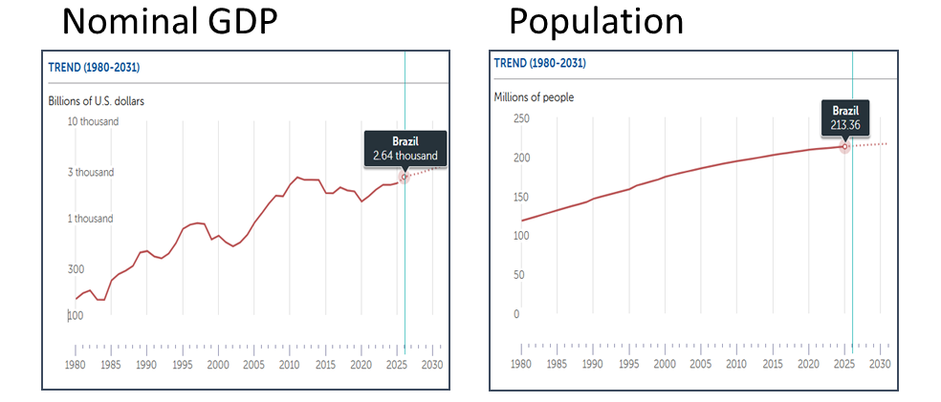
Figure 3: Nominal GDP (in Billion) and Population (in million) of Brazil. Source: IMF (2026).
Growth is beginning to slow, as GDP grew by 2.3% in 2025; the IMF (2026) and OECD (2026) are forecasting growth of about 1.6-2.0% for 2026, amid high interest rates and international pressures.
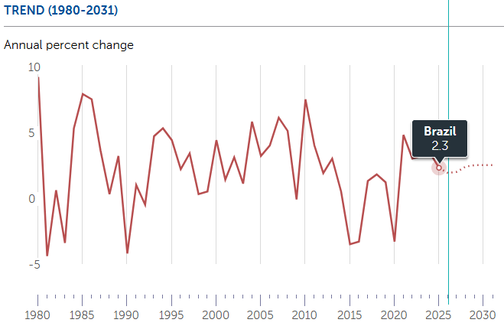
Figure 4: Real GDP growth of of Brazil. Source: IMF (2026).
This scale represents real long-run potential but GDP numbers overestimate the realistically attainable market for JD Sports. Brazil's inequality is still high, with a Gini coefficient of about 50.2-50.3, one of the highest in the G20 (World Bank, 2026) and about 20% of its population living below international poverty lines.
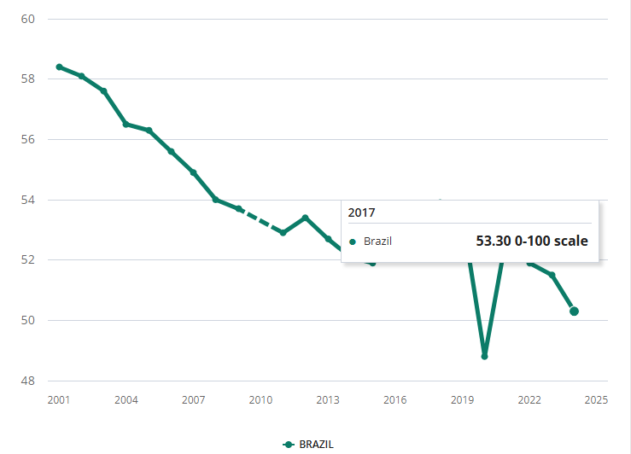
Figure 5: Gini index of Brazil. Source: World Bank (2026).
This inequality indicates that this is not the population as a whole, but rather, urban, middle to higher-income, digitally connected consumers in cities like São Paulo, Rio de Janeiro and Brasília are the ones that make up the realistic near-term market for JD Sports. This is also reflected in recent studies of market fragmentation for e-commerce in Brazil (da Veiga et al., 2024). Consumer credit and discretionary spending on non-essential apparel and footwear were low because the central bank kept real rates high to defend its credibility, and was forced to do so because inflation was at around 4.1–4.4% in early-to-mid 2026. Nevertheless, Brazil's culture of instalment consumer credit (parcelamento) is deeply rooted in retail and has the potential to aid JD Sports' pricing and promotional tactics if adapted to the local market (Couret, 2025).
Unemployment was around 5.8-6.0% in 2025-26, a low historical rate for the country of Brazil that has helped to fuel household demand and the tightness of the labour market, but has also increased local wage costs for a labour-intensive retail operation (World Bank, 2026).

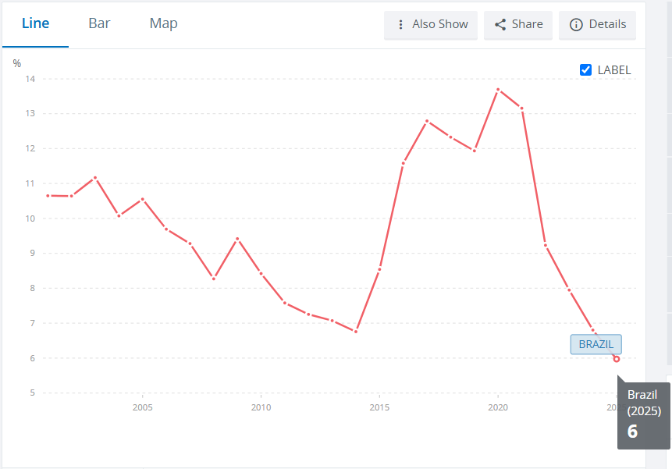
Figure 6: Unemployment rate of Brazil. Source: World Bank (2026).
Household final consumption expenditure will continue to be the largest sector in the Brazilian GDP, and the government's minimum wage adjustment rule may be responsible in part for the fact that the lower and middle income groups in Brazil have gained in real income even when growth has lagged, which may offset, to some extent, the negative impact of high interest rates on discretionary sportswear spending, if appropriately priced.
The risk of currency is a significant issue. Since 2020, the Brazilian real has experienced significant realignments from its historical average with its most recent appreciation in May 2023 being driven by fiscal risk premia, interest-rate differentials and global risk sentiment (Banco Central do Brasil, 2021; da Veiga et al., 2024), while its subsequent depreciations throughout 2024 and 2025 were linked to a widening trade deficit and a sharp rise in the cost of imported inputs across the retail sector (Gamarski and Nascimento, 2025). Retailers that are already dealing with imported goods have responded with price hikes of up to 10% in months following currency shocks, showing how quickly foreign-exchange volatility can be a squeeze on businesses that depend on imported branded inventory. This adds to a recurring margin volatility issue for JD Sports because they would be importing most of their branded inventory into Brazil, it would be difficult to translate any Brazilian earnings back to sterling for Group reporting and it would be more expensive for JD Sports to replace their inventory compared to a retailer that their inventory is sold locally. This makes the case for conservative initial inventory commitments, regular review of price lists as part of the commercial contract with any local partner and centralised discipline and Group treasury of the currency exposure, rather than the delegation of currency risk to a local operation without oversight (Walters, 2026).
The economic climate creates a true conflict. Brazil provides long run growth and diversification value in line with JD Sports's stated strategy to diversify away from its historically UK- and Europe-weighted revenue base (JD Sports Fashion plc, 2026a); its domestic consumption base is strong relative to the regional average. Yet there are short-term macro-economic issues, which are not particularly conducive to a large and fixed capital commitment: slow growth, high real interest rates, an unsettled tax-reform transition and material currency volatility. This mixture is suitable for a lower fixed cost, more flexible entry configuration that can be expanded when macro-economic and currency conditions, and initial trading results, are clear.

Legal and regulatory environment
While it is legal to have foreign companies with retail businesses in Brazil, the procedure of company formation, license and tax administration is multi-layered between federal, state and municipal levels, with Brazil now in the midst of a significant consumption-tax reform to streamline the previously complex matrix of state (ICMS) and municipal taxes (World Bank, 2026). This change brings near-term pricing, invoicing and systems configuration risk for the market entrant. Historically, footwear and apparel import duties and customs valuation are high by international standards, while administrative delays at customs remain a known challenge to efficient movement of inventory (Giachetti and Peprah, 2022). JD Sports would also have to adhere to Brazil's General Data Protection Law (LGPD) for e-commerce data and loyalty-programme data—although not to the same extent as the UK GDPR—but also to local consumer-rights and returns laws and local employment law, which has strict termination costs and social-contribution obligations compared with the UK. Alongside the National Institute of Industrial Property (INPI) that provides protection for IP rights, trademark registration and counterfeit enforcement requires proactive management considering the presence of grey-market and counterfeit sportswear in the Latin American markets (Riccipi Propriedade Intelectual, 2025). If Brazil's JD Sports plans to enter the market at its current size, competition regulation will not pose a significant obstacle, but should a future acquisition attempt be made, it will need to be early screened by Brazil's Administrative Council for Economic Defense (CADE). This legal complexity is better taken up by a partner who has an established compliance structure—such as accountants, customs brokers, employment counsel and property agents already in the Brazilian system—and is familiar with it than by a greenfield company, like JD Sports, who have to develop this structure from the ground up.

Cultural environment and consumer-market adaptation
Brazilian urban consumers are highly involved in football, fitness, and youth street culture, and consumption of athleisure and sneaker has increased as a consequence of the growing levels of health and fitness awareness, as well as e-commerce (da Veiga et al., 2024). The key features of digital retail success in Brazil include Portuguese-language content, local payment options (such as Pix instant-payment system and instalment credit), and customer-service measures that foster trust (da Veiga et al., 2024). Instead of using the stereotypical national culture segment, a more defensible approach is to use Weinstein's segmentation criteria; substantiality, measurability, differentiability, accessibility and actionability and arrive at a first segment of digitally connected, urban, middle and higher income consumers in major metros who value authentic international sportswear and fashion led retail experiences (Dibb and Simkin, 2010). Standardisation–adaption approach, typical of previous omnichannel internationalisation literature (da Veiga et al., 2024), could be applied in JD Sports, with the core of the brand identity, its standards of authenticity of suppliers and its architecture of digital platforms being standardised, but the language, payment methods, timing of promotions, local sporting affiliations, and partnerships with influencers being adapted. National-level scores, as used in cultural-dimensions frameworks like Hofstede's, should be interpreted with care: they represent an average of the tendencies of a huge population (more than 213 million citizens) residing in five distinct geographic areas; their use in predicting individual consumer behaviour is a potential form of unsupported generalisation that the brief explicitly cautions against. The most defensible approach is to only consider broad cultural indicators as background context and to use only Brazil-specific consumer and e-commerce research (da Veiga et al., 2024) for actual segmentation, pricing and promotion decision.

Figure 7: Brazil Benefit–Cost–Risk Appraisal for JD Sports. Source: Own Contribution.

VUCA Assessment
The VUCA framework is designed to help comprehend the impact of volatility, uncertainty, complexity and ambiguity in business environments that are constantly changing (Lauraeus, 2018). Aside from the political, economic, legal and cultural analysis, the VUCA framework can be used to distinguish the various forms of environmental uncertainty that JD Sports might face in Brazil as VUCA are different and need different strategic responses.

Figure 8: VUCA Assessment of JD Sports’ Potential Entry into Brazil. Source: Own Contribution.
Overall the VUCA assessment does not call for an exclusion of Brazil as a potential market, but rather reinforces the idea of a phased and flexible approach, where JD Sports is not too quick to make a total commitment and will rely on local expertise and make entry into the market only as suitable knowledge is gained.

Industry structure and market attractiveness
The competition level is considered moderate-to-high by competitors already established in the Brazilian market as well as by international marketplaces and channels where the brand is directly present (IMARC Group, 2026), leading to the conclusion that the rivalry is present; the supplier power is considered considerable, as JD Sports is dependent on Nike, Adidas, and other global brands, who are already present in Brazil with their own direct channels (IMARC Group, 2026); the buyer power is already considerable, as there is a high level of price comparison online and low switching costs; and the threat of substitute products is already present, through both informal and counterfeit markets, in addition to general e-commerce marketplaces (IMARC Group, 2026). Brand awareness building expenses, pricing is high in premium malls, the import-cost structure and capacity of local logistics and tax compliance are some of the entry barriers (Moshood, 2025). If this is the case, it points to the fact that the Brazilian sports-fashion sector is only appealing for a player with a truly differentiated, digitally-integrated business proposition, which JD Sports could provide, as long as they can manage the execution risk. Notably, the Brazilian sports-apparel market is projected to continue expanding steadily over the coming decade, driven by the growing participation in health and fitness, and e-commerce expansion, pointing towards a higher level of competitive intensity in the future and a timely, but cautious, entry into the market seems like a better bet than waiting much longer. (IMARC Group, 2026)

Market Entry

Dunning’s OLI synthesis
Dunning's (1988; 1993) eclectic paradigm suggests that a firm will invest in FDI when it has ownership advantages that can be exported overseas, when the home country location offers advantages for its production or retail operations, and when the internalisation of the transaction is more beneficial than licensing or arm's-length exchange.
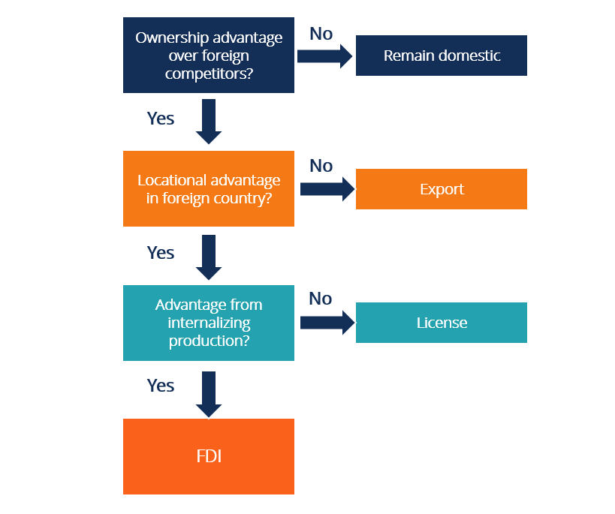
Figure 9: Eclectic Paradigm. Source: Dunning (1988; 1993).
The framework, on the other hand, does not clearly direct any country towards investment, even when applied to JD Sports and Brazil.
As far as ownership, JD Sports is a recognised global brand, has a set of exclusive collaborations with products and has the infrastructure and store design experience (JD Sports Fashion plc, 2026a). However, these benefits are not guaranteed to be maintained: brand awareness is currently relatively low in Brazil compared to the UK or US; a number of key sportswear suppliers already have established ground in Brazil; and price-based differentiation for JD Sports may be lost on the streets of Brazil due to the pricing of imported goods.
Although Brazil's scale, urbanisation and developing digital-retail infrastructure are real benefits, these are offset by import duties, tax-reform uncertainty, currency volatility, inequality and logistical complexity over such a vast territory (World Bank, 2026; Banco Central do Brasil, 2021), with location advantages helping to provide access to retail, not immediate scale.
The case is mixed on internalisation, as direct control would ensure that brand standards, product allocation and customer data are safeguarded, while local partnership has the potential to provide valuable benefits in terms of navigating uncertainty, minimising capital exposure and exit flexibility, given the institutional absence of the procedural regulation, tax administration and property relationships in Brazil (Batschauer da Cruz et al., 2022; Jacob, 2022).
As a whole, ownership and location advantages facilitate market entry, whereas non-clear internalisation advantages indicate the need for a delay in the investment to market entry, directly motivating the entry-mode analysis in the following section.

Figure 10: OLI Synthesis — JD Sports and Brazil. Source: Own Contribution.

Entry Mode Strategy and Strategic Synthesis

Historical Pattern Recognition
The JD Sports' international expansion is a history of no one clear dominant mode. The Group has been actively looking into large-scale acquisitions in selected markets (including the acquisition of Hibbett and Courir in North America and France) and capital-light franchise and joint-venture deals in key markets (including South Africa, Israel and parts of the Middle East and North Africa (MENA) region) (2025b; 2026a). This seems to be a strategy aimed at adjusting entry modes to the level of importance of the market, the level of existing infrastructure and the desired degree of control, as confirmed by the international-franchising literature in which mode choice is found to be influenced by both organizational sensitivity and environmental complexity (Giachetti and Peprah, 2022).

Strategic Fit and Justification
Based on the entry mode criteria established (risk attitude, capital availability, desired control, strategic vision, speed, flexibility, core-competency protection and local knowledge), five alternatives are worth considering for Brazil's comparison with realism. Minimal commitment from a business and fast market testing, but import tariffs, expensive relative to locally sourced competitors and limited control over the end to end customer journey (Avery et al., 2017). The advantages of a master-franchise arrangement are increased local market and regulatory expertise, access to an existing property network, and capital-light expansion – but come with the downside of diminished day-to-day operational and customer data control unless well-specified in the franchise agreement (Iyer et al., 2015). A joint venture is a partnership that shares the risk element and that brings JD Sports' know-how in brand and merchandising and the local expertise of the partner, but it is a venture that has a certain level of governance-conflict risk (where incentives of partners conflict, especially regarding reinvestment and pricing). The purchase of an existing Brazilian sports-fashion or footwear retailer would give the Group immediate access to its stores, experienced employees and customer base, though would have the risk of high upfront investment and integration costs, particularly as the Group's recent acquisition of Hibbett and Courir are still being incorporated into the Group (JD Sports Fashion plc, 2026a). A wholly owned greenfield subsidiary provides the maximum brand and operational control, but at the same time exposes the company to the largest capital, regulatory-learning and currency risks—just when the risks and uncertainty of procedures and tax reform are the biggest.
Brand and customer-experience control, local regulatory knowledge, capital exposure, supply-chain and customs fit, speed of entry, digital-data control, and exit flexibility and long-run ownership potential are all factors that can be compared with an indicative decision matrix that reveals that, while franchising does have a relative advantage in several respects, it does have a relative disadvantage where capital exposure, risk and flexibility are weighed heavily; a trade-off that aligns with the institutional-voids literature cited above (Giachetti and Peprah, 2022; Jacob, 2022). A quick sensitivity check bears this out: while acquisition and joint venture close the gap on franchising in a control-weighted scenario, neither have the opportunity to eliminate it in the capital-exposure criterion once Brazil's volatility in its currency and risk of tax transitions are taken into account, as both options put JD Sports at currency and regulatory risk from day one.
Criterion | Weight | Exporting | Franchise | Joint Venture | Acquisition | Greenfield WOS
Brand/customer-experience control | 20% | Low | Medium | Medium-High | High | High
Local regulatory knowledge | 15% | Low | High | High | Medium | Low
Capital exposure (lower = better) | 15% | Low | Low | Medium | High | High
Supply-chain/customs fit | 15% | Low | High | Medium | Medium | Low
Speed of entry | 10% | High | High | Medium | Medium | Low
Data/digital control | 10% | Low | Medium | Medium | High | High
Exit flexibility | 10% | High | High | Medium | Low | Low
Long-term ownership potential | 5% | Low | Medium (staged) | High | High | High
Figure 11: Indicative Weighted Entry-Mode Decision Matrix based on Giachetti and Peprah (2022) and Jacob (2022). Source: Own Contribution.

Recommendations
This master-franchise model, coupled with a digital channel in Portuguese and a potential for JD Sports to buy an extra stake upon agreed performance level, is the recommended entry mode into the market. This recommendation is based on the entry-mode framework that favorably rates franchising in the areas of local regulatory knowledge, low capital exposure, supply-chain/customs capability, speed and exit flexibility, and rate the brand and digital control as moderate. Acquisition and greenfield entry offer more control and carry with it potential capital, currency and regulatory risks, while a joint venture has the potential to raise capital, currency and governance-conflict risks for JD Sports.
The acquisition also aligns with JD's past internationalisation strategy of acquiring foreign brands and establishing franchise and joint-venture partnerships depending on the market conditions (JD Sports Fashion plc, 2025b; 2026a). JD Sports' brand, merchandising and supplier expertise and local understanding of regulation, property, customs and consumer behaviour (Giachetti and Peprah, 2022; Jacob, 2022) are added to this flexible approach, which is extended by a Brazilian master franchise. Territorial rights, store standards, assortment, data access, compliance with the LGPD, brand protection, termination rights are some points that should be addressed through strong contractual controls.

Figure 12: Phased Brazilian Entry Roadmap. Source: Own Contribution.

Conclusion
To sum up, JD Sports should seek a conditional ‘go' decision and take a couple of steps to Brazil before the evaluation of the master franchise, legal matters, supply chain and demand, with a clear plan to keep the initial distribution limited to the metropolitan and digital market, and to offer a potential ownership opportunity. This mode is chosen because it offers a good mix of JD Sports' ownership benefits against the actual Brazilian locations benefits and unconfirmed internalisation risk, as well as it being preferred over pure exporting to maintain brand standards and customer experience better than arm's-length transactions. Entry should only be made where due diligence, access to suppliers, landed cost modelling and evidence at the pilot level of demand has shown that JD Sports can maintain a differentiation while achieving a risk adjusted return that is satisfactory. Delay or withdrawal should remain acceptable should this evidence not be obtained.

Section 2: Reflective Account
The six stages of Gibbs' (1988) Reflective Cycle – description, feelings, evaluation, analysis, conclusion and action plan – are chosen as it offers a clear structure to analyse how the JD Sports–Brazil report has been researched and written.

Figure 13: Reflective Account using Gibbs' (1988) Reflective Cycle. Source: Own Contribution.

Description
I chose Brazil and JD Sports as a data-rich UK retailer with no reported evidence of a formal business presence and with a business model that would be subject to the brief that could be supported by primary evidence. Each of the mandates frameworks (Bartlett and Ghoshal, value-chain analysis, political, economic, legal and cultural assessment, Five Forces, Dunning's OLI paradigm and entry-mode theory) was mapped to a word plan. Then I developed a source matrix, focusing on the Annual Report and Results Statement of the company JD Sports, and other official sources, such as IBGE, Banco Central do Brasil, IMF, World Bank and OECD. Literature was searched by theoretical theme and publication dates were cross-checked with the 1 June 2026 cut-off – as per peer-reviewed literature. Triangulation, framework-based categorisation and comparative evaluation were used as evidence analysis techniques.

Feelings
I was pretty comfortable with Five Forces, PESTLE and value-chain analysis, but I wasn't sure how far I had to push the notion of the lack of JD Sports in Brazil. So I took the time that I didn't have to and checked the store locators, franchise territories, subsidiaries and corporate evidence. Also, I struggled to use a few frameworks without rephrasing the argument, and repeating it. The first appearance of the strategy classification by Bartlett and Ghoshal and the OLI paradigm appeared to be overlapping. The concept that Brazil's big population would necessarily entice me was put to the test when I looked at inequality and purchasing-power data. This made me to be more careful with the word count description.

Evaluation
The combination of the short and the source matrix decreased the likelihood of missing requirements and the ease of differentiating between authoritative source and secondary commentary. Reduced unsupported claims as primary and official data prioritised. It was better to compare the various modes of entry (franchising, joint ventures, acquisition and greenfield investment) before reaching a conclusion than to pick one mode and then look for supporting evidence. The links of each framework to a specific analytical purpose contributed to a focused report.
I just did my initial research that was too general, though. Afterwards I gathered general information about Brazil and set up the sports-fashion and urban consumer market that is relevant for the project. This used up time, and could generate a country description. In response to this, I reduced the evidence to those that would impact the costs, risks, control, flexibility, or market potential of JD Sports, and changed each paragraph to have evidence followed by a strategic implication.

Analysis
The most significant analytical advance was identifying aggregate market size from commercially addressable demand. Brazil seemed like a good population and good GDP until the inequality figures were taken into account and it became clear that the purchasing power is distributed among the population in an unequal fashion. Hence, the market attractiveness had to be drawn and discussed not with the nation's consumers but with the middle-to-high income urban consumers who were digitally connected. This shifted the proposed entry scale to a staged approach at the metropolitan level.
I changed my mind when I applied Dunning's OLI framework. At first sight, I felt that JD Sports' brand, their relationships with their suppliers, and their merchandising and omnichannel skills would make investing in the company worth it. Institutional-voids literature however revealed that the absence of ownership advantages does not eliminate the regulatory, logistics, and partner knowledge and enforcement-related uncertainties (Batschauer da Cruz, Floriani and Amal, 2022; Jacob, 2022; Giachetti and Peprah, 2022). This resulted in a more knowledgeable and collaborative recommendation.
This development was directly supported by the course learning. Week 2 confirmed that the decision on entry-mode should be based on a systematic comparison of risk, capital commitment, control and flexibility, and this comparison should not be done automatically based on ownership. The integration–responsiveness framework revealed in week 3 was a successful model for JD Sports, which were able to maintain global brand control along with technology and supplier management, while adjusting to price, promotion and operations locally. Week 5 showed that the assessment of OLI must take place simultaneously, and requires advantages of ownership, location, and internalisation. The IKEA Japan and General Electric cases demonstrated that firms may have to adjust their historical approaches to market entry when market conditions are different. During class discussion, I was reminded that there is not always one right answer to this question of entering a market, and that multiple approaches to risk, control, and local responsiveness were urged and prompted to try some other approaches to market entry. Week 9's VUCA framework facilitated the sorting of currency and inflation volatility, demand and regulatory uncertainty, as well as institutional complexity and ambiguity regarding consumer response. There were different answers to each of these needs in the phased implementation plan.
Pressures of word counts enhanced prioritisation. The economic section originally included far too many indicators, so I have only left those that have an impact on the issue of affordability, pricing, investment risk or demand.

Conclusion
This experience taught me that when selecting markets for international trade, you can't just go for size and that frameworks work best when they challenge rather than describe. I learned that evidence from the company, official data, academic literature, lecture cases and classroom discussion, can be used as a triangle to strengthen the recommendations. In the case of repeat creation, I would define addressable market and evidence requirements beforehand.

Action Plan
Going forward, I will consider my research question, target audience, and word counts for each section prior to evidence gathering. I will create the claim-evidence table, note the date and page number of each source, and document what each source was used for. Immediate verification of the DOI and peer review status will be conducted, and company / country claims will be triangulated using credible types of sources. Weighted decision matrices will be prepared with sensitivity analysis and a separate Harvard referencing audit will be conducted to ensure in-text citations are consistent with the reference list. These actions should increase efficiency, transparency and future strategic analysis.

Reference
Abdullahi, K.T., Muhammad, M.A. and Suleiman, S.U. (2025). Brazil on the rise: The interplay of political instability, FDI, and resurgent economic growth. Management and Economics Research Journal. doi:10.18639/merj.2025.9900107.
Avery, W.A., Wang, Y. and Lee, S.H. (2017). The effect of Cross-Border E-Commerce on china’s international trade: An empirical study based on transaction cost analysis. Sustainability, 9(11), p.2028. doi:10.3390/su9112028.
Banco Central do Brasil (2021). Foreign exchange rate volatility in Brazil, March 2021. [online] Brasília: Banco Central do Brasil. Available at: https://www.bcb.gov.br/content/ri/inflationreport/202103/ri202103b8i.pdf.
Bartlett, C.A. and Ghoshal, S. (1989). Managing across borders: The transnational solution. Boston, Mass.: Harvard Business School Press.
Batschauer da Cruz, C.B., Eliete Floriani, D. and Amal, M. (2020). The OLI paradigm as a comprehensive model of FDI determinants: A sub-national approach. International journal of emerging markets, 17(1). doi:https://doi.org/10.1108/IJOEM-07-2019-0517.
Brookes, M. and Roper, A. (2011). International master franchise agreements. European journal of Marketing, 45(7/8), pp.1253–1276. doi:10.1108/03090561111137705.
Cairney, P. (2025). Policymaking integration, policy coherence, and whole-of-government approaches: A qualitative systematic review of advice for policymakers. Open research Europe, 5, p.75. doi:10.12688/openreseurope.19864.1.
Couret, N. (2025). On the next installment. Film quarterly, 79(2), pp.38–43. doi:10.1525/fq.2025.79.2.38.
Dibb, S. and Simkin, L. (2010). Judging the quality of customer segments: Segmentation effectiveness. Journal of Strategic marketing, 18(2), pp.113–131.
Dunning, J.H. (1988). The eclectic paradigm of International production: A restatement and some possible extensions. Journal of International business studies, 19(1), pp.1–31. doi:https://doi.org/10.1057/palgrave.jibs.8490372.
Dunning, J.H. (1993) Multinational Enterprises and the Global Economy. Wokingham: Addison-Wesley.
Gamarski, R. and Nascimento, B. (2025). Currency Slump Ignites Price Hikes of Up to 10% in Brazil Stores. [online] Bloomberg.com. Available at: https://www.bloomberg.com/news/articles/2025-01-09/currency-slump-ignites-price-hikes-of-up-to-10-in-brazil-stores.
Giachetti, C. and Peprah, A.A. (2020). How much control do firms exercise over their resources when entering emerging markets? The influence of Institutional voids on entry mode degree of Control. BRQ business research quarterly, 25(2), p.234094442092440. doi:10.1177/2340944420924402.
Gibbs, G. (1988). Learning by doing: A guide to teaching and learning methods. Oxford: Further Education Unit, Oxford Polytechnic.
Global Edge (2026). Brazil: Risk assessment. [online] globaledge.msu.edu. Available at: https://globaledge.msu.edu/countries/brazil/risk.
IMARC Group (2026). Brazil Sports Apparel Market Size, Share, Trends and Forecast by Sport, End-User, Distribution Channel, and Region, 2026-2034. [online] Imarcgroup.com. Available at: https://www.imarcgroup.com/brazil-sports-apparel-market.
International Monetary Fund - IMF (2026). Brazil: Country Data. [online] International Monetary Fund. Washington, DC: IMF. Available at: https://www.imf.org/en/Countries/BRA.
ITA (2025). Brazil - market challenges. [online] International Trade Administration. Available at: https://www.trade.gov/country-commercial-guides/brazil-market-challenges.
Iyer, G.R., Grewal, D., Javalgi, R. and Radulovich, L. (2015). Franchise expansion into international markets: The role of Entrepreneurial orientation and knowledge resources. Cultural perspectives in a global marketplace, pp.120–121. doi:10.1007/978-3-319-18696-2_49.
Jacob, J. (2022) - Jacob, D., Svystunova, L. and Rao‐Nicholson, R. (2021). MNE post‐entry institutional strategies in emerging markets: An organizational field position perspective. European management review, [online] 19(1). doi:10.1111/emre.12472.
JD Sports Fashion plc (2025a). Q425 trading update & FY26 guidance. [online] Bury: JD Sports Fashion plc. Available at: https://www.jdplc.com/investor-relations/regulatory-news/regulatory-news-details/2025/Q425-TRADING-UPDATE--FY26-GUIDANCE/default.aspx.
JD Sports Fashion plc (2025b). JD sports fashion Plc annual report & accounts 2025. [online] Bury: JD Sports Fashion plc. Available at: https://s204.q4cdn.com/980191062/files/doc_downloads/results_centre/2025/05/2025-Annual-Report-and-Accounts.pdf.
JD Sports Fashion plc (2026a). Full YEAR results 2025/26 (FY26). [online] Bury: JD Sports Fashion plc. Available at: https://www.jdplc.com/investor-relations/regulatory-news/regulatory-news-details/2026/FULL-YEAR-RESULTS-202526-FY26/default.aspx.
JD Sports Fashion plc (2026b). FY2026 Results Statement and Presentation. [online] Bury: JD Sports Fashion plc. Available at: https://www.jdplc.com/investor-relations/regulatory-news/regulatory-news-details/2026/FULL-YEAR-RESULTS-202526-FY26/default.aspx.
JD Sports Fashion plc (2026c). JD sports fashion - our brands - complementary concepts. [online] JD Sports Fashion. Available at: https://www.jdplc.com/our-brands/complementary-concepts/default.aspx.
Kumar, P. (2025). The structure and challenges of brazilian federalism • PolSci institute. [online] Political science institute. Available at: https://polsci.institute/comparative-government-politics/brazilian-federalism-structure-challenges/.
Lauraeus, I.T. (2018). The VUCA approach as a solution concept to corporate foresight challenges and global technological disruption. Foresight, 20(1), pp.27–49. doi:10.1108/fs-06-2017-0022.
Märzheuser-Wood, B. (2017). Franchising – the route to international expansion? [online] www.dentons.com. Available at: https://www.dentons.com/en/insights/articles/2017/july/13/franchising-the-route-to-international-expansion.
Moshood, M. (2025). Assessing Brand-Driven supply chain customization and its role in Enhancing operational efficiency and sustained market expansion for global enterprises. International journal of Research publication and reviews, 6(8), pp.32–50. doi:10.55248/gengpi.6.0825.2805.
OECD (2026). OECD Economic Outlook, Volume 2026 Issue 1 — Brazil. [online] Organisation for Economic Co-operation and Development . Available at: https://www.oecd.org/en/publications/2026/06/oecd-economic-outlook-volume-2026-issue-1_8be0dba6/full-report/brazil_f971a312.html.
Porter, M.E. (1985). Competitive advantage: Creating and sustaining : Superior performance. [online] New York: The Free Press. Available at: https://resource.1st.ir/PortalImageDb/ScientificContent/182225f9-188a-4f24-ad2a-05b1d8944668/Competitive%20Advantage.pdf.
Riccipi Propriedade Intelectual (2025). Foreign trademark protection in Brazil through the Madrid protocol - ricci propriedade intelectual. [online] Ricci Propriedade Intelectual. Available at: https://riccipi.com.br/trademark-protection-brazil/?lang=en.
Veiga, C.P. da, Veiga, C.R.P. da, Michel, J. de S.S., Di Iorio, L.F. and Su, Z. (2024). E-Commerce in Brazil: An In-Depth analysis of Digital growth and strategic approaches for Online retail. Journal of Theoretical and applied electronic commerce research, [online] 19(2), pp.1559–1579. doi:10.3390/jtaer19020076.
Walters, B. (2026). The strategic re-emergence of inventory finance. [online] Trade treasury payments. Available at: https://tradetreasurypayments.com/articles/the-strategic-re-emergence-of-inventory-finance.
World Bank (2025). Brazil | data. [online] Worldbank.org. Available at: https://data.worldbank.org/country/brazil.

