Assessment

Module NaMe: Data Warehousing & Data Mining
Module Code: ACCA6026
Student NAME: Valerio Cinquemani
Student ID: 2130904
Lecturer: Rajeev Nath
Trinity saint david University of Wales (London Campus)

Table of content

Contents
Table of content 2
Task 1 3
1.1 OLTP Systems VS Data Warehousing 3
1.2: Data Warehouse Architecture & ETL 4
1.3: Data Marts for Management Decision-Making 5
1.4: OLTP Normalisation vs. Data Warehouse Dimensional Modelling 6
Task 2 7
2.1: Source System Identification 7
2.2: Star Schema Design 8
2.3 Data Marts and Schema 9
2.4 ETL Plan 10
2.5 Data Quality & Governance 10
References 12

Task 1

1.1 OLTP Systems VS Data Warehousing
NHS England currently relies on several Online Transaction Processing (OLTP) systems, including Electronic Patient Records (EPR), Patient Administration Systems (PAS), workforce management systems, and financial applications. These systems support the day-to-day delivery of healthcare services by recording and processing transactions such as patient admissions, appointments, treatments, staff scheduling, and financial activities in real time [1].
The primary purpose of an OLTP system is to ensure operational efficiency [2]. It is designed to handle large volumes of transactions quickly and accurately. For example, when a patient is admitted to a hospital, the details of their diagnosis, treatment, and discharge are stored within local operational systems. While these systems are essential for healthcare delivery, they are not designed to provide a consolidated view of performance across multiple NHS organisations and regions.
A data warehouse serves a different purpose. It collects, integrates, and stores data from multiple sources, including EPR, PAS, workforce, financial, and quality management systems. This creates a centralised repository that supports reporting, analysis, and strategic decision-making [3].
The key difference between OLTP systems and a data warehouse is that OLTP systems focus on processing current transactions, whereas a data warehouse focuses on analysing historical and integrated data. For example, an OLTP system can identify a patient's current treatment, while a data warehouse can reveal trends such as regional waiting times, bed occupancy rates, or treatment costs across England.
For NHS England, implementing a data warehouse would provide a single, consistent view of healthcare performance. This would enable senior leaders to monitor operational efficiency, identify capacity constraints, improve resource allocation, and make evidence-based decisions that enhance patient outcomes and support long-term healthcare sustainability.

Feature | OLTP Systems (EPR, PAS, Workforce System) | Data Warehouse
Primary Purpose | Day-to-day operations
  Strategic analysis and decision-making
Data Type | Current transactional data | Historical and integrated data
Users | Clinicians, administrators, operational staff | Executives, managers, analysts
Queries | Simple, transaction-focused | Complex, analytical
Update Frequency | Real-time | Periodic batch or near real-time
Example Question | "What ward is this patient in?" | "Which region has the highest readmission rate?"
NHS Benefit | Supports healthcare delivery | Supports performance improvement and planning

1.2: Data Warehouse Architecture & ETL

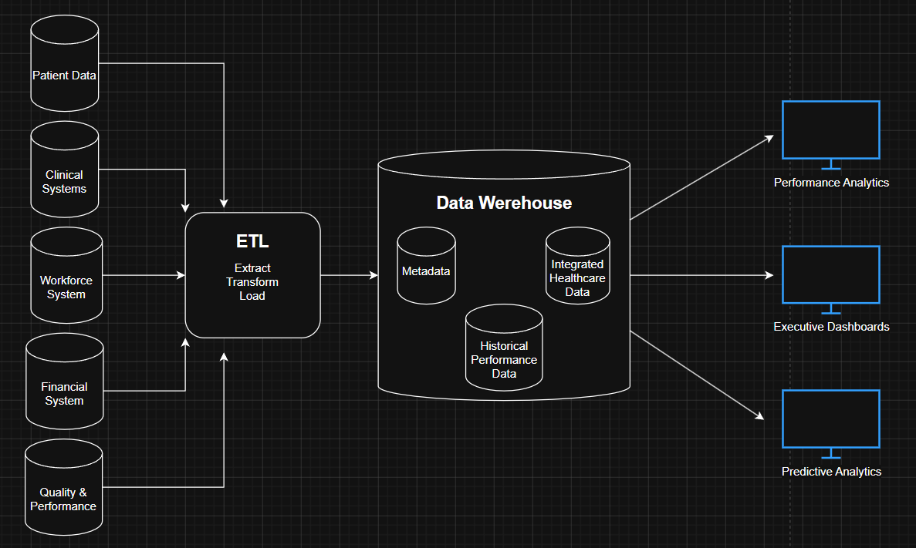
Data is extracted from operational systems during scheduled intervals, transformed into a consistent format, and loaded into the NHS Data Warehouse. This process does not interfere with daily healthcare operations because the source systems remain fully available to clinicians and administrative staff.

1.3: Data Marts for Management Decision-Making
While the NHS Data Warehouse provides a central repository of integrated data, different senior managers require access to specific information relevant to their responsibilities. Data marts are subject-oriented subsets of a data warehouse that provide tailored data and reports for users or departments [4]. By creating dedicated data marts, NHS England can ensure that decision-makers receive relevant insights without having to analyse the entire data warehouse.
The Chief Executive requires a high-level view of organisational performance across England. A dedicated Executive Data Mart could combine operational, financial, workforce, and quality indicators to provide strategic dashboards. Key metrics may include waiting times, bed occupancy rates, patient satisfaction scores, workforce utilisation, and budget performance. This would enable the CEO to monitor overall healthcare performance and identify areas requiring intervention.
The Finance Director requires detailed financial information to support budgeting and cost control. A Financial Data Mart could integrate treatment costs, expenditure, national tariffs, and budget data from NHS financial systems. This would allow analysis of cost per patient episode, budget variances, expenditure trends, and financial performance across regions and healthcare services. Such insights would support efficient resource allocation and financial sustainability.
The Medical Director focuses on clinical quality, patient outcomes, and service performance. A Clinical Data Mart could combine patient, diagnostic, treatment, and quality data to monitor clinical effectiveness. Relevant metrics may include readmission rates, mortality indicators, patient safety incidents, treatment outcomes, and referral-to-treatment (RTT) performance. This would support evidence-based clinical decision-making and continuous improvement initiatives.
By implementing specialised data marts, NHS England can provide targeted information to different stakeholders while maintaining a single integrated data warehouse as the central source of data. This approach improves decision-making efficiency, reduces information overload, and ensures that each executive has access to the insights most relevant to their role.

Executive Role | Data Mart | Key Data | Example
Chief Executive | Executive Data Mart | Operational, financial, workforce, quality data | Waiting times, bed occupancy, patient satisfaction
Finance Director | Financial Data Mart | Costs, budgets, expenditure, tariffs | Cost per patient, budget variance, expenditure trends
Medical Director | Clinical Data Mart | Patient, treatment, diagnostic and quality data | Readmission rate, mortality rate, RTT performance

1.4: OLTP Normalisation vs. Data Warehouse Dimensional Modelling
NHS England currently uses OLTP (Online Transaction Processing) systems such as EPR, PAS, workforce, and financial systems to support daily healthcare operations. These systems typically use a highly normalised database structure, where data is divided into multiple related tables to minimise duplication and maintain data integrity. For example, patient details, appointments, treatments, and hospital information may be stored in separate tables linked through keys. This design is efficient for processing transactions but can be complex and slow when performing large-scale analysis.
In contrast, data warehouses use dimensional modelling, which is specifically designed for reporting and analytics. Data is organised into fact tables and dimension tables using a star schema structure. Fact tables contain measurable business events, while dimension tables provide descriptive information used to analyse those events.
For NHS England, a fact table could store patient activity data such as admissions, treatments, length of stay, and treatment costs. This fact table would be connected to several dimensions, including Patient, Hospital, Date, Treatment, and Diagnosis. Such a structure allows managers to quickly analyse healthcare performance across regions, hospitals, specialties, and time periods [5].
The main advantage of dimensional modelling is simplicity and performance. Queries can be executed more efficiently because analysts can access data through a small number of well-defined dimensions rather than navigating complex relationships across many normalised tables. This enables NHS England to monitor key performance indicators such as waiting times, bed utilisation, treatment costs, and patient outcomes more effectively.
Therefore, while normalised OLTP databases remain essential for daily healthcare operations, dimensional models provide the analytical foundation required for strategic decision-making and performance management.

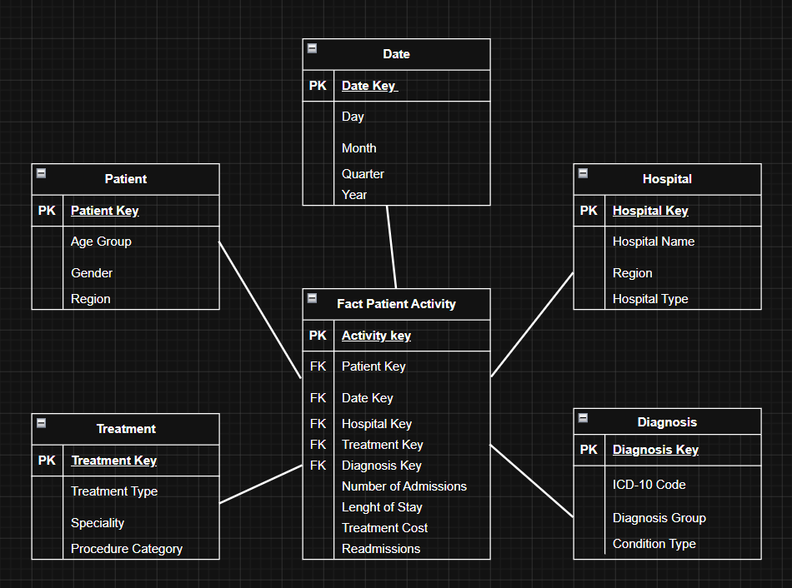

Task 2

2.1: Source System Identification
NHS England's data warehouse will integrate data from several internal and external sources to provide a comprehensive view of healthcare performance. The primary internal sources include Electronic Patient Records (EPR) and Patient Administration Systems (PAS), which capture patient demographics, admissions, discharges, diagnoses, and treatments. Clinical systems provide information on appointments, diagnostic tests, procedures, and clinical outcomes. Workforce management systems contribute data on staff roles, shift patterns, overtime, and sickness absence, while financial systems supply information on treatment costs, expenditure, budgets, and national tariffs. Quality and performance systems provide metrics such as readmission rates, mortality indicators, patient safety incidents, and patient satisfaction scores.
External sources may include population demographics, public health datasets, and national performance benchmarks. These data sources will be integrated through the ETL process and used to populate the fact and dimension tables within the NHS England star schema, supporting effective reporting and decision-making [1].

2.2: Star Schema Design
The NHS England data warehouse will use a dimensional model based on a star schema to support reporting, performance monitoring, and strategic decision-making. The schema is designed around a central fact table containing measurable healthcare activities, surrounded by dimension tables that provide descriptive information for analysis.
The central Fact Patient Activity table records key healthcare events and performance measures, including admissions, length of stay, treatment costs, readmissions, and referral-to-treatment (RTT) times. These measures enable NHS England to monitor operational efficiency, patient outcomes, and resource utilisation across hospitals and regions.
Several dimension tables support analysis from different perspectives. The Patient dimension contains master data such as patient identifiers, age groups, gender, and region. The Hospital dimension stores information about healthcare providers, including hospital name, region, and hospital type. The Date dimension enables trend analysis by day, month, quarter, and year.
Clinical information is represented through the Treatment and Diagnosis dimensions. The Treatment dimension includes treatment type, speciality, and procedure category, while the Diagnosis dimension stores ICD-10 codes, diagnosis groups, and condition types. A Staff dimension is also included to support workforce analysis using attributes such as staff role, department, and employment type [5].
Master data plays an essential role in ensuring consistency across the organisation. Patient, Staff, Hospital, and Treatment tables provide standardised reference data that can be reused across multiple analytical processes. This improves data quality and enables accurate reporting throughout NHS England.
Metadata is represented through a Service Type dimension, which classifies healthcare services into categories such as Acute Care, Community Services, Mental Health Services, Specialist Care, and Public Health Programmes. This allows performance comparisons across different service areas and supports service planning activities.
To improve executive reporting performance, aggregate tables should also be created. These tables summarise detailed transactional data into monthly performance indicators, allowing faster access to strategic information without querying millions of detailed records. Examples include monthly bed occupancy rates, average waiting times, treatment costs, readmission rates, and patient satisfaction scores.
The proposed star schema provides a scalable and efficient structure for integrating patient, clinical, workforce, financial, and operational data. By combining detailed activity records with master data, metadata, and aggregated performance measures, NHS England can support evidence-based decision-making and improve healthcare service delivery across England.

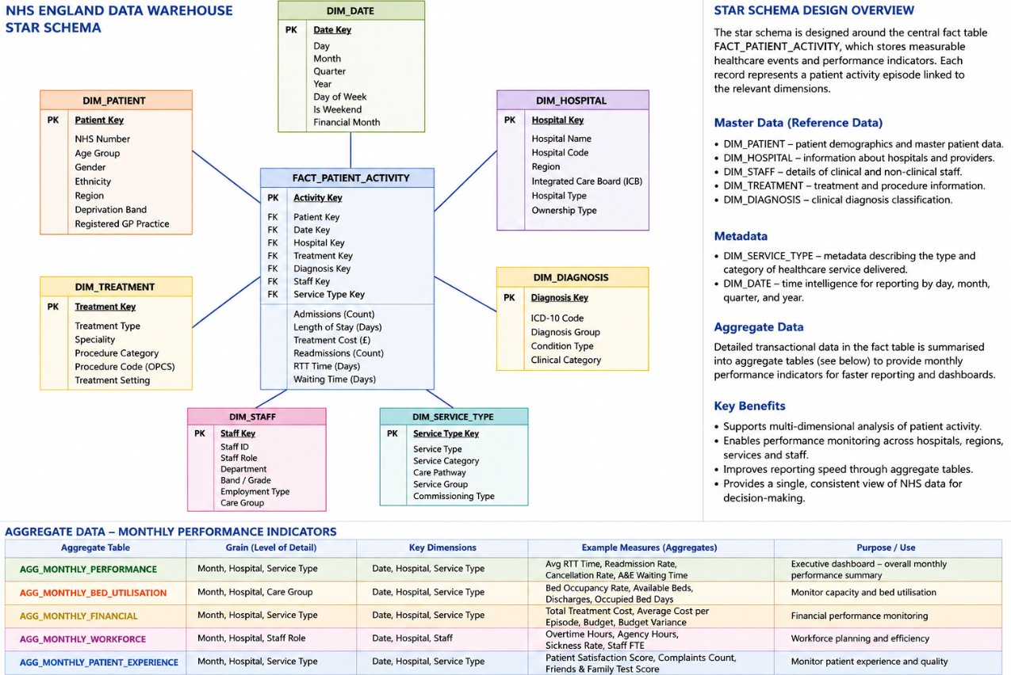

2.3 Data Marts and Schema
Data marts are specialised subsets of the NHS England data warehouse designed to support the information needs of specific departments. They provide focused access to relevant data, enabling faster analysis and more effective decision-making. Three key data marts are proposed: Finance, Operations, and Clinical Quality.
Finance Data Mart
The Finance Data Mart supports budgeting and financial management. Its schema would be based on a Fact Financial Performance table containing measures such as treatment costs, budget expenditure, and cost per patient episode. Key dimensions would include Date, Hospital, Treatment, and Service Type. This data mart would help the Finance Director monitor spending, analyse costs, and improve resource allocation [6].
Operations Data Mart
The Operations Data Mart focuses on operational performance and capacity management. The central Fact Operational Performance table would contain measures such as admissions, bed occupancy rates, length of stay, and referral-to-treatment (RTT) times. Dimensions would include Date, Hospital, Patient, and Service Type. This data mart would support decisions related to patient flow, waiting lists, and resource utilisation.
Clinical Quality Data Mart
The Clinical Quality Data Mart supports monitoring of healthcare quality and patient outcomes. Its schema would be centred on a Fact Clinical Outcomes table containing measures such as readmission rates, mortality indicators, and patient satisfaction scores. Dimensions would include Date, Patient, Hospital, Diagnosis, and Treatment. This data mart would enable the Medical Director to assess clinical performance and identify areas for improvement [1].

Data Mart | Fact Table | Example Measures
Finance | Financial Performance | Treatment Cost, Budget Expenditure
Operations | Operational Performance | Admissions, Bed Occupancy, RTT Time
Clinical Quality | Clinical Outcomes | Readmissions, Mortality Rate, Patient Satisfaction

2.4 ETL Plan
The NHS England data warehouse will use an ETL (Extract, Transform, Load) process to integrate data from multiple operational systems. Data will be extracted from EPR, PAS, clinical, workforce, financial, and quality management systems. During transformation, data will be cleansed, standardised, and validated to ensure consistency across NHS organisations. Common activities include removing duplicate records, validating ICD-10 diagnosis codes, standardising hospital and staff information, and calculating performance indicators. The transformed data will then be loaded into the warehouse’s fact and dimension tables for reporting and analysis [1].
Warehouse Table | Source System | Transformations Required
Patient Dimension | EPR, PAS | Remove duplicates, standardise demographics
Hospital Dimension | PAS, Operational Systems | Standardise hospital and region names
Staff Dimension | Workforce Systems | Validate staff roles and employment categories
Treatment Dimension | Clinical Systems | Standardise treatment and speciality codes
Diagnosis Dimension | Clinical Systems | Validate ICD-10 codes and diagnosis groups
Fact Patient Activity | EPR, PAS, Clinical Systems | Calculate length of stay, admissions, RTT times
Monthly Performance Indicators | All Source Systems | Aggregate KPIs, calculate trends and averages

2.5 Data Quality & Governance
Data quality and governance are essential to ensure that the NHS England data warehouse provides reliable and secure information for decision-making. During the ETL process, data quality must be maintained through validation, cleansing, and standardisation procedures. Duplicate patient records should be removed, missing values identified, and coding standards such as ICD-10 diagnoses applied consistently across all NHS organisations. These measures improve the accuracy and consistency of data used for reporting and analysis.
Data governance is equally important to ensure that healthcare information is managed responsibly. As the warehouse will contain sensitive patient and workforce data, strict privacy and security controls must be implemented. Access should be restricted through role-based access control (RBAC), ensuring that users can only view information relevant to their responsibilities [7].
NHS England must also comply with UK data protection regulations, including the UK GDPR and the Data Protection Act 2018. Patient information should be protected through encryption, anonymisation, and secure storage practices. Regular data quality audits and governance reviews should be conducted to ensure ongoing compliance, maintain trust in the data, and support accurate, evidence-based decision-making across the organisation.

References
[1] T. Knezevic Ivanovski et al, "Building a healthcare data warehouse: considerations, opportunities, and challenges," Front. Digit. Health, vol. 7, 2025. . DOI: 10.3389/fdgth.2025.1691142.
[2] M. Syahrudin, "DESIGN AND IMPLEMENTATION OF A WEB-BASED SALES INFORMATION SYSTEM FOR BUSINESS EFFICIENCY," .
[3] N. S. Alghamdi, "Health data warehouses: reviewing advanced solutions for medical knowledge discovery," .
[4] Anonymous "The-Data-Warehouse-Toolkit-2ed_Kimball," .
[5] G. Turcan and S. Peker, "A multidimensional data warehouse design to combat the health pandemics," J. of Data, Inf. and Manag., vol. 4, (3-4), pp. 371, 2022. . DOI: 10.1007/s42488-022-00082-6.
[6] H. Rezvanjoo and Dba, "Business Intelligence as a Differentiated Decision-Support Capability: A Multi-Level Analysis of SMEs' Decision-Making Quality," 2026. .
[7] L. Cai and Y. Zhu, "The Challenges of Data Quality and Data Quality Assessment in the Big Data Era," CODATA, vol. 14, (0), 2015. . DOI: 10.5334/dsj-2015-002.

