Academic and Employability Skills
Personal Portfolio

Mark Zankov
Student number: 2030454
Module Code: BMSW4001
Lecturer: Joanna Walsh

Executive Summary

This report discusses the time management, academic writing, and online learning experience topics for providing knowledge regarding the learning topic. The report spotlight Kolb’s reflective model for each learning topic to reflect my experience. This model improves the learning context of the students by applying their experience in real-time learning context. Kolb’s reflective model consist of four different stages and the learners need to go through these stages for achieving their learning success. The report discusses a personal development plan that develops the personal assessment for improving the skills of the students.

Table of content
1. Introduction………………………………………………………………………………………….4
2. Topic Discussion……………………………………………………………………………………5
2.1 Time management………………………………………………………………………………5
2.2 Academic Writing………………………………………………………………………………..5
2.3 Online Learning Experience……………………………………………………………………5
3. Kolb’s Learning Model for each topic…………………………………………………………….6
4. Personal Development plan……………………………………………………………………..10
5. Conclusion…………………………………………………………………………………………11
References……………………………………………………………………………………………12

1. Introduction
The report aims to focus on Kolb’s learning model for the selected three learning topics to highlight the personal experience gathered during the learning. Kolb’s learning model states that learning engages the achievement of abstract concepts and are applied flexibly in different situations. The report concentrates on time management, academic writing, and online learning experience learning topics through Kolb’s reflective model. The report sheds light on the personal development plan based on the outcomes of Kolb’s learning model for improving the learning skills.

2. Topic Discussion
2.1 Time management
Time management refers to organising the study materials and preferences based on the time (Nel and Preorius, 2019). I have understood that time management enables me to smartly organise my study, so that I can achieve more knowledge within the shortest possible time. I have realised that a to-do list helps me to organise my study and tasks. The time management capabilities will help me to manage the distractions and track the time. I set a reminder for all the study tasks, so I can successfully manage time and meet the deadlines. The creation of a daily planner helped me to give a time limit to finish each chapter of my study. It is important to make a proper routine so that the student can achieve the learning goals and organise study within the available time limit (Nel and Pretorius, 2019, p.10).
2.2 Academic writing
Academic writing refers to being concise, focussed, clear and backed up by evidence that provides different knowledge for the student (Letina and Dikovic, 2021, p.8). In my opinion, the main purpose of academic writing is to aid the understanding of the readers. Academic writing contains a formal style and tone, but it is not complex (Letina and Dikovic, 2021, p. 8). I have learned that it does not support the need of complicated vocabulary and long sentences. The academic writing explains the research findings and represents the associated idea to persuade readers. From the view of Nel and Pretorius (2019, p.10), academic writers describe the object of the writing before discussing the main perspectives. I have seen that academic writings are written to narrate the set of events. From the learning module, I have learned that academic writers have good research praxis and precise word selection. According to Henaku (2020, p. 54), it is important to have a close adherence to the proper structure and writing format.
2.3 Online learning Experience
Online learning refers to distance learning where the learning takes place online (Henaku, 2020, p.54). The traditional classroom formula gets erased, and the students are allowed to attend their classes remotely (Martin and Bolliger, 2018, p.205). The adaptation of digital technologies and the internet creates experiences that educate the students (Martin and Bolliger, 2018, p.205). I can improve my virtual communication and collaboration skills and refine my critical-thinking skills and add new technical skills. I have experienced that my motivation level of learning is decreasing, and this negatively affects my study experience. From the view of Rahiem (2020, p.1), online learning requires excellent time management skills, and the students need to invest more time to set the learning plan. I have experienced that online learning reduces the confidence level of the students. The lack of face-to-face interaction between the students and teachers creates a lack of social interaction that reduces the determination of the students to attend the class (Rahiem, 2020, p.1).

3. Kolb’s Learning model for each topic
David Kolb developed the experimental learning theory in 1984 which provides a useful model for developing the training practice (Mclead, 2017, p.1). This model is applied to reflect my experience throughout the learning process for each topic and conceptualise the experiment for deploying active experimentation. Kolb’s learning model divides the entire learning process into four stages that are explained below.

Concrete experience for time management
Time management capabilities helps the students to organise the study and prioritise the lessons (Mclead, 2017, p.1). I have learned that time management skill helps me to find a dedicated study space and schedule activities. The time management strategies address the behaviours surrounding time planning, assessment, and monitoring. I have experienced time management, including effective planning, goals setting, deadline set, and prioritising activities.

Concrete experience for academic writing
The students demonstrate academic writing as a part of their academic tasks which is useful for developing their future careers (McLeod, 2017, p.3). I have experienced that not all students are able to develop their academic writing. I have experienced that it is important to achieve good academic writing skill as I want to succeed in my higher education. The academic writing skill is described as the writing capabilities of the students to deal with academic subjects (McLeod, 2017, p.3). I have learned that academic writing is writing reports, academic papers, essays, dissertations, theses, and journal articles that express the critical thinking of the students.

Concrete experience for online learning experience
The government announced the COVID-19 lockdown that shut down all the universities, schools and colleges. The online classes were arranged by the universities, colleges and schools to conduct the learning process. I have experienced that online learning and courses are challenging if the students do not have self-motivation perception and innovative skills. The lack of innovative skills reflects that the students are not capable of operating computers and the internet (University of Illinois, 2021, p.3).

Reflective observation for time management
I have learned that the creation of a schedule is important for me to develop my time sense. I use an agenda to set goals for the study session and eliminate distractions. It is important to start working early and to finish the lesson within the deadline (University of Portsmouth, 2021, p.4). Alternatively, I have experienced that lack of time management reduces the engagement of the students to organise the study and learn them within the shortest possible time.

Reflective observation for academic writing
Academic writing expresses the knowledge of academic context writing that is clarified to realise the need of academic career development (University of Portsmouth, 2021, p.4). I have experienced that the students need to provide more descriptions and facts while doing the academic writings. I concentrate on summarising, paraphrasing and quoting to make the academic writing more appropriate. I have learned that the lack of citing in academic writing raises the questions of the originality of the content and thoughts represented.

Reflective observation for online learning experience
I have experienced that online learning invites me to participate and motivates me to hold my interest. The students can enhance their skills and abilities through online classes (University of Illinois Springfield, 2021, p.3). Alternatively, the internet connection was poor at the beginning stage of online learning. I can develop my technical skills through the online learning and develop my time management capacities as well. The technical skills helped me to develop my computer operating skills and improve internet connectivity.

The abstract conceptualisation for time management
I have learned that the time management scene is important for the students to organise the study. The hectic schedule combined with the regular distraction did not help me to complete my tasks. Effective time management helps the students to complete their tasks by involving less time (Mah and Ifenthaler, 2018, p.120). I have learned from the experience that the time management scene develops my attention to focus on my study without wating time. Effective time management helps learners to demonstrate specific time slots to organise the study according to their importance (Mah and Ifenthaler, 2018, p.120).

The abstract conceptualisation for academic writing
I have experienced that proper referencing is necessary while doing academic writing, I have learned from the experience that the avoidance of plagiarism is a necessity while doing academic writing such as essays, reports, theses, dissertations. The lack of academic writing skill reflects inadequate writing practice, limited writing skills, and ineffective writing instruction (Berkeley, 2021, p.4). I have experienced that the ineffective realisation of the tasks and difficulties to balance the discipline knowledge reflects the ineffective academic writing.

The abstract conceptualisation for the online learning experience
I have experienced that online learning can create social isolation which reduces the productivity of the students. Persistence is the key to success in online learning and basic technical skills (Educational Week, 2021, p.4). I have learned that the lack of communication skills reduces the capabilities of the students to achieve academic goals. The time management skill improved my tasks organising and submitting the tasks within the deadlines (Education Week, 2021, p.4)

Active experimentation for the time management
I have learned that it is important to take 40 to 50 minutes study break. It is important to set a timer for two minutes to deploy self-motivation (Chung at al.,2020, p.46). The ongoing study and learning process helps me to understand new study concepts and apply them in a real-time context. Time management helps to manage time effectively for completing the correct activities at the correct time. The time management scene helps me to develop my task-orientation skill.

Active experimentation for academic writing
I have learned that the proper application of proofreading resources and online editing help me to develop my academic writing. The proper structure and plan are essential to improve the quality of academic writing (Berkeley, 2021, p.4). Academic writing helps the readers to understand the academic writing quality. I have collected the proper feedback before submitting the final copy of my essay. I have experienced that the proper information is needed to represent the supporting evidence.

Active experimentation for the online learning experience
I have experienced that online learning helps the students to access their learning materials anytime from anywhere. I have concentrated on my communication skills, time management skills, technical skills, and critical thinking skills for successfully demonstrating during the online classes. The proper internet facilities, computer-operating knowledge is important to improve my skills and capabilities (Chung et al, 2020, p.46).

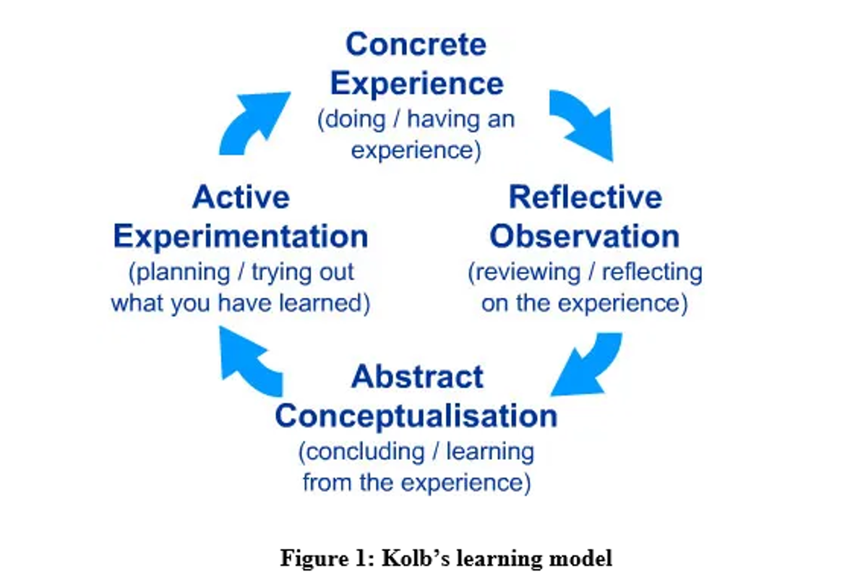

4. Personal Development Plan
Personal development plan expresses the written document of self-reflection that concentrates on the detailed action plan for developing the academic career (Rubens et al, 2018, p.1). The Personal Development Plan is developed below to develop my skills during the learning process.
Required developed skills | Resources | Action plan | Time | Comment
Communication skills | 1.Online seminars  2.Books and Journals | 1. Attending different seminars for increasing listening skills and confidence.  2. Read books and journals to improve vocabulary. | 2 months | I achieved success to successfully communicate with my team members to complete a project.
Time management skills | 1.Time management tools.  2. Guidance from teachers. | 1. The proper selection of the time management tool is necessary.  2.Join time management training courses arranged by the university. | 3 months | I have achieved success to complete my project within time.
Technical skills | 1. Computerized devices  2. Online project portfolio | 1. Develop the internet connection.  2. Join the online project doing courses | 2 months | I have achieved success to continue my online classes during Covid-19.
Critical-thinking skills | 1. Providing practical situations.  2. Creative project doing | 1. Analyze the practical situation.  2. Follow the guidelines of the instructors | 3 months | I have achieved success in analyzing online learning problems.
Table 1: Personal Development Plan

5. Conclusion
After the assessment of the report, I can conclude that the reflective learning model helps to shed light on the learning topics and gather experiences. Kolb’s learning model develops the academic career of the learner. Academic writing reflects the issues and topic deeply rather than considering the opinion of the author. Time management demonstrates the process of planning and organising how to divide my time among the different activities. Online learning demonstrates the education which takes place over the internet. The report concentrates on the personal development plan that provides knowledge regarding personal development perception.

References
Books and Journals
Chung, E., Subramaniam, G. and Dass, L.C., (2020). Online learning readiness among university students in Malaysia amidst COVID-19. Asian Journal of University Education, 16(2), pp.46-58.
Henaku, E.A., (2020). COVID-19 online learning experience of college students: The case of Ghana. International Journal of Multidisciplinary Sciences and Advanced Technology, 1(2), pp.54-62.
Letina, A. and Diković, M., (2021). Student Teachers’ Classroom Management Orientations and Their Beliefs on Effective Teaching Behaviour. Journal of Contemporary Educational Studies/Sodobna Pedagogika, 72(1).
Mah, D.K. and Ifenthaler, D., (2018). Students' perceptions toward academic competencies: The case of German first-year students. Issues in Educational Research, 28(1), pp.120-137.
Martin, F. and Bolliger, D.U., (2018). Engagement matters: Student perceptions on the importance of engagement strategies in the online learning environment. Online Learning, 22(1), pp.205-222.
Mclead, S., (2017). Kolb's Learning Styles and Experiential Learning Cycle. Simply Psychology, 25, pp.1-8.
Nel, H. and Pretorius, E., (2019). Authentic teaching, learning and assessment: real-world experiences of fourth-year students in a social work module. Social Work, 55(1), pp.10-23.
Rahiem, M.D., (2020). The emergency remote learning experience of university students in Indonesia amidst the COVID-19 crisis. International Journal of Learning, Teaching and Educational Research, 19(6), pp.1-26.
Rubens, A., Schoenfeld, G.A., Schaffer, B.S. and Leah, J.S., (2018). Self-awareness and leadership: Developing an individual strategic professional development plan in an MBA leadership course. The International Journal of Management Education, 16(1), pp.1-13.

Websites
Berkeley, (2021). “Nine Basic Ways to Improve Your Style in Academic Writing”, Available at: https://slc.berkeley.edu/writing-worksheets-and-other-writing-resources/nine-basic-ways-improve-your-style-academic-writing [Accessed on 30.07.2021]
Education Week, (2021). “What Students Are Thinking About Online Learning”, Available at: https://www.edweek.org/technology/opinion-what-students-are-really-thinking-about-online-learning/2020/05 [Accessed on 30.07.2021]
Saul McLeod, (2017). “Kolb's Learning Styles and Experiential Learning Cycle”, Available at: https://www.simplypsychology.org/learning-kolb.html [Accessed on 30.07.2021]
The University of ILLINOIS Springfield, (2021). “Strengths and Weaknesses of Online Learning”, Available at: https://www.uis.edu/ion/resources/tutorials/online-education-overview/strengths-and-weaknesses [Accessed on 30.07.2021]
The University of Portsmouth, (2021). “ORGANISATION AND TIME MANAGEMENT”, Available at: https://www.port.ac.uk/student-life/help-and-advice/study-skills/organisation-and-time-management [Accessed on 30.07.2021]

