  Biodiversity and ecosystem services. | William Strutt.  HND Environmental, sustainability climate Change.

Table of Contents
1 Table of figures. 0
Introduction 2
2 Methodology. 3
3 Results and Discussion. 3
3.1 Observation Results. 3
3.2 Lab procedure Nitrate experiment outcomes and process. 4
3.3 Behind the outcomes. Soil Sample results from Kilvey hill 5
3.3.1 Sample 1: 8 ppm 5
3.3.2 Sample 2: 12 ppm 5
3.3.3 Sample 3: 6 ppm 5
3.3.4 Sample 4: 10 ppm 5
4 Discussion 6
4.1 Tree Identification 6
4.1.1 Oak (Quercus spp). Maple (Acer spp). Beech (Fagus spp). 6
4.1.2 Conservation practises for Widley in demand trees. 6
4.2 Bee pollinators. 7
4.3 Recreational footpaths infrastructure. 8
4.3.1 Conditions of Woodland Hill's Footpaths: 8
4.3.2 Infrastructure and Accessibility 8
5 Recommendations: 9
6 Conclusion. 9
7 Bibliography 10

Table of figures.
Figure 1: UWTSD internal guidance document, provided by, (Sergio 2023). 4
Figure 2: Bee count= 10 4
Figure 3:mind map 8

Introduction
Kilvey Hill, although relatively small, is home to a wide range of species, including birds, insects, mammals, and plants. The hill consists of different habitats, such as woodlands, grasslands, and wetlands, which support various plants and animals. This diverse ecosystem highlights the long fundamental fact of Earth's biodiversity: that different habitats support different species, and each species contributes to the overall health and functioning of the ecosystem. With recreational infrastructure
But, plans are in place to gather data on how to enhance bee populations in Kilvey Hill. Such as to determine.
Habitat restoration to enhance or restore degraded or fragmented habitats to increase the availability of food, shelter, and breeding sites for a variety of bee species. This could be accomplished by planting native vegetation and removing invasive species.
Check for any potential Corridors for Pollinator Wildlife: This will be essential for maintaining genetic connectivity and promoting species movement between isolated habitat patches. It would ideally be done via interconnecting existing habitats with new planting or habitat enhancements These corridors can be established by planting small trees and shrubs along the edges of roads and trails, or by increasing the density of hedgerows.
Potential Plantation of more native trees, shrubs, and herbaceous vegetation to help increase the availability of food, and diversity of habitat for bees.
Additionally Establishing a baseline of data to ascertain the presence or absence of organisms at a site shall commence. In addition, I will assess the condition of infrastructure such as footpaths, structures, drainage, and soil structures using survey techniques. I could use a variety of survey techniques to establish this baseline.

Methodology.
- Take soil samples from various locations for Nitrogen nutrient analysis to determine Habitat suitability.

- Identify current plants and trees on the Kilvey hill site with in what experience and knowledge I possess.

- Give A Habitat observation evaluation: Conduct a habitat observation evaluation to evaluate the quality and characteristics of woodland habitats, including the availability of food resources (e.g., flowering plants) and nesting sites. This information is essential for identifying corridors suitable for pollinators.

Results and Discussion.

Observation Results.
It has been found Kilvey Hill's woodland is comprised of both deciduous and coniferous tree species, creating a complex and dynamic forest ecosystem. consists primarily of oak, ash, and beech trees. The diverse tree species and understory vegetation have created a rich and diverse habitat that can be home to a wide variety of flora and fauna, such as bees.
Numerous bee species, including honeybees, bumblebees, and solitary bees, have had ample opportunities to forage in Kilvey Hill's woodland habitat I believe due to the abundance of tree diversity., during their flowering season as noted, deciduous trees such as oak and beech produce pollen and nectar, have provided valuable food sources for bees at the time and present. Likewise, the understory vegetation, which has consisted of shrubs, wildflowers, and herbs, provides a year-round supply of forage. This variety of food sources has been essential for the maintenance of healthy bee populations, as it ensures that bees have access to sufficient nutrients during their active seasons in Kilvey Hill.
Looking at Kilvey Hill, bees still have foraging opportunities, and Kilvey Hill's woodland habitat can still provide numerous nesting sites and cover. Seeing the nesting sites, bumblebees and solitary bees have frequently utilised abandoned small mammal burrows, crevices in decaying wood, and tree cavities. This will and should continue to be proven essential for the reproduction and survival of bee populations In Kilvey hill such nesting sites exist within the forest habitat. Additionally, having seen the dense tree canopy and understory vegetation has provided protection from adverse weather conditions, predators, and human disturbance, thereby fostering a thriving environment for bees as observed in Kilvey Hill.
Overall looking at the importance of Kilvey Hill's woodland habitat to current and potential bee populations it is crucial for the development of effective conservation and management strategies. Therefore Preserving and enhancing the diversity of tree species and understory vegetation can ensure that bees have access to food and nesting sites. But, maintaining a suitable habitat structure, such as deadwood and tree cavities, should then go on to support bee populations by providing essential nesting sites and shelter as to my observation results for what is already on the site.

Lab procedure Nitrate experiment outcomes and process.

Figure 1: UWTSD internal guidance document, provided by, (Sergio 2023).
Figure 2: Bee count= 10

Site 1 | 8 ppm
Site 2 | 12 ppm
Site 3 | 6 ppm
Site 4 | 10ppm

Behind the outcomes. Soil Sample results from Kilvey hill
The presented nitrate samples, measured as nitrate-nitrogen (NO3-N) concentrations in parts per million (ppm), reflect different nitrogen availability levels in a forest soil.

Sample 1: 8 ppm
A nitrate content of 8 ppm suggests a modest availability of nitrogen in the soil. This figure may be enough for the majority of tree species, particularly those with relatively low nitrogen needs, such as some conifers. A number of 8 ppm may also indicate a region with a stable nitrogen cycle mechanism, in which the rate of nitrogen intake via fixation, deposition, and mineralization is balanced with the rate of nitrogen absorption by plants and immobilisation by soil microorganisms.

Sample 2: 12 ppm
A nitrate content of 12 ppm indicates a larger degree of nitrogen availability in the soil, which may benefit tree species with greater nitrogen requirements, such as some deciduous species. This score may indicate a region with accelerated nitrogen cycling, maybe as a result of greater organic matter breakdown or less nitrogen immobilisation. Although a value of 12 ppm may be advantageous for certain tree species, it is vital to monitor nitrogen levels to minimise the possible negative effects of high nitrogen availability, including soil acidification and nutrient leakage.

Sample 3: 6 ppm
A soil with a nitrate content of 6 ppm has a comparatively low amount of nitrogen availability. This amount may be enough for pines and firs and other tree species accustomed to low-nitrogen settings. The result of 6 ppm may potentially suggest a region with slower nitrogen cycling, either owing to poor organic matter decomposition rates or severe nitrogen immobilisation by soil microorganisms.

Sample 4: 10 ppm
A nitrate concentration of 10 ppm indicates a moderate to high amount of nitrogen availability in the soil, which may support the growth of a variety of tree species. This figure may suggest a region with balanced nitrogen cycling, where nitrogen inputs and outputs are well-matched, providing a steady and sustainable nitrogen supply to the forest vegetation.

Discussion

Tree Identification

Oak (Quercus spp). Maple (Acer spp). Beech (Fagus spp).
Observing oak, maple, and beech trees reveals that each species possesses distinctive leaf shapes and bark characteristics. Oak leaves have lobed margins, whereas maple leaves are palmate and beech leaves are elliptical with margins that are serrated. In autumn, the foliage of all three species of trees undergoes a stunning transformation of hue. Oak trees have bark that is rugged and furrowed, maple trees have smooth bark that becomes fissured with age, and beech trees have smooth, grey bark. Despite their distinctions, the growth patterns of these trees are comparable, contributing to the overall structure and diversity of the mixed deciduous forest ecosystem.

Conservation practises for Widley in demand trees.
Selective logging: Instead of clear-cutting, harvest trees selectively to minimise the impact on the surrounding ecosystem. This practise allows the forest to continue growing and regenerating while also providing economic benefits.
Utilise logging techniques that reduce soil compaction, erosion, and damage to the remaining trees. Small-scale machinery, directional felling, and meticulous planning of skid trails and log landings are employed.

Bee pollinators.
Following the results, there are scientific principles to keep khilvey hill healthy and well maintained.
Bees will be necessary for tree reproduction. But, the probability for trees to reproduce without bees is because they are necessary for the transfer of pollen from the male to the female parts of the tree, which is necessary for fertilisation and the formation of seeds according to (Klein et al., 2007).
Furthermore, Flower constancy is a behaviour exhibited by bees, which indicates that they have a tendency to visit the same species of flowers while out foraging. This behaviour increases the likelihood that pollination will be successful (Waser, 1986).
However, I did not observe as many in Kilvey Hill until a particular gradient of the woodland Hill with more light. Concerns should be raised about the potential consequences for tree reproduction because of the decline in bee populations caused by habitat loss, exposure to pesticides, and climate change
Furthermore, It has been noted of a mutually beneficial relationship should exist between bees and trees in Kilvey Hill.
A significant contribution, both to the maintenance of biological diversity and to the health of the ecosystem as a whole. Bees will be crucial to the success of tree reproduction because trees, which bees rely on for nectar and pollen, are the primary providers of these two resources according to (Klein et al., 2007).
But this connection will have a domino effect on the entire ecosystem since trees serve as homes and sources of food for a wide variety of other organisms, and the fact that trees are able to successfully reproduce helps to maintain the balance of ecosystems again according to (Tylianakis et al., 2008).
Additionally, Kilvey Hill is densely populated with trees. The relationship between bees and trees is essential to the functioning of the ecosystem, as bees are the primary pollinators of numerous tree species. However, if Kilvey Hill is not well-managed, a number of environmental factors can have a significant impact.
Deforestation reduces the number of bees by decreasing the availability of suitable nesting and foraging sites according to (Winfree et al., 2009).

Recreational footpaths infrastructure.

Conditions of Woodland Hill's Footpaths:
According to our findings, a number of Woodland Hill's footpaths are in varying states of disrepair. During periods of heavy precipitation, certain areas have uneven surfaces, potholes, and muddy sections. This can make the paths hazardous and difficult to navigate for users.

Infrastructure and Accessibility
In general, footpath signage and wayfinding are inadequate, making it difficult for visitors to navigate the area without prior knowledge or a map. In addition, there is insufficient infrastructure to accommodate disabled users, such as accessible pathways and resting areas.
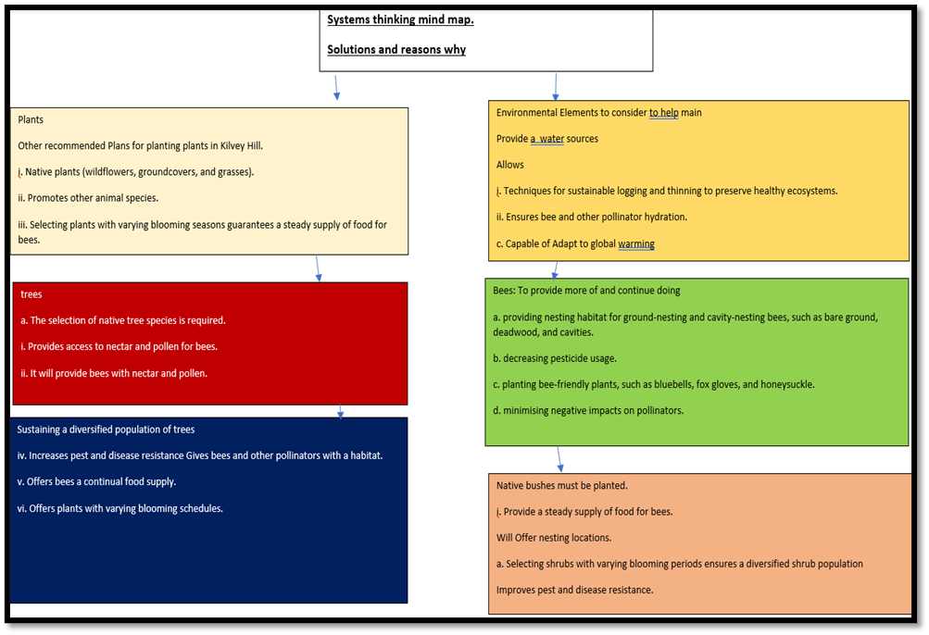
Figure 3:mind map

Recommendations:
Maintenance and Repair of Footpaths: Regular maintenance and repair of footpaths is essential for their safe and enjoyable use . This includes repairing uneven surfaces and potholes and enhancing drainage to prevent flooding and erosion .
Installing clear and informative signage throughout the network of footpaths will enhance the user experience and prevent visitors from becoming disoriented or straying from designated paths.
Developing accessible footpaths and infrastructure will make Kilvey Hill more accessible to all users, including those with disabilities, as a result of the accessibility improvements. This may involve enlarging paths, installing handrails, and establishing resting areas at regular intervals.
But I would still recommend, maintaining a suitable habitat structure, such as deadwood and tree cavities, which should then support bee populations by providing essential nesting sites and shelter for year-round conservation measures. This includes providing a well-being service for members of the public.
At the base of Kilvey Hill, where a river provides water for flowers, plant more pollinator-attracting plants to sustain pollinator levels.

Conclusion.
Overall, the forest is doing well considering its current state and the month this survey was conducted, but it must maintain consistency and prevent biodiversity loss of bees.
A variety and abundance trees, and shrubs, were observed in the forest. This provides a year-round source of nectar and pollen for numerous bee species, ensuring a stable food supply. Specialist bee species, which have evolved to depend on particular plant types, require the presence of native plants for survival.
The woodland area displays a high level of habitat diversity, with a combination of open spaces, dense vegetation, and different stages of forest succession. These conditions provide nesting and foraging opportunities for a variety of bee species, including cavity-nesting bees, ground-nesting bees, and those that favour microhabitats. The presence of decaying wood, tree cavities, and bare soil supports the nesting needs of numerous bee species.
Through the use of trapping, it will be possible to collect more precise data on the species and their distributions in order to develop additional conservation strategies. This information must be collected and analysed further for various woodland habitats and pollinator species to determine if Kilvey hill would attract a greater variety of bee species and if it can support a greater diversity of life overall.
It is preferable to collect data on climate change in order to comprehend the effects of forest pollinators. Potential range shifts, phenological changes, and the vulnerability of pollinator species to these changes should be the focus of further research as well to keep the bee population at a sustainable level to see when or if they would come out of any hibernation.
More pollinator flowers, such as foxgloves, are required at the bottom of Kilvey Hill, where there is ample sunlight.
Limit recreational fire lighting not to antagonise the bees nor disturb habitats.

Bibliography
Editorial Committee, Flora of North America, 1997. Vegetation of North America Greater than Mexico. Volume 3: Magnoliophyta: Magnoliidae and Hamamelidae. Oxford University Press, New York and Oxford. Available at: Flora of North America @ efloras.org
Klein, A.M., Vaissière, B.E., Cane, J.H., Steffan-Dewenter, I., Cunningham, S.A., Kremen, C. and Tscharntke, T., 2007. The significance of pollinators in altering landscapes for global agriculture. Proceedings of the Royal Society B: Biological Sciences, volume 274 issue 1608, pages 303 to 313. Available at: https://royalsocietypublishing.org/doi/full/10.1098/rspb.2006.3721

Tylianakis, J.M., R.K. Didham, J. Bascompte, and D.A. Wardle, 2008. Terrestrial ecosystem species interactions and global change. Ecology Letters, volume 11, issue 12, pages 1351-1363. Available at: https://onlinelibrary.wiley.com/doi/full/10.1111/j.1461-0248.2008.01250.x
Floral constancy: definition, cause, and measurement, by N.M. Waser, 1986. The American Naturalist, volume 127, number 5, pages 593 to 603. Available at: https://www.journals.uchicago.edu/doi/abs/10.1086/284507
Winfree, R., Aguilar, R., Vázquez, D.P., LeBuhn, G. and Aizen, M.A., 2009. A meta-analysis of the reactions of bees to human-caused disturbances. Ecology, ninety-eighth issue, pages 2068-2076. Available at: https://esajournals.onlinelibrary.wiley.com/doi/full/10.1890/08-1245.1

