Marissa Collins
Student Number: 1708540
Program of Study: Music Technology
Word Count: 1540
Tutor’s name: Ryan Moule

We could ask ourselves, what makes us human? We as humans experience many emotions every day of our lives, some extreme and some which differ from time to time. We don’t only have a rational mind, but in some cases our emotions can dictate our instincts and decisions on a daily basis. Entitled ‘The Power of Love’ I intend on curating a metaphorical exhibition focusing on the top five emotions that we as humans experience when facing love itself. There are many emotions we are faced with when facing ‘The Power of Love’. My chosen five emotions have included happiness, sadness, lust, anger and jealousy, with a collaboration of ten musicians and their pieces relevant to each emotion. Exploring the themes and boundaries of love, I intend on exhibiting certain senses such as sight and hearing. Given my chosen theme of exhibition focusing on the pieces of music itself, I intend on holding the exhibition at the Harpa Concert Hall and Conference Centre based in Iceland, defined as the “Modern glass honeycomb concert hall and conference centre, home to the national opera and symphony” (Harpa, n.d.) My chosen venue has many features I’d use to my advantage as seen in the floor plans below:

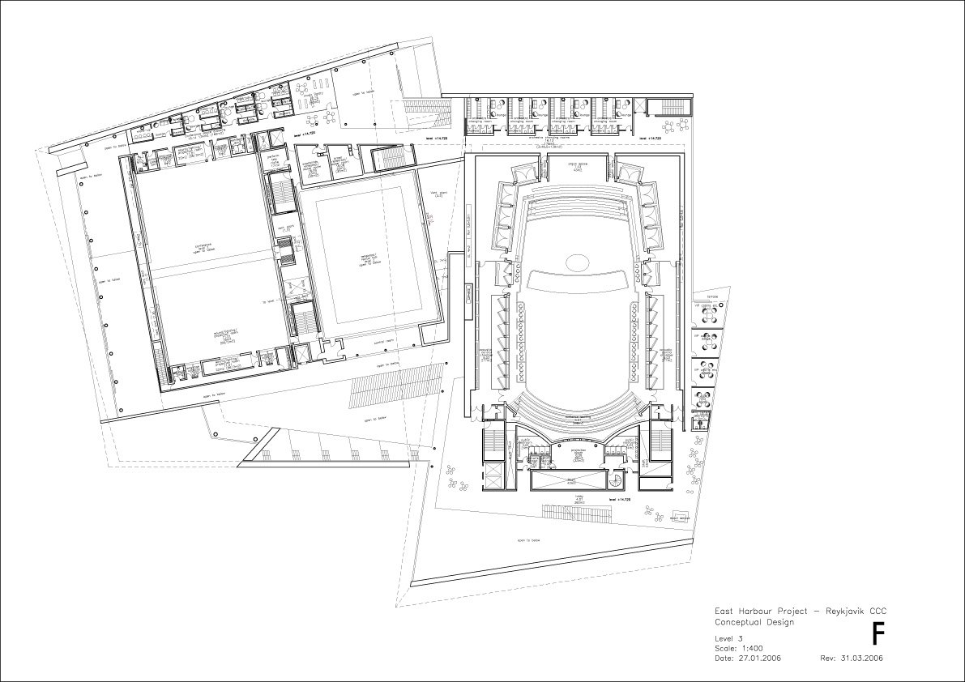
(Harpa, n.d.)

I intend on using the entire structure and splitting into my 5 separate areas for each of the chosen emotions whilst using freestanding walls to be able to split those five separate areas into two spaces again to enable two different songs to play at the same time. Shown in the floor plans, one area on the left has already been split into two spaces therefore I intend on using the centre space as another split area. I’d use a freestanding wall and placing horizontally across the space creating two separate areas and leaving the concert hall as one area, being used for the main theme and emotion which in my opinion would be happiness itself as there are many factors to include for happiness. I intend on creating an experience for the audience and visitors; instead of the feeling as if walking through time like many exhibitions and museums are but rather walking the through the human spectrum of emotion using music “Music gives a soul to the universe, wings to the mind, flight to the imagination and life to everything.” ― Plato (2016)

As the main emotion to us as humans, I have decided to use the concert hall for happiness, being the biggest section of the exhibit. The house lights will be alit as you enter the concert hall and the guests will be presented with the box like looking object which will be exhibit itself. This area of the exhibition will be lit up with yellow lights in each corner of the room to create ‘mood lighting’, in this instance the intention would be to create a happy atmosphere for the guests. In one part of the space “Better Together” by Jack Johnson will be playing with quotes of the lyrics from the song will be painted onto three of the freestanding walls, leaving one spare wall for the guests to write what they’re feeling whilst listening to the song being played. This idea applies for every room during the exhibition. The blue lines present the entrances and the exits between the two areas. The second section of the room, “I’m Yours” by Jason Mraz will be playing with the same layout with the lyrics written and painted on the walls leaving a spare wall for the guests to write out their thoughts at that moment in time.

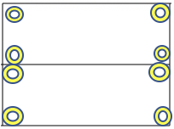
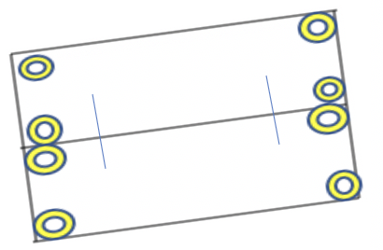

I intend on using the centre area as the “grey area” due to the two emotions that could be considered as the “grey area” in love which are sadness and lust. Humans are prone to getting sad over many factors, being financial, physical, emotional matters. In this instance sadness within love, many of us experience a sadness within love at some point with a significant other in our lives. There’s also lust where many of us confuse ourselves with the meaning and difference between loving someone and having a sense of lust over them, “Lust is the desire for their body, love is the desire for their soul” (Jarvis-Gibson, 2017). The section in which I am placing the emotion sadness is at the top of the centre area, with my chosen colour to represent the notion of being blue. One half of the section will be playing “Someone Like You” by Adele with the other section playing “Fix You” by Coldplay. Both songs with very meaningful lyrics placed on the walls also, giving the guests and visitors a sense of what emotions can be caused when listening to emotional songs written by artist who experienced heartache themselves.

As you walk through into the next section of the centre area, the guests walk through the feeling of lust. This section is for 15+ and for those under eighteen have to be accompanied by an adult to enable themselves to enter this section. As you enter, you see a sea of red, a dark mysterious red enhancing the feeling of lust, red being the chosen colour as it represents many factors, being seen as the colour of danger, excitement and prosperity. Whilst guests are walking in, the very sensual song “Earned it” by The weeknd playing as the first chosen song, creating a tense atmosphere for the guests. This is where the idea of the sublime is brought into play “The sublime is further defined as having the quality of such greatness, magnitude or intensity, whether physical, metaphysical, moral, aesthetic or spiritual” (Art and the Sublime | Tate, n.d.) Where the sense of attraction and repulsion is happening when in the presence of lust. Some could say it’s the beauty and attraction that two people have which creates a sense of lust. Walking into the second section of this area, the famously known sexual song by R. Kelly “Pony” is playing in the background, almost creating a sense of anxiety for some. There are many anxieties within lust; humility, where humans could be in awe with a beauty of some sort but also facing terror. This could be seen as nature versus culture where we as humans are a part of both but there are many complex relationships between them both. Immanuel Kant once said “beauty presents an indeterminate concept of understanding, the sublime an indeterminate concept of reason”.

As the last part of the exhibition, furthest away from the happy emotion on the furthest right of the building, we have anger and jealousy on the furthest left. We have all experienced many different types of anger and jealousy; caused by many different scenarios and situations. With many entrances and exits for the guests as this is the emotion many of us do not like to experience and attempt to avoid it to best of our abilities as possible, unfortunately we still experience it when we least expect it.

Anger being the top area of this section, the walls will painted black as black is the best colour to represent the emotion. The lights in each corner will be a soft white to enable guests to read what is being written by other visitors and of course the lyrics presented on all walls and of course to see where they are walking. As guests walk into the gently lit room they’d hear the clever worded “Good in Goodbye” by Madison Bear, to experience the chills in her words about a broken relationship. As the guests cross over to the other side of anger, they’d hear “do re mi” by Blackbear. An explicit track which creates an eerie atmosphere for the visitors. Some could call this the darker side of anger when experiencing the emotions as you enter this side of the section.

After leaving the horrific emotion of anger, there is one last area which will be explored for the emotion some have experienced and some may not have, and that is a sense of jealousy. Green coloured lights to light up the room, creating a muggy colour in the room the guests have entered. As every other emotion on the spectrum of feelings, jealousy is experienced at all types of depths with different levels, all depending on the person sometimes. A sense of humility and ego can be seen in jealousy. Trust is another aspect of jealousy which many people expect to have for one another in many different types of relationships nowadays.

One side of this section “Mr Brightside” by The Killers will be playing, with provocative lyrics from the piece written on the walls. Many feelings could be created within this area, some may get upset, memories could be relived in this moment in time for the guests. As they leave and visit the other side of the area “Jealous” by Nick Jones will be playing, with his lyrics of being jealous of another person who is with the person you want to be with, Nick Jones is creating a piece that is very relevant these days as many of us have experienced similar feelings to what the artist has experienced.

There are many ways to express different emotions, but as a musician, music is an escape route for myself. I’m sure the style of music would be different for many people also due to the many a styles and genres nowadays. Everyone’s experiences are so different to one another.

Bibliography

Cmuse.org. 2016. [online] Available at: <https://www.cmuse.org/100-famous-and-inspirational-music-quotes/> [Accessed 10 April 2020].

Tate. n.d. Art And The Sublime | Tate. [online] Available at: <https://www.tate.org.uk/whats-on/tate-britain/display/art-and-sublime> [Accessed 10 April 2020].

Donnelly, M., 2016. 36 Definitions Of Love, According To Urban Dictionary. [online] Thought Catalog. Available at: <https://thoughtcatalog.com/marisa-donnelly/2016/04/36-definitions-of-love-according-to-urban-dictionary/> [Accessed 10 April 2020].

En.harpa.is. n.d. Harpa. [online] Available at: <https://en.harpa.is/?_ga=2.199276270.1391050055.1587574001-949473389.1587574001> [Accessed 10 April 2020].

Jarvis-Gibson, L., 2017. The Honest Difference Between Lust And Love. [online] Thought Catalog. Available at: <https://thoughtcatalog.com/lauren-jarvis-gibson/2017/07/the-honest-difference-between-lust-and-love/> [Accessed 10 April 2020].

Spotify.com. n.d. Music For Everyone.. [online] Available at: <https://www.spotify.com/uk/> [Accessed 10 April 2020].

Songfacts.com. n.d. Shieldsquare Captcha. [online] Available at: <https://www.songfacts.com/category/songs-about-desire-or-longing> [Accessed 10 April 2020].

White, H., 2017. Sad Songs That Will Actually Make You Feel Better. [online] POPSUGAR Smart Living UK. Available at: <https://www.popsugar.co.uk/smart-living/Saddest-Songs-Ever-43347548> [Accessed 10 April 2020].

