An Analysis of Architectural Style and Form: Charles Church and St. Andrew’s Church, Plymouth.
Angel Valentine – 2218521
Module Code: ACAA4003

Plymouth, a city with a rich maritime history, boasts several architectural gems that reflect its cultural and historical significance. Among these, The Minister Church of St. Andrew, also known as St. Andrew’s Church, stands out as a prominent example of religious architecture, with a unique story to tell.

Beginning as a simple cruciform shape when two chapels were built in 1385, the church grew over time, with two towers, two transepts and the tower (reaching a height of 136 feet) completed by around 1490 (St. Andrew’s Church, 2009) in the Saxon village of Sutton. The growing prosperity of the town fuelled the development, and the materials were funded by the town, with the costs of labour paid for by a wealthy merchant by the name of Thomas Yogge (Old Plymouth Society, 2012). Later he also financed the Lady Chapel on the north side of the church.

According to the church’s website, St. Andrew’s Church has served the people as a place of sanctuary, stability and community over centuries (St. Andrew’s Church, 2009). This appears to have carried on even through the Second World War, where the church was directly affected by an air raid on Plymouth, with the roof completely destroyed and other damage on the building in 1941 (Plymouth City Council, 2007). The day after the air raid, someone attached a wooden sign to the door that read ‘Resurgam’, which means ‘I will rise again’. This sign was replaced by a granite plaque with the same word, after a restoration was completed on the church (Plymouth City Council, 2007). The Christian people of Plymouth believe that St. Andrew’s building mirrors Jesus’s story – a story of conquering the grave and rising again in new life (St. Andrew’s Church, 2009) – after the church went through three separate restorations prior to the war and a complete rebuild by Mr Frederick Etchells (Old Plymouth, 2017), where it was reroofed and restored.

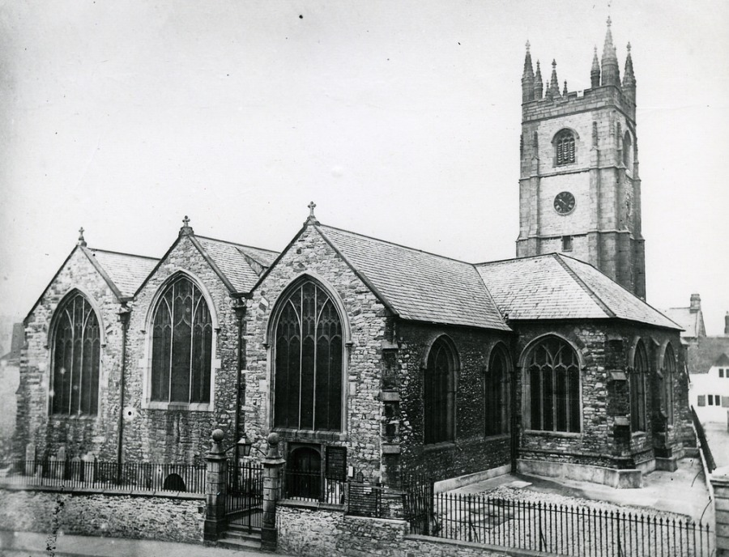
Figure 1: St Andrew’s Church, exterior (c1870, Graham Naylor, 2016)

Church architecture has been a significant and enduring expression of religious beliefs, serving as both a physical space for worship and a symbolic representation of spiritual ideals. The design of St. Andrew’s Church is a reflection of its purpose as a space of sanctuary, stability and community. As seen in Figure 1, the exterior is typical of a traditional church in its layout, with larger arched windows that allow for light to come into the space symbolising positivity and the ‘light of God’. Being built in the centre of the town, it is accessible and welcoming to all.

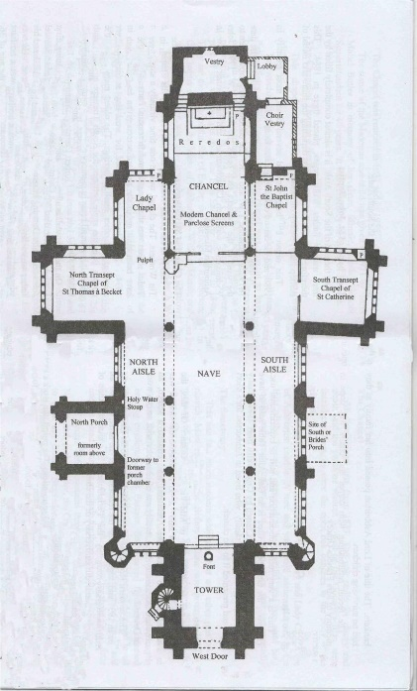
Figure 2: Plan of St. Andrew’s Church based on one drawn by C Fryer Cornelius in 1942 (Old Ashburton, 2017)
As seen in Figure 2, the church features a long nave. At the heart of the church, the altar stands as a focal point for religious rituals. The chancel, surrounding the altar, is a separated space reserved for clergy, emphasizing the sacredness of their role in guiding the congregation.
The church is known for a design with careful consideration of acoustics to enhance the auditory experience during worship. After the rebuild of St. Andrew’s Church and the roof, the ceiling was higher, with vaults and domes built that contributed to optimal sound reflection. This ensures that prayers, hymns and sermons are heard clearly fostering a deeper connection between the congregation and the sacred words spoken.

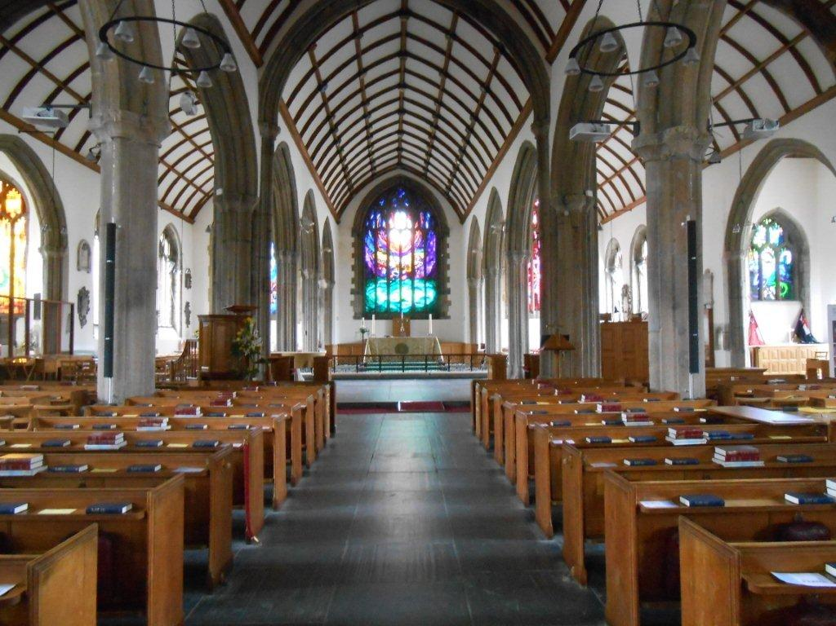
Figure 3: St Andrew’s, Plymouth (Gilbert Scott, 2018)

Stained glass windows, prevalent in Gothic and Romanesque architecture, contribute to the educational and reflective aspects of church design. These windows depict biblical stories, saints and religious motifs, serving as both an aesthetic embellishment and a tool for conveying religious narratives. The nave leads up to the largest stained window, depicting an orb of light upon waves. The church is orientated within the town centre so that the sun path enables sunlight to come directly through the orb of light and shine down the middle pathway. As well as this window, smaller stained glass windows decorate the sides of the building. The interplay of light through stained glass enhances the spiritual ambiance within the church.
The design has incorporated various spaces to cater to the diverse needs of the congregation. Chapels and side altars provide intimate settings for personal reflection and prayer. Furthermore, the transepts near the chancel in the church have been converted into educational spaces, holding a small library and classroom, which facilitates the dissemination of religious teachings, reinforcing the church’s role as a centre for spiritual growth and learning.
St Andrew’s Church has evolved over time to adapt to specific needs, but consistently provided a space for the community to come together. After many projects, the building has been safely restored and has now had all damage repaired. A new organ was installed during the post-war restoration that is still the largest organ west of Bristol – larger than that of Exeter and Truro Cathedrals. In modern Plymouth, the space is used to host events such as orchestral concerts, taking advantage of the acoustics, as well as various social events for the locals. It is in an optimal position in the city for Christians to travel to, with the Royal Parade built on the same road – a line of bus stops that provide transport to every area in Plymouth and beyond.

My study was to research into the purpose of specific architectural elements of traditional churches, and whether St Andrew’s Church successfully functions both as a building and also achieves its purpose of being a safe place for Christians. If a similar study was to be done, I’d have taken the time to visit the site to fully experience the space and the feeling it brings to me, as well as speak to the locals who attend church regularly.

Bibliography
Gilbert Scott. (2018). St Andrew’s, Plymouth [online]. Available from: https://gilbertscott.org/st-andrews-plymouth/ [Accessed on 15/1/24].
Graham Naylor. (2016). Minister Church of St Andrew, Plymouth [online]. Available from: https://someolddevonchurches.files.wordpress.com/2016/02/st-andrews-exterior-late-19c.jpg?w=900 [Accessed 13/1/24].
Old Ashburton. (2017). St Andrew’s Church [online]. Available from: https://www.oldashburton.co.uk/st-andrews-church.php [Accessed on 15/1/24]
Old Plymouth. (2017). Anglican Minister Church of Saint Andrew the Apostle [online]. Available from: https://www.oldplymouth.uk/Saint%20Andrew%20the%20Apostle%20(Anglican%20Minster%20Church%20of).htm [Accessed 14/1/24].
Old Plymouth Society. (2012). A Brief History of St Andrew’s Church [online]. Available from: https://oldplymouthsociety.net/a-brief-history-of-st-andrews-church/ [Accessed on 12/1/24).
Plymouth City Council (2007). Places of Worship [online]. Available from: https://web.archive.org/web/20071013045716/http://www.plymouth.gov.uk/placesofworship [Accessed on 13/1/24].
St. Andrew’s Church. (2009). History [online]. Available from: https://www.standrewschurch.org.uk/visit-us/history/ [Accessed 12/1/24].

