PROBLEM SOLVING AND DECISION MAKING
Ovidiu Ostafe 1919374
Executive summary
Problem-solving and decision-making analysis helps to increase the knowledge about managing complex business problems of an organization. To evaluate the problem solving and decision-making factor in the business industry the business decline problem of the postal service organization Royal Mail is considered here. This analysis reflects the nature and impact of business decline problems on the organization. Illustration of the SWOT and PESTLE findings helps to identify the present business condition of Royal Mail. This analysis recommends different solutions to solve the business decline problem of Royal Mail.

Table of Contents
Introduction 4
Nature, scope, and impact of the problems faced by Royal Mail 4
SWOT analysis 7
PESTLE analysis 9
Recommendation of the potential solution 11
Solution monitoring, reviewing, and communicating process 12
Conclusion 13

Introduction
Problem-solving is a process of identifying possible solutions to mitigate a particular problem. Decision-making is known as the part of problem-solving that helps to solve the issue strategically. The analysis of problem-solving and decision-making concept focuses on a specific business case of the postal service organization of the UK, Royal Mail. The problem solving and decision-making analysis of Royal Mail considers the business decline problem of this organization. To identify the root of this business decline issue SWOT and PESTLE tool is going to analyze this problem-solving study. Also, to emphasize the decision-making part, a different solution to the business decline issue of the selected organization is going to highlight here. Solution monitoring, controlling, and communication process is going to be analyzed in this section.

Nature, scope, and impact of the problems faced by Royal Mail
Business decline issue is the main problem factor that is faced by the postal and courier service organization of the UK, Royal Mail. A business decline is a situation when the business value of an organization is decreased day by day. To estimate the root of this business problem of the organization, the nature, scope, and impact of this problem are going to be highlighted in the below section.
Nature: The postal and parcel service company Royal Mail started their business in the year 1516 in the heart of the UK, London. This organization provides it’s postal and courier service for more than 500 years (RoyalMail, UK, 2020). This organization faces a business decline problem, where the operating profit of this organization decreases 31% in the financial year of 2019 to 2020 than the previous financial year operating profit margin. Also, their domestic parcel delivery declined nearly 8% in this financial year. In the UK postal industry, the Royal Mail is the only licensed universal postal delivery organization (fortune.com, 2020).
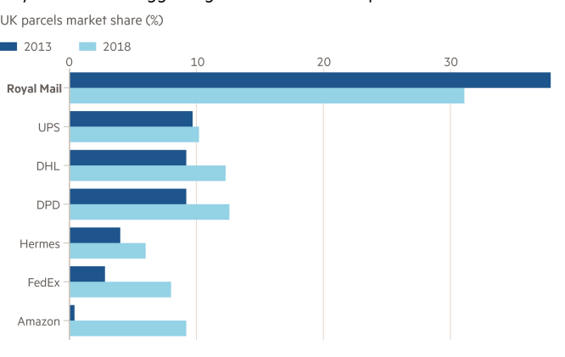
Figure1. Market share decrement of Royal Mail
(Source: ft.com, 2020)
The nature of declining the business value of this organization indicates the lower management approach of this organization to adopt modernization and beat market competition level. From the year of 2013 to 2018 Royal Mail continuously decreased their parcel market share. In the financial year of 2018, this organization declined their business performance the most among all of their competitors such as; UPS, DHL, and so on.
Scope: The analysis of the business decline problem of the postal service organization Royal Mail helps to identify this organization facing a huge challenge in the industry of the UK. The analysis of the business decline due to the imperfection of the delivery management process of this organization helps to identify the privatization scope of this company (Mustchin, 2017, p. 296). The worker's management and business restriction program of this organization faces a huge complication and triggers business decline problems. The entire postal industry of the country United Kingdom faces a challenge due to the decline of the letter volume and productivity of different postal delivery organizations. This issue also creates a scope to identify the root cause of the business decline problem of Royal Mail.
Impact: The business decline issue of the organization Royal Mail created a negative impact on the postal and parcel-based business operation of this organization. In the country UK, the COVID-19 issue creates a negative reflection over each of the business industries. On that matter, the postal service organization also declined their business value due to the increment of business management cost of nearly 80 million pounds. This organization faced decrement in their operating profit amount and the value of their business share decreased in the financial year of 2019 to 2020. Business decline issues reduce their performance graph and decrease the value of their share price in the market.

Figure2. Impact of business decline on the market value of Royal Mail
(Source: ft.com, 2020)
This business decline problem of Royal Mail creates a negative impact on their worker security and human resource management. According to the opinion of the CEO of Royal Mail, it was found that this organization faces a struggle to provide job security and salary to their postal service workers (Pender, 2016, p. 26). All over the business decline issue created a negative impact on the business reputation of this organization and this organization announced a cost-cutting plan. This company plans to sack nearly 2000 postal service employees of this organization (theguardian.com, 2020).

SWOT analysis
Application of the business analytical tool SWOT assists to evaluate the strength, weakness, opportunity and threat for this business organization.
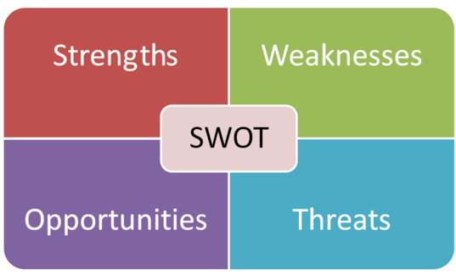
Figure3. SWOT analysis factors
(Source: Longhurst et al. 2020, p. 303)
The below section of this analysis is going to outline the SWOT outcome for the Royal Mail organization:

Strengths | Weaknesses
- Brand reputation  - Long business experience in the postal service industry (RoyalMail, UK, 2020).  - FTSE 100 index  - Huge employee strength | - Maintenance of traditional regulation hampers business development operation.  - Increment of different technology decrease the postal service demand
Opportunities | Threats
- Business expansion  - Tie-up with the online platform | - The liberalization of the industry  - Increment of private organization and e-commerce (ft.com, 2020).
Table1. SWOT analysis of Royal Mail
(Source: Self-created)
Findings of the SWOT business analytical tool of Royal Mail helps to amplify the present business condition of this postal and parcel service firm. This organization has a positive business point that is its historic brand image. This organization has a huge experience of operating business in the traditional postal and parcel delivery industry of the UK (Heller, and Rowlinson, 2020, p. 756). The Royal Mail is working under the government of the United Kingdom and also having experience of delivering the postal service university since the year 1516. This is the oldest mail service organization in the country UK. Employee strength over 150,000 can consider the effective human resource asset of this organization. After facing the business decline issue in this organization is now unable to maintain its human resource asset (Heller, 2016, p. 1036). This organization strictly follows the traditional business operation process that affects to foster business innovation in this company. Different technology and its acceptance is increasing in the present society of the UK and the world. The accuracy of the technology-based service is greater than the human-centric service.
Royal Mail always follows the human-centric courier service that reduces its service efficiency. In the time of the COVID-19 pandemic, their business also faces a huge loss and business decline problem. Analysis of the SWOT business tool helps to outline the business opportunity of Royal Mail by tying up with the online business platform to adopt business innovation. This organization can overcome its present business complexities and management issues by tying up with an efficient online e-commerce business platform to develop its postal and courier service efficiency. Also, this organization has the business opportunity of expanding their business on the international platform by opening its new branch in different regions of the world market. The major threat of this traditional postal service organization is the liberalization of the industry. This factor triggers the rapid growth of technology in the business industry of the UK. This phase of the business industry creates an extra force to this organization for adopting technological innovation. Increasing competition and e-commerce platforms like Amazon, FedEx create business threats for Royal Mail (Heller, 2016, p.38).

PESTLE analysis
This analytical tool helps to objectify different external or macro-environmental influencing factors of the business such as; Political, Economic, Sociological, Technological, Legal, and Environmental.
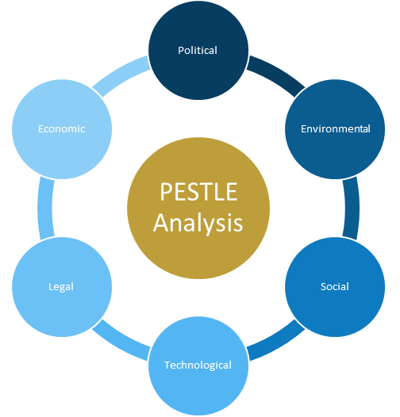
Figure4. PESTLE analysis factor
(Source: Iacovidou et al. 2017, p. 1497)
Analysis of the postal and parcel service macro environment of the UK helps to observe the business decline root cause of Royal Mail. The below section of this analysis is going to highlight the SWOT outcome for the Royal Mail organization:
Political factor: Unstable conditions of global politics create a negative impact on the business operation of an organization. The Royal Mail organization delivers the courier service in multiple countries and faces political tension. With increasing tension in the global political environment the organization Royal Mail faces a huge operation challenge to manage their postal service business at the international level. Change in the global political environment also changes the priority factor of the governments (Gallas, 2018, p. 237). Enhancement of corruption in the business environment triggers the issue of reducing the business sustainability of the Royal Mail postal organization. Mainly the political factor of the business macro-environment creates a negative impact on Royal Mail.
Economic factor: Economical factors of the macro environment of business directly create an impact on the business operation of an organization. The economic development of the country the UK can create business development opportunities for Royal Mail. On the other approach, the business interest rate and taxation of the business create a negative impact on the business operation process of this postal organization. The inflation rate and the foreign exchange rate related economic factor create fostering the business industry development of the UK. The financial market condition of the country UK is not suitable for the postal service organization Royal Mail after the covid-19 pandemic situation.
Social factor: Demographic factors and social trends of the external or the macro environment create influence on the business operation of each organization. In the country UK, the demographic analysis helps to identify the aging population of this country is dependent on the traditional postal service (Fève et al. 2020, p. 220). This is a positive factor for the business growth of Royal Mail. Social trends and culture create influence over the business operation of an organization. In the case of Royal Mail, the present tech-savvy social trends create a negative influence on the business development objective of this traditional postal and parcel service company.
Technological factor: Industrial liberalization is a weak point for the postal service company Royal Mail. This factor indicates the requirement of technological updation for different business industries of the global market. Trends of e-mail and e-commerce business increment in the international market and also in the UK industry of postal service create a negative influence on the business sustainability of Royal Mail. This organization is unable to support social media marketing and adopt digital communication technology (Rodriguez et al. 2016, p. 131). The competitors of this firm adopt emerging technology. In that context, the technological factor creates a negative impact on their business.
Legal factor: To support ethical business operations each organization has to follow the legislation of its business hosting country. In the case of Royal Mail, this organization has to follow employee protection law and consumer protection related legislation. In the present context, Royal Mail is unable to support the legislation of employee protection due to the business decline of this company.
Environmental factor: Supporting the eco-friendly business operation is an essential part of business CSR. This organization faces a negative impact from this factor due to the high amount of resource depletion of Royal Mail. In the case of the Royal Mail postal service, this organization has to develop its business waste management process. Also to grab the attention of the young generation and support environment-friendly business this company can use renewable technologies (Kowalik, 2020, p. 60).

Recommendation of the potential solution
The above analysis helps to demonstrate the root cause behind the business decline problem of the organization Royal Mail. Identification of the root cause behind the business decline of Royal Mail helps to observe their low level of business innovation management, changing social trends and technological adoption triggers this problem. To identify the potential solution to solve the business decline issue of this postal service organization the root cause of this problem has to be repaired first. Evaluation of the business performance helps this organization to identify their major fault to sustain their business effectively. This organization needs to improve its business operational plan to mitigate the negative impact of business decline problems (Ugoani, 2020, p. 120). This organization reduces its business potential due to the increasing amount of worker dissatisfaction and boardroom uncertainty issues. To manage the stakeholder and shareholder interest this organization has to improve its communication and staff management system. This parcel and postal service company Royal Mail was unable to meet their target and lost the business reputation in the market due to lack of modernization in their business. Analyzing this fact it can be said that this organization needs to incorporate modernization in their business operational plan.
This organization faces the issue of not meeting its delivery target and delivery time. This parcel and postal service organization reduce its letter volume by nearly 6% in June 2020 (proactiveinvestors.co.uk, 2020). This identification helps to decide cover-up this issue Royal Mail has to improve its letter and parcel delivery system by using emerging technology. As an alternative solution to their problem, the application of social media marketing helps this organization to improve its brand acceptance in the market. Adoption of the emerging business developing technology helps to improve their business operation plan (Górnicka, 2018, p. 39). This organization faces huge market competition and that is another reason beyond the identified problem of Royal Mail. The application of the internet and e-mail decreases the business growth of traditional postal services. Also, the delivery efficiency of the e-commerce platform reduces the business growth opportunity of Royal Mail. To reduce this issue of business decline Royal Mail can tie-up with an e-commerce organization. All those alternative solutions analyses help to identify that this organization has to develop its entire business plan to solve the business decline problem.

Solution monitoring, reviewing, and communicating process
All the alternative solutions of the problem-solving phase of Royal Mail help to identify that this organization has to use a business operation improvement plan as the potential solution. To implement the potential solution successfully in this company effective solution monitoring, reviewing, and communicating processes have to be adopted by their management team. The below table helps to identify the solution monitoring, reviewing, and communicating process for Royal Mail:

Objective | Description | Time
Monitoring | To monitor the business operation improvement plan of Royal Mail by adopting emerging technology and delivery management procedures, this organization can use a computer-based monitoring system. Application of the business process monitoring solution of SAP can help Royal Mail. Adoption of this business plan monitoring system helps to identify the transparency of the implemented solution by collecting each data and information of the business (Grube, and Wynn, 2019, p. 130). | 3 month.
Reviewing | Application of the IT decision-maker technology helps to review the business innovation plan of an organization. Application of the Key performance indicator tool helps to review the efficiency of the business plan development solution by identifying the present and past business growth data. | 6 month.
Communicating | Using a formal channel of communication helps to involve each of the stakeholders and shareholders of an organization in the business operational phase. Using an e-mail communication channel helps to communicate with shareholders of the business. Application of the stakeholder meeting communication strategy helps to connect the employee of Royal Mail in this process. | 3 month.
Table2.Solution monitoring, reviewing, and communicating process
(Source: Self-created)

Conclusion
The discussion of problem-solving and decision making helps to improve business problem management knowledge. This analysis considers the business decline problem of the postal service organization Royal Mail. Observation of this analysis helps to identify the nature and scope of the problem-solving study for the case of Royal Mail. Lack of business modernization awareness and stakeholder and shareholder management issues triggers the business decline problem for the selected company. SWOT-analysis helps to understand the present business environment and condition for the postal and parcel service organization of Royal Mail. PESTLE analysis helps to identify the macro business environmental impact on the business operation of the Royal Mail of the UK. This analysis of problem-solving and decision making evaluates different potential solutions to overcome the business decline problem of Royal Mail. This section highlights the justification for selecting a business operation plan development solution for this organization. Also, reflect the solution monitoring, reviewing, and communicating approach for Royal Mail to increase the effectiveness of the solution implementation process.

Reference list
Fève, F., Magnac, T. and Soteri, S., 2020. Demand Elasticities at the Intensive and Extensive Margins for Advertising Mail Traffic in the UK. In The Changing Postal Environment (pp. 213-224). Springer,Cham
fortune.com (2020). Royal mail cost cuts parcels letters . Retrieved on 09.11.2020<https://fortune.com/2020/06/25/royal-mail-cost-cuts-parcels-letters/#:~:text=That%20came%20after%20the%20company,the%20domestic%20Royal%20Mail%20service.&text=%E2%80%9CCOVID%20is%20exacerbating%20the%20decline,%2C%20but%20it%20already%20existed.%E2%80%9D>
ft.com (2020). Royal Mail pushed to its limits to deliver through coronavirus. Retrieved on 09.11.2020<https://www.ft.com/content/7289be77-dac7-48a9-9bd6-8dcd6c618398>
Gallas, A., 2018. The Politics of Striking: On the Shifting Dynamics of Workers’ Struggles in Britain. Workers' Movements and Strikes in the Twenty-First Century: A Global Perspective, p.237.
Górnicka, L., 2018. Brexit referendum and business investment in the UK. International Monetary Fund.
Grube, M. and Wynn, M.G., 2019. Management Guidelines for Better Application of Business Process Management in SAP ERP Projects. International Journal on Advances in Systems and Measurements, 12(1&2), pp.125-134.
Heller, M. and Rowlinson, M., 2020. Imagined corporate communities: Historical sources and discourses. British Journal of Management, 31(4), pp.752-768.
Heller, M., 2016. “Outposts of Britain” the General Post Office and the birth of a corporate iconic brand, 1930-1939. European Journal of Marketing.
Heller, M., 2016. The development of integrated marketing communications at the British General Post Office, 1931–39. Business History, 58(7), pp.1034-1054.
Iacovidou, E., Busch, J., Hahladakis, J.N., Baxter, H., Ng, K.S. and Herbert, B.M., 2017. A parameter selection framework for sustainability assessment. Sustainability, 9(9), p.1497.
Kowalik, K., 2020. The importance of chosen attributes of a digital postal service in shaping its quality in the opinion of customers at the age of 18-30. Journal of Education, Health and Sport, 10(7), pp.56-65.
Longhurst, G.J., Stone, D.M., Dulohery, K., Scully, D., Campbell, T. and Smith, C.F., 2020. Strength, Weakness, Opportunity, Threat (SWOT) Analysis of the Adaptations to Anatomical Education in the United Kingdom and Republic of Ireland in Response to the Covid‐19 Pandemic. Anatomical sciences education, 13(3), pp.301-311.
Mustchin, S., 2017. Public sector restructuring and the re‐regulation of industrial relations: the three‐decade project of privatisation, liberalisation and marketisation in Royal Mail. Industrial Relations Journal, 48(4), pp.294-309.
Pender, M., 2016. Workers’ responses to managerial driven change: the case of Modernisation in the Royal Mail (Doctoral dissertation, Keele University).
proactiveinvestors.co.uk (2020). Five reasons royal mail could fail to deliver for investors. Retrieved on 09.11.2020< https://www.proactiveinvestors.co.uk/companies/news/206195/five-reasons-royal-mail-could-fail-to-deliver-for-investors-206195.html>
Rodriguez, F., Soteri, S. and Tobias, S., 2016, March. The impact of e-substitution on the demand for mail: Some results from the UK. In 9th Postal Economics Conference on E-commerce, Digital Economy and Delivery Services, University of Toulouse.
RoyalMail, UK, 2020. Home available at[https://www.royalmail.com/] Retrieved on 09.11.2020
theguardian.com (2020). Royal mail to cut 2000 management . Retrieved on 09.11.2020<https://www.theguardian.com/business/2020/jun/25/royal-mail-to-cut-2000-management-roles>
Ugoani, J., 2020. Role of Emotional Intelligence in Corporate Decline and Successful Turnaround Strategy in This Changing World. International Journal of Economics and Business Administration, 6(3), pp.116-126.

