

Engineering and Project Management (ACDA5025)

Sean Upton (2410530)

Motor Fault Detection System

Table of contents

Table of contents 1
1. Introduction 1
2. Aim and objectives 1
3. Background research 1
3.1. What is the need for condition monitoring? 1
3.2. What are the causes of irregular vibration, temperature, or current draw? 1
4. Project design 1
4.1 Requirements 1
4.2 Specification 2
4.3 Architecture 2
4.4 Components 2
4.5 System integration 2
5. Resource list 2
6. Planning 2
7. Expected outcomes and deliverables 2
8. Risk and ethical considerations 2
9. Conclusion 2
10. References 2
11. Prevent certificate 2
12. Diversity certificate 2

1. Introduction

In an industrial environment the maintenance and service of motors is of significant importance as poorly maintained motors have an increased chance of failure, resulting in machine downtime and a loss in production. Common failures for motors include worn bearings worn brushes, insulation breakdown etc, these failure conditions will give warnings in form of conditions such as vibrations or abnormal temperatures This is why it is important to implement a condition monitoring system onto motors in the workplace.
This project covers the planning and development for the condition monitoring system, looking at factors such as vibration, current draw, and temperature to look for anomalies in the motors condition. The data will take constant readings, if the motor is not in its normal operating condition, it will display the issue in forms of an LED. Once detected, the issues can then be rectified during planned maintenance. Rather than when the motor fails. The outcome of the project will result in increased profit the business and increase production times. There are many other condition monitoring systems which have a high barrier to entry which can display real time data values generating graphs and require expensive software. For smaller organisations, this cost may be out of reach. A system of having the sensors displaying an output into an LCD will result in a lot cheaper product, making it accessible to the smaller organisations and allowing them to benefit from a condition monitoring system.

2. Aim and objectives

The aim of the project is to oversee the research and development of the condition monitoring system. During the project ethical issues have been considered such as the environmental impact and safety concerns have been considered and informed decisions have been made to ensure that the project is complete in an ethical manor
The objective is to accurately measure and display the condition of the motor. Analysing the temperature, current and vibrations. Using this to predict failure and implement the necessary controls to minimise downtime. As the objective is to monitor different conditions there will need to be various sensors which can be used to convert the sensors input into an LED output
The condition monitoring system is targeted to smaller organisations offering a more cost-effective solution, making it accessible to a smaller budget. To achieve this a simplistic design has been made in efforts to keep costs low.

3. Background research

3.1. What is the need for condition monitoring?
To appreciate the need for the project it is beneficial to understand the possibilities of condition monitoring. In the workplace many accidents occur from mechanical failure, research shows after analysis of 100 major incidents in the petrochemical industry 38 are due to mechanical failure [1]. This can also be assumed to be true for other industries and they all could benefit from a condition monitoring system to highlight failure before it occurs. This shows that not only would the companies who apply a condition monitoring system would benefit financially it would also benefit the welfare of their employees as failure of equipment could result in a serious incident and negative societal impact.

3.2. What are the causes of irregular vibration, temperature, or current draw?
Irregular vibration could be caused by a few factors such as a bent shaft or improper mounting, the most common issue being damaged bearing. Bearing damage makes up 40-50% of motor failure [2]. This could be a result of improper greasing or the lifespan of the bearing. This will result in the motor not running efficiently and lead to further damage to the internal components of the motor. If the vibrations are not identified fast enough it could result in the motor being becoming unserviceable and need replacing. The condition monitoring system would allow engineers to investigate and rectify the issue before it becomes a problem.

When looking at irregular temperatures in motors this can be caused by overloading the motor, the motor is working harder than its safe operating conditions resulting in the motor generating more heat, this can also be shown as increased current draw. The increased temperature could also be caused by a faulty frequency drive. If left unattended it could result in wasted energy and failure. [2]

4. Project design

4.1 Requirements

name | Condition monitor
purpose | Track the condition of electric motors
input | Current sensor, temperature sensor, vibration sensor
output | LEDs
function | Continuously monitor the inputs, it the motor is outside of its usual operating conditions the LED will come on

Table 1

4.2 Specification

- Motor data- the monitor data will come from the sensors. They will give out a signal which must then be converted from analogue to digital. It will have normal operating conditions and anything outside these will trigger an output.

- Software- for the controller to give out accurate readings for the motor it will need to be programmed specifically to each motor when it is in good working order.

- Data conversion- the data will be processed using a PIC microcontroller, the sensors being the inputs and the outputs being the LEDs. If the input is not in the specified limits the microcontroller will give an output

- Outputs- the output will be 3 LEDs this simplistic design will allow for easy fault indication.

4.3 Architecture

INPUT
INPUT
SDA/SCA
PIC16F877A
ACS712
ACS712
LM35
ADXL345
I/O PIN
I/O PIN
I/O PIN
VIBRATION
TEMPURATURE
CURRENT
Figure 1

4.4 Components

To achieve the desired results of tracking temperature, vibration, current draw and speed the method of doing so needs to be identified. To perform an analysis for the motor's temperature a thermistor is to be used. After researching various datasheets The LM35 temperature sensor is appropriate for the project requirements as it allows for readings between –55°C and 150°C with an accuracy of ±¼°C [3], a motor would not be expected operate at these temperatures so there will be no issue with the rage of the equipment and the accuracy is more than what is required for the project. It operates between 4V and 30V. The simplicity of the design and the appropriate features have resulted in the selection.
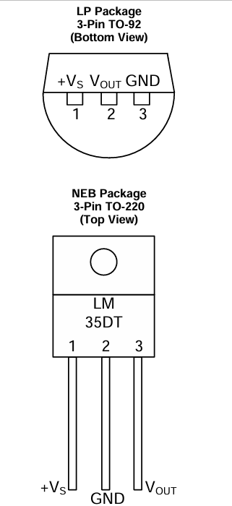
Figure 2 [3]

For vibration it has been decided that the ADXL345 sensor will be used. The sensor can accurately monitor vibrations. It can communicate using SPI or I2C. This is essential as a microcontroller is going to control the outputs. We would expect the motors to be less than 2g. It can also measure up to 16g this is high vibration rate and is more than enough for an industrial motor. When writing the program, we would want minimal vibration. We would take a reading when the motor is working correctly and program the controller to give an output when the motor is vibrating out of its specified range [4].

When tracking the current a current sensor can be used to communicate with the microcontroller. It has been determined to be the ACS721. Depending on the current rating it will give out a voltage which can be used as our input. Again, it will program to the motors normal operating conditions. If it is outsize these parameters, it will give an output [5].

4.5 System integration

Components are needed to track the condition of the motor, vibration, current and temperature. If there are anomalies LEDs need to come on, to do this a microcontroller is going to be used. To get the sensors to communicate with the microcontroller there needs to be an analogue to digital conversion so the inputs can be recognised. When selecting the PIC, it needs to have the ADC function to allow for the conversion. As the current sensor and the temperature sensor need conversion. The vibration sensor has its own conversion and communicates with the PIC using I2C. An appropriate PIC would be the PIC16F877A.

5. Resource list

To ensure that the aims and objective are met there need to be a resource list highlighting the parts needed and the cost that are going to entail. Firstly, the part to be used on the circuit must be ethically sourced, make sure if this it should be sourced from approved suppliers.
Lm30 temperature sensor is £10.30 for ten units, this is the smallest quantity available to purchase, making the price for one unit 1.30. The ADXL354 responsible for the vibration detection is £7.62 per unit. The sensor ACS721responsible for the current detection can be purchased for £50.40, this is for 20 units, making one unit £2.52. The microcontroller PIC16F877A can be sourced for £5.78 per unit. All parts are to be sourced from RS components [3][4][5].
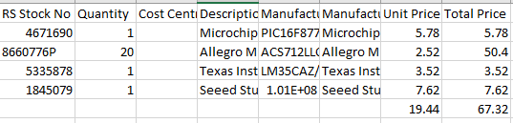
Table 2
This makes the parts cost for each motor £19.44. The software used for the project will be CCS compiler, the licence fee for this application is around £1000, this will be a onetime purchase, and this can be used for every installation. The time taken in hours for the program and installation is estimated to be 8 hours per motor, assuming the installers wage is at £20 an hour, it will cost £160 per motor, when looking for contractors to install the condition monitoring system the most suitable candidates should be selected, to give and equal opportunity to all candidates supporting equality and diversity. This makes the total cost £179.44. This meets the objectives of having a low-cost condition monitoring system which can benefit smaller operations. If we work from a profit margin of 50% the charge for reach motor could be £270.

6. Planning

The success of the project will be based on its ability to meet the aims and objectives and have the final output of a working condition monitoring system. It must meet the criteria of sending outputs to the LEDs when there is a fault. to make sure this is complete without delay there needs to be a plan that can be broken down into phases. Phase 1 will cover the initial planning of the project, phase 2 will be creating a proposal for the idea including all necessary information from the previous phase. Once the project has been approved phase 3 can then commence which will cover the build of the product, leading on to the final stage of installation.
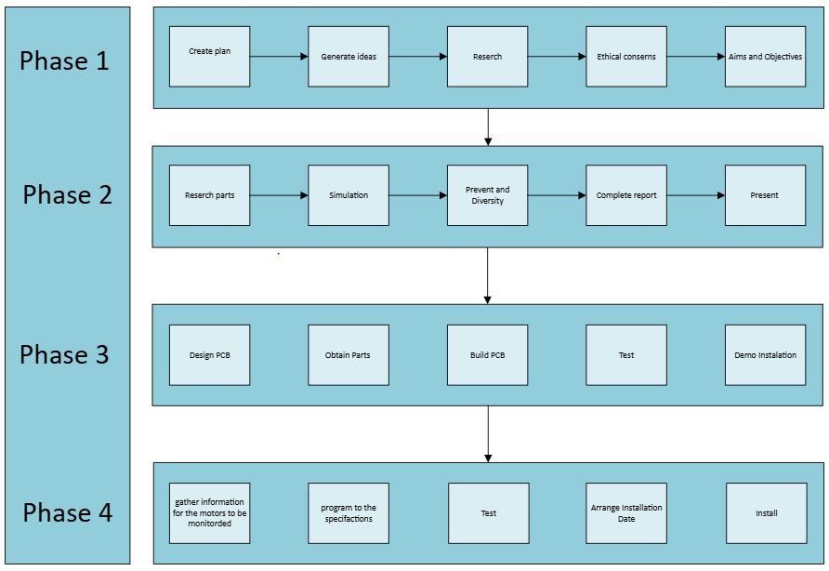
Figure 3
The flow chart shows what needs to be done without any defined dates, this is a quick visual representation of what must be done, if the task on the flow chart is correct it can then move onto the Gantt chart.
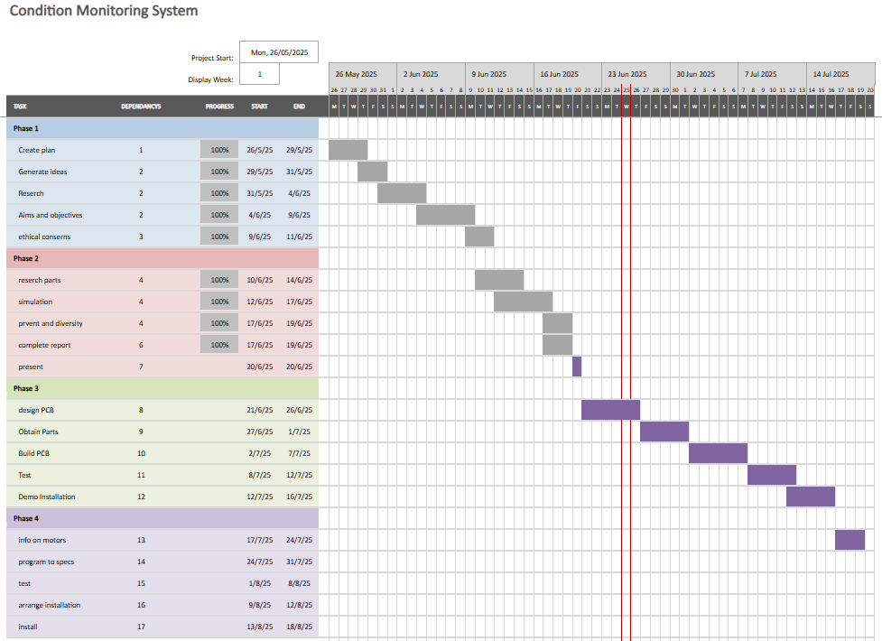
Figure 4
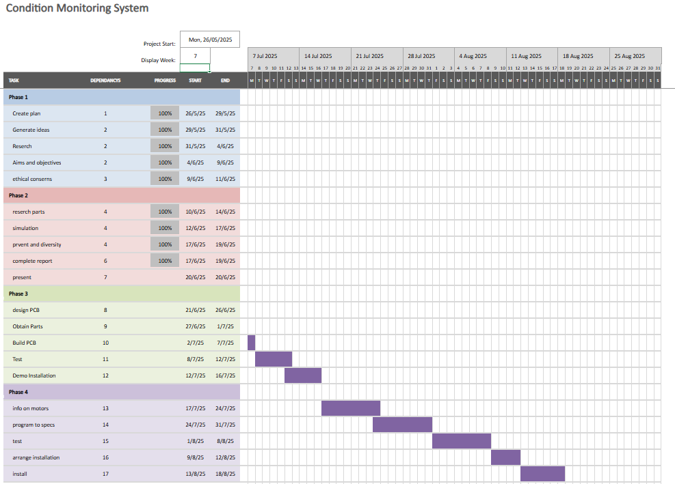
Figure 5
The Gantt is a visual representation for when all the tasks are to be complete. By having dates in place, you can ensure that the project stays on track.
When conducting my critical path analysis, I found that on phase 2 tasks could be complete simultaneously. This will take 3 hours off the plan for phase to taking it from 16 hours to 13 hours.

7. Expected outcomes and deliverables

The expectation from this project is to have a working cost-effective condition monitoring system using various sensors which allow for fault detection.
By having a condition monitoring system there will need to be more time allocated to maintenance activities as motors will need to be inspected and repaired when issues are found. But due to the chances of breakdowns being minimised this should result in less time where the machine is inactive and increase production rate.
By having a cost-effective condition monitoring system there will be limitations to its useability, by only displaying if there is an issue it only shows if there is currently an issue. There will be no saved data which means you cannon look at the historical readings, this will be on the user to record when issues occur and draw their own collusion on trends. This means that there will be no need to expensive software ad help in meeting the goal of having a cost-effective condition monitoring system.

8. Risk and ethical considerations

When implementing the condition monitoring system onto electric motors, the safety and quality concerns must be considered. The IEC 60204-1 legislation must be followed to ensure the safe implementation of the condition monitoring system. The system must not interfere with the motors operation as there is a risk this could pose a safety concern and negative societal impact, the system must be separate to the motors own circuitry and should have its own power supply to avoid interference. If these regulations are updated alteration should be made to ensure continuous improvement [6]
The project also will have a positive environmental impact, resulting in less energy wasted. If the motor is running in good condition it will result in less wasted energy in forms of heat, or the motor working harder due to worn bearings crating friction. This will meet the ISO 14001 legislation by increasing the energy efficacy. If used in an environment where the motors failure could result in pollution to the environment it is essential that a condition monitoring system is implemented [7].
There are guidelines covered in the ISO17359 legislations which relate to condition monitoring, these are to be followed in the project. It outlines the factors that should be considered when implementing a condition monitoring system. The factors to be considered are vibration, temperature and current. The condition will be continuously monitored and give signals in form of LEDs if there is an issue with the motor. It suggests that trends should be analysed, so if a motor is often having the same fault, the maintenance plan should be revaluated [8].
By following these safety regulations, the risks in the project will be minimised allowing the product to be successful.
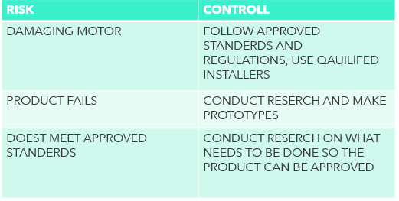
Table 3

9. Conclusion

To conclude, the aim of the project is to create a low-cost condition monitoring system which is accessible to smaller organisations. The report shows that a condition monitoring system can be implemented at a cost to the company of £270. This is a competitive price for a condition monitoring system and still allows for 50% profit margin, if the product is scaled the profits could increase as bulk part orders are available.
It should be reiterated the importance of a condition monitoring system due to the minimisation of motor failure, this will not only benefit the users in production time and down time, but it could also prevent a serious accident in the workplace. The low cost and instant benefits will give little reason for organisations to reject the product.
In the planning stage of the project there has key a key focus on inclusion and diversity as well as managing the risks of the project by researching current legislation. If the project is approved the product could be installed on the first motor by the end of august offering a quick return on investment

10. References

[1]
A. DAVIES, “Handbook of Condition Monitoring,” Google Books, 1998. https://books.google.co.uk/books?hl=en&lr=&id=UzTyCAAAQBAJ&oi=fnd&pg=PR15&dq=what+is+condition+monitoring&ots=XfhU9LdHwq&sig=4whC5A7IeKE-oB6xW39eU99hanI#v=onepage&q=what%20is%20condition%20monitoring&f=false (accessed Jun. 26, 2025).
[2]
S. Nandi, H. A. Toliyat, and X. Li, “Condition Monitoring and Fault Diagnosis of Electrical Motors—A Review,” IEEE Transactions on Energy Conversion, vol. 20, no. 4, pp. 719–729, Dec. 2005, doi: https://doi.org/10.1109/tec.2005.847955.
[3]
Texas Instruments, “LM35 LM35 Precision Centigrade Temperature Sensors,” Dec. 2017. Accessed: Jun. 26, 2025. [Online]. Available: https://www.ti.com/lit/ds/symlink/lm35.pdf
[4]
“Grove -3-Axis Digital Accelerometer(±16g).” Accessed: Jun. 26, 2025. [Online]. Available: https://docs.rs-online.com/b9f8/A700000006877256.pdf
[5]
“High Accuracy, Galvanically Isolated Current Sensor IC With Small Footprint SOIC8 Package,” RS components. https://docs.rs-online.com/17bd/0900766b813b5390.pdf (accessed Jun. 26, 2025).
[6]
“IEC 60204,” Wikipedia, Nov. 17, 2020. https://en.wikipedia.org/wiki/IEC_60204 (accessed Jun. 26, 2025).
[7]
“Legal and Other Requirements for ISO 14001 (Environment),” ISO Compliance Register, Feb. 03, 2025. https://isocomplianceregister.co.uk/iso_article/legal-and-other-requirements-for-iso-14001-environment/ (accessed Jun. 26, 2025).
[8]
“Condition monitoring and diagnostics of machines -General guidelines.” Available: https://cdn.standards.iteh.ai/samples/71194/c551f4c170654bb19be2ee017d144969/ISO-17359-2018.pdf

11. Prevent certificate


12. Diversity certificate


