

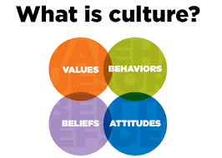

Student: Riccardo Russo

Student Number: 1815101

Lecturer: Dale Clarke

Module: M5X01923

TABLE CONTENT

- Introduction………………………………………………………………………………………..3/4

- How to behave at the table around the world……………………………………….…………..4

- Have you enjoyed your meal?...............................................................................................5

- Can I have some more?.........................................................................................................5

- Do not do ever and never!......................................................................................................6

- To do and not to do list………………….……………………………………………………...…..7

- References….……………….…………………………………………………………..…………..8

INTRODUCTION

The Memorandum or Aide Memoire of a Hotel, or Hotel Information Memorandum is a document prepared by professionals specialized in cultural communication intended for the different parties involved within the structure, from guests to employees.
It represents a formal document that allows to know a series of information useful in relating with people, and therefore peoples, of different cultures.
Knowing the various habits and customs of the various cultures allows you to show a certain professionalism from the employees and a high education from the guests.
Showing respect for the different nationalities within the structure is one of the highest grade of respect that can be had.
The Memorandum is made up of some typical parts, which summarize in detail the characteristics of the various peoples.
The typical parts that make up the Memorandum are different, depending on the type of hotel, the subject, the market and the area in which we find ourselves.
Culture is both simple and difficult to understand (Steers, et al, 2016).
Difficulties that often come out from different cultures are very complex as a multidimensional concept.
A set of knowledge, habits, uses, customs that differentiates various peoples and various areas of origin.
This explains the difficulties that researchers encounter in defining this important but complex phenomenon (Melia, D.M. and Kennedy, E. (2005),).
However, a right and effective management of different cultures within a hotel structure will be a mirage if there is no solid knowledge and understanding of culture.
Groschl (2011) argues that diversity management must focus on a strategy that recognizes the individuality of workers and believes in the benefits of diversity within organizations.
Culture, therefore, is: this set that includes knowledge, beliefs, art, law, morals, customs and other skills and habits acquired by man as a member of society (Taylor, 1871) mentioned in Minkov, (2011).
Hotel owners and hotel managers have admitted that high quality service is increasingly becoming an important success factor, high service standards allow the structure to be present in the market and actively.
Quality in the service sector is difficult to evaluate due to three distinct characteristics of the service: intangibility, heterogeneity and inseparability of production and consumption.
Parasuraman et al, (1988) developed a measurement framework to measure quality of service.
The framework is called: SERVQUAL.
Through SERVQUAL, Parasuraman et al, has divided the quality of service into 5 specific dimensions.
Reliability, responsiveness, security and empathy are tangible.
These 5 identified dimensions are used in the description and measurement of the quality of service in the hotel sector.
The reliability dimension concerns the provision of services based largely on meeting or exceeding expectations.
Responsiveness refers to the ability of employees to respond promptly and effectively to guests' requests.
The tangibles refer to the general appearance and functionality of the hotel
The guarantee implies the knowledge and courtesy of the employees and their ability to inspire trust and security.
Empathy is expressed in the sense that management and its employees care about the needs of the guest.
The quality of hotel service perceived by customers derives from a comparison between what they believe hotels should offer (i.e. their expectations) and their perceptions of the performance of the hotels that provide the services.

According to several empirical studies in the hospitality sector (eg Mok and Armstrong 1998; Pizam, et al, 1997) there are intercultural differences in the attitudes and behavior of customers.
Nobody should ever denigrate traditional beliefs and practices, especially those that are still fundamental to culture.
In the context of the organizational assistance of the service, good business sense and cultural sensitivity are essential for success
Equity is more important than wealth. (Korten, 2018)
Saving and conserving resources is highly appreciated.
The group is the most important part of society and is emphasized for motivation. (Hoecklin, 2006)
Cohesive and strong families and ties often extend to distant relatives, even to the nation and its leaders. (Reeves-Ellington, 2010)

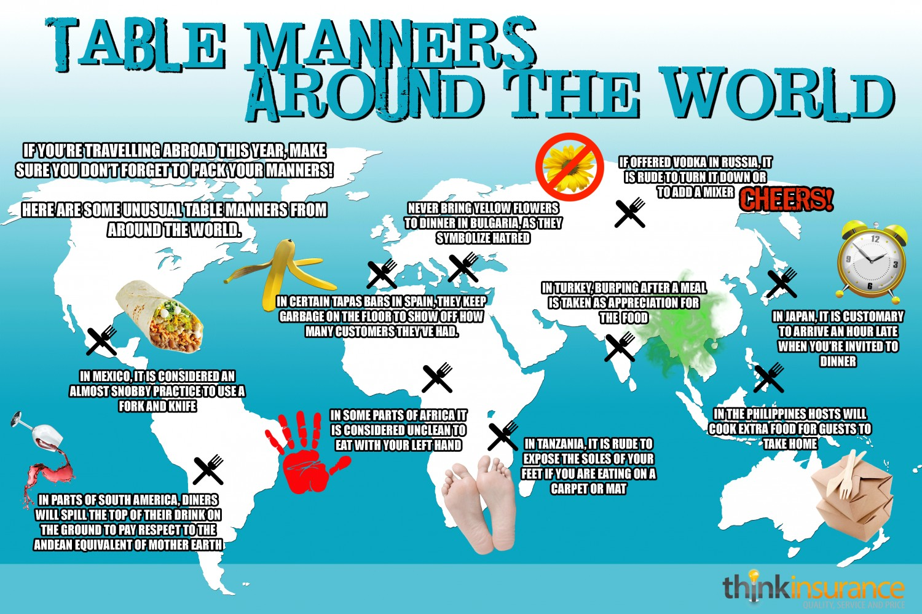

HOW TO BEHAVE AT THE TABLE AROUND THE WORLD

In Thailand, a fork and spoon is used, but only the latter is brought to the mouth. The fork is only used to accompany the food.
In China and Japan, forks or spoons are prohibited, only chopsticks are used.
Remember, however, not to cross them, lick them or leave them in a vertical position in the rice bowl, because the image would remember the incense sticks placed vertically in the bowls when the dead are mourned and the funeral is celebrated.
In India, Ethiopia, Indonesia and in some areas of the Middle East, hands are essential: you eat with your right hand (the left is a symbol of impurities because it is reserved for the most humble operations and for the cleansing of the body), all using a single large tray in the center of the table. For obvious reasons they never lick their fingers!
In France, cutlery is used, of course, but you don't cut salad leaves with a knife! This tradition dates back to the past when silver knives oxidized on contact with vinegar. Today silver is no longer used, but the habit has remained.
HAVE YOU ENJOYED YOUR MEAL?

In Japan to do honor to the kitchen it is important to do things calmly, appreciate the table, the proportions, the dish, the colors and the composition of the dishes. If you are eating a soup or a bowl of noodles, however, it is equally important to be noisy: only in this way will you demonstrate that you really appreciate the dish you are eating.
In China, a nice burp is the best way to thank the Chef for the excellent food and to show great appreciation of the meal eaten. (Denny, 1994)
In Thailand, to prove that you have enjoyed lunch, you can take food as many time as you want, but since everyone has to enjoy it, before taking the last portion, it is good to make sure that all the other diners agree.

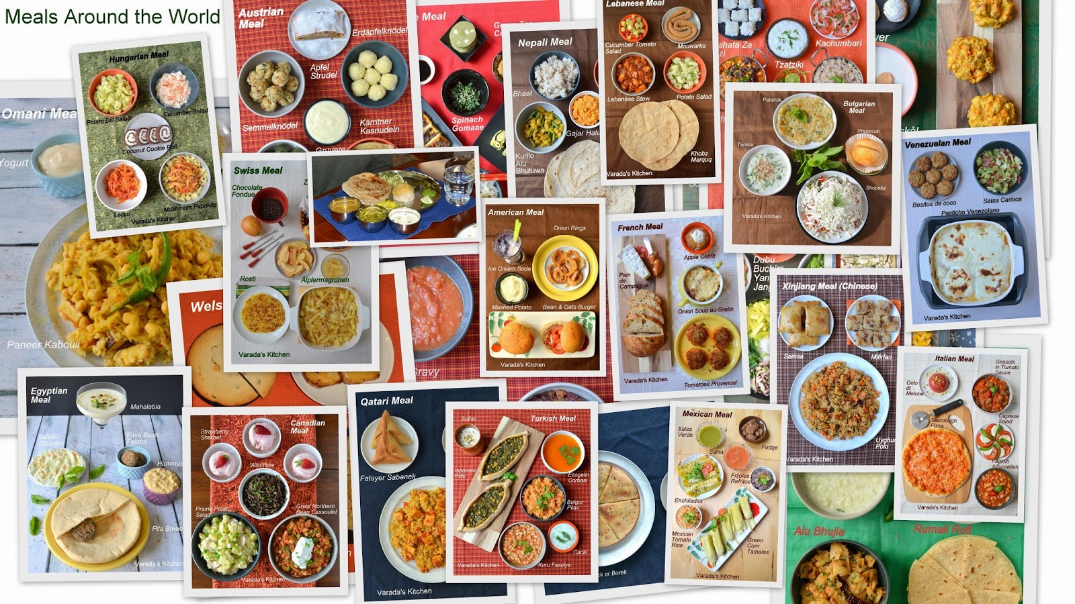

CAN I HAVE SOME MORE?

It is absolutely forbidden to ask for an encore in Spain, where it is a sign of great rudeness.
Green light instead in Georgia, where accepting the encore is almost a must.
The advice, therefore, is to eat small portions so that you can willingly accept the second or third portions.
In Arab countries, where food is always served in abundance, asking for an encore is a compliment for those who have cooked
In India, be careful to finish everything you are served, because leaving food for the Indians means wasting it and therefore disrespecting the Chef.
On the other side in China, cleaning the whole dish means not having eaten enough, so it is a way to tell the chef that he has not cooked enough to feed you. Always leave some on the plate.
Do not deep bread at the end of the meal into the plate in France unless you are eating butter éscargots.

DO NOT DO EVER AND NEVER!

Never ask for salt and pepper in Portugal: it is considered extremely rude, because it means that the meal served lacks taste.
Never split the bill in Georgia, because only one person has to pay.
In Japan, never blow your nose at the table: it is nothing short of outrageous!
Never ask for the ingredients of a dish in Zambia: you will give the impression that you are afraid of being poisoned.
If you are in South Korea, never touch the food before the older person sitting at the table has started to eat: it is unbecoming and extremely disrespectful.
In Egypt you will have to wait for the older man sitting at the table to eat.
In Austria and Germany, it is very unpolite to arrive late and you must communicate it in advance to the host.
In Mexico and Greece, however, it is normal to arrive about half an hour later than the scheduled time, up to an hour in Argentina.
Thumbs up in South Africa is a sign of approval, as in Italy, but in Bahrain and Nigeria it is a serious insult!
In Nigeria it is also forbidden to maintain eye contact while talking to someone, while making a burp at the end of the meal means that you liked it.
Never leave food on your Afghanistan plate if you are satisfied: you would need more! Also, you must eat with your left hand and not sit down before the seat is assigned.
In Egypt you must always accept tea and coffee and you must never add salt to the dishes, those who cooked would be offended.
In Russia it is polite to help those who host you to clean and cook, while it is forbidden (or in any case highly discouraged) to talk about politics.
In China, whistling is bad education, in Belgium having your fingers cracked.
In Taiwan there is no talk of death, because the inhabitants are convinced that the things spoken will then come true!
In Thailand it is considered an impure gesture to use the left hand to pass something.
In Brazil, married women must be kissed once per cheek, singles must receive a third kiss.
In Japan you have to take your shoes off before entering the house and the emotions should not be shown too much. (Ridgwell, 1993)

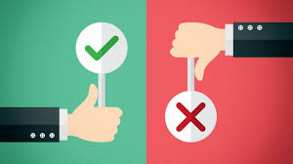

TO DO AND NO TO DO LIST

Country | To Do | Not to Do
China | Be on time
China |  | Touch or shake hand
China |  | Being loud and whistling
China | Burping at the end of the meal
China | Using chopstick
India | Using “Namaste” to greet
India | Shaking hand acceptable between men
India |  | Left hand is considered unclean, use always the right hand to eat and giving things
India | Eating with righthand
India |  | Wasting food is very unpolite
Malaysia |  | Touch the head of any person
Malaysia | Malaysians’ hand shake
Philippines | raising of eyebrows to indicate “yes”.
Philippines | Being warm and friendly
South Korea | Being extremely polite
South Korea |  | Touching
South Korea |  | Making a joke about expenses
South Korea | lay the chopsticks or spoon on the table to indicate you have finished eating
French |  | A firm and pumping handshake
French | The handshake is a quick shake with some pressure in the grip
French | Wait for a woman to offer her hand first
French | Being punctual
Germany | Being meticulous and exact
Germany |  | Being outward people
Germany | Firm handshakes are preferred
Germany |  | Being loud
Germany |  | To Talk to someone with your hands in your pocket
Portugal |  | Ask for salt and pepper
Russia |  | Talk about politic
Japan | Remove your shoes before going into a house
Egypt | Accept always coffees and teas
Egypt |  | Ask for salt and pepper
Egypt | Wait for the oldest person to start eating

REFERENCES

- Denny, R. (1994). A taste of China. New York: Thomson Learning.

- Gröschl, S. (2011) "Diversity management strategies of global hotel groups: A corporate web site based exploration", International Journal of Contemporary Hospitality Management, Vol. 23 Iss: 2, pp.224 – 240

- Hoecklin, L. (2006). Managing cultural differences. Harlow [etc]: Pearson Education.

- Korten, D. (2018). Why Equality is More Important Than Economic Growth. [online] Toward Freedom. Available at: https://towardfreedom.org/global-news-and-analysis-global-news-and-analysis/why-equality-is-more-important-than-economic-growth/ [Accessed 13 Jan. 2020].

- Melia, D.M. and Kennedy, E. (2005), Cultural Diversity: A Management Perspective, Dublin Institute of Technology, Dublin.

- Mok, C., and Armstrong, R. W., (1998). Expectations for Hotel Service Quality: Do They Differ from Culture to Culture?, Journal of Vacation Marketing, Vol 4 (4), pp. 381 – 391

- Parasuraman, A. Zeithaml, V. A and Berry, L.L. SERVQUAL: A Multiple-Item Scale for Measuring Customer Perceptions of Service Quality. Report No. 86-108. Cambridge MA: Marketing Science Institute, August 1986

- Reeves-Ellington, R. (2010). What is culture?. Lewiston, N.Y.: Mellen.

- Ridgwell, J. (1993). A taste of Japan. New York: Thomson Learning.

- Steers, R. M. Nardon, L., and Sanchez-Runde, C. J. (2016). Management Across Cultures: Developing Global Competencies, Third Edition, Cambridge University Press, Cambridge

