
University of Wales Trinity Saint David - School of Engineering

Computational Fluid Dynamics of an Ahmed body – M6X00408

Ifan Hopkins – 1701085
27/01/20

Contents

1 Contents 2
2 Introduction 1
3 Results 2
3.1 Global scale factor effect on lift and drag 2
3.2 Domain mesh size effect on lift and drag 4
3.3 Density box mesh size effect on lift and drag 5
3.4 Ahmed body part mesh size effect on lift and drag 6
3.5 Prism layers effect on lift and drag 7
3.5.1 Prism layers on the Ahmed body and floor 7
3.5.2 Prism layers on the Ahmed body 8
3.6 Domain geometry effect on lift and drag 9
3.7 Turbulence models effect on lift and drag 11
3.8 Mesh type effect on lift and drag 13
3.9 Solution methods effect on lift and drag 14
3.10 Accurate mesh 15
4 Post processing results 17
5 Mesh effect on postprocessing results 26
6 Conclusion 28
7 Appendix 29
8 References 31
9 List of figures 32
10 List of tables 33

Introduction

Computational Fluid Dynamics (CFD) is a computer software which can predict fluid flow, heat and mass transfer, chemical reactions and related phenomena. CFD solves the conservation equations for mass, momentum and energy to predict engineering phenomena.
CFD is a Computer Aided Engineering (CAE) method, which is used to optimize designs. It can be used in every stage of the design process. ANSYS Workbench 16.2 was used in this investigation.

An Ahmed body was used for testing. It is a benchmark model, which was created by S. R. Ahmed in his paper ‘Some Salient Features Of The Time-Averaged Ground Vehicle Wake’ in 1984. The Ahmed body is described as a bluff body, meaning there is substantial separated flow and it’s dominated by pressure drag. It is a simplified car model, and is often used in order to validate CFD results. The Ahmed body used in this investigation had a slant angle of 25˚ (see Figure 1), however, there are benchmark models with different rear slant angles, usually ranging from 25˚-30˚. Table 1 shows the expected results for lift and drag coefficients of this Ahmed body. The simulation was given a velocity of 40m/s from the inlet, to simulate the body travelling at that velocity.

Table 1 - Ahmed body expected lift and drag coefficients
Slant Angle (φ) | Lift Coefficient | Drag Coefficient
25 | 0.345 | 0.299

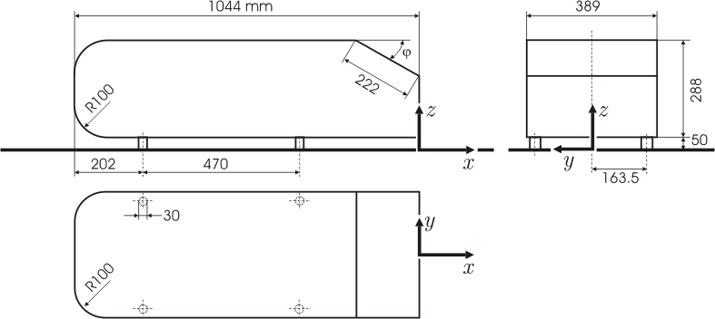

Figure 1 - Ahmed body geometry (Ahmed, 1984)

Results

The k-epsilon realizable turbulence model was used when studying the effects of mesh element size. The domain and density box geometry remained the same when changing the mesh element sizes.

Global scale factor effect on lift and drag
Figure 2 - Lift and drag against global scale factor
No prism layers

Figure 2 shows the effect of reducing the element size of the whole mesh. The results for drag are as expected; as the element size decreases, the accuracy for drag increases. Drag decreased from its maximum value 0.464 to its minimum 0.337. There is a spike in drag for the 5th mesh.
The lift results are less obvious, however, overall the results are more accurate as the mesh gets finer. Interestingly, the most accurate value for lift was the 7th mesh (see Table 2), only 0.09% larger than the known lift value. The results do not follow a linear trend, likely because the mesh selected was too big, and therefore was not accurately representing the Ahmed body’s geometry.

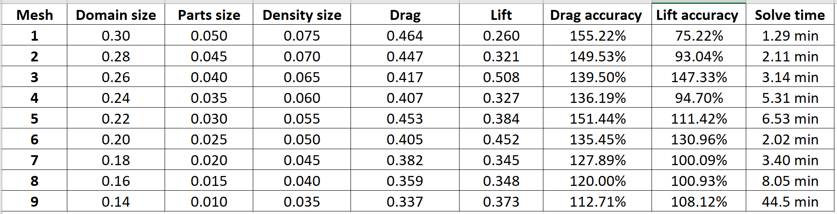
Table 2 - Lift and drag against global scale factor

Figure 3 - Lift and drag accuracy against solve time

Figure 3 shows how accuracy for lift and drag change as the solve time increases. For drag, despite having a peak in the results around 5 minutes, the drag gets closer to 100% accuracy as solve time increases. In general, lift accuracy increases as solve time increases, however there is a peak at 3 minutes and 6 minutes in the results. A value of around 90% accuracy at 3 minutes and 95% accuracy at 6 minutes would be expected.

Domain mesh size effect on lift and drag
Figure 4 - Lift and drag against domain mesh size
0.02 – Part size
0.045 – Density box size
No prism layers

Drag accuracy increases as element size decreases (see Figure 4). Changing the mesh size from 0.40 to 0.35 had no effect on lift and drag values. The same trend can be seen from 0.30 to 0.20. Changing the domain mesh size had a very small effect on drag compared to lift. This could be because the density box accurately represents most of the turbulence that causes drag.

Table 3 - Lift and drag against domain mesh size
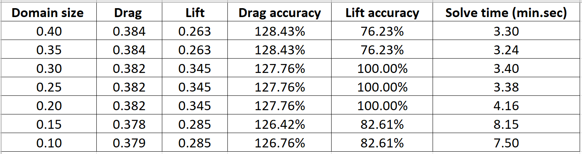

Density box mesh size effect on lift and drag
0.02 – Part size
0.3 – Domain size
No prism layers
Figure 5 - Lift and drag against density box mesh size

Figure 5 shows how lift and drag values are not affected by changing the density box size from 0.045 to 0.040 and 0.035 to 0.020. Decreasing the density box element size increases the drag accuracy, but decreases the lift accuracy. Despite a density box size of 0.045 resulting in 100% lift accuracy, the postprocessing results would likely be inaccurate.

Table 4 - Lift and drag against density box mesh size
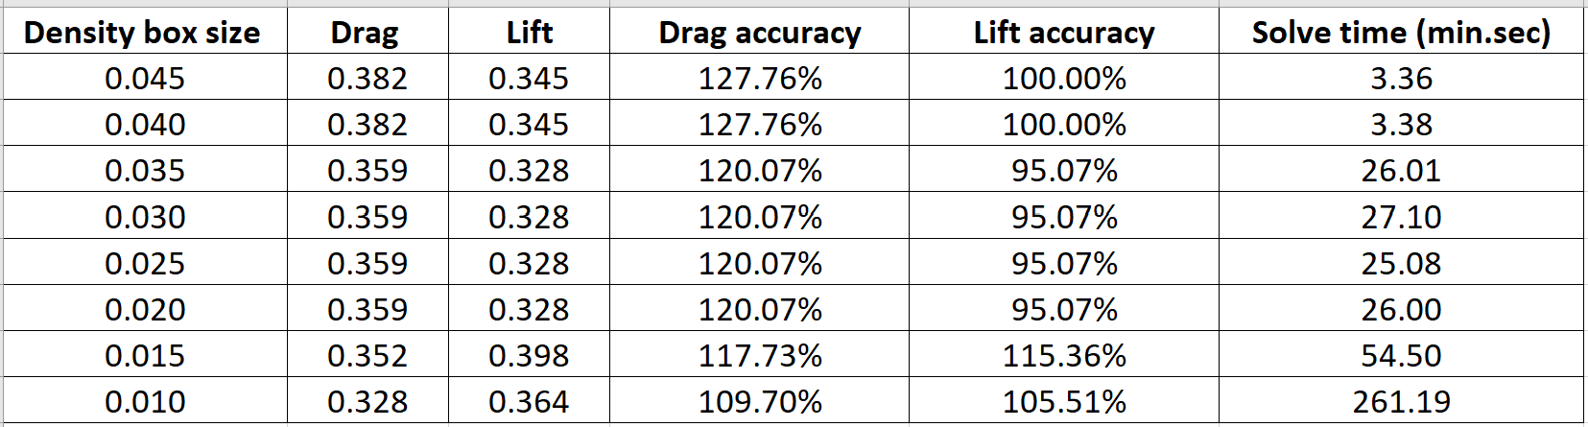

Ahmed body part mesh size effect on lift and drag

0.015 – Part size
0.03 – Density box size
0.3 – Domain
3 prism – Ahmed
1 prism - Floor
Figure 6 - Lift and drag against Ahmed body mesh size

Figure 6 shows how the accuracy of lift and drag increases as the size of the elements on the Ahmed body decrease. Changing the part size from 0.040 to 0.035 had no effect on drag, however, it makes a greater change to the lift (see Table 5). The decrease is relatively linear for drag. Lift on the other hand decreases in a jagged fashion. Had more element sizes been tested, a smoother graph would have been produced.

Table 5 - Lift and drag against density box mesh size
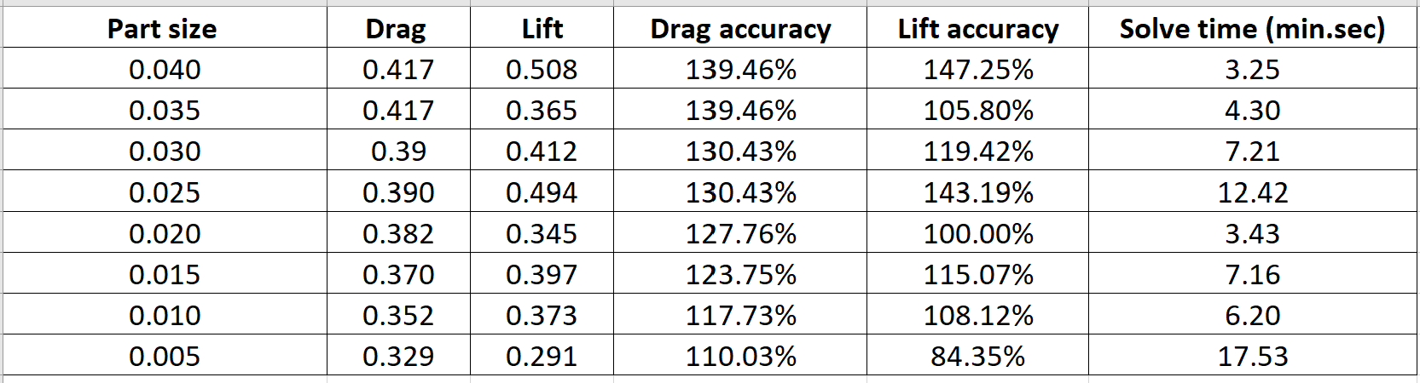

Prism layers effect on lift and drag

Prism layers on the Ahmed body and floor
0.015 – Part size
0.030 – Density box size
0.30 – Domain size
Figure 7 - Lift and drag against number of prism layers on the Ahmed body and floor

As the number of prism layers is increased, the accuracy of the drag increases (see Figure 7). Going from 1 to 3 prism layers however, does not have a large effect on accuracy, changing the value of drag by 0.005. Had a finer mesh been used to test the prism layers effect on lift and drag, the effect of prism layers would have likely been increased.
‘In theory, the interaction of the flow with the object happens near the wall around the boundary layer and it is this region which governs a lot of key characteristics of the flow over a body, like skin friction drag, convective heat transfer, multi-phase film/particle deposition etc.’ (Kapoor, 2016)
Table 6- Lift and drag against number of prism layers on the Ahmed body and floor

Prism layers on the Ahmed body
0.03 – Part size
0.05 – Density box size
0.25 – Domain size
Figure 8 - Lift and drag against number of prism layers on the Ahmed body
Figure 8 shows the effect of adding prism layers to the Ahmed body. Unfortunately, the mesh was too large to add more than 4 prism layers. The prism layers decrease the accuracy of lift and drag, likely due to the mesh elements being too large.
The prism layers are added in order to accurately represent the boundary layer forming on the walls of the Ahmed body. Since skin friction drag has a very small effect on the overall drag of an Ahmed body a large change in drag is not expected. According to Southampton University (n.d), for wall function based models, one to three layers are used.
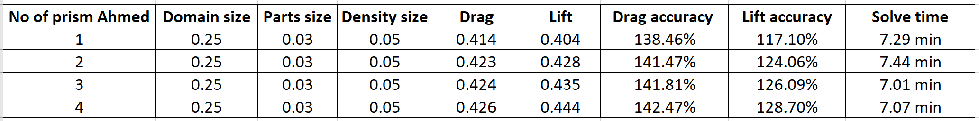
Table 7 - Lift and drag against number of prism layers on the Ahmed body

Domain geometry effect on lift and drag

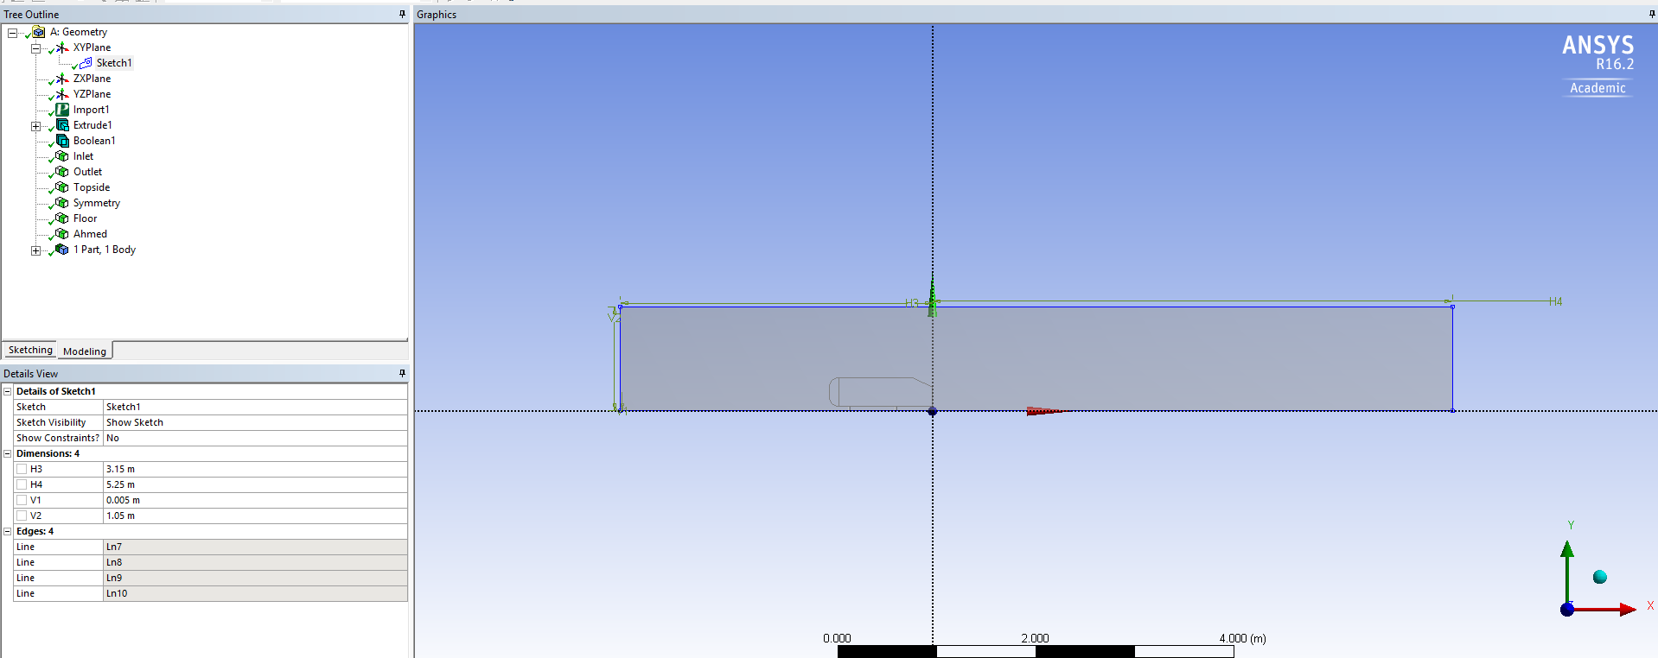
Figure 9 - Smallest domain geometry
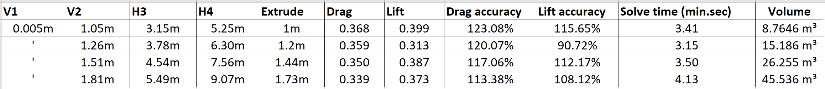
Table 8 - Domain geometry effect on lift and drag

Figure 9 shows the first domain size used. Assuming the length of the Ahmed body is L, there is a distance of 2L in front of the body and a distance of 5L behind it. The width of the domain is 2.5L. This domain size was used, as it is commonly used in other CFD investigations:
‘The front of the body is placed at a distance of 2 car lengths (2L) from the flow inlet. To reduce the computational cost, a symmetry plane is introduced to model half of the model.’ (Christopher, 2015)
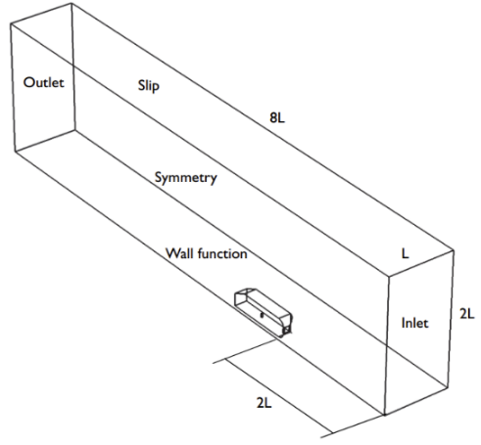

Figure 10 - Domain used by Christopher (2015) for Ahmed body investigation
0.02 – Part size
0.04 – Density box size
0.30 – Domain size
No prism layers
Figure 11 - Domain geometry against lift and drag
Increasing the domain size increased the accuracy of drag (see Figure 11). Lift didn’t show a clear trend however, the smallest domain size gave the least accurate results, and the largest domain size gave the most accurate results.

Turbulence models effect on lift and drag

Under dynamic conditions, fluid flow can be categorised into two different types - laminar and turbulent. Laminar is described as flow which follows a smooth path;
‘A fluid flows through a smooth path with no disruption between adjacent paths.’ (Solmaz, 2019)
At any point in laminar flow, the velocity, pressure and other fluid properties remain constant.
Turbulent flow is described as chaotic flow, where regular fluctuations are experienced;
‘In fluid dynamics, a turbulent regime refers to irregular flows in which eddies, swirls, and flow instabilities occur.’ (SimScale, n.d.)
At any point in turbulent flow, the velocity, pressure and other fluid properties may change in magnitude and direction. The fluid flow during this investigation is predominantly turbulent.

There are a number of different CFD turbulence models used in order to model flow close to walls. According to Frei (2017) all of the models use the Navier-Stokes equations with an additional term to represent turbulence eddy viscosity, however the way the equation is calculated differs.

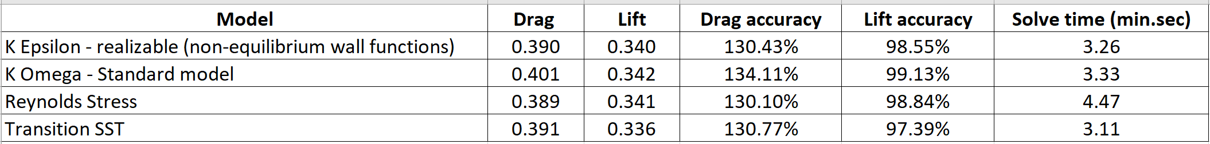
Table 9 - Turbulence model effect on lift and drag

Table 9 shows the results for four different turbulence models used in ANSYS. The most accurate model for representing lift is the Reynolds Stress model. The most accurate model for representing drag is the K Omega – Standard model.

The k-epsilon model is a two-equation model, which calculates for two variables, k, the turbulence kinetic energy, and $ε$ (epsilon), the rate of dissipation of turbulence kinetic energy. The realizable model was chosen as opposed to the standard model. The realizable model is the best for studying the Ahmed body;
‘It is also likely to provide superior performance for flows involving rotation, boundary layers under strong adverse pressure gradients, separation, and recirculation.’ (ANSYS, 2009)
This model has good convergence and low memory requirements.

Similar to the k-$ε$ model, the k-omega model is a two-equation model that calculates for k, the turbulence kinetic energy and $ω$(omega), the specific rate of dissipation of kinetic energy. It has improved accuracy for internal flows compared to the k-$ε$ model.

The Reynolds Stress Model (RSM) is the most complicated model ANSYS fluent provides. For 3D objects seven additional transport equations are solved, hence the solution time for this model is the longest. It is better for giving accurate representation of complex flows since it accounts for the effects of streamline curvature, swirl, rotation, and rapid changes in strain rate with higher accuracy compared to one-equation and two-equation models.
‘Abandoning the isotropic eddy-viscosity hypothesis, the RSM closes the Reynolds-averaged Navier-Stokes equations by solving transport equations for the Reynolds stresses, together with an equation for the dissipation rate.’ (ANSYS, 2009)
This model requires a high quality mesh for accurate results.

The Transitional SST model is based on the coupling of the k-omega transport equations with other transport equations. The default settings were used.

Mesh type effect on lift and drag
Table 10 - Mesh type effect on lift and drag
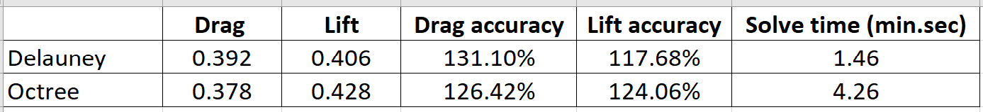

Table 10 shows the effect of changing the mesh type on lift and drag. The solve time is reduced by approximately 65% using the Delaunay mesh type.
The top-down meshing approach is used in order to create an Octree mesh. This means the whole domain is discretized into a mesh.
The bottom-down meshing approach is used in order to create a Delaunay mesh. The Delaunay mesh requires a surface mesh to be created before meshing. The mesh is grown from the premade surface mesh until the whole domain is filled with elements.

Solution methods effect on lift and drag
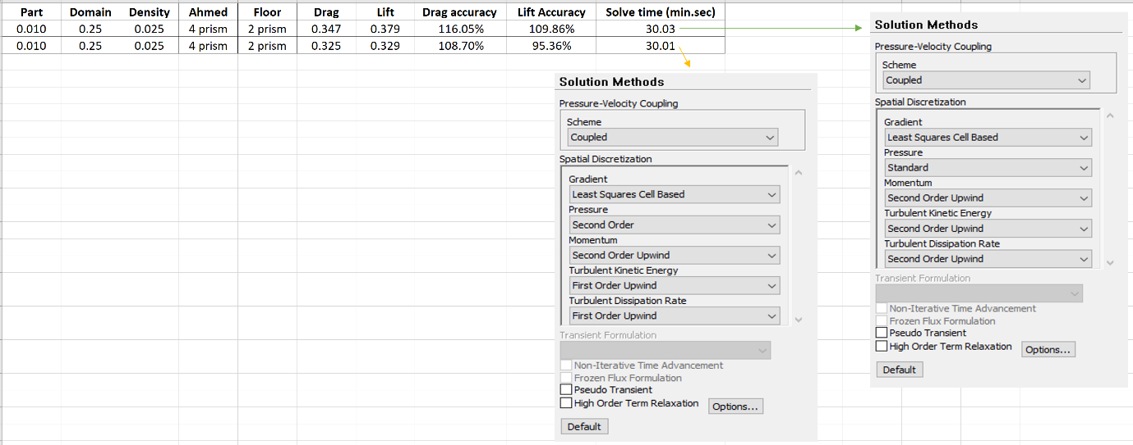
Figure 12 - Solution methods effect on lift and drag

Figure 12 shows how the pressure-based solver was used. The coupled solver was selected, which solves pressure and momentum simultaneously.
The interpolation schemes for pressure, turbulent kinetic energy and turbulent dissipation rate were changed in order to see the effect. The default settings can be seen on the left of Figure 12.
For pressure, flows exhibiting large surface-normal pressure gradients near boundaries have reduced accuracy using the standard settings. For pressure the second order setting is used for compressible flows.
Selecting second-order discretization for both Turbulent Kinetic Energy and Turbulent Dissipation rate should improve the accuracy.
‘Second-order discretization provides optimum accuracy.’ (ANSYS, 2010)

Accurate mesh

Table 11 - Accurate meshes results
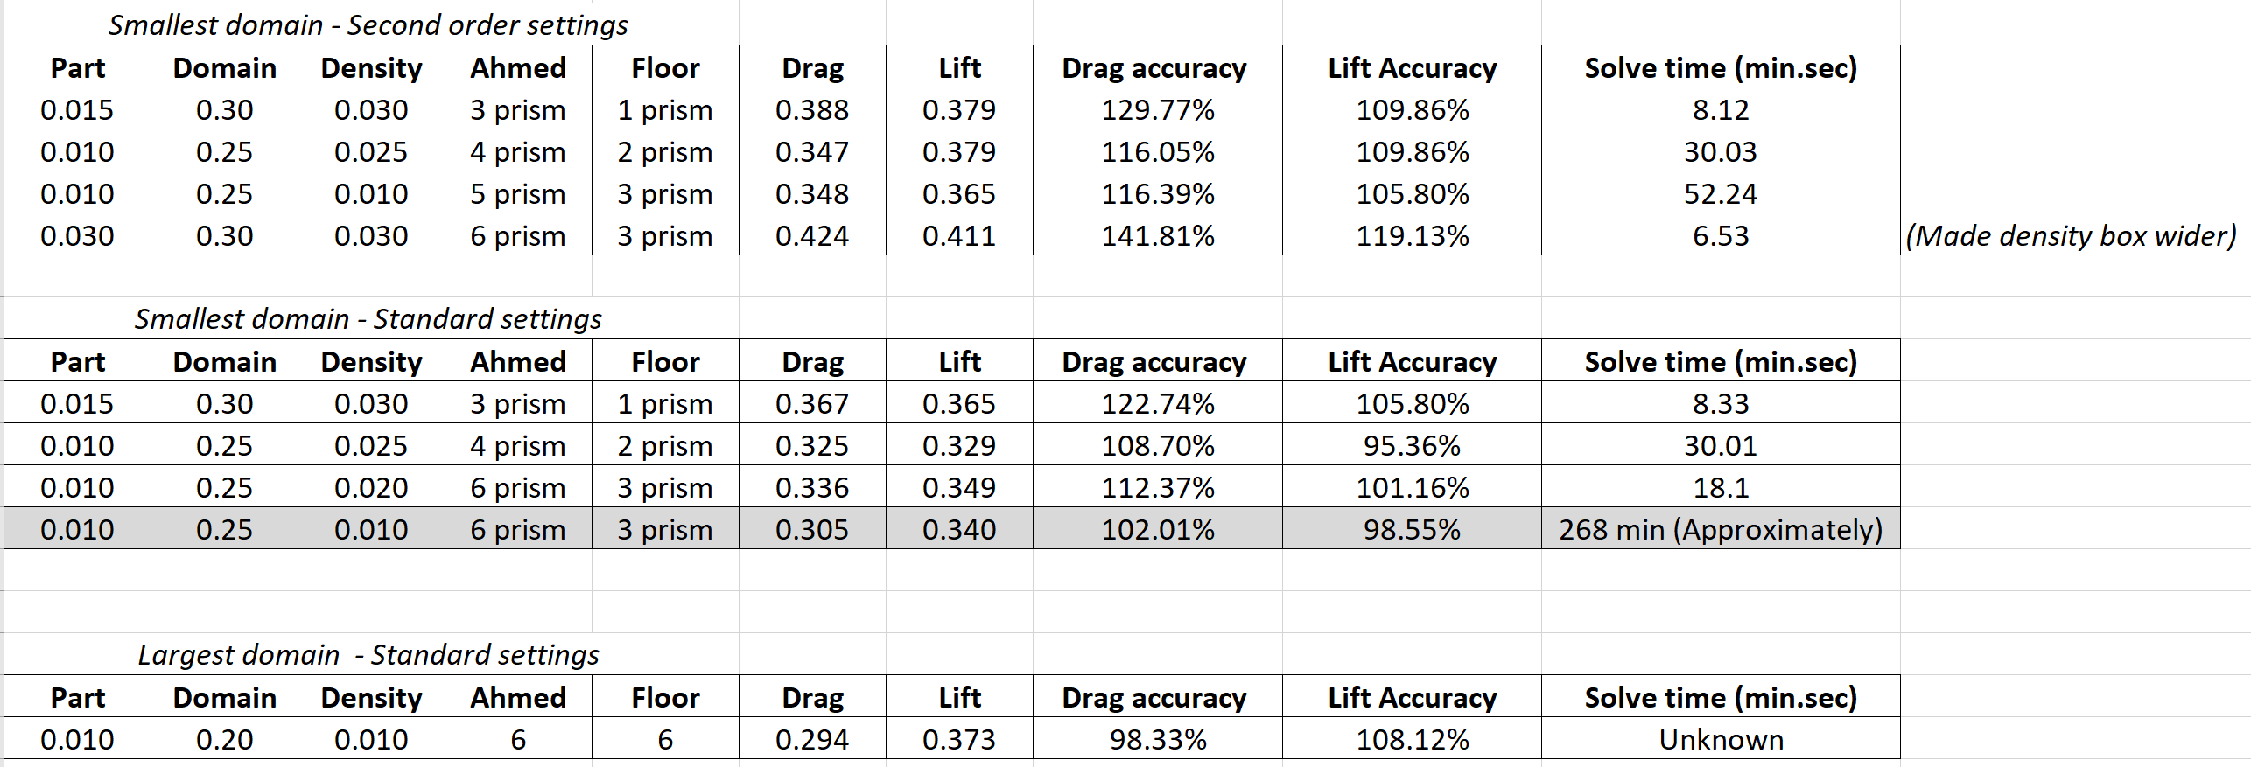

Table 11 shows how the best mesh was created to get an accurate approximation for lift and drag. Initially the Ahmed body part size was selected at 0.015 as from Figure 6 this is where both lift and drag begin to follow the expected trend; getting more accurate as the mesh size decreases. Domain size was initially chosen at 0.3 as Figure 4 shows how lift had an accuracy of 100% at 0.3, and decreasing the size of the elements in the domain had a very small effect on drag. Accuracy increases using prism layers, therefore 3 were selected for the Ahmed body and 1 on the floor. The first solve approximated 0.388 for drag and 0.379 for lift. This mesh was adapted in order to reach the most accurate mesh.

Figure 13 and 14 show the mesh used for accurate calculation of lift and drag. Using this Octree mesh, lift was calculated as 0.340 and drag 0.305. Lift was 1.45% smaller than the predicted value and drag 2.01% larger than the predicted value. The solve took approximately 268 minutes. Maximum element size of 0.25 was chosen for the whole domain, and 0.01 for the Ahmed part and density box. Six prism layers were used on the floor and Ahmed body.
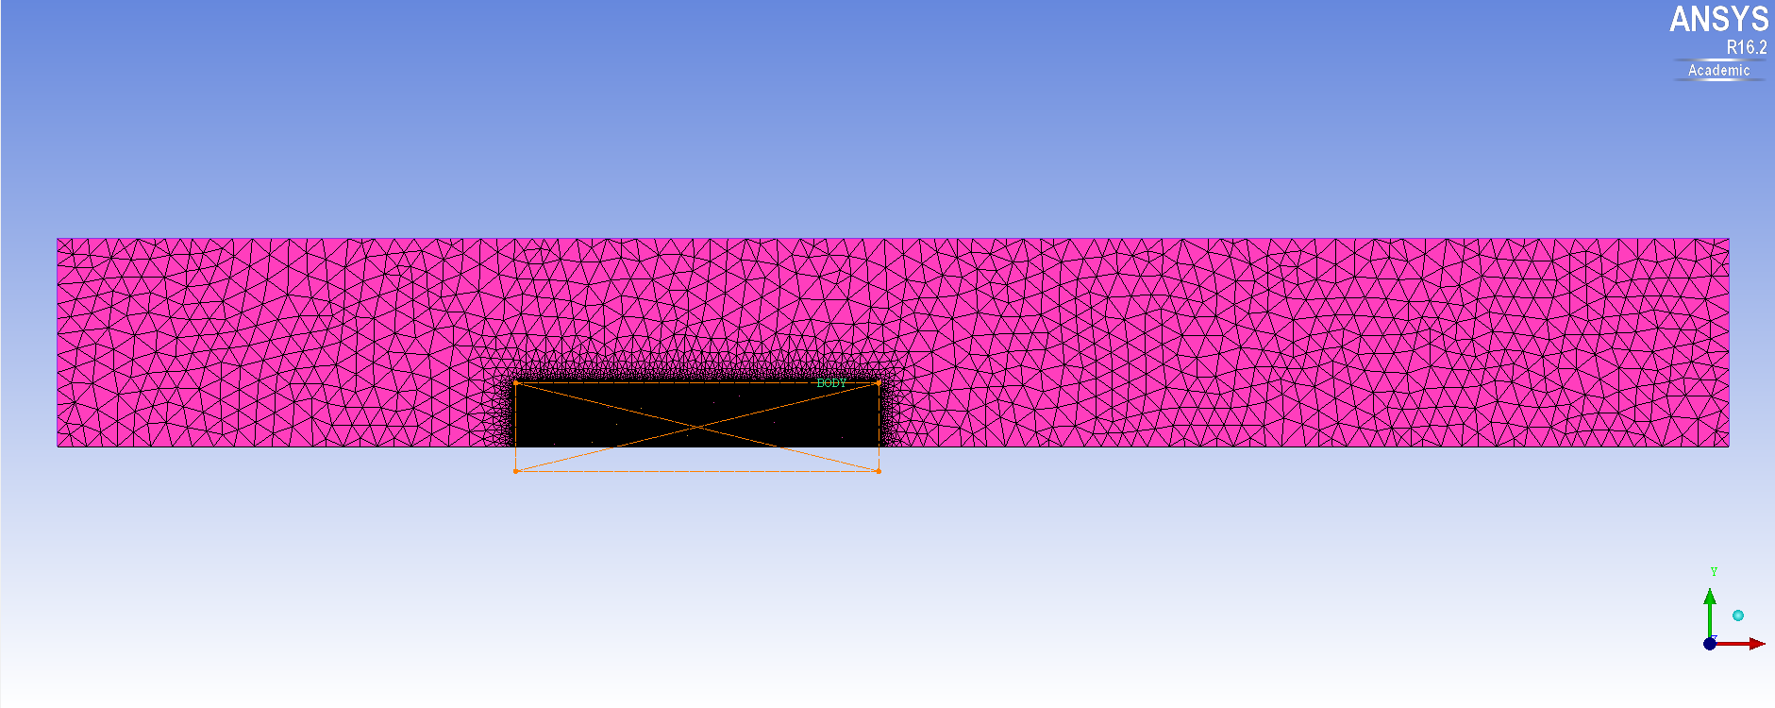
Figure 13 - Most accurate mesh used

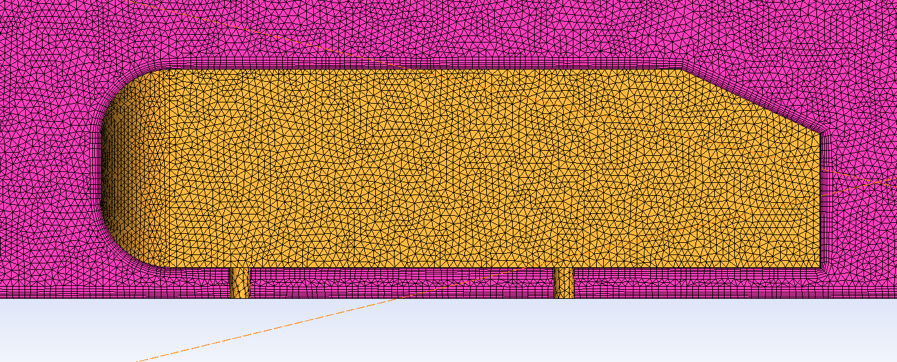
Figure 14 - Most accurate mesh used zoomed

Post processing results

These results were collected from the most accurate solve.
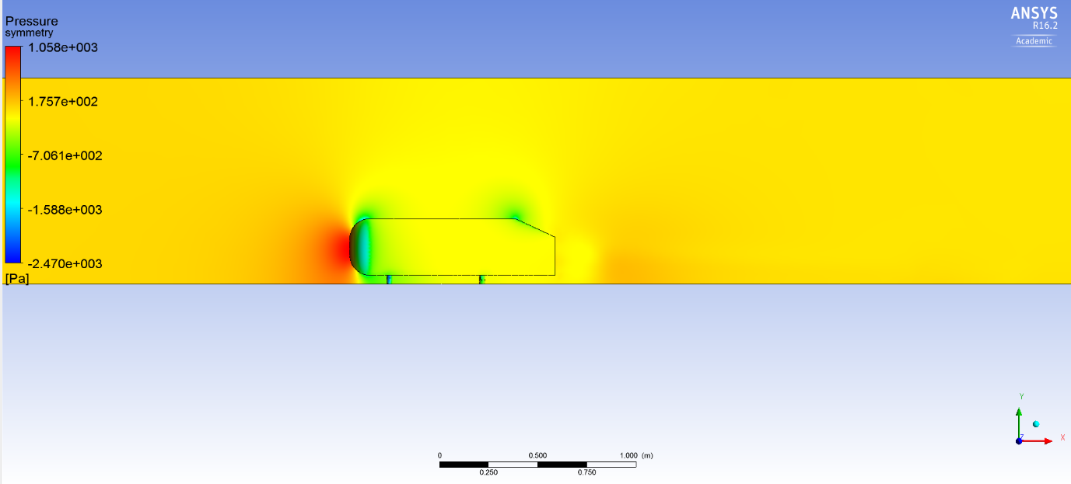
Figure 15 - Pressure on symmetry plane results

Figure 15 shows the pressure on the symmetry plane. There is high pressure at the front face of the Ahmed body, where high velocity air hits the flat face, and almost becomes stagnant. Bernoulli’s equation states the fundamental relationship of how air flows.
‘The base form of the vehicle front – first of all without cooling airflow – can be approximately represented by a rectangular cuboid… Because of the proximity of the cuboid to the ground, a positive pressure region is generated on the ground in front of the cuboid; hence the air passes preferably above the body and at the body sides.’ (Schuetz, 2015)

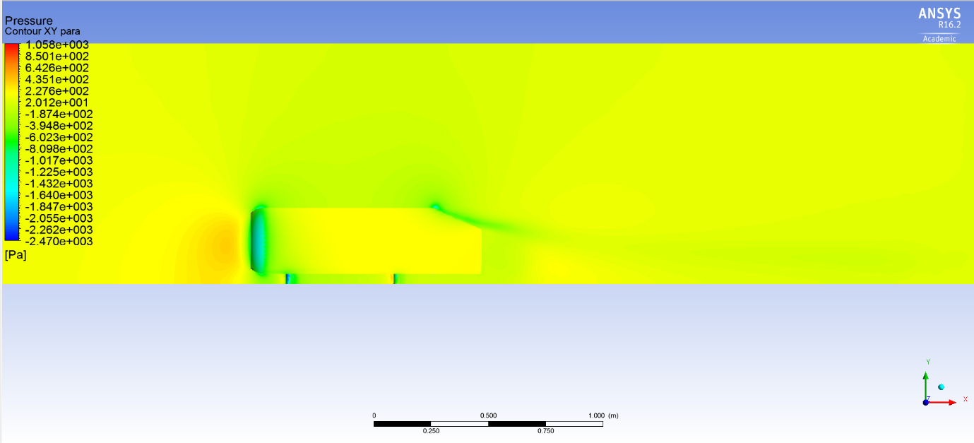
Figure 16 - Pressure on XY para plane results
Figure 16 illustrates a contour plot of pressure on the outer edge of the Ahmed body. See Figure 35 in appendix for XY para location. The pressure is slightly more at the front of the body, as the curved front allows air to attach to the walls and flow around the body. There is a lower pressure area at the rear of the Ahmed body, where it begins to slant. This is due to the c-pillar vortex generated, which has air swirling at high speed, and therefore low pressure.

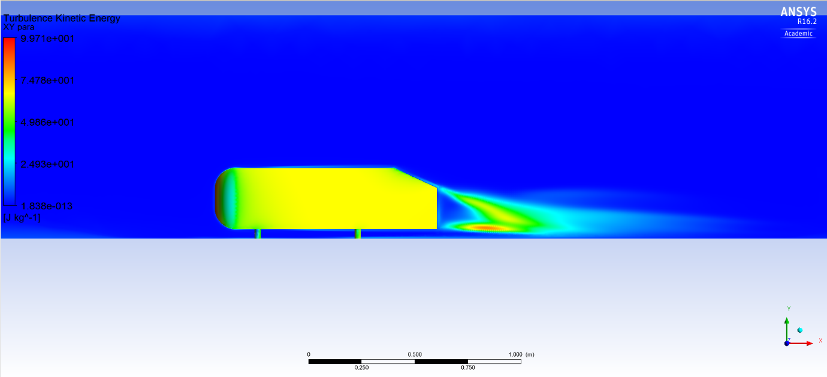
Figure 17 - Turbulent kinetic energy results

Figure 17 show how there is a large turbulence kinetic energy in the wake of the Ahmed body. There are two areas with a high turbulence kinetic energy on either side of the Ahmed body, likely due to the two c-pillar vortices.
‘Turbulent kinetic energy is one of the most important variables in micrometeorology. It’s a measure of the intensity of turbulence.’ (Šavli, 2012)

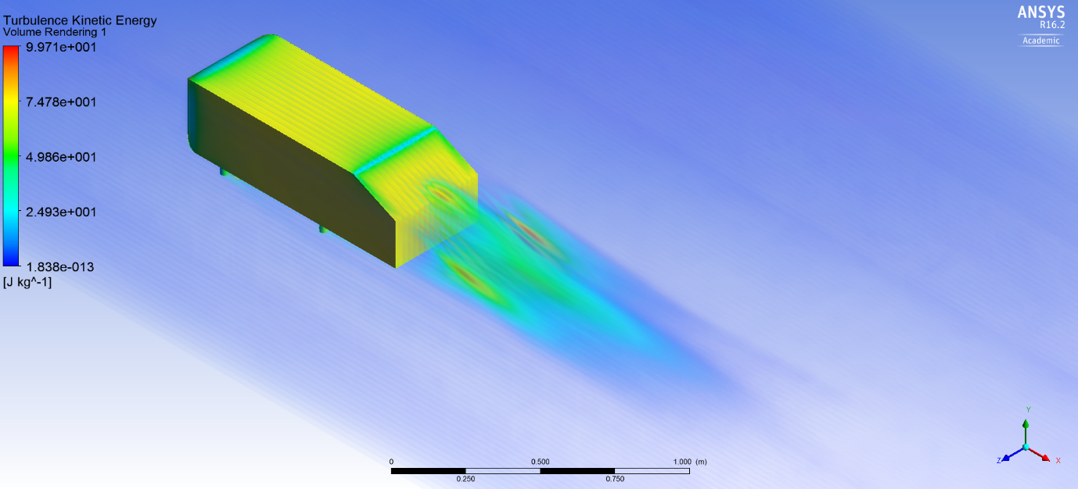
Figure 18 - Turbulent kinetic energy volume render results
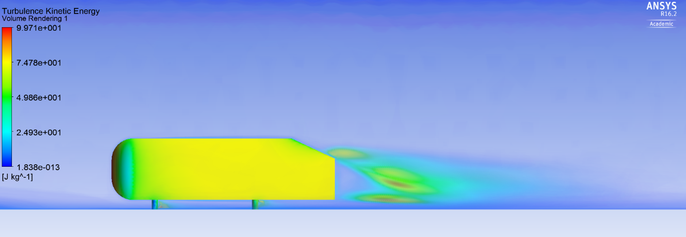
Figure 19 - Turbulent kinetic energy volume render results side view

‘Although it has the same units as pressure, dynamic pressure actually represents the kinetic energy of a unit volume (m³ or ft³) of air. Aerodynamic forces such as lift and drag are directly dependent on the dynamic pressure.’ (Barnard, 2015, p. 5)

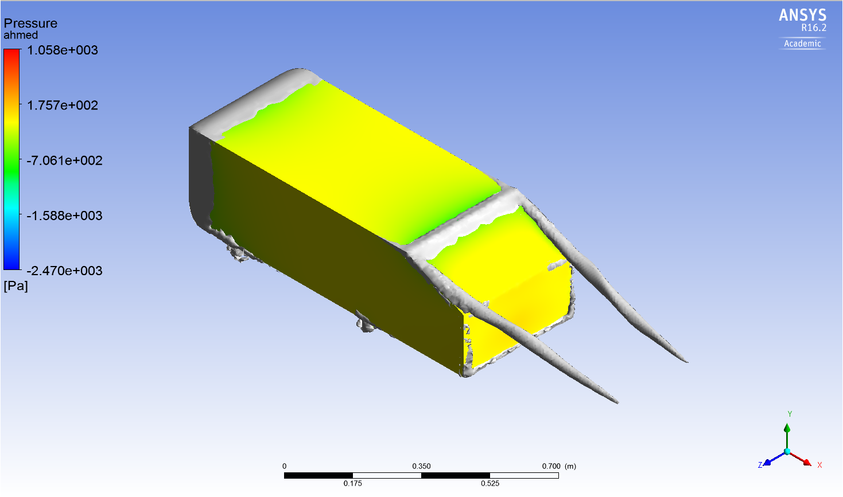
Figure 20 - Vortices created by the Ahmed body
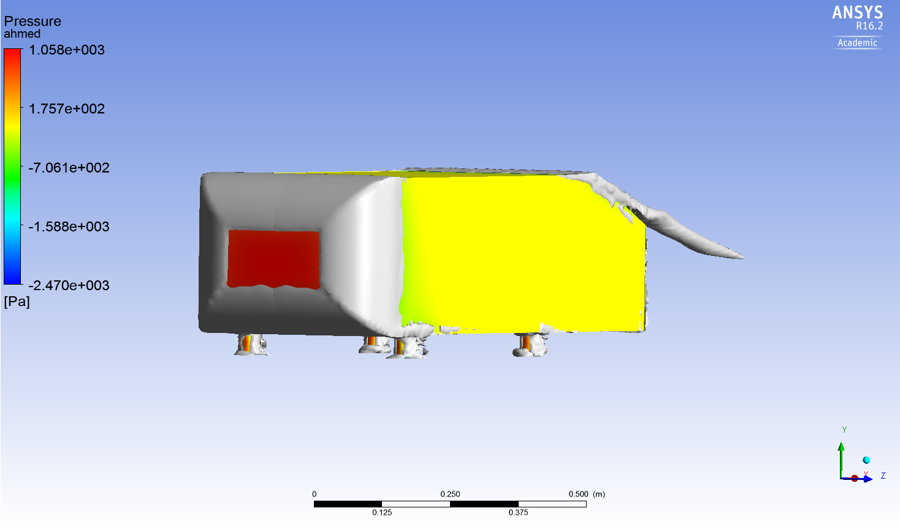
Figure 21 - Vortices created by the Ahmed body front view

Figure 20 and 21 show the vortices around the Ahmed body. Separation bubbles can be seen at the round edges of the front face. A vortex will be rotating within the separation bubbles.
‘Separation bubbles are then generated, whereby a shear layer isolates the separated flow from the undisturbed flow. A vortex rotates inside of the separation bubble… Its rotation axis is transverse to the incident flow and parallel to the edge, where the shear layer starts from (transverse eddies).’ (Schuetz, 2015)
After separating from the Ahmed body surface, the flow reattaches at a position further downstream. The stilts produce vortices.

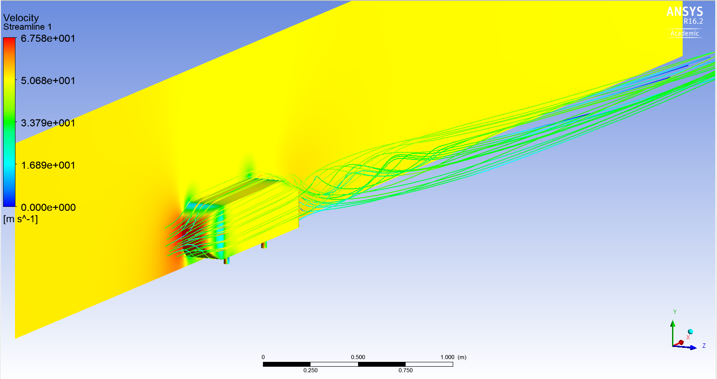
Figure 22 - Streamlines around the Ahmed body

Figure 22 shows the streamlines for the Ahmed body. These give a visual representation of how the fluid flows around the body. The flow remains attached at a slant angle of 25˚.

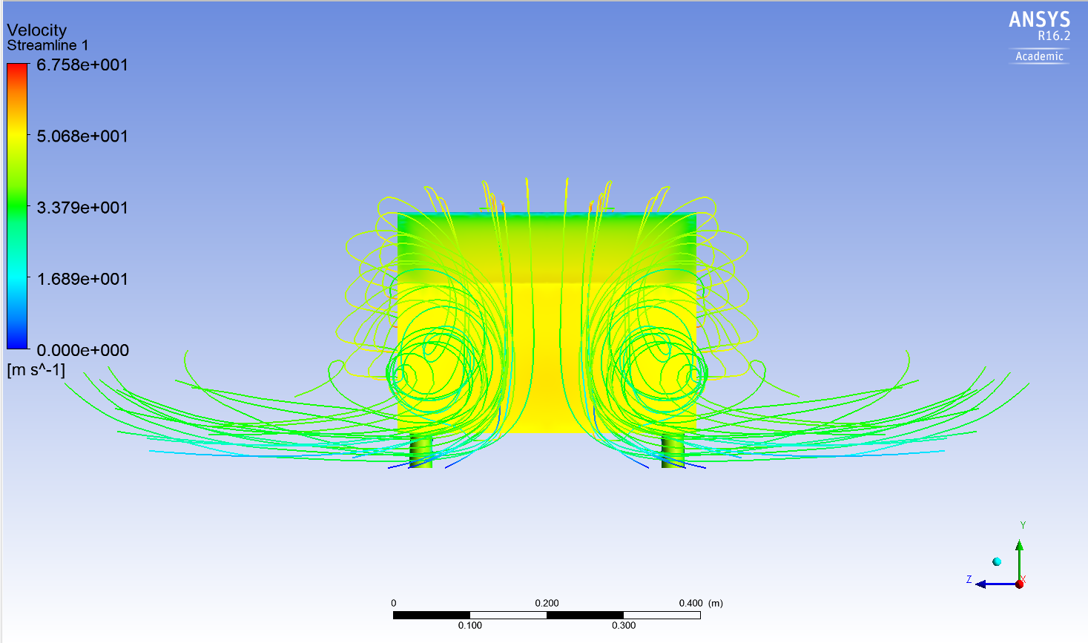
Figure 23 - Streamlines produced by the Ahmed body
Figure 23 shows the trailing vortices produced by the Ahmed body. Most vehicles have a higher pressure on the underside of the car compared to the top surfaces, therefore generating lift. Air will flow from the higher pressure underside to the top, producing vortices in the wake. A low pressure is created at the rear of the car since the trailing vortices draw air away from the rear of the vehicle. Reducing pressure over the rear of the car will create more drag.
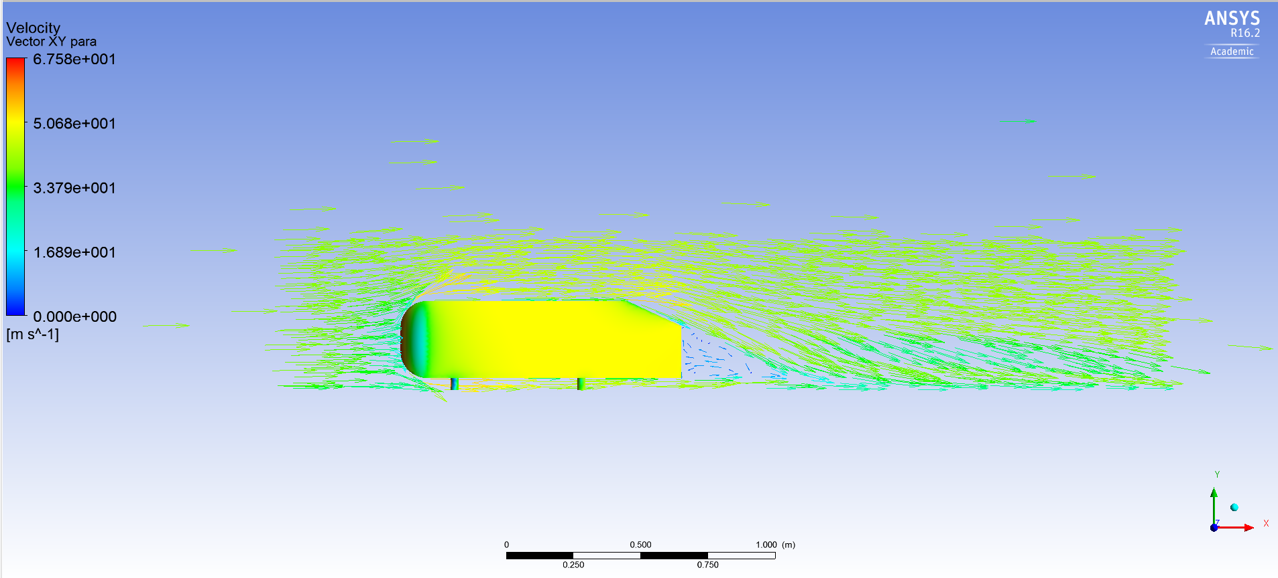
Figure 24 - Velocity vectors around the Ahmed body

Figure 24 shows the velocity of air travelling around the Ahmed body. As expected, the velocity is slow at the front face of the Ahmed body, where there is a high pressure. The air then accelerates from the high pressure front face, around the curved edges of the front face to the low pressure top face.
‘When air flows from a region of high pressure to one at a lower pressure, the pressure difference provides a force in the direction of flow, and the air therefore accelerates.’ (Barnard, 2015, p. 3)
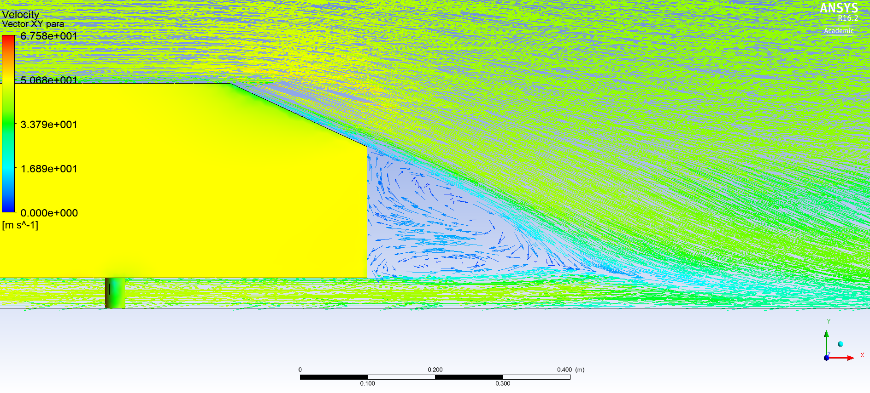
Figure 25 - Velocity vectors of Ahmed wake

Figure 25 and 27 show the wake flow pattern created by the Ahmed body. The airflow recirculates at the back of the body. These results are as expected and are very similar to the results observed by S. R. Ahmed (1984), for a body with slant angle 25˚ (Figure 26).
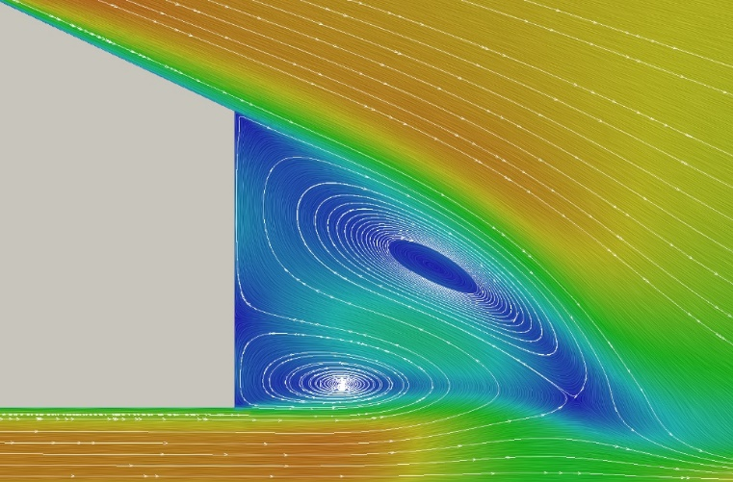
Figure 26 - Flow recirculation with slant angle 25˚ (Ahmed, 1984)

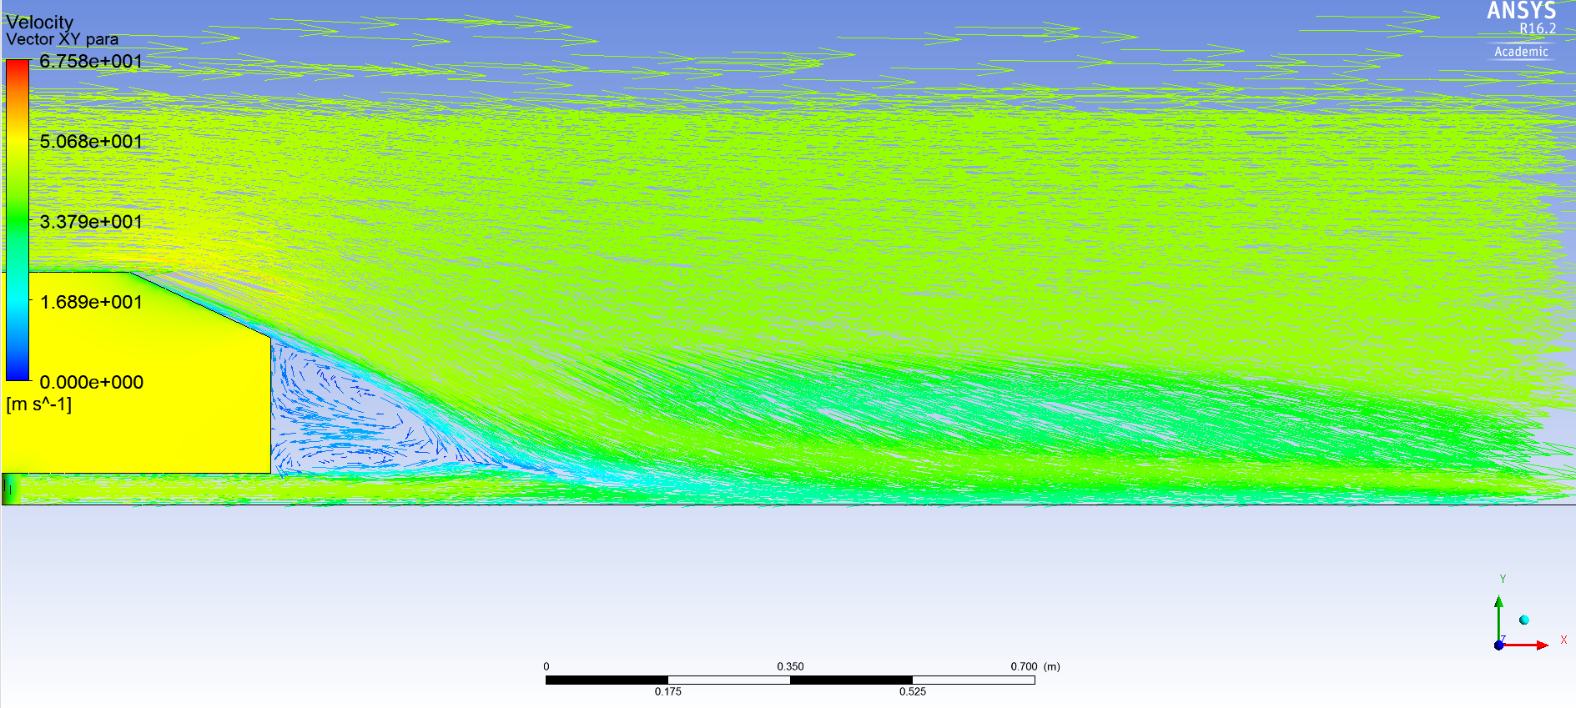
Figure 27 - Velocity vectors around Ahmed wake

Figure 27 shows the swirling c pillar vortex with relatively high velocity air.

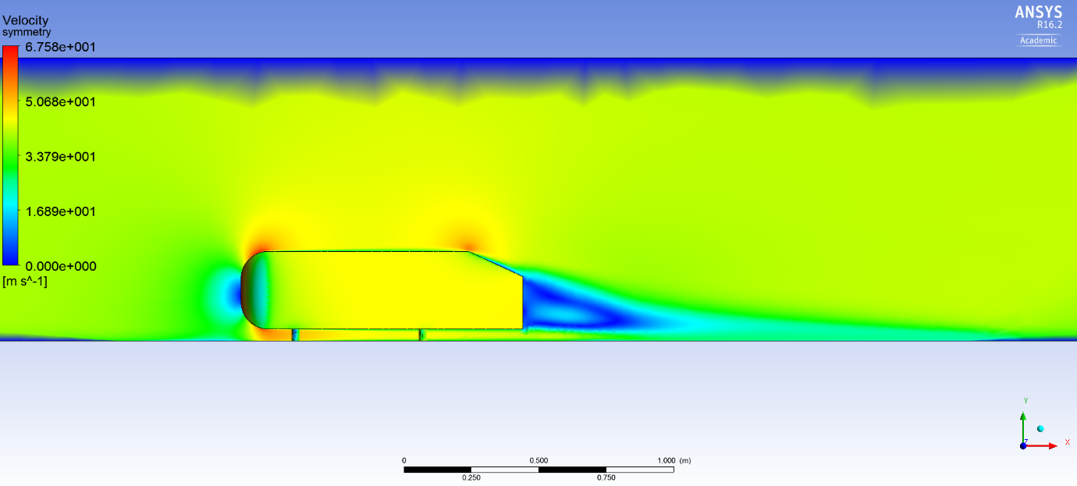
Figure 28 - Velocity on symmetry plane

Figure 28 shows velocity of air around the Ahmed body. There is very low velocity at the front face of the Ahmed body, and at the rear. The velocity of air at the surface of the top and bottom face of the Ahmed body is slower than away from the surface. This shows how a boundary layer is forming on the faces. The air is slow behind the Ahmed body, where the air is recirculating.

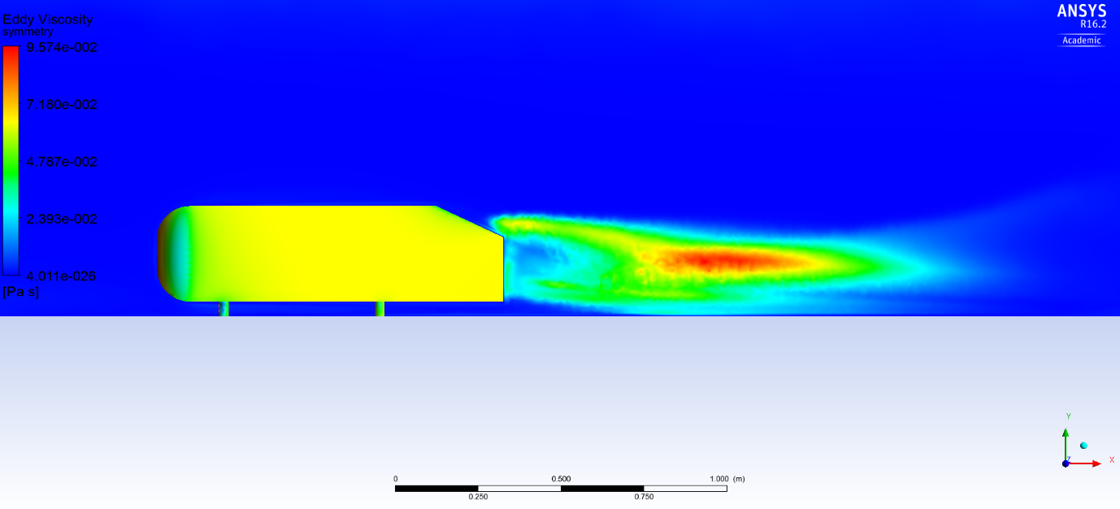
Figure 29 - Eddy viscosity of symmetry plane

Figure 29 suggests that the flow around the Ahmed body is laminar. Eddy viscosity is a function of the flow, the higher the turbulence the higher the eddy viscosity. The largest area of turbulence is reasonably high off the ground, and is likely due to the c-pillar vortices created.

Mesh effect on postprocessing results

A bad mesh was created in order to compare the postprocessing results with a good mesh. Table … shows the meshes used.
Table 12 - Bad and good quality mesh used

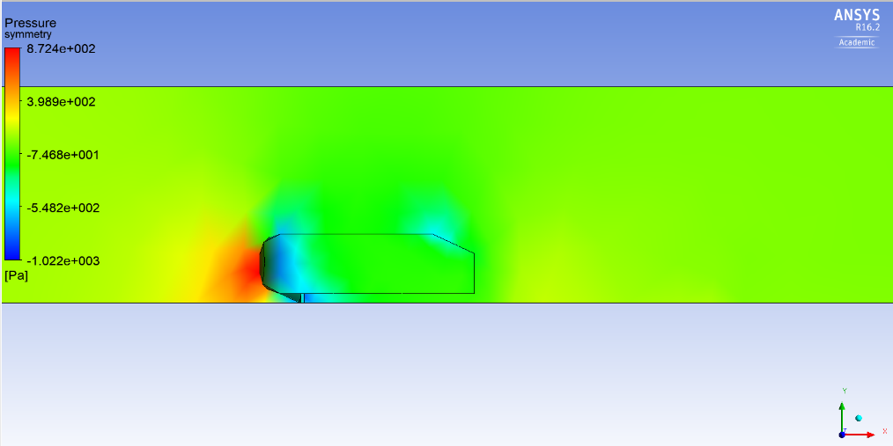
Figure 30 - Pressure results for bad quality mesh

Figure 30 show how the bad mesh cannot accurately represent the pressure around the Ahmed body. The transition from high to low pressure isn’t as smooth as it should, and the values differ vastly compared to the accurate mesh. Interestingly the elements are so large, that the curved edges on the front face of the Ahmed body haven’t been represented, and this will have a substantial effect on the drag value.

Figure 31 - Pressure results for good quality mesh
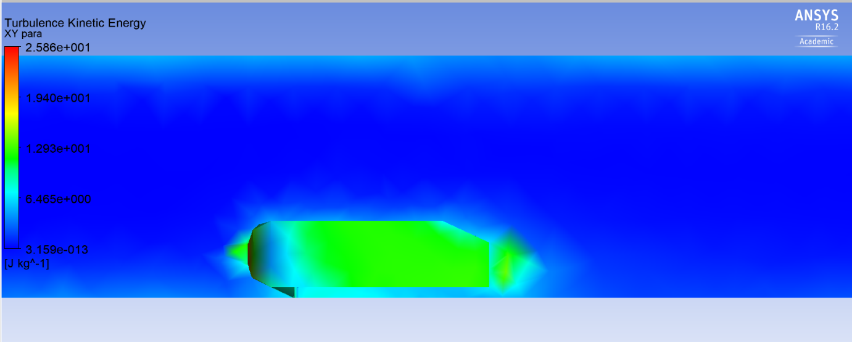
Figure 32 - Turbulence kinetic energy for bad quality mesh
Figure 32 shows the turbulence kinetic energy calculated using the bad mesh. The results are not smooth at all, and there is a high value at the front face of the Ahmed body. In comparison to Figure 33 which show the results of a good mesh, as there shouldn’t be much turbulence kinetic energy here as the velocity of air will be very small at this point.
Figure 33 - Turbulence kinetic energy for good quality mesh

Conclusion

To conclude, CFD is a very beneficial tool when studying the aerodynamics around a body. This report highlights how careful selection of the mesh is required for accurate results.
When conducting CFD for studies in industry, provided one has the budget, wind tunnel testing can also be used, and the results from the wind tunnel and CFD compared. The cost of CFD simulation will be much lower than using a wind tunnel, and using a wind tunnel alone can lead to small discrepancies in results. Using both, gives higher accuracy and the CFD results can be verified.
CFD is a balance between modelling time and accuracy, and unless the operator is very experienced, accurate results are difficult to obtain.
For more accurate, faster results a mosaic mesh could have been used. Also known as a poly-hexcore mesh, this can lead to better results and quicker solve times compared to a polyhedral mesh.
Some of the results produced very jagged graphs, and this is likely due to too large elements being tested. In future, testing would be conducted using a smaller mesh to begin with, however this would increase the solve time. Also the accuracy of the results didn’t appear to flatline.

Appendix

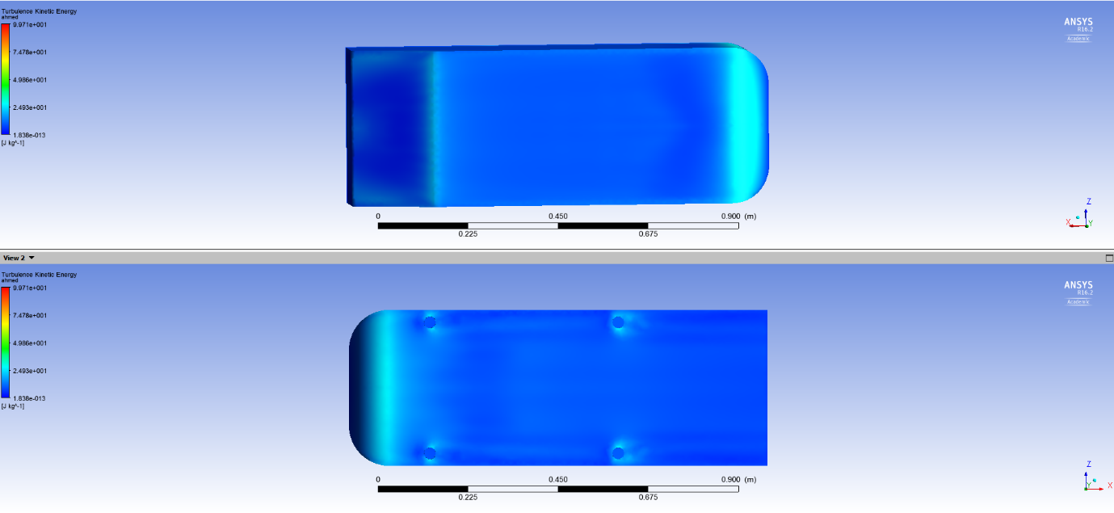
Figure 34 - Turbulence kinetic energy on Ahmed body faces

Figure 34 shows the turbulence kinetic energy on the face of the Ahmed body. There appears to be more turbulence on the top face of the body.

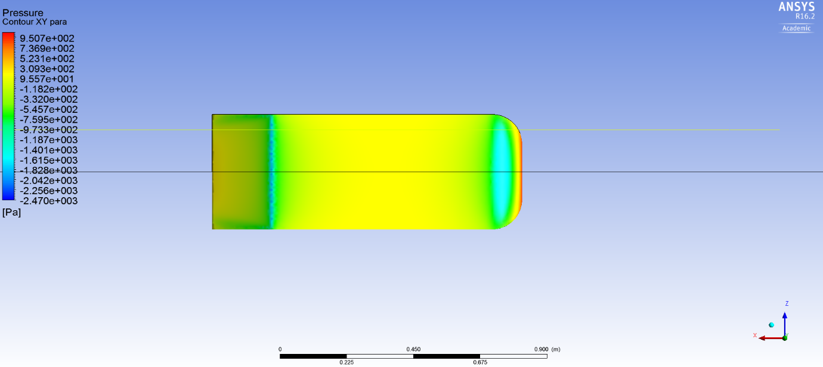
Figure 35 - XY para plane location

Figure 35 shows the location of the XY para plane and symmetry plane.
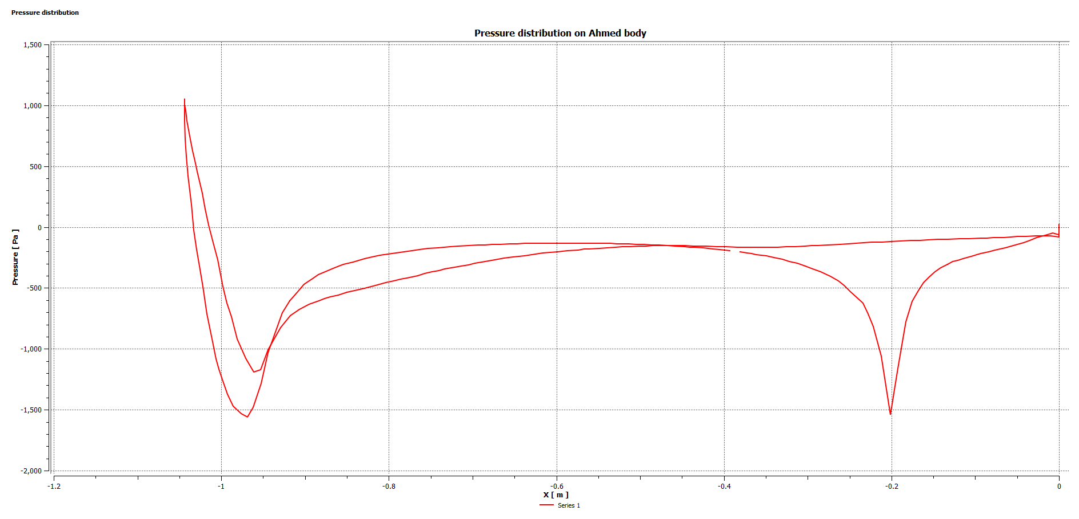
Figure 36 - Pressure distribution on Ahmed body

Figure 36 shows the pressure distribution on the Ahmed body.

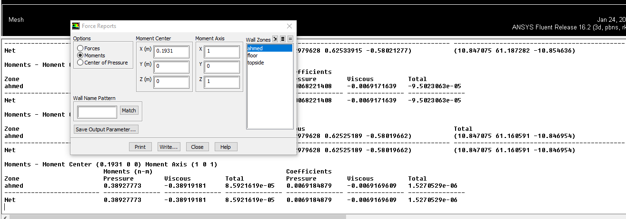
Figure 37 - Centre of pressure calculation in Fluent

Figure 37 shows how the centre of pressure was calculated. A value of 0.1931m from the rear of the Ahmed body was obtained.

References

Ahmed, S. R., 1984. Some Salient Features of the Time-Averaged Ground Vehicle Wake. [Online].
ANSYS, 2009. 4.4.3 Realizable k-epsilon Model. [Online]
Available at: https://www.afs.enea.it/project/neptunius/docs/fluent/html/th/node60.htm
ANSYS, 2009. Reynolds Stress Model. [Online]
Available at: https://www.afs.enea.it/project/neptunius/docs/fluent/html/th/node78.htm
ANSYS, 2010. ANSYS Fluent tutorial guide. [Online]
Available at: http://www.southampton.ac.uk/~nwb/lectures/2011/CompressibleFlowLab/flu_tg%5B1%5D.pdf
Barnard, R. H., 2015. Road Vehicle Aerodynamic Design. 3rd ed. s.l.:MechAero Publishing.
Christopher, B., 2015. Studying the Airflow Over a Car Using an Ahmed Body. [Online]
Available at: https://uk.comsol.com/blogs/studying-the-airflow-over-a-car-using-an-ahmed-body/
Frei, W., 2017. Which Turbulence Model Should I Choose for My CFD Application?. [Online]
Available at: https://uk.comsol.com/blogs/which-turbulence-model-should-choose-cfd-application/
Kapoor, A., 2016. A Quick Approach to Boundary Layer meshing - For Beginners. [Online]
Available at: https://www.linkedin.com/pulse/quick-approach-boundary-layer-meshing-beginners-awadh-kapoor-/
Šavli, M., 2012. Turbulence kinetic energy - TKE, s.l.: s.n.
Schuetz, T., 2015. Aerodynamics of Road Vehicles. 5th ed. s.l.:SAE.
SimScale, n.d. What is turbulent Flow?. [Online]
Available at: https://www.simscale.com/docs/content/simwiki/cfd/what-is-turbulent-flow.html
Solmaz, S., 2019. Turbulence: Which Model Should I Select for My CFD Analysis?. [Online]
Available at: https://www.simscale.com/blog/2017/12/turbulence-cfd-analysis/
Southampton Univeristy , n.d. What is the Prism Layer Meshing Model?. [Online]
Available at: http://www.southampton.ac.uk/~zxie/SESS6021/CCMP/online1/072-workingWithPrismMesh-02.html

List of figures

Figure 1 - Ahmed body geometry (Ahmed, 1984) 1
Figure 2 - Lift and drag against global scale factor 2
Figure 3 - Lift and drag accuracy against solve time 3
Figure 4 - Lift and drag against domain mesh size 4
Figure 5 - Lift and drag against density box mesh size 5
Figure 6 - Lift and drag against Ahmed body mesh size 6
Figure 7 - Lift and drag against number of prism layers on the Ahmed body and floor 7
Figure 8 - Lift and drag against number of prism layers on the Ahmed body 8
Figure 9 - Smallest domain geometry 9
Figure 10 - Domain used by Christopher (2015) for Ahmed body investigation 9
Figure 11 - Domain geometry against lift and drag 10
Figure 12 - Solution methods effect on lift and drag 14
Figure 13 - Most accurate mesh used 16
Figure 14 - Most accurate mesh used zoomed 16
Figure 15 - Pressure on symmetry plane results 17
Figure 16 - Pressure on XY para plane results 18
Figure 17 - Turbulent kinetic energy results 18
Figure 18 - Turbulent kinetic energy volume render results 19
Figure 19 - Turbulent kinetic energy volume render results side view 19
Figure 20 - Vortices created by the Ahmed body 20
Figure 21 - Vortices created by the Ahmed body front view 20
Figure 22 - Streamlines around the Ahmed body 21
Figure 23 - Streamlines produced by the Ahmed body 22
Figure 24 - Velocity vectors around the Ahmed body 22
Figure 25 - Velocity vectors of Ahmed wake 23
Figure 26 - Flow recirculation with slant angle 25˚ (Ahmed, 1984) 23
Figure 27 - Velocity vectors around Ahmed wake 24
Figure 28 - Velocity on symmetry plane 24
Figure 29 - Eddy viscosity of symmetry plane 25
Figure 30 - Pressure results for bad quality mesh 26
Figure 31 - Pressure results for good quality mesh 26
Figure 32 - Turbulence kinetic energy for bad quality mesh 27
Figure 33 - Turbulence kinetic energy for good quality mesh 27
Figure 34 - Turbulence kinetic energy on Ahmed body faces 29
Figure 35 - XY para plane location 29
Figure 36 - Pressure distribution on Ahmed body 30
Figure 37 - Centre of pressure calculation in Fluent 30

List of tables

Table 1 - Ahmed body expected lift and drag coefficients 1
Table 2 - Lift and drag against global scale factor 3
Table 3 - Lift and drag against domain mesh size 4
Table 4 - Lift and drag against density box mesh size 5
Table 5 - Lift and drag against density box mesh size 6
Table 6- Lift and drag against number of prism layers on the Ahmed body and floor 7
Table 7 - Lift and drag against number of prism layers on the Ahmed body 8
Table 8 - Domain geometry effect on lift and drag 9
Table 9 - Turbulence model effect on lift and drag 11
Table 10 - Mesh type effect on lift and drag 13
Table 11 - Accurate meshes results 15
Table 12 - Bad and good quality mesh used 26

