Cover Page

E-portfolio

Study skills in Psychology

Contents page

- AI Acknowledgement

- Task 1 - Article summary of “How to succeed in your degree, with Psychology…” by Paul Penn, taken from his new book ‘The Psychology of Effective Studying’ (Routledge).

- Task 2 - Infographic about ‘Time Management’.

- Task 3 - Essay outline to answer the ‘Describe and discuss the psychological, social and physical benefits of owning a pet’.

- Library Search Screenshots

- Summary of Sources

- Reference List

AI Acknowledgement

I acknowledge the use of Canva Untitled design - Infographic - Canva on 11/10/2024 to create a template infographic enabling me to input my own research onto it.

I used the prompt:
- Time Management Infographic

I confirm that I have not presented any AI generated text as my own work. I confirm I have copies of my drafts, notes, and other resources I used before, and after the use of AI tools which I may be asked to provide in evidence.

Task one – Summary of Article
How to succeed in your degree, with psychology… Penn, P. (2019).
Using his research into optimal approaches to studying, (Penn, P. 2019b) catalogues seven different types of study approaches, specifically aiming this article to university students. Penn references many Psychologists and their research to evidence the positive outcomes that could arise by using these approaches.
Metacognition – the accuracy of evaluating one’s own knowledge of a topic. Penn suggests retrieval practice to avoid the Dunning-Kruger effect – studies suggest that those who know the least are more likely to be unaware of their ignorance and therefore, unlikely to take action to rectify the issue. (Kruger and Dunning, 1999, cited by Penn, P., 2019b). Penn recommends retrieval practice as a more effective means of study other than rereading. (Karpicke, 2017, cited by Penn, P., 2019).
Gollwitzer and Sherman (2006, cited by Penn, P., 2019b) suggested that ‘implementation intentions’ can be used to tackle procrastination. Using this approach could help students with their time management plans.
Several studies (Pressley et al., 1987; Ozgungor and Guthrie., 2004; McDaniel et al. 2009, cited by Penn, P., 2019a) suggest that good paraphrasing practice is made up of approaches such as; ‘elaborative interrogation’ and the ‘Read, Recite and Review Method’. These will inadvertently lower the chances of a student plagiarizing work as they are in the habit of note-taking in their own words.
The guru effect (Sperber, 2010, cited by Penn, P., 2019b) suggests that the more difficult something is to understand the more weight of worthiness is given to it. In regards to student writing for tutors, Oppenheimer (2006, cited by Penn, P., 2019) evidences that this is not the case in university. It is better to keep your writing simple and clear.
Penn, P (2019b) also lists teamwork, presentations, and revision, referencing studies by (Bjork and Bjork, 2011; Brooks and Ammons, 2003; Alley et al. 2009; Williams et al. 1981) to suggest peer evaluation, ‘spacing and retrieval practice’ and the ‘assertion/evidence-based slides’ to elevate students’ academic success.
Penn, P. (2019b) concludes that study can be fun and effective when practices that are informed by Psychological research are applied for greater academic results.

Task Two - Infographic on Time Management


Task three: Essay Plan
Title – ‘Describe and discuss the psychological, social and physical benefits of owning a pet.’
Introduction  100-200 words | General  introductory  comments | Hypothesis - that it is beneficial, especially in those with health issues. Mention that animals are used in therapy and touch upon my own experience with being an only child on a farm.
Paragraph 1 | Topic sentence | What is health? Do we need a broader definition? Wellbeing through relationship with pet, social interactions increased or only economic status and other factors contribute and that explains the good health of the owners. How do we measure the benefits? Must mention the possible negative health effects of owning a pet. Depends on the type of pet. 90% of pet owners consider them family members UK.  2/3 households in USA have a pet.
Paragraph 1 | Support | McNicholas, J., Gilbey, A., Rennie, A., Ahmedzai, S., Dono, J.-A., & Ormerod, E. (2005).  Herzog, H. (2011).
Paragraph 2 | Topic sentence | Mental health and pet ownership as a meaningful occupation for people with serious mental illness. Physical benefits of responsibility to care for your pet.
Paragraph 2 | Support | Zimolag, U., & Krupa, T. (2009).
Paragraph 3 | Topic sentence | Pet ownership and human health (1980’s onwards). Children in first year of life and exposure to pet allergens – less asthma and allergic rhinitis. Less visits to GP’s.  “The Pet-Effect” – companionship, emotional support, stress reduction, cardiovascular benefits.
Paragraph 3 | Support | McNicholas, J., Gilbey, A., Rennie, A., Ahmedzai, S., Dono, J.-A., & Ormerod, E. (2005).  Herzog, H. (2011).  Allen, K. (2003).
Paragraph 4 | Topic sentence | Benefits of pet ownership in older people – conclusion was no health benefits for this group – associated with higher depression, higher dosage of pain medications and less conforming to social norms indicated by higher levels of Psychoticism.
Paragraph 4 | Support | Parslow, R. A., Jorm, A. F., Christensen, H., Rodgers, B., & Jacomb, P. (2005).
Paragraph 5 | Topic sentence | Discuss range of socio-demographic factors and pet ownership in seven-year-old children from a UK cohort.  A number of socio-demographic factors are associated with pet ownership in childhood and adolescence and they differ according to the type of pet, and age of child. These factors are potential confounders that must be considered in future HAI studies.
Paragraph 5 | Support | Purewal, R., Christley, R., Kordas, K., Joinson, C., Meints, K., Gee, N., & Westgarth, C. (2019).
Conclusion  5-10% of your doc | Summary of main ideas | Discuss it is dependent on many factors such as; socio-economic, age, social class, type of pet, gender, education level, previous health issues/ post trauma recovery, number of pets, household income, our definition of human health and mental health. Also, consider the effects of the loss of a pet, compare with benefits.
Conclusion  5-10% of your doc | Concluding remarks/recommendations | Reference all paragraphs in relation to my conclusion and suggest we cannot come to a definitive answer to my hypothesis but it is dependent on many factors mentioned in main conclusion.  Carlisle, G. K., Johnson, R. A., Wang, Z., Brosi, T. C., Rife, E. M., & Hutchison, A. (2020).

Library Search Screenshot

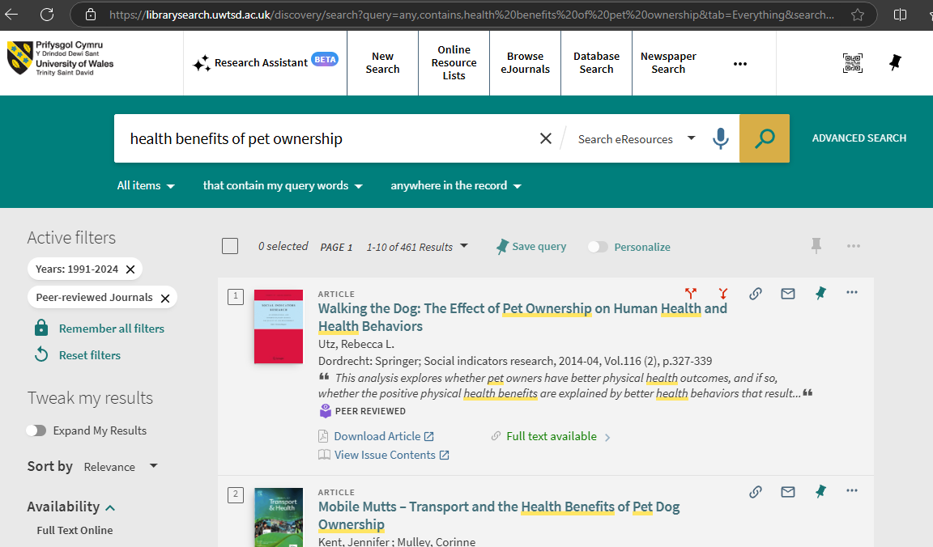

Summary of sources
- How will you decide which sources to use?

When searching for sources, I only used the library webpage. I used the filters to ensure I only saw journals that were classed as peer reviewed. This ensured that the text was reliable, correct, and accurate. I also read through the introduction of the text first, to ensure it was relevant to the topic I was discussing. I also searched for text between 1990-2024 as I felt that this would give me the most current research into the specific approaches I wanted to highlight.

References

Article
Alley, M., Schreiber, M., Ramsdell, K. & Muffo, J. (2006). How the design of headlines in presentation slides affects audience retention. Technical Communication, 53 (2), 225-234.
Bjork, E. L. & Bjork, R. A. (2011). Making things hard on yourself, but in a good way: Creating desirable difficulties to enhance learning. In M.A. Gernsbacher, R. W. Pew, L. M. Hough & J. R. Pomerantz (Eds.), Psychology and the real world: Essays illustrating fundamental contributions to society (pp. 56-64). Worth Publishers.
Brooks, C. M. & Ammons, J. L. (2003) Free riding in group projects and the effects of timing, frequency, and specificity of criteria in peer assessments. Journal of Education for Business. 78 (5), 268-272.
Karpicke, J. D. (2017). Retrieval-based learning: A decade of progress. In J. T. Wixted (Ed.), Cognitive Psychology pf memory. Vol. 2 of Learning and memory: A comprehensive reference (J. H. Byrne, Series Ed.) (pp. 487-514). Academic Press.
Kosslyn, S. M., Kievit, R. A., Russel, A. G. & Shephard, J. M. (2012). Power-Point presentation flaws and failures: A psychological analysis. Frontiers in Psychology, 3, 1-22.
Kruger, J. & Dunning, D. (1999). Unskilled and unaware of it: How difficulties in recognizing one’s own incompetence leads to inflated self-assessments. Journal of Personality and Social Psychology, 77 (6), 1121-1134.
McDaniel, M. A., Howard, D. C. & Einstein, G. O. (2009). The read-recite review Study strategy: Effective and portable. Psychological Science, 20 (4), 516-522.
Oettingen, G., Honig, G. & Gollwitzer, P. M. (2000). Effective self-regulation of goal attainment. International Journal of Educational Research, 33(7–8), 705–732.
Oppenheimer, D. M. (2006). Consequences of erudite vernacular utilized irrespective of necessity: Problems with using long words needlessly. Applied Cognitive Psychology: The Official Journal of the Society for Applied Research in Memory and Cognition, 20(2), 139–156.
Ozgungor, S. & Guthrie, J. T. (2004). Interactions among elaborative interrogation, knowledge, and interest in the process of constructing knowledge from text. Journal of Educational Psychology, 96(3),437–443.
Penn, P. R. (2019a). How to succeed in your degree, with Psychology…. The Psychology of Effective Studying. Routledge.
Penn, P. R. (2019b, November 12) How to succeed in your degree, with psychology. The Psychologist. DOI: How to succeed in your degree, with psychology… | BPS
Pressley, M., McDaniel, M. A., Turnure, J. E., Wood, E. & Ahmad, M. (1987). Generation and precision of elaboration: Effects on intentional and incidental learning. Journal of Experimental Psychology: Learning, Memory, and Cognition, 13(2), 291–300.
Sperber, D. (2010). The guru effect. Review of Philosophy and Psychology, 1(4), 583–592.
Williams, K., Harkins, S. G. & Latane, B. (1981). Identifiability as a deterrent to social loafing: Two cheering experiments. Journal of Personality and Social Psychology, 40(2), 303–311.
Infographic
Forsyth, P. (2013). Successful time management (Third edition). Kogan Page Ltd.
Fostervold, K. I., Ludvigsen, S., & Strømsø, H. I. (2022). Students’ time management and procrastination in the wake of the pandemic. Educational Psychology, 42(10), 1223–1240. https://doi.org/10.1080/01443410.2022.2102582
McMillan, K. (2021). The study skills book: your essential guide to university success (Fourth edition). Pearson Education Limited.
Essay Plan
Antonacopoulos, N. M. D., & Pychyl, T. A. (2008). An Examination of the Relations between Social Support. Anthropomorphism and Stress Among Dog Owners. Anthrozoös, 21(2), 139–152. https://doi-org.ezproxy.uwtsd.ac.uk/10.2752/175303708X305783
Carlisle, G. K., Johnson, R. A., Wang, Z., Brosi, T. C., Rife, E. M., & Hutchison, A. (2020). Exploring Human-Companion Animal Interaction in Families of Children with Autism. Journal of Autism and Developmental Disorders, 50(8), 2793–2805. https://doi.org/10.1007/s10803-020-04390-x
Herzog, H. (2011). The Impact of Pets on Human Health and Psychological Well-Being. Current Directions in Psychological Science, 20(4), pp.236–239. doi: https://doi.org/10.1177/0963721411415220
McNicholas, J., Gilbey, A., Rennie, A., Ahmedzai, S., Dono, J.-A., & Ormerod, E. (2005). Pet ownership and human health: a brief review of evidence and issues. BMJ, 331(7527), 1252–1254. https://doi.org/10.1136/bmj.331.7527.1252
Parslow, R. A., Jorm, A. F., Christensen, H., Rodgers, B., & Jacomb, P. (2005). Pet Ownership and Health in Older Adults: Findings from a Survey of 2,551 Community-Based Australians Aged 60–64. Gerontology (Basel), 51(1), 40–47. https://doi.org/10.1159/000081433
Purewal, R., Christley, R., Kordas, K., Joinson, C., Meints, K., Gee, N., & Westgarth, C. (2019). Socio-demographic factors associated with pet ownership amongst adolescents from a UK birth cohort. BMC Veterinary Research, 15(1), 334–15. https://doi.org/10.1186/s12917-019-2063-x
Zimolag, U., & Krupa, T. (2009). Pet ownership as a meaningful community occupation for people with serious mental illness. The American Journal of Occupational Therapy, 63(2), 126–137. https://doi.org/10.5014/ajot.63.2.126

