University Trinity Saint David
Institute of science & art

Project Second Assessment
Integrating Project ACHA4008

Calum Campbell (2001090), Sam Cashell (2004364), Owain Wilcox (2003601),
Aulon Pashoja (2009355), Ella Chaves (1809262)
Date (05/21)

Contents
1 Introduction 2
2 Methodology and Development 3
3 Forces and Analysis 10
4 Conclusions 13
5 Evaluations 14

Figure 1- parts list 3
Figure 2-control arm 4
Figure 3-Rear axle 5
Figure 4-Steering column/front roll bar 5
Figure 5-Rear anti-roll bar 6
Figure 6- Steering Knuckle 7
Figure 7- Bike wheel 8
Figure 8-Isometric view of Gravity racer 9

Introduction
This Assignment shows and demonstrates the team’s ability to take the final drawings from the “Integrating project part 1” to create a realistic and accurate model of the gravity racer, AKA Project GAS, in computer aided design software, the program used to produce the gravity racer was Solidworks. Further to this, is a detailed overview of how JDM Kart was created including changes that had to be made in order to make the team’s vision for the gravity racer a reality, as well the overall effectiveness of the original design and how well it translated into a computer aided design program.

Methodology and Development
In this section of the report, the process and evaluation of the procedures used in Solidworks to create Project GAS will be overviewed as well as the changes that were required to be made to produce the Gravity racer.
To begin with, a stable chassis had to be created in Solidworks. To achieve this a parts list was first created before assembly which included varies lengths of 3mm thick box section iron at 30mm width and height. See Figure 1.
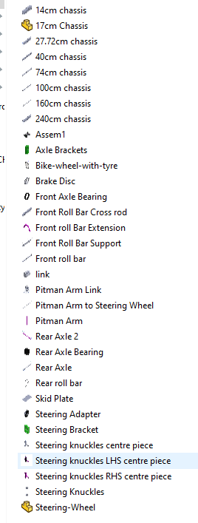
Figure 1- parts list

The parts created were then placed into an assembly page to begin mating them together to create the chassis. Based on the original design, a change had to be made to the dimensions between the lower chassis floor and the upper support rails due to not taking into consideration the thickness of the box section being 30mm. Once this was corrected then the bare chassis was assembled without further issues as per the final design.
On completion of the chassis, control arms were designed and created using trigonometry to get the angles on the box steel to mate to the chassis upper and lower side rails with a 10mm hole on both upper and lower arm to allow for the knuckle to placed and pivot at a later point. See Figure 2.

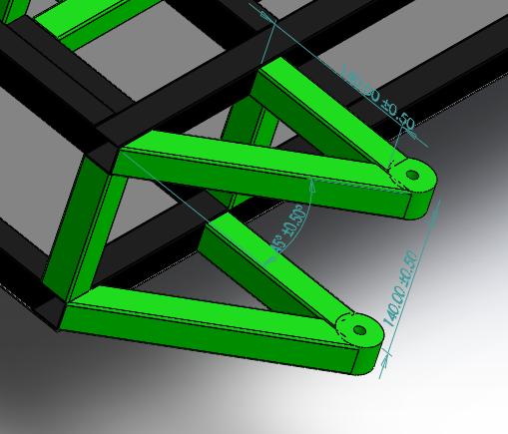
Figure 2-control arm

The rear axle was designed using a cylinder that was extruded to length, with a radius of 10mm and threaded on each end to allow for the installation and fixing of the wheels. The axle was then placed through a cylindrical sleeve with an inner radius on 11mm that was fixed to the lower part of the chassis using brackets designed for extra support to take the weight and forces applied through the axle. Further to this a flange was added to the rotating axle to allow for the bolting on of the brake disc. See Figure 3.

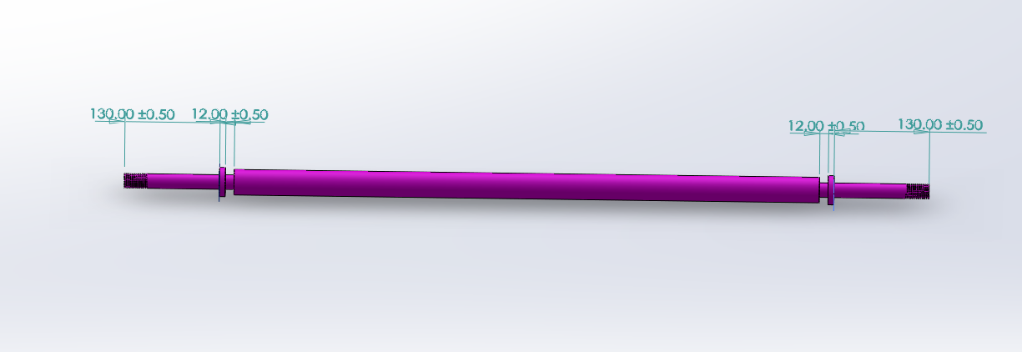
Figure 3-Rear axle

The front roll bar which also acted as the steering support was then implemented to the front of the Gravity racer using box section iron. This part included an angle of 25 degree at the mating point with the opposite end being angled at 65 degree to create a 90 degree angle to be able to mount the steering wheel directly in front of the Driver. Furthermore, strengthening bars were placed into the front roll bar to form a triangular support which increased the structural integrity for the safety of the Driver. See Figure 4.
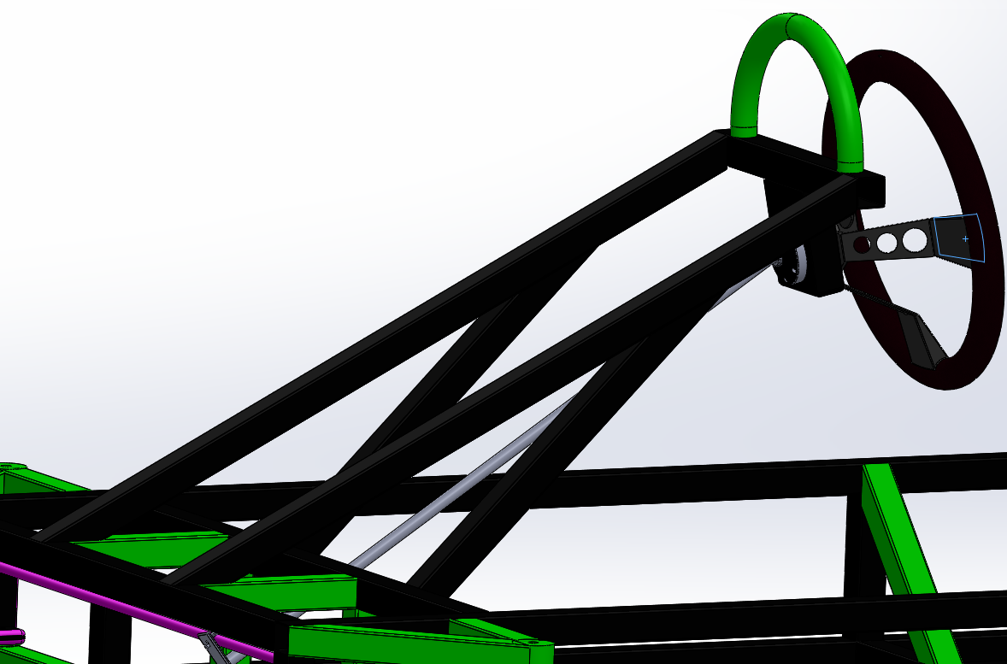
Figure 4-Steering column/front roll bar
Creating the Rear anti roll bar required some trial and error due to missing dimensions on the final design, therefore this part was re-designed completely to be able to be functional and retain the original safety specification as set out in the rules and regulations of Richards Castle’s Gravity race Criteria for entry. See figure 5.

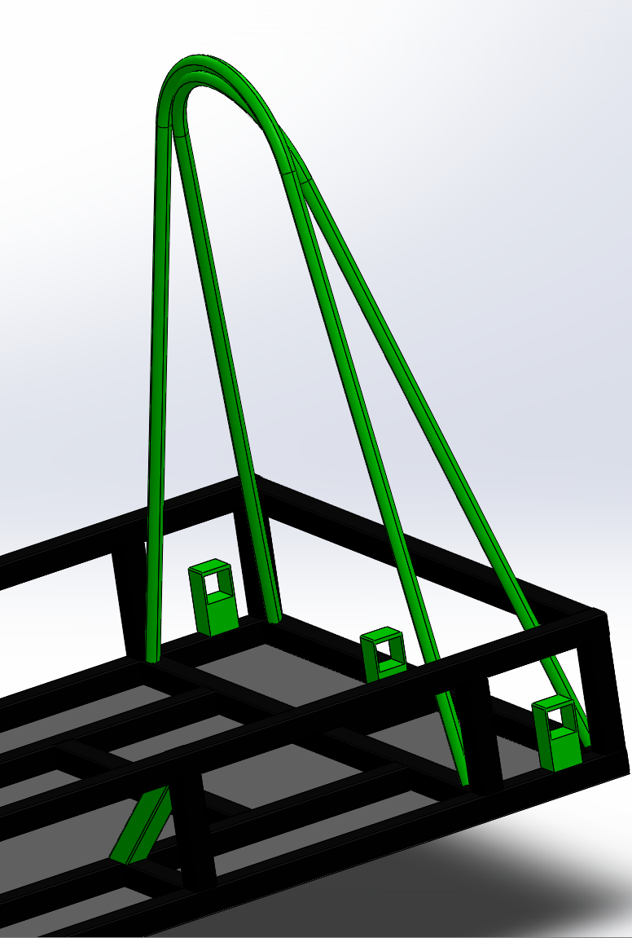
Figure 5-Rear anti-roll bar

The steering knuckle had to be redesigned for CAD, the original part was going to be used with a stiff spring to accommodate for knuckle being shorter than the lower arm but after reviewing this the team decided to modify the existing knuckle by extending its length by 70mm so that it fitted between the front upper and lower arm without a spring. See Figure 6.

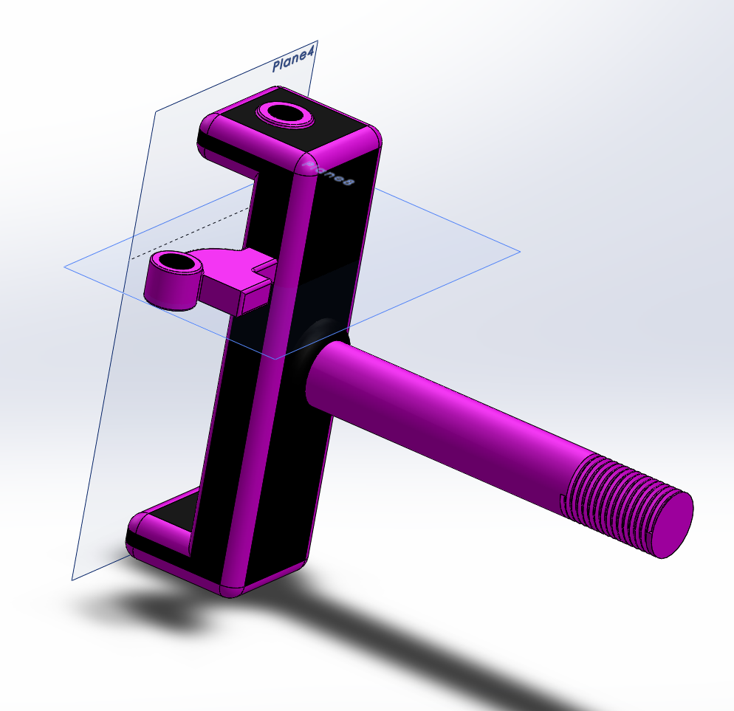
Figure 6- Steering Knuckle

Wheels were designed with a taller rim and tyre due to the modified knuckle to increase the karts ride height to keep within the regulations. See Figure 7.

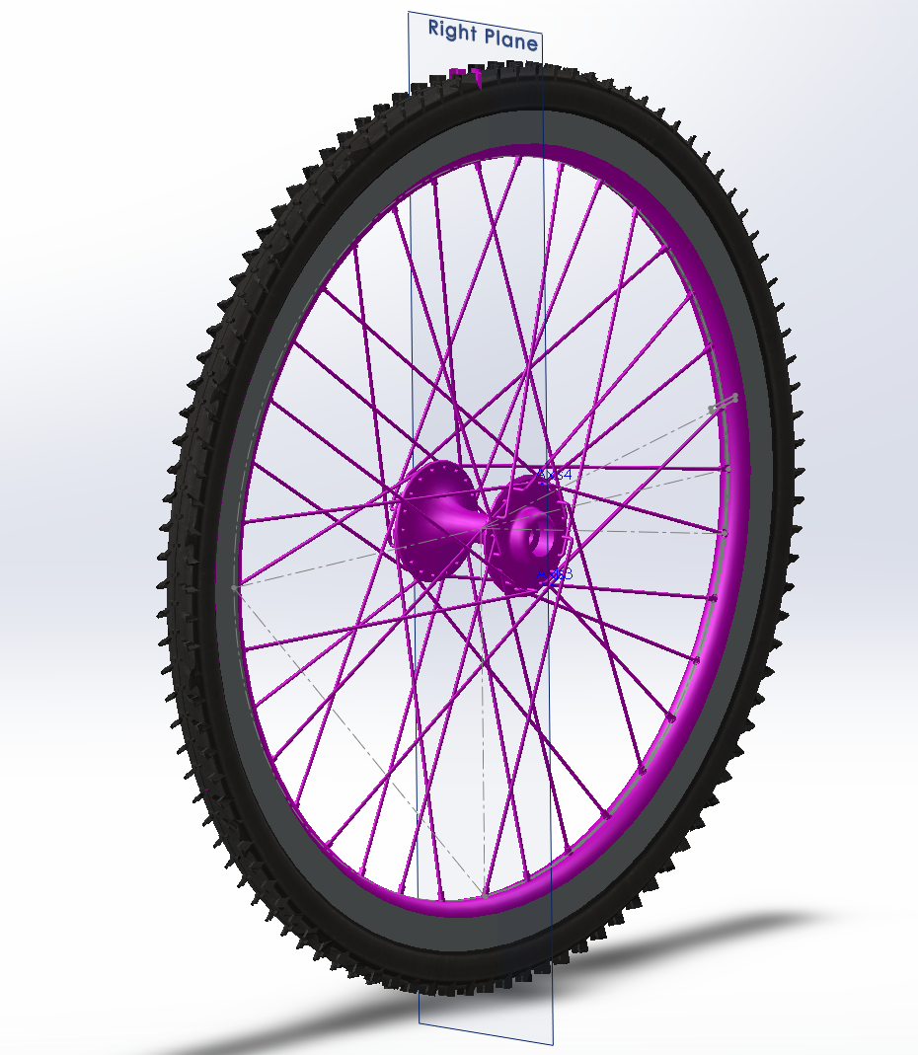
Figure 7- Bike wheel
A pitman arm steering system was used for the steering system which is functional, working through a universal joint attaching to the steering wheel.

Below in Figure 8 the final CAD isometric view of the gravity racer

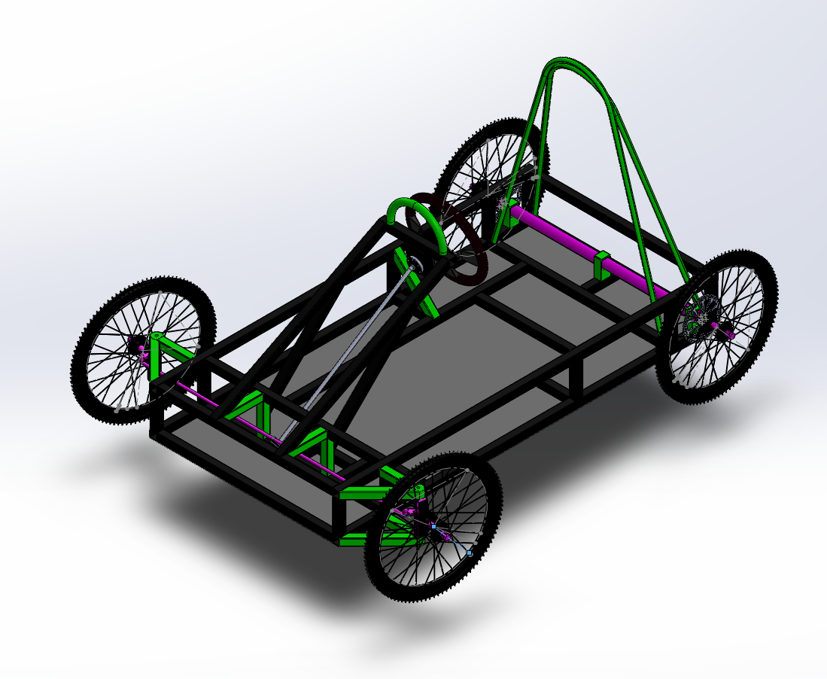
Figure 8-Isometric view of Gravity racer

Forces and Analysis
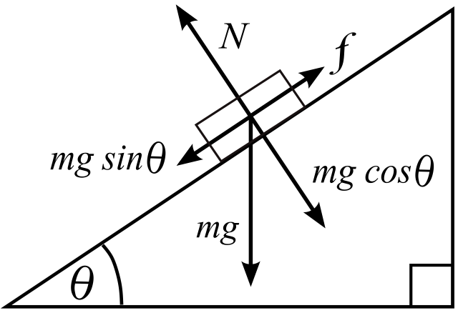
Figure 00 above depicts the forces acting on the Gravity racer when on an inclined plane,
F= Friction
mg = the mass x gravity of the kart (weight)
mg sin Ꝋ= the angle of the incline multiplied by the weight (mg) of the kart
Ꝋ= The angle of the incline
N = Reaction Force
From Figure00 the team was able to draw a forces diagram. The objective of this was to understand the magnitude of forces acting on the racer at the starting block. This allowed calculations to be made in order to ensure that the brakes were capable of applying enough clamping force to hold the kart stationary based on the design implemented.
Due to using box section iron 30mm x 30mm x 3mm, the weight of the kart was able to be calculated. 20 metres of iron weighing 2.51kg/m was used making the overall chassis weight 50.2kg. Factoring in the ancillaries such as brakes, wheels and driver, the overall weight was estimated to be around 150kg. This value was then used to calculate the forces applied to the gravity racer at the starting block on the 1/8 incline.

The formula below was used to calculate the angle on inline at the starting block.
mgsin Ꝋ =Nm
${Tan}^{-1}(\frac{1}{8})$ = 7.125 degrees
150x9.81xsin(7.125)=182.517Nm
This shows that the brakes had to exceed a force of 182.517Nm to maintain stationary. As a result, two new equations were used to calculate the force that the driver must apply to the brake pedal to keep the kart stationary at the top of the gradient.
The first equation was used in conjunction with the second via a trial-and-error method to calculate the force that needed to be applied.
Nm x r = T
Nm = Newtown Metres
r = Radius
T = Torque

The second formula is to find the clamping force applied to a 2 faced friction faced disc with the values of the karts braking system used using a friction coefficient of 0.4.$$C=\frac{T}{(r)(Nf)(n)}$$
C = Disc brake clamping load
r = effective radius of disc
Nf = Disc lining material friction coefficient
n = number of friction faces
$$C=\frac{6}{(0.075)(0.4)(2)}$$
C = 100 newtons of force
100 x 2 (number of discs on Gravity racer) = 200N
Therefore, for the Kart to remain stationary at start a force of around 80Nm was needed to be applied to the pedal by the driver as no leverage was implemented into the brake pedal.

To further support the practicality of the team’s gravity racer, the potential energy of the kart was calculated, due to knowing the mass of the racer already at 150kg and it being stated on the Richards Castle website the height of the course being 50m, the equation PE=mgh was used for this.
$$PE=mgh$$
m = 150
g = 9.81
h = 50
PE = 150 x 9.81 x 50
$P.E.=73575J$
This value of 73575 Joules shows the racers potential energy at the start of the course, from this information, the final velocity at the end of the course can be formulated using the equations below. $K.E.=\frac{1}{2}mv^{2} = P.E.=mgh$
$\frac{1}{2}mv^{2}=mgh$ $\frac{1}{2}v^{2}=gh$
$\frac{1}{2}v^{2}=9.81*50$ $\frac{1}{2}v^{2}=490.5$ $v^{2}=\frac{490.5}{\left(\frac{1}{2}\right)}$ $v^{2}=981 v=\sqrt{981}$ $v=31.32m/s$
This final velocity figure of 31.32m/s is a value obtained in a frictionless environment, due to this fact, the final velocity would be lower than this because of friction of the course and moving components on the gravity racer. However, it is a great indication of the potential of Project GAS should it be practically developed and tested.

Conclusions
To conclude the project of creating a Gravity racer in CAD Solidworks based off the final design created in the first Integrating project, the overall conversion from final drawings to computer aided design was an overall a success once the parts were created and the dimension errors were corrected, this project provided fantastic experience moving forward to future designs and a great insight into how a group needs to be structured in order to effectively complete a group project such as this. The implantation of force formulas further supported this assignment and demonstrated the practicality and functionality of project GAS.

Evaluations
To evaluate this Project, the team had a slow start due to communication problems and a lack of leadership at project start, once this had been organised, the active members of JDM Kart then worked well and communicated efficiently to be able to complete the task on time and to a high standard of quality with a lot of detail being placed on the functionality of the racer in CAD.

