Abstract
This Essay lays the groundwork for comprehending the critical issues associated with safeguarding information assets, determining the levels of protection and response to security incidents, and designing a consistent, reasonable information security system with appropriate intrusion detection and reporting capabilities.
Introduction
Multiple layers of protection are distributed across the networks, computers, programmes, and data that are intended to remain non-harmful in an effective cybersecurity strategy [1]. Cybersecurity has growing progressively throughout the years for the simple reason of the expansion of Online services. In 2010, the security community documented less than 50 million distinct malware executables. In the year 2012, this reported number doubled to around 100 million [2]. The improved of the Cybersecurity community means that the threats and vulnerabilities are rising along to mitigate and to prevent any type of threats in the following paper I will explain different topics and subjects that helps mitigates and prevent these threats.
Task 1- Research in Data Security and Compliance
Background
In 1943 After the first digital computer was developed, cyberattacks were difficult to execute for approximately 20 years. Small groups of people had access to the massive electronic devices, which were not networked, and only a handful of people knew how to operate them, rendering the threat virtually non-existent [3]. In the 1970 is where the Cyber attack has started to become from frequently to common due to the fact that ARPANET was the first rudimental network before internet was constructed. Since the 1970s, when the importance of security features in information systems began to increase due to the growth of computing power, multiuser computer systems, and shared file systems16, information security has been a crucial component of the information processing systems of the Finnish Government and the Finnish Defence Forces [4]. The most crucial change that incentivized to breach and attack was due to the poor security features the network was developed. Internet was initially used by researchers and the number of users at that time was relatively smaller compared to the number of users that are connected to internet nowadays. The term 'cybersecurity' can be traced back to at least the late 1980s, and its conceptual antecedents are much older; however, its current usage is relatively new [5]. Before using the name cybersecurity, the first conception was information security, while analysing the term it is possible to identify that it was a new concept so to understand the threats and the attacks, they had to gather information. According to Craigen utilising a variety of tools, guidelines, and practises, cybersecurity protects software programmes, computer networks, and data from attack, unauthorised access, or damage [6]. In a nutshell, information security is concerned with the identification of vulnerabilities or implementation of appropriate defence to protect the assets indicated below [7].
- Confidentiality is the property that precludes the disclosure of information to unauthorised entities, individuals, or computer systems.
- Integrity is a property that safeguards data from unauthorised modification or deletion.
- The purpose of availability is to ensure that authorised entities have prompt and dependable access to information assets and systems.

Security Risks
There are three primary security factors that are commonly regarded as threats:
(1) assaults -- who is assaulting, system vulnerabilities.
(2) the vulnerabilities or security holes they are exploiting and their effects.
(3) the repercussions of the attack.
Before implementing any defence, system these are the elements to consider.
Therefore, it is essential for organisations to have a plan in place to respond swiftly and effectively to a security breach. Different types of cybersecurity incidents may place the systems and networks of an organisation or an individual at risk [8]; they can be grouped as follows:
- Phishing attacks - Numerous definitions of the term "phishing" have been proposed and discussed by cybersecurity specialists, researchers, and institutions. Although there is no established definition for the term "phishing" due to its ongoing evolution, this term has been defined in a variety of ways based on its usage and context [9]. Phishing is a form of social engineering that involves deceiving individuals into disclosing sensitive information, such as passwords and credit card numbers, by posing as a reputable entity, such as a bank or an employer. Figure 1 shows an example of phishing attack.
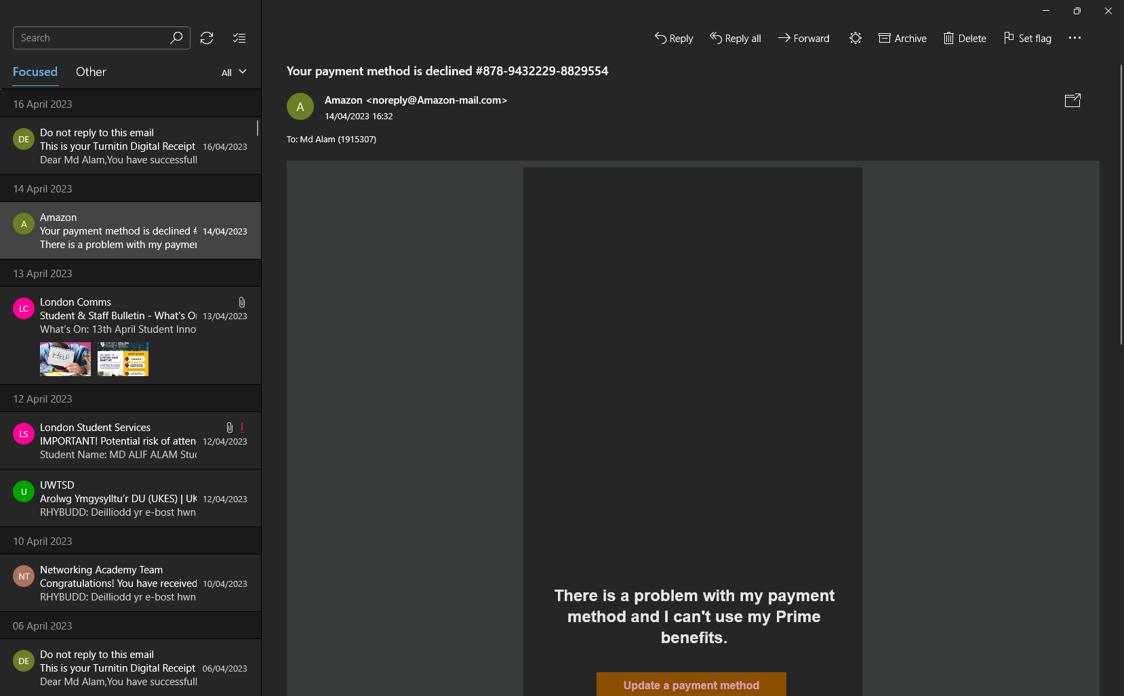
Figure 1(Phishing attack executed by University of Wales as a test to acknowledge of such attack)
- Ransomware - Ransomware is malicious software that restricts your computer or prevents you from accessing your data until you pay a ransom using private key encryption. Typically, this ransom is paid in Bitcoin [10]. In the last year ransomware was only known for attacking personal computer but with the advent of the technology they developed a version that attacks mobile devices by changing the PIN number of the device and to receive the pin you need to follow the same step for the personal computer.
- Malware- Malware refers to any software designed to cause damage to a computer system, pilfer data, or compromise network security. Malware comes in a variety of forms, including viruses, trojans, and spyware [11]. In most cases the malware sits in the OS (Operative System) undetected without the authorization of the User. Malware can spread in multiple ways for example, downloading a software from an unknown resource can lead to deceive a trojan. Trojan borrowed from the story troy where a wooden horse was used to trick the Troy’s into sneaking their soldier in the city.
Defence Strategies
Cryptography
Using mathematical algorithms and keys, cryptography is the practise of securing information by transforming it into an unintelligible format known as ciphertext. Plaintext is encrypted into ciphertext, which can only be deciphered with the correct decryption key. Cryptography is used for a variety of purposes, including safeguarding the privacy of sensitive data, assuring data integrity, and authenticating the identity of users or devices. Data in transit, such as data being transmitted over the internet, and data at rest, such as data stored on a computer or mobile device, can be protected using cryptography. The two primary categories of cryptography are symmetric and asymmetric. In symmetric cryptography, both encryption and decryption use the same key. In order to communicate securely, the sender and recipient of a message must have access to the same key (Figure 2). A pair of keys is used in asymmetric cryptography, also known as public-key cryptography, one for encryption and one for decryption (figure 3). The public key may be freely disseminated, whereas the private key must be kept confidential. Cryptography is utilised in a vast array of applications, such as secure communication protocols such as HTTPS, secure storage of passwords and other sensitive data, digital signatures, and secure payment transactions. Modern cybersecurity relies heavily on cryptography, which is an indispensable instrument for protecting sensitive data and securing network communications.
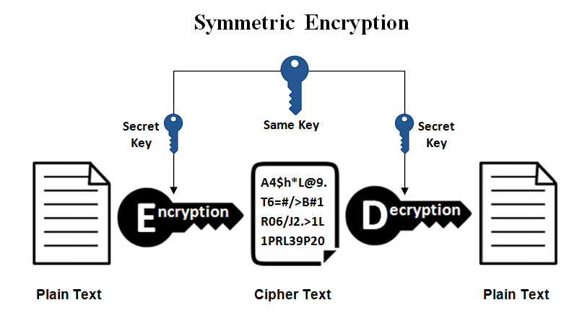
Figure 2 Image Source: (https://www.ssl2buy.com/wiki/symmetric-vs-asymmetric-encryption-what-are-differences)

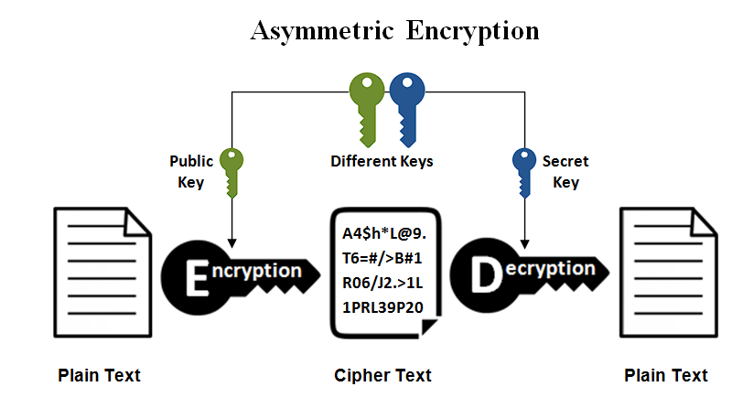
Figure 3 Image Source(https://www.ssl2buy.com/wiki/symmetric-vs-asymmetric-encryption-what-are-differences)
Intrusion Detection and Prevention Systems
Intrusion Detection and Prevention Systems (IDPS) are security instruments designed to identify and respond to prospective network security hazards. IDPS can be implemented as software, hardware, or a combination of the two, and can be administered at multiple locations within a network, including the network perimeter, internal network segments, and individual hosts Figure4.
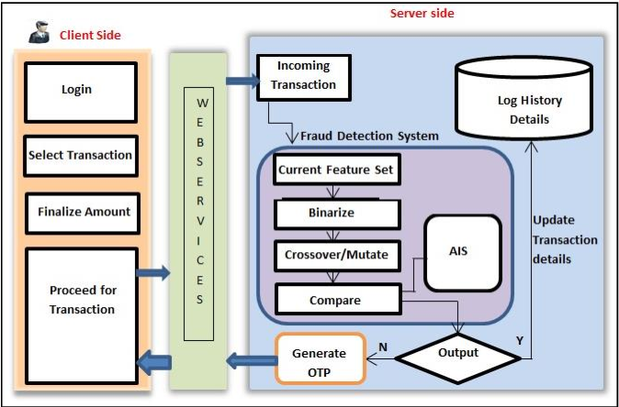
Image Source: Assignment 2 – Project Proposal: Fraud Detection Software ACCA 5033 (MD ALIF ALAM)
In addition to detecting and preventing unauthorised network access, an IDPS identifies and responds to other security threats, such as malware infections and Denial of Service (DoS) attacks. IDPS identify and respond to hazards using a variety of techniques, including signature-based detection, behavioural analysis, and anomaly detection:
- Using signature-based detection, network traffic is compared against a database of known hazards, such as viruses and malware [12]. If a match is discovered, the IDPS can block the threat by removing the traffic or notifying a security administrator.
- Monitoring network traffic for anomalous or suspicious behaviour, such as traffic patterns inconsistent with normal network utilisation, is a component of behavioural analysis.
- Anomaly detection is the process of comparing network activity to an established baseline to identify deviations that may indicate a security threat.
Physical Security
According to Lawrence Physical security is the preservation of an organization's assets, people, and data from unauthorised access, devastation, theft, or damage [13]. The objective of physical security measures is to prevent or mitigate the effects of physical hazards such as larceny, vandalism, terrorism, natural disasters, and other emergencies. Physical security can be divided into several categories, including access control, surveillance, environmental controls, and incident response [13]:
- Controlling who has access to a facility or a specific area within a facility is access control. Physical barriers such as fencing, gates, and locks, as well as electronic systems such as card readers, biometric detectors, and security cameras, can be used as access control measures.
- Surveillance involves monitoring and recording activities in and around a facility or specific area. Surveillance measures can include security cameras, motion detectors, and alarms.
- Environmental controls involve the management of a facility's physical environment to prevent injury or disruption to equipment, systems, or individuals. Controls for the environment may include temperature and humidity regulation, fire suppression systems, and emergency power supplies.
- Prepare for and respond to physical security incidents such as natural disasters, fires, and terrorist attacks. Emergency plans, evacuation procedures, and communication protocols are all examples of incident response measures.
Stages of a Cyber-Attack
Companies are able to evaluate to a Cyber-attack and can identify certain security threats. They may utilise National Institute of Standards and Technology (NIST) Special Publications despite not being a US federal agency or associated contractor [14]. The NIST provide a step-by-step guideline to follow in case of a risk assessment giving you a general idea of how to face the challenge. In this guidance the following are the typical stages of a cyber-attack[14]:
- Reconnaissance: The perpetrator collects information about the target system or organisation during this phase. This data may include IP addresses, email addresses, social media profiles, and other information that can be used to identify potential vulnerabilities and attack vectors.
- Initial Access: After gathering sufficient information, the perpetrator will attempt to obtain initial access to the target system or network. This may involve exploiting software or hardware vulnerabilities or employing social engineering techniques to deceive users into divulging logon credentials or other sensitive information.
- Escalation of Privilege: After gaining initial access to the target system, the perpetrator will attempt to elevate their privileges and obtain administrative access. This may involve exploiting operating system or software vulnerabilities or using stolen credentials to obtain access to administrative accounts.
- Lateral Movement: After gaining administrative access, the perpetrator will attempt to migrate laterally within the network in order to gain access to additional systems and data. This may entail employing tools like remote access Trojans (RATs) or exploiting weaknesses in other systems on the network.
- Data Exfiltration: After gaining access to confidential data, an adversary will attempt to exfiltrate that information from the network. This may entail using file transfer protocols (FTP) or email to transmit the data to a remote server under the attacker's control.
- Persistence: The concluding phase of a cyber-attack is persistence, which involves maintaining access to the target system or network for future attacks. This may involve installing backdoors or other malware that allows the perpetrator to re-establish access to the system even if the initial access point has been identified and corrected.
Summary
Compliance and data security are two essential components of a comprehensive cybersecurity programme. Compliance refers to meeting regulatory requirements and industry standards for data protection. Data security involves safeguarding an organization's data from unauthorised access, theft, or loss, whereas compliance refers to meeting regulatory requirements and industry standards for data protection. Organisations should implement technical controls such as firewalls, intrusion detection and prevention systems, and encryption to ensure data security. Additionally, they should create policies and procedures for data classification, access constraints, and incident response. Training and awareness programmes for employees can also aid in promoting cybersecurity hygiene and preventing human error. Compliance requirements differ by industry and region, but typically include PCI DSS, HIPAA, and GDPR. Compliance may necessitate periodic audits and assessments, in addition to the implementation of technical controls and policies. As hazards and regulations continue to evolve, achieving data security and compliance requires on-going investment and effort. However, organisations that prioritise data security and compliance can benefit from an increase in consumer confidence, a reduction in the risk of data breaches and monetary penalties, and an improvement in their overall security posture.

List of reference
[1] S. S. Bhosale, A. Sheth, and F. Kurupkar, “Research paper on cybersecurity,” CONTEMPORARY RESEARCH IN INDIA, pp. 246–251, Apr. 2021.
[2] M. Ahsan et al., “Cybersecurity threats and their mitigation approaches using Machine Learning—A Review,” Journal of Cybersecurity and Privacy, vol. 2, no. 3, pp. 527–555, 2022. doi:10.3390/jcp2030027.
[3] A. Bhadwal, “The history of cyber security: A detailed guide [infographic],” KnowledgeHut, https://www.knowledgehut.com/blog/security/history-of-cyber-security (accessed May 8, 2023).
[4] D. Murphey, “A history of information security - IFSEC insider: Security and fire news and resources,” IFSEC Insider | Security and Fire News and Resources, https://www.ifsecglobal.com/cyber-security/a-history-of-information-security/ (accessed May 8, 2023).
[5] T. Stevens, “Global cybersecurity: New directions in theory and methods,” Politics and Governance, vol. 6, no. 2, pp. 1–4, 2018. doi:10.17645/pag.v6i2.1569.
[6] D. Craigen, N. Diakun-Thibault, and R. Purse, “Defining cybersecurity,” Technology Innovation Management Review, vol. 4, no. 10, pp. 13–21, 2014. doi:10.22215/timreview/835
[7] J. Jang-Jaccard and S. Nepal, “A survey of emerging threats in cybersecurity,” Journal of Computer and System Sciences, vol. 80, no. 5, pp. 973–993, 2014. doi:10.1016/j.jcss.2014.02.005
[8] T. Fitzgerald, Information Security Governance Simplified: From the Boardroom to the Keyboard. Boca Raton: CRC Press, 2012.
[9] Z. Alkhalil, C. Hewage, L. Nawaf, and I. Khan, “Phishing attacks: A recent comprehensive study and a new anatomy,” Frontiers in Computer Science, vol. 3, 2021. doi:10.3389/fcomp.2021.563060
[10] R. Richardson and M. North, “Ransomware: Evolution, Mitigation and Prevention,” International Management Review, 2017.
[11] [1] T. Alsmadi and N. Alqudah, “A survey on malware detection techniques,” 2021 International Conference on Information Technology (ICIT), 2021. doi:10.1109/icit52682.2021.9491765
[12] L. BlogPoster, “What is signature-based malware detection?,” Logix Consulting Managed IT Support Services Seattle, https://logixconsulting.com/2020/12/15/what-is-signature-based-malware-detection/ (accessed May 8, 2023).
[13]
[14] Force, J.T. Risk management framework for information systems and organizations. NIST Spec. Publ. 2018, 800, 37

Task 2 Case Scenario
Here is a potential organisational chart for SwanTech:
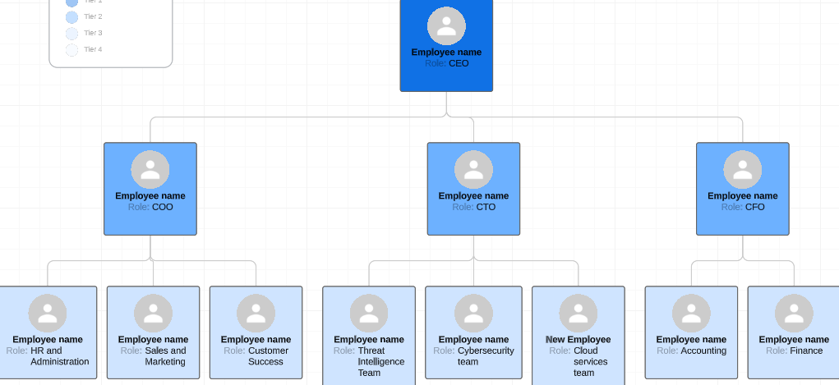
In this structure, the CEO is responsible for establishing the organization's overarching strategy and direction. The CEO is supported by the CTO, CFO, and COO departments.
The CTO is responsible for leading the technical teams responsible for threat intelligence, cybersecurity, and cloud services. These teams collaborate to safeguard SwanTech's clients from cyber threats and equip them with the necessary frameworks and tools for compliance, business continuity, data recovery, and risk management.
The CFO is accountable for the company's financial operations, including accounting and finance. This department is responsible for ensuring that SwanTech is financially stable and able to satisfy its obligations to customers and employees.
The COO is in charge of sales and marketing, customer success, human resources, and administration. These teams collaborate to acquire and retain customers, ensure customer satisfaction, and administer the company's daily operations.
Overall, this structure enables SwanTech to provide clients with high-quality services while maintaining a solid financial position and a healthy organisational culture.
Policies
Here are some policies that SwanTech could potentially implement:
Acceptable Use Policy - General
- This policy should describe the steps taken by SwanTech to protect its own systems and data, as well as those of its clients. It should include topics such as password management, network security, access controls, incident response, and employee training.
- This policy should define how SwanTech collects, stores, processes, and shares client data, as well as how it is collected, stored, and processed. In addition, it should detail SwanTech's compliance with applicable data protection regulations, such as the General Data Protection Regulation (GDPR).
- This policy should establish the norms and guidelines for how SwanTech employees may utilise company resources, such as computers, software, and Internet access. It should encompass topics such as email, social media, and other communication channels, as well as prohibited activities such as obtaining unauthorised software or accessing objectionable content.
- Business Continuity and calamity Recovery Policy: This policy should define how SwanTech assures the continuation of its services in the event of a disruption or calamity, such as a cyber attack or natural disaster. It should include subjects like backup and recovery procedures, emergency communication plans, and testing and maintenance of business continuity plans.
- This policy should define the ethical and professional standards that employees of SwanTech are expected to uphold in their interactions with clients, partners, and one another. It should include topics like confidentiality, conflict of interest, anti-discrimination, and compliance with laws and regulations.
- This policy should outline the remote work guidelines for SwanTech employees, including how to access company resources securely, maintain communication with colleagues and clients, and ensure productivity and work-life balance while working from home.
Acceptable Use Policy – Internal and internet E-Mail
Our employees have access to both internal and Internet e-mail as part of (Insert Firm/Company Name)'s commitment to the use of technology. In order to ensure compliance with copyright laws, avoid various liability issues, and protect our computer systems from the threat of viruses and other forms of harm, employees who use e-mail must adhere to the following procedures:
- Email is just as permanent, legally binding, and admissible in court as paper correspondence. External e-mail sent from (Insert Firm/Company Name) travels on our electronic stationary and, as such, is identical to company letterhead. Email is therefore subject to the same company policies as other forms of correspondence.
- Email should not be used to transmit financial and other confidential client information.
- Sending harassing, profane, and/or menacing electronic correspondence is prohibited by law.
- Employees are prohibited from sending unsolicited mail, "for-profit" messages, and chain letters.
- Employees are not permitted to transmit or receive sexually explicit messages or images.
- Employees are prohibited from sending confidential company information.
- 7. Employees may not send email under the name or address of another person.
- Emails from other users should not be read, forwarded, deleted, or altered without permission.
- Medical, intimate, and financial information about employees must never be disclosed.
- Personal communications are permitted, but their volume should be limited and they must strictly adhere to the other provisions of this policy.
- Before being purged, email correspondence will be archived and periodically reviewed.
- Any violation of the preceding rules is strictly forbidden.
- If you have any concerns regarding the use of email, please contact (Insert the name of the individual in charge of this area).
Acceptable Use Policy – Internet
As part of (Insert Firm/Company Name)'s dedication to the use of technology, our employees have Internet access. In order to secure the company and its employees, employees who use the Internet must adhere to the following procedures:
- It is the policy of (Insert Firm/Company Name) to restrict Internet usage to official business. Employees are permitted to use the Internet for personal purposes outside of normal business hours, so long as they strictly adhere to all other provisions of this policy.
- The introduction of viruses or malevolent modification of any computer system is expressly prohibited.
- Matson and Isom are represented by employees of (Insert Firm/Company Name) who have Internet access. As a result, employees should conduct themselves appropriately so as not to harm the company's reputation.
- Before installation or execution, downloaded files must be scanned with anti-virus software. To detect a virus and, if necessary, to prevent its propagation, all necessary precautions should be taken.
- 5. The veracity or accuracy of information found on the Internet and in e-mails should be considered suspect until confirmed by a separate (reliable) source.
- 6. Employees may not place company materials (copyrighted software, internal correspondence, etc.) on any Internet computer accessible to the general public without prior authorization.
- External connections to the internal network of (Insert Firm/Company Name) are prohibited unless specifically authorised.
- The Internet does not guarantee the privacy and secrecy of information. Sensitive information transmitted over the Internet is susceptible to detection by a third party. Employees must exercise caution and care when transferring such materials in any form.
- Unless otherwise specified, all software on the Internet should be considered to be protected by copyright.
- Therefore, employees are prohibited from downloading software and/or modifying these files without the owner's permission.
- The company may be liable for any infringing activity committed by an employee. This company may therefore choose to hold the employee accountable for their actions.
- 11. (Insert Firm/Company Name) will conduct periodic audits of computer systems owned by (Insert Firm/Company Name) to identify violations of this policy.
- Any violation of the policies listed above is strictly prohibited.
- Contact (Insert the name of the individual responsible for this area) if you have any queries regarding Internet usage.
Laws and compliance
SwanTech handles sensitive data and offers services related to cybersecurity and risk management. Therefore, compliance with relevant laws and ethical principles is essential for maintaining client trust and operating legally and ethically.

Among the most important laws and regulations that SwanTech must comply with are:

General Data Protection Regulation (GDPR): This regulation applies to all organisations, regardless of location, that process the personal data of EU citizens. SwanTech should comply with GDPR requirements by obtaining individuals' consent to collect and use their data, safeguarding the data with appropriate security measures, and providing individuals with the right to access, rectify, and delete their data.

The California Consumer Privacy Act (CCPA) pertains to corporations conducting business in California and collecting personal information on California residents. SwanTech should comply with CCPA regulations by providing consumers with notice of data collection practises, permitting consumers to opt out of the sale of their personal information, and granting consumers the right to access and expunge their data.

This law applies to organisations such as healthcare providers and insurers that handle protected health information (PHI). If SwanTech handles PHI on behalf of its clients, it must adhere to HIPAA's privacy and security requirements.

This standard applies to organisations that handle credit card information. If SwanTech processes credit card information on behalf of its clients, it must adhere to PCI DSS requirements for safeguarding cardholder data and maintaining secure payment processing systems.

In addition to adhering to laws and regulations, SwanTech should uphold ethical principles such as honesty, openness, and privacy and confidentiality protection. This includes obtaining clients' informed consent for the collection and use of their data, being transparent about data processing practises, and protecting the privacy and confidentiality of clients' data and information. SwanTech should also provide its employees and contractors with a code of ethics and conduct that outlines expectations for professional behaviour and ethical decision-making.

