MARKETING PLAN: IBIS HOTEL

Oana Nicoleta Stancila

MARKETING PLAN: IBIS HOTEL
Introduction
This marketing plan focuses on one of the largest Ibis styles of hotels. Ibis Styles Bangkok Twin Towers Hotel is the largest Hotel globally (Accor – Newsroom | Asia & Pacific, 2022). The Hotel is in the city center, just a small distance from the business district and shopping landmarks. The marketing plan is set to introduce a cultural yet globally welcomed dish known as Ukrainian Borscht. I will employ several marketing frameworks in this marketing plan, such as the SOSTAC model, an acronym for Situation, Objectives, Strategy, Tactics, Action, and Control. In addition, I will also adopt the 5'Cs incorporation of SWOT and PESTLE analysis in analyzing the environmental influences of the Hotel. I will also use Bowman's clock and Ansoff's matrix to analyze this new product's market.
Situation Analysis
The 5’C’s
Company: SWOT analysis
The strength of Ibis Styles Bangkok Twin Towers Hotel is the strong brand image that Ibis has obtained over time. This can be proved by a large number of traffic and engagement (SimilarWeb, 2023). The weakness of Ibis Twin Tower is the lag in online business. At the same time, the opportunities include the possibility of finding new markets due to its proximity to business districts and shopping centers (Accor – Newsroom | Asia & Pacific, 2022). The threat is the increasing number of competitors who have increased the possibility of substitutes in the market.
Customers- The leading target group for Ibis Style Twin Tower Hotel is travelers from all over the world. Most of these travelers are either business individuals or families going on vacations. Regarding market segmentation, the customer segments include solo business travelers, group business meetings, and family leisure activities such as vacations.
Competitors- The main competitors include the Cove Pocono Resorts and the hotel-am-dammtor. According to statistics on Similar Web, Cove Pocono had a total of 483 861 website visits in February compared to the 22 832 of the Twin Towers. Hotel-am-Dammtor, on the other hand, was the highest, with 3.234 Million visits (SimilarWeb, 2023).
Collaborators- The Hotel has several collaborators, including partners, Business-to-Business relationships, and Franchises. The hotel partners with food and beverage outlets such as the Gold Teak Restaurant, which serves international and Thai dishes at the lobby level. (Seet, 2022).
Climate- The political environment is favorable due to relatively stable administrations. Economically, the Hotel enjoys favorable tax policies. Socially, Thai culture has influenced its menu. Ibis Twin Tower is characterized by the most modern technologies in its design. These include modern air-conditioning systems, bathrooms, TV sets, and building designs (Hospitality ON, n.d.). The Hotel has adopted greening concepts in both design and practice.
Marketing Mix
The product strategy is divided into three: Ibis, Ibis Styles and Ibis Budget targets (Zigu, n.d.). In pricing, festive and seasonal discounts are given to attract customers. In terms of place, is mainly at the Hotel premises in Bangkok, Thailand.. In product promotion, special promotions are given for online bookings. Free nights and loyalty points are also awarded to customers (Zigu, n.d.). The current value proposition is "One of the best hotels in Bangkok." The present promotions are special offers of Discounts of up to 50% (www.thetwintowershotel.com, n.d.). The communications are conveyed through emails, ads, referrals, organic searches, and social media platforms.
Objectives

Action
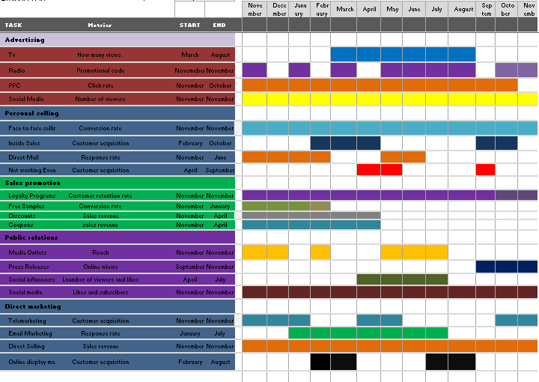
These channels are selected because most of them are relatively inexpensive, easy to use and cover a large number of the targeted market.

Control
There are several metrics of analyzing the success of this plan.Reviewing the number of viewers for social media platforms and TV will be an effective metric since it gives the exact number of people who viewed the products (Misirlis, Nikolaos, and Maro, 2018, p.273). For PPC, click rate will be used as a success metric since it shows how much the copy or link was impressive. Another metric is Sales revenue which shows how much has been gained from the sales; it is effective for discounts, coupons, and direct sales (Farris and Pau, 2016). The conversion rate is an efficient metric for channels such as free samples and face-to-face selling since it shows how many prospects have become customers. Reach metric helps in knowing how many people are aware of the product; it is effective for media outlets. Customer acquisition refers to the total number of customers acquired and is very efficient for online display marketing and telemarketing
Conclusion
Introducing this new marketing plan at Ibis Twin Tower Hotel will attract more customers, thus creating new markets. The Ukrainian Borscht dish is a dish that is appreciated across several cultures. The unique marketing mix will introduce cultural themes even in the existing products. The prices will be discounted, and free offers will be given on loyalty points. The promotion will incorporate online marketing on all social media platforms in different Languages. Further recommendations are centered on introducing more multicultural themes and dishes even with the advancing technologies; this will attract more customers and new markets.

References
Accor – Newsroom | Asia & Pacific. (2022). Accor – Newsroom | Asia & Pacific | The largest ibis Styles in the world set to open in Thailand. [online] Available at: https://press.accor.com/middle-east-africa-turkey-asia-pacific/the-largest-ibis-styles-in-the-world-set-to-open-in-thailand/?lang=en [Accessed 22 May 2023].
Bala, M. and Verma, D., 2018. A critical review of digital marketing. M. Bala, D. Verma (2018). A Critical Review of Digital Marketing. International Journal of Management, IT & Engineering, 8(10), pp.321-339.
Farris, P.W., 2016. Marketing metrics. Pearson Education India.
Hospitality ON. (n.d.). Hospitality ON. [online] Available at: https://hospitality-on.com/en/worldwide-hospitality-awards/ibis/ibis-reinventing-guest-experience.
‌Hunt, J. and Kerr, D., 2023. PARE: The four pillars for successful whitepaper lead generation campaigns. Journal of Brand Strategy, 11(4), pp.378-385.
Kent, M.L. and Li, C., 2020. Toward a normative social media theory for public relations. Public Relations Review, 46(1), p.101857.
Koks, S.C. and Kilika, J.M., 2016. Towards a theoretical model relating product development strategy, market adoption and firm performance: A research agenda. Journal of Management and Strategy, 7(1), pp.90-97.
‌Loredana, E.M., 2016. The use of Ansoff matrix in the field of business. In MATEC Web of Conferences (Vol. 44, p. 01006).
‌Media, F. (2017). Website Design Warwick | Digital Marketing Warwick. [online] Formation Media. Available at: https://formationmedia.co.uk/blog/language-in-advertising-understanding-its-use/.
Misirlis, N. and Vlachopoulou, M., 2018. Social media metrics and analytics in marketing–S3M: A mapping literature review. International Journal of Information Management, 38(1), pp.270-276.
‌Seet, A.E. (2022). ibis Styles Bangkok Twin Towers, World’s Largest ibis Styles to debut initial phase in Q3 2022. [online] SUPERTRAVELME.com. Available at: https://supertravelme.com/hotels/ibis-styles-bangkok-twin-towers-worlds-largest-ibis-styles-to-debut-initial-phase-in-q3-2022/ [Accessed 22 May 2023].
‌SimilarWeb (2023). Website Performance. [online] secure.similarweb.com. Available at: https://pro.similarweb.com/#/digitalsuite/websiteanalysis/overview/website-performance/.
Visualmodo (2019). The Benefits of Using Multilingual Marketing. [online] Medium. Available at: https://medium.com/@visualmodo/the-benefits-of-using-multilingual-marketing-9c52ffa5e14f#:~:text=Customers%20are%20more%20likely%20to [Accessed 23 May 2023].
www.thetwintowershotel.com. (n.d.). The Twin Towers Hotel Bangkok | Official Website | Near MBK, Siam Paragon and Yaowarat. [online] Available at: https://www.thetwintowershotel.com/ [Accessed 23 May 2023].
Zigu (n.d.). Ibis Marketing Mix (4Ps) | Ibis Marketing Strategy. [online] MBA Skool-Study.Learn.Share. Available at: https://www.mbaskool.com/marketing-mix/services/17538-ibis.html.

Appendices
- Ibis Competitors according to Similar Web
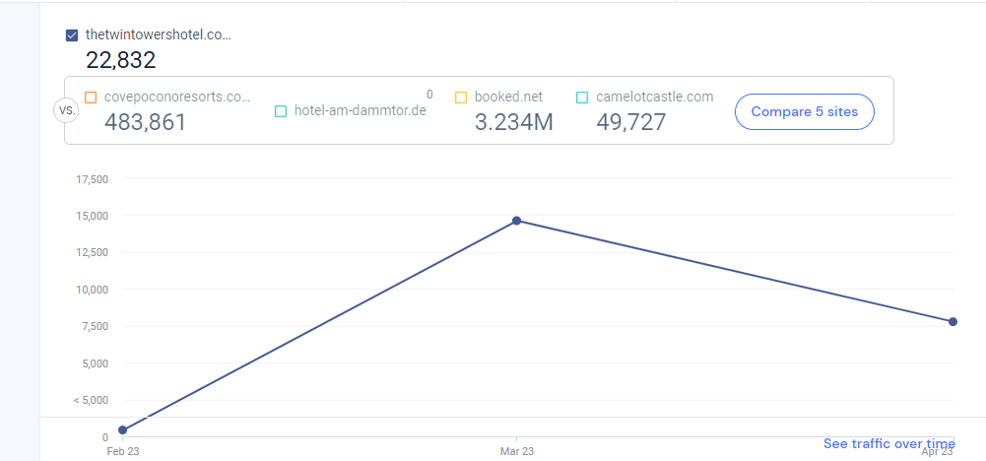

- Ibis SWOT analysis according to Accor analysis
https://www.swotandpestle.com/accor/.

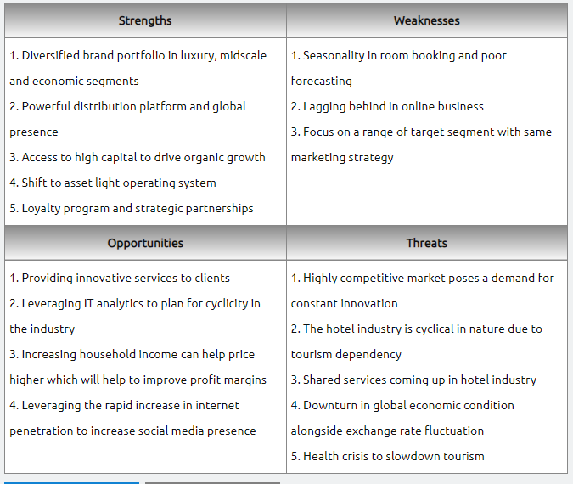

- IBIS Twin Tower Hotel Marketing Channels overview according to Similar Web

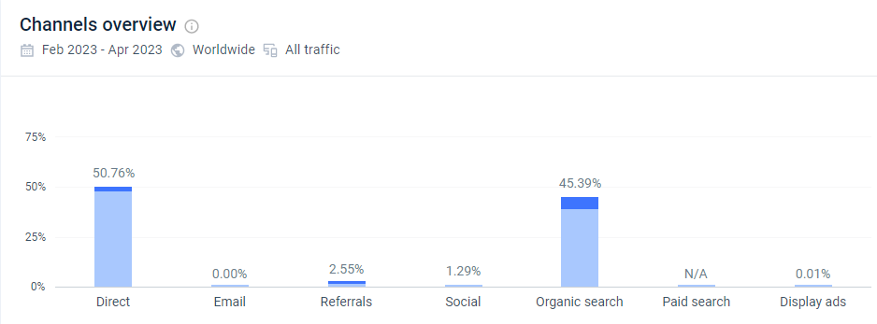
- IBIS Channel traffic according to Similar Web
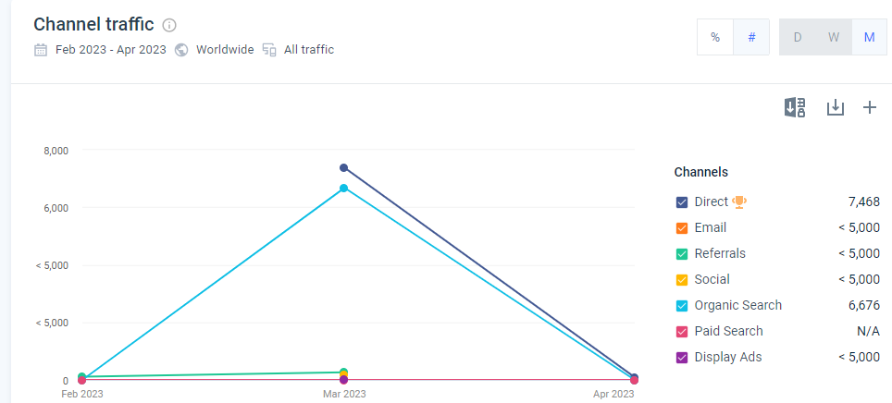
- Positioning map
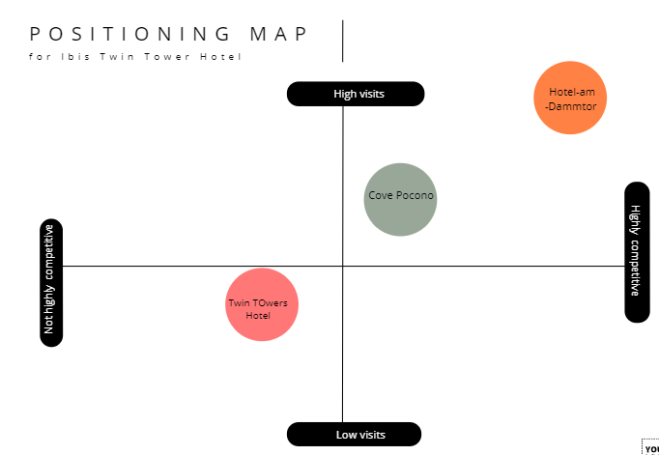

COMPONENT 1: PRESENTATION
This marketing plan focuses on one of the largest Ibis styles of hotels. Ibis Styles Bangkok Twin Towers Hotel is the largest Hotel globally (Accor – Newsroom | Asia & Pacific, 2022). The Hotel is in the city center, just a small distance from the business district and shopping landmarks. The marketing plan is set to introduce a cultural yet globally welcomed dish known as Ukrainian Borscht.
The The strength of Ibis Styles Bangkok Twin Towers Hotel is the strong brand image that Ibis has obtained over time. This can be proved by a large number of traffic and engagement (SimilarWeb, 2023). The weakness of Ibis Twin Tower is the lag in online business. At the same time, the opportunities include the possibility of finding new markets due to its proximity to business districts and shopping centers (Accor – Newsroom | Asia & Pacific, 2022). The threat is the increasing number of competitors who have increased the possibility of substitutes in the market.
.

Competitors- The main competitors include the Cove Pocono Resorts and the hotel-am-dammtor. According to statistics on Similar Web, Cove Pocono had a total of 483 861 website visits in February compared to the 22 832 of the Twin Towers. Hotel-am-Dammtor, on the other hand, was the highest, with 3.234 Million visits (SimilarWeb, 2023).

Climate- The political environment is favorable due to relatively stable administrations. Economically, the Hotel enjoys favorable tax policies. Socially, Thai culture has influenced its menu. Ibis Twin Tower is characterized by the most modern technologies in its design. These include modern air-conditioning systems, bathrooms, TV sets, and building designs (Hospitality ON, n.d.). The Hotel has adopted greening concepts in both design and practice.

The main objective is to promote multi-national culture by incorporating cultural dishes into the menu. Thus attracting more customers and increasing the competitive edge. After twelve months, the product will have brought 10000 new website traffic visits and raised social media followers by 15 000. The product also aims to create a new market among local visitors. If this marketing plan works as purposed, it will take twelve months to have achieved these objectives.

As this new dish is introduced, the value proposition will become “Home away from home" to emphasize the focus on cultural themes and dishes such as the Ukrainian Borscht. Because the main objective is to multi-national culture, thus attracting more customers, the appropriate strategy, according to Ansoff's matrix, will be product development. The advantage of this strategy is that it will not only sustain the existing market but also attract new markets (Koks, Sheila, and James, 2016, p.94). After this new business idea is launched, the market development strategy will be employed for its growth. This Ansorf’s strategy involves introducing the available products into new markets (Loredana and Ecobici, 2016). This will happen through online channels to identify the new market segments and sell the existing products at a discount. There will be a change in the pricing strategy to attract and accommodate new markets. Online marketing, frequent discounts and free offers for loyalty points will be introduced.

The public relations campaign will involve several tactics for developing and creating awareness of this new product. Constant ResearchResearch will be done throughout the entire product development process. The main areas of ResearchResearch will be the market and the other cultural dishes that are more likely to go along with this product. Secondly, after the ResearchResearch, relevant actions will be taken to make changes or execute the strategies as researched. These actions will range from adjusting several aspects of the market mix to developing the existing products. In simple words, communication will happen mostly on online platforms to reach more people (Media, 2017). Depending on the target nation or group, communications will be made in the national or native languages. Finally, the evaluation will include evaluating both the negative ad positive outcomes of the campaign. This RACE strategy aims to end up with no negative points at evaluation.
.

Advertisements will be done through TV, radio, PPC, and social media platforms such as Facebook and Instagram because these channels have access to many people, thus reaching target groups (Bala, Madhu, and Deepak, 2018, p.322). Personal selling will happen face-to-face, through inside sales, direct mail, and Networking events. These channels are cheap and accessible to customers (Author, 2021). Sales promotion will be done through loyalty programs, free samples, discounts, and coupons; these channels are easy to implement and attract many people. Public relations will be done through media outlets, press releases, social influencers, and social media platforms; these channels have a large coverage, reaching many people (Kent, Michael, and Chaoyuan, 2020). Direct marketing will be done through telemarketing, email marketing, direct selling, and online display marketing; these channels are readily available and accessible by customers at zero or low charges.

There are several metrics of analyzing the success of this plan.Reviewing the number of viewers for social media platforms and TV will be an effective metric since it gives the exact number of people who viewed the products (Misirlis, Nikolaos, and Maro, 2018, p.273). For PPC, click rate will be used as a success metric since it shows how much the copy or link was impressive. Another metric is Sales revenue which shows how much has been gained from the sales; it is effective for discounts, coupons, and direct sales (Farris and Pau, 2016). The conversion rate is an efficient metric for channels such as free samples and face-to-face selling since it shows how many prospects have become customers. Reach metric helps in knowing how many people are aware of the product; it is effective for media outlets. Customer acquisition refers to the total number of customers acquired and is very efficient for online display marketing and telemarketing

