DS 1 Template

My Screenshots/Photos
- Please add 4–6 screenshots or photos of your digital life.
- You can use your phone or laptop.
- For each screenshot, write one or two sentences explaining what it shows.

Screenshot/Photo 1
[Insert Photo/Screenshot below]
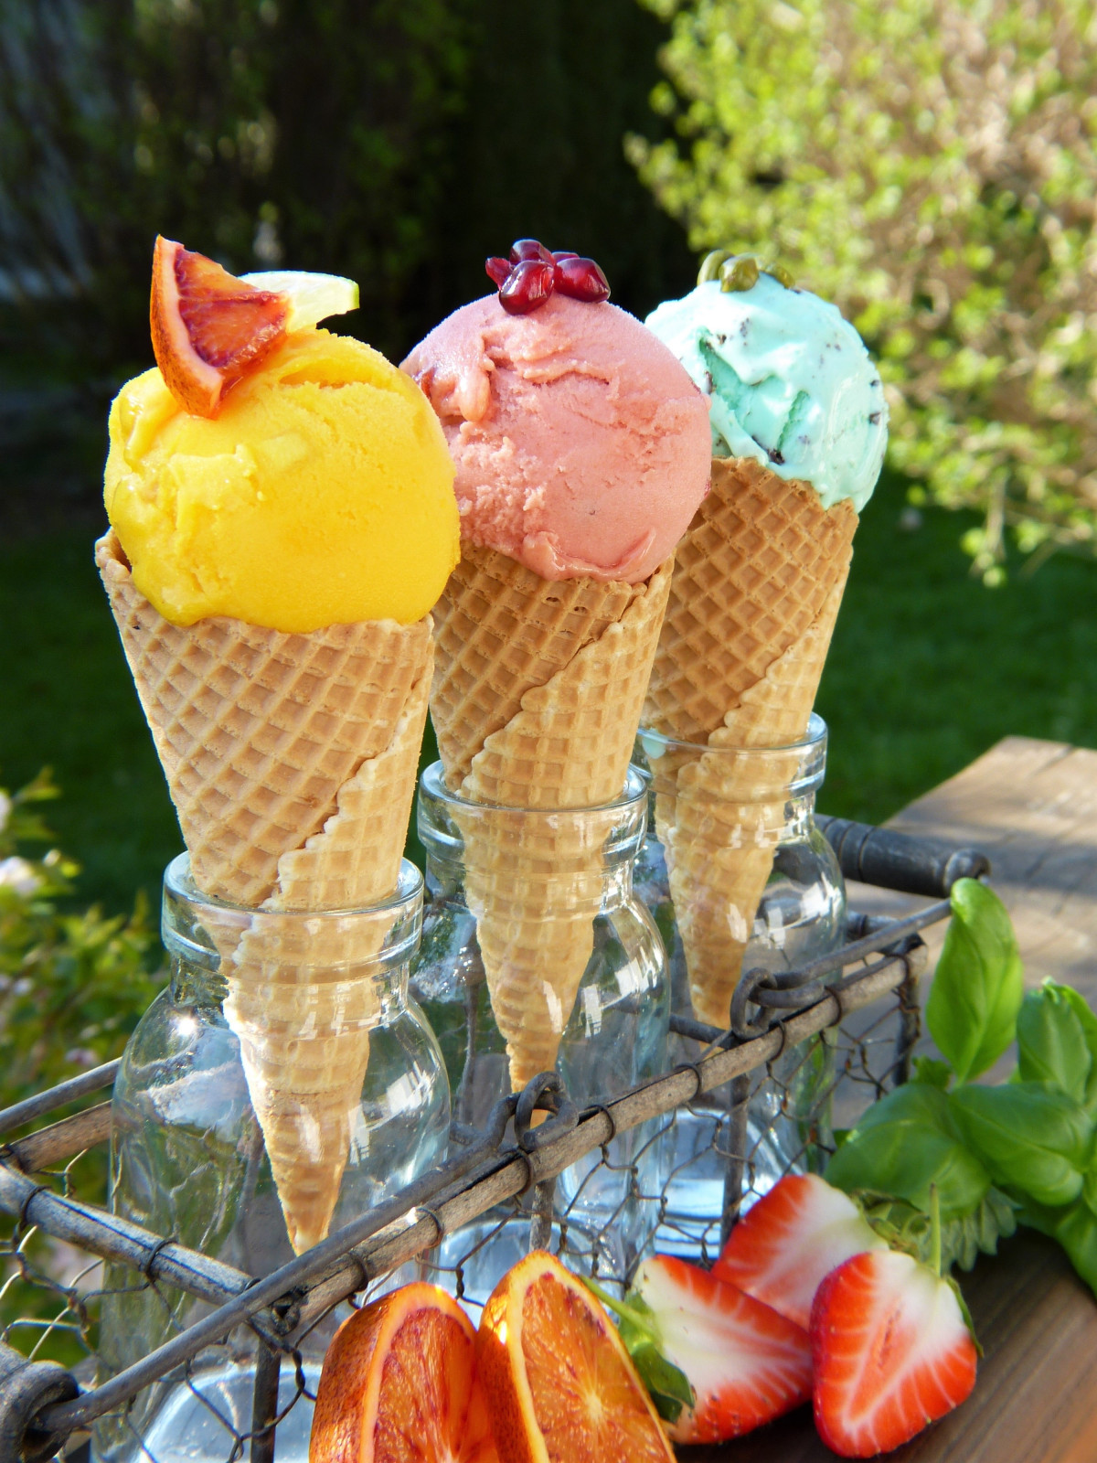
In the picture, there are three ice creams in different colours. They look colourful and delicious.

Screenshot/Photo 2
[Insert Photo/Screenshot below]

There is a laptop in the picture.I can see the person’s hands typing on the keybourd.

Screenshot/Photo 3
[Insert Photo/Screenshot below]

There is a bookshelf with lots of books. It looks tidy and organised .

Screenshot/Photo 4
[Insert Photo/Screenshot below]

I can see an aeroplane flying.The sky is blue and there are white clouds.

Screenshot/Photo 5
[Insert Photo/Screenshot below]
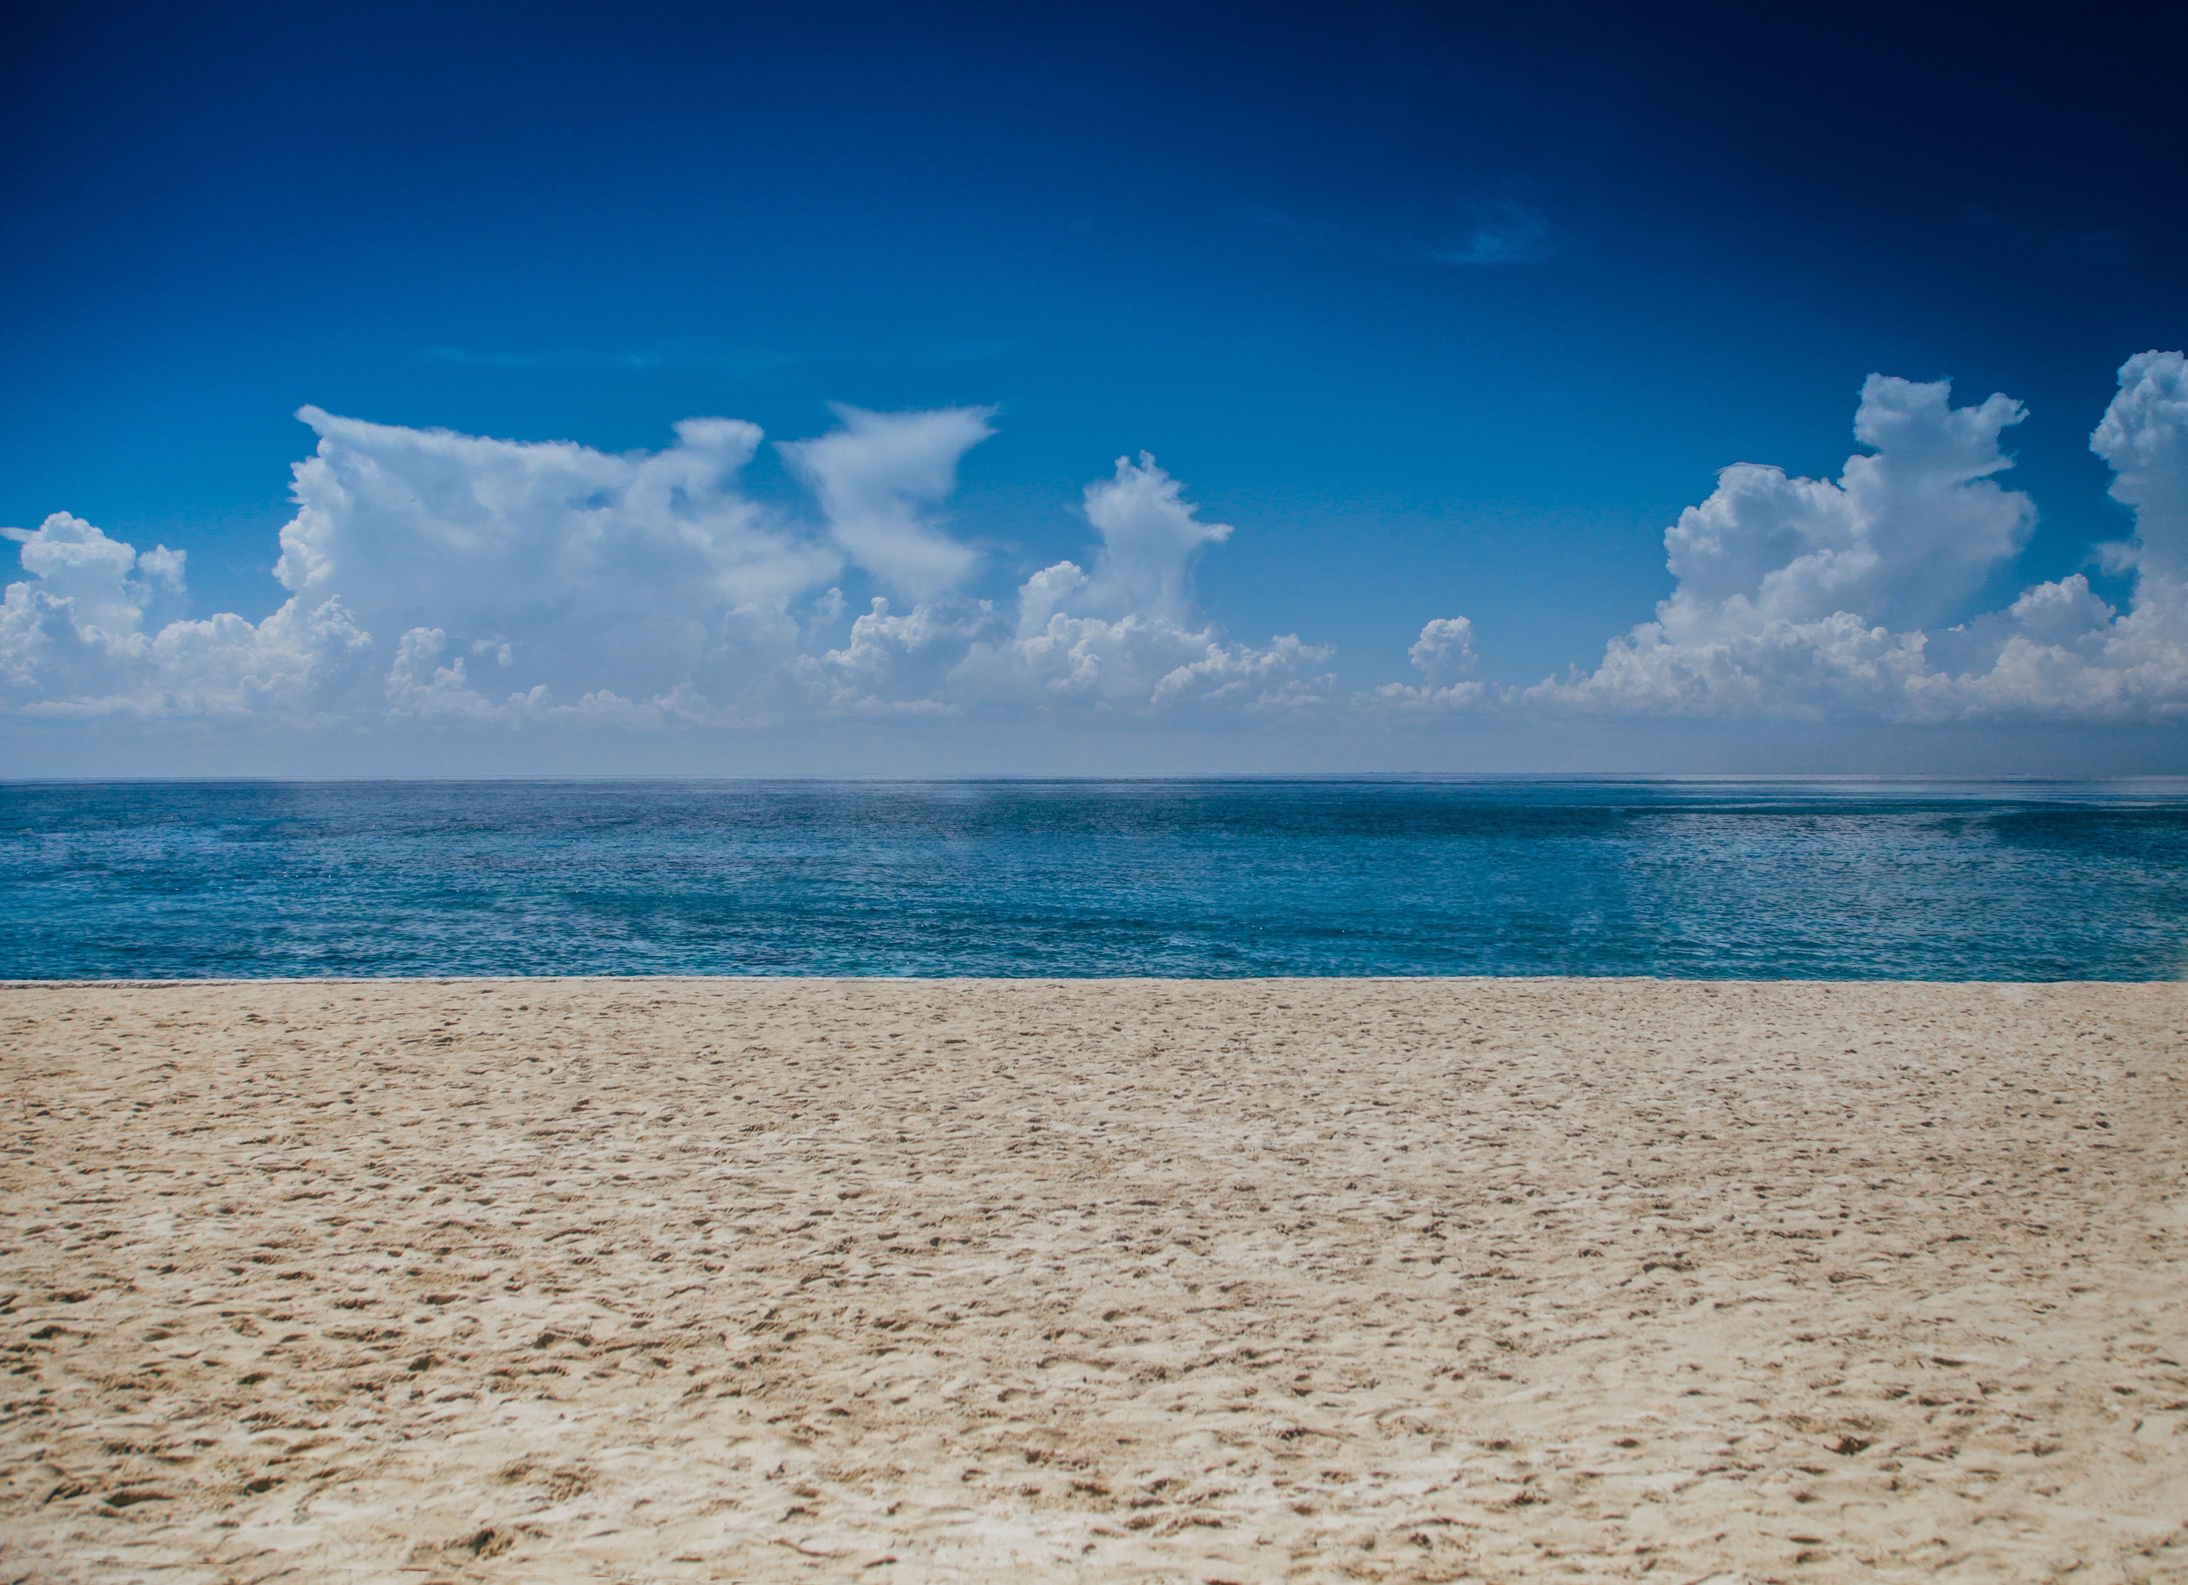
I can see the sea , the sand and the sky. It looks peaceful and beautiful.

Screenshot/Photo 6
[Insert Photo/Screenshot below]

In the picture, there is a coffee cup in the middle of coffee beans. It look cozy and inviting.

My Short Reflection
- Write 5–8 simple sentences about your digital life.
- You can use the sentence starters below if helpful.
I use digital tools to study and learn new things. I feel confident when I search for information online. But I want to improve my typing speed. I often use these tools: a laptop and a smartphone. I sometimes feel nervous about making mistakes. I hope this module will help me become better at using computers. Digital skills are important for me because I need them for school and my future job.

Sentence starters
- I use digital tools to …
- I feel confident when I …
- I want to improve …
- I often use these tools: …
- I sometimes feel nervous about …
- I hope this module will help me …
- Digital skills are important for me because …
You can write more if you want.

Submission Checklist
Before you submit, please check:
​​​ ☐ I added 4–6 screenshots
☐ I wrote short sentences for each screenshot
☐ I wrote my short reflection
☐ My work is my own
☐ My file opens correctly
​​☐ My file opens correctly

