L5 - Electronics I (EES version) (ACDB5002)
BEng Embedded Electronics
Traffic light control system for a T-Junction

Benjamin Scott (2306925)
2306925@student.uwtsd.ac.uk
Contents
Introduction: 3
The circuit and design explanation: 3
The code and how it works. 5
How does the 40 – 0 count work? 5
How does the traffic light system work? 6
How do the pedestrian lights work? 7
Background research on traffic lights: 7
flowchart showing the system operation: 10
The code: 11
Areas of improvement and tasks for the future: 13
Conclusion: 14
The brief and how the authors work compare? 14
Install three traffic signal lights on each side of the road for comprehensive traffic management. 14
Include a set of 7-segment displays on each side to either count up from 0 to 40 seconds or count down from 40 to 0 seconds. 14
Configure the system to change traffic signals every 10 seconds for predictable and smooth traffic flow. 14
Reserve the final 10 seconds of the signal cycle for a dedicated pedestrian crossing phase. 14
During the pedestrian crossing phase, program the traffic signals to either turn off or display a red signal for all three roads, ensuring pedestrian safety. 14
References 15
Table of Figures 15

Introduction:
In this assignment, the author will design a traffic light control system specifically for a T-junction. The main aim of this system is to improve traffic management efficiency while ensuring safety for both drivers and pedestrians. To achieve this, the system will include three sets of two 7-segment displays, which will count down from 40 to 0 seconds. These displays will provide clear and easy-to-read visual indicators for drivers, helping them anticipate when the traffic light will change. In the final 10 seconds of the countdown, the system will turn off the traffic lights and switch to a pedestrian crossing mode. This will allow pedestrians to safely cross the road. Additionally, the system will display a pedestrian crossing signal, clearly indicating when it is safe for pedestrians to cross. This design will help prioritize pedestrian safety while still maintaining an efficient flow of traffic through the T-junction. By incorporating these features, the system aims to optimize traffic flow, reduce potential congestion, and enhance the overall safety of the intersection for all road users.
The author uses proteus as a simulation software and uses CCS as the compiler.
The circuit and design explanation:
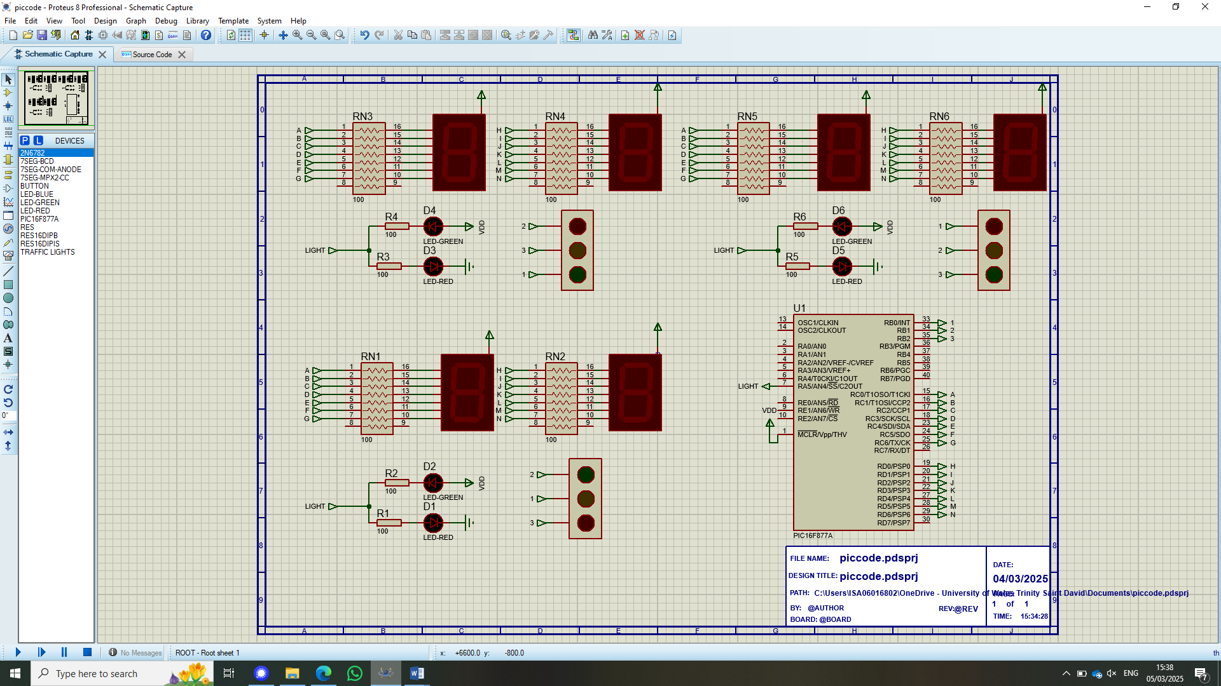
Figure 1 - The traffic light system
Figure 1 shows a three-way traffic light system for a T-junction. The circuit the author designed contains a 100-ohm resistor network on each of the different 7-segment displays, which allows for a countdown while preventing damage to the LEDs inside the display. The traffic light setup works by setting Port B0, B1, and B2 to high, which on each of the three different traffic lights corresponds to a different colour, as shown below in Figure 2.
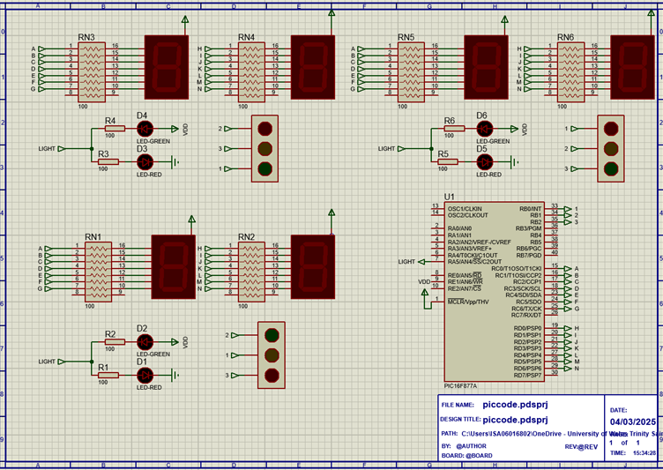
Figure 2 - Traffic light set up

The pedestrian control lights, shown in Figure 3, indicate when it is safe for pedestrians to walk during the last 10 seconds of the cycle, while the traffic lights are turned off. This allows pedestrians to cross safely, with clear signals and no vehicle movement.

Figure 3 - Pedestrian Control
Figure 3 shows the pedestrian crossing lights. When the ‘Light’ input is high, the current flows through the 100-ohm resistor, lighting up the red LED to signal that pedestrians cannot cross. In the last 10 seconds, the ‘Light’ output from the port returns low, meaning that the power source, VDD, will power the green diode, turning off the red diode. This indicates that it is safe for pedestrians to cross.
Figure 4 - output ports for the two 7-segment displays
For the countdown on the 7-segment displays, the author has chosen to start from 40 and count down to 0, providing a clear visual indication of the remaining time in the cycle. To control the display, the system uses two separate controls: Port C is responsible for managing the ‘10s’ column, which displays the tens digit of the countdown (e.g., 40, 30, 20, etc.), and Port D controls the ‘1s’ column, which shows the ones digit (e.g., 9, 8, 7, etc.). This method ensures that both the tens and one’s places are independently controlled, allowing for accurate and synchronized display of the countdown on the two, 7-segment displays. This setup provides clear and easy-to-read feedback for both drivers and pedestrians.
Figure 5 - 2, 7-segment displays for a 40 - 0 counter

The code and how it works.
The following section will clearly answer three questions: How does the 40-0 count work? How does the traffic light system work? Finally, how do the pedestrian lights work?

How does the 40 – 0 count work?
The code for the 7-segment displays is simple to understand. The code starts by defining the counter as 40. This will allow for the timing of the code and allow for the 10 second pedestrian section.
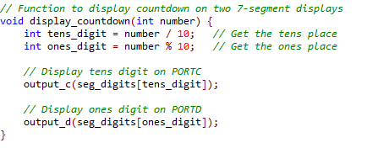
Figure 6 - display function for count
Then the function ‘display_countdown(int number);’ splits the value of counter into 10s and 1s digits as shown above in figure 6 by using integer division and modulo operations. (Cafiero, 2025)
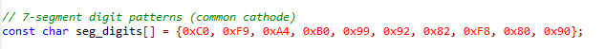

Figure 7 - array of values for 7 segment display
The code then outputs the corresponding unit value to the correct 7-segment display using either ‘output_c’ or ‘output_d.’ The different values in the array are mapped to the 7-segment displays, and the count value is reflected on the display. This allows the countdown to be shown in real-time, with the tens place controlled by output_c and the ones place controlled by output_d.
Every second, the count decreases, and when the counter reaches 10 or less, the pedestrian phase is triggered. During this phase, the traffic lights are set to low, and the stop lights are deactivated, allowing pedestrians to safely cross the road. Once the counter value drops below 0, it is reset to 40, restarting the countdown and reactivating the full operation of the traffic lights. This reset ensures the system runs continuously, maintaining traffic flow with the countdown starting again after each cycle.

How does the traffic light system work?
The traffic lights are controlled by a switch statement, shown below In figure 8.
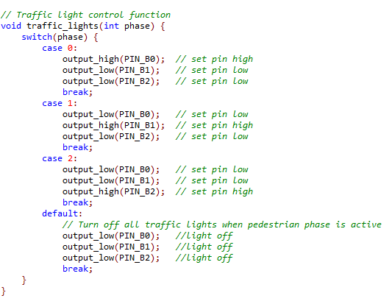
Figure 8 - Switch statement that controls traffic lights
The switch statement cycles through the different cases, controlling the activation of the pins that correspond to the traffic light phases. Initially, the switch statement turns on pin '1,' as shown in Figure 2, which corresponds to the first phase of the traffic light cycle. After 10 seconds, the switch moves to the next case, turning on pin '2.' This cycle continues, progressing through each case, with each subsequent case turning on the next pin (e.g., pin '3' for case 2, and so on). Once the cycle reaches the default case, it turns off all the pins, deactivating all the lights and signalling the beginning of the pedestrian phase. This phase allows pedestrians to cross the road safely, as all traffic lights are turned off to prevent vehicle movement. The switch statement ensures a smooth transition between traffic light phases and pedestrian crossings, maintaining safety and efficiency at the intersection.

How do the pedestrian lights work?
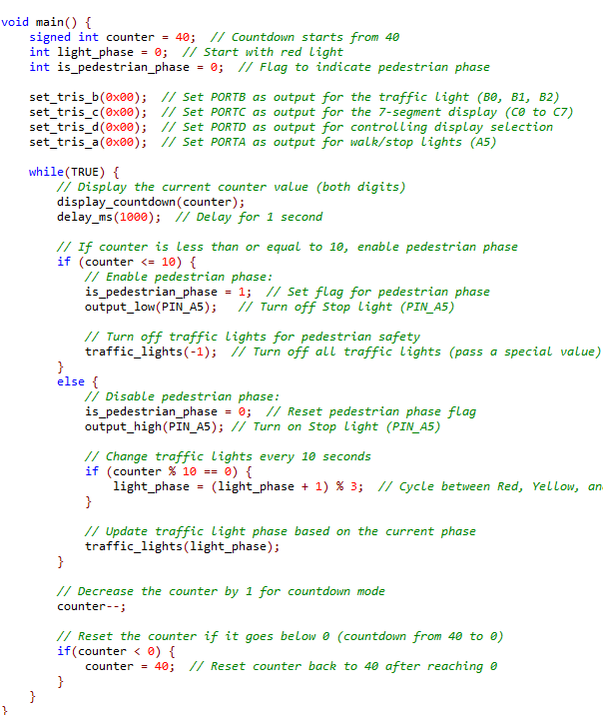
Figure 9 - Code detailing the traffic light and pedestrian mode
The above code uses an if statement to check if the counter (defined earlier in the script) is less than or equal to 10, enabling the pedestrian section of the code. When the count is above 10, it shows the red light on the pedestrian crossing light and cycles through the different traffic lights. The code decreases the counter and resets it to 40 when it reaches 0, working infinitely.

Background research on traffic lights:
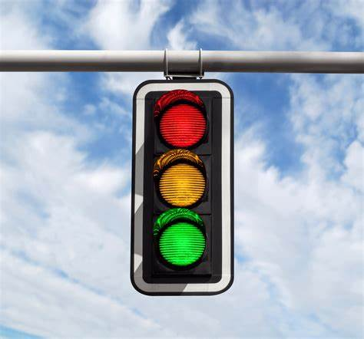
Figure 10 - A real traffic light (souza, 2019)
A traffic light, as depicted in Figure 10, plays a crucial role in managing the flow of traffic and ensuring the safety of both drivers and pedestrians. It consists of three distinct coloured lights: Red, Amber, and Green. These lights work in a continuous cycle to regulate traffic at intersections. The operation of each light is as follows:
- Red Light: When the red light is illuminated, it signals drivers to stop. Vehicles must come to a complete stop at the white line and remain stationary until the light changes. The red light serves as a safety mechanism, preventing vehicles from entering intersections when it is not safe to do so.
- Red and Amber Light: When the traffic light shows both red and amber together, it signals to drivers that they should prepare to move. This means that the light will soon turn green, and drivers should be ready to proceed. It acts as a warning that the current cycle is about to change, and drivers should remain alert to the upcoming green light.
- Green Light: The green light is a clear indicator that it is safe to proceed. Once the green light is illuminated, vehicles can move forward through the intersection, assuming there are no pedestrians crossing. Drivers should always ensure that the intersection is clear before proceeding. However, if pedestrians are still crossing or if there is any obstruction, drivers must wait until it is completely safe to move.
- Amber Light: When the amber light appears, it signals drivers to slow down and prepare to stop. The amber light is a transitional phase between green and red, warning drivers that the light will soon turn red. Drivers must stop before reaching the white line if it is safe to do so, but if they are too close to the intersection to stop safely, they should continue cautiously.
This cycle of lights—red, amber, and green—continues to repeat itself, ensuring smooth and orderly traffic flow. The light system is designed to provide clear signals to drivers, reduce the risk of accidents, and enhance pedestrian safety by allowing them to cross the road when it is safe.
This comprehensive system helps ensure safety, efficiency, and predictability on the roads, contributing to smoother traffic management and minimizing the potential for accidents. As shown in Figure 11, the cycle repeats continuously, adapting to the flow of traffic and the specific needs of each intersection. (Traffic Lights, n.d.)

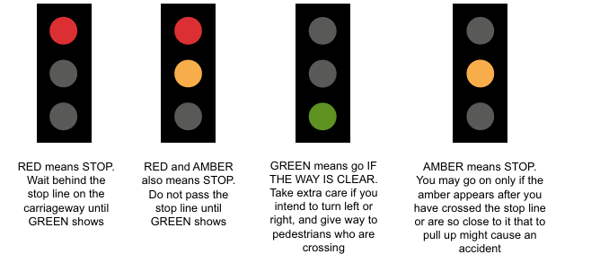
Figure 11- Traffic light configs (Transport, 2019)
The position of the traffic light must comply with S1421, as shown in Figure 12, ensuring it is visible to both drivers and pedestrians. Because traffic lights play a critical role in regulating traffic, they must be positioned to be more visible than stationary signs like stop signs. This increased visibility helps to reduce street clutter and ensures that both drivers and pedestrians can clearly see and respond to the signals. Proper placement allows for safer, more efficient traffic flow by minimizing confusion and improving overall safety. (Transport, 2019)
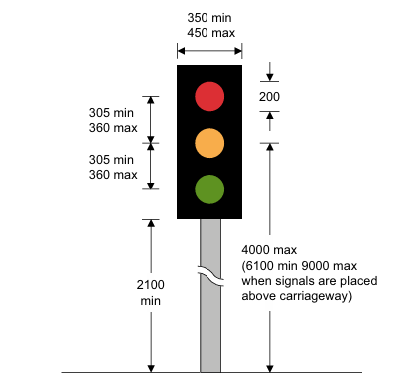

Figure 12 - Dimensions of the traffic light (Transport, 2019)

flowchart showing the system operation:
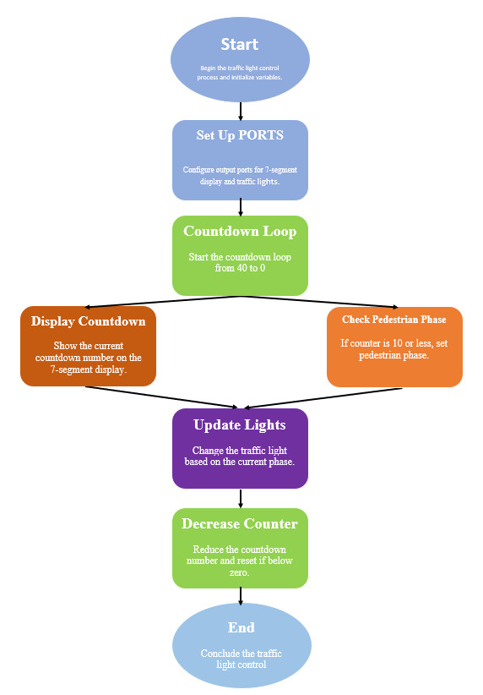
Figure 13 - flowchart explaining code

The code:
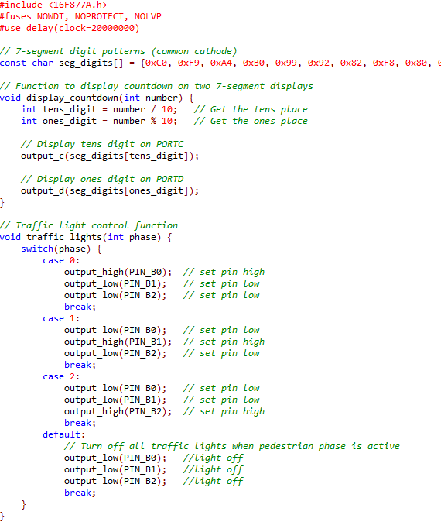
Figure 14 - First half of written code

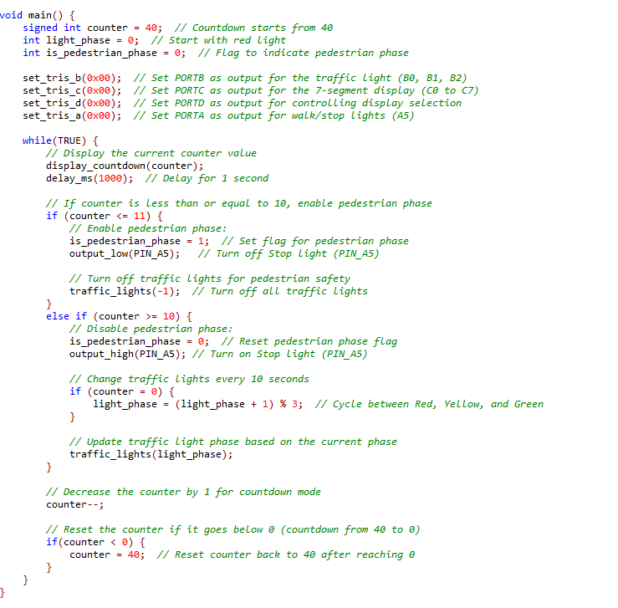
Figure 15 - second half of written code

Areas of improvement and tasks for the future:

An area that could have been improved in the traffic light system is the addition of a countdown for pedestrians, enabling them to see how much time they have left to cross. This would improve clarity and reduce accidents. This countdown could be supported by a flashing yellow light to ensure that pedestrians are aware that they have time to cross but must do so quickly.
Another improvement that could be implemented is traffic flow sensors (e.g., infrared, ultrasonic, or camera-based) at the intersection to detect vehicle congestion. This would allow the system to adapt the traffic light cycles based on real-time traffic conditions, providing longer green lights during high traffic periods and shorter cycles when traffic is light.
Adding sensors or buttons for pedestrians to trigger the green pedestrian light when they want to cross could optimize the system. Instead of having a fixed pedestrian phase at the end of each cycle, the system could adapt and respond to real-time pedestrian demand. When a pedestrian presses the button, traffic would start to slow down and stop, allowing them to cross.
As the current system only works for people with sight, adding audio cues for visually impaired pedestrians would be highly beneficial. A similar implementation could be a spinning toggle on the bottom of the button control for the traffic lights that indicates to those who cannot see or hear when it is safe to cross. The ‘cone’ spins when it is safe to cross, providing additional assistance for pedestrians who need extra help, as shown in Figure 16:
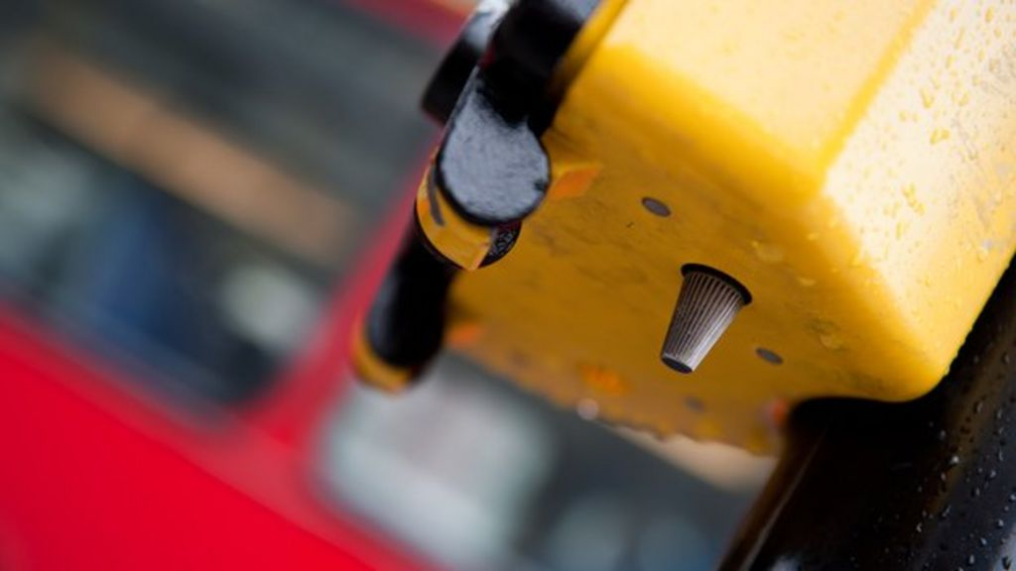
Figure 16- traffic light 'cone' (Ouchlets, 2013)

Conclusion:
In conclusion, the traffic light system designed for a T-junction efficiently manages traffic flow and pedestrian safety through a combination of traffic light phases, countdown displays, and pedestrian control lights. The system uses simple logic to control the traffic and pedestrian phases, ensuring that the intersection operates smoothly. By incorporating features like a pedestrian countdown and pedestrian crossing lights, the system prioritizes safety. While there is room for improvement, such as adding more advanced sensor technologies, the current design serves as an effective and adaptable solution for managing traffic at the intersection.

The brief and how the authors work compare?
In this section the author will compare the written brief to their own code to see how successfully they have met the criteria

Install three traffic signal lights on each side of the road for comprehensive traffic management.
The author has created three different traffic light systems that alternate light control.

Include a set of 7-segment displays on each side to either count up from 0 to 40 seconds or count down from 40 to 0 seconds.
The author has 2 separate 7 segment displays that, when the code is running, counts down from 40 – 0 and loops infinitely.

Configure the system to change traffic signals every 10 seconds for predictable and smooth traffic flow.
The author has coded so that every 10 seconds, the coloured light on the traffic light changes colour.

Reserve the final 10 seconds of the signal cycle for a dedicated pedestrian crossing phase.
The author has added a pedestrian phase in the last 10 seconds, where there is a green cross light that is otherwise red.

During the pedestrian crossing phase, program the traffic signals to either turn off or display a red signal for all three roads, ensuring pedestrian safety.
During the traffic light phase in the last 10 seconds, all the lights turn off.

References
BSM. (2025, March 12). Traffic lights: Need to know. Retrieved from BSM: https://www.bsm.co.uk/traffic-lights
Cafiero, C. (2025, January 5th). Modulo, floor division, and modular arithmetic. Retrieved from www.uvm.edu: https://www.uvm.edu/~cbcafier/cs1210/book/04_variables,_statements,_and_expressions/modulo_and_floor.html
Ouchlets. (2013, May 29th). The secret button at pedestrian crossings. Retrieved from bbc news: https://www.bbc.co.uk/news/blogs-ouch-22706881
souza, s. (2019, November 26th). Derby Street Traffic Lights Activated In Hingham. Retrieved from Patch: https://patch.com/massachusetts/hingham/derby-street-traffic-lights-activated-hingham
Traffic Lights. (n.d.). Retrieved March 12, 2025, from theorytest.org.: https://theorytest.org.uk/traffic-lights/
Transport, D. f. (2019). Traffic signs manual. Department for Transport, Department for Infrastructure (Northern Ireland), Scottish Government, Welsh Government.

Table of Figures
Figure 1 - The traffic light system 3
Figure 2 - Traffic light set up 3
Figure 3 - Pedestrian Control 4
Figure 4 - output ports for the two 7-segment displays 4
Figure 5 - 2, 7-segment displays for a 40 - 0 counter 4
Figure 6 - display function for count 5
Figure 7 - array of values for 7 segment display 5
Figure 8 - Switch statement that controls traffic lights 6
Figure 9 - Code detailing the traffic light and pedestrian mode 6
Figure 10 - A real traffic light (souza, 2019) 7
Figure 11- Traffic light configs (Transport, 2019) 8
Figure 12 - Dimensions of the traffic light 8
Figure 13 - flowchart explaining code 9
Figure 14 - First half of written code 10
Figure 15 - second half of written code 11
Figure 16- traffic light 'cone' (Ouchlets, 2013) 12

