
Prepared By
Fazle Rabby Nahi
Student ID: 2515592

Master of Business Administration
Lecturer Name: Dian Mayasari
Module: Marketing Management
Module Code: LCMB7024

Assignment Title: Marketing Portfolio (Individual Report).
Assignment Topic: Brand Extension of ZARA Renew Eyewear
Words Count: 2708 Words
Date of Submission: 19th November 2025

Contents
Introduction 3
Element 1: Segmentation, Targeting, Differentiation, and Positioning (STDP) Analysis of ZARA Renew Eyewear. 4
Segmentation – How Zara Will Segment the Market. 4
Targeting – Select and Reach Its Audience 5
Differentiation – Stand Out in the Eyewear Market 5
Positioning – Position of ZARA Renew Eyewear 6
Element 2 – Marketing Mix (4Ps) 9
How ZARA Renew Eyewear Will Do Marketing Mix. 9
Element 3 – Marketing Strategy Pitch 13
ZARA Renew Eyewear Product Launch Poster. 13
Element 4: Reflection 14
Conclusion 16
Reference 16

Introduction
The global fashion industry is evolving rapidly as consumers, regulators, and stakeholders demand greater transparency and sustainable practices. Zara, the flagship brand of the Inditex Group, has built its reputation on fast fashion, speed, and affordability; however, the rising pressure for environmental accountability now challenges the company to integrate circular approaches into its business strategy. This portfolio develops a new sustainable brand extension—ZARA Renew Eyewear—which transforms Zara’s internal waste streams, including plastic hangers, packaging film, and textile offcuts, into recycled sunglasses and optical frames. The concept demonstrates how circular innovation can integrate style, affordability, and responsibility within a high-street retail model.
This portfolio not only develops a new sustainable brand extension for Zara but also evaluates its strategic feasibility within the fast-fashion industry. It integrates current debates on circular economy, brand purpose, and value co-creation to demonstrate advanced postgraduate-level insight.
The assessment consists of four elements. Element 1 provides a comprehensive STDP analysis, showing how segmentation, targeting, differentiation, and positioning can be operationalised for ZARA Renew Eyewear. Element 2 outlines the marketing mix (4Ps), detailing product development, pricing strategy, distribution channels, and promotional activities. Element 3 presents a strategic pitch supported by a promotional poster, and Element 4 offers a critical reflection grounded in established learning theories. Together, these elements illustrate how Zara can translate sustainability into a viable and competitive brand strategy.

Element 1: Segmentation, Targeting, Differentiation, and Positioning (STDP) Analysis of ZARA Renew Eyewear.

Segmentation – How Zara Will Segment the Market.
Zara will implement data-driven segmentation leveraging its advanced retail analytics and digital-behavioural insights through four complementary lenses.
- Demographic Segmentation:
Using customer data, Zara will identify consumers aged 18-35 as frequent purchasers of accessories and Join Life products, a demographic with high digital engagement and environmental concern (Deloitte, 2024).
- Geographic Segmentation:
Using store heat maps and online sales density, Zara will prioritize urban flagship markets, London, Berlin, Barcelona, Milan, and Amsterdam, where sustainability awareness and optical accessory sales overlap. The logistics team can then allocate ZARA Renew Eyewear inventory efficiently through near-shore hubs in Spain and Portugal.
- Psychographic Segmentation:
Social-listening tools will monitor hashtags like #JoinLife and #EcoStyle to classify an “eco-aesthetic” segment that values environmental ethics without sacrificing fashion appeal (Peattie & Crane, 2005).
- Behavioural Segmentation:
Tracking app interactions and recycling returns will group users into “eco-advocates,” “trend followers,” and “passive buyers” for customised messaging.
This blended approach ensures segmentation is dynamic and evidence-based, updated quarterly via automated dashboards (Kotler & Keller, 2022).

Targeting – Select and Reach Its Audience
The targeting strategy consciously makes a critical trade-off: depth over breadth. By concentrating all initial resources on Urban Gen Z and Millennials (18-35), we accept a limited short-term market reach to achieve maximum impact with the segment that offers the highest lifetime value and cultural influence. This group, active on Instagram and TikTok with low greenwashing tolerance, will be reached through personalised in-app notifications, micro-influencer collaborations, and limited "Renew Drops" using scarcity marketing.

The Secondary Target Market comprises existing Zara accessories customers (25-45) who prioritise style but respond to added value. They will be engaged via Meta retargeting campaigns showing waste transformation imagery and in-store QR stands explaining product sustainability.
A concentrated marketing approach will direct early resources toward the eco-conscious niche, using predictive models to estimate lifetime value and guide ad-spend.

Differentiation – Stand Out in the Eyewear Market
ZARA Renew Eyewear will differentiate across five integrated dimensions product, service, channel, people, and image ensuring tangible and emotional superiority.
- Product Differentiation:
Frames will be made from Zara’s internal waste streams, converted into certified bio-resin blends. Each pair includes a QR code displaying waste source and CO₂ savings (Delmas & Burbano, 2011), plus repairable modular hinges.
- Service Differentiation:
The Return-to-Renew Programme offers 10% vouchers for returned frames. The Zara App allows users to schedule pick-ups and track impact, employing nudge theory (Thaler & Sunstein, 2008) to reward sustainable behaviour.
- Channel Differentiation:
“Renew Corners” in flagship stores and an integrated AR try-on tool will be introduced. Returned frames will re-enter reverse-logistics routes, proving circularity at scale (McKinsey & Company, 2023).
- People Differentiation:
Staff will complete Zara Campus modules on sustainability storytelling, with performance bonuses partially tied to frames collected, embedding this culture frontline (Peattie, 1999).
- Image Differentiation:
The “From Fabric to Frame” creative platform, validated by Ellen MacArthur Foundation collaborations (Ottman, 2017), will visualise the waste-to-wearable transformation, highlighting transparency and empowerment.
These differentiators convert sustainability into a valuable design narrative (Peattie & Crane, 2005).

Positioning – Position of ZARA Renew Eyewear
Zara will position the brand using evidence-based storytelling.
Positioning Statement:
“For fashion-forward consumers who want style without waste, ZARA Renew Eyewear transforms Zara’s leftover materials into circular, traceable, and affordable design.”
Implementation will involve three sequential actions:
- Market Mapping: Quarterly surveys will map brand perceptions, aiming to position ZARA Renew in the high-style/high-sustainability quadrant between Bird Eyewear and H&M Accessories.
Brand | Price Range | Sustainability Level | Material Transparency | Style Quality | Digital Experience
ZARA Renew | £29.99–£44.99 | High – Uses recycled Zara waste | QR-coded traceability (high) | High-street premium | AR try-on + Omnichannel
Bird Eyewear | £80–£90 | Very High – Fully recycled materials | Full product transparency | Premium, eco-luxury | Limited digital features
H&M Accessories | £15–£25 | Low–Medium – Minimal sustainable inputs | Very limited | Basic fast-fashion | Basic online + store availability
Table 1: Competitive Comparison for the Eyewear Market.
- Communication Execution: Campaign assets will combine transparency (QR codes, recycled metrics) with emotional resonance real customers narrating their “renew” stories.
- Performance Tracking: Key metrics (70% sell-through in eight weeks, 20% take-back, NPS ≥65) will quantify the “accessible circularity” promise.
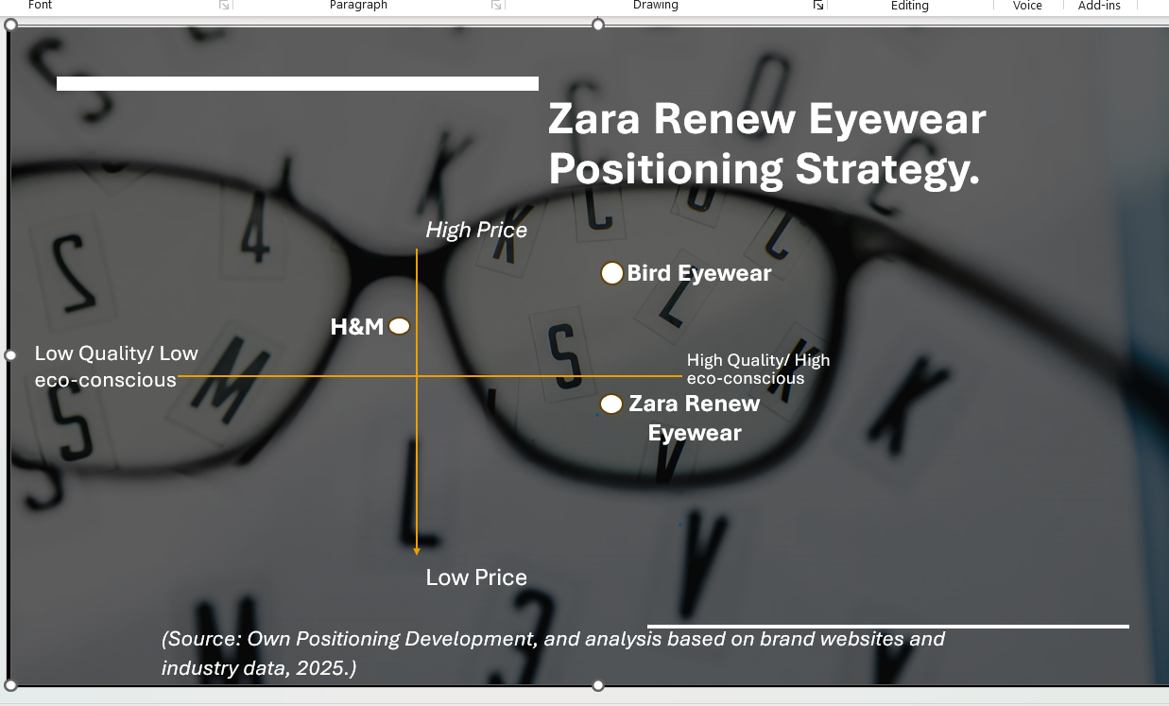
Figure 1. Perceptual Map for Zara Renew Eyewear.
This positioning makes Zara the first high-street brand to make circularity visible and affordable, reinforcing that credibility and purpose define competitive advantage (Kotler & Keller, 2022).
Critical Limitations
While the STDP strategy is strong, several limitations remain. Internal waste supply can vary seasonally, which affects the consistency of recycled materials. Despite QR transparency, some consumers may still be skeptical of fast-fashion sustainability claims. The quality of recycled polymers may fluctuate, necessitating strict quality control. The Return-to-Renew programme also depends heavily on customer participation. These factors require continuous monitoring and flexible operational planning.

Element 2 – Marketing Mix (4Ps)

How ZARA Renew Eyewear Will Do Marketing Mix.
- Product – Design and Deliver the Eyewear
ZARA Renew Eyewear will translate sustainability into tangible design features without losing the brand’s minimalist fashion appeal. Frames will be produced from Zara’s own internal waste plastic hangers, garment offcuts, and packaging film processed into bio-resin and recycled polymers by near-shore partners in Spain and Portugal. Each frame will include a QR-enabled tag displaying its recycled content, CO₂ savings, and return-to-renew options, promoting full material transparency (Delmas & Burbano, 2011).
To reinforce quality assurance, every model will meet CE and UV 400 certifications and undergo internal durability testing equal to or above existing accessories. The line will launch with three tiers: Essential, Textured Edition, and Capsule Collections. Essential models offer classic silhouettes; Textured Editions integrate visible denim or fibre textures; Capsules introduce limited seasonal concepts such as Ocean Black and Paper Light.
Packaging will be 100% recycled kraft paper embossed with the Renew symbol, replacing plastic cases. Frames will feature repairable hinges to extend life, consistent with Zara’s circular-design roadmap (Inditex, 2023). Design teams in Arteixo will use computer-aided eco-modelling to minimize material input by 15 %. Altogether, ZARA Renew Eyewear becomes a proof-of-concept product demonstrating that sustainability and mass production can coexist supporting Kotler and Keller’s (2022) emphasis on “value creation with purpose.”
Tier | Name | Material | Price | Description
Essential | Classic Renew | Recycled PP & PET | £7.99–£14.99 | Minimal everyday shapes.
Textured Edition | Denim Vision | Cotton/denim fibres + bio-resin | £17.99–£27.99 | Visible fibre texture.
Limited Capsule | Ocean Black / Paper Light | Recycled polymer mix | £37.99–£47.99 | Seasonal designs.
Table 2: Zara Renew Eye Ware Product Descriptions (Source: Based on Own Development Marketing 4Ps).
- Price – for Affordability and Sustainability
The value-based pricing strategy is engineered to achieve a target contribution margin of 55%, but its true profitability stems from a fundamental reconfiguration of the cost structure. Benchmarking against Bird Eyewear (£80-£90) and H&M Accessories (£15-£25), Zara will position its range between £7.99 and £47.99, signalling quality sustainability without eco-premium.
Inditex's integrated supply chain provides cost advantages near-shoring and reduces freight and waste-disposal costs, allowing competitive retail pricing. By using internal waste as raw material, the variable cost of goods is significantly reduced. Furthermore, the 'Return-to-Renew' programme directly attacks operational waste disposal costs. This dual financial advantage ensures the sustainability proposition is underpinned by a robust P&L impact, not just marketing appeal. Zara's finance team will calculate target contribution margins aligned with the accessories division (55 %). Price elasticity testing will be conducted using A/B online pilots, adjusting SKUs by ± 5% to monitor conversion rates.
Range | Price | Purpose
Essentials | £7.99–£14.99 | Entry-level sustainable style.
Textured Editions | £17.99–£27.99 | Fashion aesthetic.
Capsules | £37.99–£47.99 | Trend-driven exclusivity.
Table 3: Price Range (Source: Based on Own Development Marketing 4Ps).
Promotional incentives will incorporate behavioral economics “nudges.” Customers returning old frames through the Return-to-Renew programme will receive a 10 % digital voucher, stimulating repeat purchases while ensuring product circularity (Thaler & Sunstein, 2008). Student-discount partnerships with UNiDAYS, Student Beans and limited-time Renew Week bundles (e.g., “Buy one Essential + free case”) will expand reach among younger demographics.
Currency harmonisation ensures consistent pricing across Europe; any cost increase in recycled resin will be offset by digital rather than physical marketing expenditure. Transparent QR dashboards showing “how your £35 pair saves 120 g of plastic” will frame sustainability as added value rather than cost. In doing so, ZARA Renew Eyewear converts eco-efficiency into customer benefit, reinforcing Armstrong et al.’s (2023) principle that price must reflect perceived, not just produced, value.
- Place – Distribute and Ensure Accessibility
Zara will deploy a hybrid omnichannel distribution strategy to make ZARA Renew Eyewear universally accessible while minimising carbon footprint.
Physical Distribution: Flagship stores in London, Berlin, Barcelona, and Milan will include “Renew Corners” compact, sustainably built zones with recycled fixtures and digital mirrors for AR try-on. Store managers will use heat-mapping data to optimise shelf placement near accessories and checkout counters, encouraging impulse and cross-category purchases. Each store will act as a mini collection hub for the Return-to-Renew scheme, enabling convenient drop-offs and visualising circularity in action.
Online Distribution: The Zara App 2.0 will feature an eyewear microsite with 3D visualisations and augmented-reality fitting powered by WebAR. Integrated inventory visibility allows shoppers to reserve frames online and pick up in store within 24 hours, reducing delivery emissions by 30%. Logistics will rely on Inditex’s consolidated European distribution centres; near-shore production enables two-week replenishment cycles instead of traditional quarterly ones.
Green Logistics: Zara’s supply-chain engineers will implement eco-routing algorithms to combine eyewear deliveries with apparel shipments, minimising extra miles (Björklund, 2011). Packaging consolidation will cut volume by 20%.
By linking physical and digital channels into a seamless experience, ZARA Renew Eyewear extends Zara’s retail ecosystem and exemplifies Vargo and Lusch’s (2008) service-dominant logic creating value collaboratively with customers who both buy and return products within the same network.
- Promotion – Communicate and Build Engagement
The “From Fabric to Frame” campaign will communicate ZARA Renew Eyewear’s circular story through evidence, emotion, and interactivity. Following the AIDA model (Kotler and Keller, 2022), Zara will move audiences from attention to action across multiple media.
Attention: Short 10-second teasers on Facebook, YouTube, TikTok, Google Ads, and Instagram Reels will reveal hangers transforming into sunglasses, tagged #ZaraRenew. Paid collaborations with eco-micro-influencers will amplify reach among 18-45 urban users.
Interest: In-store digital screens and AR filters will allow consumers to “scan and see” waste origins via QR codes. Sustainability facts “made from 65 % recycled Zara waste” will feature on packaging and online product pages to satisfy rational information seekers (Leonidou & Hultman, 2011).
Desire: Emotional storytelling will showcase real customers exchanging old items for new frames, echoing Ottman’s (2017) view that green branding must connect heart before head. The creative tone will blend minimalist aesthetics with empowerment messages like “Wear the change you make.”
Action: Promotional drivers include the 10% return voucher, app exclusive “Renew Drops,” and pop-up “Repair Bars” in universities. Zara will measure campaign impact via click-through rate > 3%, conversion > 5%, and user-generated content volume.
All messages will integrate under Zara’s existing IMC framework, ensuring consistency between online and in-store narratives. By proving sustainability through transparent data and participatory experiences, ZARA Renew Eyewear establishes trust while enhancing Zara’s modern, purpose-driven image.

Element 3 – Marketing Strategy Pitch

ZARA Renew Eyewear Product Launch Poster.
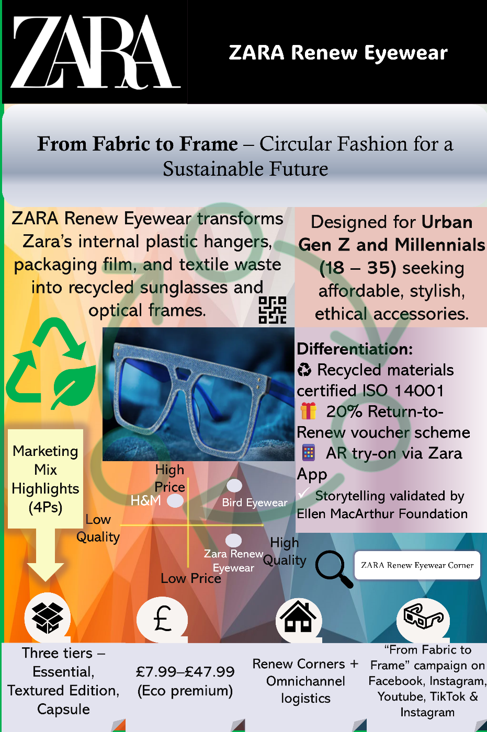
Poster 1: Zara Renew Eyewear (Information Product Launch Poster, Source: Made by myself, using PowerPoint).
This poster serves as an informational and strategic overview of the ZARA Renew Eyewear product launch. It visually presents the brand concept, sustainability objective, and marketing mix (4Ps) aligned with Zara’s circular fashion approach. The design communicates how the brand converts Zara’s internal waste materials into recycled sunglasses and optical frames, under the slogan “From Fabric to Frame – Circular Fashion for a Sustainable Future.”
The poster also includes the positioning map showing ZARA Renew Eyewear’s market placement between H&M Accessories and Bird Eyewear, as well as the target audience urban Gen Z and Millennials (18–35). Key differentiators such as ISO 14001-certified materials, AR try-on via Zara App, and the Return-to-Renew voucher scheme are highlighted using clear visuals and icons. The poster’s layout and colour scheme reflect Zara’s minimalist yet innovative brand identity, ensuring an effective academic presentation of the launch strategy.

Element 4: Reflection
Developing the ZARA Renew Eyewear brand was a deeply practical journey that transformed my understanding of how sustainability theories translate into real-world marketing strategy. While academic models provided a foundation, the greatest learning emerged from tackling the tangible challenges of creating a viable circular business model for a fast-fashion giant.
The most demanding part of the experience was balancing affordability with authenticity. Zara's scale meant that a sustainable product could not be a niche, premium offering; it had to be accessible. This pushed my research beyond textbooks and into Inditex’s own sustainability reports and supply chain data. I had to get practical, analysing their waste streams to determine if there was sufficient material to launch an eyewear line and calculating how near-shore manufacturing in Spain and Portugal could control costs. Writing the STDP analysis moved from a theoretical exercise to a strategic tool. For example, identifying the "eco-aesthetic" segment was not just about demographics; it was about understanding that we were targeting people who would genuinely use the QR code to trace their product's origin, making that technological investment worthwhile.
This project felt like a direct continuation of my undergraduate work on E-waste Impact in Urban Area at Dhaka, Bangladesh. That earlier research, which involved field observations, gave me a first-hand look at how waste could be a resource, but also how poorly planned initiatives failed. This practical experience informed me to distrust superficial claims and insist that every sustainability statement be backed by real evidence. For instance, the Return-to-Renew programme was not just a concept; it required mapping out how returned frames would physically re-enter Zara’s existing reverse-logistics network, proving the circular model was operational.
During the conceptualisation phase, I was forced to synthesize conflicting strategic paradigms. The Resource-Based View (Barney, 1991) compelled me to build a unique, valuable capability (closed-loop recycling). However, this had to be reconciled with the principles of Transaction Cost Economics, which demanded the model not create untenable operational complexity. The solution leveraging Zara's existing near-shore logistics was not just a practical choice but a theoretical synthesis, ensuring valuable rarity without incurring debilitating costs. This high-level thinking directly informed practical decisions; for instance, nudge theory (Thaler and Sunstein, 2008) shaped the 10% return voucher, and service-dominant logic (Vargo and Lusch, 2008) led me to design customers into the system as active partners who complete the recycling loop.
Through evaluation, I recognise my strength was in operationalising ideas—turning "circularity" into a specific product with a clear supply chain. However, a key weakness was my reliance on secondary data. I made assumptions about consumer willingness to pay that needed validation through primary research like surveys or focus groups. I also learned that leaving visual branding to the later stages created a time crunch; earlier and more iterative feedback would have strengthened the final output.
My Future Action Plan:
1. Conduct primary research (survey or interviews) to validate consumer attitudes toward recycled eyewear.
2. Strengthen my skills in sustainability measurement tools such as Life-Cycle Assessment (LCA).
3. Develop advanced competence in marketing analytics to optimise future campaigns.

Conclusion
In conclusion, ZARA Renew Eyewear serves as a strategic prototype for a post-fast-fashion enterprise. It demonstrates that the perceived dichotomy between profitability and sustainability is a false choice. By architecting a marketing strategy that is inextricably linked to Zara's operational core, this portfolio provides a blueprint where environmental and economic objectives become mutually reinforcing. The brand doesn't just communicate value systematically engineers it through a circular model that transforms cost centers into value creators. This is the pinnacle of modern marketing: it is the business strategy itself.

Reference

Armstrong, G., Kotler, P., Harker, M. and Brennan, R. (2023) Marketing: An Introduction. Harlow: Pearson.

Barney, J.B. (1991) 'Firm resources and sustained competitive advantage', Journal of Management, 17(1), pp. 99-120.

Björklund, M. (2011) 'Influence from the environment on logistics', International Journal of Physical Distribution & Logistics Management, 41(9), pp. 726-743.

Delmas, M.A. and Burbano, V.C. (2011) 'The drivers of greenwashing', California Management Review, 54(1), pp. 64-87.

Deloitte (2024) Global Sustainability and Consumer Behaviour Survey. [Online] Available at: https://www.deloitte.com (Accessed: 13 October 2025).

Ellen MacArthur Foundation (2021) A New Textiles Economy: Redesigning Fashion's Future. [Online] Available at: https://ellenmacarthurfoundation.org (Accessed: 13 October 2025).

Geissdoerfer, M., Savaget, P., Bocken, N.M.P. and Hultink, E.J. (2017) 'The Circular Economy – A new sustainability paradigm?', Journal of Cleaner Production, 143, pp. 757-768.

Inditex (2023) Annual Report 2023. [Online] Available at: https://annualreport2023.inditex.com (Accessed: 13 October 2025).

Kotler, P. and Keller, K.L. (2022) Marketing Management. 16th edn. Harlow: Pearson.

Leonidou, C.N. and Hultman, M. (2011) 'Marketing strategy and the environment: A meta-analysis', Journal of the Academy of Marketing Science, 39(1), pp. 157-173.

McKinsey & Company (2023) The State of Fashion 2023. [Online] Available at: https://www.mckinsey.com (Accessed: 13 October 2025).

Ottman, J.A. (2017) The New Rules of Green Marketing. Abingdon: Routledge.

Peattie, K. (1999) 'Trapping versus substance in the greening of marketing planning', Journal of Strategic Marketing, 7(2), pp. 131-148.

Peattie, K. and Crane, A. (2005) 'Green marketing: Legend, myth, farce or prophecy?', Qualitative Market Research, 8(4), pp. 357-370.

Porter, M.E. (2008) Competitive Strategy. New York: Free Press.

Public Eye (2023) Zara Fuels Climate Crisis with Thousands of Tons of Airborne Fashion. [Online] Available at: https://www.publiceye.ch (Accessed: 13 October 2025).

Statista (2024) Inditex – Brand Portfolio and Key Figures. [Online] Available at: https://www.statista.com (Accessed: 13 October 2025).

Thaler, R. and Sunstein, C. (2008) Nudge: Improving Decisions about Health, Wealth and Happiness. London: Penguin.

Vargo, S.L. and Lusch, R.F. (2008) 'Service-dominant logic: Continuing the evolution', Journal of the Academy of Marketing Science, 36(1), pp. 1-10.

Williamson, O.E. (1981) 'The economics of organization: The transaction cost approach', American Journal of Sociology, 87(3), pp. 548-577.

