  LCBB6000 Dissertation - final  Module Supervisor: Dr Anupam Mazumdar and Mr. Afzal Sayed Munna | Submisison date: 13/01/2023  BA (Hons) Business Management | University of Wales Trinity Saint David (London Campus)  Student Name: Krasimira Tsacheva  STUDENT ID: 1917122

Table of Contents
Introduction 2
Aims and Objectives of the Research 2
Research Problem 2
Objectives of the Research 3
Aim of the Research 3
Literature Review / Rationale of the Research 3
Rationale of the Research 3
Opportunities for Career Progression and Advancement 4
Compensation in Workplaces 5
Theory of Characteristics 6
Theories of Financial Transactions and Economic Change 6
Methodology 8
Overall Approach 8
Methodologies for the Collection of Data 9
The Value of the Study 10
Limitations and Scope of the Research 10
Investigational Hypotheses and Theories Incorporated in the Research 11
Quantitative Investigations 12
Method of Cross-Sectional Analysis 12
Reflection on Ethical Considerations 12
Pilot Examinations 13
Questionnaire Draft 14
Research Findings 18
Research Participant Answers 18
Graphical Representation of Findings 21
Analysis of Findings 27
Recommendations 28
Conclusion 29
References 31
Appendices 34

Determining factors of Employees Retention. A case study of Beautyfi, a local beauty salon in London.

Introduction
It is no longer necessary for an employer to have the ability to keep employees on staff in order to have a positive work environment. It is only natural for workers to look for new opportunities to advance their careers, which can lead to employees frequently switching jobs within the same industry. Nevertheless, the cost of employee turnover is significant. According to Cardy et al. (2011), employee turnover has an effect on the level of performance and success of an organisation. Furthermore, as competition for qualified and skilled workers increases, it becomes increasingly difficult to manage employee turnover. As a result, there are a variety of factors that play a role in the retention of employees within an organisation. These components consist of monetary compensation, personal development, and recognition and rewards for one's efforts.
Employees frequently look for ways to be recognised and rewarded for their outstanding performance, which makes recognition and rewards a significant factor in employee retention. This is because employees want to continue working for the organisation even as it moves closer to achieving its goals (Christeen, 2015). Employees are recognised and rewarded in a variety of ways by the organisation. These include: keeping employees entertained through exciting or social events or projects; providing employees with visibility; providing employees with mentors to advance their knowledge and skills; and holding employees accountable by rewarding them for meeting certain performance benchmarks (Cardy et al., 2011).
In addition, there are tactics that employers can use to keep their employees, such as providing visibility for the work that they do. This can be accomplished by asking employees to lead high-profile team members, manage off-site meetings, and give presentations in front of the board.

Aims and Objectives of the Research

Research Problem
Previous studies, which were conducted out in a variety of countries, unearthed a positive connection between work-life balance, reward recognition, and employee retention. This correlation was found to be helpful and the research can look into the relationship between work-life policies, incentive and recognition programmes, and the assistance provided by supervisors to employees. According to the findings of a number of studies, the primary factors motivating people to remain in their current positions are the relationships they have with their coworkers and the acknowledgment they receive for their efforts.
There is research that focuses on the relationships between work-life balance, remuneration or rewards, recognition, and employee retention. This research has been conducted. Retaining employees is one of the challenges that an organisation must surmount, particularly for those who are employed in the human resources department. According to common beliefs, millennials have high expectations not just for the company that employs them but also for the quality of their own work, as well as specific requirements before they will accept a job offer. People are able to readily switch occupations and organisations due to the fact that there are a lot of different factors to take into consideration. As a direct consequence of this, the difficulty that a business faces in retaining employees of this age is very severe.

Objectives of the Research
The primary objective of this research is to establish whether or not work-life balance and reward and recognition programmes are significant factors that encourage employees to remain with their current employers.
2. To find out if remuneration and recognition, in addition to a healthy balance between work and personal life, are considered to be significant factors in job satisfaction.
3. To investigate whether or whether factors such as job happiness, rewards and recognition, and a healthy work-life balance play a significant role in employee retention.

Aim of the Research
The primary emphasis of this study was placed solely on those aspects of an organisation that would be put to the test in the near future. These aspects include reward and recognition, work-life balance, job satisfaction, and employee retention. The questionnaires for this study were handed out by the researchers at a specific time period so that they could carry out the research. To obtain a complete picture of the elements that influence the retention of employees, it is possible that other variables will need to be incorporated.

Literature Review / Rationale of the Research

Rationale of the Research
Additional factors that influence employee retention include personal growth and development opportunities. Continuous learning opportunities, both in terms of knowledge and skills, should be provided to workers so that they can grow professionally and personally. 39 percent of Canadian employees ranked "using skills and abilities" as their top priority, while 26 percent desired encouragement through personal development, as found in a survey conducted by Global Market Insite, Inc. (Kossivi, Xu and Kalgora, 2016).
Kurdi, Alshurideh and afaishat (2020) cautioned that a lack of additional opportunities or training to develop skills could force high-performing workers to look for new positions that provide them with more experience. The research noted that this could be a problem because it could force workers to leave their current employers. Employees have a propensity to innovate, in addition to taking risks and modernising, which is why the organisation that they work for must be open to new ideas that improve efficiency and productivity. There are methods available to workers that can be utilised to advance their own personal development. One strategy for accomplishing this objective is to devise an open personal development policy that makes it possible for employees to take control of their own professional growth and make strides toward improvement in a variety of domains. In addition, the employer ought to provide a budget for employees to use on conferences, classes, and books, in addition to providing channels for employees to provide feedback.
It is not as straightforward as it may first appear that the relationship between pay and the retention of employees has. Improved compensation should be one of the strategies that employers use in their efforts to retain top employees over the long term. The effectiveness of this strategy can be improved by combining it with a greater emphasis on work-life balance. Improved compensation can only increase retention capability in the short term (De Sousa Sabbagha, Ledimo and Martins, 2018). It is recommended that the strategy combine compensation with another factor, such as work-life balance, in order to achieve the goal of increasing the retention rate through compensation. This requires ensuring that the employer provides a salary (compensation) that is competitive, as well as a work environment that is flexible and stimulating for the employee.

Opportunities for Career Progression and Advancement
Investing in one's professional growth is a crucial component of employee retention. According to De Sousa Sabbagha, Ledimo and Martins (2018), there is a connection between an individual's perception of their own professional success and an organization's capacity to keep its current workforce. Personal and professional growth have an effect on employee retention, and offering employees opportunities for advancement helps strengthen their resolve to remain with the company. There is a direct connection between quitting one's job and having problems with moving up in one's career. Therefore, there is correlation between the availability of opportunities for employee development and employee retention.
Promotions and opportunities for growth are important factors in employees' decisions regarding whether or not to leave an organisation or continue working for that organisation (Tian et al., 2020). After that, he proceeded to identify influential career growth factors such as advancement plans, internal promotion, and accurate career forecasts. Where there is little encouragement for continued education, student retention is high. Daniels and his coworkers believe that promotions are one of the most effective ways to keep employees happy and loyal. When employees are provided with adequate training, the likelihood of them remaining with an organisation is significantly increased. Tymon, his co-researcher, Pitts and his research team discovered a connection between an employee's perceived level of career success and the likelihood that they will remain with the company. Cardy and Providing employees with opportunities for professional growth can increase their commitment to remaining with an organisation.

Compensation in Workplaces
The connection between pay and employee loyalty has been the subject of a significant number of empirical investigations. There is no consensus among researchers regarding the relationship between pay and employee retention. The extent to which an employee is satisfied with their pay has a significant bearing on whether or not they choose to remain employed by the company. Some people have the opinion that compensation does not have an indirect effect on employee retention.
Tian et al. (2020) found that organisations in the United Kingdom, particularly those in the beauty and care industries, do not use salary and benefits policies to increase employee retention rates. After conducting additional research, Lambert, Lynne, and Barton all arrived at the same conclusion. One strategy that has been suggested to improve employee retention is increasing pay decision transparency. Arasanmi and Krishna (2019) believed that pay served not only as a motivator but also as a strategy for retaining employees. There is a connection between reward and retention. The research places the utmost importance on monetary compensation as the primary form of employee retention compensation. It has been found that performance-based pay is an effective way to retain employees. In 2006, under Tremblay's leadership, a group of researchers made the groundbreaking discovery that employee retention can be improved through the use of performance-based compensation.
The importance of extrinsic rewards in employee retention cannot be overstated. According to research that was conducted by Arasanmi and Krishna (2019), employee turnover can be predicted based on compensation. They came to the conclusion that increased pay leads to decreased turnover while simultaneously increasing manager commitment.
Reward is not a significant retention factor on its own, as stated by (Ahmad, 2018). An increase in pay may help with employee retention in the short term, but this effect is only temporary. This group of researchers identified the quality of work life as a factor that plays a role in employee retention over the long term. In order for organisations to be more effective in their efforts to retain a larger number of employees over time, improved compensation should be combined with the quality of work life. The research provides evidence that wage levels have no influence on employee retention, particularly among nurses.

Theory of Characteristics
During the 1930s, great man theories began to fall out of favour as a viable option for logically explaining leadership. The concept that people who were considered to be leaders shared particular mental, physical, and social characteristics began to be the focus of trait-based theories, which began to take shape (Prentice, Jayawickreme and Fleeson, 2018). The findings indicated that effective leadership can be exercised in a variety of settings and tasks, and that there are positive correlations between effective leadership and personality traits. Additionally, the results demonstrated that there are positive correlations between effective leadership and personality traits.
Academics investigated leadership behaviours as a means of responding to criticisms levelled against trait-based methods. A trait-behavior based approach to leadership was first developed by psychologist Gordon Allport, and its popularity grew throughout the 1950s and 1960s (Fleeson and Jayawickreme, 2015). This method is known as the behavioural approach to leadership. Behavioral theories of leadership shifted the paradigm of great leaders being born into one in which individual behaviours were recognised as the primary factors of individual leadership. Previously, this paradigm posited that great leaders were born.
Scheffer and Heckhausen (2018) research on the trait theory of leadership found that leadership depended on the interaction between the individual and the social context rather than on predetermined characteristics. As a result, the findings disproved the findings of study and showed that leadership was dependent on the interaction. Leadership was influenced not just by personality attributes but also by environmental circumstances.
Even though certain characteristics were linked to effective leadership, there was no set of characteristics that could be used to guarantee success in all circumstances. This is despite the fact that leadership qualities are still a popular topic in modern times (Tyssen, Wald and Spieth, 2014). Trait theories came first on the evolutionary chronology of leadership research, and then situation and contingency-based theories were proposed after them. There are theories that support both transactional and transformational styles of leadership; nevertheless, transformational leadership is now the more popular of the two due to its capacity to inspire and cultivate followers.

Theories of Financial Transactions and Economic Change
Wadhwani et al. (2020) provided research in the field of leadership studies. Both of these concepts, despite their individuality, were seen as existing on a continuum between people-oriented theories and task-oriented theories. The task-oriented end of the continuum, where leaders focused on interactions with staff to influence their behaviour and achieve results, was represented by transactional leadership. This type of leadership emphasised the importance of building relationships. Transactional leaders are those who achieve organisational goals by making and keeping promises of praise, pay raises, and promotions in exchange for excellent work while punishing subpar work (Wadhwani et al., 2020). These bosses can inspire their staff to reach new heights of productivity. There are four types of transactional leadership: contingent reward (promising rewards for excellent performance and recognising accomplishments), active management by exception (keeping an eye out for rule and standard violations and taking corrective action), passive management by exception (only intervening if standards were not met), and laissez-faire (abdicating responsibility for the outcome of the situation) (Osaghae and Cooney, 2019).
The people-oriented end of the leadership spectrum can be represented by the transformative style of leadership. To be a transformative leader, one must inspire their followers to put aside their own interests in favour of the group's and work toward the group's goals and mission (Osaghae and Cooney, 2019).
True transformational leaders inspire their teams to take full ownership of their work. Organizational success is correlated with leaders who are able to inspire change within their teams, and this is reflected in higher leadership ratings (Den Hartog et al., 1999). Evidence also shows that workers' commitment to the company can be boosted by executives who implement people-centered transformative efforts (Den Hartog et al., 1999).
To fully grasp the relationship between the social construct of leadership and employee engagement, it is crucial to have a firm grasp on the evolution of leadership theories. It was thought that via fostering the growth of subordinates' capacity to follow instructions, transformational leadership may improve both employees' and employers' emotional investment in the success of the business (Den Hartog et al., 1999). Furthermore, transformational strategies acknowledge that developing their human capital is crucial to achieving their objectives.
Over the course of their history, businesses have formed the habit of viewing their employees as valuable resources critical to attaining their objectives and providing them with a competitive edge (Shatzer et al., 2013). Organizations frequently develop talent management goals that emphasise the productivity and longevity of their workforce because of the significance of employees' contributions to the organization's progress as a whole.
The culture of an organisation is mostly the product of the decisions made by its executives (Shatzer et al., 2013). Leaders with foresight who cultivate a culture of engagement protect credibility, boost morale, increase productivity, and keep the best employees around. The study found that the senior leadership team of a company significantly affected employees' positive perceptions of the company and their level of engagement with their work..
There are many different kinds of sources for leadership literature besides only academic studies. Numerous well-known websites that cover topics including business, politics, and culture all have sections that are dedicated to this topic. When you search for "leadership" on popular business websites like Forbes and LinkedIn, you are presented with a wealth of content, the majority of which was written by practitioners and thought leaders in the field (Tyssen, Wald and Spieth, 2014). This content frequently reiterates concepts like transformational leadership and employee engagement strategies. For example, Amy Rees Anderson, a contributor to Forbes, neglected to make a direct reference to either in the article she wrote about the significance of having a strong CEO in a company. On the other hand, Anderson maintained that strong leadership had a beneficial impact on an entire organisation by moulding its culture via open communication and producing a common understanding of the goals that guided it. She stated that increased morale, employee retention, and sustainable success are the outcomes of excellent leadership; each of these is a key component of transformative leadership, which in turn leads to better levels of employee engagement. She also stated that the outcomes of excellent leadership are the outcomes of excellent leadership.
It is not always the case that supervisors and managers are perceived to be leaders. This difference has major implications for how a leader and their followers interact with one another, in particular with regard to the engagement of their workforce. It is common practise to expect managers to maintain order and steadiness, whilst leaders are expected to usher in transformation and motivate their teams (Tyssen, Wald and Spieth, 2014). True leadership goes beyond a manager's function or position, despite the fact that managers have the authority and responsibility to monitor the work of their employees. This divergence is not made with the goal of diminishing the value of capable managers in any way, shape, or form.

Methodology

Overall Approach
The generation of leads and the cultivation of new business are Beautyfi LTD primary focuses as a firm. The services that Beautyfi offers can be found mentioned on their website. The company works in close collaboration with the sales staff of our clients and provide them with an integrated solution for managing the front end of the sales process. The services that are provided include, but are not limited to, prospecting, cold calling, managing and qualifying inbound leads from your website or phone, customer satisfaction surveys, and more (Pang, 2016). The goal of these services is to locate new business prospects. Additional services offered by Beautyfi include the design and implementation of customer relationship management (CRM), as well as driver recruitment for companies that specialise in trucking. The cosmetic industry is the primary sector that Beautyfi caters to in terms of clientele (Two case studies of Irish born globals in the natural cosmetics industry, 2021).
The instruments that were used in this research were a survey-questionnaire that was assembled from numerous different sources as well as statements that were generated expressly for this investigation. There are numerous possible facets of employee engagement to consider. In addition to the statements that were used to analyse the many facets of employee engagement, there were also eight demographic items included in the evaluation. The survey utilised a response scale modelled after the Likert system, with the possible responses being strongly disagree, disagree, neither agree nor disagree, agree, and strongly agree (Baran, 2022).
Statements taken from the employee engagement questionnaire were used to take into account both the psychological state of engagement as well as behavioural engagement.

Methodologies for the Collection of Data
This technique of data collection was powered by an email list that Beautyfi provided to its customers. A message detailing the data obtained was emailed to twenty potential respondents in the morning. The message was provided to provide context for the data. The purpose of the introductory email was to provide Beautyfi personnel with information regarding the study as well as what they could expect from taking part in it (Bhutta et al., 2021). Employees were informed in the introductory email that later that day, around noon, they would receive a second email with a secure link to a Qualtrics questionnaire where they could voluntarily and anonymously participate in the study. This information was provided to employees in the introductory email. The follow-up email included a link to Qualtrics and informed Beautyfi staff that clicking the link would first take them to a page asking for their consent before starting the questionnaire if they accepted the terms of the questionnaire and understood their rights as potential research participants. The follow-up email also informed Beautyfi staff that clicking the link would take them to a page asking for their consent would take them to a page asking for their consent before starting the questionnaire. After the original invitation, a second email message was sent to the Beautyfi workers asking them to take part in the survey. This message was sent to them two working days after the first invitation (Bhutta et al., 2021).
The question that needs to be answered by the researcher is, "What are motivational factors, and how do they affect employee retention?" The following are some of the questions that will be specifically addressed by the study:
What qualities do the people who responded to the survey possess?
1.1 Sex
1.2 Age
1.3 Time Spent on the Service
1.4 The Nature of Your Relationships
To what extent did various factors of employee motivation have an impact on the following aspects of employee retention?
2.1 The Effect That Strategies Have On Results
2.2 The Impact of the Working Environment
2.3 The Effects That Rewards And Recognition Have On An Individual
2.4 Organizational Culture Specification
Which aspects of an organisation have the greatest bearing on the rate of employee retention? Classify each of the following:
3.1 Financial Remuneration
3.2 Advantages
3.3 Career Development and Promotion 3.4 Environments of the Workplace
3.5 Management and Organization 3.6Acknowledgment and Compensation
How can workers find satisfaction in their work?
At their place of employment, what considerations do workers take into account?
When searching for work, does a prospective employee place the utmost importance on the pay they will receive?

The Value of the Study
The following individuals would benefit from the findings of the study because they would provide additional information and a greater depth of understanding. Techniques and strategies can be adapted by management in order to lower employee turnover and cut costs associated with human resources (Stoecker and Avila, 2020). Employees will receive assistance in learning how to increase their productivity and will also be assisted in increasing their motivation to successfully complete tasks. The findings of this study will assist researchers in the future who wish to conduct additional research on motivational factors and how they affect employee retention.

Limitations and Scope of the Research
In this research, we'll look into what influences Beautyfi's staff retention rate: employee motivation. In addition, the study will look into strategies for reducing or eliminating staff turnover.
The perks, salary, career development opportunities, working conditions, management, and recognition and awards received or experienced by employees will be the key subject of this study (Tomás and Ravazzini, 2021). Regular and new employees at Beautyfi Salon in London, UK, will serve as responders in order to ascertain whether or not these characteristics significantly affect employee retention. In addition, participants will be asked to elaborate on how they have been affected by the elements under consideration.
The researcher will primarily rely on a modified questionnaire as the primary data collection tool to gather and guarantee the accuracy of the relevant data. This means that the data collected will be limited by the capabilities of the instrument.

Investigational Hypotheses and Theories Incorporated in the Research
Even while research shows that employee engagement should be a top business priority, the idea remains vague, with a patchwork of different theoretical and empirical foundations. Even though it was designated as a top priority for the company, this was the result (Phillips and Connell, 2002). It's hardly shocking that just about 1 in 5 workers are deemed to give their all to their jobs (Alhmoud and Rjoub, 2020). Characteristics of employee engagement may include these: trait engagement; psychological state engagement; and behavioural engagement. As the chapter comes to a close, the following research question is posed: How are the working conditions, employee engagement, and its three defining attributes related to one another?
Descriptive studies are conducted to collect information on the current state of a phenomena and to aid in addressing some of the questions associated with a specific study topic. The most significant challenge this study encountered methodologically was characterising the relationship between workplace conditions and the three factors that comprise employee engagement. The study's overarching goal was to better articulate and comprehend the complex interrelationships between many aspects of employee engagement and long-term success. Data was collected from Beautyfi LTD using a descriptive study design, and recommendations were developed with implementation in mind.
The following hypotheses will aid in determining whether or not the research on coaching's effect on employee retention and turnover is sound. These assumptions were made after reviewing the literature on coaching as a means of training and development (Lawson, Leenus and Mbuagbaw, 2020). The results of the analysis will reveal the participants' answers, which will be used to make a choice.
If the results of the current investigation are consistent with those of the prior study, then the results will support the null (H0) hypothesis; otherwise, the results will support the alternative (Ha) hypothesis.
The subsequent hypothesis will either be null (H0), which indicates that the current findings corroborate the findings of the earlier study, or alternative (Ha), which indicates that the current findings do not corroborate or differ from those that were reported in the previous literature.
- The rate of employee turnover and retention are both significantly impacted by coaching.
- There is no discernible impact that coaching has on the rates of employee retention or turnover.
- Because coaching is done for the benefit of the organisation, it does not affect the rate at which employees stay with the company.
- Employees are glad to remain with the organisation as a result of programmes that provide mentoring and training opportunities.

Quantitative Investigations
According to Wilson and Creswell (1996), quantitative research is a type of study that compiles a large amount of statistical data in order to precisely characterise a phenomenon. A set of rules can adequately and precisely represent data that has been objectively sorted, categorised, and measured. In the current investigation, a survey was used to gather data for analysis and the scientific dimension to test either the experimental or the null hypotheses, whilst quantitative research intended to evaluate and analyse correlations between variables (Rahman, 2016).

Method of Cross-Sectional Analysis
This may be of a descriptive or an analytical nature, depending on how it explores the relationship between variables of interest in a description of a population at a single instant within a restricted time frame of roughly one year (Distance education during the COVID-19 outbreak: A cross-sectional study among medical students in North of Jordan, 2020). This is done to determine how one variable affects another variable over a period of time, for as when researching the connection between an independent variable and employee retention. This was done in order to compile detailed information about what was taking place within the organisation. The approach is chosen based on its ability to research and quantify the relationship between variables, test hypotheses, analyse data, and determine potential study constraints and implications (Varela‐Centelles et al., 2019). In addition to this, it intends to make it easier to get relevant information regarding other potential difficulties that may have an effect on the retention of power. Because of the constraints imposed by the time constraint, the cross-sectional design was selected.

Reflection on Ethical Considerations
An ethical problem is a discussion of the standards that are utilised in research to differentiate acceptable behaviour from unethical behaviour. The safety of the participants, the limitation of the dissemination of false information, and the acceleration of the search for information and the truth are the three key goals of the research (Ngozwana, 2018). It offers both parties a sense of confidence, trust, accountability, and mutual regard, which encourages collaborative work in maintaining confidentiality and copyright directives. Finding and observing each ethical practise is the first step in the examination (Reid et al., 2018). This involves supplying consent paperwork, providing an explanation of the conditions under which the study was conducted, and maintaining the participants' confidentiality. The authorization document protects the participants' rights to withdraw from the study at any time before or throughout its entirety, as well as their right to have the option to delete their data at their discretion. The person was chosen for the study based on the ethical considerations that are mentioned on the information page, which is also connected to the questionnaire. These factors may be found here.

Pilot Examinations
Testing on a smaller scale was done so that reliability could be evaluated, any underperformance could be ruled out, and the feasibility of the study could be determined. It was decided to do a pilot study that would last for two weeks to guarantee that there would be no problems with the actual research and that any unforeseen problems would be solved before the major study was carried out. In addition to this, it helps to contribute to the very important dependability of the approaches, designs, and methods of data collecting (Wagner, Kawulich and Garner, 2019). This results in an increase in the value of the data, a reduction in the risk of receiving an answer that is inaccurate, and the elimination of bias that was caused by ambiguity.
A preliminary investigation that focused on the people who took part in the study was carried out before the comprehensive examination. In the beginning, the pilot questionnaire was given to a total of 20 people. After that, a representative sample was taken. The research questions have been altered to some degree as a consequence of the responses received from the participants. A pilot test enables the researcher to examine the validity and reliability of the participant data. This provides a framework for the researcher to use in arranging the questionnaire and classifying the items in a way that will allow participants to understand them. However, if the results are not what the researcher was expecting, they have the option to adjust the questions by first conducting a pilot study. As a direct consequence of this, a number of open-ended questions have been incorporated into the survey in order to assist participants in articulating the level to which they comprehend the study problem (Lawson, Leenus and Mbuagbaw, 2020). The researcher decided to add two more open-ended questions to ensure that participants presented their own ideas and highlighted how they felt about the impact that coaching and training had on retention.

Questionnaire Draft
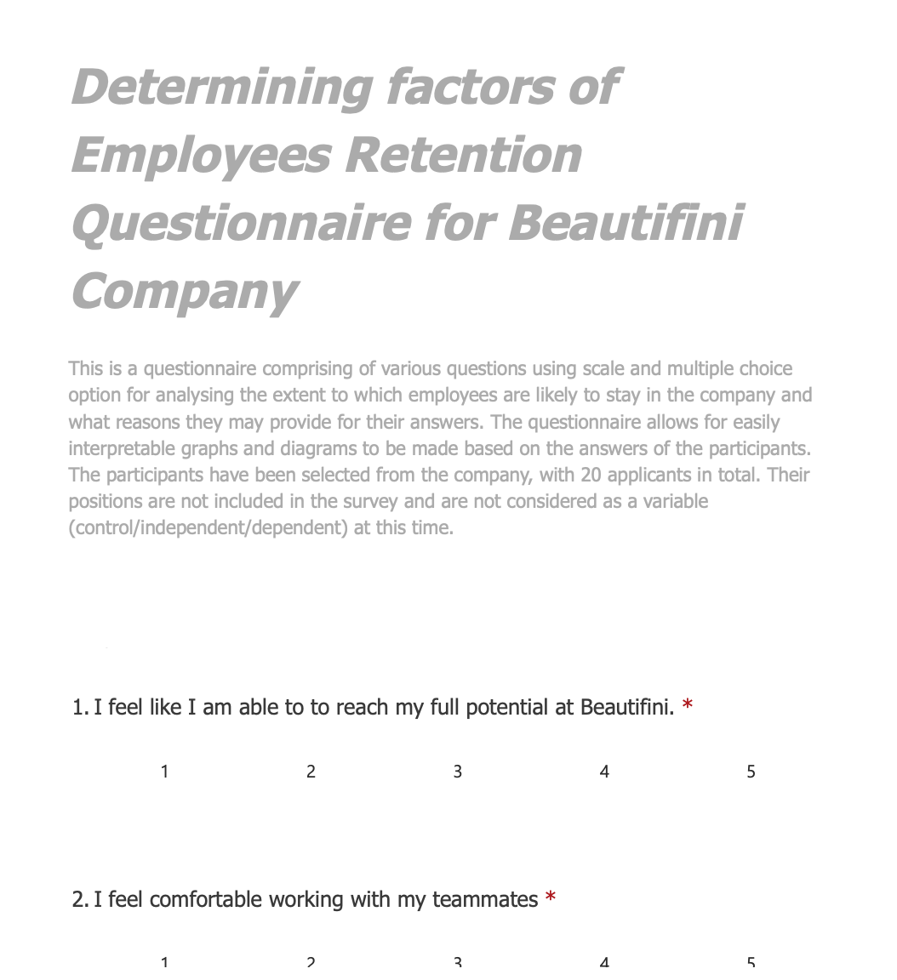
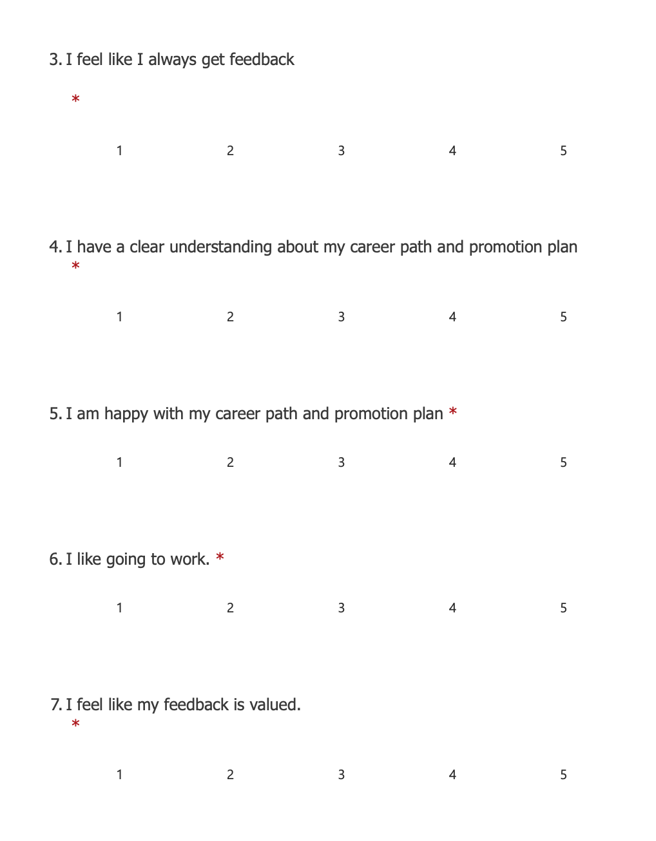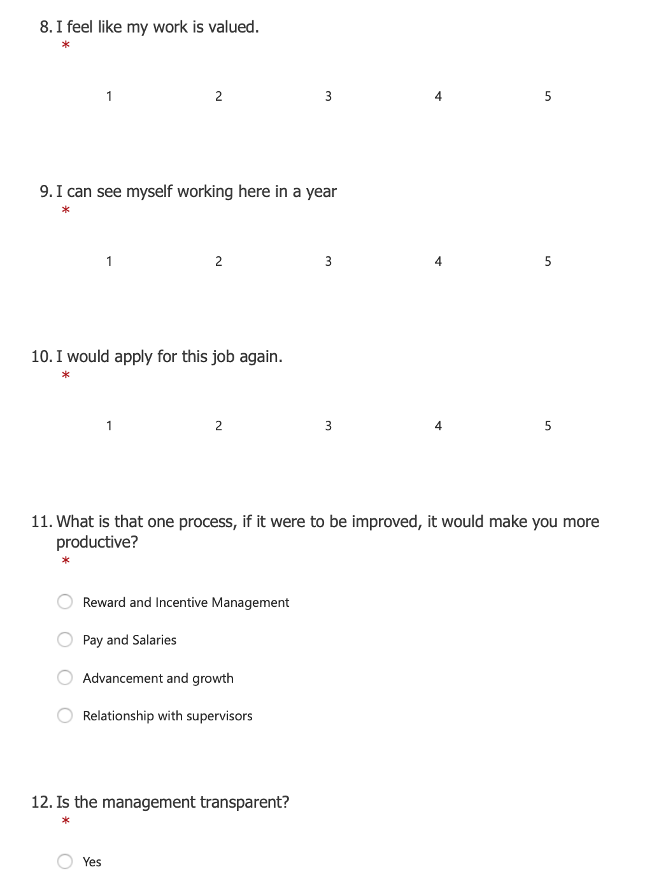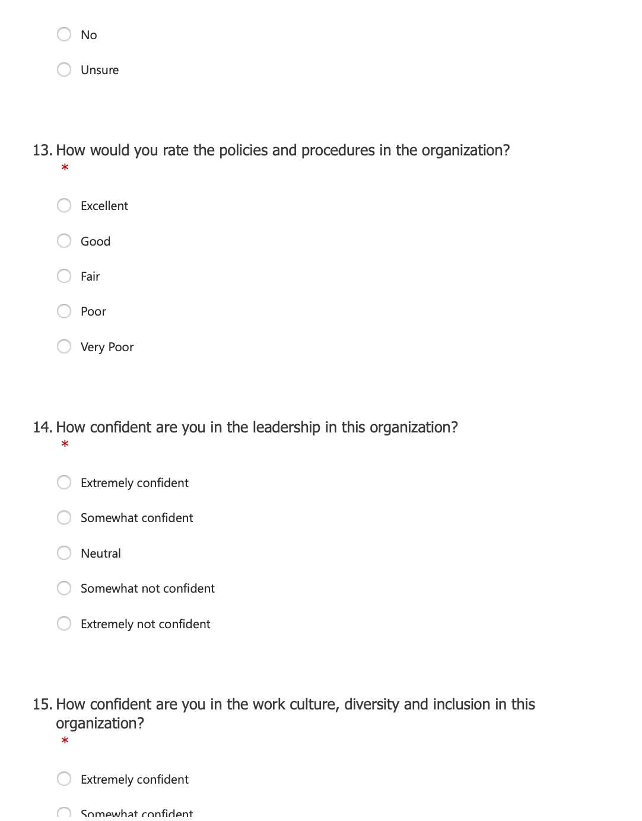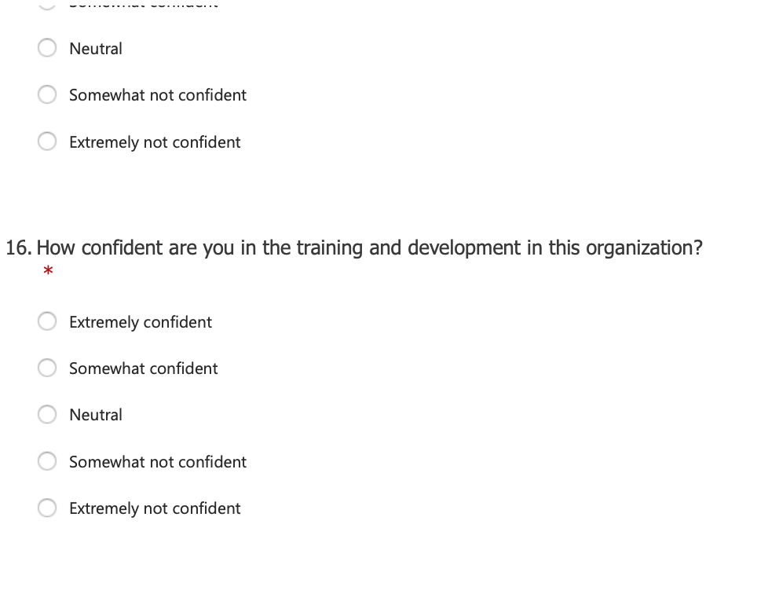

Research Findings

Research Participant Answers
After the 20 participants completed the questionnaire provided within a timeframe of 4 weeks in total, their answers were recorded on the system. The set-up on the online questionnaire included a self-destruction period (30 days) after the submitted answers to ensure that no data was left on the system. The participants were aware of this set-up and have agreed accordingly. This was done with the purpose of preserving anonymity. Also for that reason no record of age, name, address or data of this nature was provided anywhere and no participants were required to leave it.

The answers following this questionnaire are the following:
ID | Start time | Completion time | Email | Name | I feel like I am able to to reach my full potential at Beautyfi. | I feel comfortable working with my teammates | I feel like I always get feedback | I have a clear understanding about my career path and promotion plan | I am happy with my career path and promotion plan | I like going to work. | I feel like my feedback is valued. | I feel like my work is valued. | I can see myself working here in a year | I would apply for this job again. | What is that one process, if it were to be improved, it would make you more productive? | Is the management transparent? | How would you rate the policies and procedures in the organization? | How confident are you in the leadership in this organization? | How confident are you in the work culture, diversity and inclusion in this organization? | How confident are you in the training and development in this organization?
1 | 12/02/22 15:09:03 | 12/02/22 15:10:22 | anonymous |  | 5 | 4 | 4 | 5 | 3 | 4 | 4 | 5 | 4 | 4 | Reward and Incentive Management | Yes | Good | Somewhat confident | Extremely confident | Neutral
2 | 12/02/22 15:10:26 | 12/02/22 15:11:08 | anonymous |  | 3 | 2 | 3 | 3 | 3 | 4 | 2 | 4 | 3 | 2 | Relationship with supervisors | Unsure | Good | Somewhat not confident | Somewhat confident | Somewhat confident
3 | 12/02/22 15:11:12 | 12/02/22 15:11:37 | anonymous |  | 2 | 3 | 2 | 2 | 2 | 3 | 2 | 4 | 2 | 2 | Relationship with supervisors | No | Fair | Neutral | Somewhat not confident | Somewhat confident
4 | 12/02/22 15:11:39 | 12/02/22 15:12:08 | anonymous |  | 3 | 4 | 3 | 4 | 3 | 3 | 2 | 3 | 3 | 3 | Pay and Salaries | Yes | Good | Somewhat confident | Somewhat confident | Neutral
5 | 12/02/22 15:12:12 | 12/02/22 15:12:52 | anonymous |  | 2 | 1 | 2 | 2 | 2 | 2 | 1 | 2 | 1 | 1 | Reward and Incentive Management | Unsure | Poor | Somewhat not confident | Somewhat confident | Neutral
6 | 12/02/22 15:12:56 | 12/02/22 15:13:18 | anonymous |  | 4 | 5 | 5 | 5 | 5 | 5 | 4 | 4 | 5 | 4 | Advancement and growth | Yes | Excellent | Extremely confident | Extremely confident | Somewhat confident
7 | 12/02/22 15:13:22 | 12/02/22 15:14:56 | anonymous |  | 5 | 5 | 4 | 5 | 5 | 5 | 4 | 3 | 4 | 4 | Pay and Salaries | Unsure | Good | Somewhat confident | Somewhat confident | Somewhat confident
8 | 12/02/22 15:34:17 | 12/02/22 15:34:36 | anonymous |  | 5 | 5 | 5 | 5 | 5 | 5 | 5 | 5 | 5 | 5 | Advancement and growth | Yes | Excellent | Extremely confident | Extremely confident | Extremely confident
9 | 12/02/22 15:34:38 | 12/02/22 15:34:57 | anonymous |  | 4 | 4 | 4 | 4 | 4 | 4 | 4 | 4 | 4 | 4 | Pay and Salaries | Unsure | Good | Somewhat confident | Somewhat confident | Somewhat confident
10 | 12/02/22 15:35:02 | 12/02/22 15:35:23 | anonymous |  | 3 | 4 | 3 | 2 | 3 | 3 | 2 | 3 | 3 | 3 | Relationship with supervisors | Unsure | Fair | Neutral | Neutral | Neutral
11 | 12/02/22 15:35:30 | 12/02/22 15:35:52 | anonymous |  | 2 | 2 | 2 | 2 | 2 | 2 | 2 | 2 | 2 | 2 | Reward and Incentive Management | No | Poor | Somewhat not confident | Somewhat not confident | Somewhat not confident
12 | 12/02/22 15:35:56 | 12/02/22 15:36:15 | anonymous |  | 3 | 3 | 4 | 3 | 4 | 3 | 3 | 3 | 3 | 3 | Reward and Incentive Management | Yes | Good | Somewhat not confident | Somewhat not confident | Somewhat not confident
13 | 12/02/22 15:36:20 | 12/02/22 15:36:46 | anonymous |  | 4 | 5 | 4 | 5 | 5 | 4 | 4 | 4 | 5 | 5 | Advancement and growth | No | Fair | Neutral | Somewhat confident | Somewhat confident
14 | 12/02/22 15:36:52 | 12/02/22 15:37:17 | anonymous |  | 2 | 2 | 2 | 2 | 1 | 2 | 1 | 1 | 1 | 1 | Reward and Incentive Management | Unsure | Fair | Extremely not confident | Neutral | Extremely not confident
15 | 12/02/22 15:37:20 | 12/02/22 15:37:41 | anonymous |  | 1 | 2 | 1 | 1 | 1 | 1 | 1 | 1 | 1 | 1 | Relationship with supervisors | No | Very Poor | Neutral | Somewhat confident | Extremely not confident
16 | 12/02/22 15:37:46 | 12/02/22 15:38:07 | anonymous |  | 4 | 4 | 5 | 5 | 5 | 4 | 4 | 4 | 5 | 4 | Pay and Salaries | Yes | Excellent | Somewhat confident | Extremely confident | Somewhat confident
17 | 12/02/22 15:38:12 | 12/02/22 15:38:30 | anonymous |  | 5 | 4 | 5 | 5 | 5 | 5 | 5 | 5 | 5 | 5 | Reward and Incentive Management | Yes | Excellent | Extremely confident | Extremely confident | Extremely confident
18 | 12/02/22 15:38:34 | 12/02/22 15:38:51 | anonymous |  | 5 | 5 | 5 | 5 | 5 | 5 | 5 | 5 | 5 | 5 | Advancement and growth | Yes | Good | Somewhat confident | Extremely confident | Extremely confident
19 | 12/02/22 15:38:57 | 12/02/22 15:39:17 | anonymous |  | 5 | 5 | 4 | 4 | 4 | 4 | 4 | 4 | 5 | 4 | Pay and Salaries | Yes | Good | Somewhat confident | Extremely confident | Somewhat confident
20 | 12/02/22 15:39:18 | 12/02/22 15:39:48 | anonymous |  | 4 | 5 | 5 | 5 | 5 | 5 | 5 | 5 | 5 | 5 | Reward and Incentive Management | Unsure | Excellent | Somewhat confident | Somewhat confident | Neutral

Graphical Representation of Findings
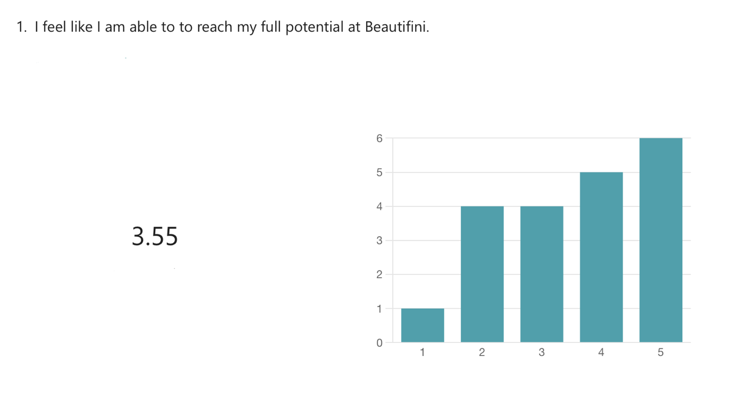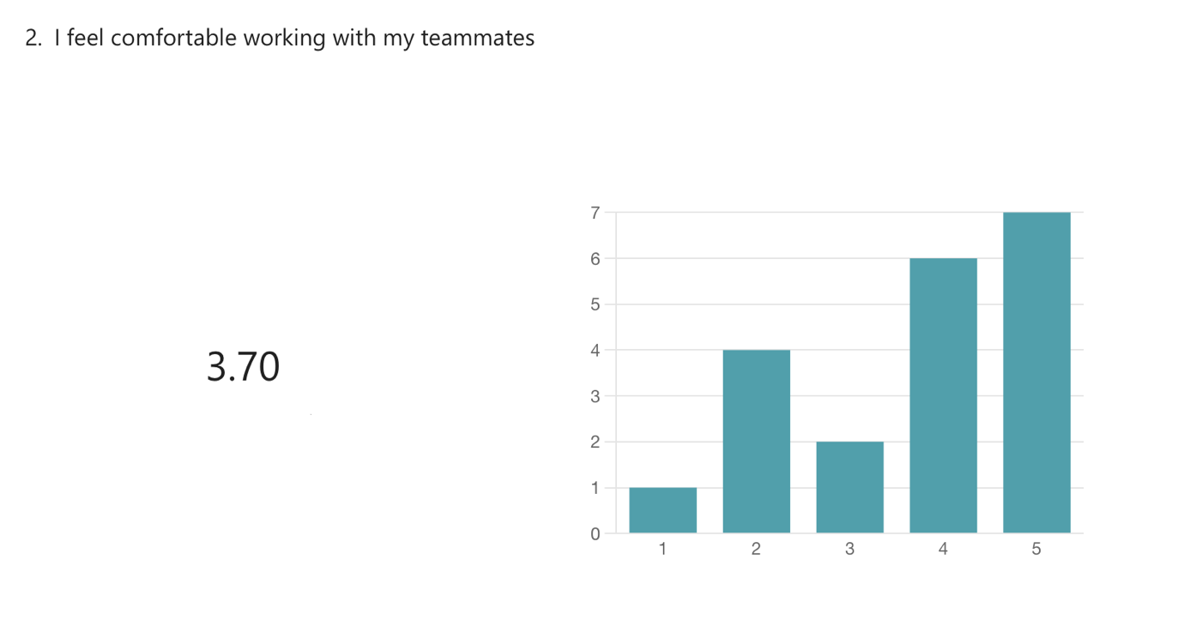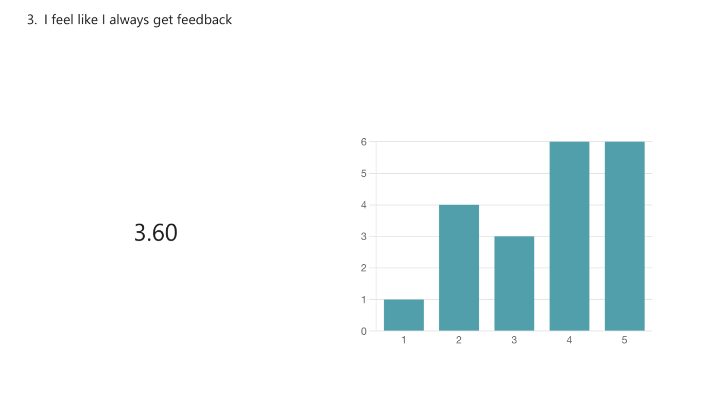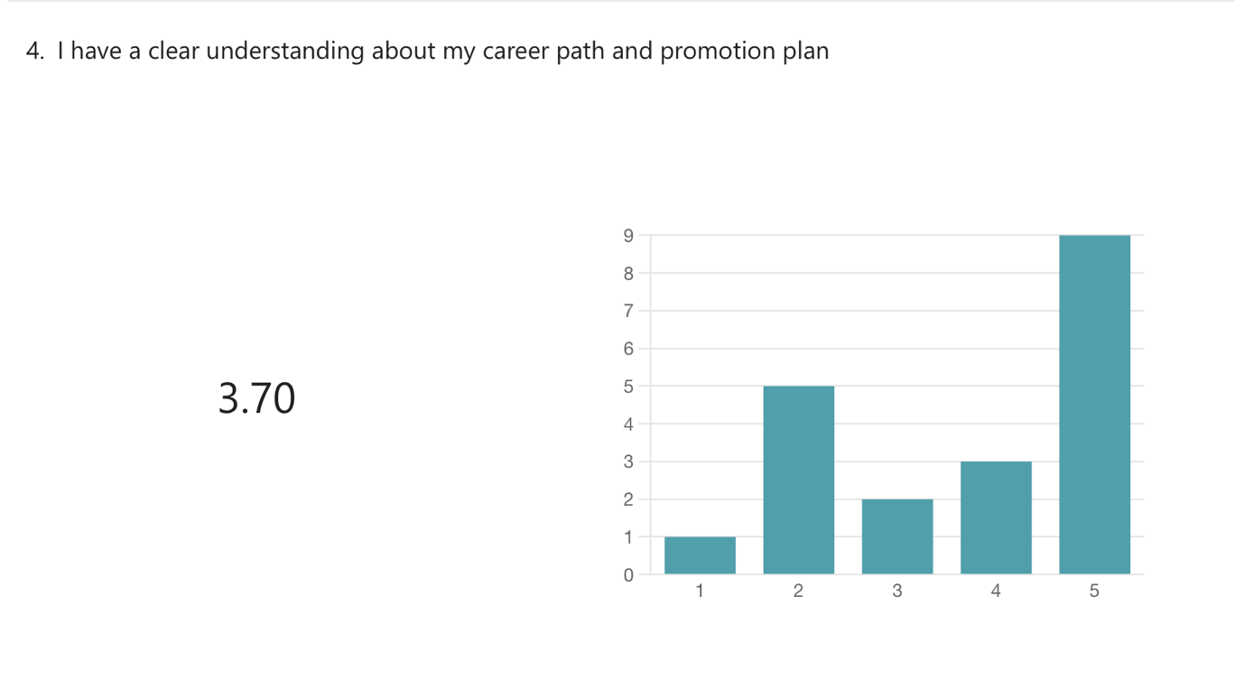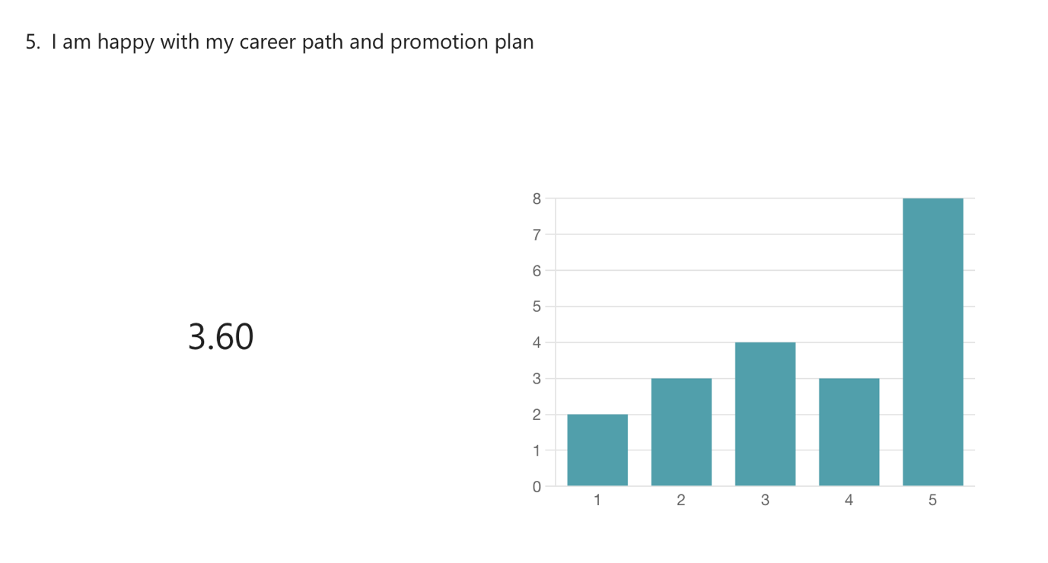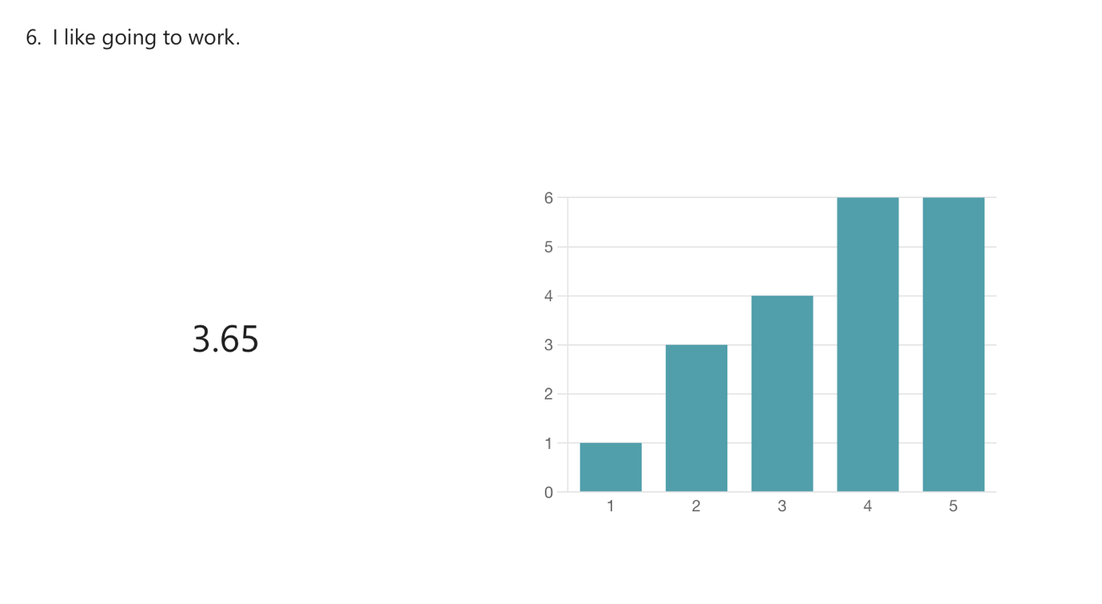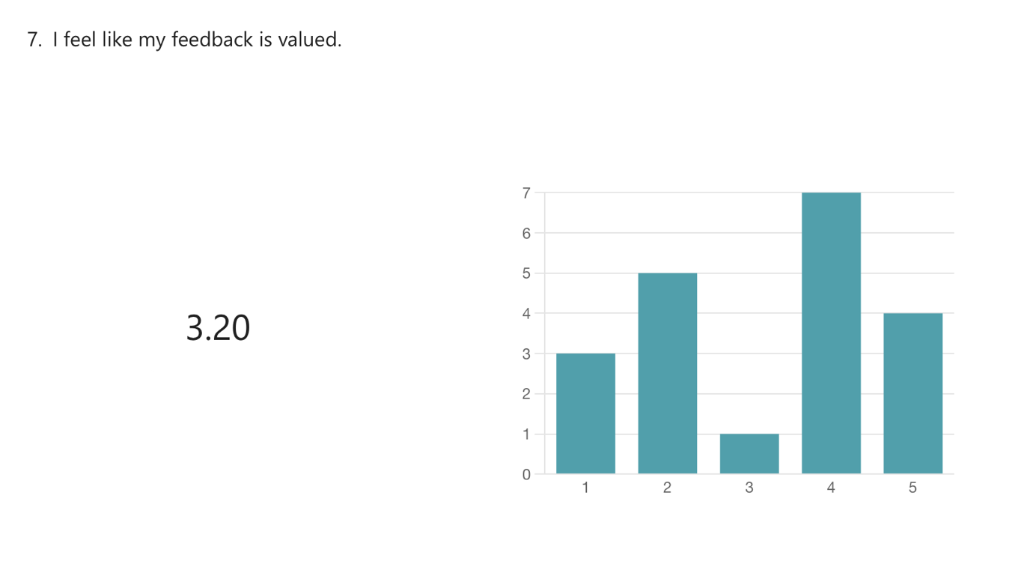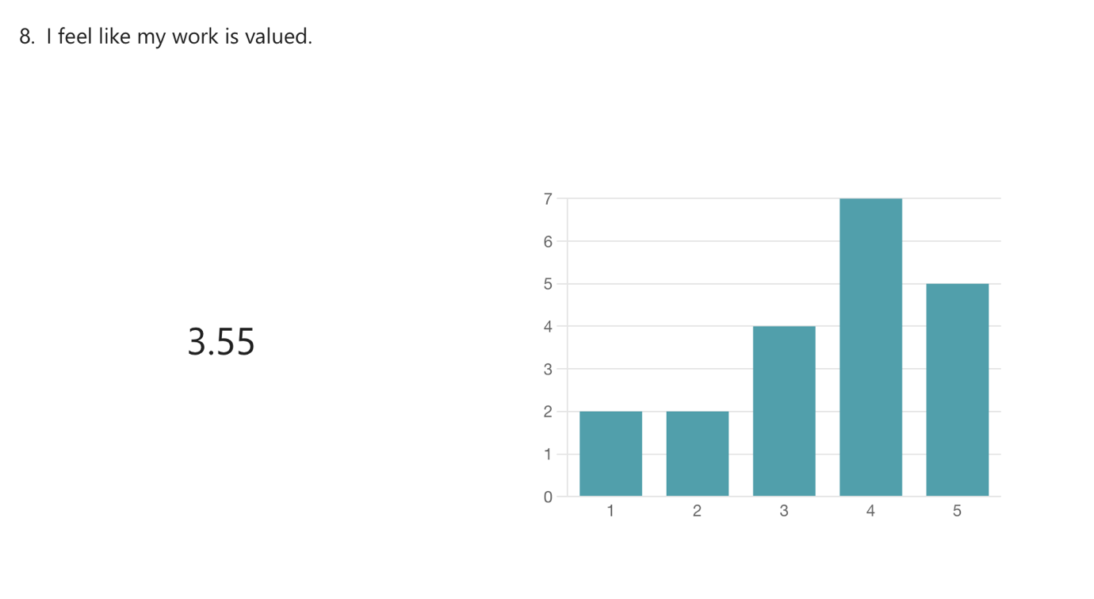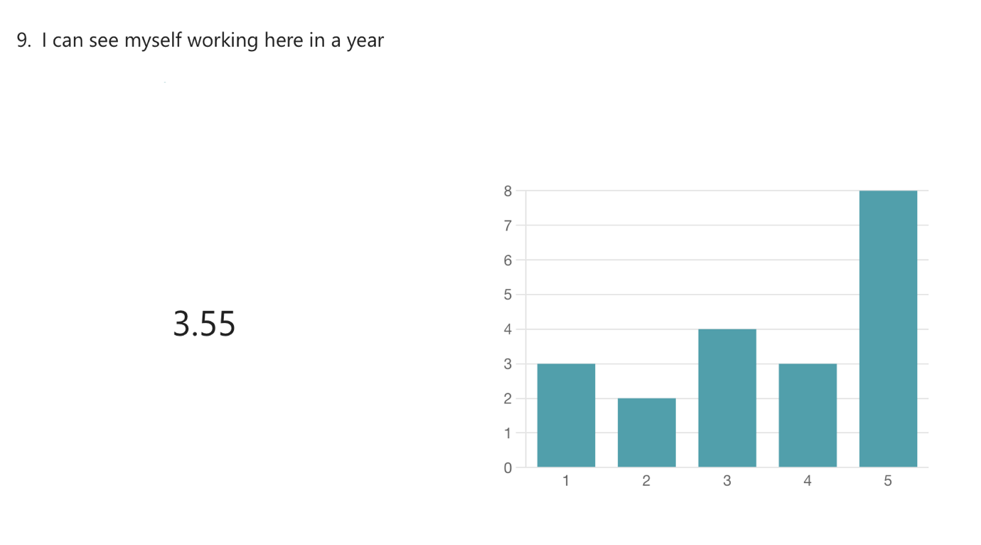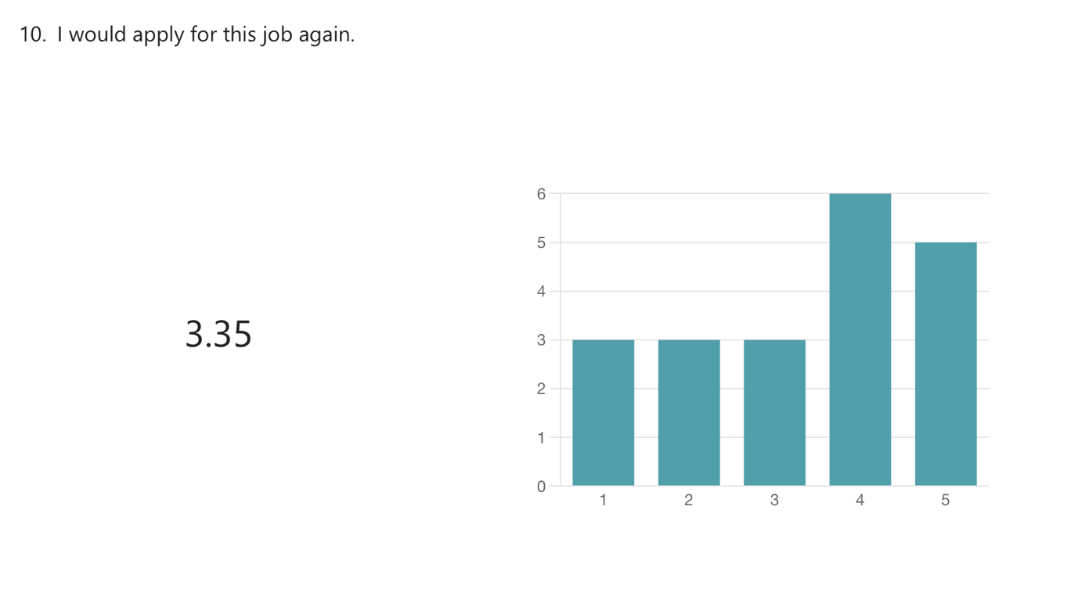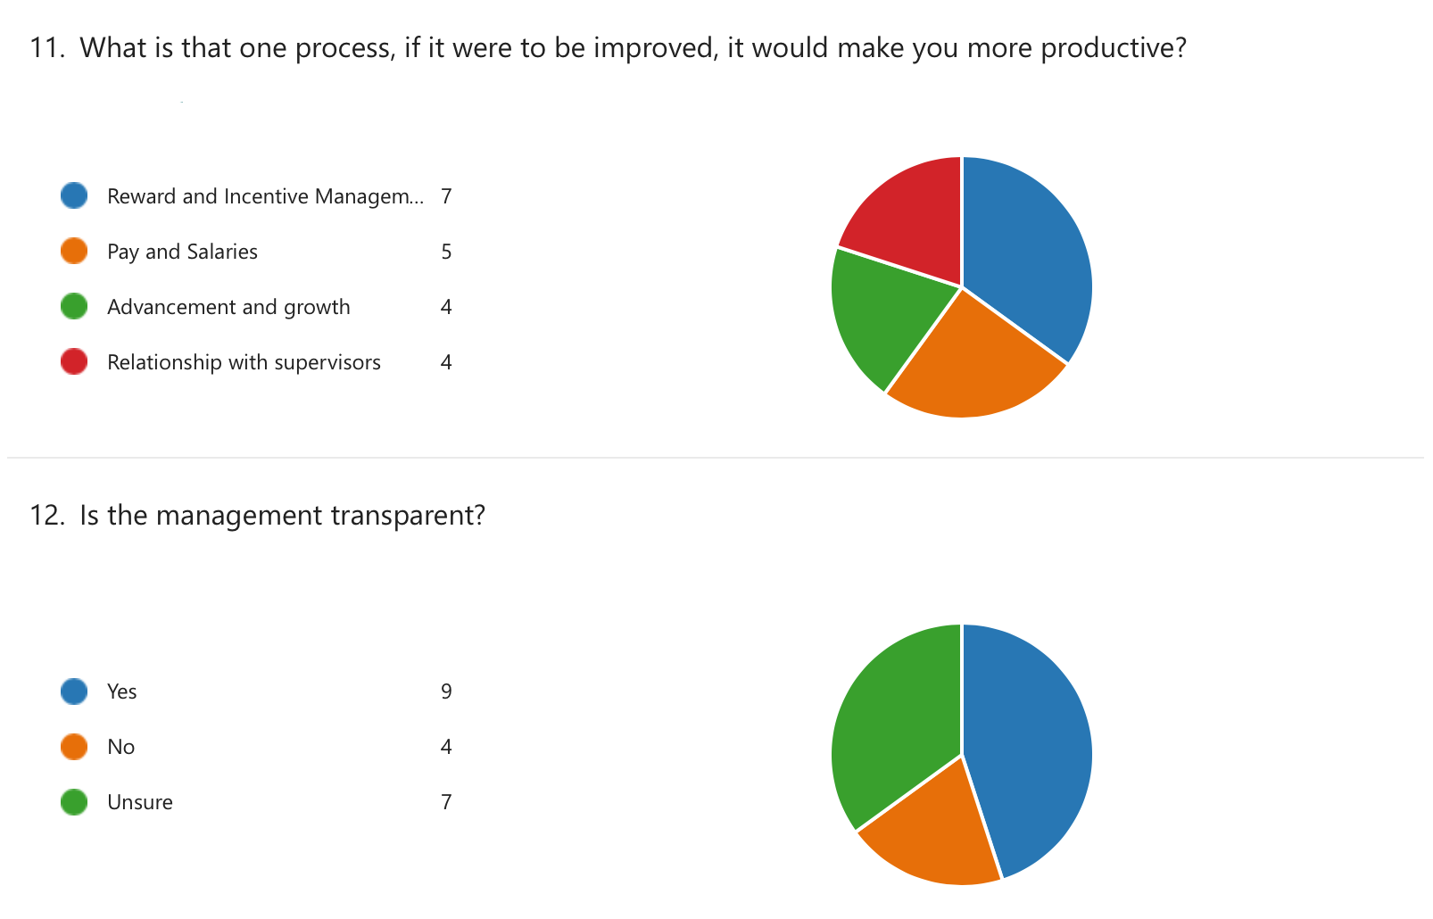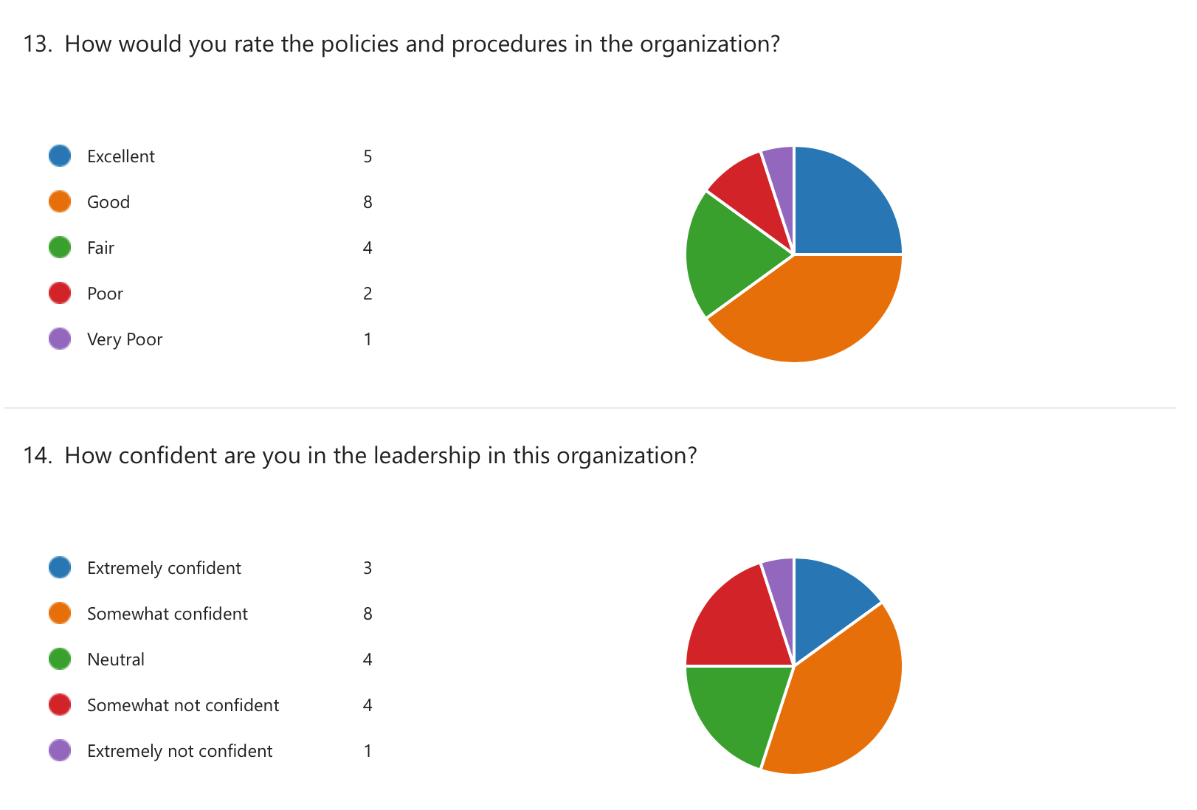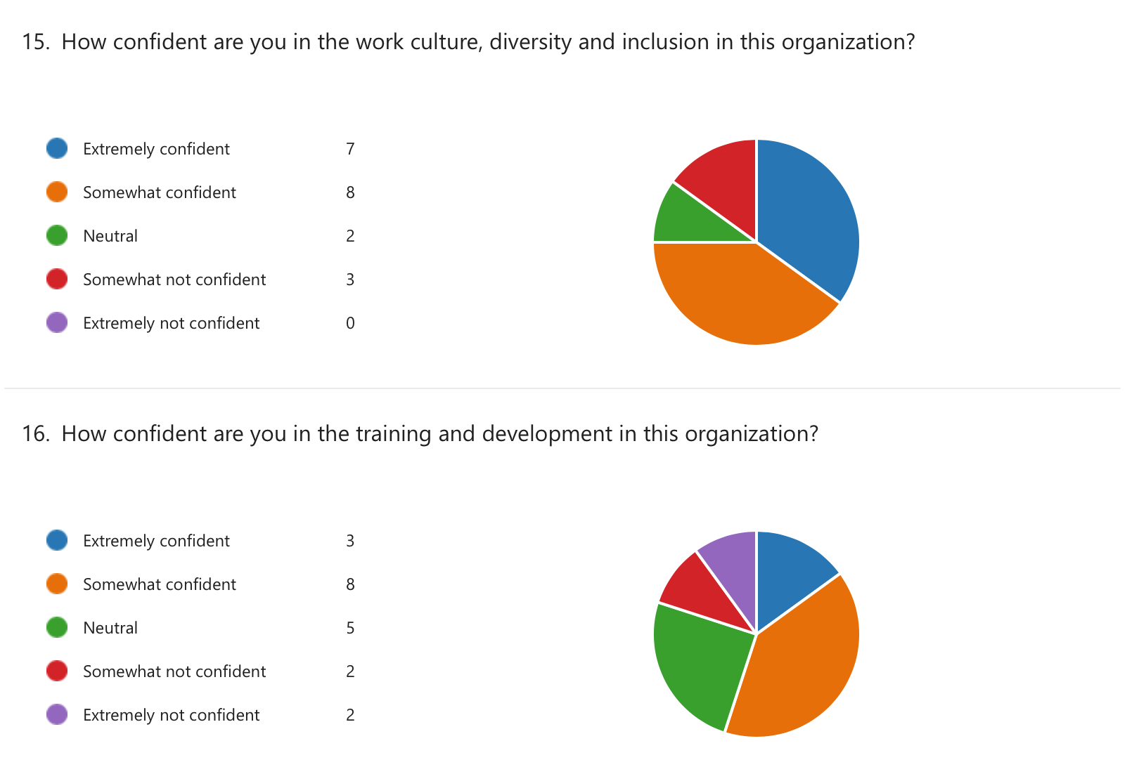

Analysis of Findings
The employees at Beautyfi LTD believed that they possessed a high level of conscientiousness, which is linked to ambition, self-confidence, and resourcefulness. In addition, the findings demonstrated that respondents possessed proactive personalities, which has been demonstrated to correspond with commercial achievement (Phillips and Connell, 2002). According to these findings, respondents tend to be ready to participate in new and difficult challenges, persistent in their pursuit of difficult activities, and open to new experiences, all of which are traits of people with autotelic personalities. Beautyfi LTD appears to hire candidates who are confident, resourceful, open to new challenges, persistent, and ready to engage; these are characteristics that have been shown to be important for sales roles. Given that the respondent's perception of their personalities aligns with their mindset at work and their behaviours, Beautyfi LTD appears to hire candidates who are ready to engage.
According to the findings of this research, the employees of Beautyfi LTD appear to have a strong feeling of commitment to the work that they do. Employees that are committed to their jobs have a strong sense of identification with their work because they view it as meaningful, inspirational, and challenging (Okotoh, 2015). In general, respondents took a stance that was somewhere between positive and negative regarding various indicators of absorption in their work. One is said to be absorbed when they are fully attentive and joyfully engrossed in their task, during which time they lose track of the passage of time and find it impossible to remove themselves from their work. According to the findings, respondents were committed to their work; nevertheless, they were less likely to be so thoroughly involved in their work that time flew by and they forgot everything else that was going on around them.
Employees at Beautyfi reported a strong sense of tenacity as one of the behavioural engagement measures. This was the case even when things did not go as planned. This was the most vigorous measure, but the other measures of vitality revealed that respondents demonstrated less energy, zest, and stamina while they were working. This was the most vigorous measure.
The findings that were returned from the employee engagement questionnaire were, on the whole, generally weighted in favour of agreement. The participants in this study gave ratings of the workplace that were closer to the more favourable end of the agreement scale, which reflects favourably on the values of the business, the community, the level of trust, and the leadership. These findings provided support for the conceptual model that posited the conditions of the workplace as the primary driving force for both psychological state engagement and behavioural engagement. Defining expectations, providing necessary materials and equipment, frequently recognising good work, encouraging development, and connecting organisational mission to specific job roles are all ways in which organisational leaders can directly influence this aspect of employee engagement, which comes before other aspects.
Respondents also judged the candidates' personalities to be conscientious and proactive, which suggests that Beautyfi has been effective in employing candidates who are eager to accept difficulties and take the initiative in their work. Respondents also demonstrated a high level of commitment, which reflects favourably on the organisational commitment component of the Psychological State Engagement measure. In spite of attributes such as devotion and initiative, respondents were more impartial when it came to whether or not they were engrossed in their work and whether or not they were able to detach themselves from their work. This may signal that the employees are developing sentiments of burnout linked with their work, which may eventually lead to tiredness, cynicism, and lower professional efficacy. Alternatively, this may imply that the employees are becoming less effective in their professional roles (Okotoh, 2015). As a result, questions regarding the length of time that workers are able to maintain high levels of work engagement were raised as a direct result of the findings. It may be challenging to maintain high levels of employee engagement for extended periods of time. Positive behavioural results may be predicted by various aspects of employee engagement related to workplace environment, personality attributes, and psychological state.

Recommendations
The ability to favourably impact others and to develop a good work environment that is favourable to high levels of employee engagement is an essential component of leadership. The direct supervisors at Beautyfi LTD should be aware that the relationship they have with their employees is the most significant relationship in terms of an employee's productivity and length of employment within the firm, and that they should treat it as such (Alhmoud and Rjoub, 2020). Workplace Conditions Things that have a direct bearing on the connection that exists between a supervisor and an employee should be given the highest priority by immediate supervisors. For instance, immediate supervisors should continue to back employee requests for essential resources and equipment and relate those requests to important business objectives. This should be done in both a positive and constructive manner. Employees rarely indicate that they are suffering from too much recognition, thus the leadership team and the directors of the business units should also make an effort to learn how each individual would like to be honoured (Terera and Ngirande, 2014).
The majority of respondents expressed neither agreement nor disagreement with the statement that their coworkers were dedicated to producing quality work. The findings indicated that respondents believed they possessed attributes linked with a proactive personality, conscientiousness, and the autotelic personality type. The company Beautyfi LTD should continue its search for people who have a history of demonstrating attributes such as the ability to influence their work environment, industriousness, openness to new challenges, and persistence in difficult jobs, and who are eager to participate in conversation. Through the process of selecting new workers and promoting existing workers into appropriate roles, hiring managers have the ability to influence the level of trait engagement, which serves as a factor that is a prerequisite for overall engagement.

Conclusion
It is a basic human need to have expectations set for oneself, and managers and supervisors ought to be held accountable for doing so. The results of the poll indicated that the management of Beautyfi LTD appeared to be setting clear expectations and informing employees about what was expected of them while they were on the job. It would appear that the managers of Beautyfi LTD are giving their employees with the tools and resources that are necessary for them to perform their jobs effectively. This is an essential precondition for achieving the highest levels of performance and efficiency, and it subtly conveys to workers the significance of the work that they do. Employees who took part in this study and agreed that Beautyfi LTD's mission makes their jobs important are evidence that management has been successful in supporting staff in understanding how their work relates to and contributes to the organization's goals and results. This demonstrates that management has been successful in supporting staff in understanding how their work contributes to the organisation. According to these findings, the employees tended to agree that there was someone at work who encouraged their personal development and that their managers were successful in providing them with possibilities. In addition, the majority of employees believed that their managers were successful in providing them with opportunities.
The outcomes of the study indicate that the staff at Beautyfi LTD appear to take pride in the work that they do. The fact that a job is significant to the employee's life, inspiring to them, and challenging to them all contribute to their passionate identification with the work they do. The degree to which the respondents were engrossed in their job was, in general, met with relatively little enthusiasm. The state of being completely concentrated and contentedly engaged in one's work is what is meant by the term "absorption." During this state, time goes fast and it is impossible to disconnect from the activity at hand. According to the findings of the study, even while respondents had a high level of dedication to their jobs, they were less likely to become so engrossed in their work that they lost track of time and forgot about everything else.

References
Ahmad, A. (2018). The relationship among job characteristics organizational commitment and employee turnover intentions. Journal of Work-Applied Management, 10(1), pp.74–92. doi:10.1108/jwam-09-2017-0027.
Alhmoud, A. and Rjoub, H. (2020). Does Generation Moderate the Effect of Total Rewards on Employee Retention? Evidence From Jordan. SAGE Open, 10(3), p.215824402095703. doi:10.1177/2158244020957039.
Arasanmi, C.N. and Krishna, A. (2019). Employer branding: perceived organisational support and employee retention – the mediating role of organisational commitment. Industrial and Commercial Training, 51(3). doi:10.1108/ict-10-2018-0086.
Baran, M.L. (2022). Mixed Methods Research Design. Research Anthology on Innovative Research Methodologies and Utilization Across Multiple Disciplines, pp.312–333. doi:10.4018/978-1-6684-3881-7.ch017.
Bhutta, M. Khurrum S., Muzaffar, A., Egilmez, G., Huq, F., Malik, M.N. and Warraich, M.A. (2021). Environmental sustainability, innovation capacity, and supply chain management practices nexus: A mixed methods research approach. Sustainable Production and Consumption, 28, pp.1508–1521. doi:10.1016/j.spc.2021.08.015.
Cardy, R.L. and Lengnick-Hall, M.L. (2011) Will they stay or will they go? Exploring a customer-oriented approach to employee retention. Journal of Business and Psychology, 26, 213-217. http://dx.doi.org/10.1007/s10869-011-9223-8
Christeen, G. (2015) Retaining professional workers: What makes them stay? Employee Relations, 37, 102-121. http://dx.doi.org/10.1108/ER-10-2013-0151
De Sousa Sabbagha, M., Ledimo, O. and Martins, N. (2018). Predicting staff retention from employee motivation and job satisfaction. Journal of Psychology in Africa, 28(2), pp.136–140. doi:10.1080/14330237.2018.1454578.
Den Hartog, D.N., House, R.J., Hanges, P.J., Ruiz-Quintanilla, S.Antonio., Dorfman, P.W., Abdalla, I.A., Adetoun, B.S., Aditya, R.N., Agourram, H., Akande, A., Akande, B.E., Akerblom, S., Altschul, C., Alvarez-Backus, E., Andrews, J., Arias, M.E., Arif, M.S., Ashkanasy, N.M., Asllani, A. and Audia, G. (1999). Culture specific and cross-culturally generalizable implicit leadership theories. The Leadership Quarterly, 10(2), pp.219–256. doi:10.1016/s1048-9843(99)00018-1.
Distance education during the COVID-19 outbreak: A cross-sectional study among medical students in North of Jordan. (2020). Annals of Medicine and Surgery, [online] 59, pp.186–194. doi:10.1016/j.amsu.2020.09.036.
Fleeson, W. and Jayawickreme, E. (2015). Whole Trait Theory. Journal of Research in Personality, [online] 56(1), pp.82–92. doi:10.1016/j.jrp.2014.10.009.
Kossivi, B., Xu, M., & Kalgora, B. (2016). Study on determining factors of employee retention. Open Journal of Social Sciences, 4(5), 261-268. https://file.scirp.org/pdf/JSS_2016053009190527.pdf
Kurdi, B.A., Alshurideh, M. and afaishat, T.A. (2020). Employee retention and organizational performance: Evidence from banking industry. Management Science Letters, pp.3981–3990. doi:10.5267/j.msl.2020.7.011.
Lawson, D.O., Leenus, A. and Mbuagbaw, L. (2020). Mapping the nomenclature, methodology, and reporting of studies that review methods: a pilot methodological review. Pilot and Feasibility Studies, 6(1). doi:10.1186/s40814-019-0544-0.
Ngozwana, N. (2018). Ethical Dilemmas in Qualitative Research Methodology: Researcher’s Reflections. International Journal of Educational Methodology, 4(1), pp.19–28. doi:10.12973/ijem.4.1.19.
Okotoh, M.A. (2015). The perceived effect of reward management practices on factors influencing employee retention at communications authority of Kenya. [online] erepository.uonbi.ac.ke. Available at: http://erepository.uonbi.ac.ke/handle/11295/93450. [Accessed 27 Dec. 2022].
Osaghae, O.-G. and Cooney, T.M. (2019). Exploring the relationship between immigrant enclave theory and transnational diaspora entrepreneurial opportunity formation. Journal of Ethnic and Migration Studies, 46(10), pp.2086–2105. doi:10.1080/1369183x.2018.1560001.
Pang, M. (2016). The Responses of Chinese Cosmetic SMEs to the Impacts of Large Foreign Firms: an Examination of Attitudes and Strategies. [online] researchspace.auckland.ac.nz. Available at: https://researchspace.auckland.ac.nz/handle/2292/31464 [Accessed 22 Nov. 2022].
Phillips, J.J. and Connell, A.O. (2002). Managing employee retention: impact, analysis, solutions, and ROI. Oxford: Butterworth-Heinemann.
Prentice, M., Jayawickreme, E. and Fleeson, W. (2018). Integrating whole trait theory and self-determination theory. Journal of Personality, 87(1), pp.56–69. doi:10.1111/jopy.12417.
Rahman, S. (2016). The advantages and disadvantages of using qualitative and quantitative approaches and methods in language ‘Testing and Assessment’ Research: A literature review. Journal of Education and Learning, 6(1), pp.102–112.
Reid, A.-M., Brown, J.M., Smith, J.M., Cope, A.C. and Jamieson, S. (2018). Ethical dilemmas and reflexivity in qualitative research. Perspectives on Medical Education, [online] 7(2), pp.69–75. doi:10.1007/s40037-018-0412-2.
Scheffer, D. and Heckhausen, H. (2018). Trait Theories of Motivation. Motivation and Action, pp.67–112. doi:10.1007/978-3-319-65094-4_3.
Shatzer, R.H., Caldarella, P., Hallam, P.R. and Brown, B.L. (2013). Comparing the effects of instructional and transformational leadership on student achievement. Educational Management Administration & Leadership, 42(4), pp.445–459. doi:10.1177/1741143213502192.
Stoecker, R. and Avila, E. (2020). From mixed methods to strategic research design. International Journal of Social Research Methodology, pp.1–14. doi:10.1080/13645579.2020.1799639.
Terera, S.R. and Ngirande, H. (2014). The Impact of Rewards on Job Satisfaction and Employee Retention. Mediterranean Journal of Social Sciences, [online] 5(1). doi:10.5901/mjss.2014.v5n1p481.
Tian, H., Iqbal, S., Akhtar, S., Qalati, S.A., Anwar, F. and Khan, M.A.S. (2020). The Impact of Transformational Leadership on Employee Retention: Mediation and Moderation Through Organizational Citizenship Behavior and Communication. Frontiers in Psychology, [online] 11. doi:10.3389/fpsyg.2020.00314.
Tomás, L. and Ravazzini, L. (2021). Inclusiveness Plus Mixed Methods: An Innovative Research Design on Transnational Practices of Older Adults. The Gerontologist. doi:10.1093/geront/gnab128.
Two case studies of Irish born globals in the natural cosmetics industry. (2021). Entrepreneurial Internationalization in an Increasingly Digitized and Networked World Economy. doi:10.4337/9781788976817.00020.
Tyssen, A.K., Wald, A. and Spieth, P. (2014). The challenge of transactional and transformational leadership in projects. International Journal of Project Management, [online] 32(3), pp.365–375. doi:10.1016/j.ijproman.2013.05.010.
Varela‐Centelles, P., Diz‐Iglesias, P., Estany‐Gestal, A., Blanco‐Hortas, A., Bugarín‐González, R., Seoane‐Romero, J.M. and Blanco, J. (2019). Periodontal awareness and what it actually means: A cross‐sectional study. Oral Diseases, 25(3), pp.831–838. doi:10.1111/odi.13026.
Wadhwani, R.D., Kirsch, D., Welter, F., Gartner, W.B. and Jones, G.G. (2020). Context, time, and change: Historical approaches to entrepreneurship research. Strategic Entrepreneurship Journal, 14(1), pp.3–19. doi:10.1002/sej.1346.
Wagner, C., Kawulich, B. and Garner, M. (2019). A Mixed Research Synthesis of Literature on Teaching Qualitative Research Methods. SAGE Open, 9(3), p.215824401986148. doi:10.1177/2158244019861488.
Wilson, R.D. and Creswell, J.W. (1996). Research Design: Qualitative and Quantitative Approaches. Journal of Marketing Research, 33(2), p.252. doi:10.2307/3152153.

Appendices

