LCDB 7012_Week 3_4 Tasks 1-4
Task 1 - INTERPRETIVISM AND CONSTRUCTVISM
Put the following images into two groups: INTERPRETIVISM AND CONSTRUCTVISM
TK1-1

TK1-2

TK1-3

TK1-4
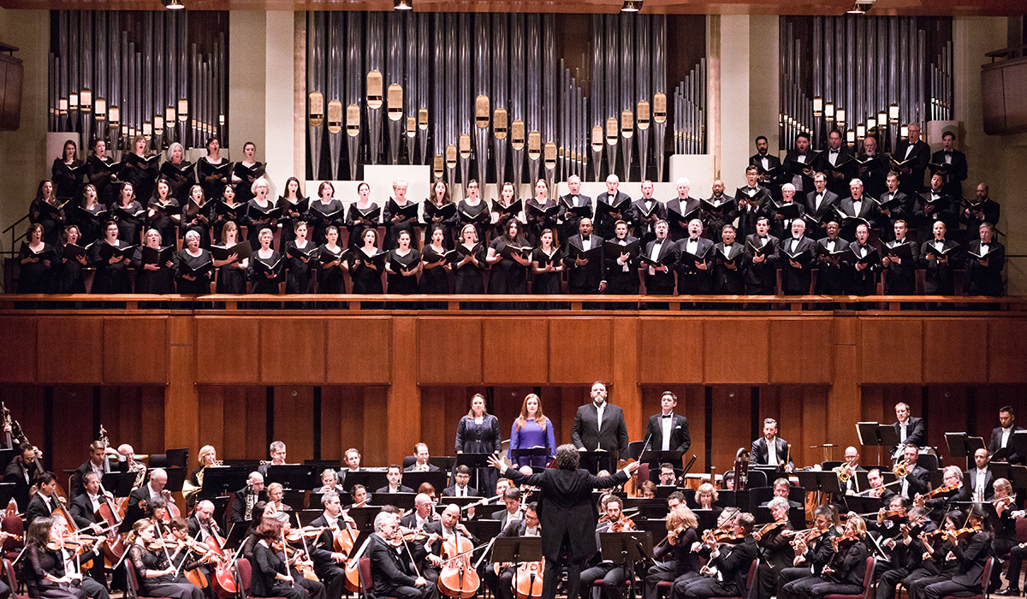

TK1-5

TK1-6


TK1-7

TK1-8


TK1-9

TK1-10


TASK 1- INTERPRETIVISM AND CONSTRUCTVISM

INTERPRETIVISM | CONSTRUCTVISM
TK1-1 | TK1-2
TK1-3 | TK1-4
TK1-5 | TK1-6
TK1-8 | TK1-7
TK1-9 | TK1-10

Task 2 - DESCRIPTIVE PHENOMENOLOGY AND INTERPRETIVE PHENOMENOLOGY:

Now put these images into two groups DESCRIPTIVE PHENOMENOLOGY AND INTERPRETIVE PHENOMENOLOGY:
TK2-1

TK2-2

TK2-3

TK2-4

TK2-5

TK2-6


TK2-7
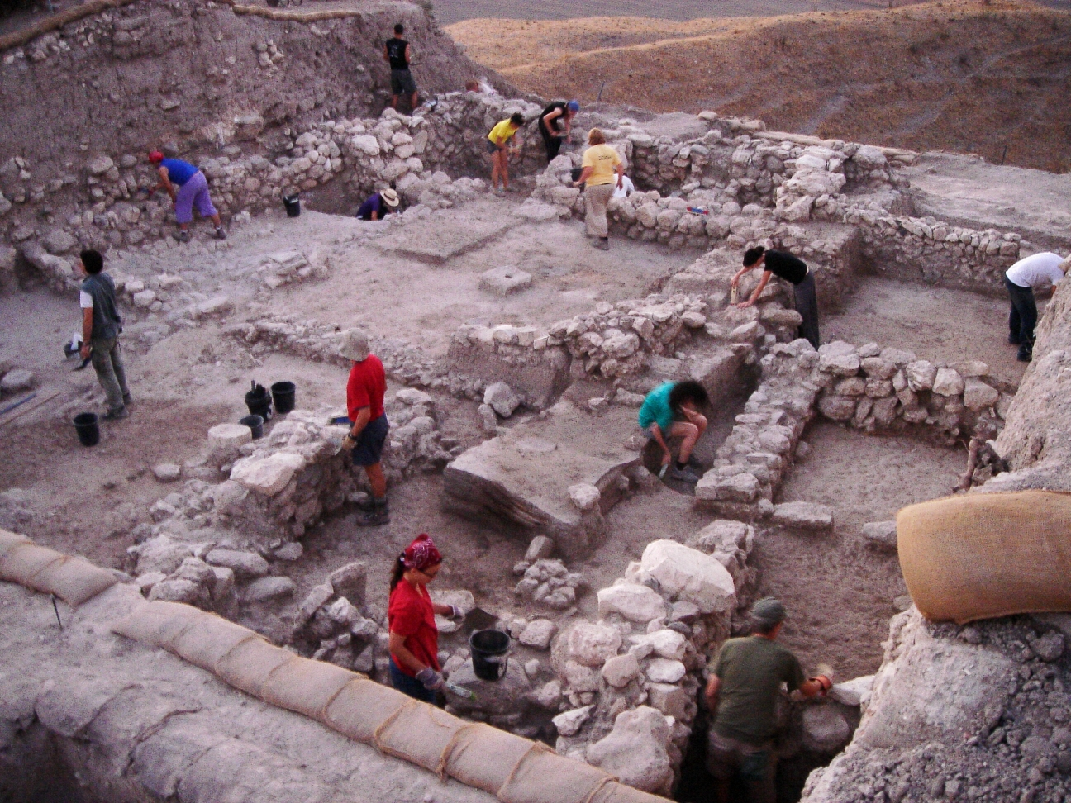
TK2-8

TK2-9

TK2-10


TASK 2 - DESCRIPTIVE PHENOMENOLOGY AND INTERPRETIVE PHENOMENOLOGY:

DESCRIPTIVE PHENOMENOLOGY | INTERPRETIVE PHENOMENOLOGY:
TK2 -2 | TK2 -1
TK2 -3 | TK2 -6
TK2 -4 ** | TK2 -7
TK2 -5 | TK2 -8
TK2 -9 | TK2 - 10

TK2 -4

Task 3 - Case Study: TechInnovate's Cultural Conundrum

1. Company Background:
- Founded in 2010
- Tech startup specializing in AI-driven software solutions
- Rapid growth from 10 to 500 employees in 8 years
- Headquartered in Silicon Valley with satellite offices in New York and London

2. Initial Culture:
- Founder's vision: "Innovative, dynamic, and employee-centric"
- Open-plan office, flexible working hours, casual dress code
- Regular hackathons and innovation challenges
- Flat organizational structure with minimal hierarchy

3. Current Situation:
- High employee turnover rate (25% annually, up from 10% three years ago)
- Declining employee satisfaction scores in annual surveys
- Increasing complaints about work-life balance
- Tension between long-term employees and new hires

4. Specific Issues:
a) Communication:
- Employees report feeling out of the loop on major decisions
- Inconsistent messaging from different levels of management

b) Work Practices:
- Some teams working long hours, others maintaining 9-to-5 schedule
- Disagreements over remote work policies

c) Decision Making:
- Confusion over who has authority to make decisions
- Some employees feel their input is ignored

d) Innovation:
- Declining participation in hackathons and innovation challenges
- Some employees feel pressure to constantly innovate, others feel ideas are stifled

5. Management's Perspective:
- CEO insists the company still embodies its original cultural values
- HR department struggling to address rising complaints
- Middle managers report difficulty in balancing company goals with employee satisfaction

6. Employee Perspectives (from anonymous survey):
- "I don't even know what our culture is anymore." - Software Engineer, 2 years at company
- "It's not the same place I joined 5 years ago." - Product Manager, 5 years at company
- "I love the energy here, but it's exhausting sometimes." - UX Designer, 1 year at company
- "We talk about innovation, but we're becoming more bureaucratic." - Team Lead, 4 years at company

7. Recent Initiatives:
- Formation of a "Culture Committee" with representatives from different departments
- Introduction of a mentorship program pairing new hires with long-term employees
- Scheduled "town hall" meetings for open discussion about company direction

8. Questions for Analysis:
- How do different stakeholders interpret TechInnovate's culture?
- How has the understanding of the company's culture evolved over time?
- What factors are contributing to the current cultural issues?
- How are different groups within the company shaping the cultural narrative?
- What role do power dynamics play in the construction of cultural norms?
- How might the company address these cultural challenges?

THE BIG THING YOU WANT TO FIND OUT IS: this technology company, TechInnovate, is experiencing high turnover rates and declining employee satisfaction. The company prides itself on its "innovative and dynamic culture," but employees seem to have varying perceptions of what this means in practice and this is something you want to explore.

Please do so using the following approaches:

Using an interpretivist paradigm
Using a constructionist paradigm
Using a descriptive phenomenological approach
Using an interpretive phenomenological approach

Paradigm/Approach | Core Idea | Focus | Research Approach | Example for Employee Turnover Study
Interpretivism (Paradigm) | Reality is understood differently by different people | How individuals make sense of their world | Understanding through participants' own viewpoints | Interviewing individual employees about their personal reasons for leaving manufacturing jobs, exploring how they interpreted workplace conditions
Social Constructionism (Paradigm) | Reality is created through shared social processes | How groups create shared understandings | Studying conversations and shared meanings | Examining how workplace culture and conversations among workers create shared narratives about manufacturing work being "dead-end" or "insecure" in South Wales
Constructivism (Approach within Interpretivism) | People build their understanding from experiences | How each person develops their own reality | Studying individual meaning-making | Exploring how a worker's previous experiences at different factories shaped their decision to leave their current job
Phenomenology (Approach) | Understanding the lived experience | The direct, conscious experience of a situation | Deep exploration of how situations are experienced | Detailed study of what it feels like to work on a manufacturing line in South Wales - the physical sensations, emotions, and daily lived experience

Task 4 – Presentation on positivism, postpositivism, interpretivism, constructionism, critical theory and pragmatism
Please select a topic and use examples, photos or images with simple words to exemplify your discussion.
Prepare a 6-min presentation (Max. 10 content-related ppt sides for each presentation excluding cover ppt, Q&A and reference ppt slides)
- How does a multi-paradigmatic approach might be beneficial in addressing complex management research questions?

- What ethical considerations align with the 6 paradigms: positivism, postpositivism, interpretivism, constructionism, critical theory and pragmatism?

- What ethical considerations align with Creswell’s five qualitative approaches?

- What are the key characteristics of the 6 paradigms: positivism, postpositivism, interpretivism, constructionism, critical theory and pragmatism?

- Develop a set of research scenarios that represent different types of research paradigms (positivism, postpositivism, interpretivism, constructionism, critical theory and pragmatism) and write relevant questions and contexts.

- How does each research paradigm (positivism, postpositivism, interpretivism, constructionism, critical theory and pragmatism) shape the types of research questions you create ? Please give examples for each paradigm.

- How does each paradigm's axiological stance influence the interpretation and application of research findings in the business context?

- List key authors for each of the 6 paradigms - positivism, postpositivism, interpretivism, constructionism, critical theory and pragmatism.

- List key authors for each of Creswell’s five qualitative research approaches?

