Digital skills and research method

Student number 1712790
Student name Mubin Choudhury
Tutor name Renuga Jayakumar

Table of Contents
Introduction 3
Part 1 3
Web-based Email and cloud file storage 3
The use of these digital devices in workplace 4
Comparison and contrasting two different providers of these devices 5
The ways by which these devices improve the efficiency in the workplace 6
Effect of these devices in increasing employability 7
Part 2 7
The most useful network for searching a job 8
The use of these networks in the workplace 8
Advantages of using these networks in the workplace 9
Disadvantages of using these networks in the workplace 9
The implications concerning personal and professional security 10
The personal preference 10
Conclusion 11
References 12

Introduction
The use of modern technologies changing the total work structure of daily life which also include the word places. The effectiveness of using modern technologies can easily be seen in the organisational development and growth process. In addition to that, the most advanced way of organisational communication, marketing and information gathering is now associated with social media networks. To understand the implication of modern technologies and social media in developing the professional life of an individual is the primary purpose of this report. In this assignment, the first part will be explaining the effectiveness of using modern technologies within the workplace and the second part will help in understanding the impact of social media platforms on the professional growth of an individual and the organisational purposes.

Part 1

Web-based Email and cloud file storage
There are various mobile devices which are used by different organisations for improving the employability and efficiency of the workplace. Among them, the web-based email and cloud file storage system will be analysed in this report.
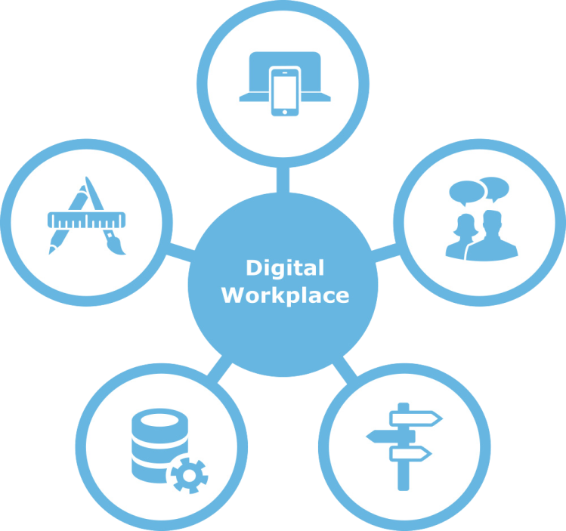
Figure 1: Use of Digital technologies in the workplace.
(Source: Cardon and Marshall, 2015)

The use of these digital devices in the workplace
Web-based email- the web-based email is best known as an address for the organisational identity. This modern technology can be used by the organisation from anywhere in the world. The different stakeholders of the organisation can quickly send any information in the web-based email to the organisational Management (Cardon and Marshall, 2015). Different organisations usually use this identity for getting their emails via the internet medium. Any individual who has the web-based email of the organisation can quickly send information to the organisation. This service or device also provides the free and massive amount of storage for the account of the organisation. For using this mobile device, organisation has to sign up and create their mailing address for their employees, customers and clients.
Cloud file storage- the use of cloud file storage has changed the structure of information technology by providing a huge amount of storage for the organisations which can be used from anywhere in the world (Colbert et al. 2016). All the important information about the organisational products and services, employees, clients and suppliers can easily store in the cloud file storage for future requirements.

Comparison and contrasting two different providers of these devices
Web-based email- the two most famous web-based email provider is Google mail and Microsoft Outlook. The Google mail is commonly known as Gmail. Both of these web-based email provider used by different organisations all over the world, which has been estimated at 3.7 billion worldwide. But the most comparing and contrasting areas of this web-based emails are their functions. The Google mail or Gmail he is associated with providing additional areas like Google photos Google drive. But the most advantages of using Gmail are their storage which is about 15 GB (Collins and Halverson, 2018). However, the storage space for outlook is 5 GB, but it also increases over time. In addition to that, the Microsoft Outlook account also provides their customers with a Cloud storage system for the use of one drive.
In addition to that, Gmail provides the users with a larger font for suitable use. However, Outlook has a smaller font and sometimes harder to read over time.
Cloud file storage- There are two different cloud storage systems one is known as one drive, and the other one is Dropbox. There are some differences in the features and functions of these mobile devices (Collins 2016). Both of these cloud storage systems provide their users with some free space but the one drive provide a larger free space then drop box. for the one drive uses one register can get 15 GB free space and with referring one friend to use one drive additional 1GB storage can be gained. However, for one registration Dropbox provides 2 GB of storage space and similarly by inviting friends the user can use extra space. There are also differences in basic and pro accounts. For the basic account 500MB peripheral which can get up to 16 GB. And for the pro accounts 1GB peripheral which can be gained up to 32GB. Except that, the characteristic features which are focused by one drive are office and Windows integration. But the Dropbox did not allow Windows or Mac, but Linux can be used for Dropbox (Kasemsap, 2016).

The ways by which these devices improve the efficiency in the workplace
The use of both these devices is associated with developing the efficiency in the workplace. For instance, it can be said that the use of web-based email can be easily accessed by any place over the world therefore if the Organisational Management is travelling they can easily know the information any stakeholder wants to share with them. However, the web-based email also has different benefits which include the Google photos and Google Drive the organisation can easily Store they are an important document which can be accessed by them from anywhere (Leftheriotis and Giannakos, 2014). In addition to that, the web-based email can also advantage for multiple users. For example, if the account name and password are available for more than one employees of the organisation they can easily use the information from their home or other places to get the work done.
The usefulness of cloud file storage is one of the basic areas of improving the organisational efficiency. Most of the files which are stored in the cloud system storage are previously stored as hard copies which can be easily misplaced or destroyed by different circumstances. But the use of the cloud file system helps the organisation in properly maintaining various files regarding different information. The process of cloud storage also provides proper information about the storage regarding the time and date (Liao et al. 2015). This process also helps the user in finding the appropriate file in the time of need. However, there is no chance of misplacing the files because all the information are saved in soft copies and can be easily accessed with proper account information. The use of these devices also increases the bonding between the organisational employees.

Effect of these devices in increasing employability
The cloud files storage and web-based email at the valuable ways of enhancing the organisational efficiency which directly impacts on the employability of the organisation. It is evident that by increasing the efficiency of the organisation the growth rate and profitability of the organisation generally increase (McDonald and Thompson, 2016). Following this process, the organisation wants to expand more which directly impact on the number of employees in the organisation. It is true that the use of Technology reduces the workload of the employees, but the opportunity of working or improving the various elements of work activities is now possible to look after because of these devices. By the use of these advanced technologies, the innovative ideas are increasing in an organisation which is leading the organisation towards growth. Therefore vacancies of the job are parallel increasing by the use of these mobile devices. In addition to that, the use of web-based email or cloud file system can be counted as problematic or advance for the old generation employees. Therefore for maintaining this modern technologies or devices, the vacancy of the employee is also increasing (Silverstone, 2017).

Part 2
For understanding the use of social media networks in the organisation and improving the professional career of individual accounts will be developed in three different social networking which includes Facebook, LinkedIn and Twitter.

The most useful social network sites for searching a job
For searching a better job, I have found the LinkedIn social networking most useful. The contacts and information about the organisation can easily available on this social network. The variation of LinkedIn also provides the specification of a job. In other words, it can be said that the LinkedIn social networking has developed on focusing the professional contact making and understanding the job requirements of various organisations (Colbert et al. 2016). Therefore for searching better job I have found this social networking as the most beneficial. However, the Twitter and Facebook is not a job exploring social networking. Therefore, there are various other agendas which are incorporated in those social networks. For that reason, the searching better job is more difficult in those social networks.
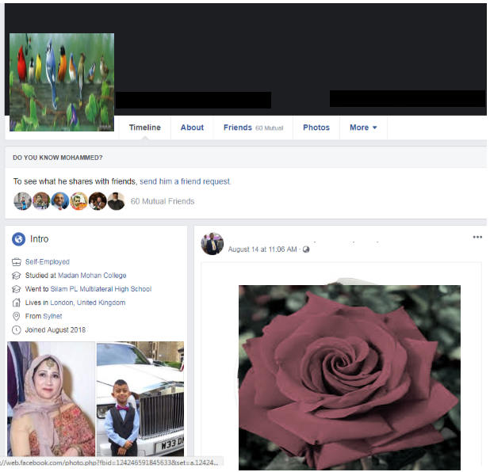
Facebook profile

The use of these networks in the workplace
In a workplace, the LinkedIn account can be used as providing a job description and job vacancies for the different candidates. Basic communication with the organisational HR can also be possible by using the details of a LinkedIn account. The organisation can also contact individual employee according to is submitted CV from the LinkedIn networking (Collins and Halverson, 2018).
In Twitter, the organisation can open an account where the organisational basic details and specification of the industry is provided. In addition to that, the organisational mission and vision can also be shared in the account. The Twitter account is mainly used for the promotion and marketing objectives of the organisation to attract some customers. Sometimes job vacancies can also be included by the organisation to this account.
However, Facebook is somehow similar to the Twitter account. The organisations are mainly using the Facebook account for product or service marketing and promotions (Kasemsap, 2016). Except that, the basic organisational details are also provided. The job vacancies can also be posted by the organisation if there is a huge vacancy.

Advantages of using these networks in the workplace
The benefits of using these three types of account are beneficial for the organisational growth and development. By using the LinkedIn, account organisation can attract their future employees. However, the use of Facebook and Twitter help the organisation in the promotion and marketing of products and services. In addition to that, the use of these three types of social networking also increases the popularity of this organisation and makes the organisation more visible for the customers. In the current time of globalisation, the organisational visibility is significant for Organisational profitability and productivity (Leftheriotis and Giannakos, 2014). However, the advantages also include the promotion of the new product from where the customers can be easily attracted to the new product which is not possible with other promotional techniques. Finally, it can be said that the use of social networking helps the organisation in reaching more close to their customers and influencing them and their purchasing behaviour.

Disadvantages of using these networks in the workplace
There are also some disadvantages to using these social networking mediums. The use of LinkedIn accounts generally more secure than the other two because it is associated with providing advertisement about the job vacancies and mainly associated with the organisational recruitment and selection process (Liao et al. 2015). But the Facebook and Twitter are more public, and any other Rival organisation can easily use the information which is provided by the organisation. For example, it can be said that The detailed information about the services and products can easily be known from the organisational advertisement in Facebook or Twitter. Therefore the customers can easily access them and try to purchase them as fast as possible. But the Rival or competitor in the same market can also obtain. Therefore, they can develop their strategy and business plan based on the information. Similarly, there are some privacy issues currently on Facebook. Thus the account details of an organisation can easily be hacked by hackers which has a huge disadvantage (McDonald and Thompson, 2016).

The implications about personal and professional security
The hacker can easily hack the information used by both the candidates and Organisation from the Facebook account. However, the privacy of Twitter is better built than facebook. Therefore, it is more secure than Facebook for both the personal and professional security. However, the use of the LinkedIn account is the most secure among all these three social networking. The implications of the security issues can be disadvantages for both personal and professional security. This is because the personal data are available in those accounts (Silverstone, 2017). Therefore any individual or institution can use those account easily which can impact on both the personal and professional life of an individual or the organisational social image.

The personal preference
In case of searching job and also the job-related activities, I prefer the LinkedIn networking procedure. However according to my personal opinion if I have to focus on both my personal and professional life, then Twitter is the best option for both the circumstances. In the case of job opportunities and job searching LinkedIn is my personal favourite.

Conclusion
In light of the above discussions, it can be easily established that the use of modern technologies is changed in the structure of the working pattern for both the organisation and individual. The purpose of these modern mobile devices is now part of the organisational work efficiency and also helpful for proper time management. The use of modern devices and social media platforms increases the opportunity for both individual and work institutions. However, the use of social media platforms within the workplace can also be disadvantages therefore for using these technological devices and social media organisations to implement proper policies and procedures.

References
Cardon, P.W. and Marshall, B., 2015. The hype and reality of social media use for work collaboration and team communication. International Journal of Business Communication, 52(3), pp.273-293.
Colbert, A., Yee, N. and George, G., 2016. The digital workforce and the workplace of the future.
Collins, A. and Halverson, R., 2018. Rethinking education in the age of technology: The digital revolution and schooling in America. Teachers College Press.
Collins, K., Shiffman, D. and Rock, J., 2016. How are scientists using social media in the workplace?. PLoS One, 11(10), p.e0162680.
Kasemsap, K., 2016. The role of social networking in global business environments. In Social media and networking: Concepts, methodologies, tools, and applications (pp. 1635-1653). IGI Global.
Leftheriotis, I. and Giannakos, M.N., 2014. Using social media for work: Losing your time or improving your work?. Computers in Human Behavior, 31, pp.134-142.
Liao, Y.W., Huang, Y.M., Chen, H.C. and Huang, S.H., 2015. Exploring the antecedents of collaborative learning performance over social networking sites in a ubiquitous learning context. Computers in Human Behavior, 43, pp.313-323.
McDonald, P. and Thompson, P., 2016. Social media (tion) and the reshaping of public/private boundaries in employment relations. International Journal of Management Reviews, 18(1), pp.69-84.
Silverstone, R., 2017. Introduction. In Media, technology and everyday life in Europe (pp. 19-36). Routledge.

