SOFTWARE APPLICATIONS FOR BUSINESS (ACCA4031)
Student Name: Sharanjeet Kaur
Student ID: 2232229

Table of Contents
Task 1: Analyzing the concept of website building along with e-portfolio creation 3
1. a. Analyzing various modern e-Commerce website software solutions 3
1. b. Design of the online portfolio 3
Task 2: Development of a mindmap to endow day-to-day Organization processes 4
Task 3: Analysis of various office applications 5
3. a. Making an analysis of several modern Office applications 5
3. b. Testing a few enterprise-related characteristics of a public Office Application 8
Task 4: Develop a digital dashboard along with handling data analytics 9
Task 5: Dealing with Project Management Application 12
5. a. Analysing Various Project Management softwares and demonstrating their features 12
5. b. Analysing a Project Management Software 14
Reference 16

Task 1: Analyzing the concept of website building along with e-portfolio creation

1. a. Analyzing various modern e-Commerce website software solutions
There is various e-commerce website software available in the market and they are getting documented hereunder.
WordPress
WordPress is nothing but a specific open-source application that is able to create all sorts of websites. It is nothing but the most prevalent Content Management application— the website gets designed on WordPress. It’s even the most effective alternative due to the fact that professionals worldwide contribute daily by fixing bugs, reviewing documentation, etc.
Wix
Wix is a very useful website in terms of the fact with this platform it is very easy for the professional to develop a website. Further, this is mentionable that the available templates inside the software can be used in order to develop the p[ortfolio or e-commerce websites.

1. b. Design of the online portfolio
Link: https://portfolioonlinetask.wixsite.com/online-e-portfolio

Figure 1.1: Snip 1
(Source: Acquired from Wix)
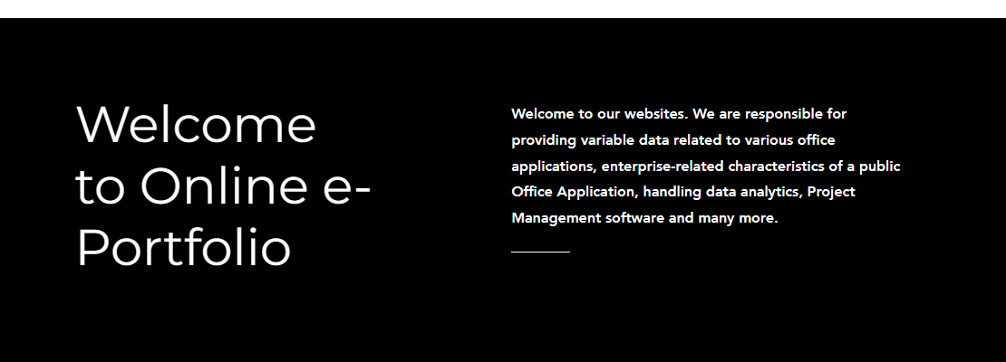
Figure 1.2: Snip 2
(Source: Acquired from Wix)

Figure 1.3: Snip 3
(Source: Acquired from Wix)
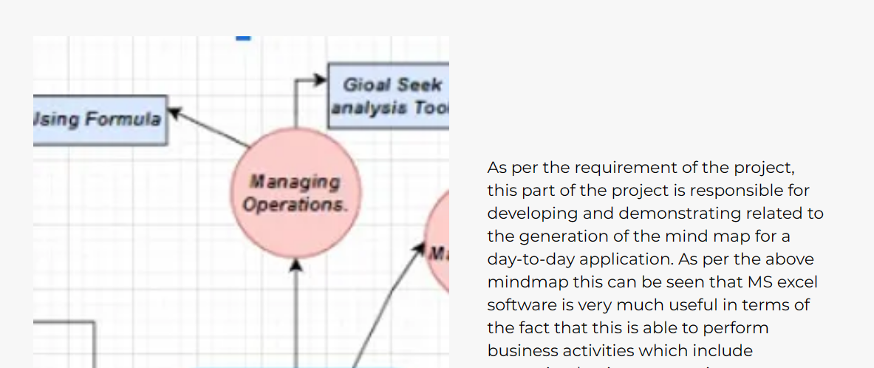
Figure 1.4: Snip 4
(Source: Acquired from Wix)
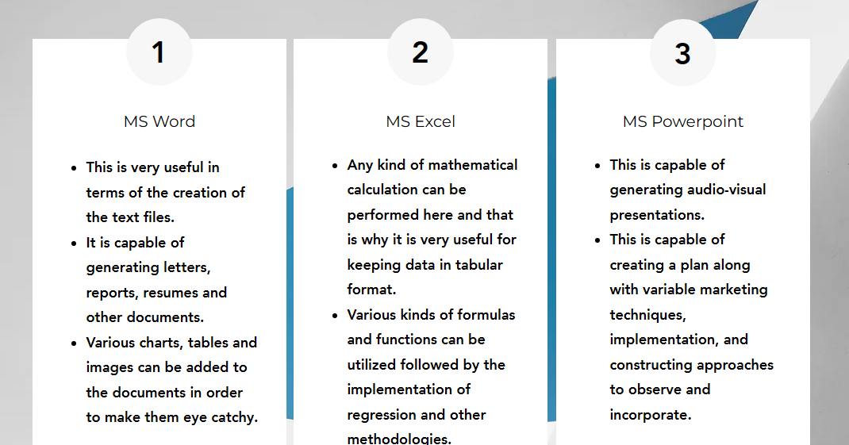
Figure 1.5: Snip 5
(Source: Acquired from Wix)
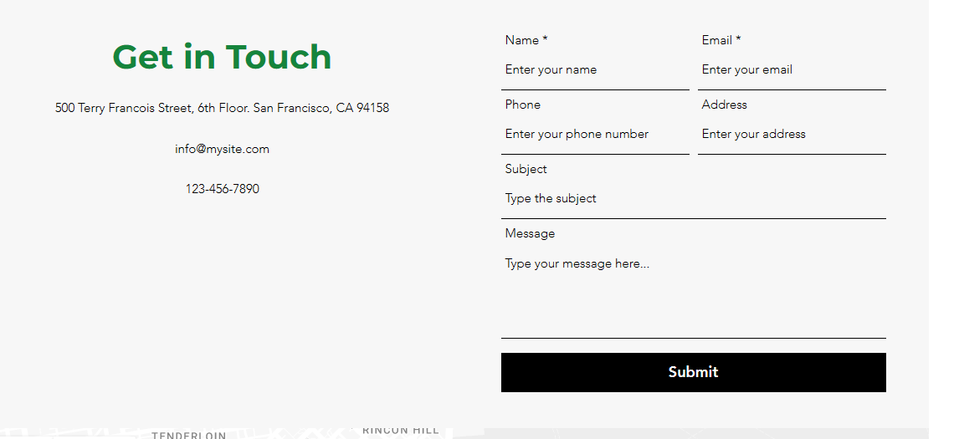
Figure 1.6: Snip 5
(Source: Acquired from Wix)

Task 2: Development of a mind map to endow day-to-day Organization processes
As per the requirement of the project, this part of the project is responsible for developing and demonstrating related to the generation of the mind map for a day-to-day application.
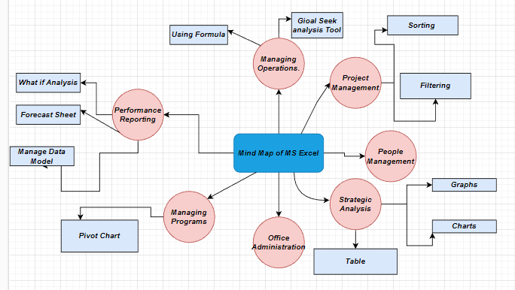
Figure 2.1: Exploring MS word
(Source: Created by Self)
As per the above mindmap this can be seen that MS excel software is very much useful in terms of the fact that this is able to perform business activities which include managing business operations, management of the programs, office administration, strategic analysis, and performance reporting. In such a scenario, this is notable that there are variable features and tools present inside the software such as what-if analysis tool, forecasting table tool, pivot table tool, recommended graph tool, filter tool and many more. All these tools are capable of performing the required business operations inside the software (Munappy et al. 2020).

Task 3: Analysis of various office applications

3. a. Making an analysis of several modern Office applications
This step is based on making an analysis of the various kinds of MS office softwares in order to demonstrate their features and utilisations along with comparing their pros and cons. In such a scenario, the following table is capable of describing all the key features associated with this office application.
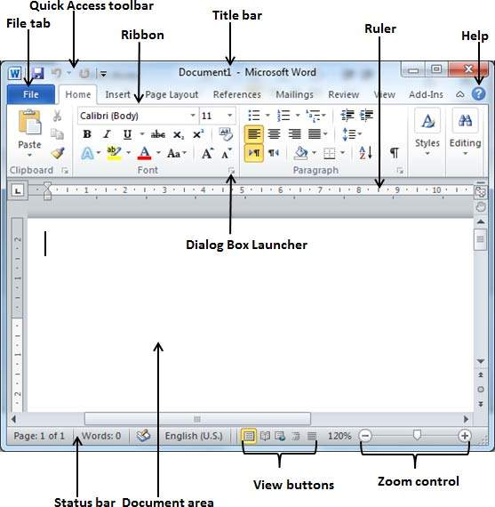
Figure 3.a.1: Exploring MS word
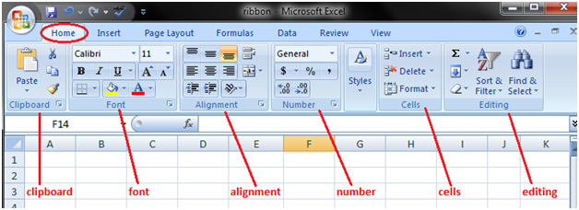
Figure 3.a.2: Exploring MS Excel
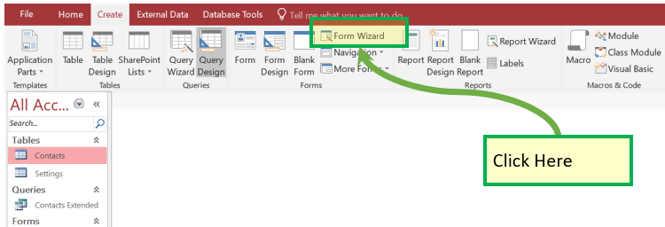
Figure 3.a.3: Exploring MS Access
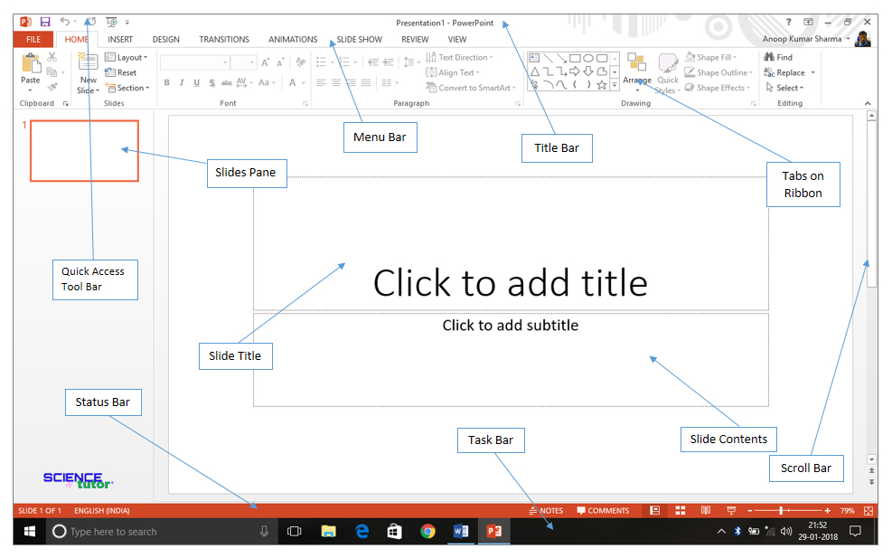
Figure 3.a.4: Exploring MS Powerpoint

Applications | Feature
MS Word | - This is very useful in terms of the creation of the text files.  - It is capable of generating letters, reports, resumes and other documents.  - Various charts, tables and images can be added to the documents in order to make them eye catchy.
MS Excel | - Any kind of mathematical calculation can be performed here and that is why it is very useful for keeping data in tabular format.  - Various kinds of formulas and functions can be utilized followed by the implementation of regression and other methodologies.
MS Powerpoint | - This is capable of generating audio-visual presentations.  - This is capable of creating a plan along with variable marketing techniques, implementation, and constructing approaches to observe and incorporate.
MS Access | - This is capable of linking with the variable data.  - It allows users to create forms, queries, tables, and reports and connect with the resource of Macros.

3. b. Testing a few enterprise-related characteristics of a public Office Application
In order to explain the business-related features linked to an office application, a brief description along with some screenshots are being added. As per the requirement, MS Excel software has been picked and its features get demonstrated hereunder (Yu et al. 2021).
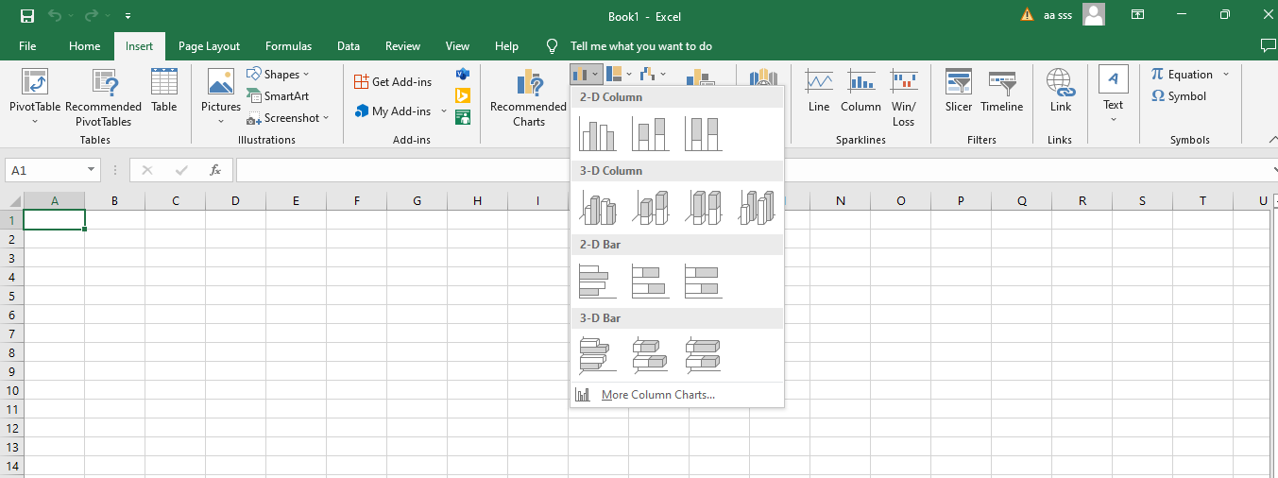
Figure 3.b.1: Various Chart and graph Features
(Source: Acquired from Excel)
As per the above feature, this can be said that the chart features are useful to illustrate the business data.
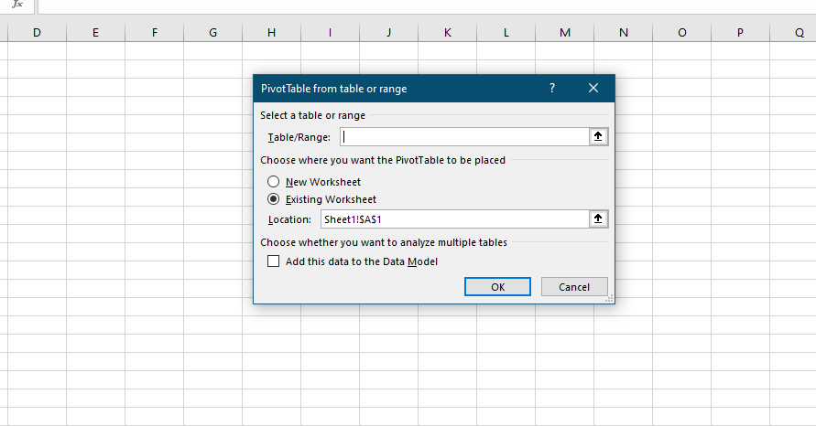
Figure 3.b.2: Pivot Table Feature
(Source: Acquired from Excel)
By inserting a pivot table, additional beneficial facts from the dataset are quick. Here, in-built operations allow summing and counting particular varieties of data.
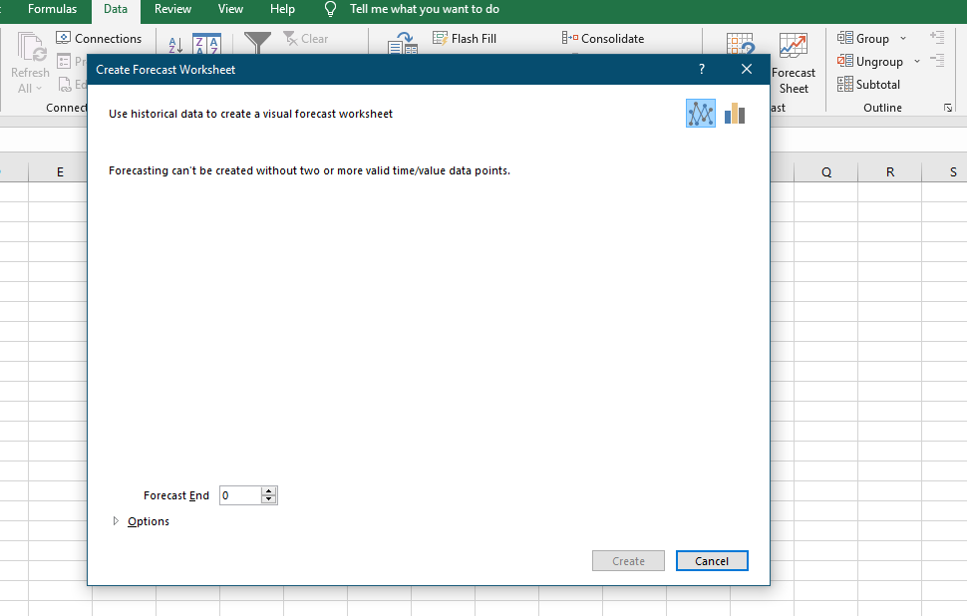
Figure 3.b.3: Forecast and Whatif analysis Feature
(Source: Acquired from Excel)
Again these are very useful in terms of analysis of business data and performing predictive analysis.

Task 4: Develop a digital dashboard along with handling data analytics
Dataset Link:
https://www.kaggle.com/code/hamzaben/employee-churn-model-w-strategic-retention-plan/input

As per the requirement of this section of the project, this is mentionable that the software named PowerBI get selected in order to perform the task. Further, the churn employee dataset gets selected in order to perform the visualisation and analysis in side the software and provide and document the practical evidence inside the report (Armenia et al. 2019).
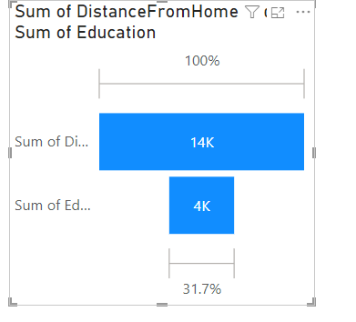
Figure 4.1: Sum of Distance from home vs Sum of Education curve
(Source: Generated in PowerBI)
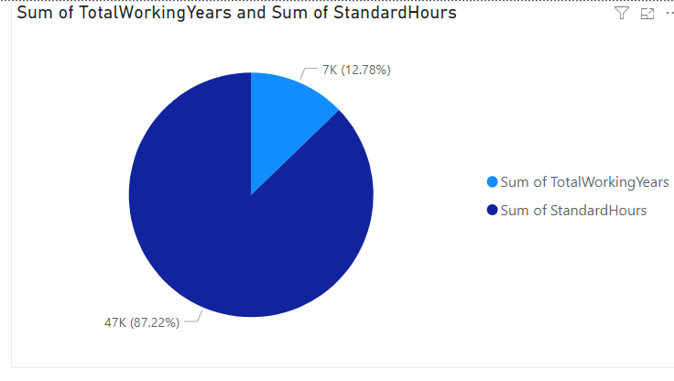
Figure 4.2: Sum of a total working hour vs Sum of the standard hour
(Source: Generated in PowerBI)
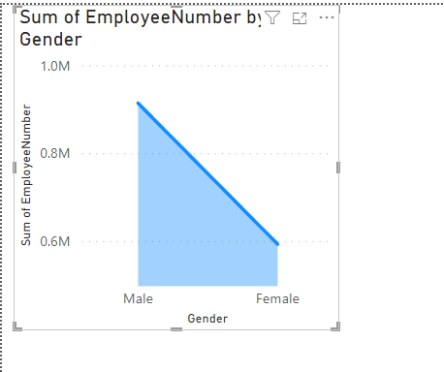
Figure 4.3: Sum of Employee Number vs Gender
(Source: Generated in PowerBI)
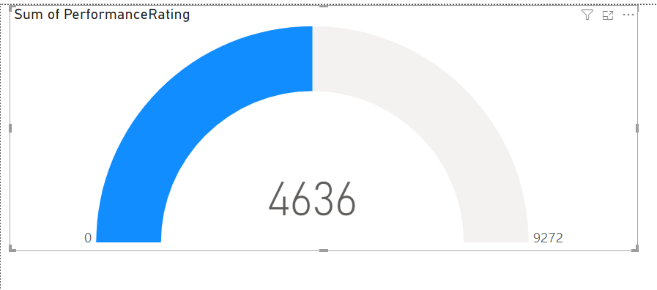
Figure 4.4: Sum of Performance Rating
(Source: Generated in PowerBI)
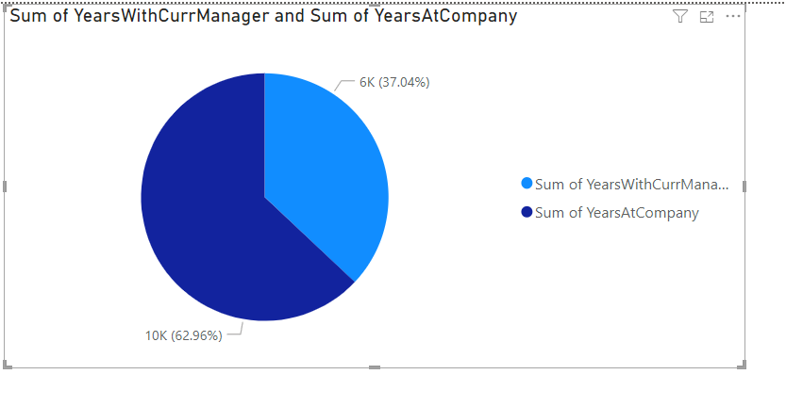
Figure 4.5: Pie graph
(Source: Generated in PowerBI)
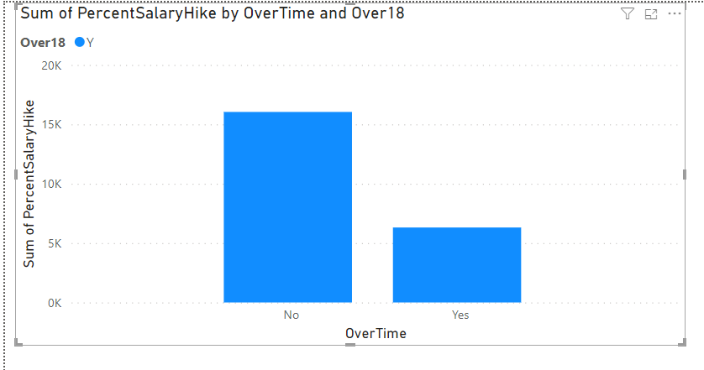
Figure 4.6: Sum of Percent Salary Hike
(Source: Generated in PowerBI)
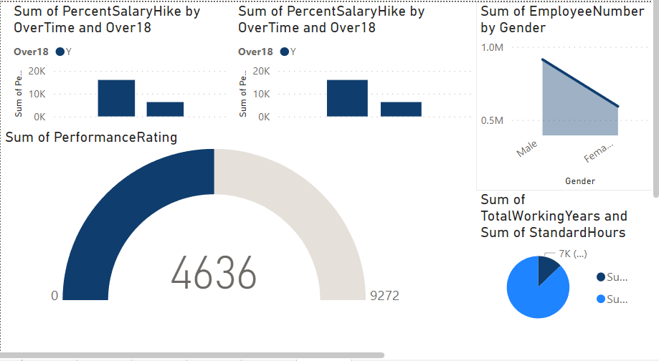
Figure 4.6: Dashboard
(Source: Generated in PowerBI)
The above images are responsible for showcasing the variable impacts and the perimeters associated with the churn data along with showcasing the value for the analysis and providing the practical visualisation (Derakhshan et al. 2019).

Task 5: Dealing with Project Management Application

5. a. Analysing Various Project Management softwares and demonstrating their features
There are various project management softwares are there in the market and each of them has different pros and cons.
ASANA
- It is responsible for facilitating the utilisation of the dashboards along with the conversations.
- The “TEAM PAGES” are able to be utilised to convey messages to the whole team.
- There is likewise a “smart box feature” that exhibits the notices solely significant to a specific team member.
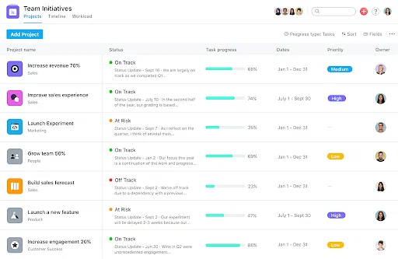
Figure 5.a.1: ASANA Platform
(Source: Syzdykova et al. 2021)
Basecamp
- Here, the storage of images, spreadsheets, documents, and other outward files is possible.
- Each project is responsible for having an element – automatic check-ins.
- This holds a unique Basecamp feature in order to visualize undertaking.
- It is available on Android, IOS and windows platforms.
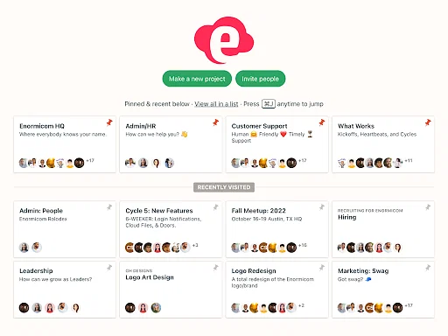
Figure 5.a.2: BaseCamp Platform
(Source:Maffei et al. 2021)
JIRA
- Here, Bugs are able to be skillfully chased and settled.
- It is responsible for using real-time reporting installations.
- Kanban boards can be created on this platform.
- Teams and communities are able to remain aligned with the utilisation of the Jira roadmaps. They qualify clients to move up positions from the team status to deal with company-wide endeavours.
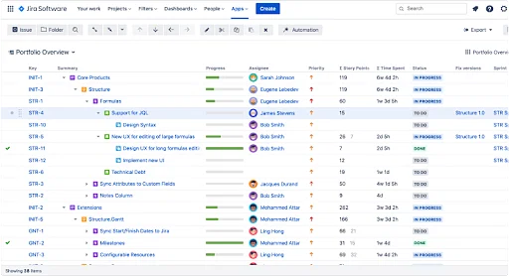
Figure 5.a.3: Jira Platform
(Source: Ngui et al. 2022)

5. b. Analysing a Project Management Software
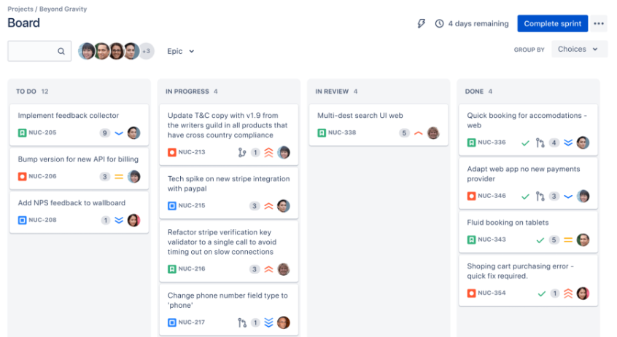
Figure 5.b.1: Scrum Board Jira Platform
(Source: Supple et al. 2023)
As per the above picture, the scrum board feature present in the Jira Platfopprm can be seen. Scrum boards support agile tandems to break enormous, complicated undertakings into effortless components of work therefore concentrated coalitions, toiling in sprints, ship quicker.
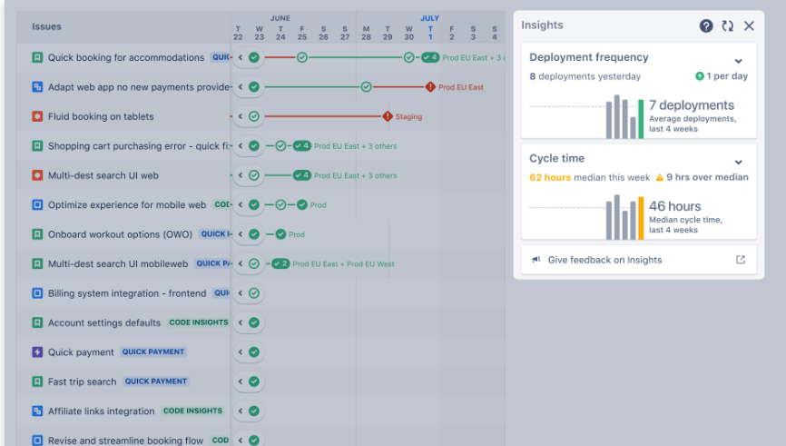
Figure 5. b.2: Reports and insights in Jira Platform
(Source: Gong et al. 2020)
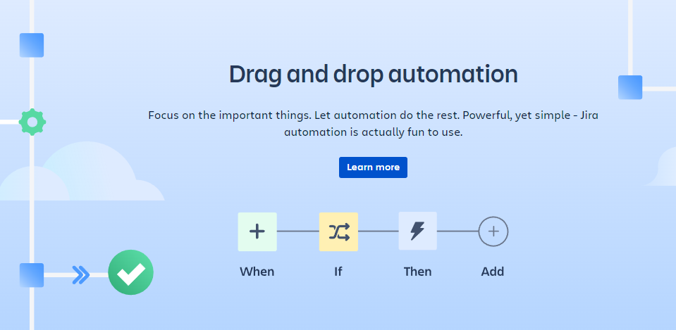
Figure 5. b.3: Drag and Drop Automation in Jira Platform
(Source: Singh et al. 2022)
Useful box reports alongside dealing with the dashboards offer imperative insights into the aspects associated with the work to secure the teams are continually up to date while as well set up to gain success.

Reference
Armenia, S., Dangelico, R.M., Nonino, F. and Pompei, A., 2019. Sustainable project management: A conceptualization-oriented review and a framework proposal for future studies. Sustainability, 11(9), p.2664.
Derakhshan, R., Turner, R. and Mancini, M., 2019. Project governance and stakeholders: a literature review. International Journal of Project Management, 37(1), pp.98-116.
Gong, Y., Yang, J. and Shi, X., 2020. Towards a comprehensive understanding of digital transformation in government: Analysis of flexibility and enterprise architecture. Government Information Quarterly, 37(3), p.101487.
Maffei, A. and Boffa, E., 2021. From Invention to Innovation: teaching business models to manufacturing researchers. Journal of Business Models, 9(3), pp.17-24.
Munappy, A.R., Mattos, D.I., Bosch, J., Olsson, H.H. and Dakkak, A., 2020, June. From ad-hoc data analytics to dataops. In Proceedings of the International Conference on Software and System Processes (pp. 165-174).
Ngui, W., Pang, V. and Hiew, W., 2022. E-portfolio as an academic writing assessment tool in higher education: Strengths and challenges. Indonesian Journal of Applied Linguistics, 12(2), pp.556-568.
Singh, R., Buddhi, D., Thapa, S., Prakash, C., Singh, R., Sharma, A., Sheoran, S. and Saxena, K.K., 2022. Sensitivity Analysis for Decisive Design Parameters for Energy and Indoor Visual Performances of a Glazed Façade Office Building. Sustainability, 14(21), p.14163.
Supple, B. and Cronin, J.G., 2023. A Pedagogy of Slow: Integrating Experiences of Physical and Virtual Gallery Spaces to Foster Critical Engagement in SoTL. Teaching and Learning Inquiry, 11.
Syzdykova, Z., Koblandin, K., Mikhaylova, N. and Akinina, O., 2021. Assessment of E-portfolio in higher education. International Journal of Emerging Technologies in Learning (iJET), 16(2), pp.120-134.
Yu, W., Zhao, G., Liu, Q. and Song, Y., 2021. Role of big data analytics capability in developing integrated hospital supply chains and operational flexibility: An organizational information processing theory perspective. Technological Forecasting and Social Change, 163, p.120417.

