
Skills for the Workplace
Module Assignment Submission
Student Name: | EMMA LAWRENCE
Student Number: | 2123569
Module No: | BMSK4006
Module Title: | Part 1 Business Plan

Statement of Confirmation of Authenticity
By the act of making this submission, the student declares that this is the work of the student named above. The work has not, in whole or in part, been knowingly presented elsewhere for assessment, or where assessment has been built on a previous assessment, this has been identified. Where materials have been used from other sources it has been properly acknowledged. If this statement is untrue, the student acknowledges that an assessment offence has been committed.
Attention is drawn to the plagiarism and unfair practice policies of both the University and of ILM.

Table of Contents
Title Page 2
Executive Summary 3
Business/Industry Overview 3
Market Analysis and Competition 4
Sales and Marketing Plan 6
Sales and Distribution 7
Advertising and Promotion 7
Ownership and Management Plan 7
Operating Plan 8
Financial Plan 8
Appendices 9
References 13

Title Page
Business Plan –
Electom
01/09/2022
66 Cefn Road, Bonymaen, Swansea

Executive Summary

Electom will be based in the South Wales region and will be managed by myself as a sole proprietor. I have over 20 years’ experience in this industry (Appendix 1). I will be contracted to work with other companies such as letting agencies and housing associations and also complete work for friends and family at a discounted cost. I will also be targeting industries such as schools, offices, pubs, clubs, and local businesses. There will, on average, be 79,900 job openings for electricians over the next ten years. The need to fill workers who change careers or leave the workforce due to retirement is expected to create many of those vacancies. I will be advertising my business through Social Media platforms as platforms such as Facebook creates both direct and indirect channels of engagement with your fans, allowing you to network, get feedback, and establish personal connections. Electom seeks an investment of £10,000 these funds will be used to purchase a van and any additional tools.

Business/Industry Overview

The business my partner and myself have is called Electom electrical services it is an electrical company which my partner have recently started up the business 3 months ago, my role in the business involves all the purchasing and invoicing which I do on a daily basis I also make sure his dairy is well organised. The services that we offer is all electrical work, testing certification, installation fitting and testing smoke alarms to all properties we have a contract with Peter Alan estate agents where all properties are checked once empty and certified to make sure all is safe also rented properties get checked on a regular basis and any faults reported will get attended too and carry out whatever work needs to be done. We also have a contract with Pobl housing association which is another big contract that also involves any faults get attended too and fixed and all void properties will be tested to make sure property is safe for families, there are also legal requirements you must adhere too you must have public liability insurance and must update the regulations and work too BS7671.
Wiring regulations certification for every electrical installation has to be provided also building control notifications, we have to renew his registration as a competent electrician every year and yearly visits to assess all work that have been carried out to make sure all work is correct safe and is following all rules and regulations.
We measure success by using spreadsheets comparing date from previous jobs we look at the pricing we gave materials used and how long the job took profits and loss and what we can change next time to make the company more beneficial, we would like to achieve a stable income with regular work on a day-to-day basis.
The service provided from Electom is always of a high standard and we always make sure the customer is happy when all work is complete, and any issue will be resolved straight away.

Electricians were in high demand. The advent of green technology has created a demand for personnel competent in product deployment and maintenance. According to the Electrotechnical Skills Partnership, an additional 15,000 electricians are required. Renewable electricity had a combined installed capacity of 44,425 megawatts by the end of 2018, having grown in each quarter of the year.

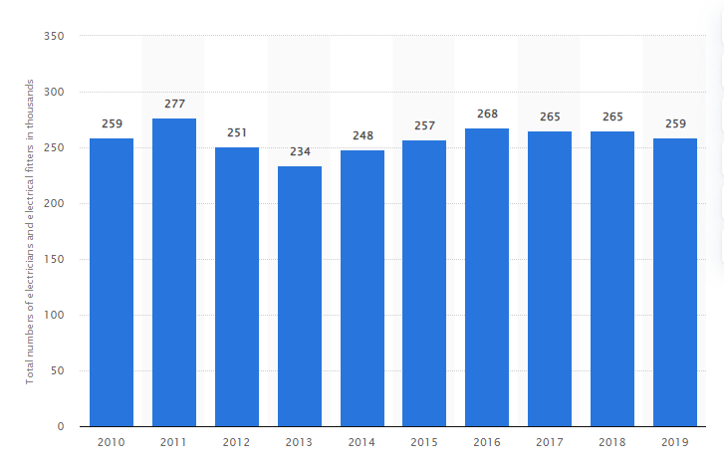

Market Analysis and Competition
The market my partner is working in is electrical installation testing and certification and all other various electrical work, the competitor analysis will be via websites such as checkatrade.com and my builder comparing prices and getting quotations from other electrical companies that way we can make sure out prices are accurate also social media is very good way for marketing, business cards leaflets I think the best way to advertise a business is through customers as they always pass your number on to friends and relatives.
Target markets will primarily be the rental and void market and commercial properties. I will target offices, schools pubs and clubs also all local businesses I will also try and beat any competitors with price and quality of work, I will always make sure presentation is very important uniforms with company logo on always look more professional, I will use foot covers when entering a property and dust sheets if any drilling or chasing of the walls have to be done to protect and respect a customer’s property that always goes a long way with customers, Also always being reliable and trustworthy that’s another important part of any business. I think the customers’ needs are competitive not the cheapest but not the most expensive I always ask customers if they have been provided with any other quotation and if so, I will compare and if possible, beat that price.
I have identified two competitive electricians and have conducted a SWOT analysis for both companies. They both advertise on Checkatrade website.
The first competitor I come across is a company called Asquith Electrical (https://www.checkatrade.com/trades/asquithelectrical). See below SWOT analysis for Asquith Electrical.

Strengths | Weakness | Opportunities | Threats
Positive reviews  Sufficient Resources  Works as a Team  Experience | Competition  Lack of trained Manpower  Energy Rises | Potential Market for energy efficient upgrades  Qualifications  Personal Support | Losing contracts to local competition  Rise in Electricity cost

Another competitor that I have come across is Jaxon Electrical Services Limited (https://www.checkatrade.com/trades/jaxonelectricalservice) See SWOT analysis below
Strengths | Weakness | Opportunities | Threats
Positive reviews  24/7 service  Limited Company  23 years of Experience | Growing demand for energy  Timescales and Deadlines  Lack of Focus | Market Development  Qualifications  Business development | Losing contracts to local competition  Rise in Electricity cost

Sales and Marketing Plan
POLITICAL | ECONOMIC
Tax Policy  Government Policy  Wars & Conflicts  Brexit | Interest Costs  Labour Costs  Inflation  Consumer Confidence
SOCIAL | TECHNOLOGICAL
Population Growth  Job Opportunities  Health  Ageing Population | New Materials  Changes in Technology  Research & Development  Growing Use of internet

Our customers at present are local estate agents, local building maintenance companies, housing associations and also work with property developers, as this is a new business we are trying different things for advertising all work from start to finish for each job is advertised on social media I think that helps a customer see before and after and what the finishing product is my pricing strategy is a day rate I will charge £200 per day that’s for labour and all parts to be purchased on top of that with 20% added on to parts, sales forecast for Electom will be £1000.00 per year.
Below is a list of jobs that I offer with estimated costs and timeframe:
JOB | ESTIMATE COST | TIME FRAME
Light fitting replacement | £25 - £50 | 1 Hour
Dimmer Switch Installation | £30 - £55 | 1 Hour
Existing exterior light replacement | £30 - £100 | 1 – 2 Hours
Install multiple light fittings | £50 - £100 | 2 – 3 Hours
PAT Testing | £50 - £150 | 3 – 8+ Hours
Install a security light outside. | £60 - £165 | 2 – 3 Hours
Add lighting to the loft | £70 - £150 | 2 – 3 Hours
Install electric shower | £100 - £250 | 2 – 3 Hours
Move an electric meter | £100 - £1000 | 1 – 8 Hours
Electrical Safety Report | £120 - £200 | 1 Day
Install garden or landscape wiring | £120 - £450 | 4 – 8 Hours
New mains switch consumer unit | £150 - £560 | 4 – 6 Hours
Install fire alarm system | £200 - £600 | 1 – 2 Days
Rewiring one-bedroom house | £1500 - £3000 | 3 – 4 Days

While some tasks, like replacing an outdated light fixture with a new one, may appear simple and straightforward on the surface, they may be more difficult to complete than first thought.

Sales and Distribution
According to an article in BLS (bls.gov), employment of electricians will increase by 7% between 2021 and 2031, which is approximately average for all occupations.
Over the next ten years, there are expected to be, on average, 79,900 job openings for electricians. Many of those positions are anticipated to be brought on by the need to replace workers who change careers or leave the workforce due to retirement.
Almost all structures have electricity. To install and replace these power systems, electricians are required. Since the installation of alternative energy sources like solar and wind is expanding, there should be a greater need for electricians. Over the anticipated ten years, electricians will still be required to connect these alternative systems to residences and electricity infrastructures. However, the government policies that boost consumer demand by bringing down installation costs, like rebates, net metering, and tax incentives, may be necessary to support employee development resulting from these alternative sources.

Advertising and Promotion
I will set up a business page on social media to advertise my business. I'll primarily use Facebook because my clients are homeowners and are probably already engaged there. Facebook is a helpful platform for sharing links to your blog posts and increasing site traffic. Facebook's chat tool can be used to interact with prospective customers who have questions. I will be giving family and friends work at a reduced rate. The power of word of mouth is unbeatable. I will also be providing business cards and giving out any opportunity I can.

Ownership and Management Plan

Electom will be the sole trader in the initial start-up phase

Operating Plan

South Wales area we will cover providing maintenance testing certification, my business will be managed from my home address to keep overhead costs down. To ensure the operation of the business goes well, I will engage regional wholesalers who will provide me with competitive pricing, and I have established multiple trade accounts.

Financial Plan

This table shows a breakdown of the anticipated costs to Electom over the initial 12-month period.

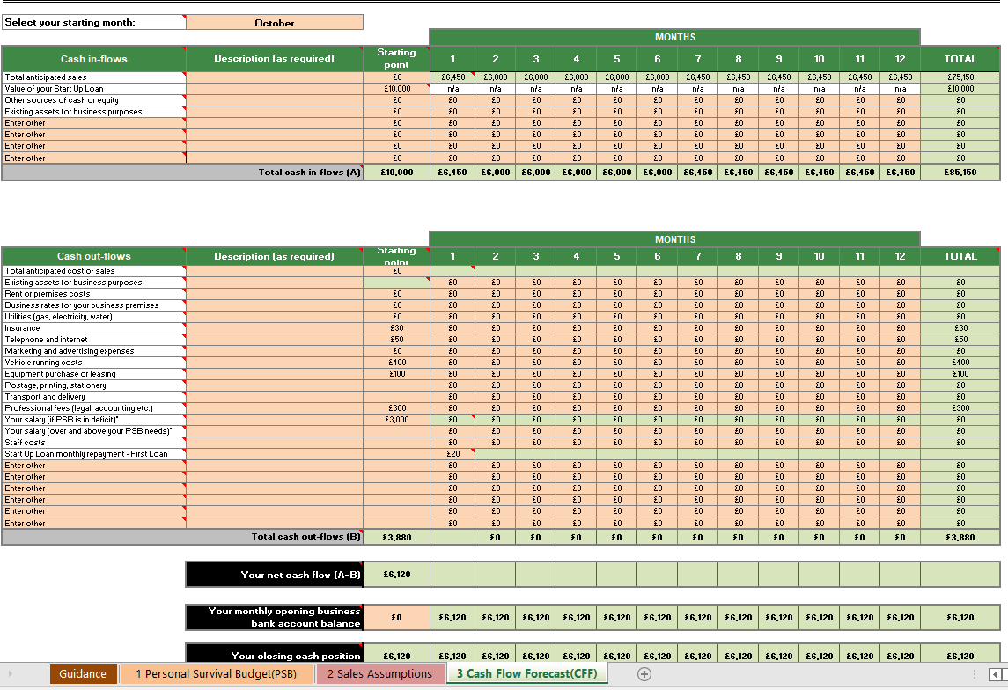

According to my Cash flow spreadsheet I will make £85150 annually. I will need to borrow £10,000 to purchase a van and some additional tools. I have most tools required for everyday jobs and will hire out additional tools when needs arise. I have estimated hiring costs to be around £100. The benefit of purchasing a van is that you can utilise it anyway you want because you own it altogether. There are no mileage restrictions or other restrictions associated with leasing a car, and you can sell it whenever you want. It also becomes a corporate asset. There may be limitations for the period of the contract if you purchase it with a financial package, such as a PCP deal, but you will own it after the contract expires.

Appendices
Appendix 1
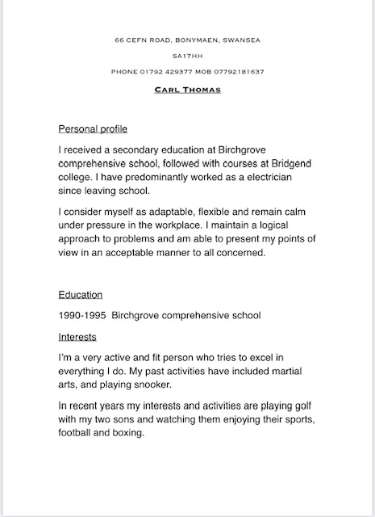
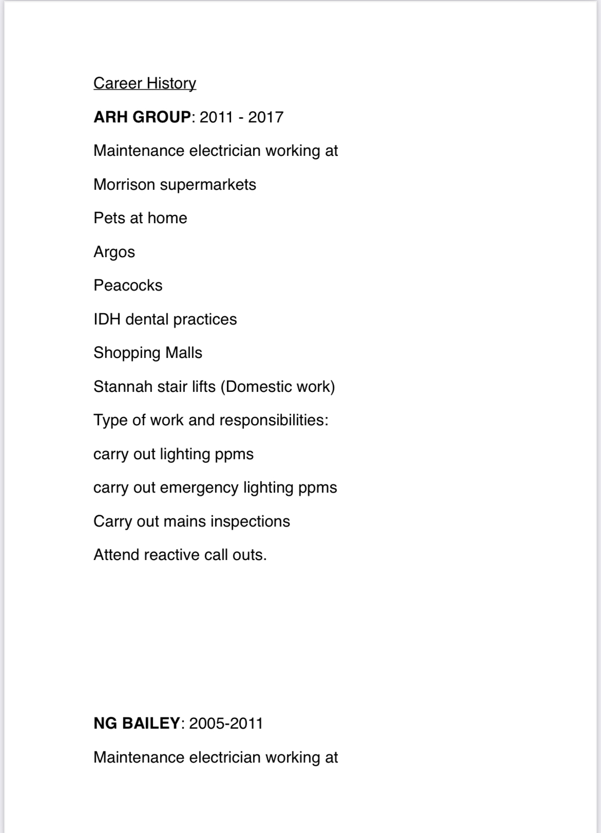
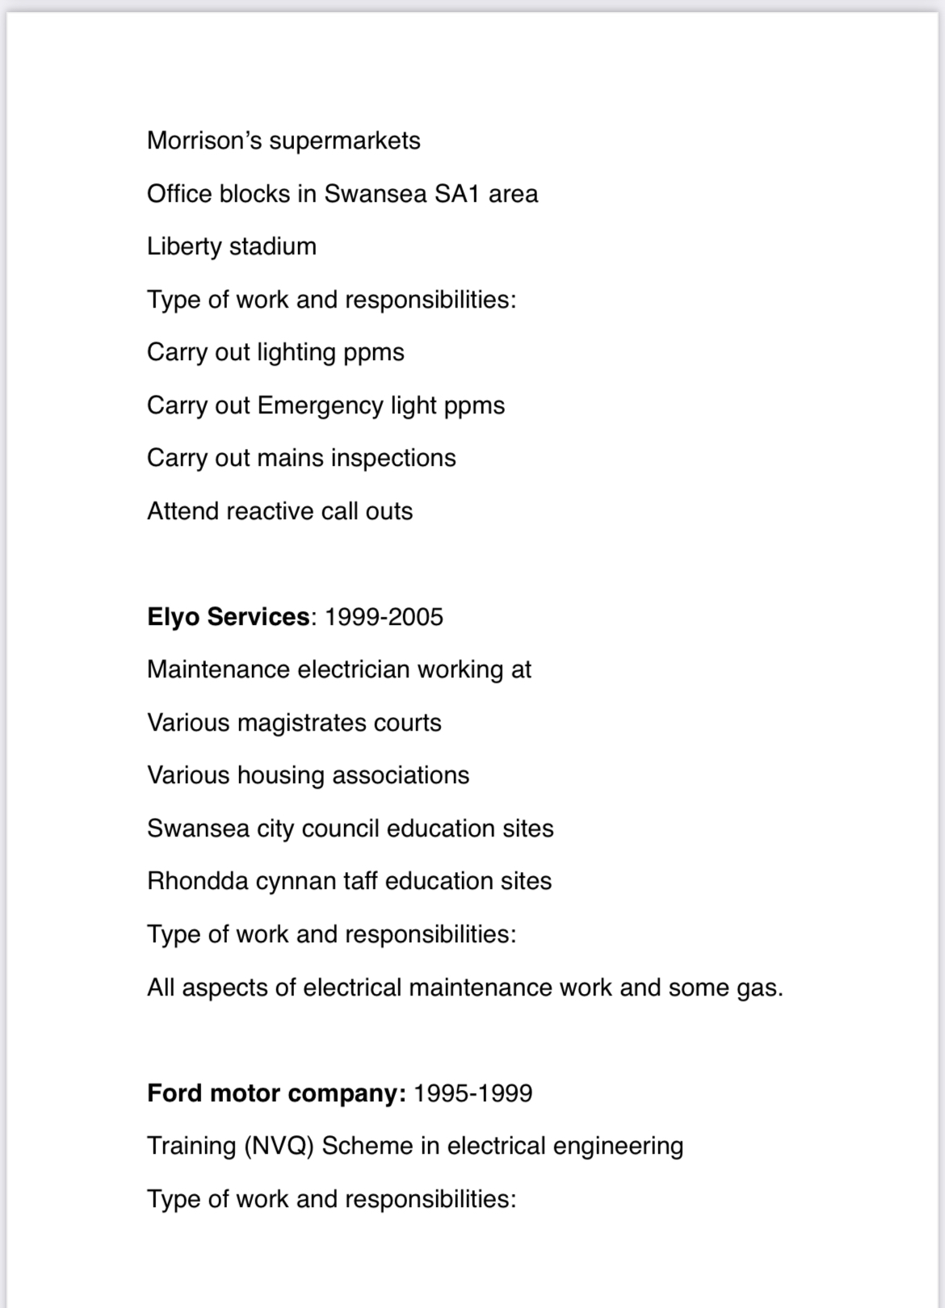
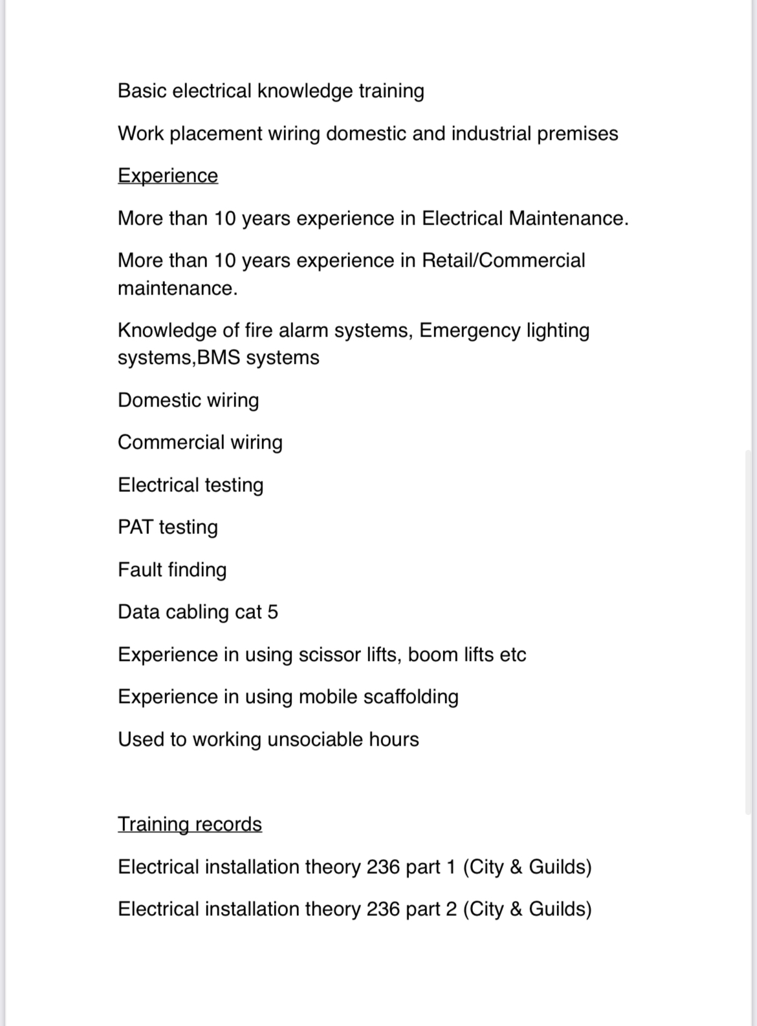

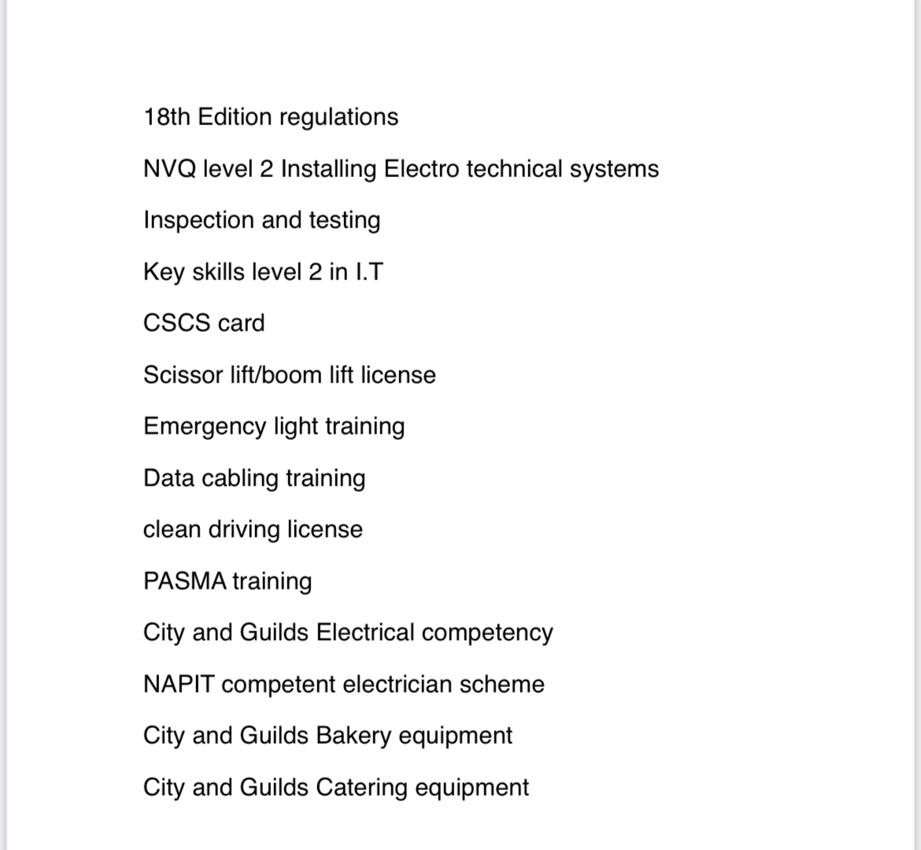

References
- HALF OF THE UK HAS A SHORTAGE OF MORE THAN 50 ELECTRICIANS. 2020.

- , Electrician Job Description | Indeed. Available: https://www.indeed.com/ [Sep 8, 2022]

- , Electricians : Occupational Outlook Handbook: : U.S. Bureau of Labor Statistics. Available: https://www.bls.gov/ooh/construction-and-extraction/electricians.htm#tab-6 [Sep 9, 2022].

- , Electricians Guide To Going Self-Employed. Available: https://www.tradeskills4u.co.uk/posts/guide-to-going-self-employed [Sep 14, 2022].

- , How to start up an electrician business. Available: https://www.startupdonut.co.uk/start-up-business-ideas/types-of-business/how-to-start-up-an-electrician-business [Sep 8, 2022].

- , Number of electricians & electrical fitters 2010-2019. Available: https://www.statista.com/statistics/318824/numbers-of-electrical-and-electronic-trades-professionals-in-the-uk/ [Sep 8, 2022].

- , Social Media Advertising Guide for Small Business. Available: https://informi.co.uk/marketing-and-sales/how-do-i-advertise-my-small-business-social-media [Sep 12, 2022].

- Social Media Marketing for Businesses.

- BUSINESS, Y.F., -01-19T22:06:52+00:00, 2020-last update, 7 electrician advertising ideas to boost sales. Available: https://business.yelp.com/advertise/electrician-advertising-ideas/ [Sep 12, 2022].

