Thohura Ahmed
1806406

Developing workplace critical thinking

Table of Contents
Executive Summary 2
Introduction 3
Findings 4
Values beliefs and attitudes 4
IKEAS Core Values 4
RED Critical Thinking Model 5
IKEA’s Flat Pack Packaging 6
Conclusion 7
Bibliography 10
Appendices 15
Classical Management Theory 15
Administrative Theory 16
Bureaucracy Theory 17
Behavioural Theory 17
Modern Management Theory 18
Contingency Theory 19
Maslow’s (1954) Hierarchy of needs chart 19
Herzberg’s (1959) two factors Theory 19
Henri Fayol’ 14 Principles 20
Max Weber’s (1905) 6 bureaucracy characteristics 21

Executive Summary

Introduction
This report briefly explains what management theories are, the types of theories available for use for any organisations and the purpose of these theories. Displaying examples of how organisations use these theories. Management is about organizing people and resources productively for the benefits of the firm as a whole, and to its employees. Management theories help to determine and explain the structure of organisations. They help understand and interpret human behaviours in organisations. The role of management theory in the workplace is to enhance the efficiency and effectiveness of the employees. It is a process, enabling organizations to set and achieve its objectives through planning, organizing and controlling resources, including the commitment of its employees. Comparing classical (also known as traditional) theories, scientific theories, modern theories and contingency theory and how management uses these. The purpose of this report is to look at what values and beliefs of IKEA’s employee possesses, what roles these values and beliefs play towards seeking employment and how these behaviour impact the success of the organisation.

Findings
Management theories study organisations and its management structure. Theories have been used long before the twentieth century. Systematic development of management thinking is thought to date back to the end of nineteenth century with the emergence of industrial organisations. Traditional (also known as classical) management theories originated during the industrial revolution when expanding trades and markets, technological development and growing number of population created opportunities for mass production of systematic and mechanical process (Kwok Angus C. F, 2014, p28-40).

Values beliefs and attitudes
According to McEwan (2001); (Rayner and Smith, 2009) and (Scheibe, 1970), Values are a set of great principles attached to something. Beliefs are accepted ideas as true without necessary facts and attitude is the behaviour, feelings, tendencies and evaluations in which individuals express their values and beliefs. Core values and beliefs help define the guiding principles and philosophy of an organization. Core values act as guide for the organization and give clarity and direction. They play an important role in shaping the culture of the organization. Analysis of leading innovative companies revealed that these organizations are committed to certain fundamental attributes that drive organisation ability to innovate and deliver growth (Sai Manohar, S. & Pandit, S.R. 2014, pp. 667-680). Maslow’s (1954) hierarchy of needs chart argues every individual has their own set of needs. These may start from very basic to the top, self-actualisation needs. Here individuals look to improve on becoming more better at something or becoming someone who is well recognised among people. Thinking critically is important to help make any important choices. Pearson’ (…) RED critical thinking model and Toulmin’s (…) models are useful to help organisations find solutions. Critical thinking is used in all aspects of organisation from recruiting employee to how management should carry out tasks (…).

IKEAS Core Values
IKEA has many values which help it to be a successful organisation. Some of which are togetherness. Togetherness and trust is believed to be at the heart of its culture. IKEA’s strength comes from trusting one another in the organisation. The employees must have trust in their leaders and the management should have trust in employees. The most important value IKEA obtains is that the organisation believes every individual has something valuable to offer (IKEA, 2019). The organisation believes in empowering people. IKEA believes giving and taking responsibility are ways to grow and develop as individuals. Being positive and forward-looking inspires everyone to contribute to development. IKEA is a caring organisation. It is mindful of people who work there, and the organisation wants to have positive environmental impact on people and planet (IKEA.com, 2019). Cost-conscious is another value IKEA possesses. The organisation wants as many people to be able to afford beautiful and functional home. To do this IKEA have adapted to using Hybrid strategy (Chaussée, L. & Foray, M., 2018). The organisation is constantly looking for new and better way forward and finding solutions to almost impossible challenges which is a source of inspiration. IKEA likes simplicity by staying close to reality, are pragmatic and view bureaucracy as its biggest enemy. IKEA sees leadership as an action and not a position. The organisation “looks for people’s values before competence and experience. People who ‘walk the talk’ and lead by example. It is about being our best self and bringing out the best in each other” (IKEA, 2019).

RED Critical Thinking Model
Critical thinking is the ability to think clearly and rationally and has been recognized as indispensable part of human life as well as in accomplishing tasks at work (Skillsyouneed.com, 2019). Before making any decision, a person has to gather, analyse, evaluate, and synthesize all the necessary information, as well as envision the consequences of the course of each alternative. To be successful in business, individuals must possess critical thinking skills to make informed decisions quickly in a highly competitive and rapidly changing environment. The RED stands for recognizing assumptions, evaluating arguments, drawing conclusions, a model developed by Pearson (YouTube, 2015). The RED model lays out a path for understanding how critical thinking works. Also, it was stated that the RED is an effective and powerful critical thinking tool that provides a systematic, step-by-step process for examining issues, events, people, and problems (Eugenia Arazo Boa, Amornrat Wattanatorn & Kanchit Tagong, 2018, pp.81–89). The Socratic method of thinking is an approach by which one seeks the truth via a process of questions and answers. Socratic method is the oldest and still the most powerful teaching tactic for fostering critical thinking (Linstead. S., Fulop. L. and Lilley. S. 2004).

IKEA’s Flat Pack Packaging
Critically thinking is a cognitive activity, associated with using the mind. Learning to think in a critically analytical and evaluative ways means using mental processes such as attention, Categorisation, Selection and judgement (Cottrell, 2011). When it comes to critically thinking, Ikea are a step ahead and are aware of its impact on the surroundings locally and globally. The company uses business strategies, valuers of its employees, customers and stakeholders to differentiate themselves from all. Ikea uses Toulmin’s Model to make its products keeping ethics in mind.
Example of their Flat pack packaging using Toulmin model;
Claim (what is it?) Flat pack packaging is environmentally friendly. Creating less carbon footprints.
Grounds (Why?) Flat packs are minimalistic, cheaper and affordable. Can be recycled.
Warrant (Proof/Data?) Waste management data of Ikea.
Backing (additional data?) Annual Waste collection report from governments comparing how much/less waste organization produced over the years. Evidence showing the organization produces products according to the governing regulatory rules and regulations.
Qualifier (strength of data?) government-based data, data collected is accurate and non-biased as data is not from private company.
Here the claim and conclusion meet on positive note which makes the claim to be correct.


(IKEA.com, 2019)

Conclusion
The report finds that Human needs and behaviour change according to the level of values and beliefs individual have. Types of values can be measured using Maslow’s (1954) needs chart starting from the basic foundation to focus to future values. Foundation values are solid and stable, long-lasting beliefs about what is important to individual. These values become standards by which individual makes choices and decisions. A belief develops into value when individual’s commitment grows and views it as being important (McEwan, 2001). Focussed values are priorities in life which inform attitude to relationships and decision making. Future values are those values that represent what is important to individuals about the future. Table below shows example of how individual perceives these values.

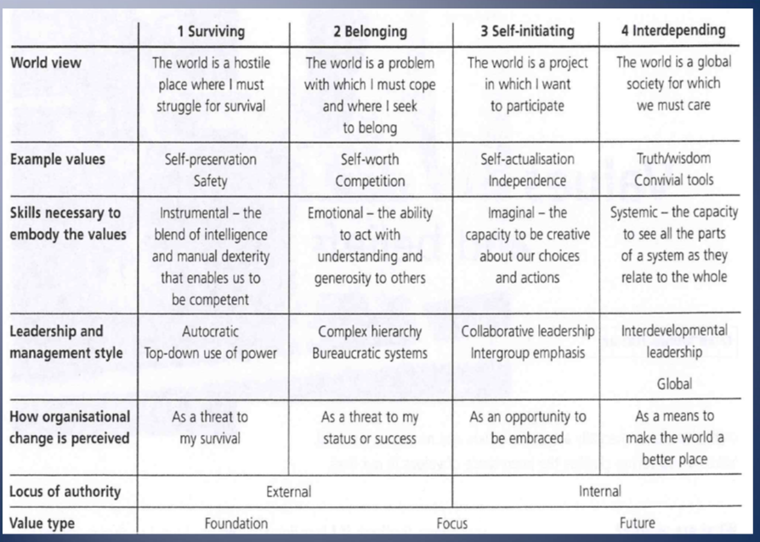

IKEA believes in togetherness, simplicity and respecting each other’s views. An employee looking for employment will search for companies where their values are aligned with the company values. As well as opportunity for personal growth. If the employee believes in looking after the planet, they will, look for similar mindset company to work in. If the individual believes the organisation will take its opinions seriously (which they value), therefore, the level of morale is increased which heightens the level of employee engagement (MSG, 2019).
IKEA values its employees’ views and is always open to suggestions from its staff. The organisation perceives employees as assets and believes by empowering. Listening and supporting employees where necessary have made IKEA a successful organisation (IKEA.com, 2019). IKEA views employee values and customer values as important as IKEA’s values and sets these view in the centre of the organisation. Personal qualities such as a strong desire to learn, the motivation to continually do things better, simplicity and common sense, the ability to lead by example, efficiency and cost-consciousness. These values are important to IKEA because their way of working is less structured than that of many other organisations (IKEA.com, 2010). Compared to Taylor’s (1909) scientific theory which takes no consideration of employee opinions or feelings and Hawthorne’s experiment where organisation viewed employees as extension machines (YouTube, 2012). Both theories does not work in organisation such as IKEA as it lacks to address the human side of needs. According to Maslow’s (1954) and Herzberg’s (1959), employees have different needs and are motivated diversely according to their values. During the Hawthorne (1920) experiment, Elton Mayo’s (1924) study revealed his findings were in line with Maslow’s theory, where individuals required recognition for further motivation (see appendices Elton Mayo. Maslow’s hierarchy of needs chart).

Employees values when aligned with organisations values, benefits the company better. The company obtains a keen team worker. Conflicts are immediately identified and resolved. Communication is effective and organisation witnesses increase in motivation and employee engagement resulting in increased productivity (MSG, 2019).

It is difficult to establish which theory or theories IKEA use to manage its organisation. IKEA have adapted to using Hybrid strategies derived from Porter’s theory (…). Henri Fayol’s Principles no. 1. Division
Although IKEA is believing bureaucracy is its biggest enemy, the management is somewhat structured with specialist department (see appendices diagram 5).

Company values are in line with employees’ values,
The advantages of
The advantages of having

Bibliography

Anon, 1979. Journal of beliefs & values: studies in religion and education.

Answers.com. (2019), ‘Compare and contrast McGregor and Herzberg?’, [online], available at: https://www.answers.com/Q/Compare_and_contrast_McGregor_and_Herzberg accessed12/12/2019

Barrett Values Centre. (2019), ‘Personal Values Assessment’, [online], available at: https://survey.valuescentre.com/survey.html?id=s1TAEQUStmw00Xkb9ByK_B4E3lIuZOgB0EGag0Ki1CIOvC8MbC5eSA&locale=en accessed 09/12/2019

Boha Ala. (2019), ‘The Role of Management Theories in Workplace’, [online], available at: https://bohatala.com/the-role-of-management-theories-in-workplace/ accessed 16/11/2016

Burns. T., Stalker. G.M., Lawrence. P.R. and Lorsch. J.W. (2019), ‘Contingency Theory’, [online], available at: http://www.businessmate.org/Article.php?ArtikelId=11 accessed 09/12/2019

Business Jargon. (2019), ‘Modern Theory’, [online], available at: https://businessjargons.com/modern-theory.html accessed 10/12/2019

Canina, L., Palacios, D. & Devece, C. 2012, "Management theories linking individual and organizational level analysis in entrepreneurship research", International Entrepreneurship and Management Journal, vol. 8, no. 3, pp. 271-284.

Cherry. K. (2019), ‘extrinsic motivation’, [online], available at: https://www.verywellmind.com/what-is-extrinsic-motivation-2795164 accessed 10/12/2019

Chaussée, L. & Foray, M., (2018). Understanding the Management Control System Used by Hybrid Companies: A Case Study of IKEA and MIO.

CFI. (2019), ‘Management theories’, [online], available at: https://corporatefinanceinstitute.com/resources/careers/soft-skills/management-theories/ accessed 05/12/2019

Conlin. B. (2019), ‘What do some of the original management theorists believe?’, [online], available at: https://www.business.com/articles/popular-management-theories-decoded/ accessed 11/12/2019

Cottrell, S. (2011), Critical Thinking Skills – Developing Effective Analysis and Argument, (Second Edition) Hampshire: Palgrave Macmillan

Dininni, J. (2011), ‘Management Theory of Douglas McGregor’, [online], available at: https://www.business.com/articles/management-theory-of-douglas-mcgregor/ accessed 08/12/2019

Elkins. H. (2019), ‘Management Theories & Concepts at the Workplace’, [online], available at: https://smallbusiness.chron.com/management-theories-concepts-workplace-17693.html accessed 15/11/2019

Eugenia Arazo Boa, Amornrat Wattanatorn & Kanchit Tagong, 2018. The development and validation of the Blended Socratic Method of Teaching (BSMT): An instructional model to enhance critical thinking skills of undergraduate business students. Kasetsart Journal of Social Sciences, 39(1), pp.81–89.
Fayol, H., 2013. General and industrial management, Mansfield Centre, CT.: New York: Martino Publishing; Pittman Publishing Corp.;

Health Knowledge. (2017), ‘Management models and theories associated with motivation, leadership and change management, and their application to practical situations and problems’, [online], available at: https://www.healthknowledge.org.uk/public-health-textbook/organisation-management/5c-management-change/basic-management-models#Classical_Management_Theory accessed 16/11/2019
Health Knowledge. (2017), ‘Critical evaluation of a range of principles and frameworks for managing change’, [online], available at: https://www.healthknowledge.org.uk/public-health-textbook/organisation-management/5c-management-change/critical-evaluation accessed 07/12/2019

IKEA. (2019), ‘Our Values’, [online], available at: https://seeacareerwithus.com/about-us/our-values/ accessed 22/11/2019

IKEA.Com. (2010), ‘Work hard, be yourself’, [online], available at: https://www.ikea.com/ms/en_US/jobs/join_us/ikea_values/index.html accessed 12/12/2019

IKEA.com. (2019), ‘IKEA culture and values’, [online], available at: https://about.ikea.com/en/who-we-are/our-roots/ikea-culture-and-values accessed 26/11/2019

IKEA.com. (2019), ‘IKEA Vision, Culture and Values’, [online], available at: https://ikea.jobs.cz/en/vision-culture-and-values/ accessed 12/12/2019

IKEA.com. (2019), ‘Do you share our values?’, [online], available at: https://www.ikea.com/ms/en_US/the_ikea_story/working_at_ikea/our_values.html accessed 22/11/2019

Kwok Angus C. F, 2014. The Evolution of Management Theories: A Literature Review. Nang Yan Business Journal, 3(1), pp.28–40.

Linstead. S., Fulop. L. and Lilley. S. (2004), Management and organisation a critical text. New York: Palgrave McMillan

Lumen learning. (2019) Organizational Structure. Available at: https://courses.lumenlearning.com/suny-fmcc-principlesmanagement/chapter/7-2-organizational-structure/ accessed 17/11/2019

Lumen learning. (2019) Organizational Structure. Available at: https://courses.lumenlearning.com/suny-osintrobus/chapter/building-organizational-structures/ accessed 05/11/2019

Marked by Teachers. (2015), ‘The relationship between management theory and practice.’, [online], available at: http://www.markedbyteachers.com/gcse/business-studies/the-relationship-between-management-theory-and-practice.html accessed 15/11/2019

Marked by Teachers. (2015), ‘What is the purpose of management theory? Explain how knowledge to understanding of management theories can help you in your work; use example to illustrate your answer where possible.’, [online], available at: http://www.markedbyteachers.com/gcse/business-studies/what-is-the-purpose-of-management-theory-explain-how-knowledge-to-understanding-of-management-theories-can-help-you-in-your-work-use-example-to-illustrate-your-answer-where-possible.html accessed 15/11/2019

Mcadam, R., Miller, K. & Mcsorley, C., 2019. Towards a contingency theory perspective of quality management in enabling strategic alignment. International Journal of Production Economics, 207, pp.195–209.

McEwan, T., 2001. Managing values and beliefs in organisations, Harlow: Financial Times Prentice Hall.

Mindtools. (2019), ‘Henri Fayol's Principles of Management’, [online], available at: https://www.mindtools.com/pages/article/henri-fayol.htm accessed 06/12/2019

MSG. (2019), ‘Motivation and Morale - Relationship and Differences’, [online], available at: https://www.managementstudyguide.com/motivation-morale.htm accessed 03/12/2019

MSU.EDU. (2019), ‘intrinsic motivation’, [online], available at: https://msu.edu/~dwong/StudentWorkArchive/CEP900F01-RIP/Webber-IntrinsicMotivation.htm accessed 06/12/2019

Mulder, P. (2019), ‘Bureaucratic Theory by Max Weber’, [online], available at: https://www.toolshero.com/management/bureaucratic-theory-weber/ accessed 05/12/2019

Mulder, P. (2015), ‘McGregor Theory X and Theory Y’, [online], available at: https://www.toolshero.com/leadership/mcgregor-theory/ accessed 12/12/2019

Petersen, V.C. 2007, Distortions of modern management theory - and an attempt to correct them, Federal Reserve Bank of St Louis, St. Louis.

Petruta Mihai, Alexandra Ioanid & Paula Voicu, 2014. CLASSICAL AND MODERN METHODS USED IN ELECTRICAL ENERGY MANAGEMENT SYSTEM. SEA: Practical Application of Science, II(5 (3/2014), pp.467–474.

Rayner. C., Smith. D. A. (2009), Managing and leading people. 2nd ed. London: the Broadway

Reference. (2019), ‘What Is the Purpose of Management?’, [online], available at: https://www.reference.com/business-finance/purpose-management-3598553db07671d4 accessed 16/11/2019

Sai Manohar, S. & Pandit, S.R. 2014, "Core Values and Beliefs: A Study of Leading Innovative Organizations: JBE JBE", Journal of Business Ethics, vol. 125, no. 4, pp. 667-680.

Scheibe, K.E., 1970. Beliefs and values., New York: Holt, Rinehart & Winston Inc.

Scott, J. & Marshall, G., 2009. Contingency theory. A Dictionary of Sociology, pp. A Dictionary of Sociology.

Skills You Need. (2019), ‘Critical thinking Skills’, [online], available at: https://www.skillsyouneed.com/learn/critical-thinking.html accessed 10/12/2019

Smith, B.H., 1988. Contingencies of value: alternative perspectives for critical theory, Cambridge, Mass.; London: Harvard University Press.

Study.com. (2019), ‘Modern theory of management’, [online], available at: https://study.com/academy/lesson/modern-theory-of-management.html accessed 29/11/2019

S. Y. Kuznetsov, 2011. THE MODERN MANAGEMENT THEORY OF BUSINESS SUSTAINABILITY. Strategičeskie Rešeniâ i Risk-Menedžment, (6), pp.62–67.

Vidal, G.G. et al., 2017. Contingency theory to study leadership styles of small businesses owner-managers at Santo Domingo, Ecuador. International Journal of Engineering Business Management, 9, pp. International Journal of Engineering Business Management, 01 December 2017, Vol.9

Walker, A., 2007. Project management in construction 5th ed., Oxford: Blackwell.

YouTube. (2017), ‘Classical Management Theory’, [online], available at: https://www.youtube.com/watch?v=d1jOwD-CTLI accessed 03/12/2019

YouTube. (2012), ‘Hawthorne Studies’, [online], available at: https://www.youtube.com/watch?v=W7RHjwmVGhs accessed 15/11/2019

YouTube. (2012), ‘The Toulmin Model Of Argumentation’, [online], available at: https://www.youtube.com/watch?v=D-YPPQztuOY accessed 01/12/2019

YouTube. (2015), ‘Pearson's RED Model of Critical Thinking’, [online], available at: https://www.youtube.com/watch?v=8-V4voD_E5A accessed 11/11/2019

Appendices

Classical Management Theory
Classical management theory consist of Frederick Taylor’s (1909) Scientific management theory, Henri Fayol’s (1949) Administrative theory and Max Weber’s (1905) Bureaucracy Theory. These are the oldest management theory. These theories focus on organisational operations and the creation of standards to increase production output. In classical Management Theory, compensation is considered the primary motivation for employees (Chron.com, 2019).
Taylor’s (1909) philosophy emphasized forcing people to work hard wasn’t the best way to optimize results. Instead, Taylor recommended simplifying tasks so as to increase productivity (CFI, 2019). According to Taylor money was key incentives for employee motivation. His theory consist of four basic objectives and they are as follows:
- The scientific selection, training and development of employees instead of allowing employee to choose their own task and train themselves to the best they can.
- The development of science for each element of task.
- The development of co-operation between employers and employees to ensure task carried out in accordance to scientifically devised procedure.
- The division of work carried out between employees and employers was almost equally shared.
(Kwok Angus C. F, 2014, p28-40).
Taylor’s theory dealt with mechanical and output production of goods and services. It does not take in consideration the human element and needs of individuals. Using Taylorism requires managers to develop a science for each operation and using science, determine accurately the correct time and methods for each job (time and motion studies). Management have to select and train employees and accept itself to be governed by the science deployed for each operation and surrender its arbitrary powers over the workers, i.e. co-operate with employees.
Taylorism required employees to share in prosperity of the organisation by completing tasks set using the required methods and receive increased salary. Employees have to give up their ideas and agree to be trained in new methods.
“Taylorism involved breaking down the components of manual tasks in manufacturing environments, timing each movement ('time and motion' studies) so that there could be a proven best way to perform each task. This was a scientific system where every task became discrete and specialised” (Health knowledge, 2019). Example of modern-day specialised services provided is in the NHS.

Douglas McGregor
Douglas McGregor (1960) developed a leadership theory known as (McGregor Theory X and Theory Y) about organization and management. X and Y represented two opposing perceptions about people and how they behave. Theory X assumes people are naturally lazy, want to avoid work as much as possible. Individuals do not wish to take responsibilities, have no ambitions and prefer to be supervised. For this type of employees, the authoritarian leadership style is best. According to this theory, pure work motivation consists of financial incentives and rewards and punishments work best for them. Douglas McGregor assumes people in theory Y have different needs than people in theory X. Theory Y assumes people are inherently happy to work and want to exert themselves. They are motivated to pursue objectives and are prepared to take responsibility for everything they do. These people want to use their creativity and they like to take a creative problem-solving approach. McGregor then arrived at the conclusion that the style of leadership depends on the manager’s perception of people (Mulder, 2015). (See appendices.)
Federick Hertzberg’s (1959) hygiene theory classifies the factors needed to motivate people into two categories: hygiene factors and motivating factors. Hygiene factors are necessary for motivation but not sufficient; they do not bring satisfaction, but they prevent dissatisfaction. Some examples are compensation; company policies; level of supervision or ownership of the assigned work; relationship with superiors, subordinates, and peers; and working conditions. Motivating factors are factors that bring (or increase) job satisfaction. Some examples are challenging work assignment, opportunity for career advancement and accomplishments, opportunity for growth, sense of responsibility, and recognition (See appendices) (Answers.com, 2019).

Henri Fayol’s Administrative Theory
Henri Fayol was born in Istanbul in 1841. He was 19 years old when he began working as an engineer at a large mining company in France. He eventually became the director, at a time when the mining company employed more than 1,000 people (Mindtools, 2019). Henri Fayol’s (1916) administrative management theory is a simple model of how management interacts with personnel. Concepts are covered in a broad way and almost any business can apply this theory of management. Fayol’s theory has 14 principles of management (see appendices Table 1. Henri Fayol’s 14 principles) and believes there are basic commands management should use in order to control and plan production. These are:
- Planning. Management must plan and schedule every part of industrial processes.
- Organising. In addition to planning a manufacturing process, management must also make certain all of the necessary resources (raw materials, personnel, etc.) came together at the appropriate time of production.
- Commanding. Management must encourage and direct personnel activity.
- Coordinating. Management must make certain that personnel works together in a cooperative fashion.
- Controlling. The final management activity. To evaluate
Fayol provided basic concepts and terminology, such as division of labour, scalar chain, unity of command and centralisation. Fayol’s theory described a structure of a formal organisation. Similar to Taylor’s theory, Henri’s theory was also missing issues relating to the sensitivity of employee needs, such as employee initiatives. He saw employees as rational organisational structure and not in terms of adapting structures and changing people's behaviour to achieve the best fit between the organisation and its customers. Many of Fayol’s principles have been absorbed my modern organisations but they do not function well with conditions of rapid change in work environment (Health Knowledge, 2017). Fayol’s ‘command’ is a description of empowering manager and not employees.

Henri Fayol’ 14 Principles
The 14 principles are as follows:
- Division of work – Employees should have complementary skill sets that allow them to specialize in certain areas.
- Authority – Management needs authority to give employees orders. This authority must be agreed upon.
- Discipline – This gets to the idea of employees listening to commands and being disciplined in getting work done. If a manager sets a deadline, an employee should have the discipline to meet it.
- Unity of command – Employees answer to their managers, and there aren't a bunch of unnecessary people involved with the process. Going over your manager's head would be an example of breaking this principle.
- Unity of direction – Teams should be striving for common goals.
- Subordination of individual interests – The team comes before the individual.
- Remuneration – There are monetary and non-monetary versions of remuneration. Both are needed to motivate employees.
- Centralization – There should be a balance between decision-making power. For example, a company's board of directors should have a say, but the midlevel managers shouldn't be overpowered.
- Scalar chain – Each company should have clear hierarchical structures.
- Order – This refers mostly to cleanliness and organization within a workplace. An office shouldn't be disgustingly messy.
- Equity – Employees should be treated well.
- Stability of tenure of personnel – This principle suggests that businesses should try to limit turnover and keep employees around as they accumulate knowledge and improve.
- Initiative – Employees should share ideas and be rewarded for innovative thinking and taking on new tasks.
- Esprit de corps – Employee morale matters. This principle suggests that managers should work to keep employees engaged and interested.
“All 14 principles can be challenging and makes more sense for a test on management than an entrepreneur running their business, but the principles apply in today's workforce. Things like equity and remuneration are important aspects of management. Other principles, like scalar chain, aren't always necessary. Some businesses find success without clear hierarchies, and the organizational setup depends largely on the business and the size of the company” (Business.com, 2019).

Max Weber’s Bureaucracy Theory
German sociologist, Max weber came up with bureaucratic theory of management. Max Weber’s bureaucracy is the basis for the systematic formation of any organisation and is designed to ensure efficiency and economic effectiveness. It is an ideal model for management and its administration to bring an organisation’s power structure into focus. With these observations, he lays down the basic principles of bureaucracy and emphasises the division of labour, hierarchy, rules and impersonal relationship. He is first to use and describe the term bureaucracy and believed it was the most efficient way to set up an organisation and administration. Weber believed bureaucracy was better than traditional structures where everyone is treated equally and where division of labour is described for each employee (Mulder, 2019). Max Weber believed there are three types of power found in an organisation; traditional power, charismatic power and legal power.

Max Weber’s (1905) 6 bureaucracy characteristics
- Task specialisation (Specialization and Division of Labour)
- Hierarchical of authority
- Formal selection
- Rules and requirements
- Impersonal (Impersonality and Personal Indifference)
- Career orientation

- Task specialisation. Weber believed every task should be divided into simple, routine categories on the basis of competencies and functional specialisations. He suggested every department has special powers and as a result managers can approach employees more easily when employees do not complete tasks. Every employee has a specific place within the organisation and is expected to solely focus on his/ her area of expertise. Going beyond your responsibilities and taking on tasks of colleagues is not permitted within a bureaucracy.
- Hierarchical of authority. Managers are organised into hierarchical layers, where each layer of management is responsible for its staff and overall performance. The hierarchy of authority is a system in which different positions are related in order of precedence and in which the highest rung on the ladder has the greatest power. The bottom layers of bureaucratic organizational structures are always subject to supervision and control of higher layers. This hierarchy reflects lines of bureaucratic communication and the degree of delegation and clearly lays out how powers and responsibilities are divided.
- Formal selection. According to Weber all employees are selected on the basis of technical skills and competences. Basic principles is that employees are paid for their services and that level of their salary is dependent on their position. Employee contract terms are determined by organisational rules and requirements, the employee has no ownership interest in the company.
- Rules and requirements. All administrative processes are defined in the official rules. By enforcing strict rules, the organisation can more easily achieve uniformity and all employee efforts can be better coordinated. The rules and requirements are more or less stable and always formalised in so-called official reports.
- Impersonal. Impersonal relationship are a prominent feature of bureaucracies. Interpersonal relationships are solely characterised by a system of public law and rules and requirements. Official views are free from any personal involvement, emotions and feelings. Decisions are solely made on the basis of rational factors, rather than personal factors.
- Career orientation. Employees of a bureaucratic organisation are selected on the basis of their expertise. This helps in the deployment of the right people in the right positions. The right division of labour within a bureaucratic organisation also allows employees to specialise themselves further, so that they may become experts in their own field and significantly improve their performance.

The advantages of this theory is that large organisations with many hierarchical layers can become structured and work effectively. It is precisely the established rules and procedures that allows for high efficiency and consistent execution of work by all employees. It is easier for management to maintain control and adjust when necessary. Bureaucracy is especially inevitable in organisations where legislation plays an important role in delivering a consistent output. The system’s biggest disadvantage of a bureaucratic organization is that bureaucracy is characterised by a large amount of red tape, paperwork, many desks, certain office culture and slow communication due to its many hierarchical layers. Employees in such system remain fairly distanced from each other and the organisation, making them less loyal. Bureaucracy is also extremely dependent on regulatory and policy compliance which restricts employees to come up with innovative ideas, perceiving employees as a number instead of an individual. Employees in such organisations have no opportunity to voice their opinion, ideas or influence decision making. This system may demotivate employees in the long run as employees’ values are not taken in consideration (Mulder. P, 2019); (Kwok Angus C. F, 2014, p28-40).

Elton Mayo’s Behavioural Theory
Behavioural management theory consists of Human relations theory and behavioural science theory. Scientific movement focused primarily on organisation, management, production, technology, and science. Very little attention was paid to what impact it had on employees. The focus on jobs which individuals performed and ways to improve them. Benefits went disproportionately to organisations and employee work experience was dehumanizing as they were treated as extension to machine (Kwok Angus C. F, 2014, p28-40). In 1920’s and 1930’s behavioural theories emerged which stressed the importance of group dynamics, motivation and leadership styles. Behavioural theories emphasized on employees social and economic needs and the quality and quantity of work they produced under the influence of organisation social settings which focussed on communication and teamwork. This increase in the attention to human factors became known as ‘human relations school of management’.
Elton Mayo (1924), a pioneer in human behavioural worked in the Hawthorne plants studying and observing employee behaviour under given conditions during the Hawthorne experiment (1920). His theory found employees saw themselves as part of a group and not individuals. Employees sacrificed their self-interests when the group faced pressure. Money was not the sole motivator and Supervisors had a significant influence on output. Mayo found an adult’s social world is patterned around work activity. 6. Employees need for recognition, security and sense of belonging was more important in determining employee’s morale and productivity than the physical conditions which they worked at. 7. Employees attitudes and effectiveness is conditioned by social demands both inside and outside of workplace. Mayo’s theory was in line with Maslow’s hierarchy of needs theory (1943) where he found every individuals are different and have different needs which determined their behaviour. Mayo found these needs to change over the course of time. There are of two types of needs. Intrinsic; is motivation which comes from within an individual. It is an energizing behaviour to do work out of will and interest. It is a psychological need and the reward is the behaviour itself (MSU.EDU, 2019). Extrinsic motivation is defined as the tendency or behaviour to engage in activities in order to gain external reward. These may be money, fame, praise and so on. These motivation arise from outside the individual (Cherry. K., 2019); (Health Knowledge, 2019); (YouTube, 2012).

Modern Management Theory
Modern management theory consist of Quantitative theory, systems theory and contingency theory. “Modern Theory is the integration of valuable concepts of the classical models with the social and behavioural sciences. This theory posits that an organization is a system that changes with the change in its environment, both internal and external” (Business Jargon, 2019). Quantitative approach is solely reliant on statistics and data, meaning the measurement of quantity or amount. Scientists, accountants and finance people use this approach and analyse data to decide how a business should run or be managed (Study.com, 2019). Systems approach to management is like Legos. It takes the viewpoint that a company is really an interconnected group of systems that all work together. View this system by thinking of a company as a machine; you have:
Inputs: Material, information or data that goes into the machine
Processes: Work that is done to the material, information or data while it's in the machine
Outputs: The final product that comes out of the machine
Take a toaster for example: first you put the bread in, turn on the toaster and when the process is complete, toast comes out. The systems approach management works with each part of the system to make sure end result is achieved so it measures what went in, what happened whilst it was in there and what it looked like when it came out. To compare this to the quantitively approach, management only need to know the data of how long the bread was in the toaster and the level of toasting that took place when it came out (Study.com, 2019).

Contingency Theory
Fred Edward Fiedler (1964) contingency theory of leadership emphasizes the importance of both the leader’s personality and situation in which that leader operates. Contingency theory is especially useful when there is a lack of an established overarching theoretical framework with an emphasis on contextually grounded approaches based on contingency fit rather than a single best way to manage an organisation (Mcadam, R., Miller, K. & Mcsorley, C., 2019, pp.195–209). Leadership involves a process of influence in order to achieve goals By being closely related to change, leaders set the direction to follow in developing a vision of the future and are concerned with the ideas that their followers can bring to align and inspire them to achieve it, this involves a more intuitive and sympathetic relationship with people evolving with the situation to inspire others to achieve what they otherwise would not accomplish on their own. The contingency theories of leadership express the need for the leader to adjust the behaviour based on a rational understanding of the situation and assume a leadership style that is appropriate for the occasion (Vidal, G.G. et al., 2017, vol.9); (CFI, 2019).

Maslow’s (1954) Hierarchy of needs chart

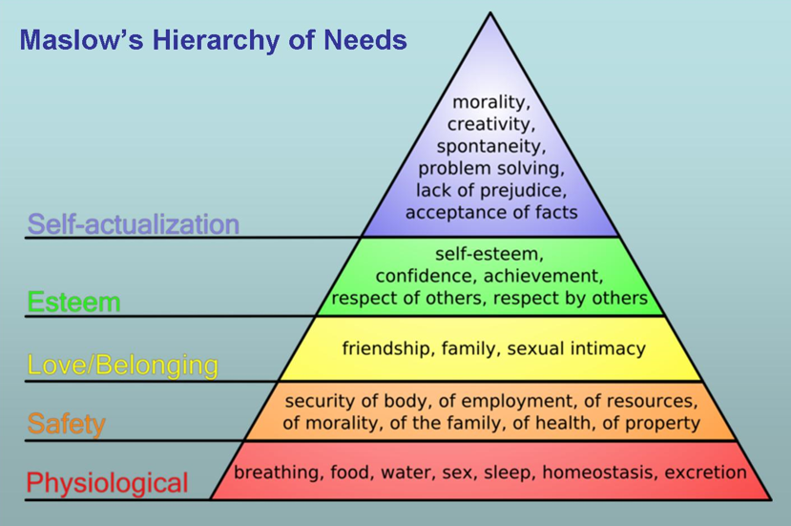
(Genius.com, 2019)

Herzberg’s (1959) two factors Theory

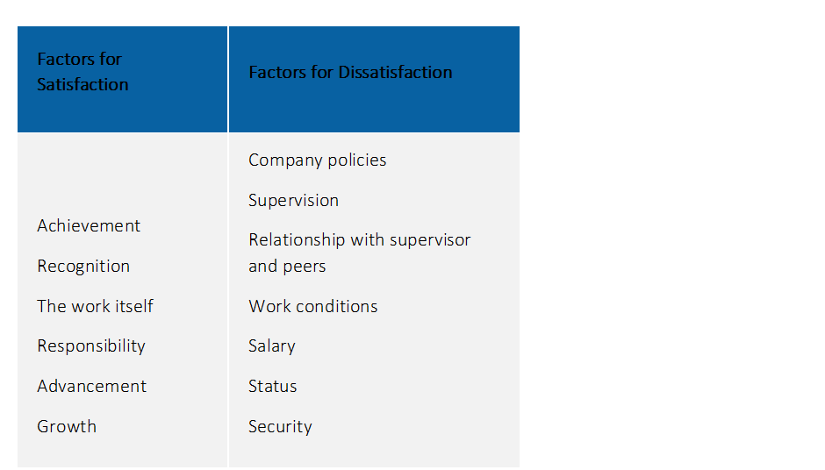
(Mindtools, 2019)

