



Vladimir Totev (2024467)
Programme: BA Leadership and Management Skills for the Workplace
Module: Understanding and Engaging in the Customer Experience (BMSW 5103)
Lecturer: Zainab Atta
Assignment Title: Organisation’s quality systems and customer relationship management – REPORT (Tasks 1&2)

Table of Contents

Task 1
How have internal and external factors affected or influenced your selected organisation’s quality systems and controls for customers to deliver a 24-hour customer service?
- Introduction & Company Context
- CRM Models Review, Selection & Application
Task 2
How can your selected organisation deal with the new customer demand and achieve its business objectives by developing and maintaining good customer relationships 24/7/365?
- Recommendations
- Conclusion

References

Task 1
Introduction and Company Context

Because this report / assignment necessitates a review of Task 1, the discussion will present the relevant organisation, its market position, and the internal and external business environment. Trade Planet’s quality control processes, as well as its interaction with consumers, will be investigated in this context.
Trade Planet Ltd. Is a company which I founded after the covid in 2021.
Our company is dedicated to produce organic yogurt for the Dorset Market. Our product brand is called Bournemouth Yogurt.
According to (Statista, n.d.) the UK total sales of yogurt produced in the United Kingdom (UK) between 2008 and 2021, including yoghurt, curdled milk, and other items, rose to almost 287 million British pounds in 2021.
Organic yoghurt is a significant consumer entrance point into the diary sector. Although the low organic premium is a clear benefit to the dairy industry, the advantages of organic yoghurt are less generally known than those of organic market. Education of consumers is still critically important.
Considering that sales of organic yoghurt currently make up less than 4% of all dairy sales, there is still tremendous room for growth. (Southwest Farmer, n.d.)
My idea is to support the local community with a product which is 100% organic and sustainable.
Our revenue for 2021 is £380 000, the company profit is £114 000.
Currently we are operating from our premisses in Bournemouth, with a staff of 11 people.
Our online shop is operating 24/7 365 days.
Externally, the United Kingdom entered an economic recession in 2020. Many staff have been furloughed or are out of work. This affected the capacity to consume/purchase all commodities. This would have influenced Trade Planet.
Simultaneously, the Covid -19 - produced demand for higher freshness of meals due to health concerns, as well as increasing needs for social distancing/mask wearing, etc.
The consequences are that Trade Planet has experienced a drop in revenue over the previous six months, making the consumer touchpoint of pricing more visible. Simultaneously, staff scheduling and social separation suggested an increase in labour expenditures and training costs as extra quality control systems needed to be promptly implemented.
Other factors to consider were suppliers and supply chain consequences, which the company now had to control.
Today I will discuss, introduce, and evaluate different CRM models, which will outline a plan for potential bottom-line benefits of excellent customer experience at Trade Planet.
Customer engagement is the process through which a business establishes a relationship with its customers to develop brand loyalty and recognition. Marketing efforts, fresh material developed for and posted to websites, and outreach via social media, mobile and wearable devices, among other techniques, can help achieve this. (SearchCustomerExperience, n.d.)
Many experts recommend that businesses start with "active listening," which entails checking for criticism left on websites, received through email, called, or mailed in, and posted to social media platforms. Answers to queries are anticipated, according to 2012 Gartner research, which found a 15% rise in customer turnover rates owing to failure to reply via social media.
Trade Planet competes with other yoghurt makers in the marketplace. Its capacity to deliver products and services for and anticipate the needs of its consumers through its people and systems will develop emotional relationships when customers interact with it in real time and through e-commerce outlets.
The inference is that Trade Planet clients have an emotional bond since the organisation addresses their quality and pricing demands as effective touchpoints. The organisation can develop and manage excellent customer relationships.
This relates to consumer and brand loyalty, functioning as a defence against rivals and retaining Trade Planet in a rapidly developing and increasing market.

Quality Control
Quality control (QC) is a procedure used by businesses to maintain or improve the calibre of their products. In order to ensure quality, the organisation must promote a culture of excellence among management and staff. This is done through training employees, creating standards for product quality, and checking items for statistically significant variations. An essential component of quality control is the development of clearly defined controls. The standardisation of manufacturing and reactions to quality issues is aided by these controls. Employee involvement in tasks for which they are not properly trained is reduced when there is less room for error, and it is clear who is to do which production activities. (Hayes, 2021)
Creating a product is expensive, time-consuming, and sometimes dangerous if safeguards are not in place. Furthermore, if a Trade Planet sells low quality products, it may be held accountable for any accidents or problems that result from consuming its products. Inspectors of quality control guarantee that faulty or dangerous products and packages are found and that the underlying reasons are addressed. Quality control employs a variety of techniques to communicate and track inspections and concerns. For instance, a quality control chart is a graphic that shows whether sampled products or procedures meet their intended standards, and if not, how much they depart from those norms.
Typically, quality checks are made at each step of a production or sales process. Employees typically start by assessing the raw materials, choose samples from the production line, and then examine the finalised product. Testing throughout different stages of production helps identify production problem locations and the necessary remedial steps to stop them from happening again.

Customer Relationship Management (CRM)

CRM refers to the process of controlling all client interactions, including prospecting, sales, and service. (Chai, 2020)

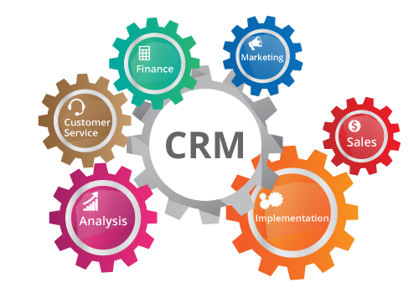

After the Covid 19 and the ongoing War in Ukraine, which is having a very severe impact on the present economic development and inflation, the goal is to improve relationships with consumers, aid in customer retention, and drive sales growth at Trade Planet Ltd.
Keeping that in mind, I need to introduce and apply proper CRM system to keep up with the current internal and external factors.
Through several channels of communication, CRM systems gather information about clients, including social media, direct mail, live chat, the corporate website, and the company's phone line. Additionally, CRM systems could give employees who deal with customers in-depth knowledge of their personal information, past purchases, shopping preferences, and problems. A CRM, which is an integrated information system, plans, schedules, and manages a Trade Planet's pre- and post-sales activities. CRM is a fundamental business strategy that combines internal operations and procedures with external networks to successfully create and offer useful services to a target market. It is based on high-quality customer-related data and backed by information technology. (Peelen and Beltman, 2013)
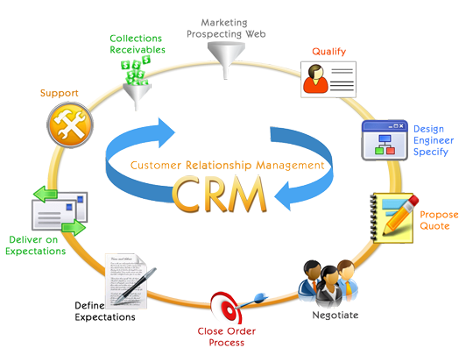
From start-up company to major corporation, Trade Planet may profit from the usage of CRM solutions:
- • If customer service representatives have immediate access to consumer data, such as past purchases and interaction history, they can provide better and faster client care.
- By gathering and having access to client data, Trade Planet may utilise reporting and analytics tools to identify trends and insights about its customers.
- Automating time-consuming yet necessary customer care and sales funnel tasks.

Customer Engagement (CE)
The idea of CE took off mostly during the digital era. As two-way contact between customers and brands expanded across internet platforms, CE increased in frequency and visibility. Of course, CE doesn't just happen online; it may also happen in person and through more conventional modes of communication. But when a client is engaged, their own agency and choice are included, not just what the company is presenting to them. Instead of being a passive consumer of an experience, the client is viewed as an active participant in CE. It looks at how clients behave and react, how they contact you, how they engage with your marketing and content, how they talk about you to others, and if they bring or subtract value. It is, to put it simply, a dialogue. (Qualtrics, n.d.)
Trade Planet competes with other organic yoghurt manufacturers in the market. As consumers connect with it in real time and through e-commerce channels, its ability to deliver items and services for and in advance of its customers' needs will forge meaningful ties.
The organisation effectively meets consumers' expectations for quality and affordability through several touchpoints, which has the result that Trade Planet clients develop an emotional bond. The business can manage and develop excellent customer relationships with its clients.
This relates to brand and consumer loyalty, serving as protection against rivals and elevating Trade Planet to a major yoghurt producer on the Dorset Market.
Next, I will discuss the importance of Quality Process for Trade Planet’s customers.
I will apply SERVQUAL model to evaluate and improve the quality processes in Trade Planet.
The Service Quality Model (SERVQUAL Model) was developed and put into action in 1988 by American marketing specialists Valarie Zeithaml, A. Parasuraman, and Leonard Berry. It is a method for determining and measuring the quality of the obtained customer service. (ToolsHero, 2018)
The early emphasis was on creating quality processes for product quality. Over time, the significance of raising the calibre of linked services has increased.. A competitive advantage for businesses may result from higher service standards.
The SERVQUAL Model focuses on qualitative analysis. The observed quality is measured using general, ambient characteristics if a satisfaction survey is primarily based on the transactions between the provider and the buyer. The SerVQUal Model will be applied to determine the gaps caused by external environmental changes and Covid 19.
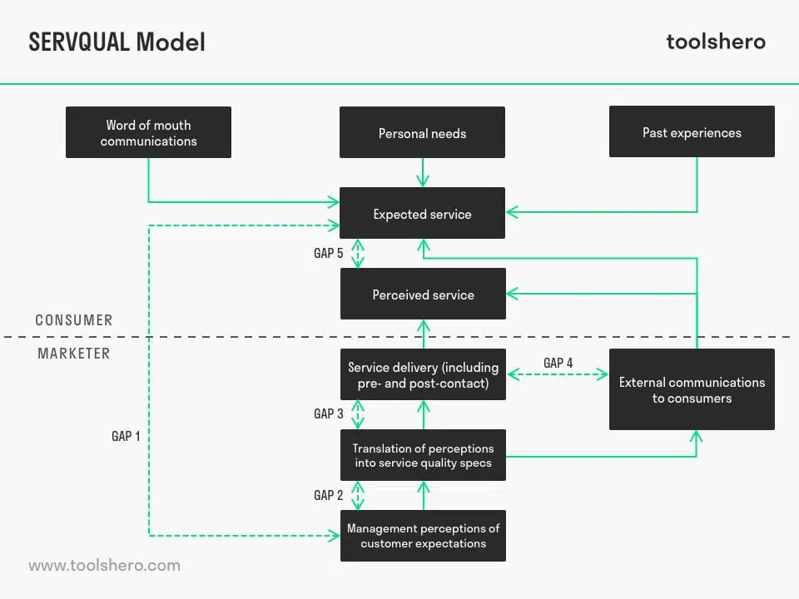
With the help of this framework, service flaws may be identified and fixed at Trade Planet. It is a "GAP Analysis" in that regard. It contrasts the actual experience with the desired level of service excellence. The experience customers have of our product or service is based on their perceptions. A study was conducted to analyse customer needs in relation to the quality of service they received. Customer perception is used to gauge this experience. It is an evaluation of client needs from the outside in terms of the level of service received. In providing customer service, the requirements of the client are always prioritised over the organization's goals or measuring methods. (ToolsHero, 2018)
Service quality depends heavily on communication, both between the client and the business providing the service and within the organisation. It is useful for Trade Planet to understand the expected patterns of the customers.
As a result, the SERVQUAL Model identifies five gaps between a company's service and the customer's needs:

- Knowledge gap - A lack of knowledge of customer expectations is preventing Trade Planet from approaching consumers the right way.

- Standards gap – Trade Planet already has a preconceived notion of what the client wants from their service. There is a high danger that the organisation would incorrectly convert this concept into a quality policy and associated regulations if it is flawed from the start and does not match what consumers truly demand.

- Delivery gap - When Trade Planet provides service that is different from what the customer had anticipated, a gap may also develop. Additionally, an improper implementation is included here. For instance, in how staff members implement policies.

- Communication gap - Customers may occasionally develop erroneous expectations as a result of external signals (marketing) supplied by a business. The firm makes claims and promises that are not compatible with what it can really provide.

- Satisfaction gap - A (significant) discrepancy between what a customer expects and what they actually get is what leads to dissatisfaction. The highest quality experience differential in Trade Planet will eventually be the outcome of this.
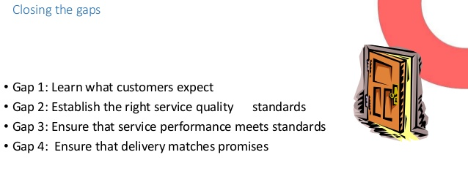

SERVQUAL Attributes
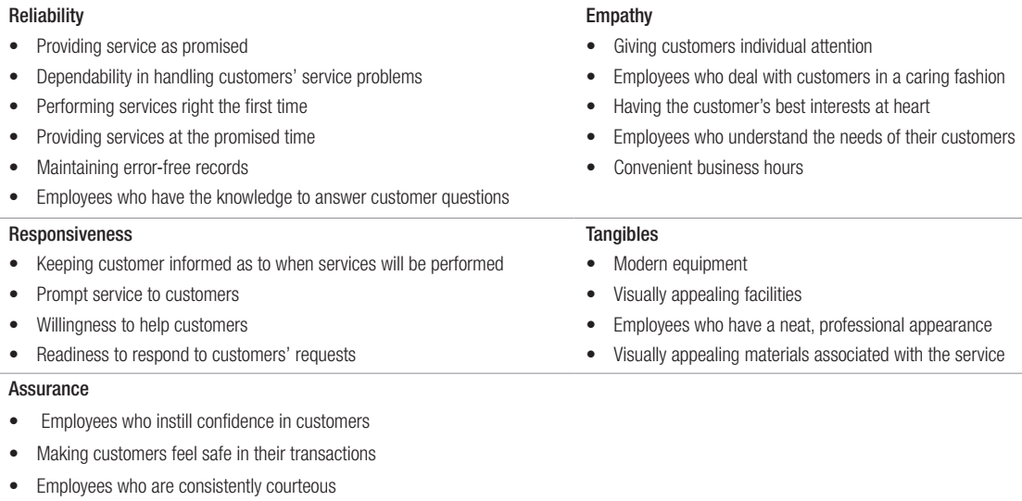

CRM Models Review, Selection & Application

To guarantee that customer service runs well, specific models are followed. These customer relationship models were developed over the previous few decades by a variety of academics. The IDIC Model, QCI Model, and Payne's Five Process Model are the most often used CRM models.
IDIC Model:
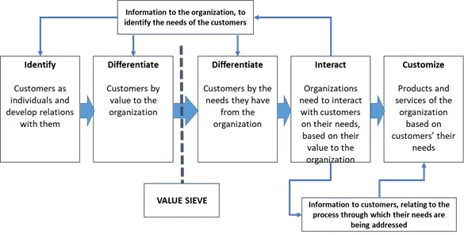

According to (Lucidchart, 2019), The Peppers and Rogers Group created the IDIC model as a key framework for deploying CRM in a range of scenarios. IDIC, the acronym for identify, distinguish, interact, and customise, stands for the four stages of CRM deployment.
Identify - Trade Planet must first identify its consumers, which it may do by collecting information about them at every point of contact across the business, including name, address, and purchase history. You may have a better understanding of each consumer's requirements, wants, and purchasing preferences by attempting to discover as much as you can about them.
Differentiate - The following stage is to group or segment our clients based on their expected and actual lifetime values. Not every consumer is worth the same amount to the company. By separating out our clients depending on their value to the business, I can focus Trade Planet's customer experience efforts on the most valuable customers and modify the company's interactions to best suit each section for optimal profitability.
Interact - I can now interact with our customers using Trade Planet's CRM plans. After researching and categorising our clients, I may design unique interactions for them, such as providing rewards or incentives for loyalty to boost customer loyalty and repeat business.
Customize - I'll be able to develop more personalised one-to-one service when I've documented Trade Planet's client interactions. The aim is to meet our clients' requirements and expectations, which I have identified personally.
Finding out what its consumers need, desire, and prefer is the first step in improving a company's customer relationship management. This supports the creation of novel products and client-centered strategies (Ahmadi et al, 2012). For instance, nestle conducted a market analysis to identify the clientele for their coffee by looking at the countries with the highest caffeine use. It was found that whereas Eastern countries preferred tea as their caffeinated beverage, Western nations had a more friendly perceptions toward coffee beverages. The firm's coffee brand, Nescafe, was later established in Western countries. The corporation also distributed candies with a coffee flavour in Eastern countries to gauge customer reaction to the flavour.

QCI model
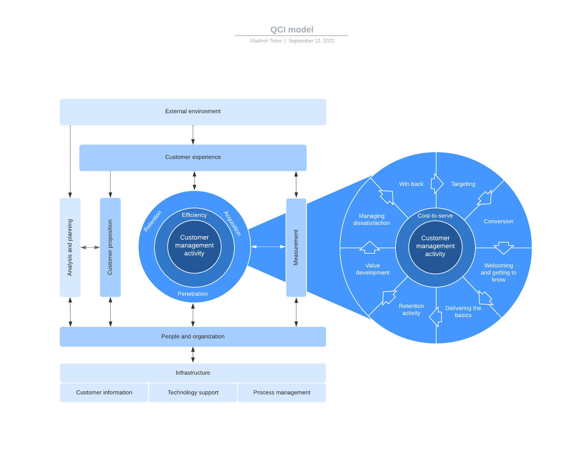

The three crucial activities of acquisition, retention, and penetration are given specific attention by the Quality Competitive Index approach, which is known as a customer management model as opposed to a customer relationship model. The external environment of the customer, which includes their pain points, business objectives, and other factors, is where the QCI model starts. These elements will determine whether or not they are prepared to make a purchase or interact with your sales team, which will have an impact on the customer experience. The customer proposition (what Trade Planet offers the customer) and customer management activities are then influenced by the customer experience. The enlarged inner circle reveals that attracting and keeping customers requires a variety of behaviours. The QCI model also considers the personnel and equipment required to keep this complete system operational. Although QCI has taken the position of "relationship" in CRM, people still come first and foremost in this paradigm. (Lucidchart, 2019).

Payne’s Five Process model
Adrian Payne and Pennie Frow created the Five Process CRM method. For efficient CRM operations, this model emphasises the need of a cross-functional approach. The concept is divided into two parts: CRM deployment basics and cross-functional CRM procedures (Lucidchart, 2019).
Payne's model covers the following five processes:
- Strategy development
- Value creation
- Multichannel integration
- Information management
- Performance assessment
According to (Lucidchart, 2019), good CRM implementation in Trade Planet requires four critical components: Employee Management, CRM readiness, CRM change management, CRM Project management, CRM change management
Trade Planet should do a CRM readiness assessment while establishing a CRM strategy to discover how prepared we are to deploy a new CRM procedure.
When new strategies are implemented and CRM efforts become more difficult because to the fundamental cultural and operational shift that CRM requires, Trade Planet should also use CRM change management and project management.
The efficiency of CRM depends on employee commitment. I must make sure every employee is aware of the goals, procedures, and new customer-centric culture. CRM techniques won't work without these essential components.

AI Efficiencies

According to (Writer et al., 2019), the basis of digital transformation is the customer experience. Every technological decision we make should be based on this fundamental element. With massive data creation comes the ability to apply the knowledge for ML and AI, which can improve normal user experiences. It is also important to emphasise that strong AI must begin with accurate data and sound data science techniques, or else the results will be unremarkable. Without a question, the largest influence of artificial intelligence will be to transform the consumer experience by making it automated, quick, and stress-free. Salespeople, contact centre operators, and other customer service personnel cannot be expected to absorb and know a client's complete history prior to each conversation. However, artificial intelligence is making it feasible right now.
Chatbots are Automation talking agents that are used in a variety of customer-interaction scenarios. They are designed to mimic human interactions and provide rapid, personalised replies 24 hours a day, seven days a week. This eliminates frustrating delays and mishaps in customer service, especially when dealing with consumer complaints.
Another keyway AI is altering the user experience is through the provision of tailored content. This is the time of year when we should hunt for goods that will make our lives easier. It's so natural these days to hunt for a suggestion based on Company’s prior background. (Writer et al., 2019)
Another way AI will overwhelm consumer experience is by providing predicted customization or a completely personalised customer experience based on the customer's behaviour and expressed desires. Previously, online buying was associated with extensive browsing hours; however, current AI alternatives enable firms to create custom-fitted online journeys for customers by using information on previous preferences, shopping patterns, browsing behaviour, and other information.
For example, AI allows Trade Planet's system to recognise a consumer who visited our site yesterday and returned today and personalise their experience based on their past search. It is basically a technique of almost directing the customer's next stage by presenting precisely what they require to view.
Obviously, the bulk of the examples of how AI is improving the consumer experience are best-case scenarios. The whole point of using AI to improve the customer experience is to make your users feel appreciated and known. Awful AI will always have the opposite effect. The emergence of AI is an unavoidable next phase of existence, and it is important for enterprises to profit on this new option. Customer experience can now reach previously unheard-of levels of sophistication, where users get what they want right away, without having to endure distasteful searches, dialogues, or make objections that appear to never be understood, while organisations can eventually leverage the seemingly limitless amount of customer data available. (Writer et al., 2019)

Task 2
Recommendations

To deal with the new customer demand and achieve company’s objectives I choose to use Porter’s 5 forces marketing theory.
The Five Forces technique is used to comprehensively analyse a corporation's industry structure and business strategy. With certain restrictions, Porter identified five undisputed factors that affect every market and organisation globally. The Five Forces model is frequently used to assess the competitiveness, attractiveness, and profitability of an industry or market. An industry's strengths and weaknesses may be ascertained using the Porter's Five Aspects model, which defines and examines the five competitive factors that characterise each sector. The Five Forces analysis, which is widely used to determine corporate strategy, may be used to determine the structure of an industry. (Scott, 2022)
Trade Planet may increase profits by using the Five Forces strategy, but I must continually check for changes in the Five Forces and adjust the business plan.
Porter's 5 forces are:
- Competition in the industry - The number of competitors and their ability to undercut a corporation are the first of the Five Forces. Trade Planet will be less effective the more competitors there are and the more similar goods and services they provide.
- The threat of new competitors entering the market: The threat of new competitors entering the market has an impact on a company's power. The less time and money a competitor needs to enter a company's market and become a credible competitor, the more severely a company's position may be lost. significantly reduced
- Power of suppliers - The strength of a corporation is also impacted by the force of new competitors entering the market. An established company's position may be significantly weakened the quicker and cheaper a competitor may enter and compete in its market. As a result, the provider will have more bargaining leverage and may boost input costs while also seeking additional trade benefits. If there are several providers or switching costs are low between competing suppliers, a corporation may be able to maintain low input costs and large profits.
- The capacity of customers to affect price or their degree of power is characterised as their power. It is influenced by the number of buyers or customers a company has, the importance of each client, and the expense of pursuing new consumers or markets for its product. With a smaller and stronger customer base, each consumer has greater bargaining power to secure cheaper rates and better deals. A company with many smaller, independent consumers will find it simpler to charge greater prices to enhance revenues.
- Threat of substitute products the fifth and last of the Five Forces is concerned with replacements. Substitute goods or services that can be substituted for a company's products or services constitute a danger.

Knowing Porter's Five Forces and how they apply to Trade Planet might aid the company in changing its business strategy to make better use of its resources, boosting revenues and profitability. To understand a company's competitive market and how it is situated within it, managers and analysts might use Porter's Five Forces Model. (Scott, 2022)
I utilise Porter's model for establishing long-term objectives because it forces Trade Planet to consider the whole industry in addition to its immediate business. Porter's still has a significant role to play in this, but it shouldn't be the only instrument used to create a business strategy.
Given the current post covid-19 and economic crisis – servqual gaps 3 (perception translation given the current circumstances and 4 delivery gaps), Trade Planet should employ the IDIC model.
Identify – Trade Planet should query its consumer information to determine how purchase content, frequency, and history have changed. This will allow it to determine which age groups and income levels, for example, are requesting more yogurt products and using internet purchasing. It will meet our goals of customer pleasure, value at a reasonable price, and retention, hence prolonging the customer lifetime and enhancing earnings.
Differentiate - Trade Planet should classify and focus the new emerging client streams/segments based on the new data from Identify.
Interacting - Our organisation must increase the efficacy of client contacts to guarantee that Trade Planet understands consumer expectations and their ties with other suppliers or brands. Each subsequent engagement with a client should be conducted considering all past interactions with that customer. A interaction with a consumer should continue where the last one ended. Effective customer interactions bring more insight into the demands of the consumer.
Customizing the offer and communicating with clients to guarantee their expectations are satisfied. Indeed, Trade Planet should modify some part of its behaviour toward a consumer based on the individual's needs.

Conclusion
At various points of the lead generation lifecycle, marketing efforts may be improved by automating repetitive tasks using CRM platforms with marketing automation tools. For instance, the system may automatically send email marketing content to sales prospects when they sign up with the aim of turning them into paying customers. (Chai, 2020)
Defining a road map plan in 7 steps for Trade Planet:
- Recognize Trade Planet's target audience's needs, goals, and preferences.
- Create economic frameworks to comprehend and prioritise the impact of decisions on marketing, sales, and service
- Keep track of client behaviour, identify trends, and adjust to meet changes.
- Create lead grooming and customer management strategies for specific audiences.
- Create a customer-focused information architecture.
- Distribute workflow-based tools to marketing, sales, and service stakeholders.
- To optimise touch points, create a customer experience map.

References

Peelen, E. and Beltman, R. (2013). Customer relationship management. Harlow: Pearson Education. Copyright.
Hayes, A. (2021). Quality Control. [online] Investopedia. Available at: https://www.investopedia.com/terms/q/quality-control.asp.
Writer, T., Entrepreneur, Marketing, M. over, Geek, F. and Thinker, C. (2019). The Role of Artificial Intelligence in Customer Experience. [online] Available at: https://www.analyticsinsight.net/the-role-of-artificial-intelligence-in-customer-experience/.
SearchCustomerExperience. (n.d.). What is customer engagement? - Definition from WhatIs.com. [online] Available at: https://www.techtarget.com/searchcustomerexperience/definition/customer-engagement#:~:text=Customer%20engagement%20is%20the%20means
Ahmadi, H., Osmani, M., Ibrahim, O., & Nilashi, M. (2012). Customer relationship management model for UTM Alumni Liaison Unit. CRM History, 2(5).
ToolsHero (2018). SERVQUAL Model, a Quality Management Tools | ToolsHero. [online]. Available at: https://www.toolshero.com/quality-management/servqual-model/.
Lucidchart. (2019). 4 CRM Models That Boost Customer Loyalty. [online] Available at: https://www.lucidchart.com/blog/crm-models#:~:text=The%20IDIC%20model%20was%20developed
Statista. (n.d.). Curdled milk manufacture value sales UK 2008-2021. [online] Available at: https://www.statista.com/statistics/481111/curdled-milk-cream-yoghurt-manufactuer-value-sales-united-kingdom-uk/
South West Farmer. (n.d.). Organic Milk Suppliers Cooperative’s (OMSCo) launch Annual Market Report. [online] Available at: https://www.southwestfarmer.co.uk/news/8377946.organic-milk-suppliers-cooperatives-omsco-launch-annual-market-report/
Chai, W. (2020). What is CRM (customer relationship management)? [online]. Available at: https://www.techtarget.com/searchcustomerexperience/definition/CRM-customer-relationship-management.
Qualtrics. (n.d.). Customer Engagement: Everything You Need to Know. [online] Available at: https://www.qualtrics.com/uk/experience-management/customer/customer-engagement/.
Scott, G. (2022). Porter’s 5 Forces. [online] Investopedia. Available at: https://www.investopedia.com/terms/p/porter.asp.
Manktelow, J. and Birkinshaw, J.M. (2018). Mind tools for managers: 100 ways to be a better boss. Hoboken, New Jersey: John Wiley & Sons, Inc.

