

Joshua Banfield
P143898
Juan Ferriz Papi

Case Study

Introduction
Planning and organising a construction site has many aspects that need to be considered. There is different equipment that needs to be put in place so that corresponding works can be developed, this will be the site managers job to decide the most finically viable way to order or to purchase the equipment needed.

Site Management
This will allow the site manager to order or have in place the correct equipment needed to carry out the work at hand, this could involve the ordering of a crane, ensuring that the crane is the correct height, not too big for the site and its boom capacity is correct.
Site conditions
-Type of soil/material to be handled
-Physical constraints (site area, layout, topography.) -Hauling distances
Nature of the work
-Payload/capacity of the equipment -Total quantity of work

Crane if brought

For this case study the plant machinery that we will be looking at is the crane, the study will try and preform the best option and the most finically viable to choose, with the choice of purchasing the crane or hiring it for the period required to complete the construction works.
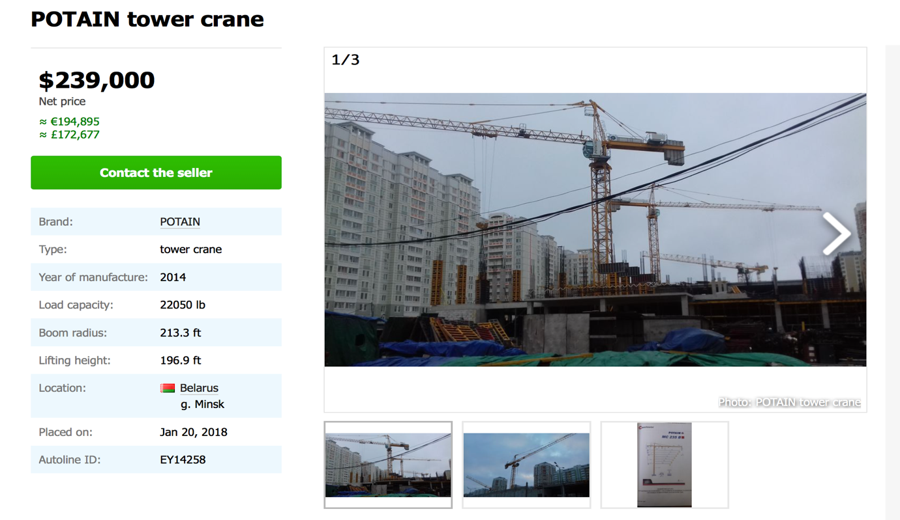
The choice of crane will be the POTAIN tower crane (seen below) At today’s exchange rate the Potain tower crane would be £212,652
(reference- autoline-eu)
To purchase the tower crane several facts should be taken into consideration. Enough money must be recovered to pay the ownership and operating cost of the tower crane, also to make a profit on the tower cranes investment.

We want to buy a new crane that is £212,652. We invest our money at 12% interest. How much is every annual payment if we want to pay the cost of the tower crane back in 15 years.

Total interest payment= £246,740.65
Total payment= £459,392.65

Years | Payment Due | Interest | Principal | Balance
 |  |  |  | £212,652.00
1 | 31,222.47 | 25,518.24 | 5,704.23 | 206,947.77
2 | 31,222.47 | 24,833.73 | 6,388.74 | 200,559.03
3 | 31,222.47 | 24,067.08 | 7,155.39 | 193,403.64
4 | 31,222.47 | 23,208.44 | 8,014.03 | 185,389.61
5 | 31,222.47 | 22,246.75 | 8,975.72 | 176,413.89
6 | 31,222.47 | 21,169.67 | 10,052.80 | 166,361.09
7 | 31,222.47 | 19,963.33 | 11,259.14 | 155,101.95
8 | 31,222.47 | 18,612.23 | 12,610.24 | 142,491.71
9 | 31,222.47 | 17,099.01 | 14,123.46 | 128,368.25
10 | 31,222.47 | 15,404.19 | 15,818.28 | 112,549.97
11 | 31,222.47 | 13,506.00 | 17,716.47 | 94,833.50
12 | 31,222.47 | 11,380.02 | 19,842.45 | 74,991.05
13 | 31,222.47 | 8,998.93 | 22,223.54 | 52,767.51
14 | 31,222.47 | 6,332.10 | 24,890.37 | 27,877.14
15 | 31,222.40 | 3,345.26 | 27,877.14 | £0.00

If the company doesn’t have this money and is excepted to borrow it at 12%. What happens if we consider monthly payments for the 15 years’ life of the tower crane.
Then we should change annual interest to monthly interest and consider the time in months.

Months | Payment Due | Interest | Principal | Balance
 |  |  |  | £212,652.00
1 | 4,730.33 | 2,126.52 | 2,603.81 | 210,048.19
2 | 4,730.33 | 2,100.48 | 2,629.85 | 207,418.34
3 | 4,730.33 | 2,074.18 | 2,656.15 | 204,762.19
4 | 4,730.33 | 2,047.62 | 2,682.71 | 202,079.48
5 | 4,730.33 | 2,020.79 | 2,709.54 | 199,369.94
6 | 4,730.33 | 1,993.70 | 2,736.63 | 196,633.31
7 | 4,730.33 | 1,966.33 | 2,764.00 | 193,869.31
8 | 4,730.33 | 1,938.69 | 2,791.64 | 191,077.67
9 | 4,730.33 | 1,910.78 | 2,819.55 | 188,258.12
10 | 4,730.33 | 1,882.58 | 2,847.75 | 185,410.37
11 | 4,730.33 | 1,854.10 | 2,876.23 | 182,534.14
12 | 4,730.33 | 1,825.34 | 2,904.99 | 179,629.15
13 | 4,730.33 | 1,796.29 | 2,934.04 | 176,695.11
14 | 4,730.33 | 1,766.95 | 2,963.38 | 173,731.73
15 | 4,730.33 | 1,737.32 | 2,993.01 | 170,738.72
16 | 4,730.33 | 1,707.39 | 3,022.94 | 167,715.78
17 | 4,730.33 | 1,677.16 | 3,053.17 | 164,662.61
18 | 4,730.33 | 1,646.63 | 3,083.70 | 161,578.91
19 | 4,730.33 | 1,615.79 | 3,114.54 | 158,464.37
20 | 4,730.33 | 1,584.64 | 3,145.69 | 155,318.68
21 | 4,730.33 | 1,553.19 | 3,177.14 | 152,141.54
22 | 4,730.33 | 1,521.42 | 3,208.91 | 148,932.63
23 | 4,730.33 | 1,489.33 | 3,241.00 | 145,691.63
24 | 4,730.33 | 1,456.92 | 3,273.41 | 142,418.22
25 | 4,730.33 | 1,424.18 | 3,306.15 | 139,112.07
26 | 4,730.33 | 1,391.12 | 3,339.21 | 135,772.86
27 | 4,730.33 | 1,357.73 | 3,372.60 | 132,400.26
28 | 4,730.33 | 1,324.00 | 3,406.33 | 128,993.93
29 | 4,730.33 | 1,289.94 | 3,440.39 | 125,553.54
30 | 4,730.33 | 1,255.54 | 3,474.79 | 122,078.75
31 | 4,730.33 | 1,220.79 | 3,509.54 | 118,569.21
32 | 4,730.33 | 1,185.69 | 3,544.64 | 115,024.57
33 | 4,730.33 | 1,150.25 | 3,580.08 | 111,444.49
34 | 4,730.33 | 1,114.44 | 3,615.89 | 107,828.60
35 | 4,730.33 | 1,078.29 | 3,652.04 | 104,176.56
36 | 4,730.33 | 1,041.77 | 3,688.56 | 100,488.00
37 | 4,730.33 | 1,004.88 | 3,725.45 | 96,762.55
38 | 4,730.33 | 967.63 | 3,762.70 | 92,999.85
39 | 4,730.33 | 930.00 | 3,800.33 | 89,199.52
40 | 4,730.33 | 892.00 | 3,838.33 | 85,361.19
41 | 4,730.33 | 853.61 | 3,876.72 | 81,484.47
42 | 4,730.33 | 814.84 | 3,915.49 | 77,568.98
43 | 4,730.33 | 775.69 | 3,954.64 | 73,614.34
44 | 4,730.33 | 736.14 | 3,994.19 | 69,620.15
45 | 4,730.33 | 696.20 | 4,034.13 | 65,586.02
46 | 4,730.33 | 655.86 | 4,074.47 | 61,511.55
47 | 4,730.33 | 615.12 | 4,115.21 | 57,396.34
48 | 4,730.33 | 573.96 | 4,156.37 | 53,239.97
49 | 4,730.33 | 532.40 | 4,197.93 | 49,042.04
50 | 4,730.33 | 490.42 | 4,239.91 | 44,802.13
51 | 4,730.33 | 448.02 | 4,282.31 | 40,519.82
52 | 4,730.33 | 405.20 | 4,325.13 | 36,194.69
53 | 4,730.33 | 361.95 | 4,368.38 | 31,826.31
54 | 4,730.33 | 318.26 | 4,412.07 | 27,414.24
55 | 4,730.33 | 274.14 | 4,456.19 | 22,958.05
56 | 4,730.33 | 229.58 | 4,500.75 | 18,457.30
57 | 4,730.33 | 184.57 | 4,545.76 | 13,911.54
58 | 4,730.33 | 139.12 | 4,591.21 | 9,320.33
59 | 4,730.33 | 93.20 | 4,637.13 | 4,683.20
60 | 4,730.03 | 46.83 | 4,683.20 | £0.00

Total interest payment= £ 52,960.33
Total payment= £ 265,612.33

Renting a crane
The typical fee for installation and disassembly runs around £40,000. This price includes shipping the crane to the site, renting the mobile crane used to assemble the tower crane, the cost of the crew that handles the assembly. A typical monthly fee for a tower crane is approximately £14,000, with an additional charge to rent the climbing frame and extra mast sections. (Citylifting,London)

With hiring a tower crane being typically £8,000 a month hiring for our 3 year build of the tower blocks would equate to;

Set up coats= £40,000
£14,000 x 36 monthly payments= £288,000
Total for our build = £544,000

With hiring, there would not be any ongoing running costs.

Deprecation of the tower crane at 10%.
Years | Deprecations amount | Asset worth
1 | 21265.20 | 191386.80
2 | 19138.68 | 172248.12
3 | 17224.81 | 155023.31
4 | 15502.33 | 139520.98
5 | 13952.10 | 125568.88
6 | 12556.89 | 113011.99
7 | 11301.20 | 101710.79
8 | 10171.08 | 91539.71
9 | 9153.97 | 82385.74
10 | 8238.57 | 74147.17
11 | 7414.72 | 66732.45
12 | 6673.25 | 60059.21
13 | 6005.92 | 54053.29
14 | 5405.33 | 48647.96
15 | 4864.80 | The tower cranes net worth after 15 years use= £43783.16

Total payment of £459,392.65 for the crane minus its resale value at the end of the 15 years working use, £459,392.65 - £43,783.16 = £415,615.49

Ownership costs

Data of tower crane:
- Purchase price = £212,652
- Salvage value = £43,783.16
- Insurance= £5,000
- Useful life = 15 years
- Working hours= 260 days/year, 8 hr./day
- Fuel consumption of generator powering the tower crane = 2.4L /hr. (Diesel_Fuel_Consumption.aspx)
- Lube oil cost = 10% of fuel
- Interest rate = 12%
(crane crew)

Depreciation
£212,652 - £43,783.16= £168,869
£168,869 ÷ 15 = £11,257.93

Annual investment cost
£60,426 - £41,740 - £11,296 – 12,340= £12,193/ year

Total ownership costs
£11,257.93 + £12,193 + 5,000= £28,450.93/year
260 days x 8hr days = 2080hr/ year

ownership cost= £28,450.93 ÷ 2080 = £13.66/ hour.

Maintenance and repair costs

Total= 1.1x 43,783.16 = £48,161.47/ year

£48,161.47 ÷ 2080 hours =£23.15 / hr

Fuel and lubricate oil costs

Fuel consumption = 10.9L / hr x 8hr / day = 87.2L/day
Fuel cost = £1.20 / Litre x 10.9 = £13.08/ hour
Lubrication= 13.08 x 0.1= £ 1.30 / hr

Total operation costs = £23.15 + £13.08 + £1.30 = £37.53 / hr
Total cost per hour = £13.66 + £37.53 = £51.19

Conclusion

There is two different outcome with the two options of hiring and purchasing a tower crane, if we was going to purchase a crane for its life of 15 year it would cost a total of £459,392.65 if brought with credit at 12%, Total payment of £459,392.65 for the crane minus its resale value at the end of the 15 years working use, £459,392.65 - £43,783.16 = £415,615.49. This would then include running costs of;

2080 / hr x 15 /years= 31,200hr
31,200hr x £51.19 = £1,597,128

A full 15-year life of a crane with full maintenance and running costs would be £2,012,743.49. If there is a use for the crane via moved to another construction site or hired

If the crane was hired the cost would be considerably hire for the period which it is needed but for the lifetime of 15-years, it would be dramatically more than investing in a tower crane. Even though maintenance cost is on the hire company you would still need to pay for the daily running of the tower crane
2080 / hr x 15 /years= 31,200hr
31,200hr x £37.52 = £1,170.624

If the tower crane was hired for the build which it was required and nothing else the cost would be £ 265,612.33 + £1,170,624 = £1,436,236,33

The cost for the period of the build hire would be cheaper, but if the crane was finically viable to move to another building site after use, or even hired, the overall cost would be claimed back and a profit. So, the purchasing of the tower crane would make more financial sense than hiring in this case.

References
Website- http://citylifting.co.uk/mobile-crane-hire/tower-crane-overview/
Website- https://autoline-eu.co.uk/-/tower-cranes/POTAIN---18012014450314392400
Website- http://www.dieselserviceandsupply.com/Diesel_Fuel_Consumption.aspx
Website- https://www.assetworks.com/useful-life-and-depreciation/
Website- https://www.cranecrews.com/crane-blog/how-much-do-tower-cranes-cost

