Here Be Aliens:
Researching Aliens for CHIMERA

Major: 3D Computer Animation
Student: Qianru Zhou

6th Dec .2021

Declaration

I certify that I wrote this report that all of the work included here in is original to me, except where the text clearly states otherwise, and that this work has not been submitted for any other degree or professional qualification.

Date: 12/06/2021

Abstract

The alien character image in the film “Avatar” is a typical new alien image that breaks through the conventional ugly and terrible alien image. This paper arranges, studies and analyzes the visual effect of alien character modeling in the film, the expression of character setting and cultural connotation, and the industrial production process in the visual effect of character modeling. The follow-up will be “Avatar” as the main reference object to design their own alien characters, the preliminary plan of character design is written at the end of the article.

Keywords: Character Design, Avatar, Aliens
Contents
- Introduction..................................................................................................1
- Research......................................................................................................2
  - Modeling design style and characteristics.............................................3
  - The prominent role of modeling on the character setting expression....................................................................................................4
- Methodology.................................................................................................7
3.1 Visual effect of character modeling and expression of character setting and cultural connotation...............................................................................7
  - Industrial production process in character modeling visual effect...........................................................................................................11
- Defining a proposal plan.............................................................................16
- Evaluation and Conclusion.........................................................................17
References......................................................................................................18
Bibliography.....................................................................................................19
Appendices.....................................................................................................20

- Introduction

In recent years, the means of three-dimensional special effects in film production has become more and more mature. It combines reality and illusion, brings people a surreal experience, and creates one magic and science fiction world after another for the audience, so that everyone can see the characters and scenes that seem to come from a different world.

Aliens, as a mysterious existence that human beings on earth have explored for thousands of years but still have no exact answer, have always been talked about by people. In today's film industry, science fiction film has always been a film type with extremely box office appeal. Computer three-dimensional special effects are the best way to make alien images. Contemporary computer technology has been very mature. Creators can give full play to their strong imagination and turn the alien images that cannot be displayed by conventional shooting in real life into real presentation in the film through three-dimensional special effects. Therefore, in recent years, the unique alien characters and the illusory alien world emerge one after another, which is fascinating and gives people's fantasy sustenance.

In most people's fantasies, aliens always appear in images such as ugliness, terror and danger. This type of well-known alien characters have also been created in many films, such as alien, skyscraper and World War Goliath. But aliens should not have only this image. They may also be friendly, beautiful or cool. For example, when people give them good characteristics and beautify the image of aliens, they can create films with different artistry, profound significance and resonance. In particular, the alien characters in the film “Avatar”, through their extremely beautiful and unique modeling characteristics, shape their stories very magical and fascinating, coupled with beautiful scenes like dreams, add a lot of style to the film, and let the audience love these characters and stories from the bottom of their hearts.

This paper will be committed to the research on the character modeling design method in the film “Avatar”. The qualitative research method is used to complete the research by consulting relevant literature, browsing film shots and watching analytical videos. “Avatar” has created another wonderful situation in the film world and brought the audience a visual feast that has never been seen before. The key factor for the success of the film is its unique and incomparable character modeling. It is expected that through research, we can find out how “Avatar” characters capture the audience's attention and favor through modeling design, improve artistry and resonate with the audience from the bottom of their hearts, The research includes color composition, body shape and the structure of facial features, hair style, clothing matching and lighting arrangement.

In addition, a new alien character design and story of the same type will also become the direction of follow-up character design tasks. I will design a unique, beautiful and attractive alien character, and design this character and his background story by using the professional knowledge learned in the research process.

- Research
“Avatar” uses unique character design techniques and advanced and powerful three-dimensional film effects to create this unique alien race and the whole excellent film with beautiful and profound significance. This paper will analyze its character design from three aspects: modeling style and characteristics, the prominent role of modeling on its personality and state, and the life implication that resonates with the audience in the environment of the whole film.
  - Character modeling design style and characteristics

"Fantasy character design often starts with the real state of the character, seizes its inherent functional characteristics, subverts the representation and law of the real state, makes people's seemingly familiar real state in nature and human life present an unfamiliar and extraordinary state in cinema animation, completely subverts the conventional feelings of the audience, and makes it have a strong influence on the new fantasy characters Interest" (Fang, 2016, P34).

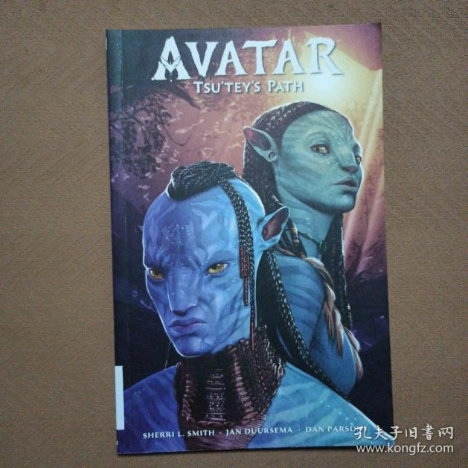
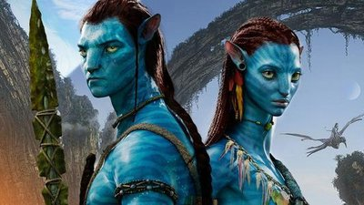
In the film, the Na’vis, who live on Pandora, have similar shapes to human beings, but they are not exactly the same, and have their own unique characteristics. Na’vis have the same head, facial features and limbs as humans, but they are 3 meters tall, far more than humans. Their skin is blue with patterns, their eyes are very large, and their ears are higher and pointed than humans. Behind them, they also have a tail much like a leopard. In addition, they have no hair all over their body. The long things like hair on their heads are their exposed nervous system, which can communicate with the branches of the soul tree and the tentacles of the Banshee winged beast.

The costumes of the Na’vis are very simple and primitive. Similar to the primitive people in human history, they expose most of their body skin, only cover their private parts with leaves, vines and other primitive objects, and then appropriately add some decorations, such as the cover on Tsu'Tey's neck, Neytiri's armband and feathers tied to her hair.

These features are both familiar and unfamiliar to the audience. They look very similar to human images, but there are obvious differences. This surreal fantasy feeling can firmly grasp the audience's heart, so as to make a visual impact on the audience to generate strong interest.

  - The prominent role of modeling on the character setting expression

The most important part of character modeling elements is to express the characteristics of characters. The settings of personality and identity of each character can be expressed through different character modeling. "She is nearly 10 feet tall, with blue skin and zebra like purple stripes. She has a pair of wild ears and a nose. Her physique is long, thin and angular" (Fitzpatrick, 2019, P45). This is the description of Neytiri's modeling design in book The Art of Avatar--- the original set of “Avatar”, it is also the unified image of other Na’vi characters in subsequent design.
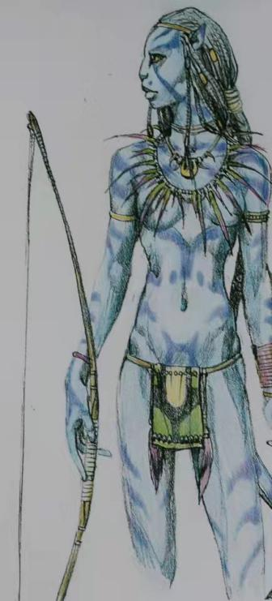
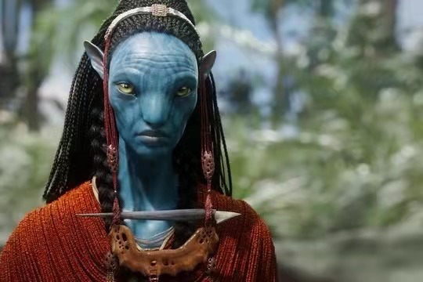
Na’vis are strange to humans, but at the same time, they are not as disgusting and terrible as the alien characters in other films. On the contrary, they have beautiful blue skin, dark patterns, glittering spots on their bodies and faces, tall and thin bodies, and their simple, simple and distinctive clothes. These characteristics match the environment of Pandora, It is a fantastic visual enjoyment for the audience. At the same time, combined with the plot content, the audience can feel that Na’vis are kind-hearted, personalized, loyal, do not blindly exclude foreigners, hate mankind, and pledge to defend their homeland to the death, not afraid of strong enemies and death, which is in sharp contrast to the greedy and vicious human characters in the film, So that when humans attack Na'vis, they can trigger the anger of Pandora, which is why they can finally use their intelligence, agility and unity to defeat humans and protect their homes.

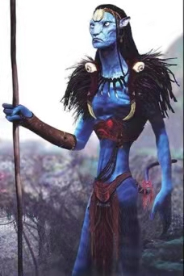
In addition, the costumes of Na’vis can express their different identities. Most Na’vis’ costumes are very similar. Only two people are completely different, that is, nitley's parents. They are the chief couple of Na’vi, the leader of Na’vi, and their status is supreme. The film highlights their special status by using their relatively gorgeous costumes, such as headdresses, necklaces and capes made of animal skeletons, feathers, stones and branches.

  - The cultural connotation that character modeling express

The alien characters in the film “Avatar” are not only beautiful, simple and high-quality characters, but also the Na’vi characters have successfully expressed some profound cultural connotation in the whole film environment. "Like ‘Alien’ and ‘The Terminator’, this film obviously has a broader cultural connotation, including the parable of ecological destruction, the parable of genocide and the drama of post colonialism" (Clarke, 2014, P132).
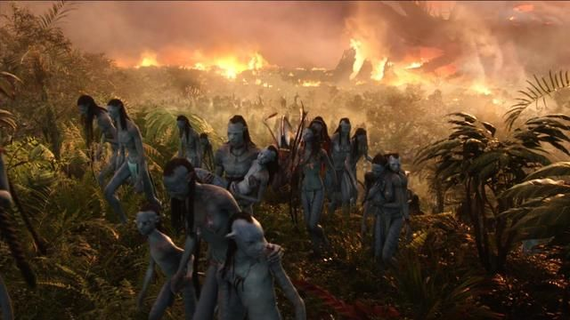
The image of Na'vi is in line with the barbarian nation imagined by people. They have a long tail, indicating that the evolution of their race is very backward. They use the ends of their hair to communicate with animals and plants, symbolizing the combination of man and nature. The unique language of Na'vi in the film represents some human languages that are disappearing or have disappeared. The primitive but kind, brave, pure Na'vi image and developed science and technology are greedy and vicious. In order to seize the resources of Pandora, they do not hesitate to use high-level weapons to brutally kill many Na'vis and seriously damage the natural environment of the planet. Many people can think of the painful history of the American occupation of Indians, The Indians accepted the colonists with goodwill, but they indiscriminately killed the Indians and devoured their land.

Na’vis only believe in their holy tree and don't care about material civilization. They believe that all beings are equal. The heroine kills wolves in order to save the hero. She will also kneel down and pray for these bloodthirsty wolves just for her own survival.
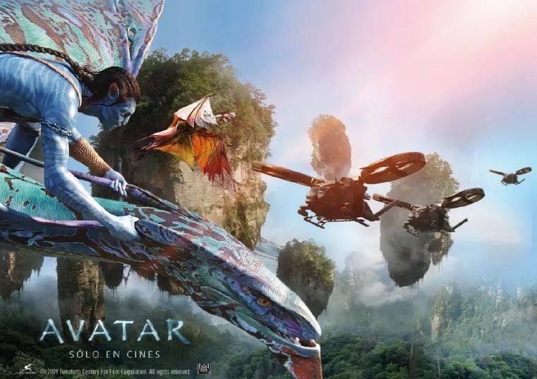
Finally, in the face of human aggression, all the last animals on Pandora angrily launched a counterattack under the guidance of Goddess Ava. The moral expressed through the character image of Na'vi in this film is that human beings are overbearing and greedy, ignoring the tolerance of living creatures, and will eventually be damned by heaven, from which the audience can get soul resonance, The theme of the film has been sublimated.

- Methodology

This paper uses qualitative research methods for the film “Avatar”, collects and arranges information by consulting literature such as journals, newspapers, books and papers, and makes an in-depth analysis and review of the research direction, that is, the character design concept and policy in Avatar, And discuss some more other high-quality literature for in-depth research, also including the comparative study of other films of the same type.

  - Visual effect of character modeling and expression of character setting and cultural connotation

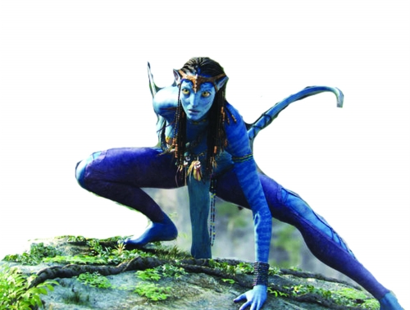
In the movie “Avatar”, the costumes, props, weapons and behavior patterns of Na'vi characters are very primitive and simple. They only cover their private parts with objects in the forest such as leaves, animal feathers and wood, expose most of their bodies, and then add some decorations, such as the colored feathers tied to Neytiri's hair, and there are armbands on the arms and sleeves on the necks of many male Na'vi. They sleep in a vine net at night. When it is cold, they will make a fire with wood. Their weapons are spears and wooden bows and arrows. They will roar like animals, jump high and climb trees.

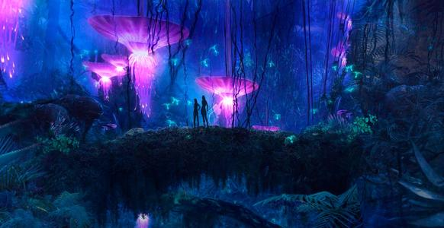
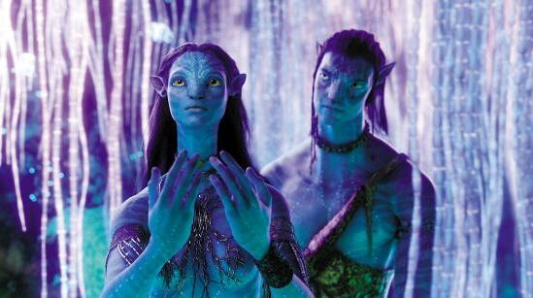
But they have a unique, cool and beautiful appearance that is generally similar to human characteristics, but not exactly the same. They have blue patterned skin, tall body, very thin waist, long tail, big eyes and nose. Their hair can be used to communicate with plants and animals. Secondly, their environment, that is, the environment of Pandora, also has a style that matches them. Pandora planet has jungles, mountains, waterfalls, cliffs, and even fantastic floating mountains. In the forest, there are beautiful sacred trees symbolizing pure and sacred beliefs, as well as a series of plants that emit shocking beautiful lights of different colors at night, setting off the whole planet like a fairyland. And their mounts are also fictional. They look like horses and birds, but they have unique and strange characteristics. On the whole, Na’vi's modeling is primitive, simple but beautiful, cool and unique, which brings wonderful visual experience to the audience.

Such a strange but beautiful shape can express the good character of Na'vi people, such as kindness, intelligence, agility, unity, not blindly hating mankind, bravely fighting invaders and not afraid of death, unique personality, loyalty and simplicity. This character is in sharp contrast to the domineering, greedy and vicious human images in the film. The mysterious natural forces of Pandora in the later stage were triggered by the war, which also highlights their extremely brave and selfless quality. It is also relying on this quality that they can finally defeat human beings with the help of animals.

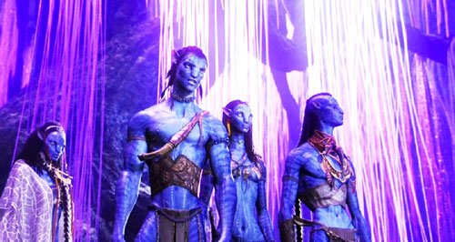
The costumes of Na’vis can be used to express their character identity. Although most Na’vis people wear similar clothes, the costumes of the chief and his wife, that is, Neytiri's parents, are very different. Compared with other Na’vis, their costumes are relatively complex and gorgeous, using a lot of animal skeletons, feathers, fur Clothes made of stones and branches that can highlight their leadership status.

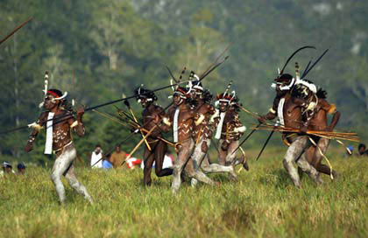
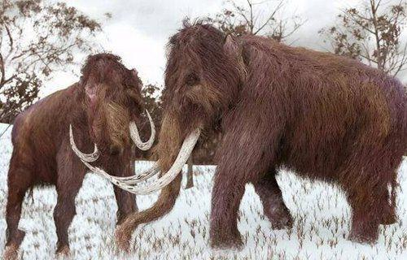
"The Na'vi represent the forces of good in the movie. These blue, graceful, ten-feet- tall, monumental humanoids are an idealized version of certain Native American tribes, such as the Sioux plainsmen or indigenous populations linked to the Amazon rainforest, who live close to the land and demonstrate reverential respect for the natural world in general and all living things in particular" (Mosaic, 2014, P103). "In principle, there is no more mysterious and incalculable power at work. People can master everything through calculation. This means disenchantment of the world. People no longer have to resort to magic in order to control or pray for Gods, like barbarians who believe in the existence of this mysterious power. Technology and calculation play such an effect, and this more clearly means intellectualization than anything else" (Weber, 1998, P29). Human beings who do not care about human ethics and natural laws have made a cruel attack on Pandora, and the environment of Pandora was seriously damaged. This image can remind the audience of the painful history of the occupation of colonies like Indians and the indiscriminate killing of residents by colonists. At the same time, it also reflects the wrong behavior of people in modern society to destroy the natural ecological environment, hurt animals and even lead to the extinction of some animal groups for the purpose of resource development and production.

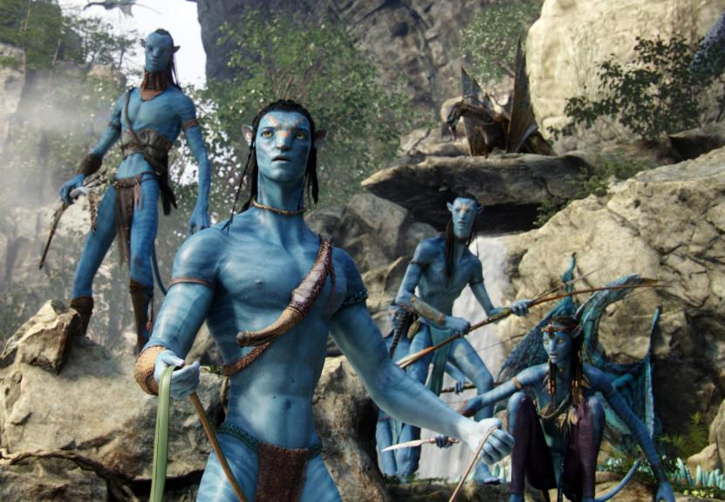
Na’vis are kind, simple and brave. When there is little hope, they still bravely protect their homes and fight against mankind regardless of their lives. At the end, the animals on Pandora launched a counterattack against mankind under the guidance of the goddess Ava, and finally defeated mankind. First, the plot expresses the implication that these selfish, greedy and overbearing behaviors will eventually be punished by heaven, whether it is the harm of powerful people to colonies in history, or the damage of human beings to the natural environment and animals today. On the other hand, it expresses the idea that as long as you keep a kind, pure and brave heart, don't abandon or give up, even if the process is very difficult, as long as you don't change your original heart and stick to it all the time, you will succeed.

  - Industrial production process in character modeling visual effect

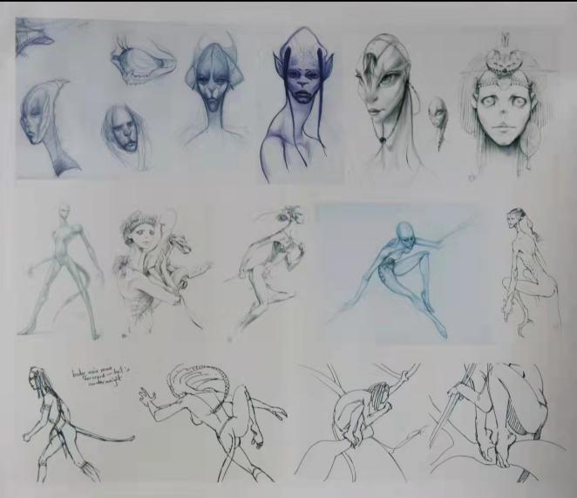
In the movie “Avatar”, Avatars and Na’vis are made using three-dimensional computer special effects. Their images have been designed and modified many times. At first, they are plane paintings, and then their three-dimensional images are carved to highlight the character's personality and attitude. Then, they enrich the character design with computers and make three-dimensional concept photos of the characters.

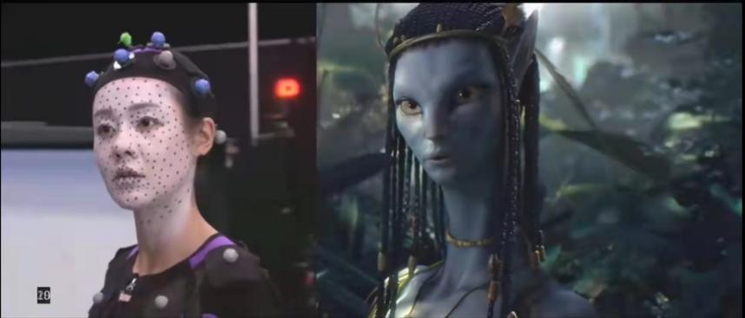
This film uses the method of motion capture to make animation. They put actors in full-body motion capture clothes with many sensors, draw capture points on their faces, place many cameras in all directions to record and capture actors' actions and expressions, and then import them into the computer to complete the animation. Of course, we only made a test animation at the beginning. After we are satisfied with this animation, the team will officially start the design and production of the character computer model.

They first actually painted a staff member's whole body with the color of Na'vi skin in reality, and then designed various accessories and clothes to wear and modify for him, not only the style and color, but also tested the weight of clothes according to actual tests, such as blowing with a blower, and finally determined.
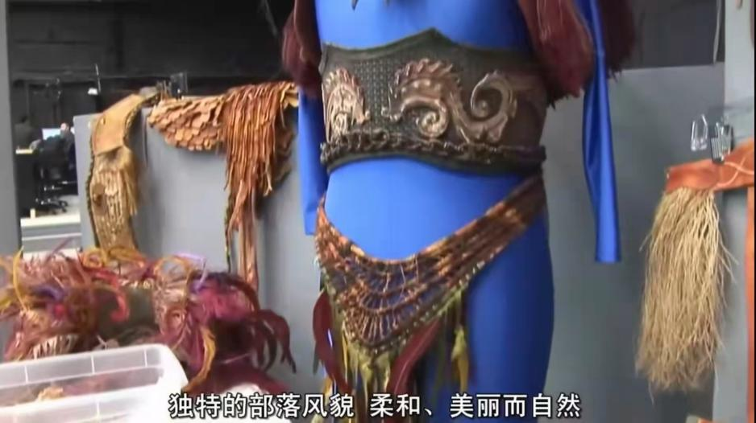
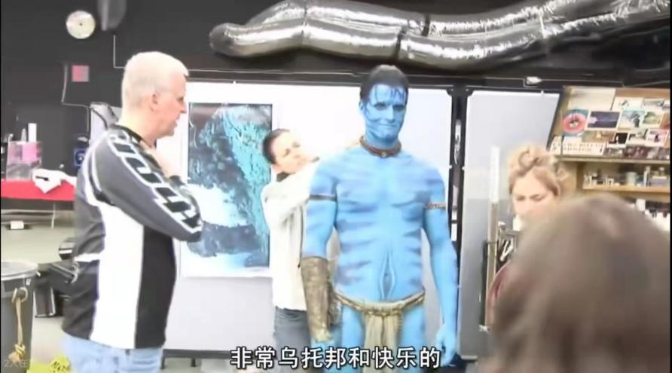
Actors are not randomly selected. The production team will look for actors who meet the character modeling characteristics for audition. After selecting actors who meet the character, they take photos for them, enrich the three-dimensional photo design according to their facial features, then making real-life plaster models and scan them into the computer, and make the three-dimensional computer models of the characters according to actors’ facial features and body.
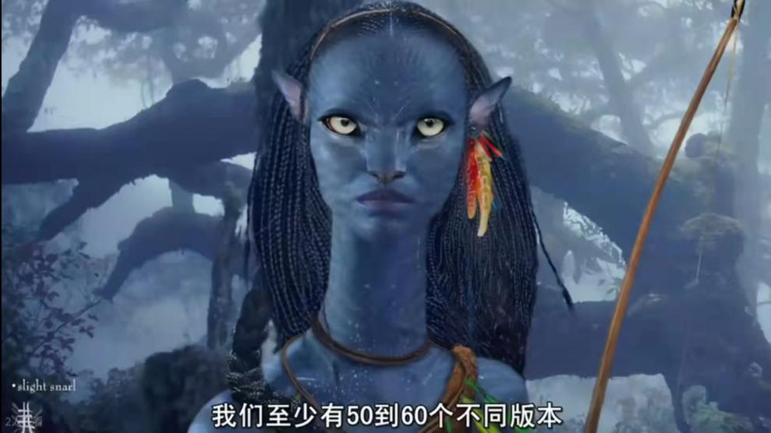
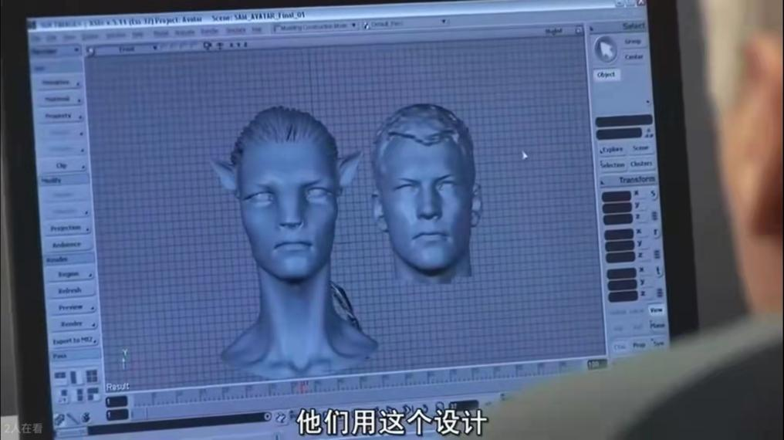
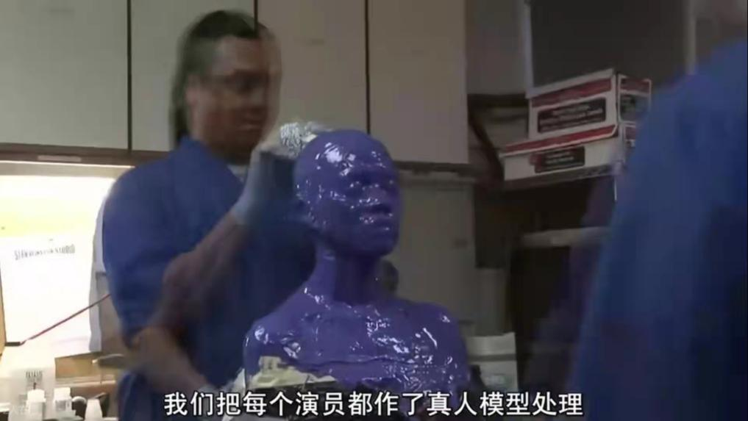
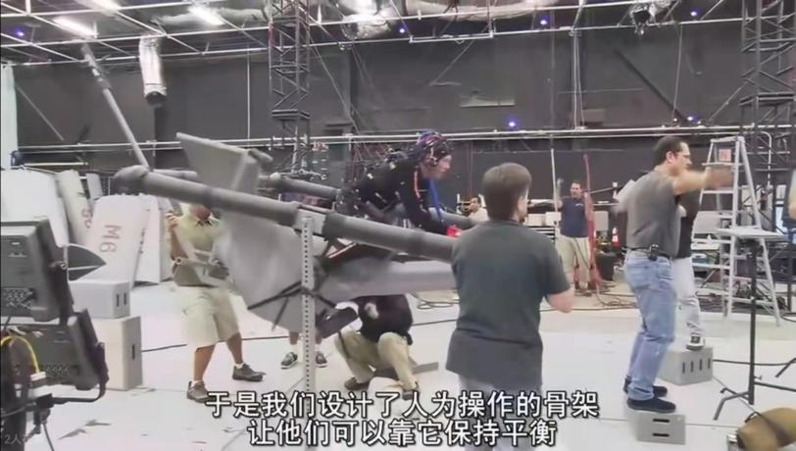
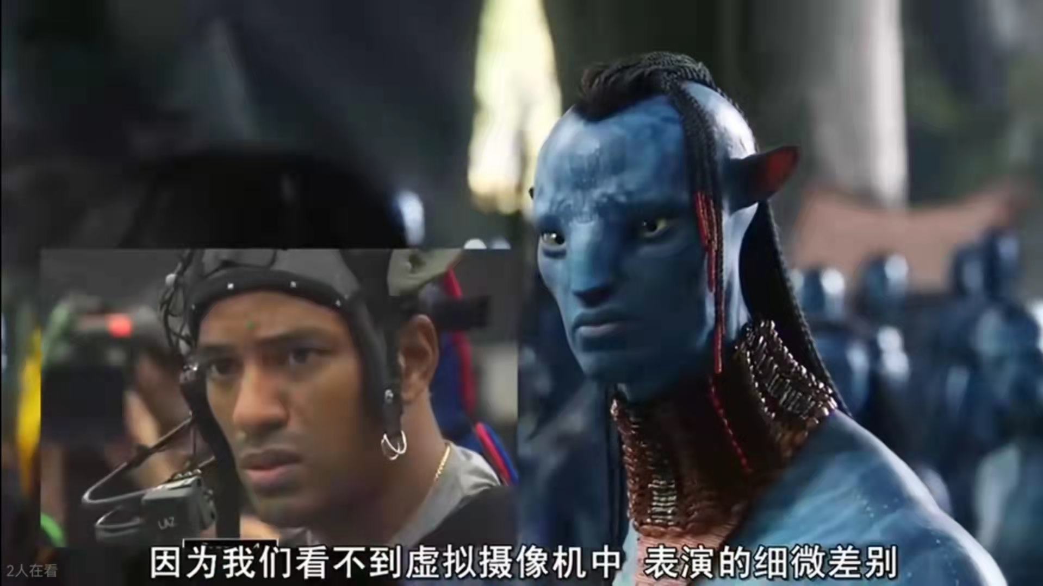
In the formal shooting stage, in addition to putting on motion capture clothes for the actors, for the actors who need to shoot expressions, the production team installed cameras on their heads to correctly capture facial expressions. In order to shoot the aerial lens of the big scene, they made a miniature iron wire model and made a mark that can be recognized by the system. Then a person moved in the air with the model. The actors sat on the bird mount model operated by man-made swing and performed flight performances according to the instructions. Devices such as forced climbing, jumping, grasping and swinging were built on the shooting site. At the same time, the actors were scanned all over their bodies and heads, and the production team obtained many kinds of motion coding systems, which were then combined with motion
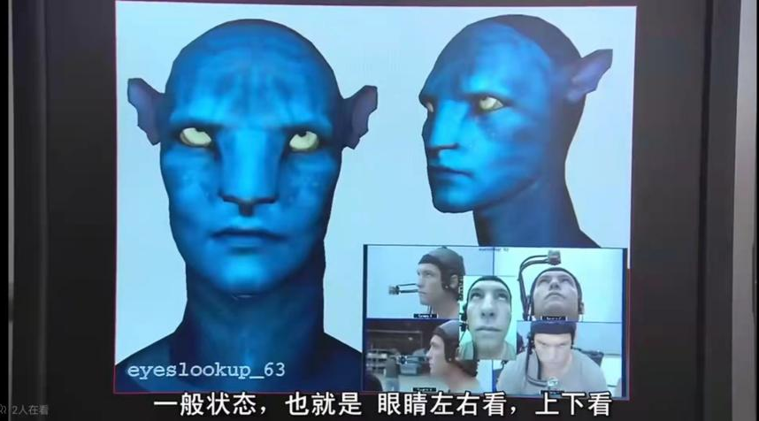
capture to create the most natural and realistic pictures. “The animator’s job is to analyze performance, analyze every details of them and make sure it’s coming across” (Lightstorm Entertainment, 2009). After completing the motion capture animation, the animators will make appropriate analysis and modification to make the animation look better and more in line with the character and plot.

85% of the animation in the film comes from actors, while the remaining 15% of the performances such as ears and tails need to be completed by animators. The production team studied the behavior of cats, dogs and other animals and integrated them into the movement of ears and tails.
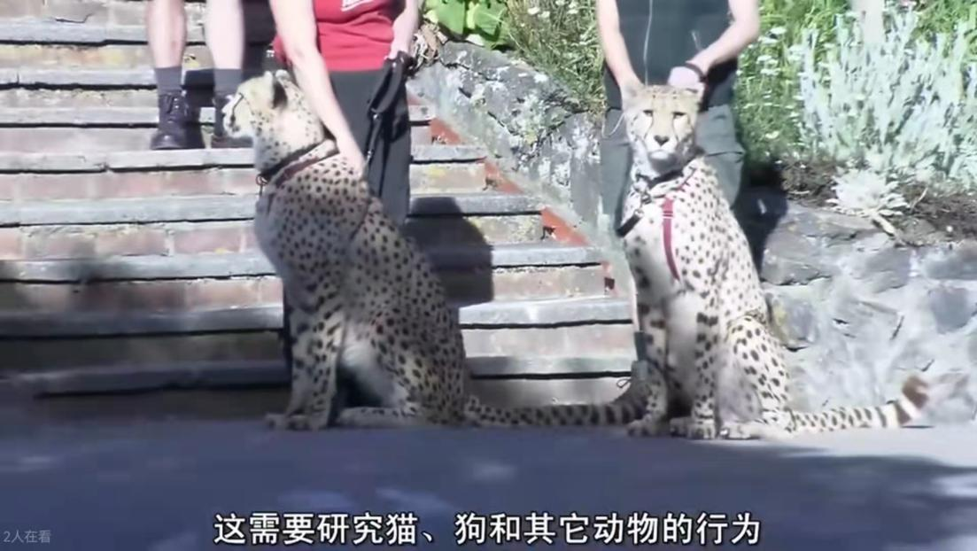
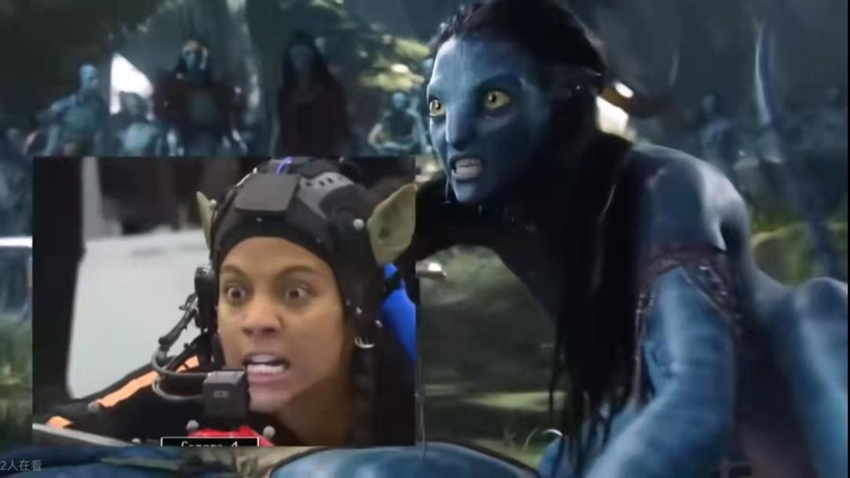
These detailed industrial production steps are integrated together, making the characters not only very real and characteristic in appearance and figure, but also extremely natural and smooth in character action and expression animation, making the overall picture of the film beautiful, real and artistic.

- Defining a proposal plan

The theme of this assignment is "Chimera", which requires the design of alien images that can hide in the human world. Through the study of the film “Avatar”, it is found that such alien characters have high artistic value and good reference value. Therefore, this visual element will take “Avatar” as the reference object for in-depth design.

The original living planet of aliens designed this time is a forest of birds and flowers. Forest elements will be used in the presentation of visual elements, and different types of clothing elements will be designed for men and women, such as women's flowers, butterflies and branches, as well as men's stones, leaves and wood. For the modeling of the body, It will retain the general characteristics of human beings and add an appropriate amount of strange elements, such as different skin colors and details of body characteristics. Because it is stipulated that they are hiding in the human world, they also need to design their human image. They have the ability to change adults. In order to collect energy from human beings and protect the homes that lack energy year by year from withering, they turn into people with different identities and hide in human society to collect energy. Their human image design will be similar to the original image, conform to human modeling, and retain and transform some planet elements, such as clothes printed with flowers or forests, butterflies and stone necklaces, etc.

What they need to be vigilant about is that they will change back to their original appearance at night and need to hide in an empty place for the night. However, there is an occasional danger of being discovered by humans. At this time, they will use some energy to erase the memory of humans. This scene will also be presented by designing a concept map, which will cooperate with the character design display drawings to comprehensively express the characters.

- Evaluation and Conclusion

The strange and beautiful alien characters in “Avatar” give people a new impression, which includes the meticulous, thoughtful and creative professional ability of the production team, so that the audience can not only feel the visual effect of extreme enjoyment, but also have an immersive resonance feeling. It is a very excellent film with artistic value. The follow-up design refers to “Avatar” and the alien images of the same type in other movies, and applies the studied information to the design, hope the presentation of visual elements will be more natural, appropriate and in-depth, so that the character design drawing has highlights, gives audiences a good impression, and likes the presentation of these characters from the heart.

References
- Fang, W. (2016). Research on the Design Thinking of Fantasy Characters in Contemporary Cinema Animation. Lanzhou: Lanzhou University.
- Fitzpatrick, L. (2019). The Art of Avatar. America: Harry N. Abrams. (Original work published 2010)
- Clarke, J. (2014). The Cinema of James Cameron: Bodies in Heroic Motion. [online]. Available from:
https://www-jstor-org.ezproxy.uwtsd.ac.uk/stable/10.7312/clar16976.12?refreqid=excelsior%3Afd3d06ef95f02da2fcff0bab2f92c96a&seq=1#metadata_info_tab_contents. [Accessed on 4 December 2021]
- Mosaic, C. (2014). Echoing Romance: James Cameron's Avatar as Ecoromance. [online] 47(2), P103-109. Available from:
https://www.proquest.com/docview/1536859859?accountid=130472&pq-origsite=primo. [Accessed on 2 December 2021]
- Weber, M. (2010). Academia and Politics. (Yongxiang Qian. et al. Trans) Guangxi: Guangxi Normal University Press
- Lightstorm Entertainment. (2010). Behind the Scenes Making of “Avatar”. [online]. Available from: https://b23.tv/w4ekc02. [Accessed on 4 December 2021]

Bibliography
- Williams, R. (2011). The Animator’s survival Kit. (Xiaoe Deng Trans). Beijing: Chinese Youth Press. (Original work published 2002).
- Xing, H. (2018). Human Body Structure Design of Animation Characters. Beijing: Electronic Industry Press.
- Xu, L. & Zhang, K. (2019). Cold Knowledge of Film, Taiwan: Taiwan Press.
- Sheldan, S. (2013). Digital Short Film Creation. (Xiujing Ren.et al. Trans). Beijing: People's Posts and Telecommunications Press. (Original work published 2009).
- Gao, H. & Wu, Y. (2011). Animation Writing Course. Beijing: China Light Industry Press.
- Chen, J. & Wang, Q. (2017). On the Ecological Aesthetics of “Avatar”. Journal of Nanjing Forestry University. 02(10). P75-82.
- Qiong, W. (2013). Analysis of 3D Special Effects Technology in the Film “Avatar”. Movie Literature. 13(13). P113-114.
- Lin, Q. & Liu, Y. (2010). Analysis of Computer Digital Character Modeling in the Post “Avatar” Era. Journal of Beijing Film Academy. 10(03). P10-17.

Appendices
- Scenes and animal pictures in the movie “Avatar”

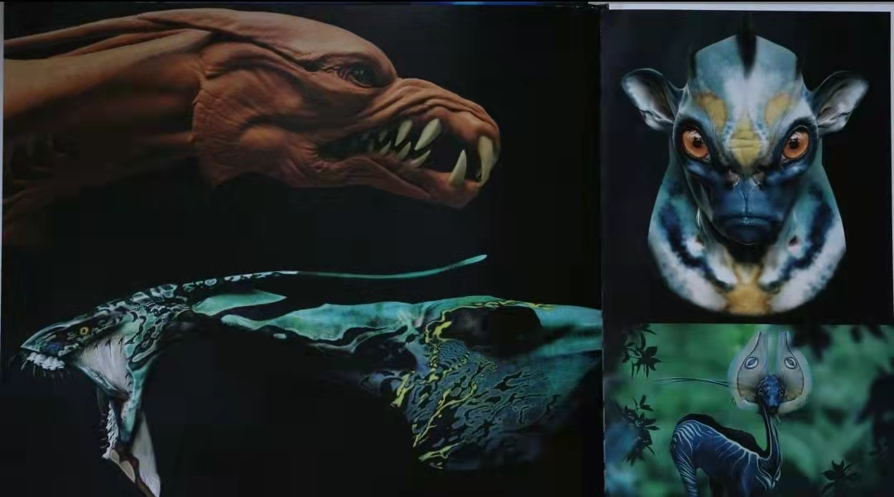
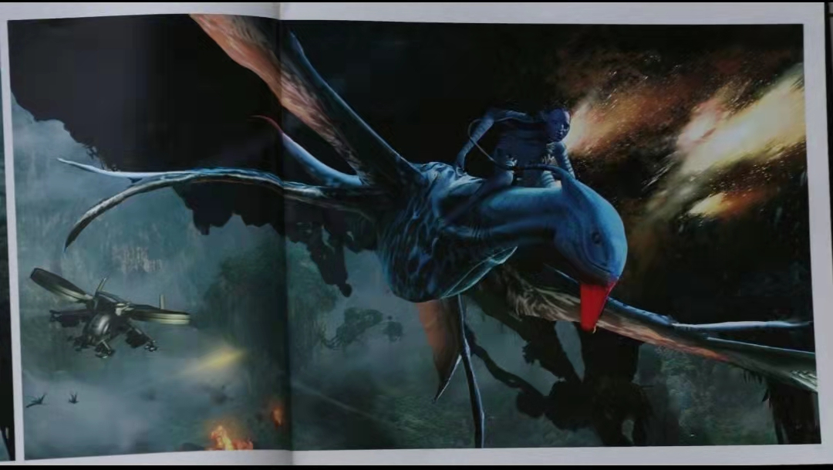

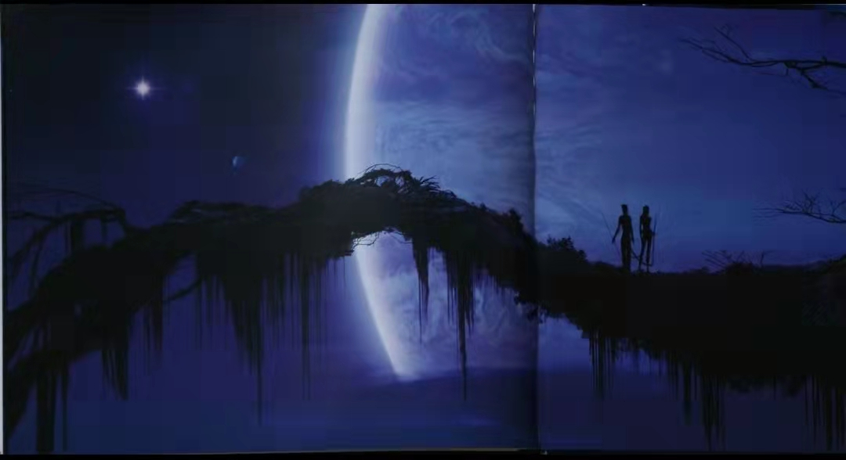
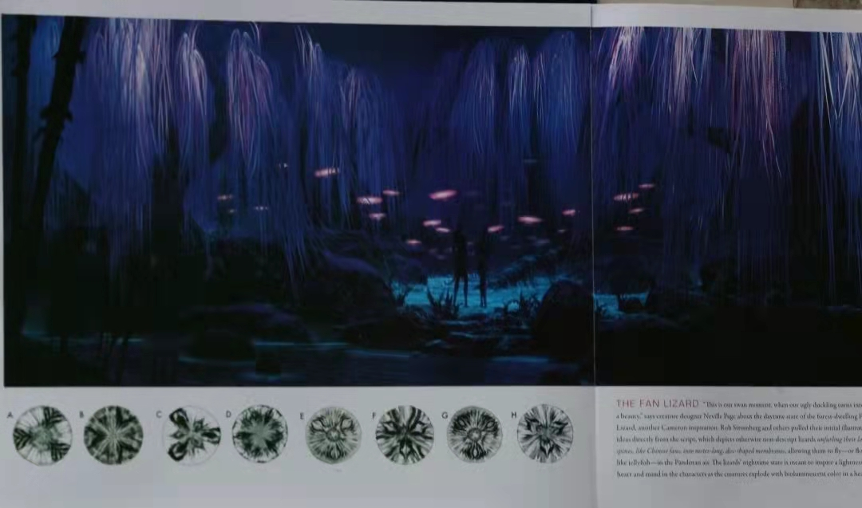

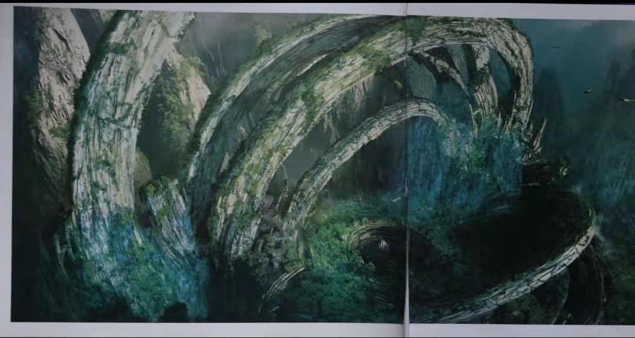
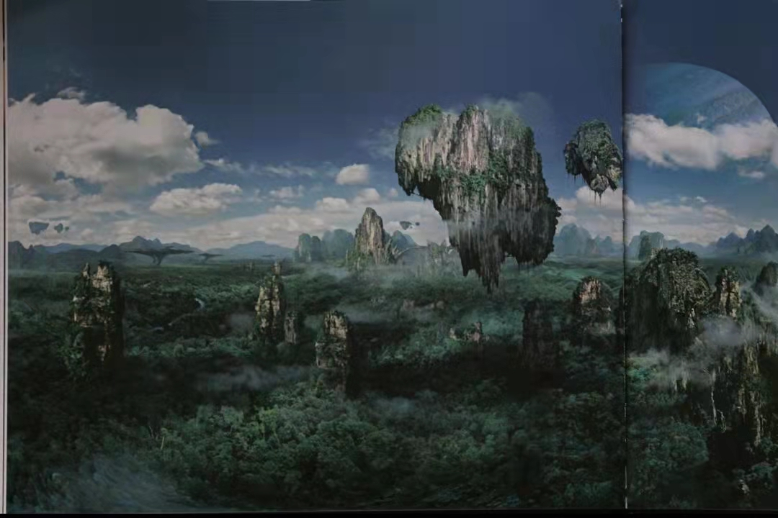

- Na’vi character design drawings
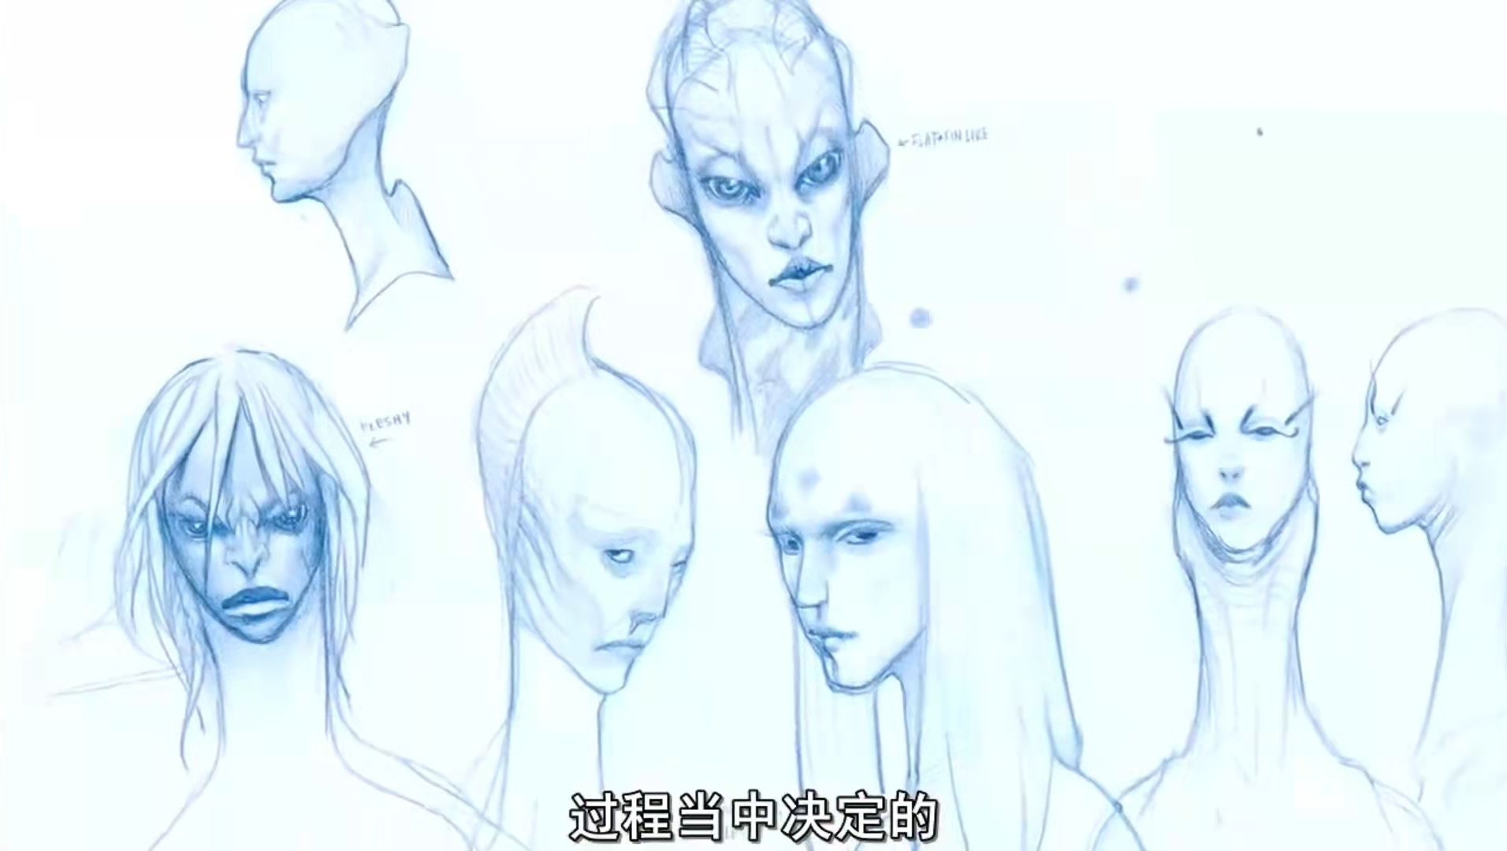
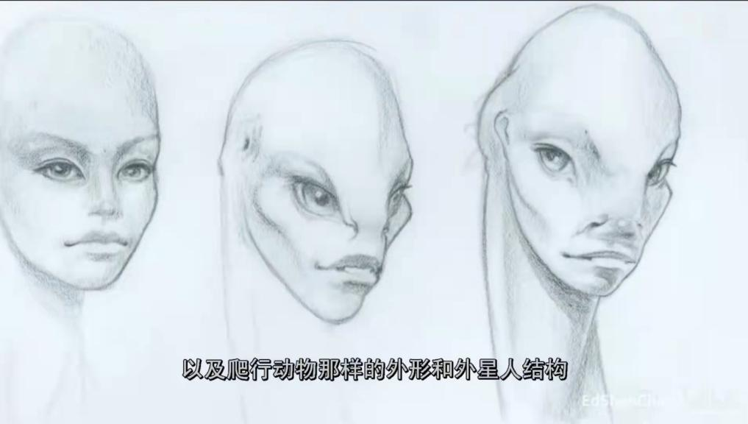
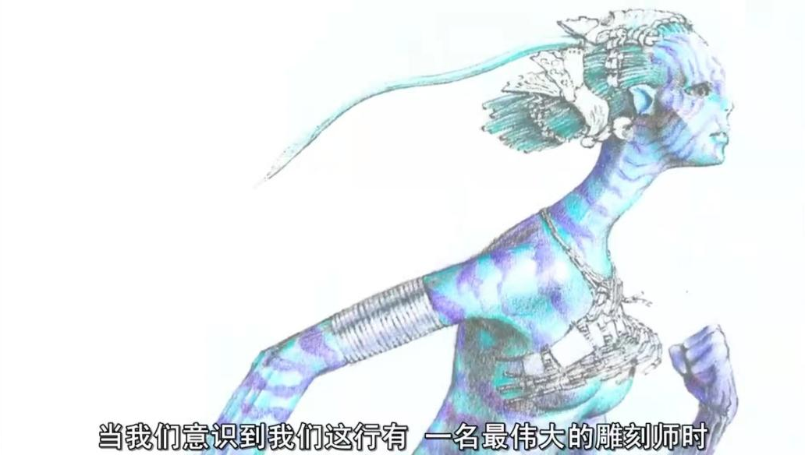
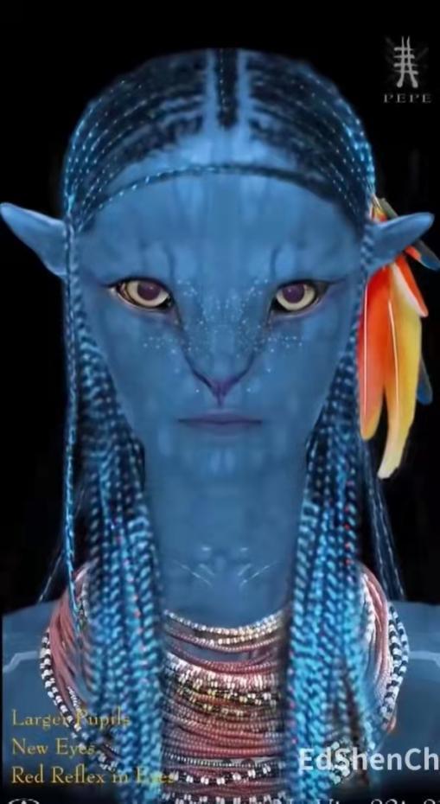
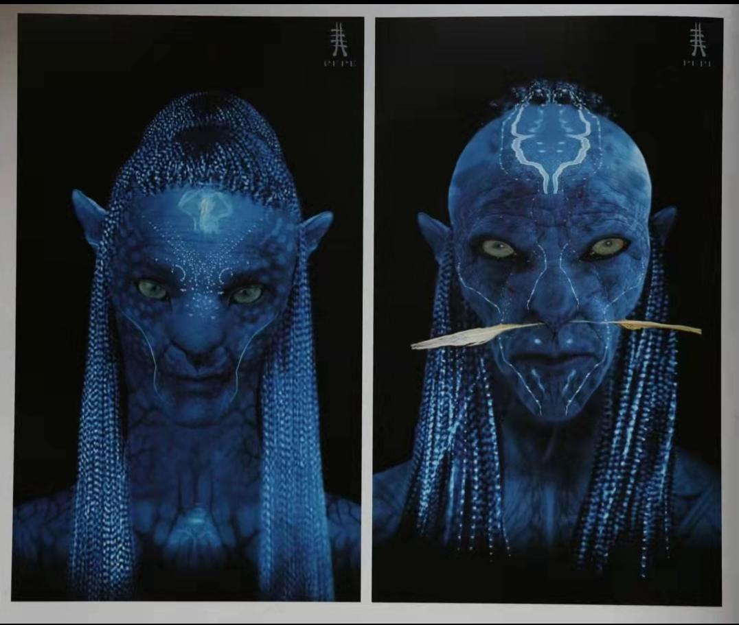

- Preliminary modeling making

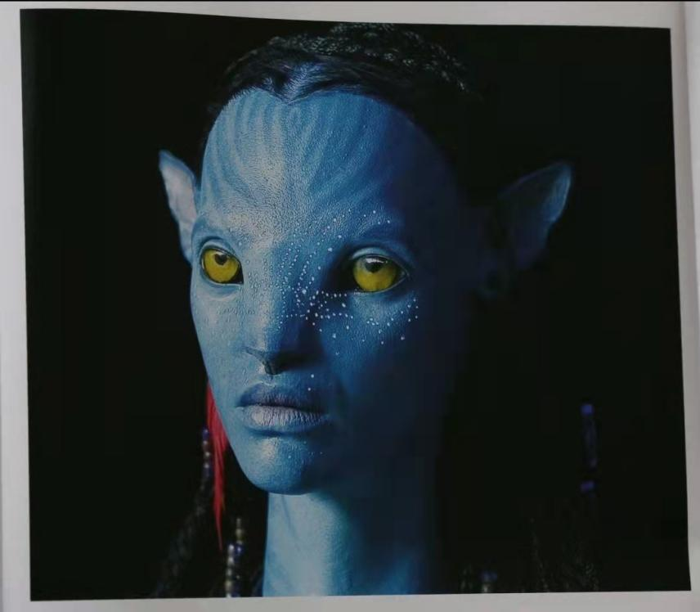

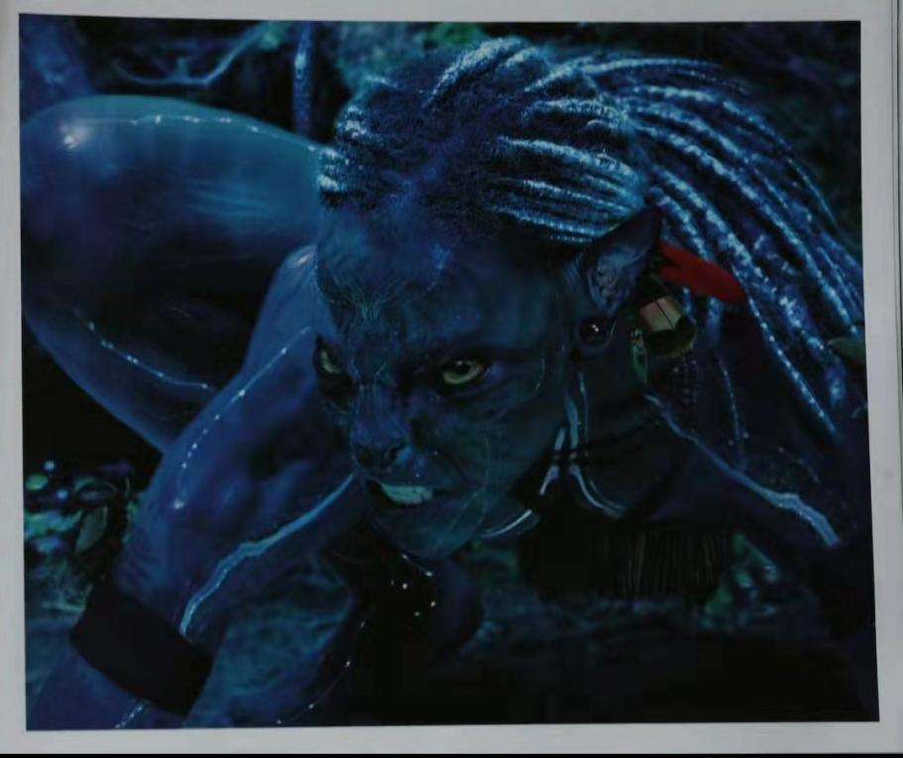

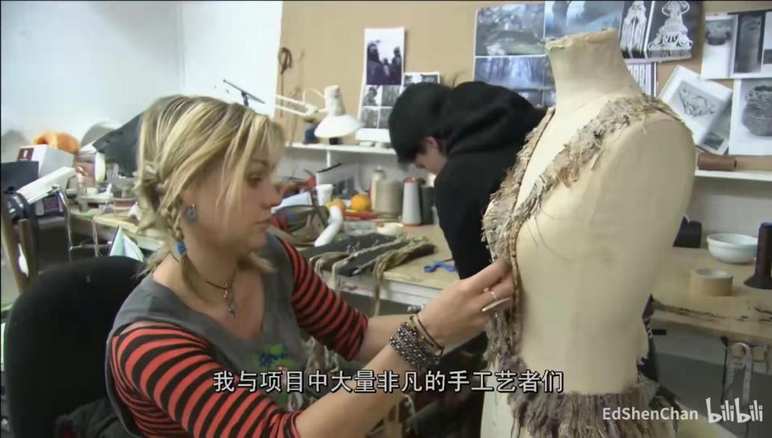
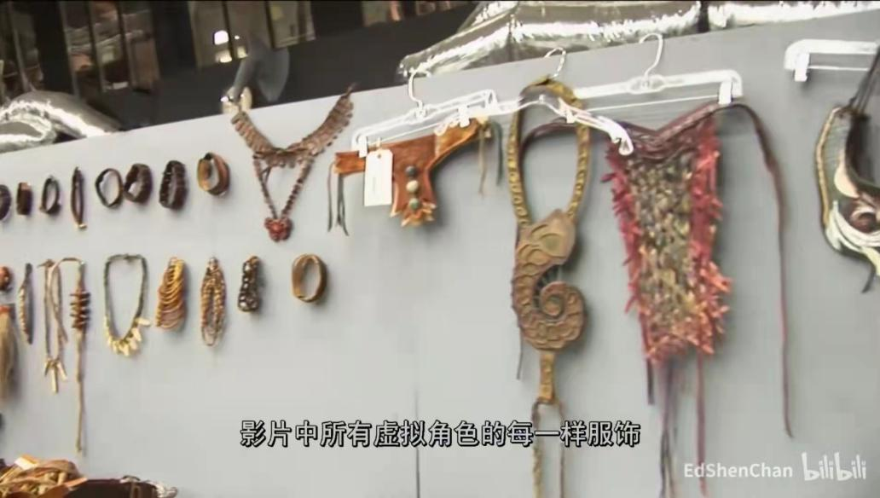
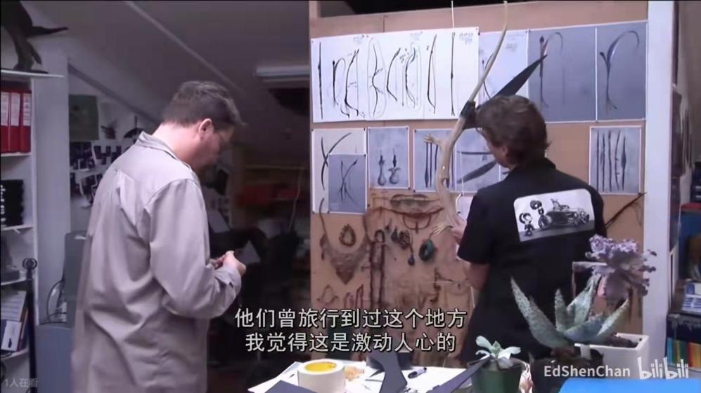
- Clothes design process

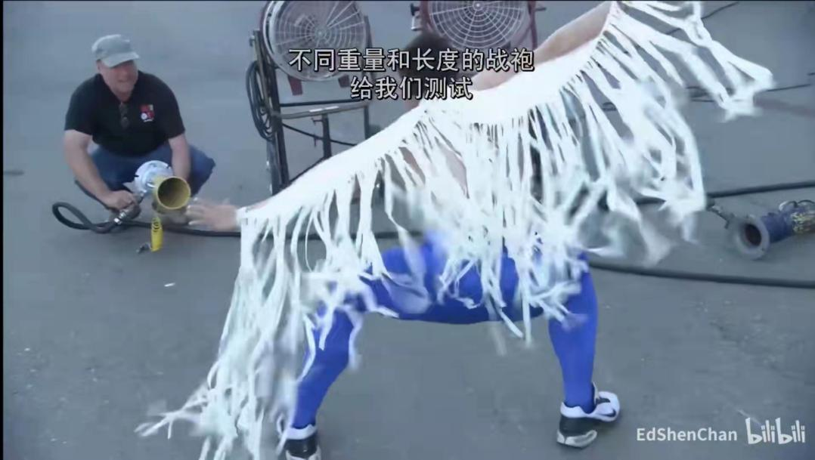
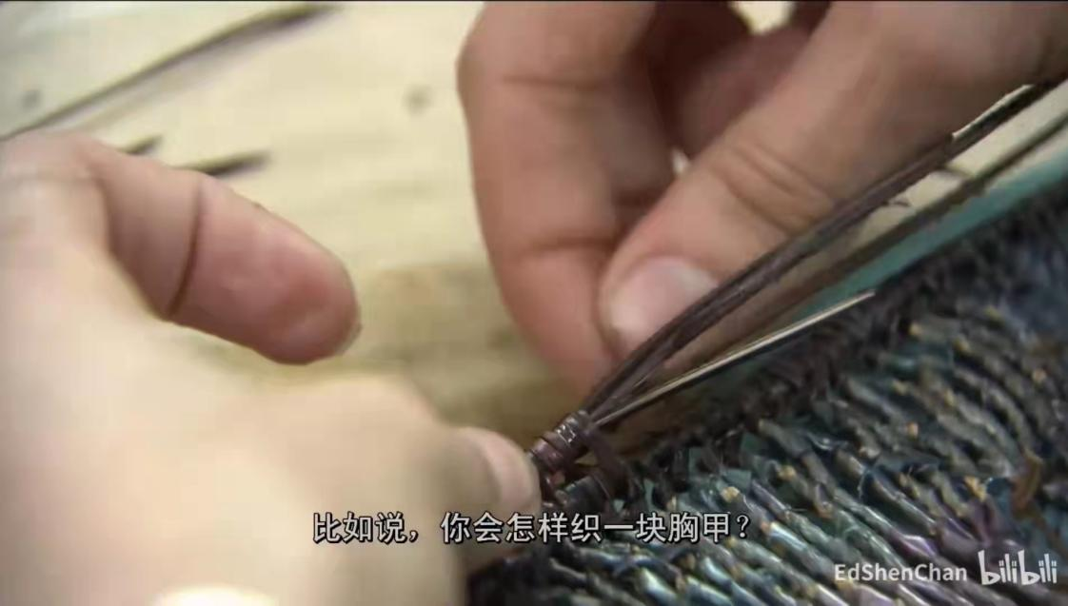

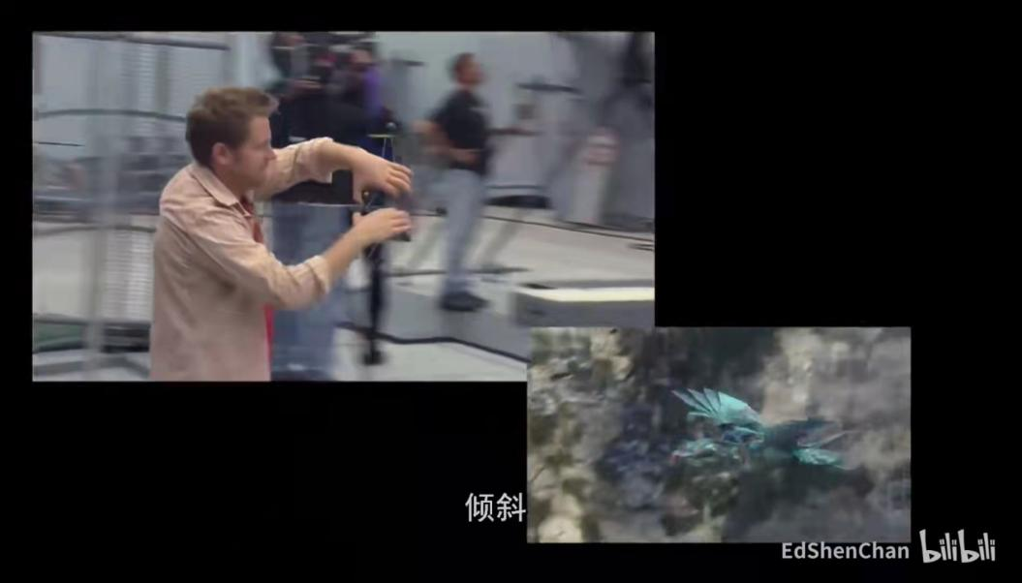
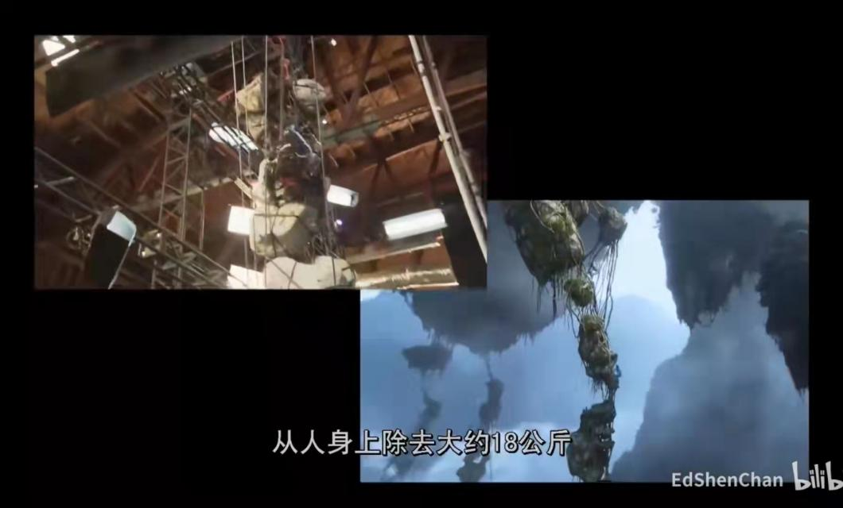
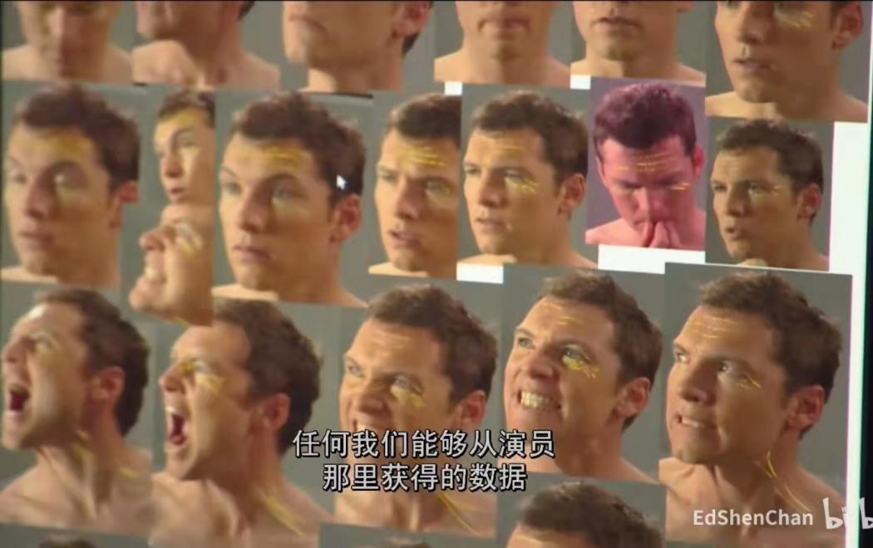
- Animation shooting and Making


